WebFlow/UML: Web, Commodity and DoD Standards based Toolkit for
Scalable Distributed Collaboratory Software Process Engineering

Translet, Inc. Proposal to the U.S. AirForce / Rome Laboratory
In Response to the SBIR 2000.1 Topic
AF00-131: Distributed Collaborative Environment Technology

Technical Abstract

The emergent distributed collaboratory environments are expected to play a crucial role in complex cross-disciplinary enterprises such as simulation based acquisition, agile manufacturing or crisis management. However, building software for the underlying multi-component multi-supplier multi-player heterogeneous distributed systems that coordinate humans, agents and simulation modules raises non-trivial engineering and integration challenges. We believe that the new DMSO HLA standard for simulation interoperability, when combined with the emergent Object Web standards of CORBA, Java and XML offers now a promising open platform to attack this problem, This project will develop a general purpose distributed collaboratory infrastructure, based on our WebHLA implementation of HLA in terms of Web/Commodity standards, and it will demonstrate it by prototyping (Phase I), productizing (Phase II) and commercializing (Phase III) a specific software system, WebFlow/UML in a domain of collaboratory software process engineering (CSPE). WebFlow/UML will offer an integrated CSPE toolkit with scalable visual graph authoring tools ranging from whiteboard style UML editor to our WebFlow based componentware assembly and workflow manager. The system will be built as a Java/CORBA based distributed environment that implements and integrates a suite of recent OMG technologies towards CSPE including UML, MOF, XMI, HLA, CCM, CWM, Workflow and Agent Facilities.

Anticipated Benefits/Potential Commercial Applications of the Research or Development

We propose here our innovative WebHLA framework for distributed collaboratory environments which is based on integrating Web, Commodity and DoD HLA standards. If successful, WebHLA can significantly advance the field and accelerate development of advanced distributed collaboratory systems due to the strong DoD mandate for HLA and the rapid progress in Web/Commodity technologies, driven by the growth of the Internet. The specific product WebFlow/UML, proposed here for distributed collaboratory software process engineering is expected to have commercial impact both for DoD and commercial software industry. We see the growing need for collaborative software engineering tools and we feel that our proposed product will have perfect timing due to the ongoing software process standardization efforts within the Object Management Group.

- Identification and Significance of Problem or Opportunity

Complexity of Collaboratory Systems Engineering and Deployment There is now a broad and growing consensus across various software communities that distributed collaboratory environments are going to play the leading role in shaping the next generation problem solving environments for the New Millennium [1]. Such systems enable and optimize cooperation between humans, software agents and simulation modules to cope collectively with the complex cross-disciplinary and cross-cultural challenges such as simulation based acquisition, agile manufacturing or crisis management. However, building software for the underlying multi-component multi-supplier multi-player heterogeneous distributed systems raises several non-trivial implementation and dissemination challenges. Complexity of collaboratory systems is due to several diverse factors such as:

- rapid evolution and hence poor stability of the enabling computing, communication and information technologies which often results in non-optimally designed, implemented, tested or fine-tuned solutions that discourage non-technology-savvy participants;

- diversity of software technologies associated with human APIs, intelligent agents and simulation modules that causes interoperability between these modalities and in large integration of collaboratory systems to become truly hard problems;

- natural reluctance of Western society, built around the success model of an individual, to participate and share personal assets in collaboratory endeavors - which slows down the broader acceptance of collaboratory environments.

The obstacles listed above need to be carefully analyzed and properly accounted for when planning commercialization of collaboration products, especially by a small business operation with the limited capabilities for test, evaluation and advertisement of collaboratory software. We believe that our project and product proposed here includes built-in mechanisms that will help us to avoid all typical caveats listed above and to succeed commercially. Indeed, we claim and demonstrate in this document that: a) we have selected the most stable and adequate technology suite for the problem domain; b) we know how to solve the hard integration and interoperability problem; and c) we plan our pilot product in the area where the stakeholders of a collaboratory enterprise are naturally motivated to participate, collaboratory protocols are well-defined and collaboration culture is already well-established.

High Level Architecture (HLA) Since humans represent the most demanding, the least predictable and the hardest to control category of collaboration participants, we start our analysis and design from the simulation end and we look for stable, slowly evolving and long lasting technologies that would be capable of enforcing cooperation and interoperability among individual models, components, simulation modules and subsystems, developed by various DoD programs and industry segments. DoD plays in fact a special role in this area due to the distinctive mission-critical aspect of modeling and simulation (M&S) for military operations and weapon systems. In consequence, M&S represents a significant fraction (of order of 10%) of the whole DoD software development budget but activities in this area were so far dispersed over many programs and DoD-wide interoperability was not considered so far a high priority requirement. This situation is dramatically changing over the last few years as a result of the emergence and rapid deployment of High Level Architecture (HLA) [2]. HLA, developed by DMSO, standardized by SISO and monitored by the DoD AMG, is a DoD-mandated language-independent object-based distributed software architecture for simulation reusability and interoperability that is now being enforced DoD-wide across all individual M&S programs, systems and simulation paradigms, including both real-time (DIS) and logical time (event-driven) management models.

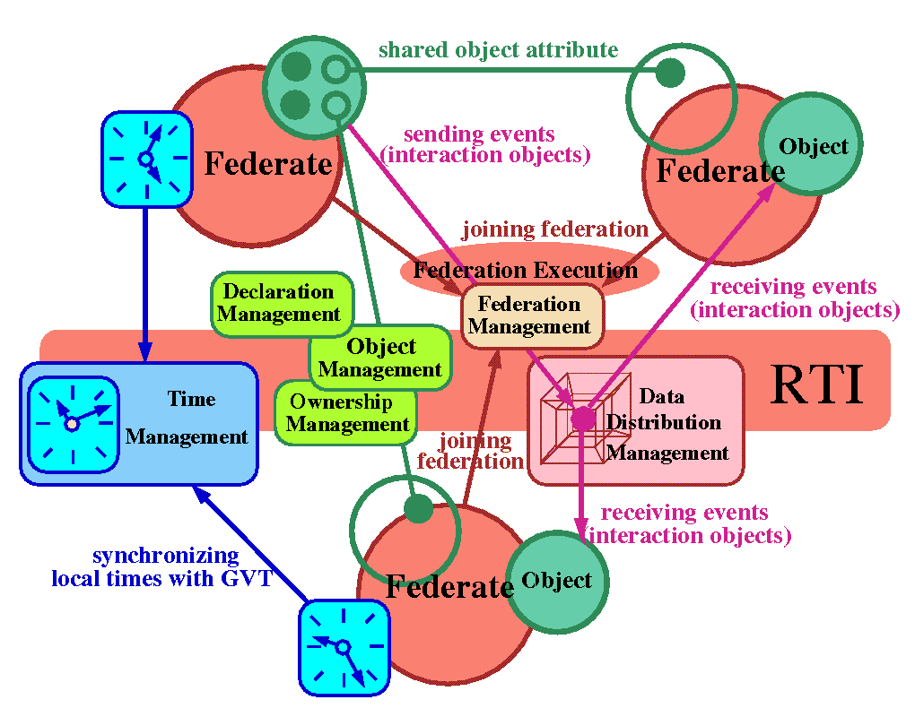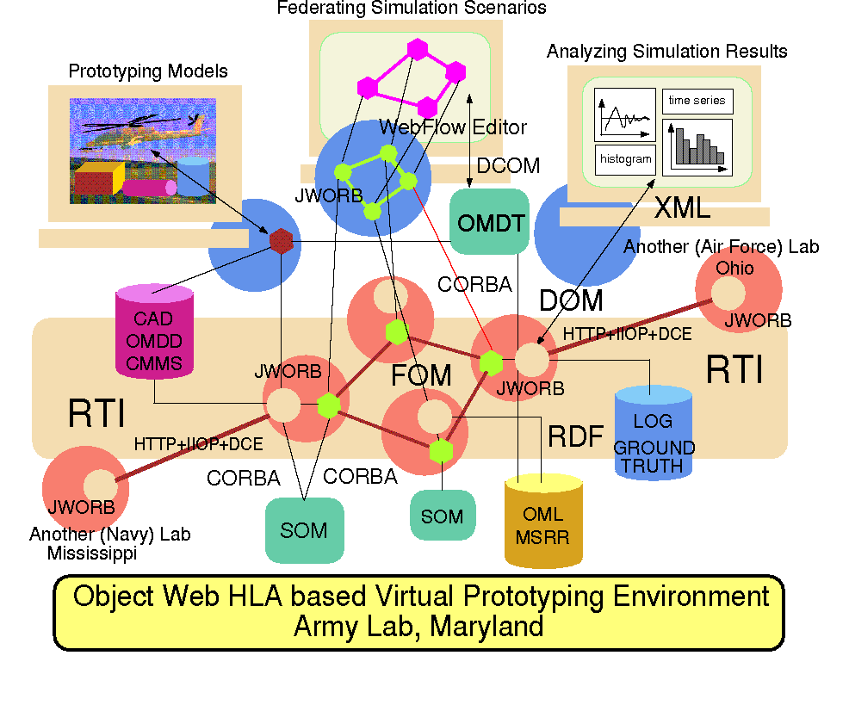
Fig. 2: An illustration of a possible use of WebHLA for a distributed collaboratory Simulation Based Acquisition application that includes Army, Navy and Air Force labs participating in the DoD High Performance Computing Modernization Program.
Fig. 1: Overall organization of Run-Time Insfrastructure (RTI) software bus of High Level Architecture (HLA). Circles represent entities, rectangles represent RTI service, and lines illustrate interaction patterns described in text.

HLA views distributed simulation as a federation of coarse grain opaque semi-autonomous entities called federates that govern locally and independently their simulation objects and that conform strictly to some global federation rules, specifying the information exchange policy across the federation. The associated Run-Time Infrastructure (RTI) offers the software bus services available to the HLA-compliant federates and including Federation, Object, Declaration, Ownership, Time and Data Distribution Management. We illustrate the overall organization of RTI in Fig 1. Federates (large circle) maintain their simulation objects (medium circles) given by attribute sets (small circles) and they interact via RTI services (rounded rectangles) managed by the RTI bus (central elongated rectangle). Both local (simulation) and global (federation) objects conform to a simple attribute-value based entity format specified by the Object Model Template (OMT) and are suitably grouped and maintained by the RTI as SOMs (Simulation Object Models) or FOMs (Federation Object Models). Federates can join or leave federation (using Federation Management), they create their objects and register them with the RTI (using Object Management), they can publish and/or subscribe some of their objects (or their selected attributes) for sharing (using the Declaration Management), they can negotiate update rights for shared objects (using Ownership Management), they can evolve their objects in time and they can synchronize their local simulation clocks with the federation time (using Time Management), and they can build dynamic multi-dimensional routing channels for optimized multicast delivery of discrete communication events called interaction objects (using Data Distribution Management).

HLA/RTI as Collaboratory Engine Our central observation in this proposal is that HLA/RTI, albeit it is most frequently used for distributed simulations, also can be naturally employed as a powerful scalable engine for distributed collaboratory environments due to its abstract, generic and dynamic architecture outlined above and depicted in Fig. 1. More generally, it is perfectly legitimate to build distributed federations that include and coordinate both simulation (synthetic) and human (live) federates. Both types of entities obviously follow very different internal time evolution patterns, but they can work collectively and smoothly together on solving some complex simulation-information problems if only they adhere to the HLA rules i.e. they export their SOMs and FOMs, exchange information via and employ management services of the RTI. The advantage of using the core DoD simulation technology as a generic collaboratory engine is that it allows us to tap directly into the rapidly growing repository of diverse simulation modules being now transitioned all over the DoD to HLA and hence being converted to HLA-compliant simulation federates that can plug-and-play on RTI bus together with human and agent federates.

Moving towards human component of a collaboratory environment, we notice that the current HLA framework is focused more on communication performance and simulation management support then on user-friendly front-ends and hence there is no specific high level collaboratory API for live federates offered by HLA right now. Further, DMSO main emphasis so far was on supporting reusability of and HLA-enabled interoperability among diverse existing legacy codes rather than on providing HLA based software engineering support for new simulations that would utilize the latest Web/Commodity technologies of Java, CORBA and the XML.

WebHLA as Collaboratory Framework We recently proposed to fill this gap in our WebHLA framework [3] [8-10] that offers open implementation of HLA in terms of a suite of emergent object standards for the Web based distributed computing – we call it Pragmatic Object Web - that integrate Java, CORBA, COM and XML. WebHLA follows a 3-tier architecture with the middleware given by JWORB (Java Web Object Request Broker) that integrates Java, CORBA, COM and WOM (Fig. 7), with the Object Web RTI (i.e. DMSO RTI 1.3 as a JWORB service) software bus for the communication between HLA federates (Fig. 8), with the backend simulation modules wrapped via CORBA/COM as FOM or SOM objects, and with the WebFlow based visual dataflow authoring and runtime steering front-ends (see Figs 3-6).

WebHLA is being developed within the DoD High Performance Computing Modernization Program where we lead the Forces Modeling and Simulation (FMS) Programming Environment and Training (PET) Computational Technology Area (CTA). Our approach is based on and explores synergies between ongoing and rapid technology evolution processes such as: a) transition of the DoD M&S standards from DIS to HLA; b) extension of Web technologies from passive information dissemination to interactive distributed object computing offered by CORBA, Java, COM and W3C WOM; and c) transition of HPCC systems from custom (such as dedicated MPPs) to commodity base (such as PC clusters). We are addressing WebHLA design and prototype development in a set of PET FMS tasks at ARL, ERDC and NAVO MSRCs, including: JWORB based Object Web RTI for Metacomputing M&S [6], WebFlow based Visual Authoring Tools [4], Web linked commodity database backends [7] and DirectX based multiplayer gaming front-ends for Training in Advanced M&S [5].

Translet Expertise, Contacts and Technologies Through the PET program activities listed above, we developed contacts with a set of M&S programs and we now have a broad insight, know-how and the source code level access to several advanced systems such as ModSAF by STRICOM/DMSTTIAC, SPEEDES by SPAWAR/Metron, Inc. or CMS (Comprehensive Mine Simulator) by the Night Vision Lab at Ft. Belvoir. We are also building ties with other ongoing M&S projects such as IMPORT by SPAWAR, TEMPO/Thema by NRL and SAIC, or PANDA by OriginalSim, SPAWAR and Metron. We are also participating with Metron in the new FMS CHSSI project aimed at developing High Performance RTI for the Origin2000 platform on top of the SPEEDES simulation engine.

We believe that our contacts, know-how and in-house technologies reached a critical mass where we are ready to start moving from academic research prototypes towards products and services for the DoD M&S community. Therefore, in parallel with these R&D tasks, conducted in the academic environment of Northeast Parallel Architectures Center (NPAC) at Syracuse University (SU), we are currently in the process of licensing the associated core technologies to Translet, Inc., founded in ’97 by Dr. W. Furmanski as an SU/NPAC spin-off company. Translet business so far has focused on custom Web software development in the area of Web linked databases and collaboratory multi-user environments for distance education and healthcare communities. With this SBIR proposal, Translet is proposing to merge its Web collaboration expertise acquired in industry projects with the WebHLA simulation expertise developed in DoD funded academic R&D projects towards commercial products in the area of general purpose distributed collaboratory infrastructure of relevance both for DoD and commercial industry.

Towards Simulation Based Acquisition (SBA) One major area in the DoD realm where the distributed collaboratory environments are expected to play an essential role is Simulation Based Acquisition (SBA) that employs the end-user centered and agents-aided full product cycle virtual prototyping in realistic synthetic environments to build better products cheaper and faster. SBA is already being explored by industries such as aircraft (Boeing) or automotives and significant savings (of 50% and more) are reported. Facing flat or shrinking budgets and ever increasing demands on new systems quality, reliability and complexity, DoD is also starting initiatives towards SBA as indicated by a series of recent multi-disciplinary conferences [4-7] in this domain. We believe that WebHLA, defined as the final product at the convergence point of the standardization processes outlined above will offer a powerful modeling, simulation and collaboration framework, capable of addressing the new challenges of DoD computing in the areas of Simulation Based Design, Testing, Evaluation and Acquisition. We also feel that, based on our contacts we are gradually establishing in various DoD labs across all Services, we soon will be in the position of addressing the practical pilot SBA projects using WebHLA based Metacomputing environment that enables collaboration across several DoD Labs such as envisioned in Fig. 2.

Current Focus on Collaboratory Software Process Engineering (CSPE) However, a full blown SBA environment as in Fig 2 is clearly beyond the scope of any single SBIR effort. Also, there are several cultural and political obstacles that need to be bypassed before we can start prototyping, reliably testing and successfully deploying such cross-organizational systems. In this project, we propose to develop a more modest, focused, well-defined and realistically deployable distributed collaboratory environment that will further advance our general WebHLA framework and customize it for a specific product in the area of collaboratory software process engineering (CSPE). As pointed out before, collaboratory environments raise non-trivial software challenges and hence taking software engineering as the first problem to be collaboratively solved towards SBA seems to be a reasonable and practical bootstrap strategy. Furthermore, we view the object-oriented spiral software process engineering as a perfect initial target for WebHLA based collaboratory infrastructure. Indeed, all state-of-the-art software process models currently offered both by industry (such as Unified Software Development Process [11] or the Rational Unified Process [12]) and by academia (such as the WinWin [17] model by the Barry Boehm research team at USC) stress the relevance of collaboratory technologies, employed in terms of a suite of spiral iteration workflows that facilitate coordination of dedicated teams and help to organize, instantiate and manage individual phases of the software process such as Requirements, Analysis, Design, Implementation and Testing. The underlying notation for the software process artifacts and workflow activities, represented by the new industry standard Unified Modeling Language (UML) is based on visual interactive graph authoring, and as such, it also admits a natural whiteboard style distributed collaboratory implementation.

Software processes offered today by the industry are still proprietary but we are witnessing the onset of industry convergence towards the common software process engineering tools that is being facilitated by the Object Analysis and Design Task Force with the OMG. This successful recent activity within the OMG was initiated in '97 by the standardization and rapid adoption of UML [19], then followed by a suite of related technologies such as Meta-Object Facility (MOF) [18] for general meta-modeling support, XML based Metadata Interface (XMI) [20] for scripting UML models, MOF/XMI based Common Warehouse Metamodel (CWMI) for interoperability across diverse heterogeneous databases, and now moves towards standardizing the metamodel that would govern the artifacts, activities, roles and workflow topologies involved in software process engineering (SPE) [21].

Proposed Product: WebFlow/UML In view of these ongoing efforts of the OMG OA&D Task Force, growing popularity of UML, urgent need for high level software authoring paradigms and increasing emphasize on collaboratory environments, we see a unique window of opportunity for a new category of software process engineering product that we feel we are able to develop and commercialize, and we therefore propose in this document. We call this product WebFlow/UML to indicate that it merges and integrates Web based collaboratory computing, high level dataflow authoring and UML based analysis and design. In a nutshell, WebFlow/UML will offer a WebHLA based integrated suite of software process tools that start from collaboratory fine grain UML editor and then continue smoothly towards coarse grain componentware authoring, and finally towards software process artifacts, activities and workflow management tools based on our WebFlow model of Web enabled visual authoring of distributed dataflow graphs. The unifying principle for all tools comprising the WebFlow/UML package is that of an interactive collaboratory visual i.e. WYSIWIS (what-you-see-is-what-I-see) graph authoring that will be coordinated and integrated across all diagrammatic topologies and software granularities, ranging from fine grain objects, classes, states and events of UML to coarse grain distributed components of WebFlow that will integrate CORBA Components, Enterprise Java Beans, and HLA Federates models.

The timing of our proposed WebFlow/UML project is closely associated with the OMG time scales for the SPE metamodel. The deadline for the SPE Metamodel RFP is May 2000 and hence the specific OMG recommendations for the SPE would start appearing during the course of this project. Our plan, elaborated in Section 3, is to start the project in sectors where the relevant standards such as UML or HLA are already specified, adapt the general collaboratory WebHLA infrastructure for SPE purposes, integrate UML and WebFlow authoring paradigms and then gradually align the specific design of the WebFlow/UML tools with the SPE standards as they will start emerging later this year from the OMG. This way, our WebFlow/UML stands a chance to become the first distributed collaboratory implementation of the SPE toolkit that will be both OMG (Commodity) and HLA (DoD) compliant. We believe that these features of our proposed product, combined with the timing of its prototype (Phase I) and product (Phase II) version deployment will generate visibility both within the DoD and industry that will boost successful commercialization of our product in Phase III.

Translet Plan for WebFlow/UML We are demonstrating in this document that Translet can gather together all resources required to accomplish the proposed WebFlow/UML project. Close linkage between the ongoing WebHLA effort within the FMS project at Syracuse University and the proposed Translet SBIR project will be provided by Dr. Furmanski who is: a) technical lead of the FMS PET project in his capacity of NPAC Chief Technologist and Research Professor of Physics at Syracuse University; b) Translet President; and c) Principal Investigator of the proposed WebFlow/UML project. Would this proposal be funded, Dr. Furmanski intends to reduce his Syracuse University capacity and dedicate more than 50% of his time for Translet where he will lead and implement the proposed SBIR project.

WebFlow/UML project and product will accumulate and integrate Translet expertise in building collaboratory interactive Web services (such as CareWeb or LCU discussed in more detail in Section 4), our FMS PET expertise in advanced M&S systems, our contacts established in the DoD community which we view as the initial customer base, and our suite of operational Web/Commodity technology prototypes such as WebHLA and its components (JWORB, OWRTI, WebFlow) that we intend to utilize in the first series of builds planned within the WebFlow/UML spiral development described in Section 3. On top of these assets, we will bring the suite of new OMG technologies, some of them already standardized (such as UML, MOF, XMI, CWM) and some still under development (such as SPE Metamodel) and we will initiate in Phase I and complete in Phase II a collaboratory software process that will implement these technologies and integrate all components towards the WebFlow/UML toolkit.

Our specific R&D objectives for Phase I are summarized in Section 2 and then elaborated upon in Section 3 where we describe in detail our Phase I Work Plan. In Phase I, we intend to follow the Unified Software Development Process and we organize our Work Plan accordingly in terms of the Requirements, Analysis, Design, Implementation and Testing Workflows. At the end of Phase I, WebFlow/UML will be ready for initial field tests, one of them being its use as the actual collaboratory software process engineering environment for the Phase II of the project that will fully productize the Phase I prototype while continuously testing and refining it in the spiral bootstrap mode.

- Phase I Technical Objectives

Our objectives for the Phase I project can be summarized as follows:

- Explore the concept of Web, Commodity and HLA integrated platform for a general purpose cross-discipline collaboratory framework further developing our WebHLA prototype and evaluating it in the context of a selected critical application domain of collaboratory software process engineering.

- Specify requirements and perform analysis and design of the specific WebFlow/UML product for collaboratory software process engineering that will use and test WebHLA as a general purpose distributed collaboratory platform.

- Perform a set of initial iterations of the implementation and testing workflows that will start from the current suite of Translet technologies such as WebFlow, JWORB, OWRTI and WebHLA, and it will deliver by the end of Phase I a working prototype of WebFlow/UML;

- Continuously re-evaluate and adjust the software process and the project plan during the Phase I project so that it will converge by the end of the Phase I into a solid development plan and process model to productize WebFlow/UML in the Phase II.

- Phase I Work Plan

As outlined above, our Phase I objectives include exploration of WebHLA as a general purpose distributed collaboratory platform in the context of designing and prototyping the WebFlow/UML product, and shaping the Phase I artifacts (design, prototype, lessons learned) so that they are ready as input for the Phase II product development. Following the style of modern software engineering, we view all aspects of our work as activities within some organized software process. The goal of this process is to build WebFlow/UML starting from day one of Phase I , and continuing throughout Phase I towards initial demonstrable prototype and then through Phase II towards final deployable product. Phase I WebFlow/UML will offer initial tools to facilitate assembly of various software process models and we will experiment with and gradually enhance these capabilities during the Phase II spiral bootstrap process. In Phase I, we intend to follow the general Unified Software Development Process [11] and its elaboration Rational Unified Process [12], recommended by the UML and process experts from Rational Corporation as state-of-the-art solution. We do not intend to use any commercial software process tools in Phase I since the current products in this area are prohibitively expensive, the whole field is in the state of flux due to the OMG SPE initiative, and there is now enough public information on the Rational/Unified Process to use it as a guidance without the need to buy expensive and heavy-weight process tools from Rational.

Following the Unified Software Development Process, we organize our Work Plan presentation in terms of the associated process phases that include Requirements, Analysis, Design, Implementation and testing. Since Unified Process is architecture-centric, our objective of WebHLA exploration and evaluation will appear very naturally in this framework in terms of the core architectural platform that is domain and product independent but it effectively binds all components of a project towards the final product. Since Unified Process is iterative, it will naturally generate the plan for Phase II as one of the Phase I artifacts.

Requirements First pass requirements for WebFlow/UML to be used in the initial Phase I iterations will be provided by Translet based on our experience, know-how and needs in the area of software engineering and process modeling. After reaching the stage of a minimal releasable prototype in the course of Phase I, we will engage our partners with well-defined software engineering experience and/or needs such as SU/MAME, Teknowledge or Metron to refine our initial requirements, Their comments and edits will be included in the second pass Phase I iterations.

For the first pass purposes, we specify WebFlow/UML toolset in terms of the following tools and their associated Use Cases:

- Extensible UML support - this tool will support visual authoring of UML diagrams using interactive 2D vector graphics. Apart from the standard UML 1.3 diagram topologies (inclduing Class, Object, Use-Case, Sequence, Collaboration, Statechart, Activity, Component and Deployment Diagrams) the user will be able to design, build and use new topologies and assign new action semantics to visual authoring operations.

- WebFlow style componentware authoring - this tool will support visual interactive authoring of distributed applications (federations) in terms of dataflow diagrams of opaque plug-and-play components. WebFlow topology will be constructed as an UML extension described above. WebFlow component model will include CLORBA components, Enterprise Java Beans, COM components and HLA federates.

- Collaboratory brainstorming - this tool will facilitate groupware support for early stages of the software process including requirements gathering, common ontology negotiation, selection of initial classes and their responsibilities etc. Both asynchronous techniques (such as CRC cards) and synchronous techniques based on real-time audio/video/chat/whiteboard based teleconferencing tools will be supported and integrated.

- Collaboratory UML graph editor - UML editor described in item 1 will offer collaboratory modes, including both the synchronous WYSIWIS (what-you-see-is-what-I-see) mode as well as a set of delayed/locked/concurrency controlled asynchronous modes that facilitate groupware style of UML based object analysis and design.

- Collaboratory WebFlow graph editor - WebFlow editor described in item 2 will offer collaboratory modes, similar as for the UML editor above, that will facilitate groupware style of visual authoring of distributed applications.

- Support for SPE artifacts and activities - this tool will offer base file I/O, format templates and editing support for a set of typical artifacts used as links in popular software process workflows, including software documentation, process plans, analysis models, design models, source codes, test plans etc. It will also include libraries of typical activities used as nodes in popular software process workflows.

- Web exchange of UML models / SPE artifacts - this tool will allow to exchange UML models and other SPE artifacts across the Internet and Intranets between collaborating software teams that are organized as cooperating nodes of some distributed collaboratory software process workflow.

- Common Web repository of UML models / SPE artifacts - this tool will offer a common database for the UML/SPE artifacts that will be accessible, usable and editable in a concurrency controlled fashion by all members of distributed software enterprise that follow a WebFlow/UML supported software process.

- Workflow authoring, management and enactment - this tool will allow to assembly new workflows in terms of the SPE primitives or select one of the standard workflow design patterns, enact the workflow i.e. instantiate the associated workflow activities and manage the information flow.

- Plug-in simulation support - this tool will allow to emulate design time software entities such as objects, components or activities captured by the UML models in terms of simplified run-time software modules to support spiral process and testing in the Simulation Based Design style.

- Plug-in agent/wizard support - this tool will support emulation of user nodes in WebFlow/UML diagram such as actors in use-case diagrams or roles in workflow diagrams by suitable intelligent agents to support spiral process and testing in the Knowledge Based Software Engineering style.

- Full cycle (forward and reverse) software engineering support - this tool will allow UML designers to generate software stubs in a particular programming language that correspond to the appropriate UML models (forward engineering) and to generate visual UML models from the existing software modules by parsing the sources codes and extracting the design entities and topologies (reverse engineering).

- Interoperability with other UML/SPE tools - this tool will offer a set of translators and filters that transform between native data formats for UML models and SPE artifacts used by various popular software engineering systems such as Rational Rose or Rational Suite, and the corresponding (OMG standards based) data formats used by WebFlow/UML.

Analysis We now map the use cases formulated above from the end-user perspective onto the planned system software architecture of the proposed WebFlow/UML product. We plan to build it in terms of the emergent OMG standards for the middleware Object Web, using Java as implementation language, Web/XML as the scripting framework and HLA as the distributed simulation and collaboration framework. Our suite of prototypes such as WebFlow, JWORB, OWRTI and WebHLA is already following this general approach and we intend to use these technologies as input for the WebFlow/UML software process. Below, we summarize the functionality, the current status and the planned evolution of these four software subsystems.

WebFlow WebFlow is a Java based visual dataflow programming environment (see Figs 3-6). Front-end (tier 1) is given by a Java applet which offers interactive graphical tools for composing computational graphs by selecting, dragging and linking graph nodes represented by visual icons. Each such node corresponds to a computational module in the back-end (tier 3), instantiated and managed by the WebFlow middleware (tier 2). WebFlow middleware is implemented as a group of management servlets, hosted by individual Java Web Servers and including Session Manager, Module Manager and Connection Manager. Data flows between connected WebFlow modules from input to output ports. Each new data input activates internal computation of a module and results in generating some new data on the module output ports. This way a computational graph, once setup by the user via the visual authoring tools, can realize and sustain an arbitrary coarse grain distributed computation. Dataflow model for coarse grain distributed computing has been successfully tested by the current generation systems such as AVS or Khoros, specialized for scientific visualization tasks and offering rich libraries of image processing filters and other visualization modules. The distinctive feature of WebFlow is that it is constructed as a mesh of Web servers and hence it can be viewed as a natural computational extension of the Web information model.

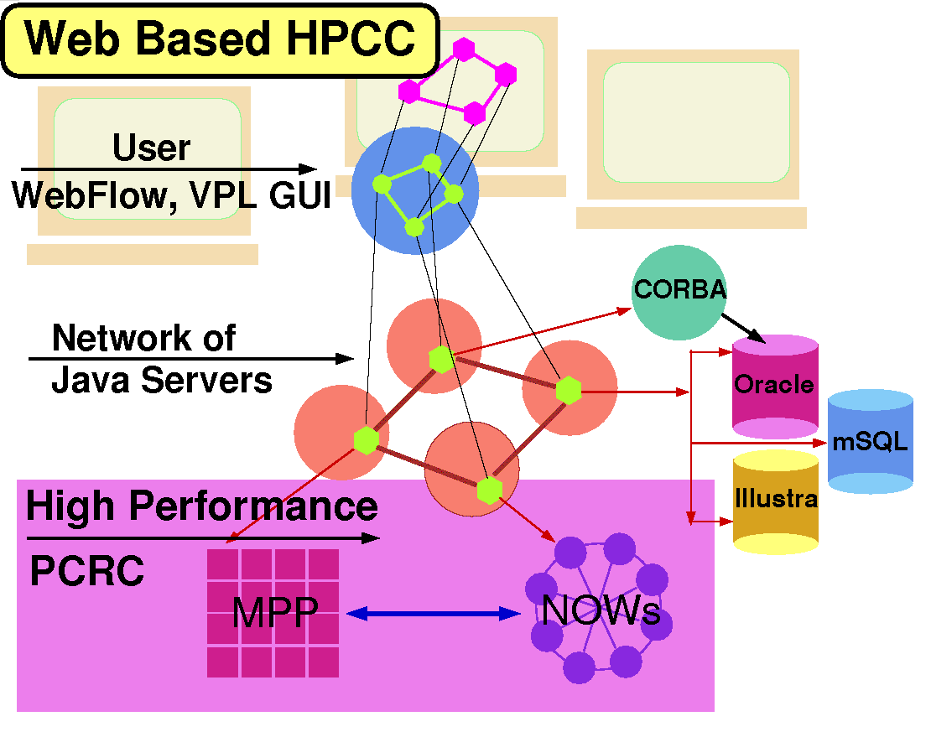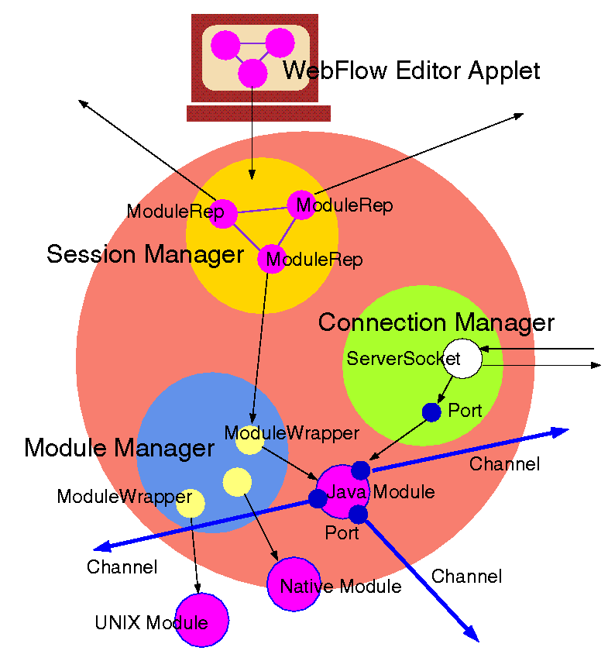
Fig 3: Top view of the WebFlow system: its 3-tier design includes Java applet based visual graph editors in tier 1, a mesh of Java servers in tier 2 and a set of computational (HPC, Database) modules in tier 3.

Fig 4: Architecture of the WebFlow server: includes Java servlet based Session, Module and Connection Managers responsible for interacting with front-end users, backend modules and other WebFlow servers in the middleware.

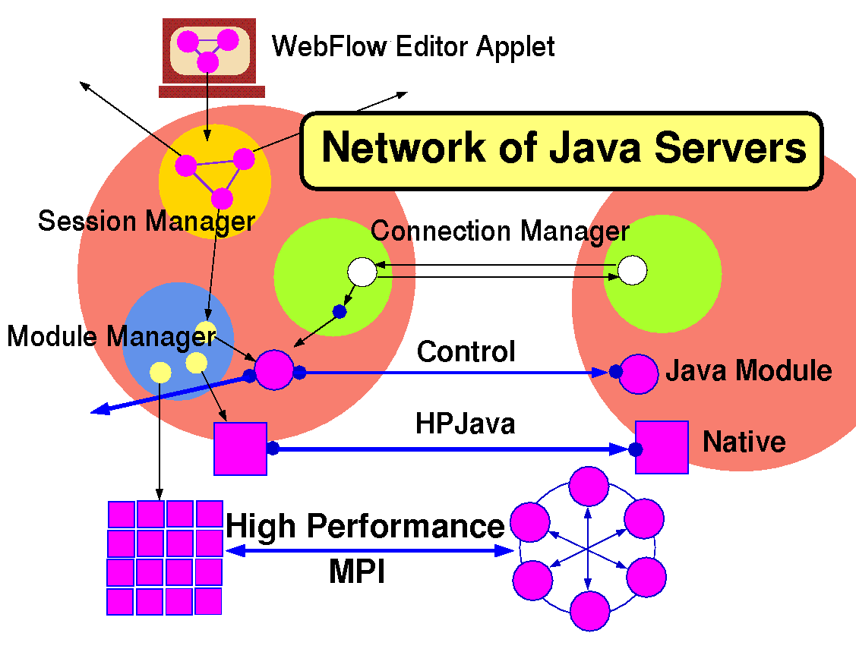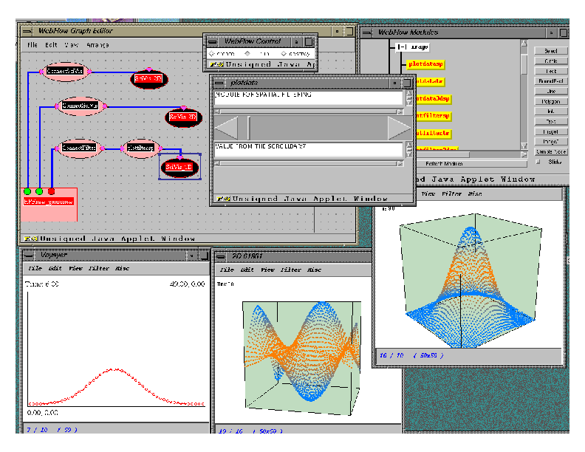
Fig 5: WebFlow middleware given by a mesh of Java Web Servers, managing distributed compute-webs of WebFlow modules, implemented in pure Java, native code or given by wrappers to external (high performance) codes.
Fig 6: A screendump from the Supercomputing ’98 WebFlow demo, including a set of real-time visualization modules, monitoring a high performance computational science (Binary Black Hole) simulation.

JWORB (Java Web Object Request Broker) JWORB is a multi-protocol network server written in Java (see Fig. 7). Currently, JWORB supports HTTP and IIOP protocols i.e. it can act as a Web server and as a CORBA broker or server. In progress is support for the DCE RPC protocol which will provide COM server capabilities. Base architecture of JWORB can be represented as a protocol detector plus a collection of dedicated servers for the individual protocols. Message packets in IIOP, HTTP and DCE RPC protocols all have distinctive anchors or magic numbers that allow for easy and unique identification of their protocols: IIOP packets always start with the GIOP string, HTTP packages start with one of the protocol method names such as POST, GET, HEAD etc. and DCE RPC packets start with a numerical value representing protocol version number. After the protocol is detected, the appropriate protocol handling code is dynamically loaded and the request handling thread is spawned for further processing. JWORB is a useful middleware technology for building multi-server multi-vendor distributed object systems and bridges between competing distributed object technologies of CORBA, Java COM and the W3C XML/DOM. JWORB offers an attractive economy model in which commonalties between server internals for various protocols can be naturally identified and the corresponding system services can be maximally reused when building the multi-protocol server.

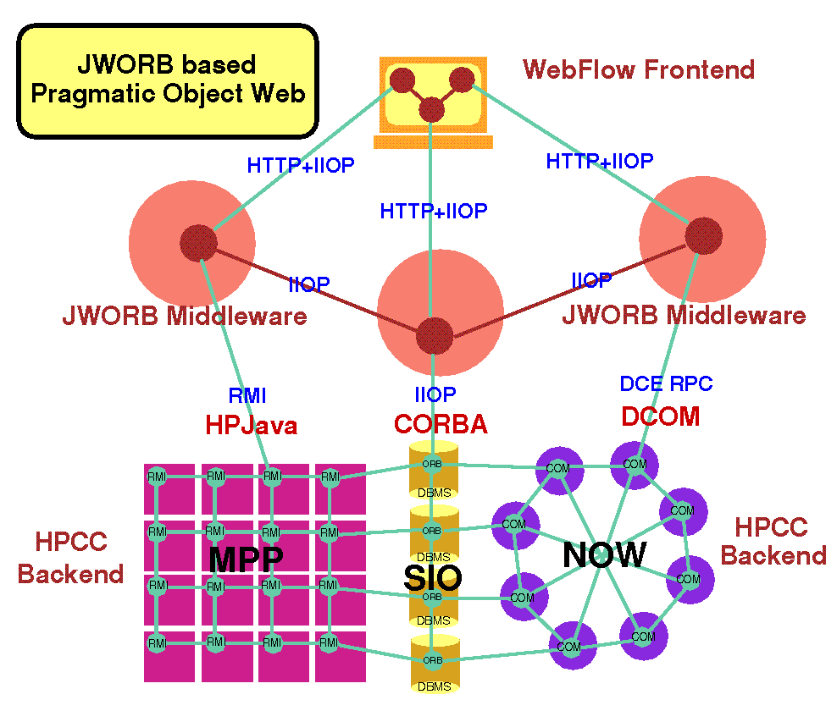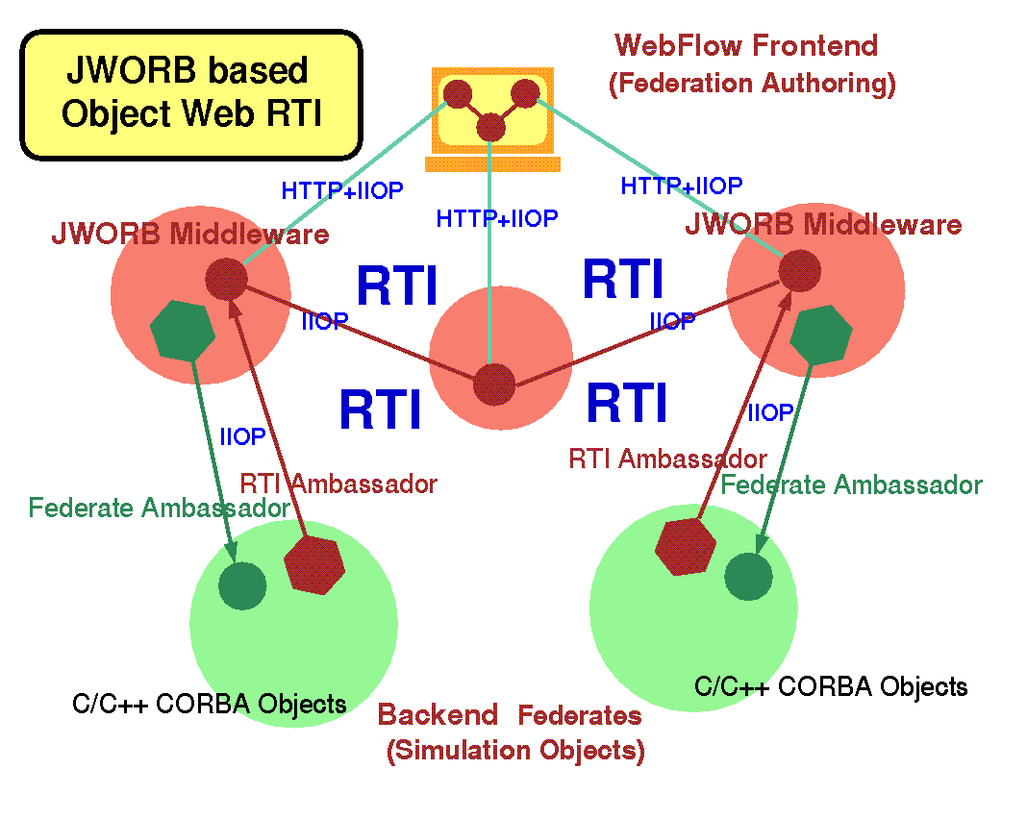
Fig 7: Illustration of the communication protocol integration within our JWORB based Pragmatic Object Web. JWORB uses Java to integrate HTTP with IIOP and then it connects with NT clusters via COM/CORBA bridge.

Fig 8: Top view representation of Object Web RTI: RTI Ambassador is Java CORBA object maintained by JWORB middleware; Federate Ambassador is (typically C++) CORBA object maintained by the backend federate; WebFlow front-ends tools are available for visual authoring of federation configuration.

OWRTI (Object Web RTI) RTI (Run-Time Infrastructure) is a new software bus technology for distributed object and simulation management developed recently by the Defense Modeling and Simulation Office (DMSO) as part of the High Level Architecture (HLA) standard that supports DoD-wide interoperability across diverse modeling and simulation frameworks, systems and applications. Object Web RTI (OWRTI) is an implementation of DMSO RTI 1.3 written in Java on top of the JWORB middleware i.e. packaged as a JWORB CORBA service (see Fig 8). As any RTI implementation, OWRTI acts as a software bus, offering management services to a set of federates (participants of a distributed simulation) that form or join and cooperate within a federation (an instance of a distributed simulation application). In OWRTI, each of the management services listed above is implemented as an independent CORBA object. Other CORBA objects in the system include: RTIKernel with acts as a core top level manager, FederationExecution which represents a federation instance mapped on a dedicated Java thread, RTIAmbassador which acts as a client side proxy of the RTI bus, and FederateAmbassador which acts as the RTI side proxy of a federate.

WebHLA (Web based High Level Architecture) WebHLA is an interactive 3-tier programming and training environment including: a) DMSO HLA architecture and our JWORB based Object Web RTI implementation in the middleware; b) Web/Commodity front-ends (such as Web browsers or Microsoft Windows); and c) Customer and application specific back-end technologies (ranging from relational databases to modeling and simulation modules). HLA focus is on middleware support to enable interoperability between existing simulations whereas the user front-ends or simulation/database back-ends are left open for the individual simulation developers. WebHLA is filling these gaps by combining the HLA/RTI middleware standards with the new Web/Commodity standards such as XML, VBA or DirectX for the front-ends or ASP, OLEDB or JDBC for the database backends. The resulting system can be customized and adapted for a variety of application domains, ranging from the DoD M&S to resource management for distributed computing to collaboratory environments for distance training to multi-player online gaming environments.

New OMG technologies for WebFlow/UML Using JWORB as our base ORB, WebHLA/OWRTI as the collaboration and simulation plug-in bus, and WebFlow as the visual authoring paradigm for distributed componentware, we will prototype the following new technologies of relevance for WebFlow/UML that were recently specified by the OMG:

- MOF (Meta-Object Facility) - a meta-metamodel facility i.e. a general framework for building metamodels such as UML metamodel , Common Warehouse Metamodel, SPE Metamodel etc.

- UML Metamodel - a MOF based metamodel that offers a set of CORBA objects to represent features and semantics of all elements of all UML diagrams, including their nodes, links, dependencies, associations, adornments etc.

- XMI (XML Metadata Interface) - an XML application that can capture the internal representation of any MOF based metamodel (such as UML metamodel) in terms of a suitable DTD so that the individual models (such as UML diagrams) can be scripted as suitable XMI files.

- CWM (Common Warehouse Metamodel) - a MOF based uniform CORBA and XMI interface for and a set of translators between various datasets in a heterogeneous distributed data warehouse including object-oriented, relational, record-based, multi-dimensional and XML based databases.

- CCM (CORBA Component Model) - a new encapsulation and deployment model for CORBA entities that offers middleware containers to manage components that implement a set of CORBA interfaces and offer connection hooks and built-in support for vital CORBA services such as security, transaction, trading etc.

- SPE (Software Process Engineering) Metamodel - a metamodel under development that will specify a set of CORBA objects to represent all generic constructs of a SPE including artifacts, workflow roles, activities and topologies.

New Java and XML technologies for WebFlow/UML We will also use the following new Java and XML technologies when building WebFlow/UML:

- Java Swing - a new light-weight GUI builder in Java 2 that is comparable and often more powerful than the Microsoft Foundation Classes for Windows

- Java2D - a new scalable 2D vector graphics framework with PostScript quality rendering, stroking, imaging and printing capabilities

- SVG (Scalable Vector Graphics) - a new XML application under development by the Web Consortium and companies like Adobe, Macromedia and Microsoft that offers scripted/wire format for scalable 2D graphics similar to PostScript and compatible with the Java2D model.

- Java XML Parsers - a collection of freely available powerful XML parsers offered by Sun, IBM and other vendors, written in Java and supporting efficient parsing of XML applications and the conversion of the XML based stream formats to the DOM (Document Object Model) based memory object formats that can be naturally linked with OMG object facilities listed above.

- ANTLR (Another Translator and Language Recognizer) - a new powerful Java based parser generator offered by the MageLang Institute of Java Gurus which is useful for parsing both the wire-formatted streams such as XML and the regular programming languages such as Java, JavaScript or C++.

Mapping enabling technologies to WebFlow/UML User Cases Using the suite of enabling technologies enumerated above, we are now able to address the implementation of all WebFlow/UML use cases listed at the beginning of this Section. Below, we illustrate our implementation plan by presenting a mapping from the use case to the technology space. Specifically, we will implement:

- Extensible UML support - using Swing + Java 2D and the extensible UML metamodel;
- WebFlow style componentware authoring - using the current WebFlow model and aligning it with the UML metamodel for graphs and with CORBA Components and HLA federates for modules;
- Collaboratory brainstorming - using commercial teleconferencing tools such as NetMeeting;
- Collaboratory UML graph editor - using OWRTI collaboratory linked with UML metamodel;
- Collaboratory WebFlow graph editor - using OWRTI collaboratory linked with CCM;
- Support for SPE artifacts and activities - using the coming SPE Metamodel from OMG;
- Web exchange of UML models / SPE artifacts - using XMI scripting;
- Common Web repository of UML models / SPE artifacts - using Common Warehouse Metamodel;
- Workflow authoring, management and enactment - using WebFlow aligned with SPE Metamodel;
- Plug-in simulation support - using HLA federates aligned with CORBA components;
- Plug-in agent/wizard support - using XML scripts aligned with CORBA components;
- Full cycle (forward and reverse) software engineering support - using ANTLR for parsing;
- Interoperability with other UML/SPE tools - using ANTLR for data transforms.

Design As seen from the technology-to-use-case mapping presented above, we plan to build WebFlow/UML on top of standards and hence we inherit a broad base of design patterns, already deposited in various specifications coming from the OMG and Java domains. In particular, all OMG specifications come with their IDL (Interface Data Language) representations which can be automatically converted to suitable Java stubs and skeletons using standard ORB tools. The emergent UML Profile for CORBA will also provide us soon with the IDL-to-UML mapping that will facilitate the use of UML tools for analyzing standard CORBA objects and designing their application specific extensions.

One large chunk of WebFlow/UML functionality where no standards are still available is the UML and WebFlow graphics front-end. OMG specifies the UML notation and semantics for the UML diagrams but the mapping from the metamodel classes to the visual graphics representation classes is left for the tool vendors. We intend to use as input for the iterative design of the graphics front-end of WebFlow/UML some design concepts and prototype components coming from early open software process tools that start appearing on the Web. Examples include: ARGO/UML [14] that offers Java implementation of UML front-end (but does not use Java 2D or CORBA yet); SoftDock [15] that implements distributed UML (using custom version of XMI and without collaboratory support) or Serpenditity-II [16] that implements early collaboratory tools for a custom (non-OMG and non-UML based) software process.

In the area of simulation plug-in support, we intend to explore, evaluate and align our model with the early design efforts for the simulation componentware, pursued by advanced DoD M&S systems such as SPEEDES by Metron, Inc. For the agent plug-in support, we will explore design elements present in the current generation of Web based intelligent agents such as DARPA Agent Grid, and we will participate in the DARPA Agent Based Computing effort aimed at standardizing this area in terms of the DARPA Agents Markup Language (DAML) specification.

Implementation We plan six iterations for the Implementation Workflow in Phase I that will be focused on the following process goals and extend over the indicated time intervals:

- Put together all available components (WebFlow, JWORB, OWRTI, WebHLA) wrapped with new Swing/Java2D based GUI (1 month);
- Implement selected OMG OA&D technologies (UML, MOF, XMI, CWM) (2 months);
- Implement CORBA components and integrate with HLA/EJB via WebFlow (2 months);
- Implement selected SPE Metamodel components (1 months);
- Refine and Integrate all components (2 month);
- Document and Package all artifacts as input for Phase II (1 month).

Testing Our planned testing strategy for individual iterations is correlated as follows with the implementation iterations:

- Test internally by the project team;
- Involve other affiliated projects at Syracuse University (MAME);
- Include selected DoD corporate partners (Metron, Teknowledge);
- Include some OMG partners (Adiron, LLC);
- Include selected DoD labs such as HPCMPO MSRCs, Rome Lab or WPAFB;
- All of the above, also put trial evaluation version on the Web.

- Related Work

We summarize here a set of our previous or ongoing projects that are sources of our expertise and are related with WebFlow/UML requirements, models and technologies in the areas of Web based collaboration (CareWeb, Language Connect University, WebHLA Multi-Player Gaming), distributed simulation (WebFlow/Gateway, Forces Modeling and Simulation), intelligent agents (DARPA Agent Markup Language) and Meta-Modeling (Uniform Meta-Modeling Framework, Agile Manufacturing Towards SBA).

CareWeb Based on our early start (summer/fall '93) with Web technologies at Syracuse University, we were ready in mid '90s to start building Web based information and computation systems for various communities. In spring ’96, we constructed a Web based collaboratory system CareWeb that offered a Web navigable student health record database, integrated with audio/video teleconferencing and shared browser based interactive consultation tools for nurses, nurse practitioners and pediatricians. The CareWeb project, led by Grace Chicadonz, Dean of College of Nursing and aimed at helping school nurses in the Syracuse City School District, attracted an entrepreneurial group of Syracuse University faculty, researchers and administrators. In spring/summer ’96, CareWeb was demonstrated at several conferences and attracted significant interest of the healthcare community. The overall architecture of the early CareWeb prototype included an Oracle database backend linked via Web server middleware with Java Script based multi-frame Netscape front-end and public domain VIC/VAT audio/video teleconferencing tools. A follow-on pilot project conducted in ‘97/’98 by Translet, Inc. developed a scaled-down affordable version of CareWeb based on Microsoft Web technologies such as Internet Explorer, Access Database, Active Server Pages and NetMeeting collaboratory tools. This production version of CareWeb was deployed in selected Syracuse schools by spring '99.

References for this work can be obtained from Dr. Eileen Lantier, CareWeb pilot project manager, Syracuse University, College of Nursing, elantier@mailbox.syr.edu.

Language Connect University Our Web linked database technologies used in the CareWeb prototype attracted the interest of the software industry. Translet, Inc. spin-off from Syracuse University was formed based on a contract from Syracuse Language Systems (SLS), a successful CNY based developer and provider of electronic tools for foreign language instruction. This first Translet project developed in '97 the Web/Oracle database backend for Language Connect University (LCU), a collaborative content and people management tool for interactive courses, offered by SLS from an Internet based virtual campus. LCU architecture included multimedia client, based on previous generation CD-ROM language instruction technology from SLS, linked via ActiveX plug-in with the Web server operated at SLS that in turn communicated with the Oracle database. Users of such Web distributed language learning environment included: students, language instructors, instruction coordinators, and customer support. LCU functionality included course delivery and management, student record, interactive quizzes and exams, email and auxiliary training materials. LCU received awards at several multimedia conferences which helped the company to transition from CD-ROM multimedia to Internet based language instruction technologies. During the acquisition process of SLS by Cendant Software and later on by Havas Interactive, the LCU capability played an important role in assessing the company value.

References for this work can be obtained from Janusz Niemiec, Syracuse Language Systems Vice-President and the Internet Division Manager, Syracuse, NY, jniemiec@syrlang.com.

WebFlow/Gateway Original WebFlow prototype, described in Section 3, was developed in '96-'98 based on DoE funding. WebFlow offered a natural computational extension of the Web information model and was adopted by various distributed computing projects at Syracuse. One of them, led by Salim Hariri and sponsored by Rome Laboratory developed VDCE (Virtual Distributed Computing Environment) that adopted WebFlow middleware model based on a mesh of Java Web Servers. The other one, called Gateway, sponsored by NSF and DoD and led by Tom Haupt at NPAC, added CORBA and XML capability for the middleware, linked it with the Globus based HPC backend and applied the system to selected science and engineering applications in various government labs (NCSA, CEWES, ASC). More specifically, WebFlow/Gateway was used by: a) Solid State Nanocomputing project at NCSA led by Lubos Mitas for coordinating complex multi-component and multi-stage Quantum Monte Carlo computations; b) Globus project led by Ian Foster at Argonne as a candidate visual front-end for Metacomputing; c) Landscape Modeling and Simulation (LMS) project at CEWES led by Jeff Holland as a high-level end-user friendly framework for interactive composition of complex environmental simulations from the coarse grain reusable modules; d) Problem-Solving Environment for Computational Chemistry at the Ohio State Supercomputer Center and the ACS Center at the Wright-Patterson Air-Force Base led by Dick Pritchard.

References for this work can be obtained from Geoffrey Fox, WebFlow/Gateway Principal Investigator, Syracuse University, gcf@npac.syr.edu.

Forces Modeling and Simulation In summer '97, we joined the DoD High Performance Computing Modernization Program through the Syracuse University participation in its academic liaison program PET (Programming Environments and Training). We took the technical lead in PET FMS (Forces Modeling and Simulation) area and we also established close ties with more development oriented FMS CHSSI (Common High Performance Scalable Software Initiative) corporate program. FMS addresses HPC support for military modeling and simulation (M&S) enterprises such as wargaming, interactive training, planning, analysis, acquisition, testing and evaluation etc. Our role in the program is to identify new promising technologies for FMS, develop training and prototype new programming environments. Specific DoD systems and the associated tasks addressed by our FMS effort include Parallel CMS (Comprehensive Minefield Simulator) i.e. our parallel port to Origin2000 of the CMS simulator by Ft. Belvoir, and the development of Web based interactive training for the SPEEDES (Synchronous Parallel Environment for Emulation and Distributed Event Simulation) system by Metron Corporation. M&S is a large software initiative within DoD that was so far fragmented into many programs and is now integrated via the new interoperability standard platform called HLA (High Level Architecture). As part of the FMS project, we developed a set of technologies under the common name WebHLA that implements HLA on top of Web/Commodity standards of Java, CORBA, COM and XML. WebHLA builds on top of a middleware mesh of JWORB servers, cooperating via OWRTI interconnect and managing the HPC M&S modules such as Parallel CMS, ModSAF or SPEEDES.

References for this work can be obtained from the FMS CTA Lead, Bob Wasilausky, SPAWAR, San Diego, wasilaus@nosc.mil.

WebHLA Multi-Player Gaming Apart from using WebHLA as wrapper for DoD M&S legacy codes, we also constructed some collaboratory experiments in the area of multi-player gaming. One of our FMS tasks involves building Web based interactive training for SPEEDES which will include real-time multi-player wargaming scenarios. In preparation for this task, we explored connectivity between Microsoft DirectX/Directr3D platform used for Windows based gaming and our CORBA/Java based WebHLA middleware. Specifically, we merged the Jager game distributed by DMSO as part of the RTI release with the Space Donuts games distributed by Microsoft as part of the DirectX release. In the resulting Jager Donuts game, we reshaped the Space Donuts front-end by including the geometry constraints and collision detection requirements of the Jager game space. We used here our RTICap C++ interface to reach from the Microsoft COM C++ code of DirectX via the public domain omniORB2 C++ CORBA broker at the client side to our Java based Object Web RTI at the server side. The result was an RTI based multi-user multimedia game in which distributed real-time players could send to each other remote donuts and use local cannons to shot them as in the original Jager scenario but now with the additional colorful debris and other appealing visual and sound effects provided by the real-time commodity multimedia. Our Jager Donuts distributed multi-player game was successfully demonstrated in summer '98 in SPAWAR San Diego during the JSIMS/Panda meeting and included real-time players in San Diego, CA and Syracuse, NY.

References for this work can be obtained from Jeff Wallace, previous JSIMS Maritime technical director at SPAWAR and now SPEEDES project manager at Metron, Inc., wallace@ca.metsci.com.

Uniform Meta-Modeling Framework (UMMF) Uniform Meta-Modeling Framework (UMMF) is a new multi-disciplinary effort at Syracuse University, including faculty from the College of Engineering and Computer Science (ECS) and from the School of Information Studies (IST). The goal of the project, currently proposed to the NSF ITR program, is to facilitate information technology research by integrating complementary, multi-faceted knowledge representation patterns that integrate computer science and social science perspectives on distributed collaboratory environments within a common UMMF environment. The associated software toolset, synergistic with the WebFlow/UML model proposed here, will offer generic graph authoring capabilities with natural support for distributed collaboratory topologies and interoperability across the emerging suite of meta-information representational standards such as: MOF and UML metamodel by the OMG; XML and RDF by W3C; and the OKBC based meta-ontology and the associated KIF language by DARPA and FIPA. Our approach will be applicable to a broad range of domains and problems in information technology research that involve multiple cognitive perspectives by various (human and synthetic) 'actors' participating in virtual enterprises that call for some unifying semantic/metamodel capabilities. To illustrate it, we will quantify our framework and customize our toolset towards practical product prototypes in a few selected computation, information and knowledge domains, including collaboratory software engineering, agile manufacturing, large scale modeling and simulation, multi-player real-time distance training, crisis (such as cyberwar attack) management environments.

References for this work can be obtained from Dr. Carlos Hartmann, UMMF Principal Investigator and Chairman of Department of Electrical Engineering and Computer Science, Syracuse University, Syracuse, NY, chartman@syr.edu.

DARPA Agents Markup Language Integration (DAMLINX) The goal of the new DARPA ISO BAA 00-07 program in Agent Based Computing is to facilitate the development of an integrated but widely distributed infrastructure that will allow intelligent software agents to collaborate on the Web. Specifically, DARPA intends to develop DARPA Agents Markup Language (DAML) as a XML application that will facilitate smart information retrieval from knowledge based search engines, meta-ontology repository development, content-based Web page markup and other distributed intelligence tasks to be performed by cooperating agents. Translet will participate in the DAMLINX project as subcontractor to Teknowledge Corporation which will act as the DAML program integrator. DAMLINX pre-proposal was accepted by DARPA and we are now developing the full proposal. In this project, Translet will provide WebHLA middleware for interoperability between agents and backend simulations and databases. DAMLINX technologies will cooperate with and gradually cross-fertilize the DARPA Agent Grid under development by the CoABS program. We will also reach out towards and establish strategic ties with other key agent-related communities such as W3C with their RDF based Semantic Web, FIPA with their ACL and Meta-Ontology Services, and OMG with their new Agent Computing Initiative (already linked to the CoABS program). Through the OMG window, we will expose DAML program activities to the computer industry at large. Of particular relevance here is linkage with the exploding new field of consumer electronic devices and wearable computers such as Palm with their emergent ubiquitous wireless Web connectivity. Analysis of new micro-browsers such as Palmscape and HandWeb would provide additional opportunities for DAML to have a broad impact when transitioned to DoD, industry, and end user communities.

References for this work can be obtained from John Connell, DAMLINX Project Leader and the Manager of the Distributed Systems Divison at Teknowledge Corporation, Palo Alto, California, connell@teknowledge.com.

Agile Manufacturing towards SBD/SBA Within the UMMF project discussed above, we collaborate with the Manufacturing Engineering faculty at Syracuse University and we intend to evaluate UMMF in the context of a collaboratory manufacturing model that integrates a set of heterogeneous and hierarchical submodels, operating from a common source of data and knowledge base at various levels of abstraction. The entire manufacturing environment will be represented in sufficient detail so that any model user, from factory manager to equipment operator, will be able to extract useful results. The specific areas for the technology demonstration will include: (a) executive level (strategic analysis and evaluation of alternatives; strategy formulation; planning for implementation of strategies), (b) finances (cash management; profitability), (c) human resources (hiring metrics; team management; training; rewards; multinational teams), (d) marketing (gathering customer input; forecasting sales by product and geography), (e) product design and development (R&D, design, prototyping, and verification; design methodologies and management; computer-aided design tools; process design and verification), (f) production (fabrication, assembly, logistics; distribution; inventory control; resource procurement and use planning; source qualification; maintenance and repair of facilities), and (g) miscellaneous (legal concerns for alliances, contracts, safety, environment, liability, etc).

References for this work can be obtained from Dr. Utpal Roy, Processor at the Department of Mechanical, Aerospace and Manufacturing Engineering, Syracuse University, Syracuse, NY, uroy@ecs.syr.edu.

- Relationship with Future Research or Research and Development

We strongly believe that our innovative WebHLA framework for distributed collaboratory environments, based on integrating Web, Commodity and DoD HLA standards, can significantly accelerate the development of distributed collaboratory systems due to the strong DoD mandate for HLA and the rapid progress in Web/Commodity technologies, driven by the growth of the Internet.

The specific product WebFlow/UML, proposed here for distributed collaboratory software process engineering is expected to have commercial impact both for DoD and commercial software industry. We see the growing need for collaborative software engineering tools and we feel that our proposed product will have perfect timing due to the ongoing software process standardization efforts within the Object Management Group.

As discussed in the Phase I Work Plan above, we view Phase I and Phase II of this project as linked via our software process model. Phase I evaluates enabling technologies, refines our initial requirements, design and analysis summarized here and develops WebFlow/UML prototype in the set of six spiral iterations of the software process discussed in the Work Plan. The first four iterations, to be accomplished in the first six months of the project, will deliver the initial demonstrable prototype. The following two iterations to be performed in the last three months of Phase I will consolidate the prototype software, construct the documentation and perform packaging of all Phase I artifacts to be ready as input and the final product development plan for the Phase II of the project.

- Commercialization Strategy

We intend to advertise, disseminate and commercialize WebFlow/UML through various channels and to various potential market segments described below and ordered according to their perceived volume:

Metacomputing FMS DoD Labs and Contractors In our ongoing PET FMS activities we are exploring the use of WebHLA at various DoD labs for building HLA-compliant Metacomputing FMS applications that wrap the existing M&S legacy codes as WebHLA federates. WebFlow/UML will be a perfect add-on to our current suite of tools installed in these labs as indicated by the initial successes of the Webflow/Gateway projects described in Section 4. Our initial targets are DoD labs such as NRL in Washington, DC, ARL in Aberdeen, MD, NAVO and ERDC in Vicksburg, Mississippi, and SPAWAR in San Diego. We will install WebFlow/UML prototype in these labs where we anticipate some interest in the high-level visual authoring tools at the WebFlow end of the spectrum. This way, we expect to generate some visibility of WebFlow/UML and to extend it towards the contracting companies, affiliated with the DoD labs. We expect the software development teams in these companies to be also interested in our UML and software process tools. Initial target companies include our current collaborators such as Metron, Inc. in San Diego, Teknowledge Corp in Palo Alto, EOR-Measurements in Ft. Belvoir, VA and HPTi in Aberdeen, MD.

Joint Modeling and Simulation Enterprises Through our corporate contacts with companies such as Metron or Teknowledge, we already have some insight into several large scale DoD M&S enterprises such as JSIMS, JMASS 2000 or Wargame2000. Based on the information we received on the current software process practices in these programs, we expect WebFlow/UML to be very positively received by the associated software contractors. Indeed, the J* programs raise true software engineering and integration challenges and the shortage of qualified OO programmers becomes a critical obstacle for some of these programs in meeting the coming delivery timeframes. Hence, we expect that our high-level authoring tools linked with software process support and HLA-compliant simulation plug-in mode of WebFlow/UML will be able to accelerate the software development process in the Joint M&S programs. We also expect that due to the built-in HLA capabilities, WebFlow/UML will turn out competitive in this market segment when compared with general purpose industry tools such as Rational Rose and Rational Suite. This way, we expect to gain initial market share for our product which we believe can significantly improve the software engineering culture and process of the Joint DoD M&S programs.

Agile Manufacturing Towards SBA We are also initiating efforts towards identifying some potential non-DoD customers for WebFlow/UML. In particular, we are collaborating with the Department of Mechanical, Aerospace and Manufacturing Engineering (MAME) at Syracuse University on applying and extending the software process technologies for the agile manufacturing and concurrent engineering environments. MAME faculty has good ties with NIST and with several manufacturing companies which expressed initial interest in our Object Web technologies. In one of the current projects, we are exploring the WebHLA based distributed collaboratory support for the leading CAD/CAM tool Pro-Engineer marketed by the Parametric Technology Corporation. Parametric expressed interest in our work and will provide us with the add-on development packages such as Pro-Developer and J-Link that enables interactive Java scripting of Pro-Engineer GUIs. We are also exploring options of adapting WebHLA simulation backend for combinatorial optimization and FEM/CFD simulations required by the simulation based agile manufacturing process. Our interaction with MAME is in the early stage but it seems to be a very promising window to the manufacturing software market.

OMG as Customer for SPE Tools By the end of Phase I, we expect WebFlow/UML prototype to be mature enough and aligned sufficiently well with the SPE Metamodel standards to become available by this time that we can join OMG and start participating in the work of Object Analysis and Design Task Force. This will include attending OMG meetings, responding to the RPIs and RFPs, and building contacts with other corporate members. This way, we expect to generate some visibility for Translet product within the OMG which includes some 800+ corporations. Many of these companies are software houses which can be interested in OMG compliant collaboratory software engineering tools such as WebFlow/UML. We expect SPE to become a long lasting and high profile activity within the OMG and hence our strategy of early involvement might turn out to be an important step towards successful commercialization of WebFlow/UML.

E-Software for Virtual Corporations Perhaps the most promising commercialization strategy for WebFlow/UML is to publish such system on the Web, distribute it freely to software industry, generate visibility for Translet as e-software process tool provider for Virtual Corporations, re-focus Translet operations on suitable Internet services such as collecting and maintaining reusable design patterns for WebFlow/UML, offering advanced software process training, or acting as software process broker for virtual software enterprises, and go public. We already discussed this strategy and we got some initial interest from the financial community. The practical implementation of this strategy would require venture capital support that would assure sustained quality of Translet software and Web services in the pre-IPO stage. Our initial business plan draft estimated that the WebFlow/UML venture would require $10M venture capital investment and it would generate market value on $100M after 5 years.

- Key Personnel
Dr. Wojtek Furmanski will act as Principal Investigator of the proposed project. The project team will also include: a) two junior software engineers, Tom Pulikal and Krishnan Rangarajan, working full time for Translet and acting as Project Lead and Technical Lead of this project, respectively; and b) three Syracuse University graduate students of computer and information science, Hojung Lim, Anand Rau and Narmada Rustumsingh, funded by Translet as Graduate Research Assistants at the CASE Center at Syracuse University. CASE Center acts as a small business incubator and it provides matching funds from the New York State to the corporate support for graduate research assistantships.
Wojtek Furmanski is President of Translet, Inc., Research Professor of Physics and Chief Technologist of NPAC (Northeast Parallel Architectures Center) at Syracuse University. As theoretical particle physicist in CERN, Geneva, he developed diagrammatic techniques for systematic analysis of scaling violation in Quantum Chromodynamics and performed the first complete calculation for the two loop parton densities. This work is now a standard reference in high energy physics. At Caltech, he conducted research on optimal collective communication algorithms for parallel machines, on use of neural networks for load balancing parallel computation, on use of parallel processing for neurophysiological simulations of cortex and on multigrid algorithms for early vision. He also created at Caltech the MOVIE (Multitasking Object-oriented Visual Interactive Environment) system, sponsored by the U.S. Army agency ASAS and representing an early mix of pre-ORB, pre-Java and pre-Web ideas towards a high level scalable architecture for heterogeneous distributed computing. The system was used for the GIS (terrain image understanding) applications for ASAS and as the backend support for the DARPA funded High Performance Fortran Interpreter.
In ‘94, Furmanski initiated a research program at Syracuse University on Interactive Web Technologies (IWT), sponsored by NPAC, IBM Watson and more recently also by Translet. IWT is focused on exploring new emergent World-Wide Web technologies and developing a next generation environment for multiuser interactive hypermedia/televirtual Internet services. The first set of prototypes in this area, WebTools developed by Furmanski in ‘94/’95 attracted interest of DoE and resulted in the WebSpace project that developed WebFlow - a visual dataflow authoring system for Web based computing.
In ‘96, Furmanski was also conducting research in Web linked databases and he prototyped a collaboratory community network for telemedicine called CareWeb. CareWeb attracted significant interest of the healthcare community and also of the software industry exploring similar Web/database collaboratory technologies for distance learning. Based on industry contracts in this area, Furmanski founded Translet, Inc in ‘97. While growing Translet, Furmanski and his IWT R&D group at Syracuse University continues the exploration of leading edge emergent Web/Commodity standards, with the current focus on CORBA, Java, COM, WOM, and the Modeling and Simulation standards such as HLA/RTI.
Since '97, Furmanski leads the Forces Modeling and Simulation technology area within the DoD High Performance Computing Modernization Program. This project provides training and programming environments assistance for the DoD users of large M&S systems such as ModSAF or SPEEDES and it develops the enabling technologies for the HLA and Web/Commodity technology transfer, including WebFlow, OWRTI, JWORB and WebHLA.

- Facilities / Equipment

Phase I WebFlow/UML will be prototyped a NT+UNIX cluster at Syracuse University that includes eight NT workstations, two SGI 02s and two Solaris machines.

- Prior, Current or Pending Support of Similar Proposals or Awards

None.

- References

[1] J. Sanders and F. Nunamaker, "Collaborative Computing: The Next Millenium", IEEE Computer, September 1999, pp 66-71.

[2] High Level Architecture, Defense Office of Modeling and Simulation, http://hla.dmso.mil.

[3] G. C. Fox, W. Furmanski, S. Nair, H. T. Ozdemir, Z. Odickin Ozdemir and T. A. Pulikal, WebHLA - An Interactive Programming and Training Environment for High Performance Modeling and Simulation, to be published in Proceedings of the Simulation Interoperability Workshop SIW Fall 1998, Orlando, FL, Spetember 14-18, 1998

[4] G. C. Fox, W. Furmanski, B. Goveas, B. Natarajan and S. Shanbhag, WebFlow based Visual Authoring Tools for HLA Applications, in Proceedings of the ITEA'98 Workshop on High Performance Computing in Support of Test and Evaluation, Aberdeen, MD, July 13-16, 1998.

[5] G. C. Fox, W. Furmanski, S. Nair and Z. Odcikin Ozdemir, Microsoft DirectPlay meets DMSO RTI for Virtual Prototyping in HPC T&E, in Proceedings of the ITEA'98 Workshop on High Performance Computing in Support of Test and Evaluation, Aberdeen, MD, July 13-16, 1998.

[6] G. C. Fox, W. Furmanski and H. T. Ozdemir, Object Web (Java/CORBA) based RTI to support Metacomputing M&S , in Proceedings of the ITEA'98 Workshop on High Performance Computing in Support of Test and Evaluation, Aberdeen, MD, July 13-16, 1998.

[7] G. C. Fox, W. Furmanski and T. A. Pulikal, Evaluating New Transparent Persistence Commodity Models: JDBC, CORBA PSS, OLEDB and W3C WOM for HPC T&E Databases, in Proceedings of the ITEA'98 Workshop on High Performance Computing in Support of Test and Evaluation, Aberdeen, MD, July 13-16, 1998.

[9] G. C. Fox, W. Furmanski and H. T. Ozdemir, Java/CORBA based Real-Time Infrastructure to Integrate Event-Driven Simulations, Collaboration and Distributed Object/Componentware Computing in Proceedings of PDPTA98, Las Vegas, Nevada, July 15, 1998.

[8] G. C. Fox, W. Furmanski, S. Nair, H. T. Ozdemir, Z. Odcikin Ozdemir and T. A. Pulikal, WebHLA - An Interactive Multiplayer Environment for High Performance Distributed Modeling and Simulation, in Proceedings of WebSim99 - International Conference on Web-based Modeling and Simulation, San Francisco, CA, January 17-20, 1999.
[9] G. C. Fox, W. Furmanski, G. Krishnamurthy, H. T. Ozdemir, Z. Odcikin-Ozdemir,
T. A. Pulikal, K. Rangarajan and A. Sood, Using WebHLA to Integrate HPC FMS Modules with Web/Commodity based Distributed Object Technologies of CORBA, Java, COM and XML, in Proceedings of the Advanced Simulation Technologies Conference (ASTC99), San Diego, CA,
Apr 11-15, 1999.

[10] G. Fox, W. Furmanski, G. Krishnamurthy, H. Ozdemir, Z. Ozdemir, T.Pulikal, K. Rangarajan and A. Sood, WebHLA as Integration Platform for FMS and other Metacomputing Application Domains, In Proceedings of the DoD HPC Users Group Conference, Monterey, CA, June 8-15, 1999
[11] I. Jacobson, G. Booch and J. Rumbaugh, Unified Software Development Process, Addison-Wesley 1999.

[12] P. Kruchten, Rational Unified Process, Addison-Wesley 1998.

[13] Rational Rose, Rational Corporation, http://www.rational.com/products/rose/index.jtmpl

[14] Jason Robins, University of California, Irvine, ARGO/UML,
http://www.ics.uci.edu/pub/arch/uml

[15] J. Suzuki and Y. Yamamoto, "Leveraging Distributed Software Development", IEEE Internet Computing, September 1999, 59-64.

[16] J. C. Grunchy, M. D. Apperley, J. G. Hosking and W. B. Mugridge, "A Decentralized Architecture for Software Process Modeling and Enactment", IEEE Internet Computing, Sept-Oct 1998, 53-62.

[17] B. Boehm, A. Curran and E. Horowitz, "WinWin Spiral Model and Groupware Support System", USC Center for Software Engineering, '98, http://cse.usc.edu/WinWin/winwin.html.

[18] Meta-Object Facility (MOF) Spec v 1.1, http://uml.shl.com/adptf/technologies.htm

[19] UML Semantics and Metamodel, OMG UML Spec v 1.1, http://uml.shl.com/adptf/technologies.htm

[20] XML Metadata Interchange (XMI) Spec v 1.0 , http://uml.shl.com/adptf/technologies.htm

[21] SPE Metamodel and Management RFP, OMG Technical Committee Work In Progress, http://www.omg.org/techprocess/meetings/schedule/SPE_Management_RFP.html

10. Cost Proposal (Appendix C)

- Name of the offeror: Translet, Inc.
- Home office address: Translet, Inc., 1146 Meadowbrook Dr., Syracuse, NY 13224, (315) 449-4832.
- Location where work will be performed: Translet, Inc., Center of Science and Technology CST 3-281, 111 College Place, Syracuse University, Syracuse, NY 13244-4100, (315) 443-9297, (315) 443-1799.
- Title of proposed effort: WebFlow/UML: Web/Commodity Standards based Environment for Collaboratory Software Process Engineering.
- Company's taxpayer identification: 14-1797734.
- Topic number and topic title from DoD Solicitation Brochure: AF00-13: Distributed Collaborative Environment Technology.
- Total dollar amount of the proposed effort: $99,736.
8-20: Itemized Cost – see Table below.

Item | Explanation | Cost | Sub-total
Wojtek Furmanski  Principal Investigator | Direct Labor: 10h/week x 36 weeks x $50/h | $18,000
Wojtek Furmanski  Principal Investigator | Labor Overhead: Taxes + Fringe = 20% | $3,600
Wojtek Furmanski  Principal Investigator | General and Admin Expenses = 10% | $1,800
 |  |  | $23,400
Tom Pulikal  Project Lead | Direct Labor: 20h/week x 36 weeks x $25/h | $18,000
Tom Pulikal  Project Lead | Labor Overhead: Taxes + Fringe = 20% | $3,600
Tom Pulikal  Project Lead | General and Admin Expenses = 10% | $1,800
 |  |  | $23,400
Krishnan Rangarajan  Technical Lead | Direct Labor: 20h/week x 36 weeks x $25/h | $18,000
Krishnan Rangarajan  Technical Lead | Labor Overhead: Taxes + Fringe = 20% | $3,600
Krishnan Rangarajan  Technical Lead | General and Admin Expenses = 10% | $1,800
 |  |  | $23,400
Hojung Lim  Software Engineer | Direct Labor: 10h/week x 36 weeks x $12/h | $4,652
Hojung Lim  Software Engineer | Syracuse University Tuition + Fringe = 40% | $1,860
 |  |  | $6,512
Anand Rau  Software Engineer | Direct Labor: 10h/week x 36 weeks x $12/h | $4,652
Anand Rau  Software Engineer | Syracuse University Tuition + Fringe = 40% | $1,860
 |  |  | $6,512
Narmada Rustumsingh  Software Engineer | Direct Labor: 10h/week x 36 weeks x $12/h | $4,652
Narmada Rustumsingh  Software Engineer | Syracuse University Tuition + Fringe = 40% | $1,860
 |  |  | $6,512
SU Licensing Costs | WebFlow, JWORB, OWRTI, WebHLA | $10,000
 |  |  | $10,000
TOTAL |  |  | $99,736

21. Cost Breakdown Signatures:

Date: Wojtek Furmanski, Translet Inc. President

Date: Anna Sanicka-Furmanska, Translet Inc. Vice-President
22. a) no; b) no; c) yes, progress payments.
23. Translet proposes firm-fixed price.

AF00-131 TITLE: Distributed Collaborative Environment Technology

TECHNOLOGY AREAS: Information Systems

OBJECTIVE: Develop technologies that support cross-discipline collaboration including dynamic planning, engineering, simulation, mission rehearsal, and analysis.

DESCRIPTION: The contractor shall research, develop, and demonstrate innovative collaborative technologies that support the overall concepts of the AFRL Collaborative Enterprise Environment (CEE). Technologies developed shall be consistent with the Joint Technical Architecture and Defense Information Infrastructure and support interoperability of distributed collaborative environments such as collaborative planning systems, mission rehearsal systems, distributed logistics, command and control, and collaborative engineering, simulation based acquisition, and distributed collaborative simulation. Special emphasis is placed on innovative approaches to show the impact of technology on affordability of weapon systems. Collaborative technologies offer the opportunity to develop consistent, shared plans and consistent battlespace pictures, conduct split operations and perform distributed, collaborative, fully interactive mission rehearsal and training. Maximum use of commercial-off-the-shelf desktop, workstations, web-based, and distributed information and simulation technologies shall be employed to provide a virtual development and operational environment so that integrated information concepts can be evaluated in a realistic combat-like scenario. Research from this effort shall play a critical role in the rapid cost effective spiral development of information and weapon systems. Technologies developed shall provide characterizations, performance data, life-cycle cost information to assess mission benefits, generate designs and implementations, and/or generate affordability, cost of function, and measure of effectiveness estimates. The following technical areas are of major concern: product and process modeling, innovative affordability and cost modeling, multi-level security, human collaboration tools, workflow management, web-based simulation, and advanced distributed visualization.
PHASE I: The desired products of Phase I are: 1) identification of the enabling collaborative environment technologies, 2) conduct of specific simulation experiments to verify critical aspects of the defined concepts, and 3) development of a system specification, implementation approach, and demonstration plan. The contractor shall also document the potential for a Phase II follow-on effort.
PHASE II: The contractor shall accomplish a detailed design, develop the prototype technology, and demonstrate the proposed technology in the appropriate Information Directorate simulation facility. The contractor shall also detail his plan for his Phase III effort.

PHASE III DUAL USE APPLICATIONS: The desired product of Phase III is a robust collaborative environment/collaborative simulation capability for use in defense and commercial information and sensor technology development. Collaboration is a crucial enabling technology for the 21st century and a change in the way of doing business that will have major implications for the commercial and defense sector. The commercial marketplace is presently making greater use of product and process modeling, generic simulation techniques, simulation infrastructure, and off-the-shelf components for applications in financial industries, manufacturing, industrial process control, biotechnology, healthcare, communication, and information systems. The aircraft and automotive industries have demonstrated the success of integrated computer assisted design with supporting modeling and simulation to bring products to market quickly. Advances in software and computer technology are making virtual prototyping possible and affordable for the small to medium business. Software development itself is a manpower intensive endeavor. Requirements definition remains a problem area where the user is unable to verbalize what he/she wants in detail. Virtual prototyping of software requirements and modeling of the software is a future growth area in which simulation is used to review completeness of software requirements and functionality.

REFERENCES:
1) "Put a Virtual Prototype on Your Desktop," Program Manager Magazine, 94-99, September-October 1997.
2) "Air Force Modeling and Simulation Trends," Program Manager Magazine, September-October 1997.
3) "A Collaborative Engineering Environment For 21st Century Avionics," 1998 IEEE Aerospace Conference Proceedings, March 1998.

KEYWORDS: Modeling and Simulation, Collaboration, Collaborative Environment, Virtual Prototype, Cost Models, Product Data Model, Visualization, Collaborative Engineering

