Palmtop Future

By Sangyoon Oh

- Java on the Palm (J2ME/MIDP/CLDC)
  - Sun announced that it plans to ship a developer release of Java 2 Platform, Micro Edition technology and the Mobile Information Device Profile (MIDP) for the Palm OS platform. If it is released, it will make easy for developers using Java to create applications for the Palm OS. This is not only providing developer Java API for Palm OS, but also it allows Palm to use Thousand of MIDP application, which is initially targeted at Mobile Phone.
  - At PalmSource 2000 conference in Santa Clara, Ca, there are several J2ME products for Palm. They are using Connected Limited Device Configuration (CLDC) and Palm Overlay, which is evaluation version of CLDC API. If MIDP for Palm is available as Sun announced, they can move on to CDLC plus MIDP on Palm OS.
One of interesting product is a wireless trading application from Swiss company, Ergon. It is based on Java and operated on Palm platform. It uses IR as a communication method between Palm and Mobile Phone. After it makes a wireless connection to Trading Server, SSL 3.0 gives secure transaction as equal as PC with wired-connection.

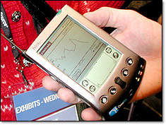
Pic. 1 Demonstration of Egron’s trading application-using Java

- Waba vs KVM
  - Before KVM be a perfect as its siblings, Waba is possible choice for Palm Java Programmers. It is created by California Company Wabasoft and makes Java-like coding for Micro OS (Palm OS / WinCE).
  - Waba is a very strict subset of Java language for smaller device. Its VM need just 34K in memory and additional 40K is for standard library.
  - Many important features of Java are removed to obtain micro-size VM. They are:
    - GUI: No AWT, No Swing.
    - Events: Very few event such as KeyEvent, No ActionListener and others.
    - Exception Handling: Lacks an Exception class.
    - Threads: No threads, No multithreading.
One other inconvenience is very critical for network programmer like us. Waba package contains Socket class but neither of exception class or ServerSocket class and the method in class is very weak so you can only write and read Byte to Socket.
  - Waba has better performance on Palm (Maybe, it left so many things out). Waba classes are loaded almost 2 to 5 times faster than KVM class.
  - So far, Waba won in reliability and performance. But as soon as Sun is serious on Palm, as they announced, the power will shift to Sun’s Java.

- WinCE vs PalmOS
  - Microsoft released WinCE 3.0 embedded operating system. It has many new features (http://www.microsoft.com/windows/embedded/ce/guide/features/whatsnew30.asp), but among them, COM (limited features)/DCOM (Full support compatible with Windows NT 4.0 SP5) support is eye-catching application service. Also it has enhanced Microsoft Message Queuing Service (MSMQ), which is independent message queuing service with Window 9x, NT and 2000 compatibility. The new Internet Explorer for WinCE 3.0 support XML, 128-bit SSL, HTML 4.0/DHTML and ActiveX controls.
  - Palm OS 4.0 (Currently, 3.5) is planed to release this spring. But since Palm OS 3.5 support 1, 2, 4, and 8-bit color and grayscale, there are not much expected from this coming 4.0 version Palm OS. Palm OS is still market-dominant PDA OS and not only Palm (3Com) is involved OS development and application. Rather, other device manufactures such as IBM, Handspring, and Sony is also participating in its development.

- PalmVNC
  - PalmVNC is a client for the Palm that provides remote access to VNC server machine (PC/Mac/UNIX) over a normal TCP/IP network connection.
  - PalmVNC was originally written by Vladimir Minenko. He wrote version 1.1 for Palm OS 1.0 to 3.1. Which were black and white display and the performance was un-bearable. It was like not working after event was occurs.
  - On Jan. 7th of 2001, PalmVNC version 1.40 has been released and it solve the performance problems. Even the display for non-color device is not very good, the performance improvement is remarkable. Initial loading time for 1.10 is about a half minute and 1.40 version can be initiated less than 6 seconds. Also, display refresh after event occurs is several times faster than 1.10.
  - For this test, PalmIIIx with Palm OS 3.3 and 9600bps Palm modem is used.

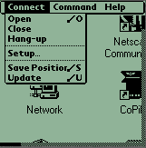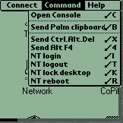

Pic. 2 PalmVNC 1.40

- Wireless Issue
  - Currently, Wireless Service provider, such as OmniSky, connects many Palm devise to network. But Wireless LAN is more and more popular after they have power on price and performance. Definitely, the price matters are including installation and maintenance issues. Based on IEEE 802.11b protocol standard, we can get 11Mbps on it. And IEEE 802.11a will be 54Mbps. → Mature enough to use
  - Bluetooth: In fact, the future of Bluetooth was vague. After the specification has been released, it is rare (Not much product on the market), buggy (More complete version 1.1 will not release until June) and it is above the affordable price range. Currently, early products of 1.0 are reported that it has power consuming and interoperability problems. UK based CRS is trying to push down Bluetooth chip price to $5 from current $15. If it will be by this summer, that make a big effect on wireless connection market with new released version, since Bluetooth will make a better effect on Collaboration. It is not only make a connection to LAN (like wireless LAN); rather it will make a connection with any of Bluetooth device. → Premature to use.

- Simple collaboration.
  - This is a simple implementation of “Control Java3D object from PDA with Waba application”. Java3D object communicates with Waba application on PDA over TCP/IP socket over Wireless LAN.
  - .ppt: Java3D Controlling over PDA-Server Connection
  - Snapshot
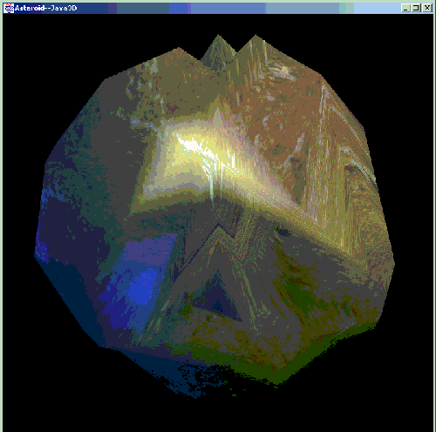

Pic.3 Java3D Object
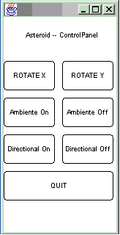

Pic 4. User Interface on PDA

