WebHLA based Metacomputing Environment for Forces Modeling and Simulation

Introduction We discuss here the use of HPC for the DoD Modeling and Simulation, addressed by the Forces Modeling and Simulation (FMS) Computational Technology Area (CTA) within the DoD HPC Modernization Program. Syracuse University acts as a technical lead of the academic part, PET (Programming Environments and Training) of the FMS CTA and we provide assistance for the FMS users both in the infrastructure and application development sectors. Our approach presented here explores synergies among and integrates distributed object standards emerging from industry (CORBA), Web (Java, XML) and the DoD (HLA). More specifically, we developed a 3-tier WebHLA environment that offers standards based plug-and-play support both for the back-end HPC simulation modules and for the front-end Web/Commodity interfaces. In this section, we overview DoD Modeling and Simulation domain from the perspective of HPC, we summarize the High Level Architecture (HLA) standard, we outline our WebHLA environment and we illustrate its use for building a metacomputing level battlefield simulation that involves large scale minefields (of order of million mines).

DoD Modeling and Simulation (M&S) Modeling and Simulation is a major computationally intense mission-critical domain of DoD computing. It addresses broad range of application areas ranging from weapon engineering to multi-player training to campaign analysis, and it includes a spectrum of granularity and fidelity levels ranging from close combat to entity level to force-on-force simulations. Being naturally modular in terms of distributed simulation entities, DoD Modeling and Simulation always acted as a driving force for new distributed computing and network technologies. Based on lessons learned from SIMNET, the first generation standards emerged such as DIS (Distributed Interactive Simulation) for real-time simulations or ALSP (Aggregate Level Simulation Protocol) for logical-time simulations. Several large scale joint enterprises address now various aspects of the broad field of M&S, including JSIMS (Joint Simulation System) for training simulations, JMASS (Joint Modeling and Simulation System) for engineering simulations and JWARS (Joint Warfare Systems) for campaign level analytical simulations. These large scale efforts were accompanied by numerous smaller scale modeling and simulation activities in many DoD labs so that the whole field was significantly fragmented until recently. New mechanisms for simulation interoperability are being developed and enforced recently by DMSO (Defense Modeling and Simulation Office) in terms of the HLA (High Level Architecture) based federation framework discussed below.

Forces Modeling and Simulation (FMS) One relatively small but special sector on the large DoD Modeling and Simulation landscape called FMS (Forces Modeling and Simulation) is focused on large scale simulations that require HPC support. Most other CTAs within the DoD HPC Modernization Program such as CFD, CSM, CEA etc. are based on traditional data parallel time-stepped HPC simulation technologies, whereas FMS represents a special domain of object-oriented event-driven task parallel HPC simulations. Parallel and distributed event-driven simulations (PDES) are often classified according to the "real-time" (or "as-fast-as-possible") or "logical-time" management scheme. The former, typically used for real-time battlefield simulations e.g. for training purposes were usually based on DIS protocol. In such simulations, all active objects (vehicles, troops, weapons etc.) broadcast periodically their entity state PDUs (Protocol Data Units), informing all other players on their positions and internal state. Based on received PDUs, all entities update their states "as-fast-as-possible" and the resulting simulation advances in "real-time". In the logical time management mode, simulation objects generate events and schedule them for execution at some future time instances. For example, when a missile is fired, its space-time collision point is pre-computed and the corresponding "target hit" event is constructed and put into the time-ordered queue for future execution. Simulation time advances in discrete irregular steps, given by the timestamps of the subsequent events in the queue.

Both time management regimes are being addressed by FMS projects. In the logical time domain, the dominant PDES technology is based on the SPEEDES (Synchronous Parallel Environment for Emulation and Distributed Events Simulation) system by Metron Corporation. SPEEDES uses optimistic rollbackable parallel time management scheme based on a variant of the Time Warp algorithm developed by NASA/JPL in late '80s. In the real-time domain, the DIS based battlefield simulations map naturally on networks of workstations and hence the use of MPPs was rather limited in this area. However, there are some specific DIS simulation problems that require HPC. One of such challenges, raised recently by Ft. Belvoir, VA addressed support for entity level battlefield simulation in large minefields (of million or more mines) that are required by modern warfare models. We will discuss this Comprehensive Mine Simulator (CMS) application and our support for Parallel CMS in the following sections. First, however, we summarize the current status in the area of simulation interoperability, represented by the HLA federation framework.

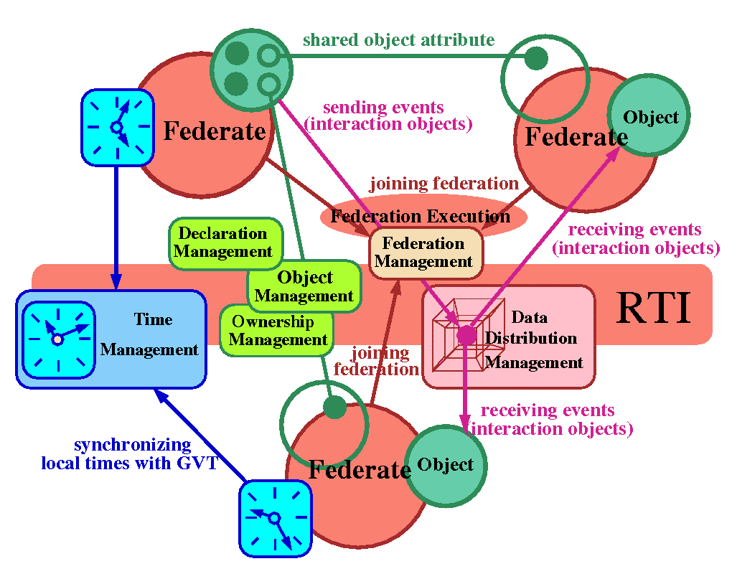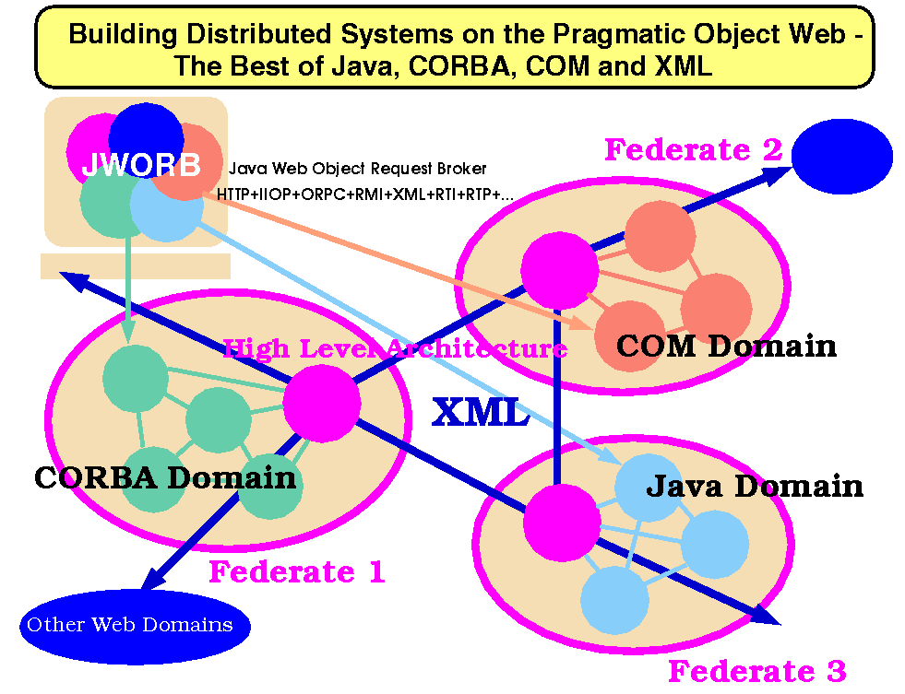
Fig. 1: Architecture of the Run-Time Infrastructure (RTI) software bus of the High Level Architecture (HLA) - circles represent entities (such as federates, objects, attributes), rectangles represent services.
Fig. 2: Pragmatic Object Web architecture - fine grain distributed objects of CORBA, Java and COM interoperate as coarse grain HLA federates linked via XML messages.

High Level Architecture (HLA) HLA is a language-independent object-based distributed software architecture for simulation reusability and interoperability that is now being enforced DoD-wide across all individual M&S programs, systems and simulation paradigms, including both real-time (DIS) and logical time (event-driven) management models. HLA views distributed simulation as a federation of coarse grain opaque semi-autonomous entities called federates that govern locally and independently their simulation objects and that conform strictly to some global federation rules, specifying the information exchange policy across the federation. The associated Run-Time Infrastructure (RTI) offers the software bus services available to the HLA-compliant federates and including Federation, Object, Declaration, Ownership, Time and Data Distribution Management. We illustrate the overall organization of RTI in Fig 1. Federates (large circles) maintain their simulation objects (medium circles) given by attribute sets (small circles) and they interact via RTI services (rounded rectangles) managed by the RTI bus (central elongated rectangle). Both local (simulation) and global (federation) objects conform to a simple attribute-value based entity format specified by the Object Model Template (OMT) and are suitably grouped and maintained by the RTI as SOMs (Simulation Object Models) or FOMs (Federation Object Models). Federates can join or leave federation (using Federation Management), they create their objects and register them with the RTI (using Object Management), they can publish and/or subscribe some of their objects (or their selected attributes) for sharing (using the Declaration Management), they can negotiate update rights for shared objects (using Ownership Management), they can evolve their objects in time and they can synchronize their local simulation clocks with the federation time (using Time Management), and they can build dynamic multi-dimensional routing channels for optimized multicast delivery of discrete communication events called interaction objects (using Data Distribution Management).

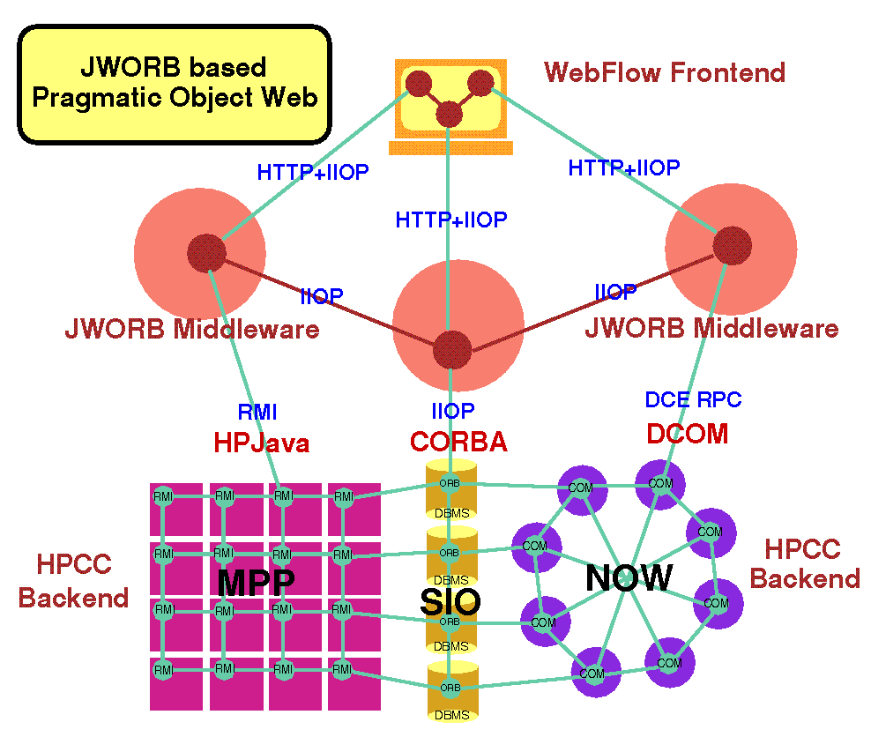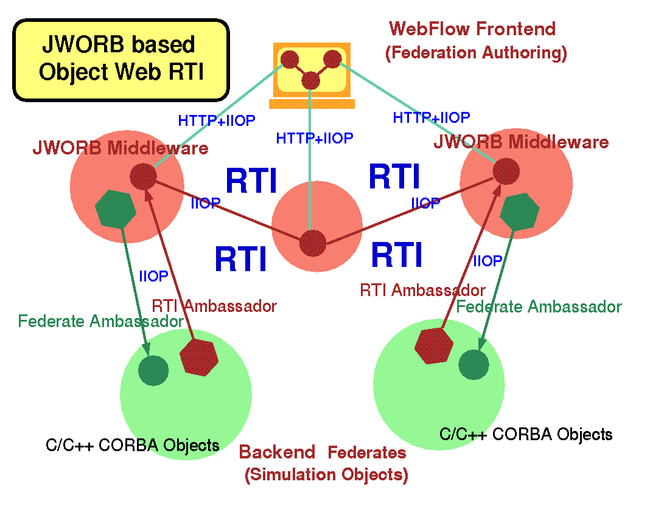
Fig. 3: Overall architecture of the multi-protocol JWORB server - front-end browsers (orblets) connect via HTTP (IIOP), middleware is IIOP based, legacy backends are linked via dedicated protocols.
Fig. 4: Overall architecture of OWRTI, packaged as JWORB facility. RtiCap library is employed to link C++ simulation backends via RTI in terms of RTI Ambassador and Federate Ambassador proxies.

WebHLA DMSO main emphasis so far was on supporting reusability of and HLA-enabled interoperability among diverse existing legacy codes rather than on providing HLA based software engineering support for new simulations that would utilize the latest Web/Commodity technologies of Java, CORBA and the XML. We recently proposed to fill this gap in our WebHLA framework that offers open implementation of HLA in terms of a suite of emergent object standards for the Web based distributed computing - we call it Pragmatic Object Web - that integrate Java, CORBA, COM and XML (see Fig. 2). WebHLA is an interactive 3-tier environment including: a) DMSO HLA architecture and our JWORB based Object Web RTI implementation in the middleware; b) Web/Commodity front-ends (such as Web browsers or Microsoft Windows); and c) Customer and application specific back-end technologies (ranging from legacy systems such as relational databases to HPC modeling and simulation modules). Below, we outline both the core components of WebHLA such as JWORB and OWRTI and a suite of tools and plug-and-play federates developed so far and including RtiCap, JDIS, PDUDB and SimVis.

JWORB (Java Web Object Request Broker) is a multi-protocol network server written in Java (see Fig. 3). Currently, JWORB supports HTTP and IIOP protocols i.e. it can act as a Web server and as a CORBA broker or server. In progress is support for the DCE RPC protocol which will provide COM server capabilities. JWORB recognizes a particular protocol based on the anchor/magic number of the current network packet and it invokes a suitable handler. JWORB is a useful middleware technology for integrating and efficiently aggregating competing distributed object technologies and the associated network protocols of CORBA, Java, COM and XML.

OWRTI (Object Web RTI) is an implementation of DMSO RTI 1.3 written in Java on top of the JWORB middleware i.e. packaged as a JWORB CORBA service (see Fig 4). In OWRTI, each of the RTI management services shown in Fig. 1 is implemented as an independent CORBA object. Other CORBA objects in the system include: RTIKernel with acts as a core top level manager, FederationExecution which represents a federation instance, RTIAmbassador which acts as a client side proxy of the RTI bus, and FederateAmbassador which acts as the RTI side proxy of a federate.

RtiCap library provides RTI C++ programming interface, packaged as a CORBA service that offers access to Java based OWRTI from C++ federates. RtiCap glue library uses public domain OmniORB2 as a C++ Object Request Broker. RTI Ambassador glue/proxy object forwards all C++ client method calls to its Java/CORBA peer and the Federate Ambassador object forwards all received callbacks to its C++ peer. Versions of RtiCap library are running on Windows NT, IRIX and SunOS platforms.

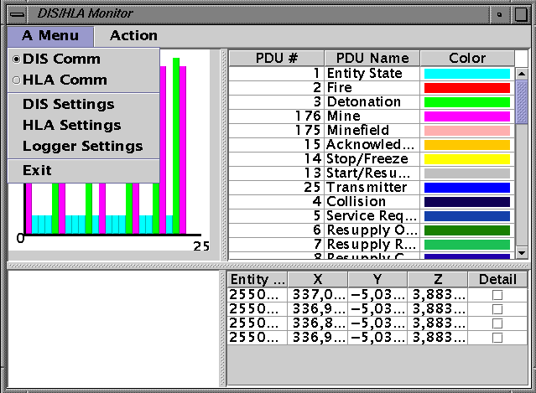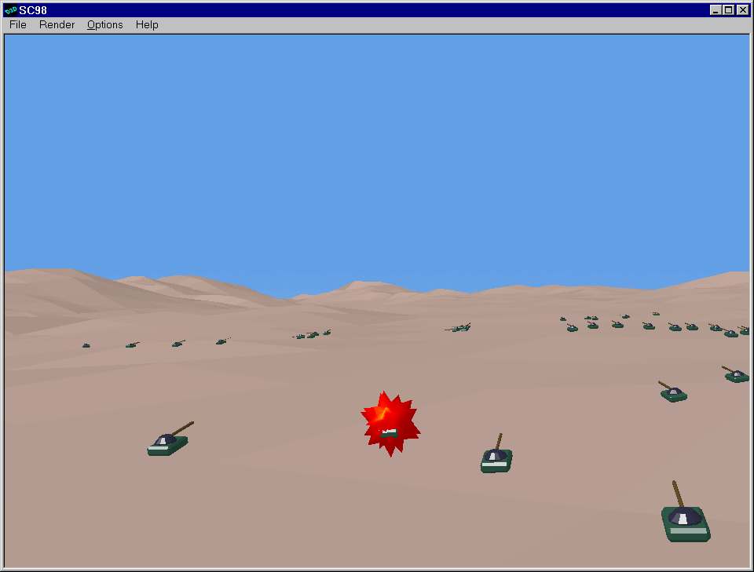
Fig. 5: A sample screen of the JDIS and PDUDB control monitor window, illustrating the dynamic display of the PDU flow and various protocol and I/O modes (DIS vs HLA, runtime vs playback).
Fig. 6: A sample screen of SimVis, used to visualize a battlefield (including tanks propagating through a terrain with deployed minefield) associated with Parallel CMS + ModSAF simulation.

JDIS To link DIS based legacy simulation systems such as ModSAF (Modular Semi-Automated Forces) with HLA federations, a bridge node is required to transform between different event models used in both frameworks: DIS PDUs (Protocol Data Units) and HLA Interactions. We constructed such a bridge called JDIS in Java, starting from a public domain DIS Java parser and completing it to support all PDUs required by the ModSAF system. JDIS can also write / read PDUs from a file or a database and hence it can be used to log and playback sequences of simulation events. In order to facilitate the transmission of PDUs and their persistent storage, we adopted XML as a uniform wire format and we constructed suitable PDU-XML converters.

PDUDB Playing the real scenario over and over again for testing and analysis is a time consuming and tedious effort. A database of the equivalent PDU stream is often needed for selectively playing back segments of a once recorded scenario. We constructed and packaged as WebHLA federate such a PDU database, using Microsoft’s Access for storage, Java servlets for loading and retrieving the data, and JDBC for servlet-database communication. The PDU logger servlet receives its input via HTTP POST message in the form of XML-encoded PDU sequences. Such input stream is decoded, converted to SQL and stored in the database using JDBC. The playback is done using another servlet that sends the PDUs generated from the database as a result of a query. A common visual front-end for JDIS and PDUDB federates is shown in Fig. 5. It supports runtime display of the PDU flow, and it offers several controls and utilities, including: a) switches between DIS, HLA and various I/O (file, database) modes; b) frequency calibration for a PDU stream generated from file or database; c) PDU probe and sequence generators; and d) simple analysis tools such as statistical filters or performance benchmarks that can be performed on accumulated PDU sequences.

SimVis Using Microsoft Direct3D technology, we constructed a real-time battlefield visualizer, SimVis (see Fig. 6) that can operate both in the DIS and HLA modes. SimVis is an NT application written in Visual C++ that extracts the battlefield information from the event stream, including state (e.g. velocity) of vehicles in the terrain, position and state of mines and minefields, explosions that occur e.g. when vehicles move over and activate mines etc The renderer performs the real-time visualization of the extracted information, using the ModSAF terrain database, a suite of geometry objects and animation sets for typical battlefield entities such as armored vehicles (tanks) and visual events such as explosions. We developed these objects using 3D Studio MAX authoring system and we imported them into the DirectX/Direct3D runtime environment.

Example WebHLA Application: Parallel/Metacomputing CMS Having outlined our WebHLA framework we illustrate now its application in a particular FMS project conducted by NPAC that developed Parallel and Metacomputing CMS based on the CMS simulator from Ft. Belvoir. This effort included converting the CMS system from the DIS to HLA framework, constructing scalable Parallel CMS federate for Origin2000 and linking it with ModSAF vehicle simulator and other utility federates towards a Metacomputing CMS federation. In the following, we review the original CMS system, we present our approach and performance results for Parallel CMS, and we describe our current and planned Metacomputing CMS configurations.

Comprehensive Mine Simulator by Ft. Belvoir The Night Vision Lab at Ft. Belvoir, VA conducts R&D in the area of countermine engineering, using the advanced Comprehensive Mine Simulator (CMS) as an experimentation environment for a synthetic battlefield. Developed by the OSD sponsored Joint Countermine Advanced Concepts Technology Demonstration (JCM ACTD), CMS is state-of-the-art high fidelity minefield simulator with support for a broad range of mine categories, including conventional types such as buried pressure-fuzed mines, antitank mines and other types including offroute (side attack) and wide-area (top attack) mines. CMS organizes mines in components, given by regular arrays of mines of particular types. Minefields are represented as heterogeneous collections of such homogenous components. CMS interoperates via the DIS protocol with ModSAF vehicle simulators. Mine interaction with a target in controlled by its fuse. CMS supports several fuze types, including full width, track width fuzes, off-route fuzes and others. CMS mines can also interact with countermine systems, including both mechanical and explosive countermeasures and detectors.

The relevance of HPC for the CMS system stems from the fact that modern warfare can require a million or more of mines to be present on the battlefield, such as in the Korean Demilitarized Zone or the Gulf War. The simulation of such battlefield areas requires HPC support. As part of the PET FMS project, Syracuse University analyzed the CMS code and ported the system to the Origin2000 shared memory parallel MPP. Below, we summarize our approach and results.

Parallel CMS: Approach In our first attempt to port CMS to Origin2000, we identified performance critical parts of the inner loop, related to the repetitive tracking operation over all mines with respect to the vehicle positions and we tried to parallelize it using the Origin2000 compiler pragmas (i.e. loop partition and/or data decomposition directives). Unfortunately, this approach delivered only very limited scalability for up to 4 processors. We concluded that the pragmas based techniques, while efficient for regular Fortran programs, are not very practical for parallelizing complex and dynamic object-oriented event driven FMS simulation codes - especially the 'legacy' object-oriented codes such as CMS which were developed by multiple programming teams over a long period of time and resulted in complex dynamic memory layouts of numerous objects that are now extremely difficult to decipher and properly distribute.

In the follow-on effort, we decided to explore an alternative approach based on a more direct, lower level parallelization technique. Based on our analysis of the SPEEDES simulation kernel that is known to deliver scalable object-oriented HPC FMS codes on Origin2000 (such as Parallel Navy Simulation System under development by Metron), we constructed a similar parallel support for CMS. The base concept of this 'micro SPEEDES kernel' approach, borrowed from the SPEEDES engine design but prototyped by us independently of the SPEEDES code, is to use only the fully portable UNIX constructs such as fork and shmem for the inter-process and inter-processor communication. This guarantees that the code is manifestly portable across all UNIX platforms, and hence it can be more easily developed, debugged and tested in the single-processor multi-threaded mode on sequential UNIX boxes.

In our micro-kernel, the parent process allocates a shared memory segment using shmget() and then it forks n children, remaps them via execpv(), and passes the shared memory segment descriptor to each child via the command line argument. Each child attaches to its dedicated slice of the shared memory using shmat(), thereby establishing the highest possible performance (no MPI overhead), fully portable (from O2 to O2K) multi-processor communication framework. We also developed a simple set of semaphores to synchronize node programs and to avoid race conditions in critical sections of the code. On a single processor UNIX platform, our kernel, when invoked with n processes, generates in fact n concurrent threads, communicating via UNIX shared memory. In an unscheduled Origin2000 run, the number of threads per processor and the number of processors used are undetermined (i.e. under control of the OS). However, when executed under control of a parallel scheduler such as MISER, each child process forked by our parent is assigned to a different processor, which allows us to regain control over the process placement and to realize a natural scalable implementation of parallel CMS.

Parallel CMS: Architecture On top of this micro-kernel infrastructure, we put suitable object-oriented wrappers that hide the explicit shmem based communication under the suitable higher level abstractions so that each node program behaves in fact as a sequential CMS, operating on a suitable subset of the full minefield. CMS module cooperates with ModSAF vehicle simulator running on another machine on the network. CMS continuously reads vehicle motion PDUs from the network, updates vehicle positions and tracks all mines in the minefield in search for possible explosions. In our parallel version, the parent node 0 reads from the physical network and it broadcasts all PDUs via shared memory to children. Each child reads its PDUs from a virtual network which is a TCP/IP wrapper over the shmem communication channel.

Minefield segments are assigned to individual node programs using the scattered/cyclic decomposition which guarantees reasonable dynamic load balancing regardless of the current number and configuration of vehicles propagating through the minefield. We found the CMS minefield parser and the whole minefield I/O sector as difficult to decipher and modify to support scattered decomposition. We bypassed this problem by constructing our own Java based minefield parser using the new powerful public domain Java parser technology called ANTLR and offered by the MageLang Institute. Our parser reads the large sequential minefield file and chops it into n files, each representing a reduced node minefield generated via scattered decomposition. All these files are fetched concurrently by the node programs when the parallel CMS starts and the subsequent simulation decomposes naturally into node CMS programs, operating on scattered sectors of the minefield and communicating via the shmem micro-kernel channel described above.

Parallel CMS: Performance We performed timing runs of Parallel CMS, using the Origin2000 systems at the Navy Research Laboratory in Washington, DC and at the ERDC Major Shared Resource Center at Vicksburg, MS. The performance results are presented in Figs 7, 8 and they illustrate that we have successfully constructed a fully scalable Parallel CMS for the Origin2000 platform. Figs 7 and 8 present timing results of Parallel CMS for a large minefield of one million mines, simulated on 16, 32 and 64 nodes. The timing histogram in Fig. 7 displays total simulation times in a run on a 16-node spent by each of the nodes and it illustrates that we got almost perfect load balance. Higher bars on this figure represent full simulation run with all ModSAF PDUs activated, whereas lower bars represent dry CMS run without vehicle updates. The comparison of both sets illustrates that communication with ModSAF vehicles took of order of 20-25% of the total simulation time and that both computation and communication parts are fully load balanced.

Fig. 8 illustrates the speedup measured on 16, 32 and 64 nodes. Instead of T(1)/T(n) we present un-normalized 1/T(n) in this plot since we couldn't measure T(1) - when trying to run million mines simulation in one node we got memory overflow error. The SPEEDUP plot illustrates that Parallel CMS offers almost perfect (linear) scaling over broad range of processors.

Fig. 7: Simulation time spent by various nodes in a Parallel CMS run for million mines on a 16-node subset of Origin2000 at NRL (both for full run with vehicle PDUs and for a dry CMS-only run without PDUs) - illustrates very good load balance.
Fig. 8: Speedup of Parallel CMS on NRL Origin2000 for million mines and 30 vehicles, measured on 16, 32 and 64 nodes - illustrates almost perfect scalability across a broad processor range.

Metacomputing CMS The timing results described above were obtained during Parallel CMS runs within a WebHLA based HPDC environment that span three geographically distributed laboratories and utilized most of the WebHLA tools and federates discussed above. The overall configuration of such initial Metacomputing CMS environment is shown in Fig 9. ModSAF, JDIS and SimVis modules were typically running on a workstation cluster at NPAC in Syracuse University. JWORB/OWRTI based Federation Manager (marked as RTI in Fig 9) was typically running on Origin2000 at ERDC in Vicksburg, MS. Parallel CMS federate was typically running on Origin2000 at NRL in Washington, DC. Large MISER runs at NRL need to be scheduled in a batch mode and are activated at unpredictable times, often in the middle of the night. This created some logistics problems since ModSAF is a GUI based legacy application that needs to be started by a human pressing the button. To bypass the need for a human operator to continuously monitor the MISER batch queue and to start ModSAF manually, we constructed a log of a typical simulation scenario with some 30 vehicles and we played it repetitively from the database using our PDUDB federate. The only program running continuously (at ERDC) was JWORB/OWRTI based Federation Manager. After the Parallel CMS was started by MISER at NRL, it joined distributed federation (managed at ERDC) and automatically activated the PDUDB playback server at NPAC that started to stream vehicle PDUs to JDIS which in turn converted them to HLA interactions and sent (via RTI located at ERDC) to Parallel CMS federate at NRL. Each such event, received by node 0 of Parallel CMS was multicast via shared memory to all nodes of the simulation run and used there by the node CMS programs to update the internal states of simulation vehicles. Inner loop of each node CMS program was continuously tracking all mines scattered into this node against all vehicles in search of possible explosions.

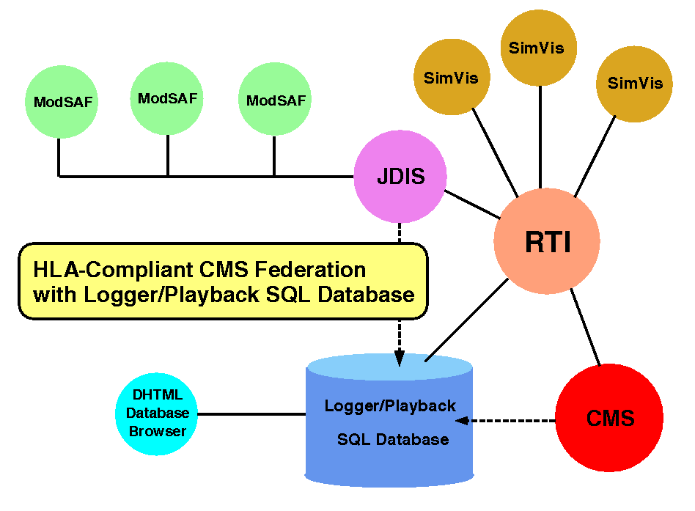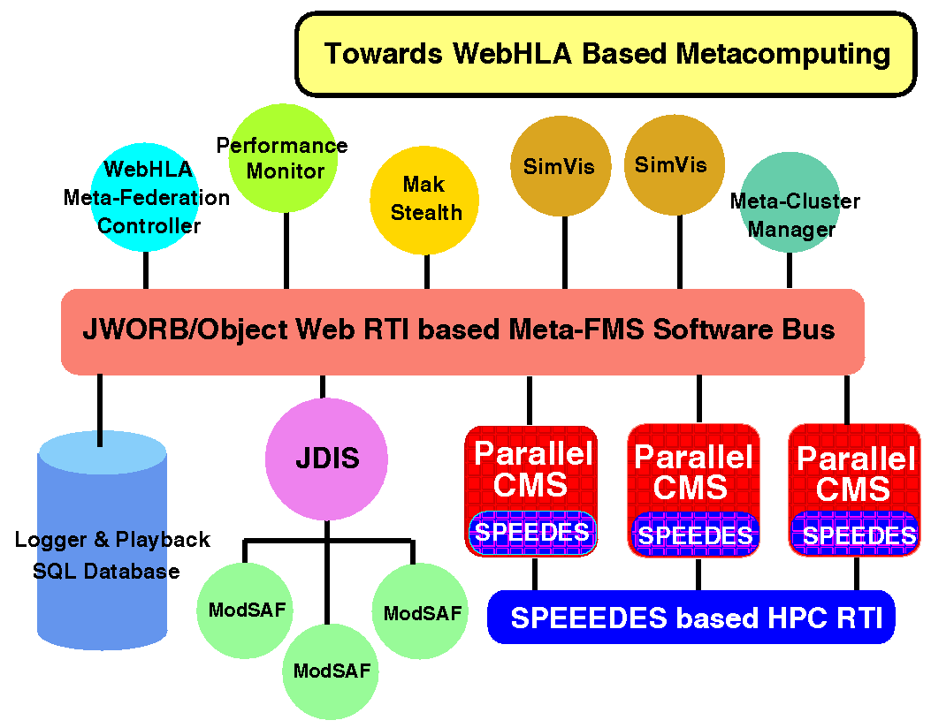
Fig. 9: A WebHLA environment that supports Parallel CMS experiments and includes: ModSAF vehicles, SimVis front-ends, JDIS bridge between DIS and HLA domains, event logger and playback database, Parallel CMS and RTI Federation Mgr
Fig. 10: Planned Metacomputing CMS with WebHLA based distributed management similar as in Fig. 9 and with SPEEDES based HPDC support for large scale geographically distributed minefields.

Next Steps Having constructed fully scalable Parallel CMS federate and having established a robust Metacomputing CMS experimentation environment, we proceed now with the next set of experiments towards wide area distributed large scale FMS simulations, using CMS as the application focus and testbed. In the first such experiment, we intent to distribute large minefields of millions of mines over several Origin2000 machines in various DoD labs using domain decomposition, followed by the scattered decomposition of each minefield domain over the nodes of a local parallel system. In the next experiment, we intend to replace our simple SPEEDES micro-kernel discussed above by the full SPEEDES simulation kernel as illustrated in Fig 10. This way, we will be able to offer optimized communication between individual MPPs using the SPEEDES based HPC RTI under development by Metron, and to convert the legacy CMS code to a well-organized programming model of SPEEDES. One of our tasks within the PET FMS program is to provide Web based SPEEDES training for the DoD users and we view our WebHLA metacomputing environment, outlined in this section, as a useful training framework to be employed for this task in the context of Metacomputing CMS as a trial large scale FMS application.

