Use Java to Link to Databases
for Library Management

Sep. 8, 2000
By Dongmei Gao

1. Project Requirement
This library database management project is used to create and maintain databases over network. User can use web to add/remove new catalogue, add /remove books, view book’s abstract, or search some information, etc. Assume that the library database already exists. Linking to this database is a main part of this project. In this article we just concern about using Java to link to library database.

2. Java in This Project
Java was chosen as the programming language for this project, not only because it is robust, secure, easy to use, and free, but also because it is portable (write once, run anywhere) and convenient for GUI design (provided by its AWT and Swing package).

We will use the Swing package to develop a convenient graphical user interface. This package provides many different classes for the user to write lightweight GUI components. A program that uses lightweight components will make more efficient use of resources because a lightweight component is the one that ‘borrows’ the screen resources of an ancestor.

We will use JDBC to develop database applications. JDBC (Java Database Connectivity) is an application program interface specification for connecting programs written in Java to the data in popular database. The application program interface lets you encode access request statements in structured query language that are then passed to the program that manages the database. It returns the results through a similar interface.

3. Three-tier Client-Server Paradigm
This Java project is a three-tier client-server application. The back-end tier is the relational database, assume we may use MySQL database system. The middle tier is application server. The front-end tier is client. The Java Database Connection (JDBC) API serves as the interface between the server program and database. The communication between the client and the server occurs via a TCP/IP socket.

Database ----------------> Server----------------->Client
JDBC Socket

Users access the database over a network through the Java applet running inside a conventional web browser (Netscape version 4.5 or above). This GUI makes it possible for user to create and manipulate database tables online, without paying attention to the fact that MySQL, JDBC, server, and sockets are working in the background. User can use button on GUI to send a request for the appropriate action to the server program via a socket. The server program translates this request into an SQL statement and then sends this statement to MySQL via JDBC. After MySQL executes the statement in database, if there is a return value (such as with a select statement), the data will be sent back to the server program via JDBC. Then the server sends the data to the client via the socket and the client will display the result in the web browser.

4. Connection Paradigm

4.1. Using JDBC to Connect Server and Database
When the server is started, it establishes a connection with the database through JDBC (Java Database Connectivity). JDBC is the API that allows Java programmers to access relational database using SQL.

The architecture of JDBC is illustrated below.
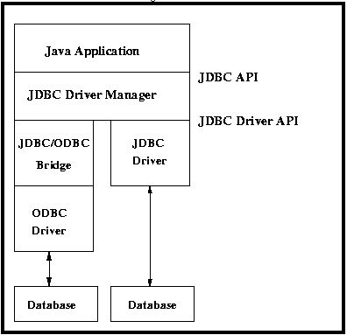

The JDBC API can be found in java.sql package. An individual database system is accessed via a specific JDBC drive that implements the java.sql.Driver interface.

There are two steps involved establishing the connection.

Step 1. Loading Drivers. We will use the JDBC driver is to get a database connection. This involves loading a specific driver class into the application’s JVM (Java Virtual Machine). This makes the driver available later, when it is need for opening the connection. To load the driver class use the Class.forName() method.

Public static Class forName(String className)
throws ClassNotFoundedException

The value of the variable className is the name of the driver. This method tries to locate, load, and link this driver to the application. For instance, if the class name is jdbc.DriverX, we use

Class.forName("jdbc.DriverX");

When the driver is loaded into memory, it registers itself with the java.sql.DriveManager class as an available database driver.

Step 2. Making the Connection. This step is to ask the DriverManager class to open a connection to a given database, where the database is specified by a specially formatted URL. The method used to open the connection is DriverManger.getConnetion(). It returns a class that implements the java.sql.Connection interface. In this project, the DriverManager uses three parameters--- username, password, and url---to make the connection:

Connection con = DriverManager.getConnection(url, ”username”, password”);

4.2. Using Socket to Connect Server and Client
In the Client/Server network configuration, the server is always running, waiting and listening for a client to connect to it. Once a client requests a connection, the server accepts the connection and they communicate through the socket. The cases of before and after a client is connected to a server are illustrated below.
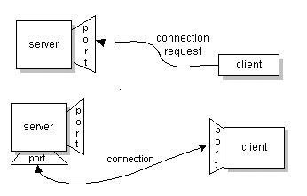

Once a connection request is accepted by the server, a socket is created for the client. After this, the client can write to the socket to send service requests to the server, and read from its socket to get the results. Notice that unlike the server-side socket, the client's socket is not bound to a specific port number.

Java provides the ServerSocket class in the network package. This class can be used to create a socket on the server side bound at a specified port number. Whenever the connection from a client is accepted a new socket is created, and the communication with the client is done through this newly created socket. Following is the method used in this project.

Public ServerSocket(int port_number, int backlog)
throws IO Exception;

The server creates the socket with a particular port_number and listens on that port. backlog is the maximum queue length for an incoming connection indications. If a connection indication arrives when the queue is full, the connection is refused.

When the client wants to talk to the server, it creates a socket with the host name of the server machine and the port number on which the server is listening.

clientSocket = new Socket( serverHostName, port_number)
throws unknownHostException, IOException;

The port number must be between 0 and 65536, inclusive. Ports 0 through port 1023 are referred to as “well-known” ports and are reserved for well-known services. We can select any port number between 1024 and 65535.

5. Further Work

Since we assume that the library database already exists, after establishing the connection between database and server, between server and client, we can work on GUI of client side. Using this connection, we can realize many kinds of operations between user and database. Such as, adding /removing new catalogues, adding/removing books, viewing book’s abstract, or searching some information, etc. All operations can be done through web.

The security issue is very important in the further consideration of this project. The library database should be modified only by staffs who work in library. However, normal users, like customers of library, should have no authorities to modify database.

6. Useful URL
[1] http://aspen.csit.fsu.edu/it1fall00/ CIS6900 Course Web Site

From the IT course notes, I got some knowledge about Java, JDBC and three-tier Paradigm, etc.

[2] http://www.cs.fsu.edu/~kou/java/notes Xuekuen Kou’s Java Lecture Notes.
When I took Java course, I learned Java basic and series knowledge from these notes.

[3] http://java.sun.com/products/jdbc JDBC Data Access API.
It introduces how JDBC works and how use it.

[4] http://java.sun.com/products/jdk/1.2/docs/api Java 2 Platform, Standard Edition, API Specification.
I can find JDBC and Socket classes and methods in here.

[5] http://java.sun.com/docs/books/tutorial/jdbc/basics/index.html Lesson of JDBC Basics.
There are some lessons about JDBC.

[6] http://www.idg.net/crd_design_9130.html Introduction to "Design Techniques".
From here I got some idea about project design.

[7] http://www.wdvl.com/Authoring/DB/Intro/jdbc.html Web Developer’s Virtual Library .
From here I can learn many knowledge, such as, JDBC, XML, CGI, JavaScript, etc.

[8] http://whatis.techtarget.com/WhatIs_Browse_Alphabetical_Page/0,3940,J,00.html
Whatis.com.
This is a good IT dictionary. I can get many definitions about IT technology.

