7 Java Grande and High Performance Java

7.1 Roles of Java in Technical Computing
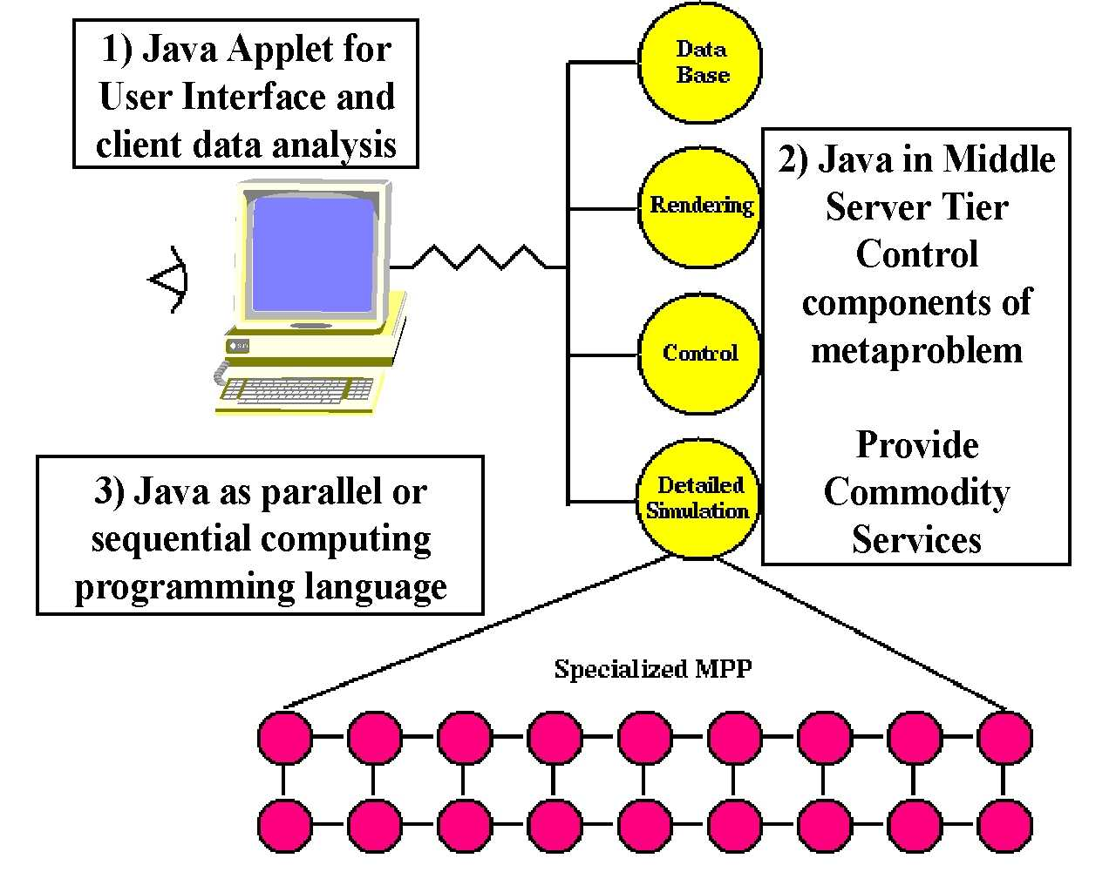
fig 7.1: Three Roles of Java in HPCC
In this section, we focus on the role of the Java language in large scale computing. In fig. 7.1, we picture three possible roles for Java corresponding to its use in the client, middle-tier or backend tiers of fig A respectively. The use of Java at the client is well understood and in spite of the battle between Microsoft and Netscape, seems likely to flourish. We have discussed at length the use of Java in the server tier in the previous sections and noted that Java plays a role both as an object model and as the language to build servers like JWORB which implement competing distributed object paradigms. This is perhaps the dominant use of Java in the Intranet software industry and Java is attractive here because it is a very productive programming environment. C++ currently gives higher performance as shown in fig. B but Java servers are already very robust and new generations of Java compilers are expected to give excellent performance. In this section, we will largely focus on the third role of Java – that as a basic programming environment. These sections are built on the results of four workshops held in Syracuse (Dec. 96), Las Vegas (June 97), Palo Alto (February 98) and Southampton (England, September 98).

7.2 Why Explore Java as a Technical Computing Language?
Why would one use Java to code one’s favorite scientific code? One can cite the usual features.
- The Java Language has several good design features. It is in particular secure, safe (with respect to bugs), object-oriented, and familiar (to C, C++ and even Fortran programmers).
- Java has a very good set of libraries covering everything from commerce, multimedia, images to math functions (see for instance NIST’s library under development at http://math.nist.gov/javanumerics). These frameworks can embody both real software (i.e. fully coded methods) but also interfaces which define standards that lead to uniform easier to use uniform environment where different vendors can focus on the best implementation of a particular service without using their own irrelevant proprietary names. It is curious that the Fortran community never agreed on the names of basic numerical libraries – we should spend our creative energy on the best coding of the best FFT algorithm and not on the subroutine calling sequence.
- Java has best available electronic and paper training and support resources. There are in particular over 1000 books in Java.
- Industry is aggressively developing for Java the best integrated program development environments
- Java naturally integrated with network and universal machine supports powerful “write once-run anywhere” model
- There is a large and growing trained labor force. Java is already being adopted in many entry-level college programming courses. In fact, it seems likely that in the future, students entering college will increasingly have Java expertise. They will learn about it from their excursion on the Internet while it should grow in interest as the language used to teach programming at middle and high schools. (Note NPAC’s Java Academy at http://www.npac.syr.edu/projects/k12spring98/ ) which was very successfully taught each Saturday in the depth of a bleak Syracuse winter to a group of middle and high school students and teachers). Java’s natural graphical (applet) view makes it a very social language whose value is more obvious to a beginning programmer than C++ or Pascal. Of course, the Web is the only real exposure to computers for many children, and the only languages, to which they are typically exposed today, are Java, JavaScript, and Perl. We find it difficult to believe that entering college students, fresh from their Java classes, will be willing to accept Fortran, which will appear quite primitive in contrast. C++ as a more complicated systems-building language may well be a natural progression, but although quite heavily used, C++ has limitations as a language for simulation. In particular, it is hard for C++ to achieve good performance on even sequential and parallel code, and we expect Java not to have these problems if the process described in sec. 7.3 is successful.

- As well as these laudable positive reasons, we can also compare Java with the “competition” which is Fortran or C++ for serious technical computing. Note the following points.

- Fortran77 has excellent compilers, good user base but will not be taught broadly and clearly limited in capabilities; in particular not object oriented
- I t appears that although Fortran90 and HPF have useful features, they have not “taken off” and it seems likely that they will not “make it”
- Five years ago, it looked as though C++ could become language of choice in complex scientific codes (perhaps with Fortran as inner core and especially when irregular data structures could not be easily expressed in Fortran). However this movement appears stalled – partly because this trend was halted by a growing interest in Java and users are awaiting events. C will remain widely used as a simple elegant language but object oriented techniques seem essential in large software systems and so the essential competition appears to lie between C++, Fortran90 and Java.
- The C++ language is complex and splintered with no agreement on standards for libraries and parallelism. This is partly because its use in Grande applications is too small to motivate standards and partly due to the prevailing culture.

So we argue that although existing large-scale codes are written in Fortran C and C++, the associated unattractive and comparatively unproductive programming environment handicaps developers. Current languages and tools are sufficient but it does not seem likely that one can easily greatly improve on existing environments without a radically new approach. We suggest that it will easier to try to build an attractive technical computing environment around Java rather than the existing languages. We can list some additional reasons why we might be more successful in Java than previous Fortran or C++ based programming environments
- Java has some natural advantages due its internet base with threads and distributed computing built in
- Java is a young language and we can take steps now to avoid unproductive proliferation of libraries and parallel constructs
- We could be third (Fortran, C++, and now Java) time lucky
- Java has the expressivity and object oriented advantages of C++ combined with performance levels of C and Fortran
- It can use Java’s clear advantages in building user interfaces as an entrée into other aspects of large-scale programming.

There are some serious problems to be solved in using Java in technical computing and now we turn to discuss these.

7.3 Java Grande
First we need to define a Grande application as any sort of large-scale or technical commercial or academic problem. Thus it subsumes areas such as:
- High Performance Network Computing or HPDC (High Performance Distributed Computing)
- Scientific and Engineering Computation
- (Distributed) Modeling and Simulation
- Parallel and Distributed Computing
- Data Intensive Computing
- Communication and Computing Intensive Commercial and Academic Applications
- High Performance Computing and Communication (HPCC)
- Computational Grids
We adopted this offbeat nomenclature, as it was hard to find a “conventional name” that doesn’t get misunderstood by some community. Now Java Grande is the application of Java to Grande applications; Grandecomputers are of course compute engines used to execute Grande codes and the adjective can be used in other related ways.
The Java Grande forum was set up to enhance the possibility that one can build around Java a better Grande application environment than is available through Fortran or C++. We described in the previous section why this might be possible and the Forum’s sole goal is sponsor community activities designed to realize the “best ever Grande programming environment”. The Forum products include recommendations and community actions that could lead to necessary changes to Java or establishment of standards (frameworks) for “Grande” libraries and services. We have had three meetings in March, May and August 1998 while we are now planning a public discussion of our initial conclusions at SC98 in Orlando for November98. The current status is given at our home page http://www.javagrande.org while the NPAC resource http://www.npac.syr.edu/projects/javaforcse has more personal broader collection. The Forum is interacting in two rather different dimensions. In the near term, we need to work with the computing mainstream and Sun to discuss a few key changes in Java to allow it to be a complete efficient Grande Programming Language. This includes the floating-point processing, complex type and RMI performance issues described later.
Secondly The Forum needs to work within the Grande community to encourage and initiate those activities that will lead to standards in such areas as numeric libraries and the Seamless Computing Interface. We suggest that the Grande community has unnecessarily handicapped progress by having as much creativity in the interfacing of its artifacts as in the essential algorithms. As we illustrate in the next section for databases, sometimes all can benefit if one agrees to standard which initially handicap particular and perhaps even the best implementations.

The Forum is set up currently with two major working groups. The Numerics working group is led by Ron Boisvert and Roldan Pozo from NIST and is centered on Java as a language for mathematics. Issues studied include:

Changes in Java controversial handling of floating point which currently has goal of reproducible results but this leads to non-optimal accuracy.

Support for efficient Complex types or classes.

Lightweight classes and Operator overloading – this is a natural way of enabling efficient implementation of complex as a class but can also be applied in other circumstances.

“Fortran rectangular multidimensional arrays” – Java’s current multi-subscript language construct gives “arrays of arrays” which often do not lead to efficient code.

High quality math libraries with agreed interfaces – examples are FFT, Matrix algebra, and Transcendental functions.

Performance and expressivity and their tradeoff underlie these proposed enhancements. As discussed in the four workshops on Java for Science and Engineering computation (Refs and URL’s incl Europar), the goal is Java compilers that obtain comparable performance to those for C or Fortran. Marc Snir has given a very clear analysis of the different issues that inhibit the performance of Java on classic array-based scientific codes. Industry efforts are mainly focussed on Just in Time compilers (JIT) which support the critical applet and servlet models of computation. However traditional native machine specific compilers are possible and will surely be useful. It will be interesting to compare their performance with the best JIT’s and see if and for what application any performance degradation for servlets and applets outweighs the convenience of their mobile dynamic portable computing model. A related issue is if the Java language version of a code has any more information for a native or JIT compiler than the VM (or Java bytecode) representation. Initial studies suggest that the VM and language versions of the code can be compiled with comparable performance. Difficulties in compiling Java include quite surprising points such as Java’s rich exception framework that could restrict compiler optimizations. Users would need to avoid complex exception handlers in performance critical portions of a code. An important feature of Java is the lack of pointers and their absence, of course, allows significantly more optimization for both sequential and especially parallel codes. In general with some possible restrictions on programming style, we expect Java compilers to be competitive with the best Fortran and C compilers. Note that we can also expect a set of high performance ``native class'' libraries to be produced that can be downloaded and accessed by applets to improve performance in the usual areas one builds scientific libraries.

The charter of the second working group led by Dennis Gannon and Denis Caromel (INRIA, France), includes issues associated with coarse grain distributed scientific objects; distributed and parallel computing, concurrency support and applications. The detailed agenda includes:

Performance of RMI or “remote method invocation” which is the attractive Java distributed object model.

Performance of Java runtime (the virtual machine VM) with lots of threads, I/O, and large memory use.

Parallel Computing interfaces including Java MPI binding and higher level interfaces such as that in HPJava discussed in section 7.6.

Development of a framework for a universal Java Seamless interface to computing resources as discussed in the next section.
- Development of Grande Application benchmarks. This overlaps the activities of the first working group, which has already started an interesting numeric kernel collection at http://math.nist.gov/scimark based on the ideas pioneered in the Java version of LinPack - http://www.netlib.org/benchmark/linpackjava/

Both working groups have made substantial progress in the last few months with initial reports including key issues we need to bring up with Sun in both the Numerics and RMI performance areas. We need broad community involvement in critiquing our proposals, collecting Java Grande benchmarks, and defining standard classes and libraries.
We hope to get good participation in a set of workshops on the seamless computing framework. We also need applications that will stress Java and Java runtime (the VM) with large applications – we need to find those weak links of the VM which lead to performance problems? Note that enterprise Intranets will lead to some such scaling tests but there are some features that will only appear with Grande problems.
European involvement in the Grande Forum has been excellent so far with Denis Caromel, Vladimir Getov, and Michael Phillipsen as major contributors. Organizationally NAG and the Edinburgh Supercomputer Center are members.

7.4 Java Seamless Computing Framework or CORBA Facility for Computation
Thinking about computing abstractly, we see that at a high level, it involves a collection of entities – computers, programs and datasets -- which can all be considered as objects with properties and methods. It is thus attractive to consider establishing a uniform terminology to allow definition of interoperable modular tools and procedures (services). Three major areas that could benefit from this standard definition for computer related distributed objects are seamless interfaces, metacomputing and performance modeling. We term a seamless interface as some sort of user interface allowing the invocation of a given program on any one of multiple backend computers. Metacomputing refers to the more complex situation where several linked modules are run synchronously on multiple geographically computing resources. Sophisticated performance analysis systems need this type of distributed object structure to allow structured specification of the performance characteristics of computing resources and of the resource needs of job modules. The seamless interface is perhaps the simplest case; metacomputing needs in addition specification of the linkage between jobs while the performance estimation application of course requires additional properties specifying performance characteristics. However these three application areas have a set of core properties that are in common. We are starting the community activity needed to establish first requirements and then explore a possible standard interface. The initial workshop will be co-sponsored by the Java Grande Forum and the Globus metacomputing group. We can set up standards in many ways – it can be an XML specification; a COM or CORBA IDL or a set of Java Interfaces and methods. These different representations can easily co-exist as different external specification of the same object properties. In the following we will focus on the Java implementation as there is a very natural use of the seamless computing interface as the target of Web-based computing interfaces using Java applets on the client user front end. If we can agree on the seamless framework, then we can allow multiple developers of different front ends customized to different user needs to each access the same set of back end computers.
In Java frameworks and libraries are related concepts. Frameworks have a mix of interfaces (agreed syntax for methods and properties but allowing multiple implementations) and coded classes. On the other hand, libraries are always essentially fully instantiated. Well known Java frameworks cover the enterprise, commerce, 2D and 3D scene specification, multimedia and security areas. A Java framework is a set of agreed Java calls (as discussed above these are mainly Interfaces and not methods) to capabilities expressed in implementation neutral form. Then drivers convert these general calls to vendor specific implementation of the service This framework Java code can either be all on client (2-tier) or on client and middle tier (3 or 4 tier).
Let us briefly discuss one well-known example framework – that of JDBC (Java Database Connectivity) which is a universal interface to all relational databases. Hence it has some similarities to the seamless interface, which as proposed is the universal interface to all computers (as opposed to just databases running on computers). The architecture shown in fig. 7.2 has an application JDBC API as well as the capability of linking it different managers for the different database types.
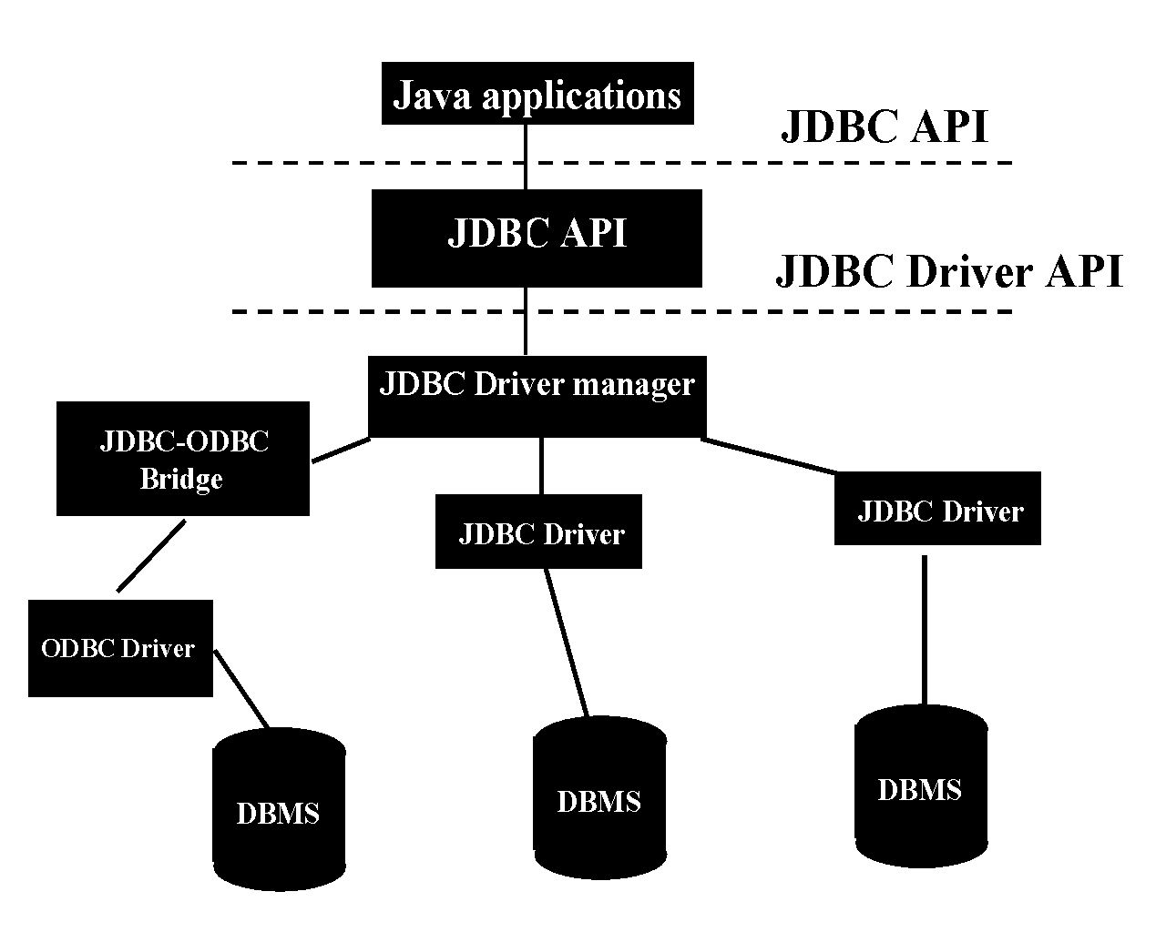

Fig. 7.2: Architecture of JDBC Database Connectivity Framework
This can be implemented in a multi-tier fashion with the Java JDBC calls either on client, middle-tier server or like Oracle’s PL/SQL most efficiently of all on the database back end. We show some of these different implementations on fig 7.3.
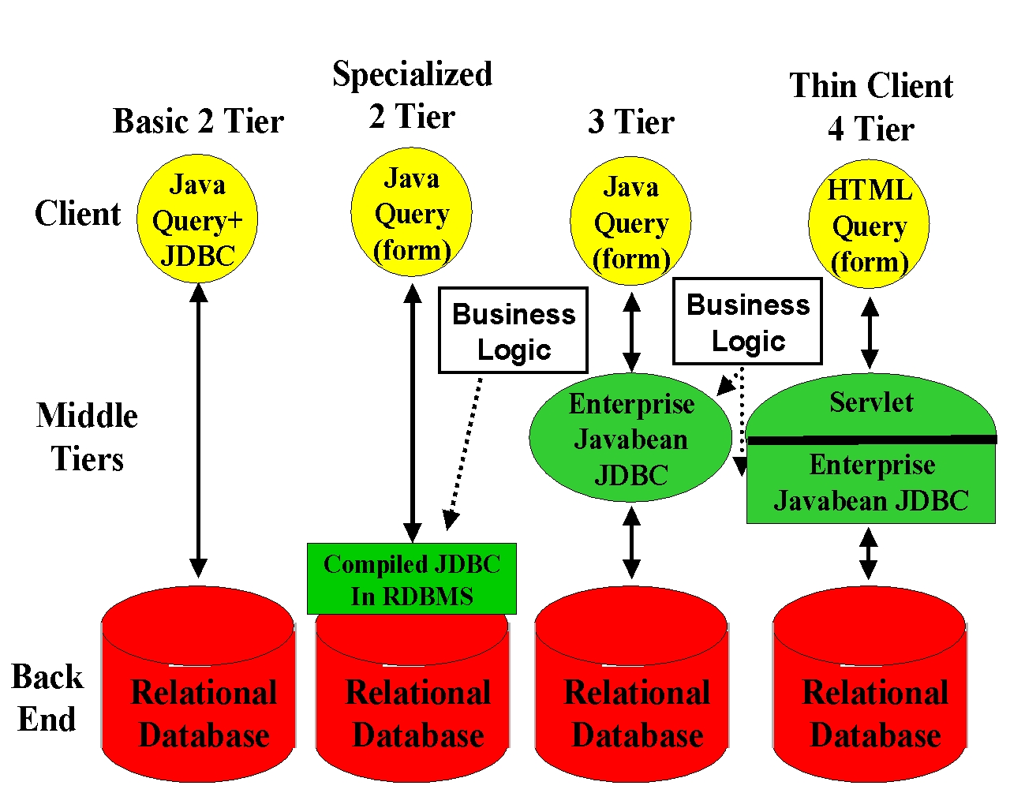

Fig 7.3: Multi Tier Implementations of JDBC
Note that adoption of JDBC was not without cost for the database vendors because it immediately implied that proprietary solutions such as PL/SQL were of less importance. However essentially all vendors must however support JDBC because of competitive pressure. Note that the resultant “seamless” interface increases the ease of use of databases and so increases the overall market. Thus the loss of proprietary advantages has positive side effects. In the resultant standards based environment, vendors compete for a larger market with compliant modules, which compete on basis of issues like performance and cost. Similarly the proposed seamless computing framework will allow vendors to compete on either the user front end (GUI) or back end services with the JSCF framework providing universal linkage. The JSCF framework could be implemented at the backend as a set of drivers, which relate the generic Java framework interfaces to particular software (e.g. invocation of a compiler) on particular machines. One would include JSCF support as a requirement in system purchases and so encourage vendors to implement support for the standard.
Setting up a community framework such as JSCF requires reaching agreement by “suitable interested parties” on what are the services and then what are the interfaces for a given service. This process as with JDBC and Oracle’s PL/SQL can lead to difficult choices by some organizations. We had already started to accumulate possible services and their features at http://www.sis.port.ac.uk/~mab/Computing-FrameWork/ for a workshop on seamless interfaces at Reading England, September 97. In our initial planning we intend to include existing ideas from metacomputing projects such as Condor Globus Legion and from performance estimation projects PACE POEMS andPetaSIM. Obviously existing seamless interface projects such as WebSubmit (NIST) and UNICORE (German Supercomputer consortium) need to be included.
Possible Services in a Java Seamless Computing Framework include
- Grande Resource discovery, allocation and scheduling where the recently announced JINI technology from Sun looks attractive
- Compiling, Executing, Specification of features needed for execution optimization. This includes parameters needed by MPI/HPF decompositions such as number of processors
- Resource Management and Scheduling jobs as in Codine or LSF or commercial NT environments
- Accounting where one could use features from the rapidly developing Web commerce technology?
- Authentication, and Security which is especially hard in metacomputing where one naturally links computer resources with several different management policies. Here again Internet commerce and its associated public key infrastructure will give useful building blocks.
- Sharing, Accessing and Storing into File Systems
- Data and Performance Visualization Interface
- Performance measurement and recording (cf: Pablo SDDF)
- Interfaces for Programming Tools
- Debuggers
- Computational Steering and Interpreted Execution interfaces
- Libraries including names in generalized Math class which the Java Grande is defining in its numerics working group
- Module linkage model for metaproblems (multidisciplinary applications) although this could be “outside scope”. Earlier we showed how the Java AWT event model as used in the JavaBean framework could be used for this

The preliminary list of services given above will surely be refined and elaborated with further study. They need to be integrated into an object model for distributed computers and problems which will then have these services as methods and further properties.

7.5 Parallelism in Java
In order to discuss parallelism in Java, we divide the forms of parallelism seen in applications into four broad categories.

1: Modest Grain Size Functional Parallelism
Here we are thinking of the type of parallelism used when computation and I/O operation are overlapped as exploited extensively by web browsers but can also be seen in possible overlap of message traffic with computation in the Java plus MPI parallel programming paradigm of sec. 7.7. This parallelism is built into the Java language with threads but has to be added explicitly with (thread) libraries for Fortran and C++. In the browsers, one typically sees the different components (multiple images, applets etc.) processed by different threads concurrently.

2: Object Parallelism
This is quite natural for C++ or Java where the latter can use the applet mechanism to portably represent and invoke concurrently objects. We have already discussed implicitly this form of parallelism in section 6 for distributed military simulations that use large-scale object based models where we have suggested the WebHLA framework. Note that one could include “metaproblems” (described in category 3 below) in this category for there is a continuum of objects used in HLA and similar distributed simulations spanning fine to coarse grain sizes.

3: Metaproblems
This is the parallelism in applications that are made up of several different sub-problems which themselves may be sequential or parallel. We have already discussed in the earlier sections, the power of Java in this case for overall coarse grain software integration or what is essentially equivalent, the linkage of distributed (coarse grain) objects. This category is seen in the use of Java in CORBA and web servers in the middle tier and is explicitly discussed in sec. 3, which describes linkage of Java modules using WebFlow for multidisciplinary applications.

4: Data Parallelism
Here we refer to natural large-scale parallelism found from parallel updates of grid-points, particles and other basic components in scientific computations. Such parallelism is supported in Fortran (or C) by either high-level data parallel HPF or at a lower level Fortran plus message passing (MPI). Java does not have any built in parallelism of this type, but at least the lack of pointers means that natural parallelism is less likely to get obscured than in C or C++. There seems no reason why Java cannot be extended to high level data parallel form (HPJava) in a similar way to Fortran (HPF) or C++ (HPC++). We describe in sec. 7.6, an effort at NPAC [REF38], which is focussing on a high level SPMD rather than the traditional HPF style approach to data parallel Java. Data parallelism can be supported using threads on shared memory machines as pioneered at Indiana [REF] whereas in distributed memory machines, explicit message passing must be used at the low level. This leads to the hybrid model of fig 7.4. One advantage of distributed shared memory architectures is their support of a single Java VM and a uniform programming model. Comparing with the discussion of category 2 above, we see that threads can of course we used to support multiple forms of relatively fine grain parallelism. Message passing is clearly satisfactory for Java as the language naturally supports inter-program communication, and as described in sec. 7.7, the standard capabilities of high-performance message passing are being implemented for Java. One can see the linkage of the natural distributed computing message-passing models built into Java with the specialized MPI/PVM style systems in parallel computing.
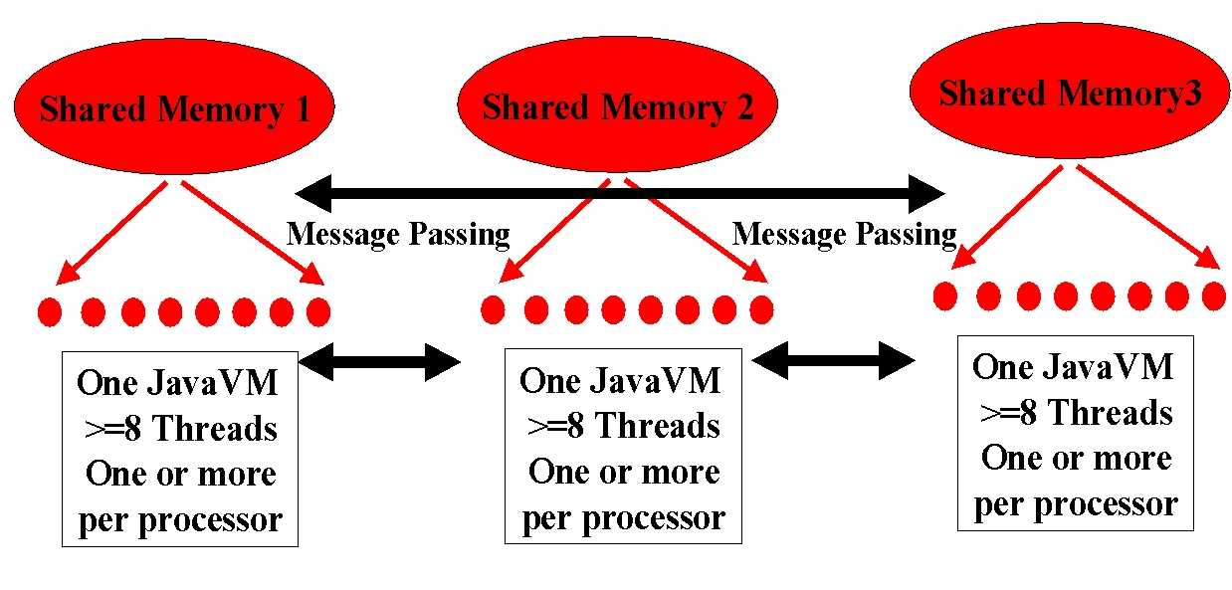
Fig. 7.4: Hybrid Java Model for Parallelism

In summary, Java directly addresses three of the four forms of parallelism described above. In these areas, it seems superior to other languages. Java needs to be augmented to fully support data parallelism but so do Fortran and C++!

7.6 HPspmd and HPJava: Pragmatic Data Parallelism
Data parallelism is obviously very important in High Performance scientific computing and currently explicit user specified parallelism and message-passing libraries are the dominant approach to scaling data parallelism. Much research has gone into more attractive higher level programming models such as HPF. Currently this has promising features and some success with the Grande user community. However the complexity of the compiler has delayed deployment and prevented timely implementation of critical capabilities. Considering a rapidly moving field such as Java, now does seem the time to consider approaches requiring complex compilers with a lengthy development cycle. Further experience ha shown that library based approaches to Grande programming are quite successful – one hides the complexity of message passing by invoking parallel libraries from an SPMD environment. Thus we introduced what we call the HPspmd programming model, where we provide some of the HPF distributed array capabilities through a library interface rather than through a compiler analysis of either loops or Fortran90 syntax as in HPF. The library calls support communication and arithmetic and include manipulation of “ghost cells” used in many regular problems. This concept is designed to have base technology implementation complexity, and ease of use lying in between those of MPI (straightforward to develop the MPI routines but low level user interface) and HPF(high level elegant environment but with the need for a major compiler development activity). Note HPspmd programs can intermix pure MPI and in HPF through its extrinsic interface with the HPspmd library calls. Although HPspmd can be applied to any language, we have designed a prototype Java environment that we call HPJava. HPJava is built on top of MPI and comes with a full featured Java interface to MPI mentioned in the next section. As well as MPI for low-level message passing, HPJava uses the library Adib built at NPAC to dupport HPF for regular collective operations. One could add further capabilities such as Global Arrays for 1-sided access to remote data, and CHAOS for irregular collective operations. We compare the expression of a simple block decomposed vector B and array with four processors in HPF and HPJava in table A.

Table A: Comparison of HPF and HPJava Specification of two arrays B(100), A(100,100) spread in one dimension block fashion over 4 processors
Typical HPJava Specification of Distributed Arrays | Corresponding HPF Specification of the same distributed Arrays
Procs p = new Procs1(4) ;  Range x = new BlockRange(100,p.dim(0));  float [[,*]] a =  new float [[x, 100]] on p ;  float [[]] b = new float [[x]] on p ; | !HPF$ PROCESSOR P(4)  !HPF$ DISTRIBUTE T(BLOCK) ONTO P  REAL A(100,100)  !HPF$ ALIGN A(:,*) WITH T(:)  REAL B(100)  !HPF$ ALIGN B(:) WITH T(:)

In the following table B, we show how red-black iteration on a two dimensional array can be expressed in HPJava. Note that the [[]] notation is used to signal a distributed array. We translate the special syntax used in HPJava, into conventional Java plus library calls and then invoke your favorite Java compiler.

Procs p = new Procs2(NP, NP) ;

on(p) {

Range x = new BlockRange(N, p.dim(0), 1) ; // ghost width 1

Range y = new BlockRange(N, p.dim(1), 1) ; // …

float [[,]] u = new float [[x, y]] ;

for(int parity = 0 ; parity < 2 ; parity++) { // red and black

Adlib.writeHalo(u, widths) ; // Communicate Ghost Cells

overall(i = x [1 : N - 2])

overall(j = y [1 + (x.idx(i) + parity) % 2 : N - 2 : 2])

u [i, j] = 0.25 * (u [i - 1, j] + u [i + 1, j] +

u [i, j - 1] + u [i, j + 1]) ;

}

}

Table B: Red-Black Interation in HPJava

In fig. 7.5, we give some preliminary HPJava performance numbers for a simple Jacobi iteration where HPJava outperforms Java due the HPJava translators use of efficient one dimensional arrays to represent the distributed [[]] syntax in Table A. Note that communication in HPJava is quite efficient as its uses native calls to C++ libraries to handle array operations.

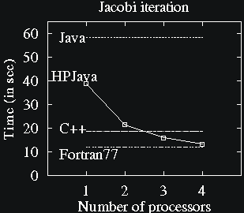
Fig. 7.5: Preliminary Performance of HPJava

7.7 Java links to MPI

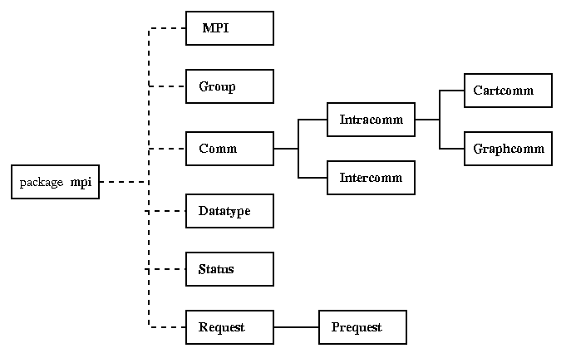
Fig. 7.6: Class Structure of mpiJava

Naturally one can implement an MPI linkage for Java and this has been implemented by NPAC (mpiJava in [refmpi] and [refmpipap]) and a Westminster College London group ([refmpi9] and [refmpi14]). Further Mississippi State has announced the availability of a commercial version JMPI [refmpi11]. Although there are Fortran C and C++ defined bindings to MPI [refmpi5], there is no formal definition of Java binding to MPI. Hence different approaches have been pursued. The Westminister College version automatically links C version of MPI to Java Native Interface (JNI). On the other although still using JNI, the NPAC version mpiJava “optimizes” the Java link based on C++ MPI standard by exploiting several features of the object oriented structure of Java. The NPAC version could be further extended to use serialization and pass any array of Java Objects. The Mississippi State version goes one step further with a version even more tuned to Java.
In the remainder we give a few more details of mpiJava which is a fully featured Java interface to MPI 1.1 but as described above using an Object-oriented API based on MPI 2 standard C++ interface. One interesting feature is the comprehensive test suite translated from IBM MPI suite and which was used to test all the myriad of MPI functions. JavaMPI is available for Solaris, Windows NT and other platforms. Fig 7.6 defines the class structure of mpiJava, which is freely available for download from [refmpi]. One can illustrate the MPI Java binding with the simple method invocation to send an array of characters to all processors from the mpiJava call:
MPI.COMM_WORLD.Send(message, 0, message.length, MPI.CHAR, 1, 99) ;
The initial implementation has been benchmarked with results shown in fig 7.7 and 7.8 for both shared memory and distributed memory implementations on multiprocessor PC and Sun Solaris UNIX platforms. We used the WPI NT version of MPI [refmpi15] and the well-known MPICH for UNIX. The figures compare C and Java implementations and we see that not surprisingly the extra overhead of the Java is most important in the Shared Memory mode where the latency is smallest anyway. In shared memory, the zero byte message transfer time increases from 70 μs to 160 μs for NT and 150 μs to 375 μs for UNIX. In distributed memory mode, the increase is from 620 μs to 690 μs for NT and 680 μs to 960 μs for UNIX. Obviously these Java measurements are quite ephemeral as the compiler technology is rapidly improving. However even now the Java MPI binding appears to have acceptable performance.
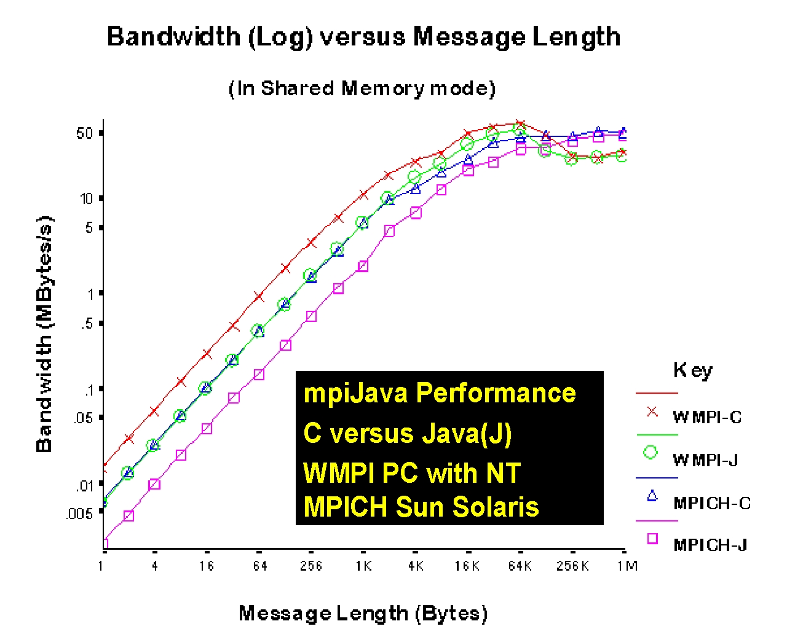
Fig. 7.7: Performance of Shared Memory mpiJava for C and Java on UNIX and NT
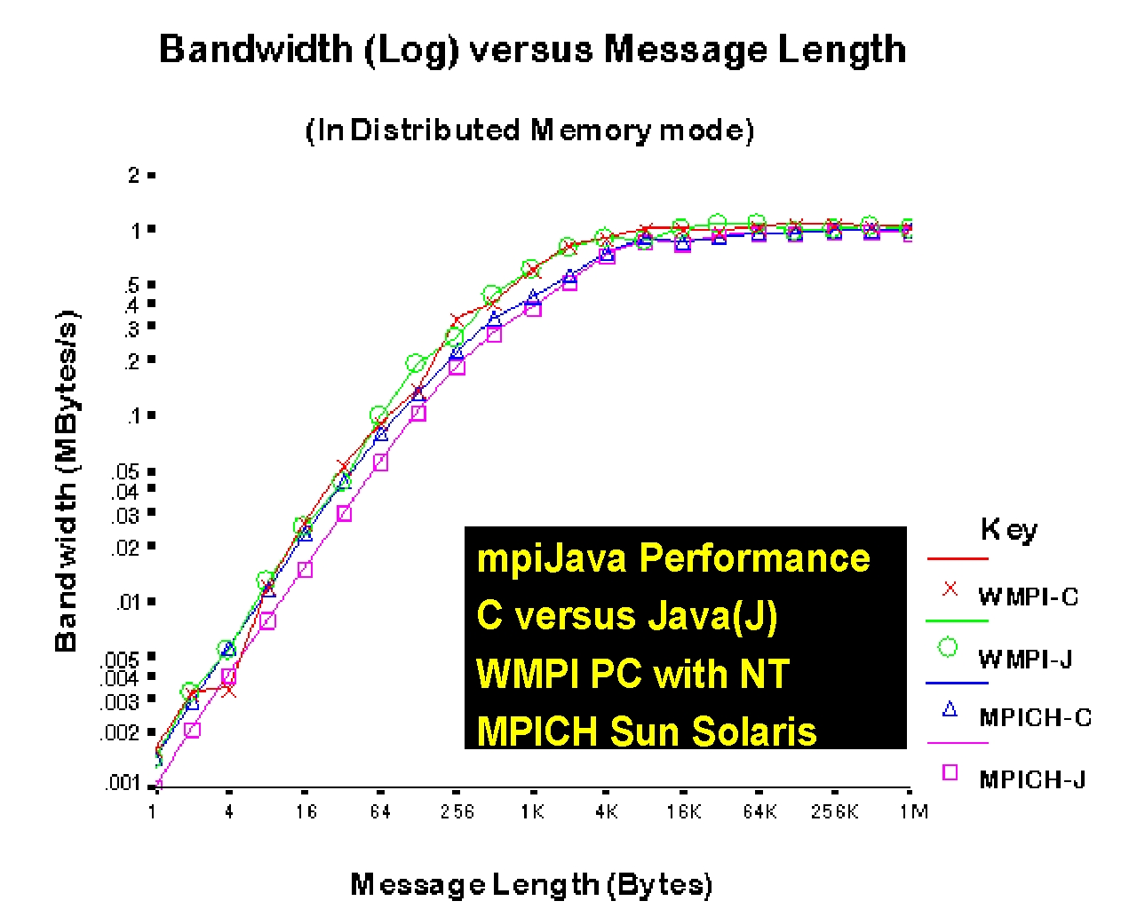
Fig. 7.8: Performance of Distributed Memory mpiJava for C and Java on UNIX and NT

8 HPcc and Parallel Computing
Most of the discussion in this paper has been devoted to the use of commodity technologies for computational grids or the field that is sometimes termed HPDC (High Performance Distributed Computing). However as we explored in the last subsection in the special context of Java, we believe that one can also use commodity technologies to build parallel computing environments, which combine both high functionality and high performance. As usual the functionality comes from inheriting commodity services and the challenge is to combine these with high performance. We assert that this approach will lead to sustainable attractive programming environments. In metacomputing, The HPcc approaches of sections 3, 5 and 6 leads to novel high level environments for there are few pre-existing high level metacomputing and distributed simulation environments. In parallel computing, HPcc offers an alternative to other approaches which could be advantageous as HPcc leads to uniform vendor neutral, productive and sustainable (lower maintenance costs) programming environment.
First compare the two views of a parallel computer in figs. 8.1 and 8.2.
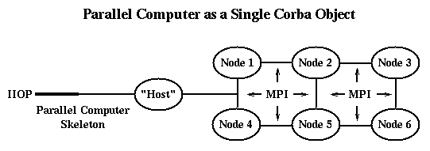
Fig. 8.1: A Parallel Computer viewed as a single CORBA object in a classic "Host-node computing model". Logically the "Host" is at tier-2 and the nodes are at
tier 3. The Physical architecture could differ from the logical architecture.
In the above figure, we see a simple multi-tier view with commodity protocols (HTTP, RMI, COM or the IIOP pictured) used to access the parallel computer as a single entity. This entity (object) delivers high performance in an obvious way by running classic HPCC technologies (such as HPF, PVM or the pictured MPI) in the third tier. This is model pictured in fig 1.1 and 9.1 where the parallel machine is viewed as a single back end service. The seamless interface of sec 7.4 would again interface to this a single computer with its parallel architecture reflected in the value of certain properties such as the number of nodes. This could be considered a representation of the "host-node" model of parallel programming. Note that in figs. 8.1 and 8.2, we draw various nodes and the host as separate entities. These represent logically distinct functions but the physical implementation need not reflect the distinct services. In particular, two or more capabilities can be implemented on the same sequential or SMP system.
In fig. 8.1, we are not exploiting the distributed computing support of commodity technologies for parallel programming. However in fig. 8.2, we view the parallel computer as a distributed computer with a particularly fast network and integrated architecture.
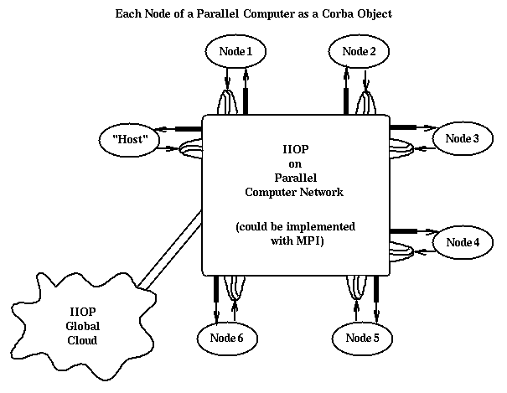
Fig. 8.2: Each node of a parallel computer instantiated as a Corba object. The "Host" is logically a separate Corba object but could of course be instantiated on the same computer as one or more of the nodes. Using the protocol bridge of fig. 8.4, one could address objects using Corba with local parallel computing nodes invoking MPI and remote accesses using Corba where its functionality (access to very many services) is valuable.

In fig. 8.2, each node of the parallel computer runs a Corba ORB, Web Server or equivalent commodity server. Now commodity protocols can operate both internally and externally to the parallel machine. This allows a particularly powerful environment where one can uniformly address the full range of commodity and high performance services. Remember that even in parallel computing, one Further tools such the visual environment of sec. 6.3 can now be applied to parallel as well as distributed computing. Obviously one should be concerned that this flexibility has been accompanied by a reduction in communication performance from that of fig. 8.1. Indeed most messaging protocols such as RMI, IIOP and HTTP have unacceptable performance for most parallel computing applications. However we can use the ideas of sec. 3.2 to obtain good performance with a suitable binding of MPI and PVM to the commodity protocols. In fig. 8.3, we redraw fig. 2.3 in a fashion to demonstrate the analogy to fig 8.2.
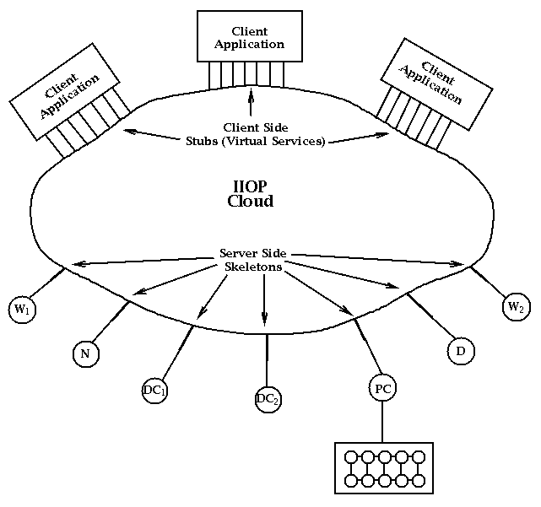
Fig. 8.3: Pure Corba architecture for the heterogeneous DcciS services of fig. 2. There is a similar Java version of this using RMI and JDBC with of course the linked application being restricted to Java code. Corba and the analogous COM solution are cross-language solutions.

In fig. 8.4, we extend the previous figure to show an approach to high performance, which uses a separation between messaging interface and implementation. The bridge shown in this figure, allows a given invocation syntax to support several messaging services with different performance-functionality tradeoffs.
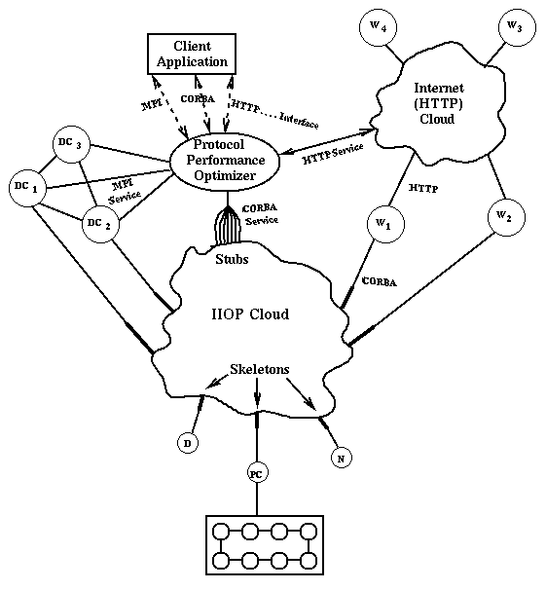
Fig 8.4: A message optimization bridge allows MPI (or equivalently Nexus or PVM) and commodity technologies to coexist with a seamless user interface.

In principle, each service can be accessed by any applicable protocol. For instance a Web Server or database can be accessed by HTTP or Corba; a network server or distributed computing resource supports HTTP Corba or MPI. Of course one can substitute equivalent commodity (RMI, COM) or HPCC technologies (PVM, PVMPI, Nexus) in the above discussion. Note that there are two ways of linking MPI and Corba. Firstly there is the MPI function call that actually calls a Corba stub; secondly a Corba invocation can be trapped and replaced by an optimized MPI implementation. One could for instance extend the MPI communicator field to indicate a preferred protocol implementation and this could be an interesting capability of the Java-MPI linkage of sec. 7.7. This preference can be set using the mechanism of sec. 3.2. As discussed in the Java Grande forum, there are important research issues in efficient object serialization needed for a high performance implementation of fig. 8.4.
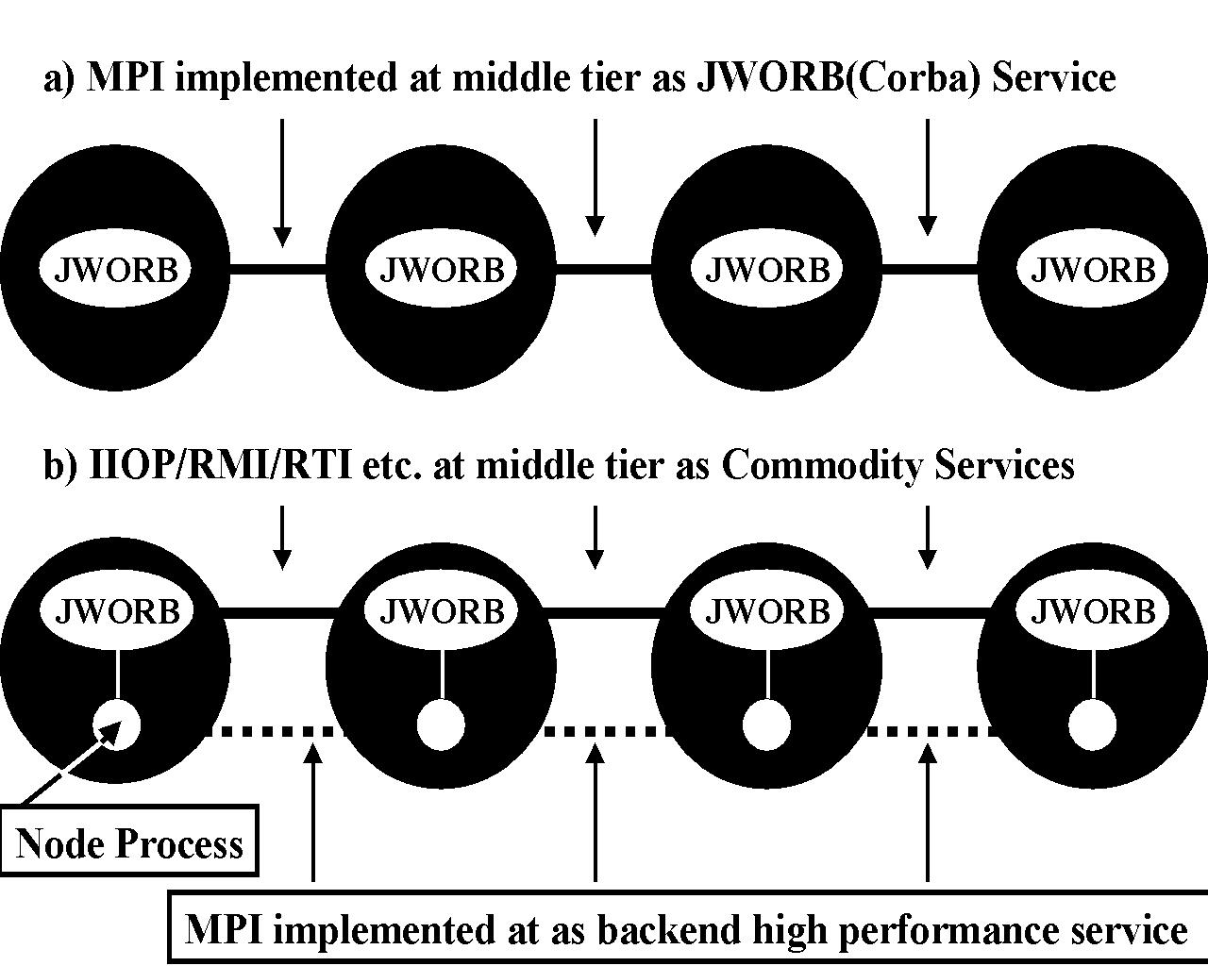
Fig. 8.5(a) Middle Tier and (b) High Performance backend implementations of MPI in HPcc

There are two versions of parallel processing in HPcc when we adopt the view of running middle tier servers on each processor of an MPP. The simplest is shown in fig. 8.5(a) where we implement all message traffic at the middle tier level so as in our current RTI implementation, we use base JWORB or equivalent services for MPI. In fig. 8.5(b), we use the hybrid approach of sec.3 where each node of the parallel runs both a commodity server and a "native high performance MPI" interacting with the typical node programs. The commodity server is providing Object Web services in the same spirit that UNIX or NT on each node of most current MPP's provide operating system services. The network of JWORB servers in fig. 8.5(b) provide an important management layer -- using perhaps HLA as discussed in sec. 6.3 -- as here we do not need high performance but rather the rich functionality of the middle tier
.

9 Conclusions: A Multi Tier Grande Computing System
So suppose you think HPcc and/or Java Grande is interesting. How does this impact your implementation of a computing environment? The situation with Java Grande is perhaps clearest as now is not the time to deploy it except on clients and servers; we should experiment with and evaluate the use of Java as a scientific programming language.In more detail we summarize situation as:

- Don’t need to rewrite existing codes in Java!
- Instead use Java freely at client and middle (server or “gateway”) tier and wrap existing codes as CORBA or Java distributed objects. This will you all the advantages of Java for distributed objects
- Conduct suitable experiments in using Java in complete Grande applications
- Make certain your interests are represented in Java Grande Forum
- Retrain your staff in Java Web and distributed object technologies
- Put “High Performance Grande Forum compliant” Java support into your RFP’s for hardware and software

Now suppose you wish to put together a computing environment that builds in some of the ideas described here. We can expand figure 1.1 to a more explicit Grande computer application in figure 9.1 which illustrates the richness of the use of the middle tier. Here we call it a Gateway as it naturally acts as this to the set of available special purpose backend systems such as databases and massively parallel computers. The component called “Gateway Control” in fig. 9.1 is intended to implement the seamless interface described in sec 7.4. The remaining middle tier components in fig. 9.1 are servers (CORBA, servlet etc. in general sense of pragmatic object web) either implementing directly or invoking proxies to the backend for the labelled services. We see in this figure multiple supercomputers in the backend -- one doing CFD simulation of airflow; another structural analysis while in more detail you have linear algebra servers (NetSolve from Tennessee); Optimization servers (NEOS from Argonne); image processing filters(using perhaps Khoros);databases (here a particularly rich example is the NCSA Biology workbench); visualization systems(from low end PC systems to AVS to virtual environments in CAVEs)
All these services are linked together and to commodity services such as collaborative information systems in the sea of middle tier. The example shown is roughly aimed at multi-disciplinary applications to design of vehicles but other areas would produce a qualitatively similar situation.
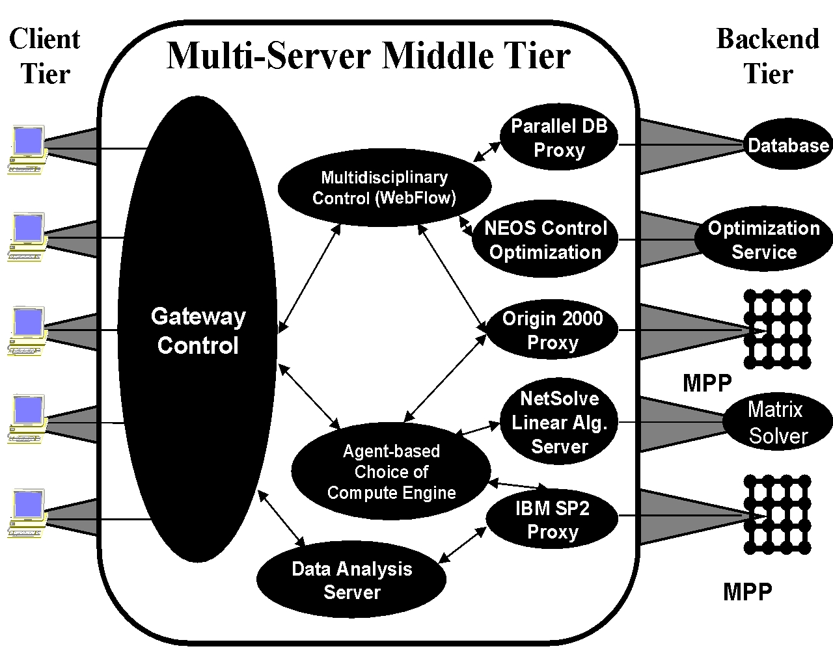
Fig. 9.1: Typical HPcc implementation of a complex high performance multidisciplinary application.with the middle tier naturally implemented on the Gateway machine

We can enumerate capabilities of middle tier as illustrated above and discussed throughout this paper – especially in sec. 3.
- Seamless Interface in “Gateway Control” -- an Enterprise Javabean which processes input from user’s Java Applet interface and maps user generic commands to those on specific machine as discussed in sec. 7.4
- Accounting, Security, Compiling Interface, Seamless Tools Interface, global data and file system interface
- Resource management of heterogeneous MPP backend (linked to seamless interface)
- Database and Object Brokers; Network servers like NetSolve and NEOS
- Uses agents (as used in NetSolve) to determine optimal execution platform
- Collaboration Servers including Habanero, Tango, Lotus Notes etc.
- Visualization Servers
- “Business Logic” to map user data view (e.g. objects) to persistent store (e.g. Oracle database) and simulation engine (MPP) preferred format

Now we suggest that the logical architecture of fig. 9.1 could naturally imply a physical architecture as the hardware and software tradeoffs of the middle tier are of course different from those of a backend resource. Roughly you can say that middle tier is naturally supported by a modern business enterprise system – typically a shared memory SMP.
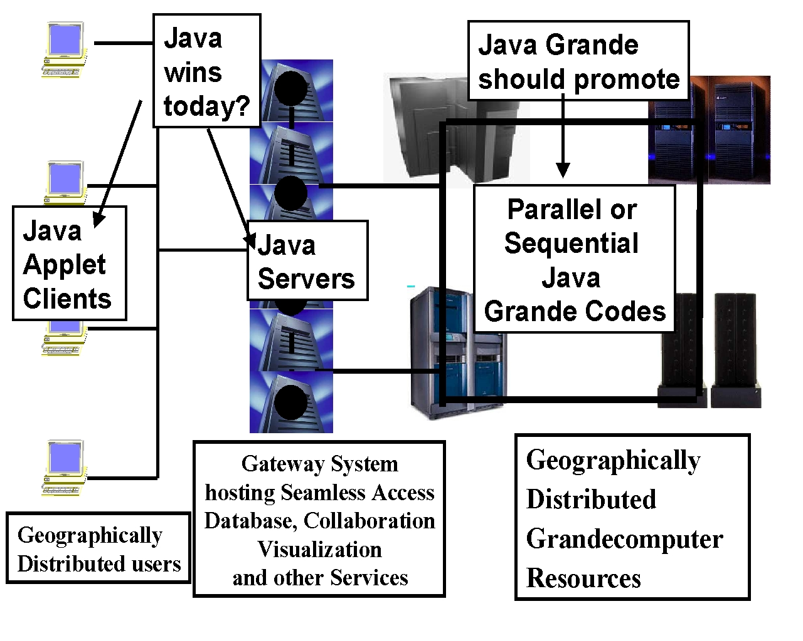
Fig. 9.2: The Hybrid Gateway Architecture implemented with separate middle tier, client and backend hardware.
Several subsystems and applications will run on the Gateway or middle tier.
- The 90% of users who only need HPCC occasionally!
- Most of a Command and Control application.
- Several FMS (forces modeling) and IMT(Integrated modeling and testing) applications using the WebHLA of sec. 6.
- Some I/O and database intensive applications. Note business enterprise systems are natural hosts for commercial databases.
- High value services with modest computational needs e.g. grid generation and other pre-processing, data manipulation and other post-processing.
- Video Servers for training and education.
- Design and planning tools.
- “Glue” such as WebFlow servers for multidisciplinary interactions.
- Control of metacomputing applications.
- Capabilities such as the new JINI Java resource registration and discovery service.

Although these are simple concepts, we note that the structure of figs. 9.1 and 9.2 are not seen in many Grande computing environments and the need for Gateway middle tier systems is not reflected in many solicitations for center hardware and software. We suggest that it will be fruitful to plan and support such hybrid Grande computing environments.

References

[refhpjava1] Bryan Carpenter, Yuh-Jye Chang, Geoffrey Fox, Donald Leskiw, and Xiaoming Li. Experiments with HPJava. Concurrency: Practice and
Experience, 9(6):633, 1997.

[refhpjava2] Bryan Carpenter, Yuh-Jye Chang, Geoffrey Fox, and Xiaoming Li. Java as a language for scientific parallel programming. In 10th
International Workshop on Languages and Compilers for Parallel Computing, volume 1366 of Lecture Notes in Computer Science, pages
340--354, 1997.

[refmpi] javaMPI Home Page http://www.npac.syr.edu/projects/pcrc/mpiJava
[refmpipap] Mark Baker, Bryan Carpenter, Geoffrey Fox, Sung Hoon Ko and Xinying Li. mpiJava: A Java MPI Interface in Java Grande workshop at Europar, September 2-3, 1998, Southampton.

[refmpi4] Adam J. Ferrari. JPVM: Network parallel computing in Java. In ACM 1998 Workshop on Java for High-Performance Network Computing.
Palo Alto, February 1998, Concurrency: Practice and Experience, 1998. To appear.

[refmpi5] Message Passing Interface Forum. MPI: A Message-Passing Interface Standard. University of Tennessee, Knoxville, TN, June 1995.
http://www.mcs.anl.gov/mpi.

[refmpi9] Vladimir Getov, Susan Flynn-Hummel, and Sava Mintchev. High-Performance parallel programming in Java: Exploiting native libraries. In
ACM 1998 Workshop on Java for High-Performance Network Computing. Palo Alto, February 1998, Concurrency: Practice and Experience,
1998. To appear.

[refmpi11] George Crawford III, Yoginder Dandass, and Anthony Skjellum. The jmpi commercial message passing environment and specification:
Requirements, design, motivations, strategies, and target users. http://www.mpi-softtech.com/publications.

[refmpi13] Sava Mintchev and Vladimir Getov. Towards portable message passing in Java: Binding mpi. Technical Report TR-CSPE-07, University
of Westminster, School of Computer Science, Harrow Campus, July 1997.

[refmpi14] Narendar Yalamanchilli and William Cohen. Communication performance of Java based parallel virtual machines. In ACM 1998 Workshop on Java for High-Performance Network Computing. Palo Alto, February 1998, Concurrency: Practice and Experience, 1998. To appear.

[refmpi15] WMPI - http://dsg.dei.uc.pt/w32mpi

Need Glossary
Need acknowledgement to Bryan Carpenter and Tom Haupt groups
Funding acknowledge PET and Sandia and NCSA(NSF)

