Gateway Project: An Approach to
The Interoperable Problem Solving Environments
at the
Aeronautical Systems Center Major Shared Resource Center

Bill Asbury, Geoffrey Fox, Tom Haupt, and Ken Flurchick

Introduction
The Gateway project to develop Interoperable Problem Solving Environments (IPSE) is a collaborative effort between the Northeast Parallel Architectures Center (NPAC), Ohio Supercomputer Center (OSC), and the Aeronautical Systems Center (ASC) Major Shared Resource Center (MSRC). The ultimate goal of this project is to provide desktop access to ASC MSRC resources via commonly used web browsers. This “point & click” graphical interface hides the underlying complexities and details of the High Performance Computing (HPC) resources and creates a seamless interface between the user’s desktop system and the heterogeneous computing resources of the MSRC. Scientists and engineers can then concentrate on the scientific aspects of their work instead of the computer science issues. Also, the novice HPC user can utilize the computing resources in a more timely and efficient manner. The initial implementation of IPSE will be within a test and development environment at the ASC MSRC. The first official release is slated for November 1999 with a demonstration at SC99.

IPSE Framework
The IPSE framework is based on the multi-tier Gateway architecture developed by NPAC. The primary advantage of the Gateway architecture is the use of commodity hardware and software which provides a user friendly, visual computing environment. This capitalizes on the current web technology efforts and advancements while minimizing the use of specialized protocols and software. Thus, the IPSE framework becomes a more extensible and maintainable framework.
This framework is implemented as a modern multi-tier system. Tier 1 (Client Tier) is a high-level front-end for visual programming environment built on top of web and object-oriented commodity standards. This Tier 2 (Gateway Tier) consists of reusable web servers, object broker servers, and metacomputing servers. The initial implementation will use the existing services of Globus to interface with the HPC resources in Tier 3. Tier 3 (Back-end Tier) corresponds to HPC resources and complementary resources, such as databases and computing clusters.
This structure permits a single web-based entry to the user via a Gateway Portal in the Client Tier. The portal provides user authentication based upon existing standards: SSL, PKI, and Kerberos/SecurID. CORBA security services, Globus GSSAPI services, and access policies maintain security through the Gateway Tier to the back-end resources. The Gateway Tier provides implementation of many different PSEs via the WebFlow API layer. The following diagram illustrates the IPSE framework.
By using commodity software, Java, and CORBA this framework is more easily adapted for new technologies, future PSEs, and specialized middleware components. One example would be the use of NetSolve with in the Gateway Tier to handle mathematic subroutines. Another would be to use DICE within the Gateway Tier to perform scientific visualization functions. In short, this type of framework is highly modular and adaptable to accommodate future growth and changing needs of our user base.
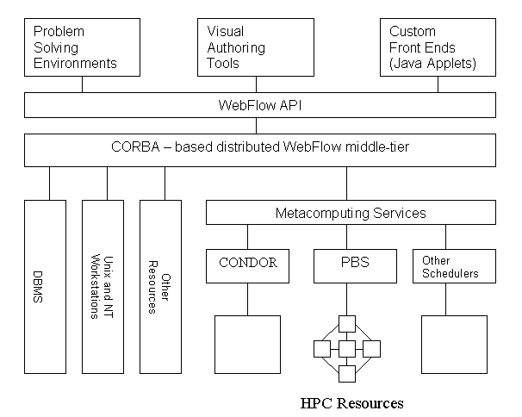

IPSE Components

Problem Solving Environment
The PSE is a flexible application environment that allows the DoD researcher to more effectively access and utilize available resources in developing computational solutions for their research problems. The PSE is a component of the IPSE framework and interfaces to the Gateway Tier, which processes user requests and interacts with all the available resources. Additionally, the user can obtain assistance to describe, in science terms, the problem to be solved, investigate a variety of computational methods, and the PSE can suggest application codes to solve the problem.

Gateway Tier
This tier provides a seamless interface between the user’s desktop system and the heterogeneous HPC resources of the MSRC. In this CORBA-based framework, an Enterprise Javabean, which processes input from the user’s Java applet interface, maps the user’s generic commands to those on a specific machine.

Back-end resources
The initial IPSE implementation will be within the ASC MSRC test and development environment. This environment will include the following systems:

- IBM SP
- IBM Winterhawk SP
- Compaq Regatta
- O 200
- Several Sun, IBM, and SGI workstations

The test and development environment will closely match the current configuration of the ASC MSRC production environment. Although the initial production environment is the ASC MSRC, current metacomputing efforts should expand available resources across HPC centers.

