From Computational Science to Internetics
Integration of Science with Computer Science

Geoffrey C. Fox
Syracuse University
Northeast Parallel Architectures Center
111 College Place
Syracuse, New York 13244-4100
gcf@npac.syr.edu
http://www.npac.syr.edu

Dedicated to John Rice Purdue University

Abstract
We describe how our world dominated by Science and Scientists has been changed and will be revolutionized by technologies moving with Internet time. Computers have always been a well-used tool but in the beginning only the science counted and little credit or significance was attached to any computing activities associated with scientific research. Some 20 years ago, this started to change and the area of computational science gathered support with the NSF Supercomputer centers playing a critical role. However this vision has stalled over the last 5 years with informational technology increasing in importance. The Holy Grail of computational science -- scalable parallel computing -- is still important but is just one supporting component of the Internet revolution. We discuss the emergence of the field of Internetics -- bridging computer science and all application areas whether simulation or information based. Internetics is an exciting field, which seems complete and rich enough to be a lasting interdisciplinary area.
Physics and other core science and engineering disciplines used to attract the very best minds but now their popularity is declining. We describe curricula initiatives that can re-invigorate these fields. This curricula turmoil must be addressed by our education infrastructure whose professional staff find it hard to develop courses to satisfy student and employer interests in times of such rapid change. Distance education is very relevant as it can be used to disseminate expertise to students and teachers in these new areas. All of this has implications for our educational institutions, which could be quite profound.

1: In the Beginning: Science

Throughout my life, I have wandered discontentedly from field to field seeking the perfect blend of intellectual stimulation and real world value. Like many students in my time I was attracted first to Mathematics and then theoretical physics as fields with a clear fundamental basis and major important challenges. My desire to embrace reality led me from the usual paths and from the start of my career, I used computers as a critical part of my research, which focussed on the interplay of theory and experiment in high-energy physics. At that time, I mistakenly did not understand the academic field of computer science but I did differ from my peers in physics. I tried always to apply the rigorous methodological standards I learnt as a physicist to my computing. Computing was not hacking but as interesting an application of the scientific method as studying quarks and gluons. Often research groups in my general area (phenomenology of particle physics) assigned "failed theoretical students" to the "trivial" tasking of using computers to translate real physics (equations) into quantitative comparison with experiment. Again a sizeable fraction of experimental high-energy graduate students did not continue in their field after getting a Ph.D. but rather got jobs exploiting their considerable software skills. Typically these skills had been obtained on the job and the students knew essentially no computer science and had no understanding of the principles underlying the hardware and software of computers. In this world only the "physics" counted.

2: The Initial Interdisciplinary Vision: Computational Science

As computers got more powerful
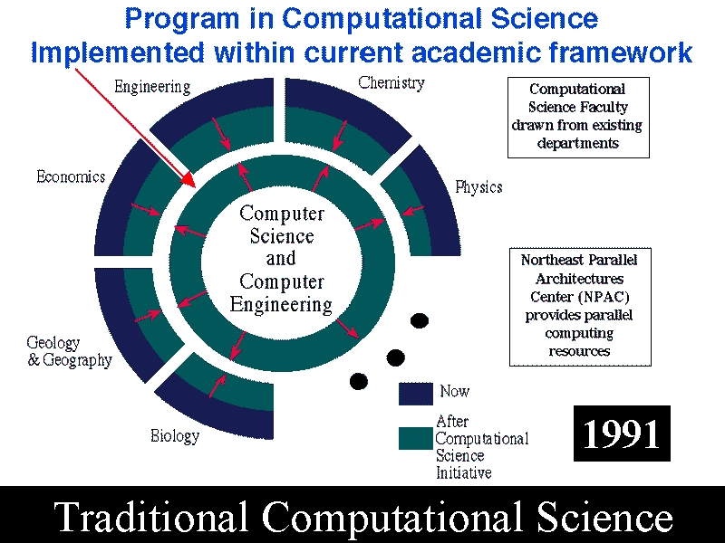

3: A Better Dream: Internetics

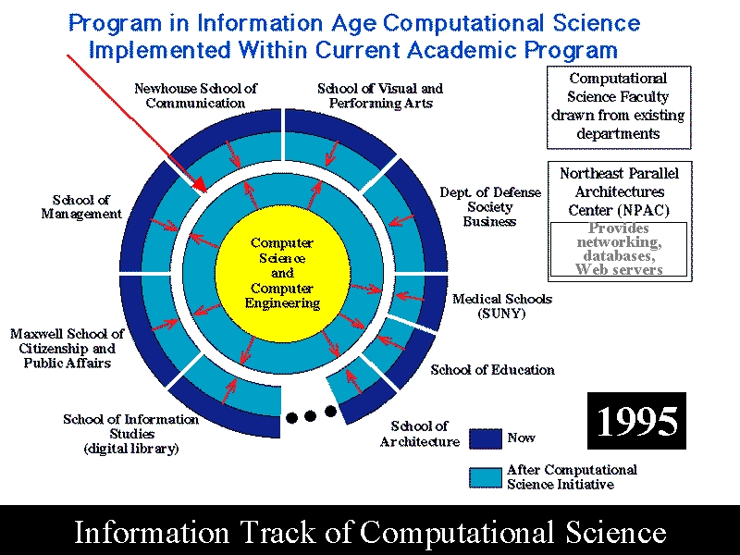

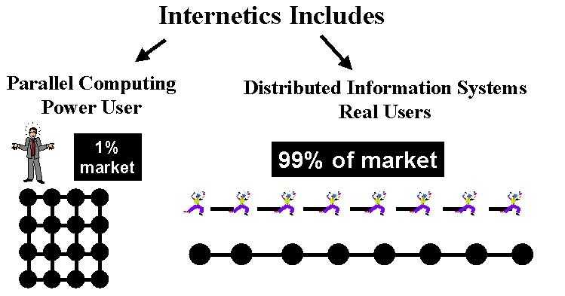

4: Down but not quite out: Physics on the Ropes

5: Even Rocks can Crumble: Changing Enterprise Model for Universities

