3.2: TangoInteractive Background
…
Web Document Server
Tango Server
CDA DOM
CDA DOM
CDA DOM
Knowledge Agent
Customized interface
Initial User
Other users with CDA DOM allowing customizable presentations of knowledge to each user
TangoInteractive (or Tango; http://www.npac.syr.edu/tango) is an advanced, powerful, and extensible Web collaboratory, and is perhaps the most flexible of systems of its type. It is not aimed at exploring research issues in collaborative system design, but rather at exploring applications such as those proposed here. In this regard, great effort has been put into making the base infrastructure quite robust, so that it can be used outside a tolerant research environment.

Tango is written in Java, but supports collaborative applications in any language. Further Tango is fully integrated with Web browsers, and this provides the basis of convenient, familiar interfaces. To run Tango, one starts the system from a browser and connects to a Tango server. Both the client and server code for Tango are freely available on CD-ROM or from our Web site, which also contains the well documented API’s for C++, Java, Java Beans, and JavaScript. Once in the system, the user can select from over 25 collaboratory applications to work on projects with partners, play a game of Bridge or Chess, take a class at a virtual university, create and use a public or private chat room, conduct a videoconference, view a movie, or surf with friends using the powerful shared browser. It is possible to do all this at the same time, in any combination, and multiple copies of applications such as chat rooms can be launched. Further, Tango can provide shared sessions for either client- or server-side applications. The latter include both shared (Web-linked) databases (as in Oracle-based WebWisdom curriculum management system) and shared CGI scripts (as in our integration of NCSA’s Biology Workbench with Tango). We believe that no other collaboratory system, public domain or commercial gives you so many applications under such consistent and simple session and floor control.

Besides running Java applets under Tango, one can run JavaScript-based client-side Web applications. Moreover, in Tango the user can take an arbitrary HTML page and automatically turn it into a shared entity. To build a 3D VRML world, populate it with avatars, and let them interact, Tango provides support via two integration modes: VRML JavaScript nodes and External Authoring Interface. Applications written in C or C++ (e.g. PowerPoint) can also be readily adapted to run collaboratively under the Tango API. In this proposal, we will use the C++ interface of Tango to link the NeatTools specialized interfaces. Note that the shared collaboration model of Tango allows each client to have different views of the same shared application, and this is essential for cross disability access. Shared display systems such as Microsoft’s NetMeeting are less flexible.

3.3: Systems Architecture and Software Infrastructure

3.3.1 Pragmatic Object Web
As discussed in sec. 2, we intend to build and deploy a CDAKN, which means that we must make particular choices in today’s rich and evolving technology world. We do this in the context of a knowledge model described in sec. 3.1 with technology choices based especially on the open standards of organizations like W3C. However limitations in commercial systems (e.g. bugs and unimplemented features in web browsers) means that these lofty principles must be leavened with practical and sometimes ugly implementation choices. Further although we will articulate and test general architecture principles in this project, we must build on existing software to develop systems which are appropriately robust and functional. Thus we intend to build on two key NPAC technologies, TangoInteractive and WebWisdom, developed to support distance training but with no delivered cross disability support. We believe this is justified not only because of our familiarity with them but because they exhibit two key capabilities. WebWisdom supports the managed integration of distributed educational objects while TangoInteractive’s (unique?) collaborative JavaScript API naturally allows cross disability interfaces to Web documents. Where it is necessary to reference the resultant system, we will term it CDAWebWisdom.
Our proposed software will be built around an emerging architecture for distributed systems that we call the “Pragmatic Object Web”. This notes the ongoing convergence of web and distributed object technologies to form what is usually called the object web. This is currently approached from four major points of view: CORBA (from an Industry Consortium) the Object Management Group, Java from Sun Microsystems, COM from Microsoft and a set of technologies from the web consortium W3C including XML and a document object model (DOM). These approaches are somewhat complementary but often competitive and in constructing real systems, we pragmatically propose to use the best of each approach – this assumes that some complex unpredictable worldwide process will blend these four giants into a composite distributed system architecture and technology base. Our pragmatic approach appears more likely than any other to lead to systems that are both powerful today and likely to be quite consistent with future changes. These ideas are described in a book that we are writing “Building Distributed Systems on the Pragmatic Object Web” which gives examples and detailed discussion of the concepts.
Both the hardware and software infrastructure of the object web is changing with remarkable speed and so our plans are necessarily tentative especially in out years. However we believe that the activities discussed below illustrate our approach and in some sense represent a lower bound to our goals for they do not require any major new object web base technology developments. Of course, we will take advantage of any significant new relevant technologies that become available during the performance period and modify our plans accordingly.
The object web revolution has been driven as much by the adoption of open standards such as HTML, JDBC (Java database connectivity standard) and IIOP (CORBA protocol) as by the more obvious remarkable software artifacts and technologies such as browsers and the Java language. These object web standards and technologies appear to offer significant potential for improvements in cross disability access. In particular the object web standards allow the development of a more structured uniform information space wherein reusable universal access interfaces can be developed and used in a wide variety of circumstances. Although this potentially possible, it is by no means guaranteed as an unguided haphazard development of object web applications could lead to a situation actually worse than that now with increased information served by more and not less data structures. As a relevant example, XML technology could allow the definition of the structure of glossary items used to support more or less all education and training applications. We could then optimize cross disability access for this structure. On the other hand, it is also possible for each web site to develop and use a different XML syntax for their glossary and force the costly and inefficient scenario with a separate cross disability access mechanism in each case. We intend in this proposal to carefully design XML structures to best represent the information in our knowledge network and to allow accurate cross disability rendering.

3.3.2: Architecture of CDAWebWisdom
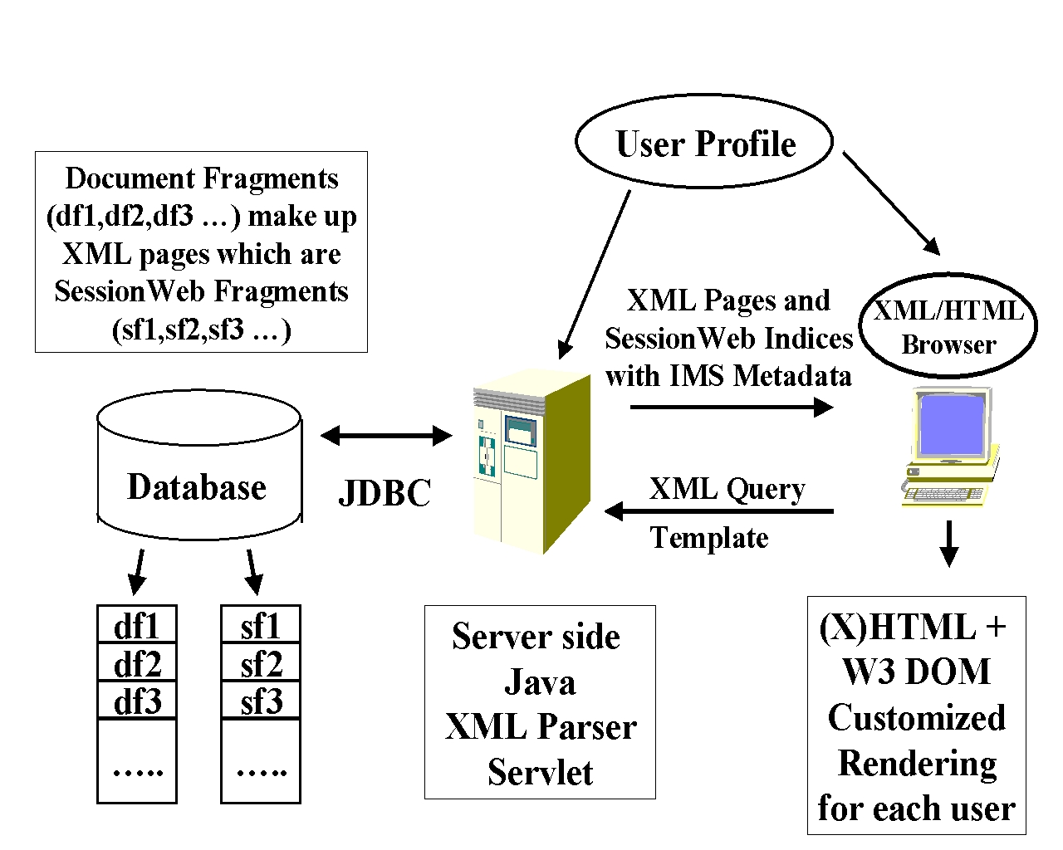
fig.1: Architecture of Cross Disability Rendering
This proposal aims to help and accelerate the development of common information structures that can both express the application in a general fashion and support well cross disability interfaces. In this fashion, our project will help the development of both cross disability access and the ongoing activities defining key object web standards. The Trace center is already a participant in the key W3C object model discussions. Our CDAKN is built on the concept that knowledge is formed iteratively by successive organizations of base information “nuggets”. These are viewed technically as “distributed educational objects” with a four level navigation scheme described below. Cross disability access is needed for both the unit information objects and perhaps even more importantly for their synopsis and indices describing their integration into knowledge. We support the knowledge management by using conventional databases (in our case Oracle) to store persistent information objects and their dynamic organization. Java servers using JDBC map the stored object model into the user view, which is accessed (as in modern web-linked databases) through XML templates. XML is converted into HTML either on the server or (increasingly in the future) browser. The XML/HTML Web documents are shared through TangoInteractive, which allows client profiles to optimize the rendering of both the information nuggets and their synopsis. This pragmatic mix of conventional databases, Java Servers, and XML specification of knowledge and information objects illustrate CDAWebWisdom’s technical choices. JavaScript is used to capture interactive events and allow cross disability rendering of dynamic information objects, which respect the web document model (DOM). Currently this DOM is rather erratically designed and implemented by Netscape and Microsoft but we expect the recent W3C proposals to bring more power and uniformity during the time period of this project.
TangoInteractive can share essentially any distributed object with its defined API’s to multiple languages but we stress web pages here as these are natural realization of shared information for the activities in this project. However this is more general than appears at first sight, because web pages can be user interface to general server or client side objects – databases (as above), CORBA object brokers, CGI Scripts (as in TangoInteractive’s shared web form interface to NCSA’s Biology workbench), etc.

3.3.3: Collaborative Knowledge and Cross Disability Rendering
TangoInteractive manages the sharing of educational objects and allows each client to optimize its view of the information based on user preferences and capabilities of the client machine and network connection. This capability is available in any system using a shared event collaboration model, which allows separation of display and shared object specification. As a simple example, a client with a low bandwidth network connection would request the low resolution version of an image and one serving a user with impaired vision, the audio augmentation of this image. As shown in fig. 1, we encapsulate this optimized choice of document fragment rendering in terms of a knowledge agent. Collaborative systems like TangoInteractive, can be used to share distributed objects between different users or between different display devices for a given user. This replication of object between different display modalities can be implemented within a single machine or between multiple machines serving a single user. Note that although it may seem extravagant, using multiple machines for a given user is quite practical given the rapidly decreasing hardware prices. In fact, we regularly use this strategy when teaching, so that one puts the key functionalities of audio/video conferencing, chosen curriculum page and chat/white boards on different machines assigned to the teacher. Students in this example typically view the curriculum on their own lab machine while a single machine handles audio and video for collocated students.
As described later, we will support shared cross disability views of both basic information pages to TangoInteractive some automated support for an "orientation view" (who's there, what's happening) comparable to the role of the "table of navigation" in the DAISY/NISO digital talking book. This is the missing information for blind usability, replacing the visual maintenance of orientation via the shared GUI panels. The latter is a good example of a bottom-up definition of an accessible knowledge corpus. There was enough participation from blind people and people expert in serving the blind so that it works. We should not re-invent this. Articulating the relationships among the discourse fragments provides a higher level of knowledge consolidation and makes the course experience more ready to re-use and re-combine.

3.3.4: Integration of Asynchronous and Synchronous Learning Models
We note that our model for information includes both asynchronous and synchronous modes supported in a common fashion for cross disability access. We assume that in each case, students and teachers access curriculum material stored as web pages or more generally distributed objects on web servers, object brokers or equivalent. Asynchronous or self-paced learning occurs when each participant accesses this material in his or her own time. Synchronous learning occurs when this same material is replicated among a class and discussed interactively. This model allows a single approach to cross disability access, which is independent of learning model.

3.3.5: Two Level Navigation Model for Distributed Objects
We start with a conventional hybrid information object model and define a distributed information object by a tuple (Page_URL, Component_DOM). This approach views information as a collection of document fragments (labeled by Component_DOM) arranged in pages labeled by Page_URL. When one uses a backend database, this conventional label is mapped into a reference to a database cell and distributed objects can be constructed at any level of granularity as a collection of the contents of multiple cells. Each cell corresponds to a document fragment specified in XML at the client side and converted in a Java servlet to a JDBC access to the database. Pages are accessed through web address, file location, CORBA or Java naming service or whatever hierarchical naming scheme evolves on the object web. A “Page” is, for information underlying traditional education, the basic curriculum unit. It is a “screenfull” or “foil” which is discussed by the lecturer or studied by the student as a single unit with cross referencing between concepts not requiring tiresome browsing and reloading of the browser page. The conventional hierarchical labeling of Page_URL seems quite natural for future web education and training with, some name like university/ college/ department/ program/ course/ lecture. However the information within a given page is much less structured and consists of some often-haphazard arrangement of multimedia information nuggets. Further fragments within the page can be repositioned dynamically using dynamic HTML as evolved in the W3C DOM.
This two level model will be used in our initial work in this project as it essentially represents current practice. We will support a limited view of knowledge integration at this stage with all participants allowed to browse the hierarchical page structure and to dynamically arrange pages into new information streams. The XML templates that define the interface to document fragments in the database will be extended to support customized rendering as shown in fig. 1.

3.3.6: Four Level Navigation Model Supporting Knowledge Integration
As part of this project, we will investigate a new approach to document object models, which is designed to support both an easier definition of the overall structure of the document and the dynamic linkage of input-output devices to components. We return to the hierarchical structure labeled by the tuple (Page_URL, Component_DOM). We wish to support the hierarchical grouping of information described in section 3.1. In this regard we consider a four way grouping of information – namely the Internet or World Wide Web, the SessionWeb, the Page and the document fragment. As emphasized earlier, we will follow the market place in the area of resource discovery and coupling to the hierarchical URL namespace defining the World Wide Web. We will use appropriate metadata such as those proposed by Educause's IMS project to integrate educational objects to the topology of the resource-discovery world. Here however, we focus on the natural organization of knowledge in a “session” such as is found in a lecture or a single self study activity. We now discuss this limited fine grain or local Session Wide Web, which we abbreviate to SessionWeb. This is a subset of the (pragmatic) object web whose transactions are the natural units of learning and whose contents are persistent objects whose methods support such transactions. For instance for a lecturer, the SessionWeb consists of all pages relevant to a particular lecture as well as all their subcomponents. This local SessionWeb is of course likely to be dynamically updated with outside links as topics come up during the lecture. We include in this concept all local navigation both within pages and within the document space of a given learning session. In particular this definition allows the lecturer to pick and choose between presentation material with an order that is determined in real-time. This contrasts with clumsy frameset technology and the static sequential order convenient in most systems (e.g. PowerPoint) today. In a more general browsing activity, a student learner's SessionWeb would be less structured and roughly consist of all pages and components stored in the browser cache. Technically the SessionWeb is quite small and so able to support richer linkage and access models using very fast client side technologies such as Java and JavaScript with the data structures stored in memory.
One approach to the SessionWeb that is attractive today is based on Sun Microsystems JavaSpaces and Jini technologies but these are of course only illustrative of appropriate technologies and better choices may become available. We can suppose that the local SessionWeb forms a JavaSpace, which includes both the curricula material defined above and all relevant input-output devices. JavaSpaces are built on top of a resource registration and discovery service Jini, which offers its leasing concept to support dynamic component structure and applet download of interfaces to support dynamic device capabilities. In this model, the agent in fig. 1, is a matching service between the curricula and interface entries in the JavaSpace. As explained above, the agent will also effectively generate the dynamic “index” supporting navigation between components. Assistive technology will include worldview inference services in these agents which are AI functions which map an under-documented XML document DOM tree into the richer SessionWeb with adaptive views supported by the best current practice ontology for universal SessionWeb Objects that will emerge as the conclusions of this research. These tools build on and extend the capabilities of the W3C/WAI Evaluation and Repair Working Group to which the Trace Center is a major contributor (http://www.w3.org/WAI/ER).
Note that this architecture illustrates the Pragmatic Object Web with multiple object models coexisting. Java provides the content and display device registration and discovery. We expect to use XML to define the properties of the JavaSpace components and of course HTML to define final layout. The base educational objects can perhaps be served from a CORBA object broker and originate (as in PowerPoint) with a COM specification.
We will build a prototype of such a rich SessionWeb object model linked to TangoInteractive. This will be in last half of the project after we have further experience from using the existing W3C DOM. We expect this SessionWeb model to give considerable insight to future designs of object models with richer navigation models supporting the knowledge structure discussed in sec. 3.1, with definition of document components and their dynamic linkage as well as their interface to input-output devices.
There are many important projects investigating educational objects but few looking as here at their management and organization supporting intra- and inter-object navigation and cross disability access. We believe our research will build on and extend the existing practice as seen in projects such as IMS (Educause), ADL (DoD) and CILT (NSF) incorporating cross disability access in all fashions encompassing different user capabilities, different client machines and different communities (from K-12 to continuing education).
We believe that the SessionWeb is unique in its characteristics, which include an architecture that is opportunistic and adaptable to underlying technology shifts; consciously inclusion-driven design; and a framework that has great potential for "understanding power". The SessionWeb makes "found" collections of resources more coherent as integrated by the standard services, as well as more adaptable across interface modalities. This knowledge-based open object architecture is thus more compatible with new communities nucleated on the Internet and their rapid construction of knowledge formation (consolidation and dissemination) infrastructure. The result is that the Internet realizes its full potential as a catalyst for accelerated knowledge generation.

3.3.7: Range of Authoring Strategies
We will look at cross disability access for the following types of educational pages which show increasing sophistication in terms of authoring tools and hence internal W3C DOM structure.
- HTML Pages where below we expand on the special capabilities that one gets from shared dynamic HTML supported by modern Netscape and Microsoft browsers.
- PowerPoint exported to the web using Microsoft’s Internet Assistant and modest restructuring (with a server side filter described below) to better define object components (labeled by Component_DOM).
- PowerPoint accessed via COM components, which allows one to properly define a base object model. Existing web-linked database technology allows one to export this to the web using XML templates. One can also integrate material from PowerPoint with other web components such as audio-video renditions of the teacher and class discussions. This approach also gives one a clean object structure defined in XML rather than the heuristic choices that need to be made in interpreting the HTML tags in the cases 1) and 2) above. The XML version allows support of the multi-resolution images and cross disability access discussed earlier.
- We will elaborate the object structure seen in pages of the types 1) through 3) in various ways, such as through the addition of glossaries, notes and quizzes in fashions popularized by tools like WebCT. We can implement these using modern XML, dynamic HTML, and Java technology and so keep a consistent document object model. We allow both database repositories and dynamic web pages to link in such material where one can choose between either independent views or shared display between teacher and students. As always this material supports either synchronous or asynchronous views of curricula.
- Java applets are used in some of the best interactive educational curricula and these are well supported with our existing collaborative technology. Authoring of such shared applets is simplified if they are constructed according to the Javabean design frameworks. Then Tango Bean technology automates the sharing of events represented by the standard Javabean rules. We do not expect to stress this importance choice as it would a major extension of our object model to include user interfaces defined by Java rather than the XML/HTML technology and W3C object model on which this project is focussed. Looking deeply at such Java based educational objects, using perhaps UML to define an initial object model would be an important follow-on project.
- There are other important authoring systems such as Macromedia Authorware, which is quite popular and can be very successful if substantial courseware effort is invested. We do not expect to explore pages developed in such fashion as it does not seem easy to represent them at present in a terms of an XML based web document object model.

3.3.8 Research Issues
We emphasize that the basic linkage of TangoInteractive to pages of this type will be available through work funded at NPAC by other sources. Thus this proposal focuses on studying the cross disability issues for the different document object structures. TangoInteractive is particularly well suited for this study as it has a native JavaScript interface, which can access the full W3C DOM structure. For instance, we can identify the images contained in a document and so manage the rendering of these in the modality required by the user. TangoInteractive also captures all events in a page and so precisely shares all form input and output. Again this control of form fields and buttons, allows it manage alternative cross disability text and button input or output display devices on the different clients sharing the form. We can illustrate the difference between page types 2) and 3) in sec. 3.3.6. In case 2), one must use a heuristic to distinguish the image which corresponds to the PowerPoint slide web export from those images which are buttons defining “home”, “next”, “previous” etc. In case 3), the XML structure defines exactly which image is which as XML defines the document structure. It also allows one to associate with image multi-resolution and sonified versions.
So what’s wrong with this approach? Well many things no doubt but here we note one flaw in the current document object model. Even though it does indeed define reasonably the individual page components, it does not link them in a rich and robust fashion. In current systems, the relationship of DOM components requires an understanding of the page layout and the dynamic structure of any DHTML which must be either done heuristically or by an approach such as 3) above which essentially captures the COM structure in XML. In general, good cross disability access requires both a definition of the individual components and their relationship (such as order of presentation) as well a clear definition of alternative forms needed in cross disability access. For instance, document elements at the level of paragraphs and table cells may appear un-modified as compared across audio and screen views, but at any larger scale the morphing between views will involve different presentation flow and different levels of articulated connectives. The connection information will be more overt in the oral/aural view and more implicit in the visual view, and we need a DOM that easily expresses and supports the different depths of cut as the different display modalities slice the underlying view-invariant world model. As another simple example of the difficulties with the current DOM, suppose a participant puts their cursor at a particular point in a viewed page. We can recognize ("capture") this event and so in principle realize it in different modalities for cross disability access. Unfortunately in the current DOM, the cursor position is usually tagged by its pixel position on the browser page and not by what you want -- its relationship to the content of the page. The latter is of course clear to the sighted viewer and we can propagate this information to other sighted users by replicating both pointer position and content pages with the same layout. This illustrates how in current DOM, components are essentially linked implicitly by the layout of the HTML page -- something, which at present can only be addressed heuristically and imprecisely. In our initial work, we will for instance address this difficulty by breaking text pages up to into small fragments (using <DIV> and <SPAN> tags) and relating pointer positions to these components. Images are dealt with by displaying them in a Java whiteboard which correctly captures the position of pointer in image space and not in browser page space as with current version 4 browsers. This example also illustrates that support for cross disability access is relevant for users without disabilities as the reliance on HTML layout, implies for instance that TangoInteractive cannot directly share such pointer information between clients of different types (PC's and UNIX, or even PC's with different browsers). So cross disability (for people) access is also helpful in ensuring universality between client machine types.

