
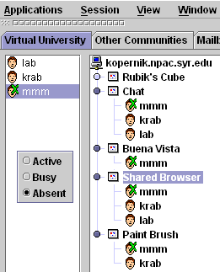

Glossary of Systems and Concepts used in WebWisdomNT

Asynchronous: A self paced learning model

COM: Distributed Object Model from Microsoft used in internals of Windows, Word etc.
Component_DOM: Label of an HTML component internal to a page
CORBA: Distributed Object Model from the OMG (Object Management Group) – an industry consortium
DEO: Distributed Educational Object using any approach of the Pragmatic Object Web
DOM: Document Object Model – usually that developed by the Web Consortium W3C
Dynamic HTML (DHTML): Technology supported by Netscape and Microsoft browsers with version 4 and higher. It enables pages to be built in layers from multiple components that can be separately repositioned and changed in both contents, order in layer and if necessary hidden
FoilWorld: A hierarchical collection of Curricula pages displayed by WebWisdomNT and stored either on a web site or in the WebWisdomDB database.
IMS: Instructional Management System from Educause aimed at setting Internet learning standards and supplying reference implementations. (http://www.imsproject.org )
Java: The dominant web computing language and an important distributed object model
LecCorder: WebWisdom.com packaged product to allow convenient audio and video recording of lectures with web display in high or low resolution form. (http://www.leccorder.com)
Page focus: Part of Page receiving current attention either because the pointer is there or the user performed some action such as clicking a button
Page_URL: Web label for a WebWisdom Page.
PAPI: Personnel and Performance data being standardized by IEEE P1484 activity. Supported by the WebWisdom Course Server
Pragmatic Object Web: A concept developed at Syracuse University, which captures the coexistence of multiple object models with different characteristics
SessionWeb: The collection of Internet material used in a single learning session such as a lecture.

Synchronous: A learning model where information is shared in real time between students, mentors and teachers

Tango Bean: A WebWisdom.com technology that allows automatic sharing of Java DEO’s that are built according to the popular Javabean design frameworks
TangoInteractive: A WebWisdom.com technology supporting sharing of general DEO’s with a Java, C++ and JavaScript interface. TangoInteractive is packaged with a myriad of basic shared tools such as chat, whiteboard etc.

WebCT: A popular authoring tool for courses featuring a rich set of options such as glossaries and quizzes.
WebWisdom.com: A small business located in Syracuse New York with leading edge multimedia, collaboration and distance education products.
WebWisdom Active Object: A technology developed by WebWisdom.com to enable the sharing of Java applets placed in Web pages. It combines the Java and JavaScript interfaces of TangoInteractive
WebWisdom Course Server: An Oracle or equivalent database supporting day to day operation of a course including student registration, homework submission and grading, and surveys.
WebWisdomDB: A modern web-linked database optimized for storing educational objects DEO’s
WebWisdomDB Manager: A Java administrative interface to the WebWisdomDB database.
WebWisdom DEO: A Distributed Educational Object DEO that is either a WebWisdom Page or a component thereof.
WebWisdom DynamicViewer: The integration of TangoInteractive with a dynamic HTML browser pages to provide a powerful interface to shared curricula material. The WebWisdom DynamicViewer can also be used independently of TangoInteractive in asynchronous learning modes.
WebWisdom DynamicFilter Converter: A Java technology developed by WebWisdom.com that implements batch filters adding dynamic HTML to permanently modify and enhance the curricula value of simple Web Pages including those exported from Microsoft PowerPoint.
WebWisdom DynamicFilter Server: A Java Servlet technology developed by WebWisdom.com that implements a dynamic server approach to filters adding dynamic HTML to enhance the curricula value of simple Web Pages including those exported from Microsoft PowerPoint.
WebWisdom Integrated Mail: This supports threaded discussion lists and mail, which is fully integrated with conventional mail systems, listservs and mail sent from TangoInteractive sessions. As each mail item can be accessed by a URL, one can link audio-video recordings of discussions connected to resource. Dynamic HTML or Java interfaces allow administrators to arrange material into topics.
WebWisdomNT: An integrated distance education system supporting both asynchronous and synchronous learning models. WebWisdomNT includes the TangoInteractive collaboration system for sharing objects and interacting between teacher and students. This is combined with the WebWisdom DynamicViewer client and can accept either conventional web pages or those enhanced with the WebWisdom DynamicFilter Converter/Server. Large users will put curriculum in the WebWisdomDB database with WebWisdomDB Manager and WebWisdomNT provides web linkage through the WebWisdom XMLTemplate Server.
(Enhanced) WebWisdom Page: Material viewed by teacher or learner on a computer screen as part of a WebWisdomNT Session. Note this includes any pages taken from the World Wide Web or that statically or dynamically modified by a WebWisdom DynamicFilter Converter or Server. It also includes pages generated dynamically from the WebWisdomDB XMLTemplate Server front ending a WebWisdomDB database. Enhanced WebWisdom Pages include support for dynamic HTML to represent cursor, notes, quizzes, glossaries, thumbnails (for review and preview) as well as event handling to improve TangoInteractive's monitoring of network performance and notification of problems in synchronous delivery.
WebWisdom TangoInteractive Executive: The JavaScript code that links WebWisdom browser pages (using WebWisdom Dynamic Viewer) to the TangoInteractive collaboration system for an interactive session.
WebWisdom XML Template Server: The Java server combining the WebWisdomDB database and XML templates to enable display of curricula stored in the database in Web browsers.
World Wide Web: All the material (Pages) stored on the Web
XML: A powerful new technology from W3C that enables custom tags to be developed that can capture the structure of general content.

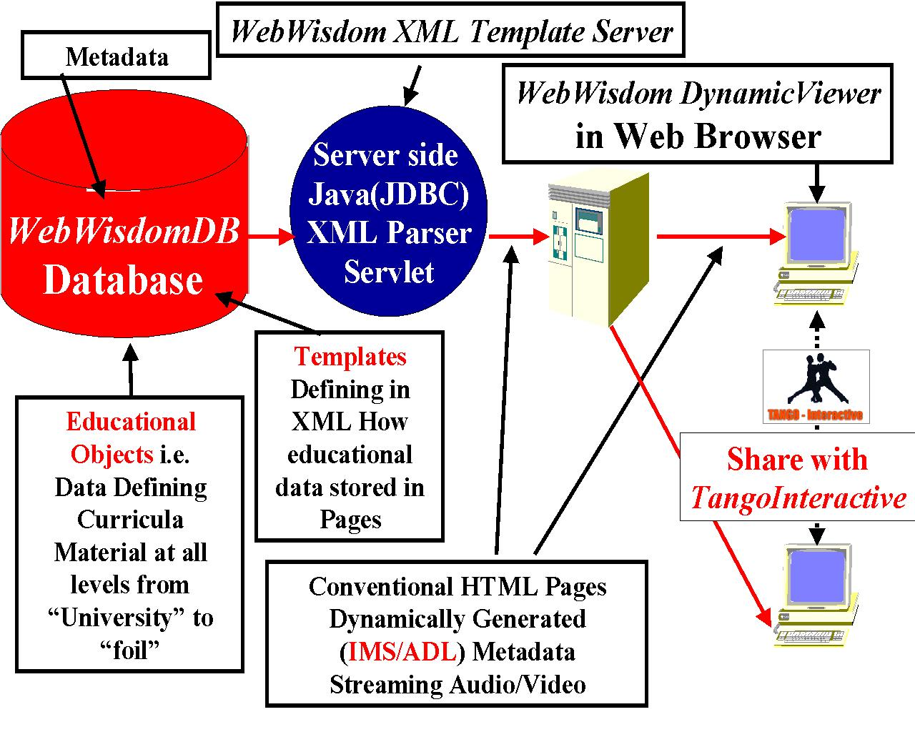
Architecture of WebWisdomDB
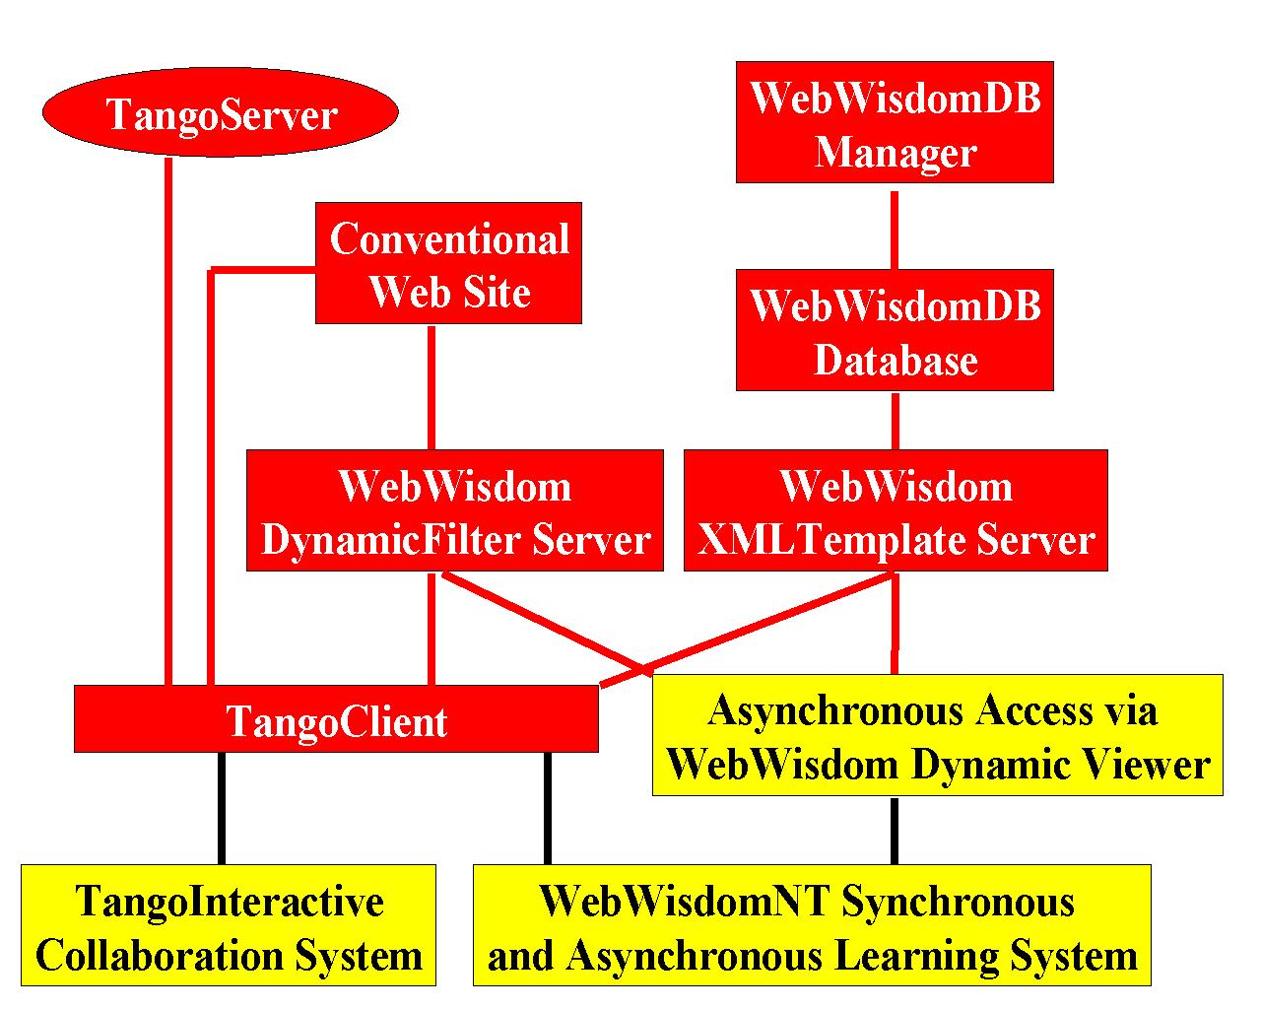

Components of the WebWisdomNT System

