April 26, 2001
High Performance Technologies Inc.
4121 Wilson Blvd., Suite 200
Arlington, Virginia 22203-1839

Tommy G. Thomas
General Services Administration
Federal Technologies Center
Information Technology Acquisition Center
GSA-FTS-ITAC-SDC
401 W. Peachtree St., STE 2700
Atlanta, GA 30308

Dear Mr. Thomas:

Enclosed is our written discussion addressing the deficiencies in our proposal in response to your Solicitation 4TS-TT-01-0001.

This discussion presents our technical approach and management plan for XML schema/usage, training and elaborates on the description of personnel skill levels we presented on page 28 of our original technical proposal.

We also submit for your reference an updated proposal to include clarification directly relevant to these questions. All updates in the revised proposal are in blue font and marked on the left with change bars. The updated sections and the associated topics are as follows:

XML: Sections 1.3.1, 1.4.1, 2.1.3
Training: Sections 1.8, 2.1.5, 2.1.6, 2.1.7 , Figure 8
Personnel: Sections 2.0, 2.4

These amendments do not change the cost of our proposal, as we had already planned to address these issues. Our original cost submission and our updated technical proposal represent our best and final proposal.

Sincerely,

Brad Beil
Solicitation 4TS-TT-01-0001 Page 6, Concept of Operation states “Figure 2 IEDA would interface using XML defined data definitions with existing and possible new local data repositories at each site. The contractor would be responsible for producing the XML specification in consultation with HPCMP management. The contractor would define basic mechanisms using industry standards for the IEDA to interface with either XML flat files or with conventional databases including Oracle and MS Access”

Extensible Markup Language (XML) will provide the foundation for all data interchanges amongst the various IE components and tools. All data interfaces will supported by this standard, and will be the recommended format for interoperability between the various site formats. We will develop XML specifications in coordination with the HPCMP and SRC staff. A resulting a set of (Document Type Definitions) DTD will be established to define a standard for data exchange between the various formats at each participating IE site and for communication amongst the IE tools. The data collection and export tools will use these schemas to define the IE stored data format. There will also be metadata specifications that will allow the data collection tool to utilize XML parsers to convert data between these IE standard data repository formats and the existing legacy data at each site, thus accounting for any discrepancies in data format and storage application. Additionally, this will provide an extremely flexible system for converting data between formats such as CSV, XML, and database tables. Additional formats could be easily implemented by merely using the IE DTDs to provide a definition for data conversion. Initial data conversion formats will be provided for conversion between XML, CSV, and ODBC.

Requirement #55 of the Statement of Work states, “The contractor shall provide installation, usage and maintenance training for a specified period of time.

Installation, usage and maintenance training will be provided to IE systems and tools users based on their roles and responsibilities. These roles essentially fall into four categories: SRC Site Administrator, S/AAA, HPC Management/Staff, and HPC User. We will deliver the training via several methods to include, one-on-one hands-on training, classroom seminars, multimedia, and online interactive help systems.

The IE tools will be developed using the best in usability engineering processes, and will be composed of intuitive interfaces. Users can choose to self-train via the available an on-line interactive help system that will be context based; the viewer will see the appropriate help information available for that tool and for the specific screen from which they launch help. Additionally, IE training material consisting of videos and supplementary seminar course notes will be posted on selected SRC web sites. This will serve as reference material for new IE users that have not or choose not to attend classroom training and also serves as refreshers for previously trained users.

To optimize the number of attendees in the IE classroom training sessions and to minimize the cost of travel, training sessions will be scheduled to coincide as appropriate with S/AAA, DC and MSRC Center Directors meetings as well as the annual DoD HPCMP Users Group meetings. Additional classroom seminars on IE tools usage will also be given at an SRC during their beta and final release installation. This will be convenient for on-site users as well as the SRC staff. All classroom training will be completed by 12 months from date of contract award. Table A. provides a synopsis of types of training, attendees and schedule. Figure A is a revision of our proposal’s Figure 8: Task Plan Schematic to include our training plans.
Table A: Training Matrix
Attendees | Type | Objective | Method | Schedule
SRC Site  Administrators | Installation | - Understand architecture and configuration of the IE system and tools  - Tailor to specific site policies and requirements | - Hands-on training during installation and deployment of beta and final release | - Conducted while HPTi team is on-site for installation and deployment  - HPTi team will work together with SRC site administrators
SRC Site  Administrators | Maintenance | - Monitor and maintain system | - Hands-on training during installation and deployment of beta and final release | - Conducted while HPTi team is on-site for installation and deployment  - HPTi team will work together with SRC site administrators
SRC Site Administrators and SRC Staff | Usage | - Use and understanding of Tools 1-5 to enable support to all users of IE application tools | - Classroom seminar  - On-line help  - Video and course material archived on selected SRC Web sites | - Classroom seminar offered while HPTi team at SRC for installation and deployment – minimizes cost on travel
SRC Managers  HPCMO | Usage | - Use of Tools 1,2,5 | - Classroom seminar  - On-line help  - Video and course material archived on selected SRC Web sites | - Scheduled to coincide with MSRC & DC center directors meetings
S/AAA | Usage | - Use of Tools 1,2,3,5 | - Classroom seminar  - On-line help  - Video and course material archived on selected SRC Web sites | - Scheduled to coincide with S/AAA meetings  - DoD HPC UG
HPC Users | Usage | - Use of Tools 1,2,4 | - Classroom seminar  - On-line help  - Video and course material archived on selected SRC Web sites | - DoD HPC UG  - While HPTi team at SRC for installation and deployment

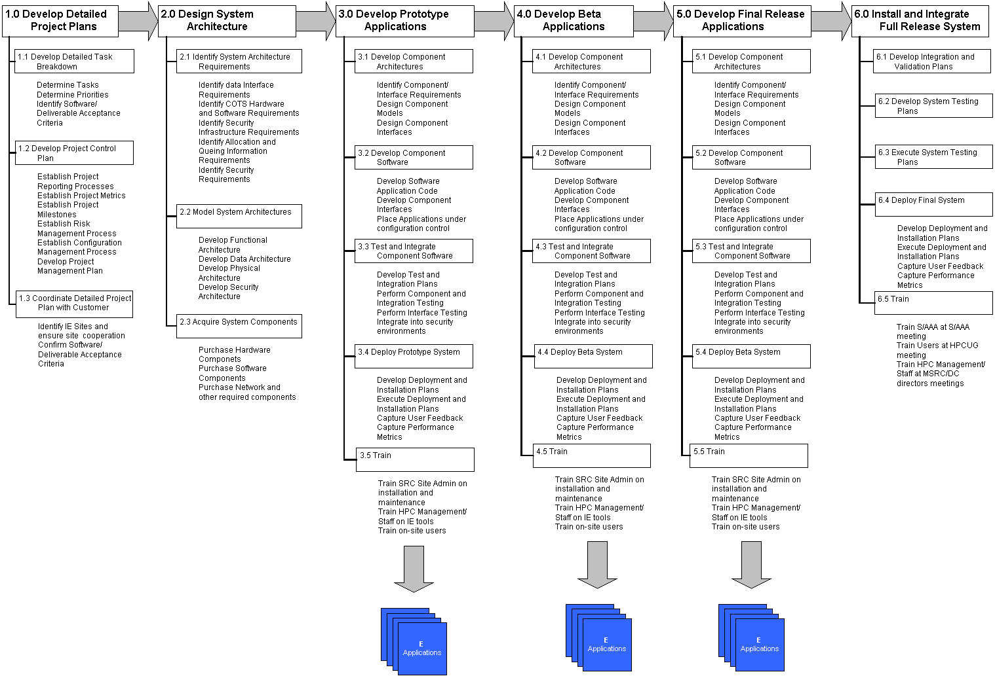
Figure A. Revised Task Plan Schematic
Section L-8 (7) II(c) requires your approach/methodology used to match personnel skills to roles and responsibilities.

HPTi’s approach to determine skills required to meet the SOW requirements and to determine the number and kinds of people needed to meet those requirements is five step process.

- Decompose the IE SOW to understand WHAT needs to be accomplished to meet the SOW requirements
- Develop Task Plan Schematic to understand HOW to accomplish those requirements. Refer to Figure 8 in our proposal
- Analyze the Task Plan Schematic and resources to derive WHO will be working on the project. Determine the skill sets required to accomplish the tasks
- Develop a Work Plan and Schedule to determine WHEN and HOW MUCH. Identify the milestones and deliverables, based on this information determine how many of each type of person and the necessary skill level required to accomplish the SOW goals.
- Review the Work Plan – Schedule – Personnel mapping and adjust accordingly to produce a final organization.

Figure B. depicts our methodology in developing a mapping to skill sets and roles/responsibilities required for this proposal.

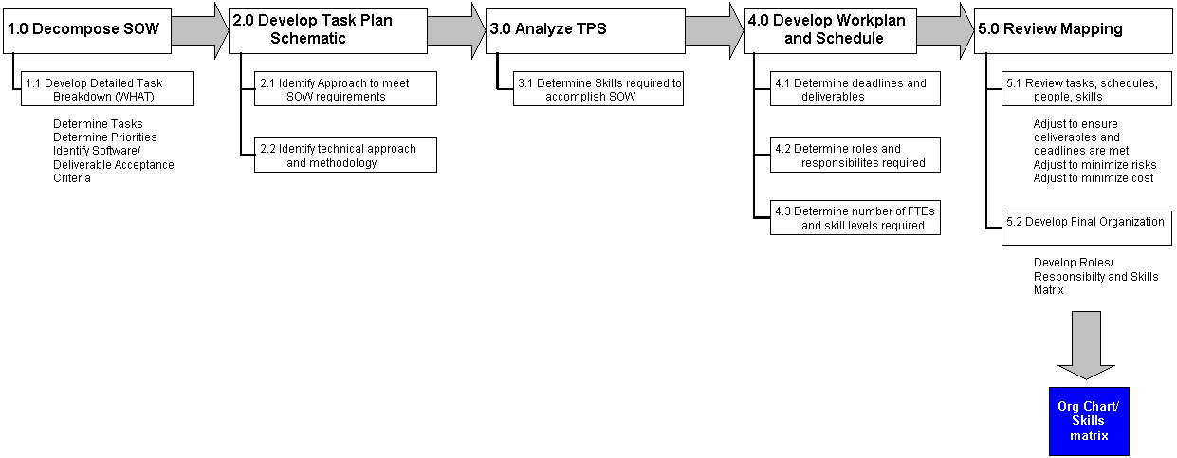
Figure B. Personnel Selection Methodology

Additionally Table B describes the roles and responsibilities of team members of our organization found in chart in Figure 7 of our proposal.
Table B. Personnel Responsibility and Skills Matrix
Position Title | Responsibilities | Skill Level
Program Manager | - Primary POC with Govt IE representatives  - Overall responsibility for this project  - Supervises operations, develop procedures, plans/ directs execution of the IE project from development through integration and to deployment  - Works with Govt IE representatives to develop overall schedule for IE deployment and training to the SRCs. Manages IE team to that schedule.  - Manages and controls financial and administrative aspects of all deliverables and milestones.  - Acquires prototype system components. | - Minimum of ten years IT experience.  - Experience includes increasing responsibilities in information systems design and management.  - A BA in business management from an accredited college or university
Technical Director | - Primary POC with Govt IE representatives on technical issues.  - Works and coordinates technical issues with both the integration/deployment team and the development team  - Designs the IE systems architecture requirements to include the software, hardware, and communications to support the total requirements as well as provide for present and future requirements and interfaces.  - As required, technical director with expertise in security will be available for consultation and technical oversight on IE security issues. Will work closely with the network specialist.  - Reports to Program Manager | - Experience with the logical and physical functional, operational, and technical architecture of large and complex distributed information systems  - Experience in database and web architectures to include the software, hardware, and communications.  - Expertise in database systems such as VLDB, Oracle, Access and/or Informix  - Programming experience: Perl, Java, HTML, SQL, XML  - OS experience to include: Unix, Windows  - Minimum of seven years experience.  - MS in Comp Sci, Information Systems, Engineering, or related technical discipline or BA degree and nine years of general experience is required  - Security Tech Director: security experience for complex distributed computing systems  - Expertise in Kerberos, PKI, SSL
Task Leader | - Provides overall day-to-day coordination and execution of the IE integration and deployment tasks.  - Regularly interfaces with the integration and database engineers.  - Makes recommendations on staffing of deliverables.  - Develops test standards for IE systems perfomance  - Point of contact for the SRC staff at the administration and operational level.  - Ensures strong communications between the SRC staff and the integration and deployment teams.  - Prepares status reporting.  - Develops IE documentation and training material  - Reports to Program Manager | - Six years experience consisting of management experience with respect to technical program/projects; minimum three years of experience as a team leader investigating large and complex problems, and making sound recommendations relevant to computing, quality control, analysis, and testing systems in a government contracting environment.  - Experience in managing and reporting baseline project schedules, managing resources, providing estimates along with budget and contract management.  - BS in Computer Science, Information Systems, Engineering, or related scientific discipline.
Network Specialist | - Oversees all security matters.  - Provides recommendations as to security issues in the IE architecture and on applications level security.  - Monitors, trains and supports other SRC staff in monitoring for unauthorized access into IE related systems  - Develops policies and procedures to prevent unauthorized use IE systems and databases  - Develops IE documentation and training material as related to security issues. | - Minimum of three years experience working with network technology.  - Knowledge of network fundamentals, computer security and intrusion detection required  - Basic knowledge of cryptography.  - Masters Degree in Electrical Engineering, Computer Science or Mathematics or other related discipline, or Bachelors Degree plus 3 years related experience
Integration Engineer | - Assists task lead in developing test standards for IE systems performance and reliability. Implements test programs  - Coordinates and works with SRC staff to identify and solve integration issues.  - Works closely with SRC staff in the installation and testing of IE components with the existing SRC resources.  - Provides hands on training to SRC systems administration staff on the IE tools during beta and final installation  - Write reports on both testing compliance areas.  - Develops IE documentation and training material  - Provide IE training | - Minimum two years of directly related information technology experience.  - Proven ability to apply performance and technical standards to assure compliance with project requirements  - Knowledge of the design, operational use, and functional characteristics of standards-compliant information and/or communication systems, experience in network analysis, design and integration, a broad knowledge of quality assurance standards and testing strategies.  - Experience in training user applications  - Systems Administration experience to include: Irix, Solaris, Windows, NT  - A Bachelors Degree in Engineering or a related discipline and two years experience,
Database Engineer  (Integrations and Deployment Team) | - Assists task lead in developing test standards for IE applications as related to IE databases. Assists integration engineer to implement test programs.  - Together with integration engineer , coordinates and works with SRC staff to identify and solve integration issues as related to IE database architecture and systems.  - Works closely with SRC staff in the installation and testing of IE components with the existing SRC resources.  - Provides hands on training to SRC systems administration staff on the IE database during beta and final installation  - Write reports on both testing compliance areas.  - Develops IE documentation and training material | - Experience includes: designing, developing and administering database systems to include web applications for information retrieval and analysis; developing database schemas for data and metadata management; API-level database programming  - Expertise with database systems such as Oracle, and Access  - Programming experience with Perl, Java, HTML, SQL, XML  - OS experience to include: Unix, Windows  - Bachelor's degree in Computer Science, Information Systems, Engineering, or related technical discipline
Database Engineer  (Software Development Team) | - Works with the technical director in the conceptual design/redesign of the IE database systems.  - Develops the database systems from design, through prototype, beta and final release.  - Ensures IE systems conforms with IE policy, procedures, standards and guidelines.  - Works closely with Integration/Deployment database engineer on early stages of deployment to ensure smooth transition from development to deployment. | - Experience includes: designing, developing and administering database systems to include web applications for information retrieval and analysis; developing database schemas for data and metadata management; API-level database programming  - Expertise with database systems such as Oracle, and Access  - Programming experience with Perl, Java, HTML, SQL, XML  - OS experience to include: Unix, Windows, NT  - Bachelor's degree in Computer Science, Information Systems, Engineering, or related technical discipline
NASCE Team Lead | - Reports to the HPTi Program manager.  - The overall team lead for the IE software development team at NASCE.  - Works closely with the HPTi program manager and the integration and deployment team task leader to ensure timely and smooth transition between development and deployment of the IE tools and database applications.  - Supervises the software development project by management procedures, plans and directs execution of the technical effort, and monitors and reports progress. | - Minimum 6 years experience in software development management and supervisory experience including performance with respect to engineering program/projects  - Experience includes leadership in investigating large and complex problems, and making sound recommendations relevant to computing, quality control, analysis, and testing systems.  - Master's degree in Computer Science, Information Systems, Engineering, or other related scientific
Sr Systems Programmer | - Develops conceptual design/redesign of the IE applications tools.  - Develops the IE application tools from design, through prototype, beta and final release.  - Ensures IE applications tools in conforms with IE policy, procedures, standards and guidelines  - Works closely with network specialist to design and implement security mechanisms in IE software.  - Works with the Usability Engineer to design the user interfaces as required.  - Works closely with Integration engineer on early stages of deployment to ensure smooth transition from development to deployment. | - Experience as an applications programmer on information management systems, knowledge of computing hardware for high-availability database systems and ability to develop complex software to satisfy design objectives.  - Design and implementation of web-to-database applications in a secure environment.  - Minimum of six years experience to include but not limited to JAVA, C++, C, HTML, XML etc.  - A Bachelor's degree in CS, IS, Engineering, or other related technical discipline
Systems Programmer | - Works with and assists Sr. Systems Engineer  - Develops the IE application tools from design, works through from prototype, beta and final release.  - Ensures IE applications tools in conforms with IE policy, procedures, standards and guidelines  - Works with the Usability Engineer to resign the user interfaces as required.  - Works closely with Integration engineer on early stages of deployment to ensure smooth transition from development to deployment. | - Experience as an applications programmer on information management systems, knowledge of computer equipment and ability to develop complex software to satisfy design objectives; implementation of components of complex, heterogeneous solutions in client-server networking; software solutions for web-to-database applications in a secure environment  - Minimum of four years experience to include but not limited to JAVA, C++, C, HTML, XML etc.  - A Bachelor's degree in CS, IS, Engineering, or other related technical discipline
Usability Engineer | - Works with representative users (selected in coordination with the Govt IE representatives) to elicit they way they want tool interfaces.  - Develop initial interface requirements and prototype interface.  - Work closely with Systems programming team to ensure interfaces meet user requirements  - Performs usability test of all IEDA tools.  - Interfaces with representative users to gather and analyze feedback during prototype and beta deployment. Feedback will be implemented in next release.  - Assists with developing training materials | - Design and implementation of web-based user interfaces, elicitation of user requirements, development of specifications from user requirements, and rapid prototyping of user interfaces from specifications  - Minimum of five years experience.  - Bachelor's degree in Computer Science, Information Systems, Engineering, Business Management Scientist, or other related scientific or technical discipline

