Grid Computing Environments Community Practice (CP) Document

Project Title: Mississippi Computational Web Portal
CP Document Contact: (include email): Tomasz Haupt (haupt@erc.msstate.edu)

Project Participants: (include emails): Tomasz Haupt (haupt@erc.msstate.edu), Purushotham Bangalore (puri@erc.msstate.edu), Gregory Henley (henley@erc.msstate.edu), Sheikh Ghafoor (ghafoor@erc.msstate.edu)
Project URL(s): http://www.erc.msstate.edu/labs/mssl/mcwp/index.html

1. Overview - including:

A. Description & Goals

Mississippi Computational Web Portal is a web-based Problem Solving Environment or a Simulation Environment where the user can state complex multistep problems, allocate all resources needed to solve them, and analyze results. The definitions of problems, methods of solving them, and their solutions are persistently stored; consequently they can be viewed and reused at later time, can be shared between researchers and engineers, and can be transitioned for operational or educational use. The portal environment extends the user desktop by providing seamless access to remote computational resources (hardware, software, and data) and hides from the user complexity of heterogeneous, distributed, high performance back end.

- Services provided

  - Authentication and Authorization
  - Remote Job Submission
  - Remote File Transfer
  - Composition of Multistep tasks
  - Superscheduling
  - Distributed Visualizations
  - Dissemination of Results
  - Persistency of Tasks and their Configurations
  - Sharing of Tasks

- Systems/Sites/User Served

  - Distributed Marine Environment Forecast System (Office of Naval Reseach)
  - Distributed Simulation Framework of Seismic Performance of Urban Areas (NSF)

- Status

Under development. Demonstrations scheduled for Spring 2001.

- Other

2. Architecture

The Mississippi Computational Web Portal is implemented as a multitier system. Web Browser based front-end allows for visual composition of complex computational tasks and transition them into operational use, as well as for analysis of the results. The middle-tier is split into Java Server Pages based Web tier responsible for request processing and dynamic generation of responses, and Enterprise Java Beans based application server. The EJB container is populated by a hierarchy of entity beans representing the state of the system or acting as proxies of services rendered by the back end. Operations on the entity beans are implemented as session beans. This design makes it possible to separate user requests (in terms of application independent task specification) from the back end resource allocation (through platform independent resource specification). The middle-tier provides a transparent mapping between task and resource specification, hiding complexity of the heterogeneous back-end system from the user.

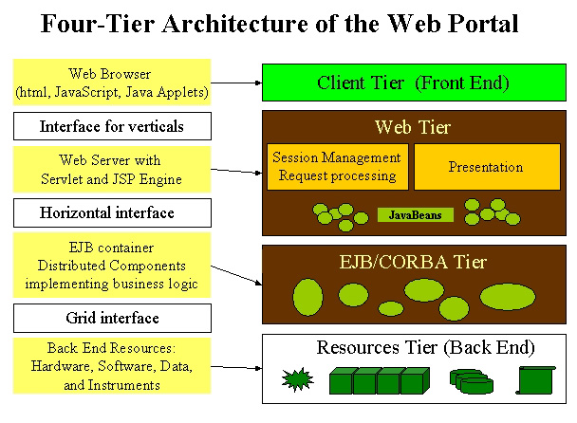

- Define Grid software/services that the GCE currently depends upon and relationship to GF Working Group.
  - Currently the back-end system comprises a single security domain. It is accessed by either combination of SSL and SSH or Kerberos (client-middle tier using kerberized CORBA and “personal client-side mini-server)
- Define Grid software/services that the GCE plans to make use of
  - Security (as soon as the Grid certificates can be imported to browsers)
  - Remote job submission (to take advantage of the Grid Security Services)
  - Data transfer
  - Information services
  - Resource discovery
- Define Grid software/services that are needed by the GCE but are not supported by the Grid
  - Event Services
  - Access to Remote File Systems
  - Access to Mass Storages
  - Access to Databases
- Define software/services used/needed by the GCE that are outside the scope the Grid
  - Support for user sessions
  - Persistent representation of user tasks, and superscheduling of those
  - Client side “personal server” that allows seamless integration of the desktop resources with the grid (or used for a secure communication with the middle tier)
  - Support for generating vertical portal applications (“presentation layer”)
  - Support for remote visualizations (taking advantage of desktop capabilities)
  - Support for model coupling
- Other

3. Implementation

- Commodity technologies/software used (e.g., EJB, JMS, JINI, Perl, XML, databases..)
  - Java 2 Platform Enterprise Edition
  - Enterprise JavaBeans (middle-tier application server) (Sun’s J2EE server and Orion)
  - Java ServerPages (presentation layer) (Sun’s J2EE server and Orion)
  - CORBA (Orbacus from Object Oriented Designs)
  - ORBAsec 2 (Kerberos-based CORBA security services for Orbacus ORB)
  - XML/XSL
- Proprietary technologies/software developed that can be shared with others
  - Definitions of complex (multistep) computational task

A. Other

4. Supported Grid Services

See 2A above

5. Project Status and Future Plans

See 1D above

6. References

http://www.erc.msstate.edu/labs/mssl/mcwp/index.html

