INSTRUCTIONS:
- Prepare document using Times Roman, 10 point font.
- Submit document in MS Word or PDF format
- Complete each of the indicated sections (so that all docs are uniform). Each section has a sub-section entitled “Other” where you can insert information that our CP template did not cover.

Grid Computing Environments Community Practice (CP) Document

Project Title: The Cactus Code: A Problem Solving Environment for the Grid
CP Document Contact: (include email): lanfer@aei.mpg.de

Project Participants: (include emails): cactus@cactuscode.org
Project URL(s): http://www.cactuscode.org

1. Overview - including:

- Description & Goals
Cactus is an open source problem solving environment designed for scientist and engineers. The code originated in the academic research community where it has been developed and used over many years. The name Cactus comes from the design of a central core (or flesh) which connects to application modules (the thorns) through an extensible interface.
- Services provided
The modular structure of the Cactus Code facilitates parallel computations across different architectures and collaborative code development between different groups. Through its modular design it allows scientist to take easy advantage of Grid computing by writing their applications within the Cactus framework.
Cactus runs on many architectures, applications developed on standard workstations can be seamlessly run on clusters or supercomputers. Parallelism and portability is achieved by hiding the parallel driver layer and features such as IO system under a simple abstraction API.
- Systems/Sites/User Served
Cactus runs on all major supercomputing architectures and operating systems. The default communication layer for Cactus uses MPI and so can make use of the Globus MPICH-G implementation (compiling with MPICH-G is a standard compilation option). The modular design of Cactus makes it possible to write and use alternative communication layers using e.g. OpenMP, PVM etc.
- Status
The Cactus Code is fully operational, it can be downloaded at www.cactuscode.org

2. Architecture

- Define Grid software/services that the GCE currently depends upon and relationship to GF Working Group
- The Cactus Code can be used in conjunction with Globus MPI to allow distributed computations across remote sets of computers as the simulation is distributed over tightly coupled supercomputers.
- A Cactus Portal enables users to access their remote resources with a single authentication; they assemble and compile Cactus, submit batch jobs, monitor and visualize simulations. The Portal provides a collaborative archive for simulation and machine details. The Portal uses Globus tools, GSI authentification, Java COG, the GDPK and JSP.
- The Grid Application Toolkit (GAT) is in a design stage and will be employed to make use of a wide spectrum grid services, e.g. contacting available information services, resource brokers, resource contract services.
- The Cactus worm allows the migration of a simulation from site to site based on resource information obtained from the user, the simulation itself and resource brokers. Site authentication is performed with Globus.
B. Define Grid software/services that the GCE plans to make use of
It is intended to extend the usage of the above mentioned Globus features.
C. Define Grid software/services that are needed by the GCE but are not supported by the Grid
Sophisticated resource broker and resource scheduling systems would be very beneficial for the advancement of this application framework in a dynamic grid environment, where resource become available and go off-line with unpredictable timings.
- Define software/services used/needed by the GCE that are outside the scope the Grid
- Other

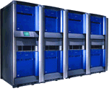
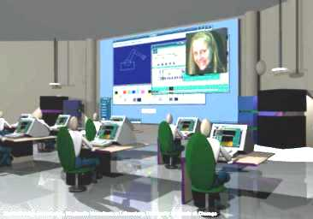
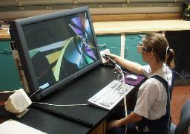

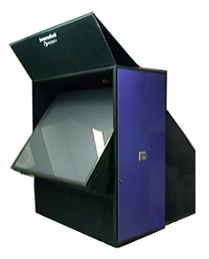

Origin2000: NCSA
Hitachi SR8000: Garching
Simulations launched from Cactus Portal
Grid enabled Cactus runs on distributed machines
Remote Viz and steering from Berlin
DataGrid/DPSS
Downsampling
Globus
Serving and Receiving http

HDF5 Data
IsoSurfaces
Remote Viz in
St Louis
3. Implementation
Fig. 1: Grid enabled Cactus runs on distributed machines with interactive steering and visualization

A. Commodity technologies/software used (e.g., EJB, JMS, JINI, Perl, XML, databases...)
- The Cactus framework itself is written in C and Perl. Users can write their modules in C, C++, F77, F90. We have plans to include support for Perl, Java and Python.
- The current communication layer of Cactus supports any implementation of the MPI standard, including MPICH, native MPI or the Glous MPI-G.
- Cactus high-performance IO methods can be chosen from FlexIO or HDF5.
B. Proprietary technologies/software developed that can be shared with others
- Several visualization clients (OpenDX, Amira) exist to visualize HDF5 data.
- The HDF5 virtual file driver, which is incorporated in the new HDF5 release, has been developed as part of the Cactus streaming technology.
C. Other

4. Supported Grid Services

A. Security: Globus based authentication
B. Information services: a running Cactus application can be become its own information server. The application generates HTML code that contains information on the current state of the simulation and simple visualizations. The information can be accessed by pointing a web browser at the hostname:port where the simulation is running. The code can also be steered through the web browser: the user can modify certain aspects of a running simulation as increasing output frequency, add variables to be outputted, etc.
C. Scheduling
- Data transfer
- Cactus provides sophisticated parallel IO based on HDF5. The code generates architecture independent checkpoint files, which can be used to restart a simulation on a machine configuration other than the previous one. The machine configuration can differ in machine architecture, operation system and number of processors.
- Cactus can stream data of the network by using the virtual file driver capabilities of HDF5. A simulation written within the Cactus framework can be interactively monitored by streaming either raw data or prepared data like isosurfaces to a remotely running visualization client.
- Additional Grid services
- Other

5. Project Status and Future Plans
The Cactus Code can be downloaded at www.cactuscode.org and is fully operational. It is used by researches in different numerical disciplines.
We intend to use the Cactus framework as the foundation to provide sophisticated grid services to the scientists and engineers. The Cactus Code modularity allows us to do this on a level of abstraction, where the average scientist can concentrate on the research and does not have to be concerned about the pitfalls of grid computing.

- References
Cactus Code Sources and Tools to download:
- www.cactuscode.org
Publications, Presentations and Tutorials can be found at : http://www.cactuscode.org/Showcase/Publications.html
- Allen, Goodale, Lanfermann, Seidel, Benger, Hege, Masso, Radke and Shalf:
Solving Einstein’s Equations on Supercomputers, IEEE Computer, December 1999
http://www.cactuscode.org/Papers/IEEE_1999.pdf
- The Cactus Code, A Problem Solving Environment for the Grid, Proceedings of the Ninth IEEE International Symposium on High Performance Distributed Computing (HPDC9), Pittsburgh http://www.cactuscode.org/Papers/HPDC9_2000.ps.gz
- Cactus Grid Computing: Review of Current Development, Conference on Parallel Computing (Euro-Par) 2001, Manchester
http://www.cactuscode.org/Papers/Europar01.ps.gz
- Early Experiences with the Egrid Testbed, IEEE International Symposium on Cluster Computing and the Grid, Brisbane, Australia
http://www.cactuscode.org/Papers/CCGrid_2001.pdf.gz

