Grid Computing Environments Community Practice (CP) Document

Project Title: NPACI GridPort Toolkit and the HotPage
CP Document Contact: (include email): Mary Thomas (mthomas@sdsc.edu)

Project Participants: (include emails): Steve Mock (mock@sdsc.edu), Kurt Mueller (kurt@sdsc.edu), Jay Boisseau (boisseau@sdsc.edu)
Project URL(s): http://gridport.npaci.edu, http://hotpage.npaci.edu, http://genie.npaci.edu

INSTRUCTIONS:
- Prepare document using Times Roman, 10 point font.
- Submit document in MS Word or PDF format
- Complete each of the indicated sections (so that all docs are uniform). Each section has a sub-section entitled “Other” where you can insert information that our CP template did not cover.

1. Overview - including:

A. Description & Goals

The Grid Portal Toolkit (GridPort) enables the rapid development of web portals on computational grids. GridPort leverages both commodity technologies and metacomputing, or grid, software (Globus, Network Weather Service, etc.) to provide secure methods for manipulating files and data, submitting jobs, and managing allocations on all grid resources for which a user has privileges.
The NPACI HotPage is a user portal built using the GridPort Toolkit that provides views of a distributed set of HPC resources as either an integrated meta-system, or as individual machines. GridPort is being used to provide the foundation for a new user portal: The NPACI Genie Portal (GridPort Enabled Interactive Environment), formerly the HotPage. These web pages run on any web browser, regardless of system or geographical location and are supported by secure, encrypted login sessions where authenticated users can access their HPC system accounts and perform basic computational tasks. Users can directly access multiple compute resources by logging in once. They have secure access to all of their accounts, files, and data, and all interactions are point-and-click in a web browser. This enables 'web-based supercomputing,' which greatly simplifies the scientific process of running simulations on diverse resources.
B. Services provided

- These web pages run on any web browser, regardless of system or geographical location.
- Security: encrypted login sessions via HTTPS/SSL and Globus GSI
  - Supports single login environment across all portals
- Portal Account system
  - provides basic personalization features
  - job tracking (limited)
  - personalization
  - Incorporating HPC resource account management features
- Authenticated users can access all the HPC systems at NPACI, NCSA, and NASA/IPG.
- Informational services allow any user to glance at portal and get machine status (load, node usage, up/down, etc.)
- Job Execution:
  - Users can perform basic computational tasks such as Unix commands,
  - Can submit, monitor, and cancel jobs in the batch queues.
  - Template batch script generator available for all HPC systems
- Files:
  - upload/download from local to host to remote HPC system
  - maintain portal file spaces for users
  - tar/untar, compress/uncompress
- User toolkit so they can build their own application portal.

C. Systems/Sites/User Served

- Systems Served: GridPort is deployed across all HPC and archival resources at NPACI, and many systems at NCSA, and NASA/IPG. This includes CRAYS, O2K’s, clusters, etc. Currently this number is over 20 active systems.
- Users Served: any user with an account on the systems connected into our network can run jobs on them, provided that their accounts are active.
  - User Portals - the PACI computational science community
  - Apps: LAPK is a group of MD’s, Gamess is computational chemists
  - Toolkit: we work with other scienctists to help them build their own web portals without having to run a full portal service.
- In addition to the HotPage and Genie User Portals, the GridPort Toolkit has also been used to develop a number of applications portals:
  - User Portals:
    - NPACI: https://hotpage.npaci.edu, https://genie.npaci.edu
    - PACI: https://hotpage.paci.org
    - NCSA: https://hotpage.ncsa.uiuc.edu
  - Application Portals:
    - https://gridport.npaci.edu/LAPK
    - https://gridport.npaci.edu/Gamess
    - https://gridport.npaci.edu/Telescience

D. Status

The GridPort Toolkit and the HotPage/Genie portals are in production, as are several application portals. The software is available via download, but it is very early beta.

E. Other

2. Architecture

In the GridPort model, we distinguish between 3 types of portals: the service portal, the user portal, and the application portal. The service portal is that part of the system that supports services such as authentication, account management, and job submission. Application portals are built to access the portal services via form actions calling CGI scripts. Thus, a user can build a portal but be required to be an expert in IT and Grid services.
There are informational services and interactive services provided by the HotPage user portal. The HotPage is designed to be a single point-of-access to compute resources. The layout of the page allows a user to view these resources from both the grid and individual machine perspectives, to quickly determine system-wide information like status (machines up/down, machine load, nodes/cycles available, etc.). This design provides a simple, fast, and direct access to HPC systems and general information about them, with a focus on getting users working on NPACI systems quickly.
The informational services provide a user-oriented interface to NPACI resources and services. They consist of on-line documentation, static informational pages, and links to events within NPACI, including basic user information such as documentation, training, and news. As part of the information services, there are user tools that provide real-time information for each machine, including: operational status and utilization of all resources; summaries of machine status, load, and batch queues; displays of currently executing and queued jobs; and graphical display of running applications mapped to nodes. The system for acquiring this data will be migrated to an LDAP/GIS model.
Interactive services are the secure transactions that provide users with direct access to the HPC compute resources and allows the user to perform many task that could be run on a Unix command line, including: command execution, including compiling and running programs; job submission and deletion; file and directory access; account and allocation management; and file transfer between the local workstation and the HPC resources. All secure transactions, including login, are accessed through a separate web server running services based on the GridPort Toolkit.
The GridPort Toolkit (version 1.0) consists of two modules. The web portal services module runs on a commercial web server, and provides authenticated connectivity to the grid that are used by client applications. The client interface tools provide a WWW interface that allows customized science portals development by end users, who need to have no knowledge of the underlying portal infrastructure. A key feature of the architecture is that the client application and the grid portal services can be run on separate web servers.
Because web interfaces are common, well understood, and pervasive, client portals based on the GridPort architecture are accessible wherever there is a web browser, no matter where the user is located.
On the web server, web pages are either stored as static HTML (with server-side includes), or built dynamically, using Perl scripts. User input information is obtained via form input elements, so CGI must be supported. Most of the back-end portal functionality is implemented in Perl5/CGI as well. In addition, Perl runs on most HPC systems, making it easier to develop a set of uniform, compatible, and portable scripts.
Both modules are based on commodity web technologies and existing grid services and applications such as Communicator and Internet Explorer (4.0 or greater), HTML/JavaScript Perl/CGI, SSH, FTP, GSI, Globus, etc. The choice of which grid technology to use is determined by a broker layer. Based on such simple technology, this user portal technology is easily ported to and used by other sites. In addition, the GridPort Toolkit does not require that additional services to be run on the HPC Systems.
By using the GridPort Toolkit, an application programmer can extend the set of basic functions provided by the HotPage. Thus, Users can also construct customized web pages and program directly to existing portal services, given a basic knowledge of HTML and/or Perl/CGI.

- Define Grid software/services that the GCE currently depends upon and relationship to GF Working Group.
  - Security: Globus GSI, Myproxy
  - Jobs: Currently run all jobs using Globus GRAM
  - Information Services: we have internal cron jobs, and are integrating GIS
- Define Grid software/services that the GCE plans to make use of
  - Files: The SDSC Storage Resource Broker
  - Jobs: Use Legion and Entropia virtual OS’s as allocated resources for users to submit jobs to.
  - GIS: planning to fully integrate the GIS/LDAP/XML infrastructure to publish not only resource information, but use this for publishing portal information
  - Metascheduling
- Define Grid software/services that are needed by the GCE but are not supported by the Grid
  - Portal-2-Portal commication needed at the back end layer
  - Safe cert/key repository
  - Grid Accounting/Meta accounts
- Define software/services used/needed by the GCE that are outside the scope the Grid
  - Security: need better mechanism for authentication other than Cookies.
  - Portal user account personalization – we use this to configure the portal for the user, track history, etc.
  - SDSC cert/key repository – our users do not want to keep certs/keys, so we store them in a locked down local filespace.
  - Data viewing: low level, we use the Perl Image module and a specialized visualization server to render low level, 2 d images of some data.
- Other

3. Implementation

A. Commodity technologies/software used (e.g., EJB, JMS, JINI, Perl, XML, databases): Netscape I-Planet server, Perl5, CGI, Javascript, HTML, SQL/Oracle, Globus, GSI, Globus/GIS, LDAP, csh scripts, cron jobs, databases,
- Proprietary technologies/software developed that can be shared with others:
  - The GridPort toolkit is available for those who would like to build a portal.
  - Portal Services can be accessed/used by application developers.

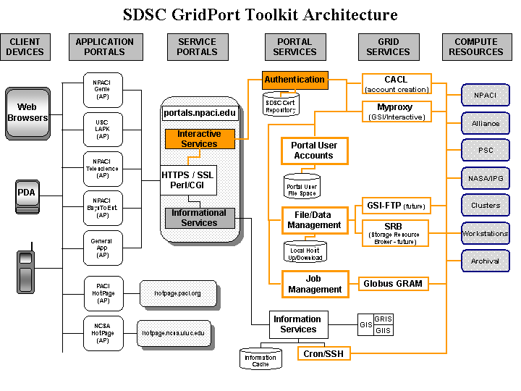

C. Other

4. Supported Grid Services

A. Security: Globus GSI, MyProxy
B. Information services: Globus GIS, GIIS, and GRIS
C. Scheduling: none
D. Data transfer: none, we do our own since GSI-FTP is not universally installed everywhere.
- Additional Grid services:
- Other

5. Project Status and Future Plans

- We are working on getting the new Genie user portal up and running, which will have extended services and user tools.
- SRB integration: we will be incorporating the use of the SRB (Storage Resource Broker) for all of our file and data storage, including portal user information, session and job tracking and history. We will start to build 2 large data portals with SRB in the back end. A portal user will be default get and SRB collection.
- Performance Improvement: The latencies associated with performing tasks via the Globus GRAM gatekeeper are enormous. We are working with the Globus team to develop a client-server model for portal users to remain connected to HPC systems at all times.
- GIS: we are working with the new GIS model, which has GSI built into it. But, we are still concerned about latencies associated with the existing MDS services.

6. References

