ECCE: Electronic Communities for Computing and Education

Geoffrey Fox
Florida State University
Computational Science and Information Technology
400 Dirac Science Library
Tallahassee FL 32306-4120
fox@csit.fsu.edu
- Introduction
This presentation describes the essential features of a framework called ECCE: named for Electronic Communities for Computing and Education. ECCE builds on two technologies - the Gateway computing environment and the still developing Garnet collaboration system. It is built in a modular fashion to enable multiple applications to re-use the same basic technology. Further the design recognizes that is very difficult for a University research group to build a complete system in this area; rather we build a modular system that uses other academic, government or commercial components where possible. ECCE uses commercial technology for the event system, instant messenger, and the shared display collaborative module and allows a choice of audio-video conferencing support. This approach allows one to build a sustainable high functionality system taking advantage of the latest technologies.
In the rest of this abstract, we describe first our strategic approach and goals; then we sketch some highlights of the technology used.

2. Strategy and Goals
We want to support the convenient interaction between multiple users (clients) and multiple resources, which form a grid or peer-to-peer (P2P) network. The resources are computers, networks, instruments, storage devices, and visualization systems for computing portals. They are curriculum pages, quizzes, homework, and registration systems for education. Both applications need information resources to provide the ever-increasing sea of knowledge in which either to learn or to do research. Information is divided by ECCE into two classes – structured and what we call the Gallimaufry below. For those familiar with Yahoo or Google, the structured information corresponds to a directory labeled by a thoughtful hierarchy of topics; the Gallimaufry is accessed the typical web search interface suitable for a hodgepodge of material. We build ECCE to support both classes of information using the W3C concept of a URI (Universal Resource Identifier) [35] to label all entities in the system. Note that a URI is just a general hierarchical label; it is does not have to be a web site. In fact the implicit hierarchy can be irrelevant; the URI could just be an ordered list of tags separated by a / symbol. We could for instance catalog all the computers in our organization using URI’s such as organization://things/computers/pc/2001/serialnumber. This objects would have properties attached it for which one would develop an XML schema – for computers, the schema would identify location, owner, manufacturer, CPU, memory, windows name, DNS name etc. Such metadata would typically (today) be specified in a XML file which is likely to have one or more web addresses – this is the URI for the metadata file – in general quite different from the URI of the object. The Grid Forum is developing such metadata for the computing case [17,23] while in the education and training arena, the IMS and ADL activities [14,15] have specified the structured information with the expected hierarchical arrangement. IMS and ADL cover curriculum modules and student related information. Objects like grades and curricula pages and object properties like prerequisites and completion requirements are specified. We assume that a similar approach will be adopted in all areas with the key objects identified and schema for their properties developed. Furthermore we see the universal use of URI’s allowing an integrated approach based on a core XML schema specifying a hierarchical structure with specialized properties for each field. This is accessed with a generalization such as XQUERY (to XML) [34] of standard database methodology with all data (including the unstructured Gallimaufry with URI’s but no systematic arrangement) allowing a Web search like interface. Note the resources in the Gallimaufry and structured information directory are all labeled by URI’s. We expect the URI to be a useful classifier for the structured information but not for the Gallimaufry. We have designed and partially implemented an XML Schema GXOS and operating environment MyXoS to support these ideas
Portals are built in terms of web access to services on objects and above we have discussed the underlying distributed object structure we will use. Note that we did not describe the particular model we will use – CORBA, COM, Java, SOAP – for this doesn’t seem to us critical. At the distributed object level one has services such as object lookup and registration, object persistence and database support, event and transaction services. Security and fault tolerance are key services needed by all portals. We expect the technology to be driven by commodity and commerce portals, which must also have an excellent Information service. Globus and other projects have already developed good security capabilities optimized for computing portals and we can use these solutions. Education systems could use either approaches like Globus or for some cases the less formal security models of P2P networks would be appropriate. Object sharing and the collaboration service is an area we are concentrating on, as this very important in both application areas. For education and training, the collaborators are teachers and students while for computing they are researchers or perhaps computationalists and consultants. We have already found here that formal scenarios such as class or science lectures or project reviews can be successfully supported for synchronous collaboration where shared objects (documents) are displayed at different sites and their view kept consistent. More dynamic scenarios such as brainstorming or office hours need improved technology. Our collaboration research has focused on resource sharing and we have taken other key technology such as audio-video, chat rooms, white boards etc. from other projects. We have also learnt that quality archiving of real-time session and the integration of synchronous and asynchronous collaboration is very important. Most activities use person to person interactions as an enhancement to asynchronous interactions mediated by e-mail and other non-instantaneous information exchange. There are other services, which tend to be application specific. For computing one can list accounting, job monitoring, file services (such as FTP), visualization, programming, application integration or composition, seamless access for job submission, and a parameter specification service (e.g. get data from web form into your Fortran program wrapped as backend object). Also the basic application independent services need special optimization; in the computing case, we need high performance in object access and inter-object data transfer; we need to support special characteristics of our field such as information services that support mathematics and scientific data. Technically this corresponds to support of MathML, HDF5 [31] and higher-level specifications such as XSIL [24] and those developed within DICE (ICE) project at ARL [32]. For education, special services include delivery of lectures, support of “office hours”, grading, homework submission, quizzes and assessment. These need to be sensitive to IMS and ADL standards, which specify the structure of many of the relevant objects (tests and quizzes, assessment, grading sheets etc). ECCE has been designed so that the base framework can support generic services like security and collaboration and so that one can add these other services and other object standards.
We have prototyped the use of hand-held devices in both education and scientific research and although these devices and their support is still immature, we see continued increase in the capability and use of these devices. Thus our portals must be designed so objects can be accessed from a wide variety of clients and further that such diverse clients can collaborate in the same session. This implies technically that we must separate object sharing from the rendering (display) of the object. This can be done with modern web systems where the object or information specification (application specific XML) is separated from its rendering (HTML, WML). This architecture allows natural support of universal access for users whatever their physical capabilities. Here we build on the ideas of the Trace Center from Wisconsin [37].

3. Technology Overview
Our approach has several key and novel features that have been designed to address issues coming from both previous research [1] and a detailed analysis [2] of major commercial tools in the collaboration and object management area. The collaboration service is formulated as the Garnet system, which uses an integrated distributed object framework, consistent with the discussion in sec. 2, to specify all the needed object properties including both their rendering and their collaborative features. Sharing a complex object is difficult and we believe that one must have a sophisticated base object model to be able to build a successful broadly applicable collaboration system. Thus it makes sense to build the requirements of collaboration into any portal system. Including rendering information in an object's description allows one to customize to different clients and so build collaborative environments where one shares the same object between hand-held and desktop devices. We assume that we are building our computing portal on a computational grid infrastructure and so we can layer our high level services on top of the capabilities under development by projects such as the NEES Grid [4] being developed for earthquake engineering and for experimental physics, the Particle Physics Data Grid [5] and GryPhyN [6]. Users, computers, software applications, sessions, and all forms of information (including experimental data, simulation results and recordings of audio/video conferences) are all objects, which can be accessed from ECCE. Education objects are built to be compatible with IMS and ADL standards as explored in Sen’s Syracuse PhD thesis [33]. This thesis was based on the course and grading support system (“The NPAC Grading System”) used to support all our distance education including that with Jackson State. ECCE objects will all be self-defining; namely they will make explicit all the necessary metadata to enable ECCE to perform needed functions such as searching, accessing, unpacking, rendering, sharing, specifying of parameters, and streaming data in and out of them. This metadata is defined using a carefully designed XML schema GXOS and exploiting the new RDF framework from W3C [19]. Typically ECCE only manipulates the meta-objects formed from this metadata so that we build a high functionality middleware that only performs control functions. The XML meta-objects used by ECCE are proxies that point to the location of the “real object” they define and can initiate computations and data transfers on these real objects. Objects can be identified by a URI and referenced with this in either RDF resource links (such as <rdf:description about="URI" .. ) or fields in the GXOS specification. The important URI's are the GXOS name such as gndi://gxosroot/jpl/gem/users/?, and the web location of either the meta-object or object itself. All objects in GXOS must have a unique name specified in a familiar (from file systems) hierarchical URI syntax.
ECCE software is largely written in Java (using Enterprise Javabeans in the middle tier) but Java/XML is only the execution object model of the meta-objects; one can load persistently stored meta-objects or control target “real objects” formed by flat files, CORBA, Microsoft .net (SOAP) or any distributed object system to which we can build a Java gateway. Our Gateway computational portal [1,3] has used this strategy already; here all object interfaces are defined in XML but CORBA access is generated dynamically. Further this system also only uses meta-objects in the middle tier and invokes programs and files using classic HPCC technology such as MPI. This strategy ensures we combine the advantages of highly functional commodity technologies and high performance HPCC technologies.

The Garnet collaboration service in ECCE uses the shared event model of collaboration where these events use the same base XML schema as the meta-objects describing the entities in the system. The uniform treatment of events and meta-objects enables us to use a simple universal persistency model gotten by a database client (shown in the figure to the left) subscribing as a client to all collaborative applications. Integration of synchronous and asynchronous collaboration is achieved by the use of the same publish/subscribe mechanism to support both modes. Hierarchical XML based topic objects matched to XML based subscribing profiles specified in RDF (Resource Description Framework from W3C) control this. Topics and profiles are also specified in GXOS and managed in the same way as meta-objects. These ideas imply new message and event services for the Grid, which must integrate events between applications and between clients and servers. This GMS (Grid Message service) is one major focus of our current computer science research. We will describe the work of Pallickara [18], which examines the architecture of server networks needed to support large P2P grids. The figure below shows a typical scenario with 22 servers supporting 2 clients separated by 4 hops and where 50% of the topic based matching is satisfied.
Fig. 1:
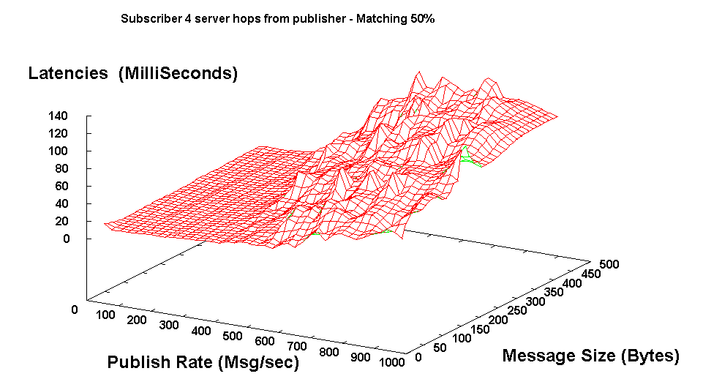
One extension of importance GMSME (GMS Micro Edition) handles messages and events on hand held and other small devices. This assumes an auxiliary (personal) server handling the interface between GMS and GMSME and offloading computationally intense chores from the handheld device. Currently we use JMS (Java Message Service) to provide publish/subscribe services for events in our prototype Garnet system but have already found serious limitations that we will address in GMS. [36]

The event based synchronous collaboration model handles both the classic microscopic state changes (such as change in specification of viewpoint to a visualization) but also the transmitted frame-buffer updates for shared display which our experience has shown to be the most generally useful sharing mode for objects. We also support shared export where objects are converted to a common intermediate form for which a powerful general shared viewer is built; shared PDF, SVG, Java3D, HTML and image formats are important export formats. Collaborative visualization using either shared SVG or Web export is a promising capability supported by ECCE.
Although the use of XML based objects is relatively well understood, there appears to be less consensus as to the distributed programming or execution model needed to build the services needed by applications. In other words, what is the distributed operating system for the objects and meta-objects? The Ninja project [7] at UC Berkeley is addressing such issues with a philosophy similar to our approach, which is termed MyXoS, and supports ECCE with such capabilities as the creation, access, copying and editing of meta-objects. MyXoS has a "shell" similar to that provided by UNIX but specified (at a low level) by RDF statements and aimed at manipulating GXOS objects not files in UNIX. W3C likes to talk about the Semantic Web [8] formed by the synergistic interaction of web resources and this intriguing concept is an underlying research issue for systems like Ninja and MyXoS. Another important trend is peer-to-peer computing (P2P [24]) with recent work typified by JXTA from Bill Joy at Sun Microsystems [9]. As shown in figure above, collaborative systems create P2P networks although in our approach (and most other systems), this is an "illusion" for the P2P environment is created by the routing of messages through a network of servers. Note that JXTA has a shell like MyXoS and uses a message queue (pipe) as a primitive; it does not use JMS or any server based solution to manage queues. We suggest the solution will lie in combining the P2P and server based approaches. Another interesting research issue is how best to perform this mix of software and hardware multicast and where the servers should be placed; MyXoS allows the dynamic instantiation of servers to support clusters of clients with similar subscription profiles. The message routing strategy needs to integrate the published topic and subscription profile objects and is quite complicated for heterogeneous client subscriptions. Best ways to link XML backends to databases and programmatic interfaces is an area of active research. We separate the “personal” (e.g. individual faculty) from the “Enterprise” (support all the courses for a University) edition. The former is simply implemented with an in memory database gotten by using Castor [38] to map back and forth between XML and Java objects. The Enterprise version needs sophisticated query mechanisms and partial loading of the XML data into Java middleware programs.
Below we show the Garnet prototype illustrating the collaborative linkage of a PDA with desktop devices. The system was prototyped in May 2001 and is rapidly changing. We will give an update as to its current capabilities.
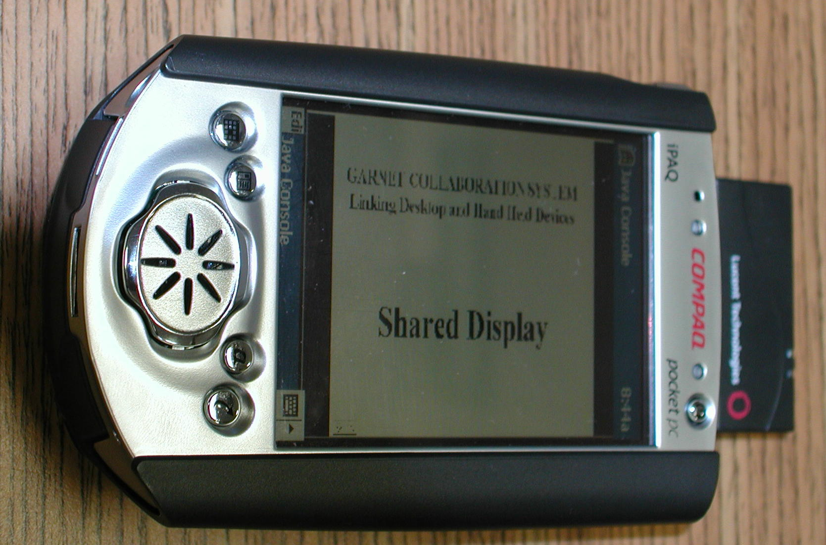
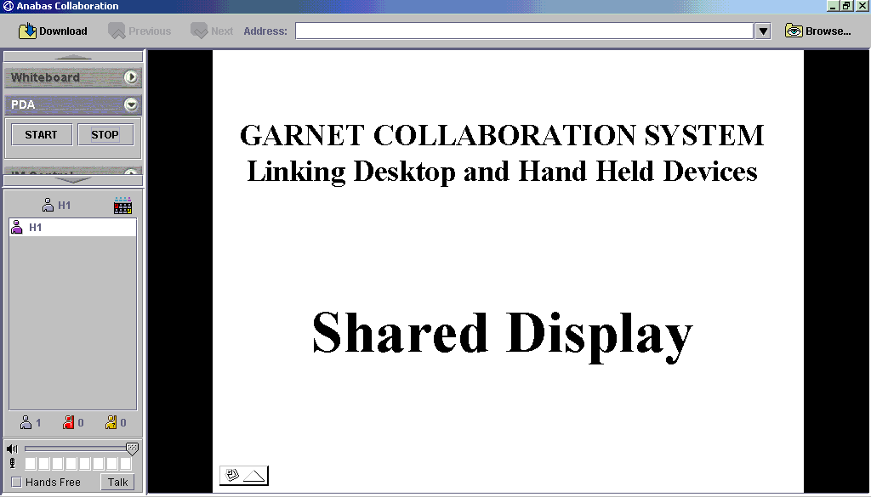
Shared Display of Window in Garnet and below its collaborative view on a iPAQ personal digital assistant.

Bibliography and Background References

- Portals and Frameworks for Web-based Education and Computational Science, http://www.new-npac.org/users/fox/documents/pajavaapril00/
- General Review of Portals by G. Fox, http://aspen.csit.fsu.edu/collabtools/CollabReviewfeb25-01.html
- Gateway Computational Portal, http://www.gatewayportal.org
- NEES Earthquake Engineering Grid, http://www.neesgrid.org/
- Particle Physics Data Grid, http://www.cacr.caltech.edu/ppdg/
- GriPhyN Project Site, http://www.griphyn.org/
- Ninja Project, http://ninja.cs.berkeley.edu/
- Semantic Web, http://www.w3.org/2001/sw/ and article in May 2001 Scientific American by Tim Berners-Lee, James Hendler and Ora Lassila at http://www.sciam.com/2001/0501issue/0501berners-lee.html
- Sun Microsystems's JXTA, http://www.jxta.org and http://conferences.oreilly.com/p2p/p2p_brochure.pdf
- The Tango System, http://www.new-npac.org/users/fox/documents/generalportalmay00/erdcportal.html
- Virtual Network Computing System, http://www.uk.research.att.com/vnc
- X3D http://www.web3d.org/x3d.html
- Access Grid, http://www.mcs.anl.gov/fl/accessgrid/
- HearMe, http://www.hearme.com
- Instructional Management Systems (IMS), http://www.imsproject.org
- Advanced Distributed Learning Initiative, http://www.adlnet.org
- Grid Forum Computing Environment Working Group, http://www.computingportals.org/cbp.html
- Grid Message (Event) System, http://aspen.csit.fsu.edu/users/shrideep/mspaces/ This will be June 2001 Syracuse PhD of Shrideep Pallickara.
- Resource Description Framework (RDF), http://www.w3.org/TR/REC-rdf-syntax/
- RDF implementation in the Netscape Browser, http://www.mozilla.org/rdf/doc/
- Jabber Instant Messenger, http://www.jabber.org
- Castor: XML Schema to Java Data Structure Converter, http://castor.exolab.org/sourcegen.html
- The Grid Forum http://www.gridforum.org
- The open Peer to Peer P2P organization http://www.openp2p.com
- XSIL from Roy Williams at Caltech, http://www.cacr.caltech.edu/SDA/xsil/index.html
- WebCT Commercial Education Portal http://www.webct.com
- Blackboard Commercial Education Portal http://www.blackboard.com
- Akarsu, E., Fox, G., Furmanski, W., and Haupt. T., ``WebFlow-High-level Programming Environment and Visual Authoring Toolkit for High Performance Distributed Computing,'' in Proceedings of Supercomputing '98, August 15, 1998.
- Erol Akarsu, Geoffrey Fox, Tomasz Haupt, Alexey, Kalinichenko, Kang-Seok Kim, Praveen Sheethaalnath, and Choon-Han Youn, “Using Gateway System to Provide a Desktop Access to High Performance Computational Resources”, Proceedings of HPDC-8 Conference, Redondo Beach Ca., Aug 3-6, 1999, IEEE Press.
- Tomasz Haupt, Erol Akarsu, Geoffrey C. Fox, “Landscape Management System: A WebFlow Application”, ERDC Technical Report August 1999(updated), http://www.new-npac.org/users/fox/documents/LMSERDCC425/C425LMSrep2.html
- HDF5 scientific file format http://hdf.ncsa.uiuc.edu/HDF5/
- ICE Interdisciplinary framework and eXtensible Data model and Format (XDMF), http://www.arl.hpc.mil/SciVis/dice/ and http://www.arl.hpc.mil/PET/training/SEM77.html
- Mehmet Sen, Syracuse PhD Thesis November 2000, “Distributed Open Asynchronous Information Access Environment” at http://aspen.csit.fsu.edu/collabtools/senthesisdraft.html
- XML Query Working Group http://www.w3.org/XML/Query.html
- URI Universal Resource Identifier, IETF RFC 2396 August 1998, Tim Berners-Lee, R. Fielding, L. Masinter, http://www.ietf.org/rfc/rfc2396.txt
- Java Message Service http://java.sun.com/products/jms/index.html
- Gregg Vanderheiden and Al Gilman, Trace Center at the University of Wisconsin, http://trace.wisc.edu/
- Castor Open Source Data binding framework for Java. http://castor.exolab.org/

