1. Introduction:
Peer-to-Peer is the next great thing for the Internet. Because there are millions of devices and information, they need to be shared with each other. The key thing for P2P system is no central server. This not only solves the current bandwidth problem but also let the user share more resource. The P2P application is a distributed application, so it takes all advantages of distributed system.
The JXTA technology provides a fundamental mechanism to solve the peer-to-peer problem. It is a platform. If your application builds on this platform, you can get a lot of benefit. First, there is a lot of low level API. Your application does not need to develop your own low level API. You can just use the already exist API do build the application. This will let the developer focus more on the application. It will save a lot time and money to write and test the low level code. Second, you application can get interoperability. Unlike some already exist P2P system to build their own community; JXTA application will not lock the user into one community. Third, JXTA technology is designed to be independent of programming language, system platform, and networking platforms. Your application can be deploy at any platform with Java VM or KVM.
The JXTA technology also has a huge potential to build the e-business application in the further, but there are a lot of issue needed to figure out.

2. Technique Overview about JXTA:
We can roughly break down a typical P2P software stack into three layers.
2.1 At the bottom is the core layer.
It deals with peer establishment, communication management such as peer groups, peer pipes and peer monitoring. To realize this functionality, it develops six protocols. The main difference between JXTA’s protocols and traditional Ipv4, TCP, UDP protocol is JXTA’s protocols use XML as its message content. XML is perfect for meta-data (language independent, self-describing, strongly-type), so the message sender and receiver can get enough information to do more things than usually protocols.

The core layer also response for the security. It has a simple crypto library to support MD5, RC4 and RSA. It has a plugable authentication model. It brings your application some flexibility for security. It also has simple password-based login schema, simple access control mechanism and transport security mechanism.
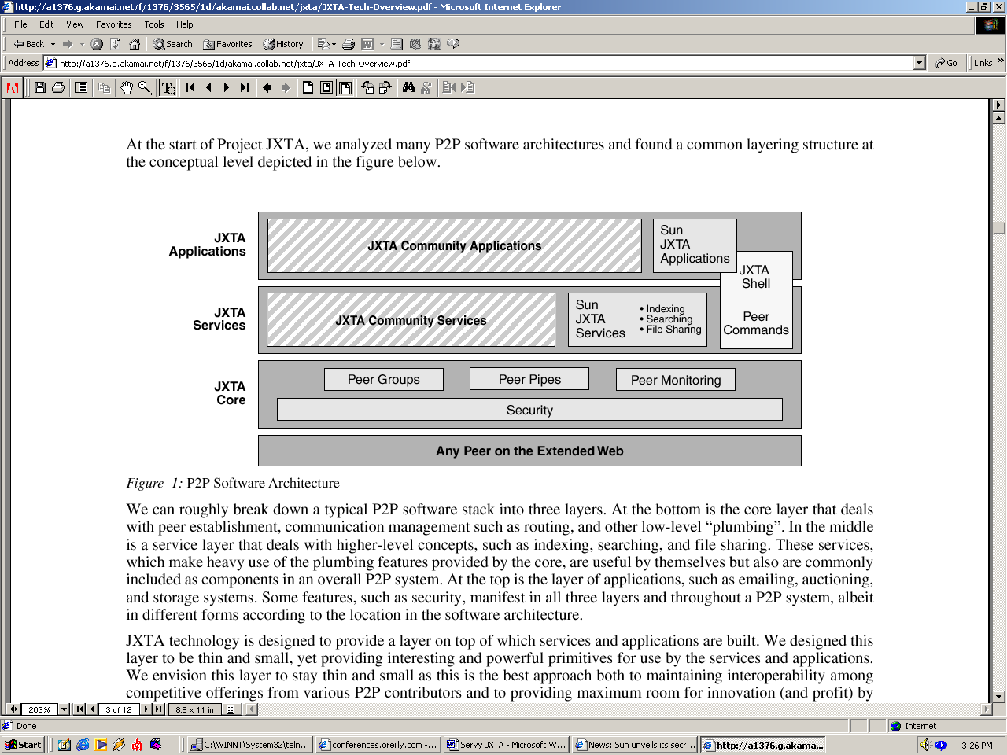

2.2 The middle layer is the service layer. I provide the resource management functionality.
The layer is a little higher layer. It provides the service between the peers rather than deal with low level networking issue. The JXTA platform already provides some basic service such as indexing, searching and file sharing. You can easily add this function into your application by using this already exist API. You also could add your customize service in this layer.
2.3 The top layer is the application layer. You can build your JXTA application such as JXTA shell and your GUI.
The JXTA platform provides the shell, which is similar with UNIX shell. Basically, the JXTA shell is command interprets application that parses user’s commands and interacts with the JXTA platform core service. It borrows some UNIX shell ‘s grammar and command to let people easy learn. It also can execute the batch file.

3. Compare with other exist technology:
3.1 Intel has a group to build the Peer-to-Peer standard (IXA).
Intel Internet Exchange Architecture offers an attractive framework for a wide range of network applications.
Provisioning and managing new services is now occurring rapidly at the carrier and ISP networks (the WAN backbone). Security, QoS, IP billing, traffic shaping and monitoring are newer services that require much more processing on each data packet than with forwarding.
I can see the Intel’s IXA frame is more close to its hardware. Usually it will be faster, but it will lose portability.
3.2 Microsoft’s strategy is universal plug play:
Universal Plug and Play (UPnP) is architecture for peer-to-peer network connectivity of PCs of all form factors, intelligent appliances, and wireless devices. UPnP is a distributed, open networking architecture that leverages TCP/IP and the Web to enable seamless proximity networking in addition to control and data transfer among networked devices in the home, office, and everywhere in between.
Step 1 in UPnP networking is discovery. It provides the function to find the peers. This step is similar with the JXTA core layer.
Step 2 in UPnP networking is description. The control point is responsible for getting peers information. This is similar with the JXTA core. But the UPnP’s information is a pointer to point some URI.
Step 3 in UPnP networking is control. Control points may invoke actions on a device's services and receive results. This step is similar with the JXTA service layer.
Step 4 in UPnP networking is evening. It deals with the sanded event by sending event message, subscribe and unsubscribe the event. This step is similar with the JXTA core layer peers groups and pipe idea.
Step 5 in UPnP networking is presentation. Presentation exposes an HTML-based user interface for controlling and/or viewing device status. The JXTA platform doesn’t provide this function, but it is not hard to do the same thing in your application.
Summary, the universal plug play technology doesn’t define the security mechanism at all. It depends on the Microsoft’s operating system. It is free and unrestricted source code.

5. How to apply JXTA technology:
Advantage:
If our application builds on JXTA platform, we do not need to write the low level code about the security, network connection, indexing, searching, and file sharing. We can simply use already exist API to realize the functionality. At the same time, our application will inherit the platform’s flexibility and interoperability.
Disadvantage:
We need some time to familiar with JXTA platform and its API. The API is not standard, so we may reuse part of its source code.
The JXTA project is still development. It is not stable.
Application:
We may use it to manage our user and user group. We may use its security mechanism to share resource between the user and user group.
The teacher can write the shell script or run exist script to get student homework.
We also use it to manage the Object on different site by building the hierarchy group.
6. Summary:
JXTA is the technology to reduce the relay on the operating system. We can see the further net operating system. We have your own OS on your desktop. We can run the net OS to access the Internet resource.

