Draft 5-11-01
Marvin Goldberg

A Computational Grid For The Americas

Motivation

- President George W. Bush, at the Summit for the Americas in Quebec, argued for enhancement of the economic integration of the Americas. In this note we discuss a technology-based scenario that could provide a partial foundation for such integration.

- The European Union intends to utilize emerging computer Grid technologies to enhance economic and other collaborative activities through the EuroGrid project. John Taylor (Director-General of Research Councils, U.K. Office of Science and Technology) promotes the Grid as the basic infrastructure for “e-science” (http://www.eurogrid.org).

- The US, via funded ITR proposals and other activities, is a leader in Grid technology development. Indeed, fundamental Grid concepts were first described by U.S. computer scientists, and have been well supported by NSF and other Federal agencies. Background material can be found at: http://www.nature.com/nature/webmatters/grid/grid.html and http://www.globus.org/research/papers/anatomy.pdf.

- Two of the experiments being used by the US and the Europeans for Grid development are ATLAS and CMS at the Large Hadron Collider (LHC) at CERN. Data acquisition, storage, and processing requirements for these experiments led to the idea for “GriPhyN” – the “Grid Physics Network”. GriPhyN, which is supported in the ITR program, has now been expanded to include both LIGO and the Sloan Digital Sky Survey (SDSS), and there is a desire to include projects from other areas as well (e.g. biology and the geosciences). A description of GriPhyN can be found at http://www.phys.ufl.edu/~avery/mre/

- The LHC experiments are highly collaborative. With CERN management, they are planning to participate in developing these technologies with support from the European Union and the private sector. The LHC experiments require a Grid able to handle exceptional speeds and data volume – a so-called Petascale Virtual-Data Grid.

- The experiments must develop Grid architectures well before the LHC turns on in 2006. With this timescale, they can serve as a testbed for other Union collaborative activities.

- As Grid concepts are understood and appreciated, their development has quickly followed. Indeed, Gridmania is spreading rapidly – at the Global Grid Forum and DataGrid meetings in Amsterdam, there were 320 attendees, twice the expected number. The paradigm seems to have great appeal.

Steps toward a Grid for the Americas

All of the above suggests the possibility of using NSF-supported experiments distributed throughout the Americas as a testbed for integrated collaborative activities that are taking place in this hemisphere. Such work would certainly lead to a much greater connectivity in the Americas that could form the basis of other important technological developments, and thus to begin realizing the President’s vision.

- US, Canadian and South American collaborations in astronomy and particle physics could lead to possible partnerships in a “Grid for the Americas.” Gemini and CTIO are potential immediate users of Grid ideas; in the future the Pierre Auger ultra high-energy cosmic ray experiment in Argentina (an NSF-DOE collaboration with international partners) and the National Virtual Observatory would also be included.

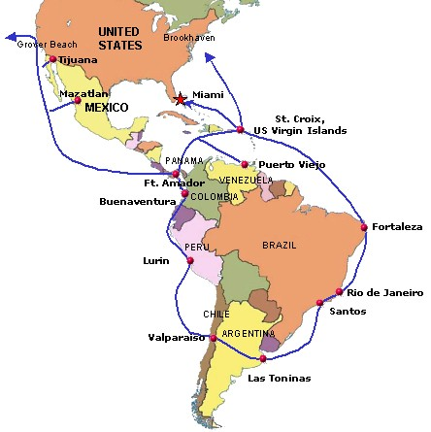
- The necessary high-speed networking from the US to South America is under development. (http://www.ampath.fiu.edu/) See the map below.

- For many experiments it useful to organize Grid structures into hierarchical "Tiers," where Tier 0 is the central facility (e.g. at CERN for the LHC experiments), Tier 1 is a national center, Tier 2 a center covering one region of a large country such as the US or a smaller country, Tier 3 a workgroup server, and Tier 4 the (thousands of) desktops. (See next page) This allows strong university and student participation in the experiments.

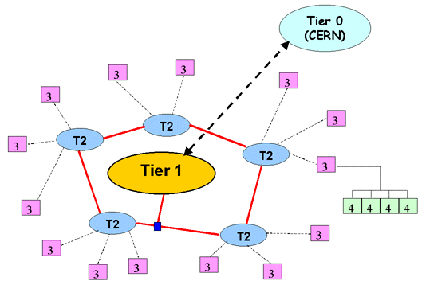
- Nations in North and South America can leverage the NSF-ITR supported Grid products being produced by the GriPhyN project.

- The level (and cost) of participation of each country would vary according to needs- from Tier 0 to Tier 4. And the cost of adding additional Grid programs would be offset by developments from earlier activities.

Possible Action Items

- An internal NSF working group could be set up, consisting of members from all Directorates that are interested in possible participation in either technical developments related to the Grid, applications of the Grid, or creating intergovernmental contacts and structures. An NSF POC should be appointed.

- Working with INT, NSF staff and selected scientists should explore the interest of candidate countries and experiments.

- Working with the Department of State, a vehicle (perhaps an OAS committee) could be established to facilitate the formation of international Grid collaborations.

- A center for the coordination of Grid activities should be established, where all funding agencies and interested scientists can interact. A director should be appointed. This center should host future project needs and develop ideas for implementation.

- A plan for inviting, reviewing, managing and funding grid proposals should be developed, and a joint finance board should be established.

