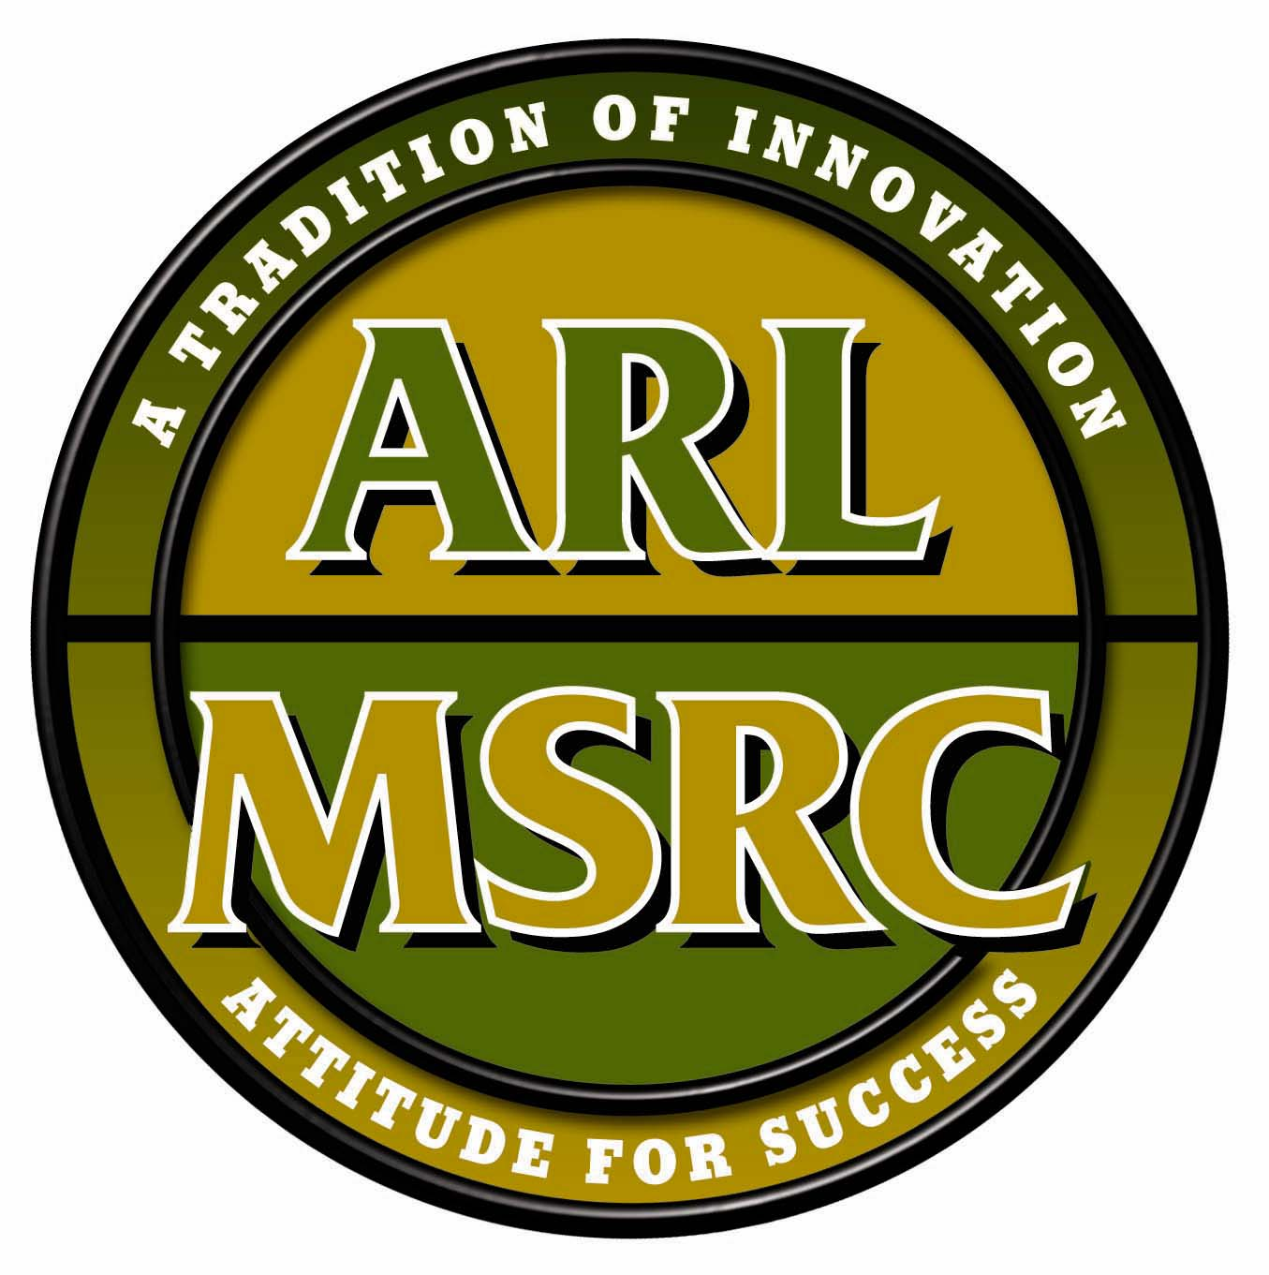

Quarterly Report
Army Research Laboratory
Major Shared Resource Center
For the period 01 October through 31 December 2000

Accomplishments 4
Management and Administration - Denice Brown 4
Operations - Tom Brezee 4
System Usage 4
System Administration 4
Facilities 4
Systems Integration 4
Networking 4
Expansion and Analysis - Tom Kendall 4
User Services - Phil Matthews 5
Applications Support - Steve Thompson 5
Scientific Visualization – Rick Angelini 5
Programming Environment and Training (PET) – Jack Benek 5
Management 5
Education and Training 5
Computational Chemistry and Materials Sciences (CCM) 5
Computational Structural Mechanics (CSM) 5
Computational Fluid Dynamics (CFD) 5
Integrated Modeling and Test Environments (IMT) 5
Signal Image Processing (SIP) 6
Forces Modeling and Simulation (FMS) 6
Programming Tools 6
Information and Communication 6
Minority Serving Institutions (MSI) 6
Miscellaneous – Denice Brown 6
Papers/Reports Published/ Presented 6
Conferences/Meeting Attendance 6
Visitors and Briefings 6
Support for HPCMP 6
Future Plans 7
Management and Administration – Denice Brown 7
Operations - Tom Brezee/Mike McCraney 7
Expansion and Analysis - Tom Kendall 7
Users Services - Phil Matthews 7
Applications Support - Steve Thompson 7
Scientific Visualization – Rick Angelini 7
Programming Environment and Training – Jack Benek 7
Management 7
Education and Training 7
CCM 7
CSM 8
CFD 8
IMT 8
SIP 8
FMS 8
Programming Tools 8
Information and Communication 8
Minority Serving Institutions (MSI) 8
Miscellaneous – Denice Brown 8
Papers/Reports to be Published/ Presented 8
Conference/Meeting Attendance 9
Visitors and Briefings 9
List of Machine Names and Types 10
Glossary 11

Accomplishments
Management and Administration - Denice Brown

Operations - Tom Brezee

System Usage

System Administration

Unclassified

Classified

Facilities

Systems Integration

Networking

Expansion and Analysis - Tom Kendall

User Services - Phil Matthews

Applications Support - Steve Thompson

Scientific Visualization – Rick Angelini

Programming Environment and Training (PET) – Jack Benek

Management

Education and Training

Computational Chemistry and Materials Sciences (CCM)

Computational Structural Mechanics (CSM)

Computational Fluid Dynamics (CFD)

Integrated Modeling and Test Environments (IMT)

Signal Image Processing (SIP)

Forces Modeling and Simulation (FMS)

Programming Tools

Information and Communication

Minority Serving Institutions (MSI)

Miscellaneous – Denice Brown

Papers/Reports Published/ Presented

Conferences/Meeting Attendance

Visitors and Briefings

Support for HPCMP

Future Plans

Management and Administration – Denice Brown

Operations - Tom Brezee/Mike McCraney

Expansion and Analysis - Tom Kendall

Users Services - Phil Matthews

Applications Support - Steve Thompson

Scientific Visualization – Rick Angelini

Programming Environment and Training – Jack Benek

Management

Education and Training

CCM

CSM

CFD

IMT

SIP

FMS

Programming Tools

Information and Communication

Minority Serving Institutions (MSI)

Miscellaneous – Denice Brown

Papers/Reports to be Published/ Presented
ARL MSRC personnel have the following papers/reports awaiting publication/presentation:

Conference/Meeting Attendance
ARL MSRC staff anticipates attending the following conferences:

Visitors and Briefings
The ARL MSRC plans to host the following groups for a tour of our facility:

List of Machine Names and Types

Glossary

AHPCRC Army High Performance Computing Research Center
AHU Air Handler Units
AIAA American Institute of Aeronautics and Astronautics
ALC Adelphi Laboratory Center, ARL
ARL Army Research Laboratory
ASC Aeronautical Systems Center
ATC Aberdeen Test Center
CAU Clark Atlanta University
CCM Computational Chemistry and Material Sciences
CEN Computational Electronics and Nano-electronics
CFD Computational Fluid Dynamics
CHSSI Common HPC Software Support Initiative
CIMP Center for Intrusion Monitoring and Protection
COTS Commercial Off-the-Shelf
CRPC Center for Research in Parallel Computations
CSM Computational Structural Mechanics
DBA Database Administrator
DICE Distributed Interactive Computing Environment
DoD Department of Defense
DPE Data Processing Enclosure
DTC Developmental Test Command
EAIWT Expansion and Analysis Integrated Work Team
ELT Effectiveness Level Test
ERDC Engineering Research and Development Center
EUSIPCO European Signal Processing Conference
FCN Fibre Channel Nodes
FMS Forces Modeling and Simulation
FSU Florida State University
GECCO Genetic and Evolutionary Computation Conference
GRD Global Resource Directory, a batch queuing system
HEAT Higher Education and Applied Technology
HPC High Performance Computing
HPCAP High Performance Computing Advisory Panel
HPCMO High Performance Computing Modernization Office
HPCMP High Performance Computing Modernization Program
ICTAM International Congress of Theoretical and Applied Mechanics
IDS Intrusion Detection Systems
IEEE Institute for Electrical and Electronics Engineers
IMT Integrated Modeling and Test Environments
JSU Jackson State University
K Thousand
LAN Local Area Network
MAPINT Multi-disciplinary Applications and Interoperable Computing 2000 Conference
MHPCC Maui High Performance Computing Center
MPT Message Passing Tool
MSI Minority Serving Institutions
MSRC Major Shared Resource Center
NAVAIR Naval Air Systems Command
NAWCAD Naval Air Warfare Center- Aircraft Division
NCSA National Center for Supercomputer Applications
NID Network Intrusion Detection
NIST National Institute for Science and Technology
NRL Naval Research Laboratory
NSA National Security Agency
OSC Ohio Supercomputer Center
OSU Ohio State University
PAL Program Access Library
PDU Power Distribution Units
PET Programming Environment and Training
PKI Public Key Infrastructure
PL Performance Level
RIB Repository in a Box
SC Super Computing
SIAM Society for Industrial and Applied Mathematics
SIG Security Implementation Group
SIP Signal Image Processing
ST&E Security and Testing Evaluation
TI Technology Insertion
USAMRIID US Army Medical Research Institute of Infectious Diseases
USMA United States Military Academy
UTK University of Tennessee Knoxville
WMRD Weapons and Materials Research Directorate, ARL
WOMPAT Workshop on OpenMP Applications and Tools
WSMR White Sands Missile Range

