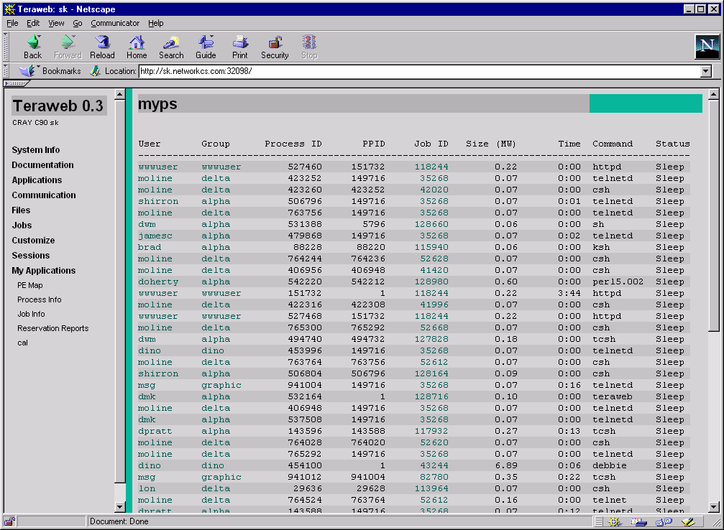
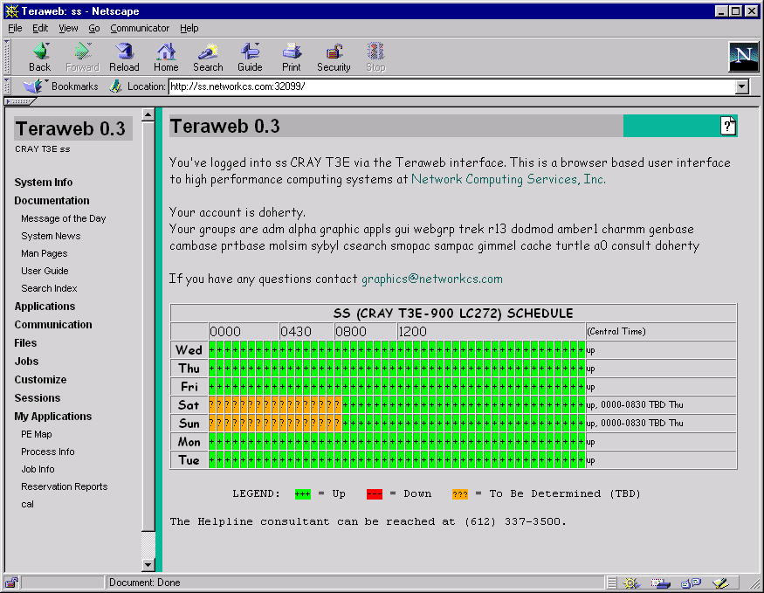
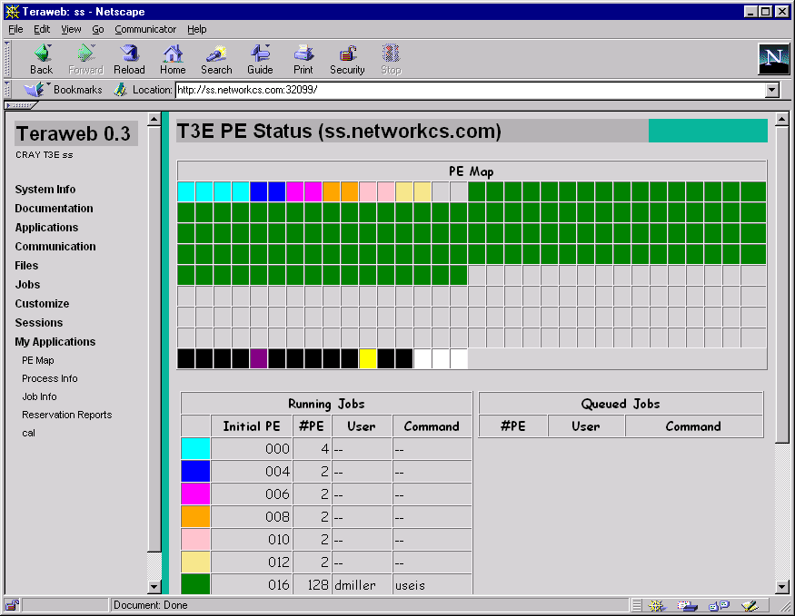
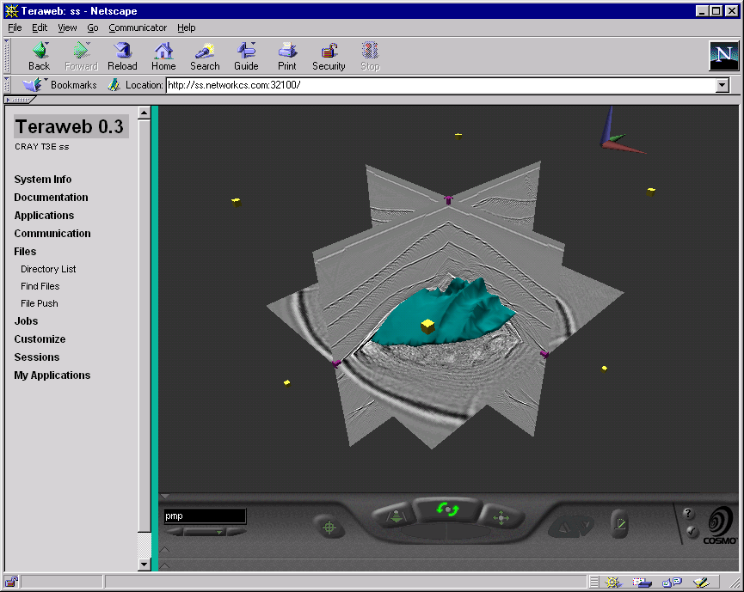
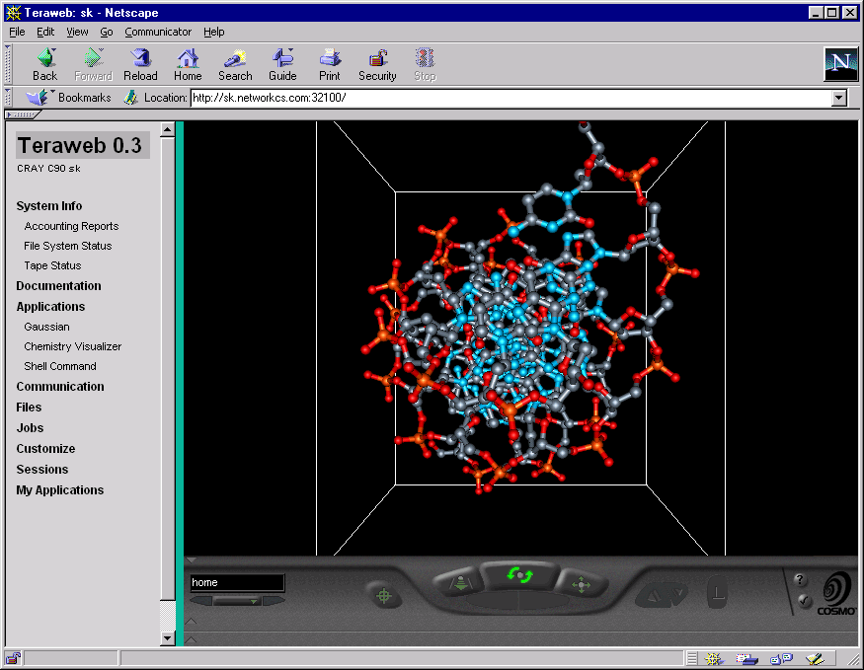
Teraweb

Copyright © 1998 by Network Computing Services, Inc.
RESTRICTED RIGHTS LEGEND
Use, duplication, or disclosure of this software and its documentation by the Government is subject to restrictions as set forth in subdivision { (b) (3) (ii) } of the Rights in Technical Data and Computer Software clause at 52.227-7013

Teraweb
A Teraweb RoadMap

A Web-based HPC Interface

Teraweb Features
Login and Sessions
System Information
File Access
Job Control
Applications
Documentation
Supported Systems

Security

Training and Documentation

Maintenance and Support
For More Information about Teraweb:

Network Computing Services, Inc.
1200 Washington Avenue S
Minneapolis, MN 55415
612/337-0200
612/337-3400 Fax

salesinfo@networkcs.com

Teraweb: A Web-based HPC Interface
Teraweb is a Web-based graphical user interface to High Performance Computing (HPC) systems. It provides users a complete set of tools to prepare, submit, and monitor work and to visualize results all through a Web browser. Accessing HPC services though Teraweb’s point-and-click interface allows users to avoid learning arcane Unix commands and to concentrate on what they want to do: simulation and analysis.

Teraweb enables HPC administrators to provide services that hide the underlying differences between heterogeneous operating systems. Users see similar functionality across systems and need not be burdened with remembering differences between, for example, specific queuing or accounting systems. Administrators also use Teraweb to build and deliver customized, easy-to-use interfaces to any package available on their systems.

Developed by Network Computing Services, Inc. (NetworkCS), Teraweb uses the standard Web client/server model, implemented with custom server software to perform its special functions. Portable across all Unix HPC platforms, it features a distributed architecture that allows simultaneous access to multiple HPC systems. Teraweb was engineered to provide enhanced security, with its login facility supporting SecurID, Kerberos, and optionally, the Secure Sockets Layer (SSL).

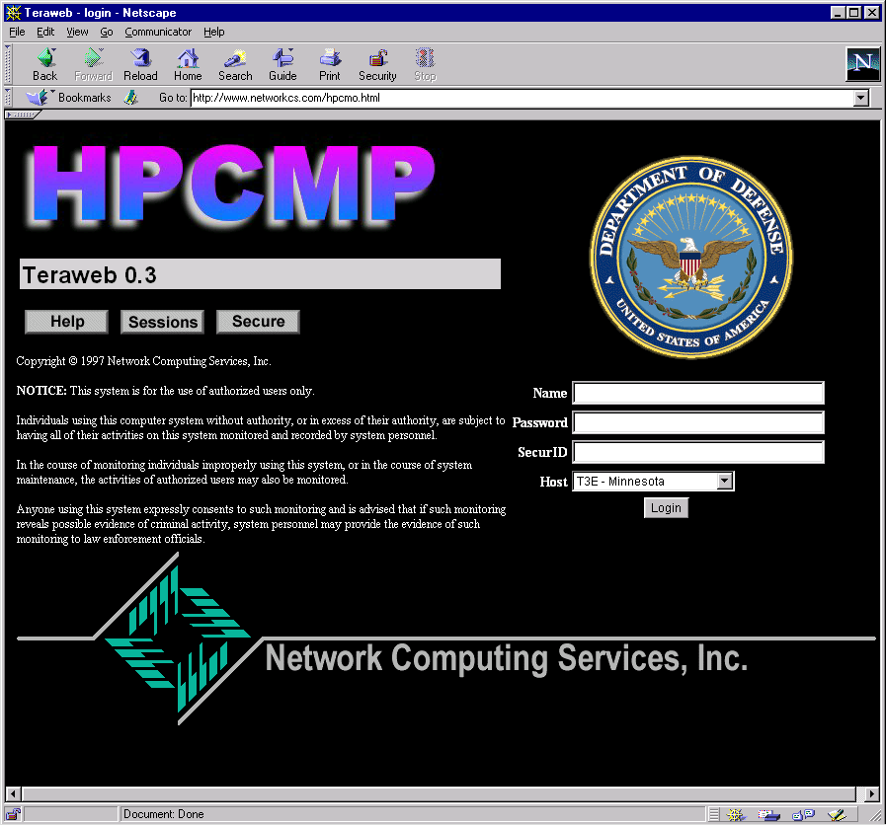
The Teraweb Login Screen provides a secure entry point to various HPC systems.

Teraweb Features: A Quick Tour
The functionality provided by Teraweb is designed to allow users to perform all of their HPC work through the Teraweb interface. This functionality includes the ability to search and read online documentation; to manipulate files on the HPC system; to prepare, submit, and monitor jobs; and to visualize job results.

In this section, we provide a “guided tour” of the functions provided by Teraweb.

Login and Sessions

Users interact with HPC systems via “Teraweb sessions” that are controlled by a Web browser. Each session represents a connection to a system (just as a connection can be established through Telnet). Sessions are established by opening the Teraweb Login Facility page. Users enter their User IDs, passwords, and (optionally) their SecurID card entry, select a machine to connect to and press the “Login” button to connect.

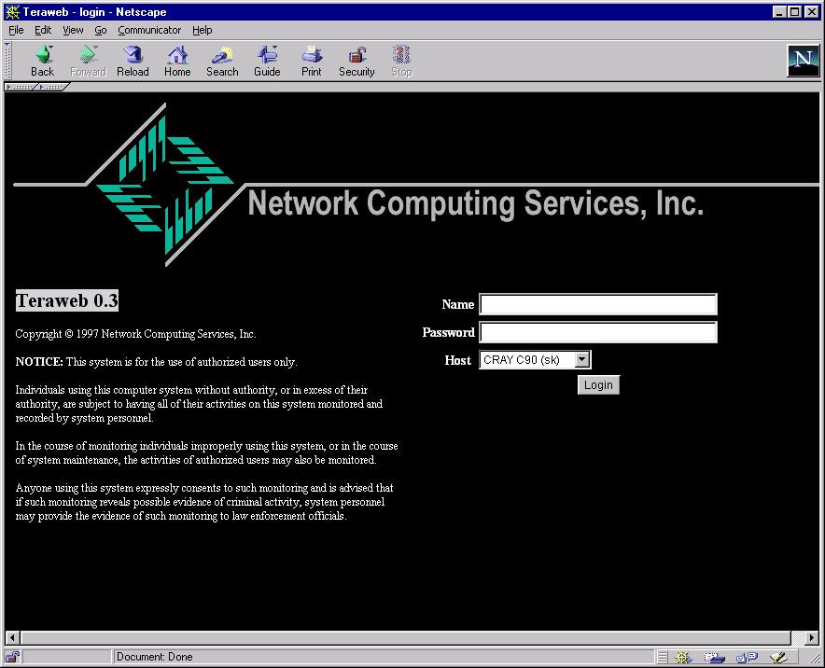
The Teraweb Login facility is the starting point for establishing Teraweb sessions.
Once a session has been established, the browser window splits into two sections: with the Menu of Teraweb functions on the left and the “working area” on the right. The initial “Welcome Screen” displays summary information about the session and messages to the user (such as the machines “message of the day).

The “Welcome Screen” that is displayed upon login displays session information and informational messages to the user.
Frequently users are performing work on multiple machines. Multiple sessions can be established to a single machine or multiple machines. Teraweb handles the details of the state of each session and allows users to switch back and forth between sessions.
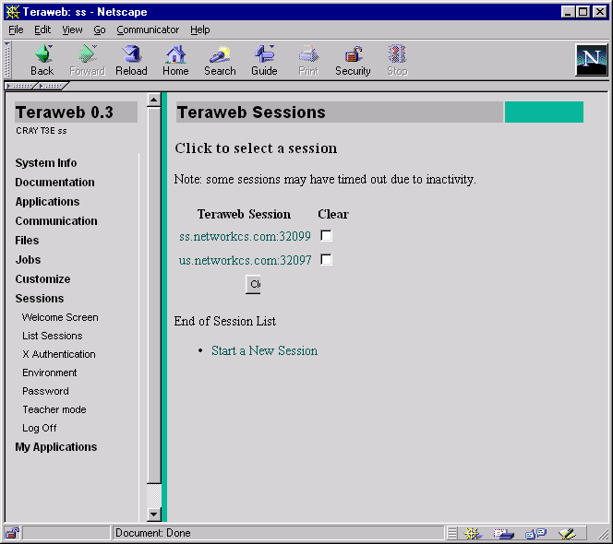
Teraweb allows users to establish and to switch between sessions.

File Access
Teraweb provides full access to all files on the server system. In addition, it allows users to upload files from their local systems to the server file system. Central to this capability is the Teraweb File Browser.
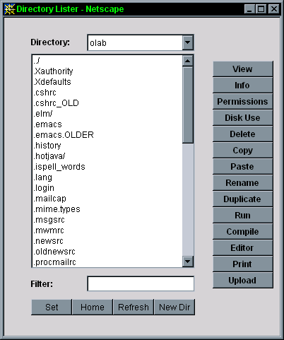
The Teraweb file browser facilitates file uploading and other file actions such as copying, viewing or printing.
Button | Function
View | View selected files in Browser
Info | Detailed information about files
Permissions | View and set file permissions
Disk Use | Disk usage of selected files
Delete | Delete selected files

The “Upload” button effects file transfers from the local workstation to the HPC file system.
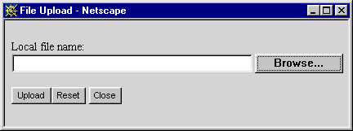
Uploading files from the local machine.
Teraweb allows users to set file permissions (including AFS permissions).

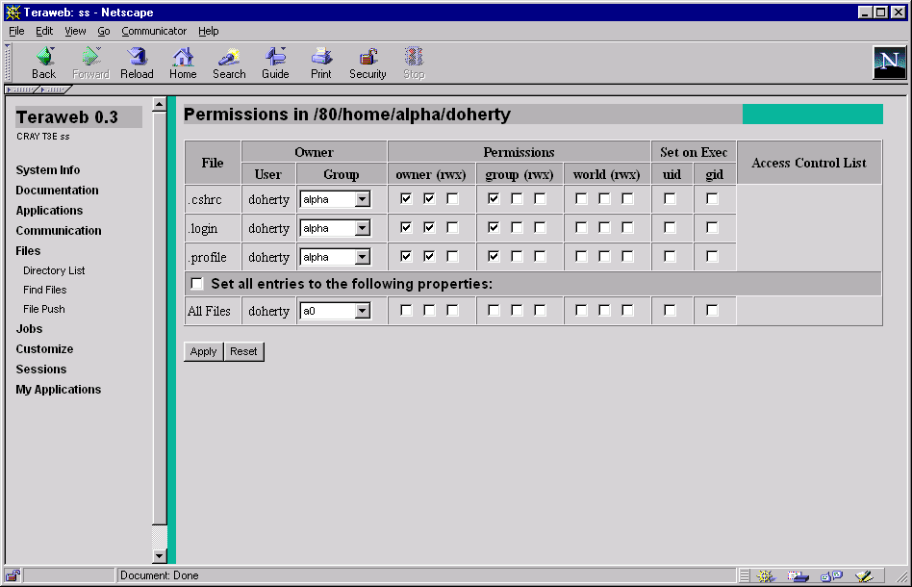
Setting file permissions

Job Control

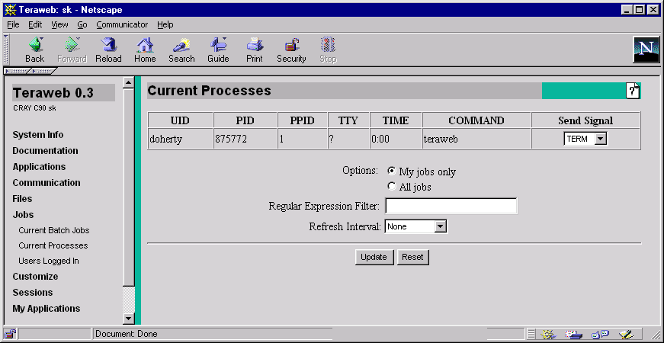

Applications
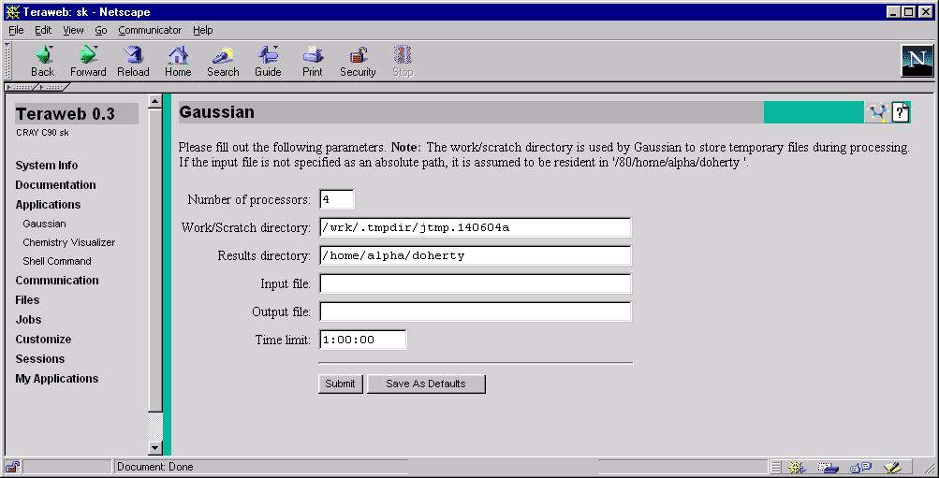

Documentation

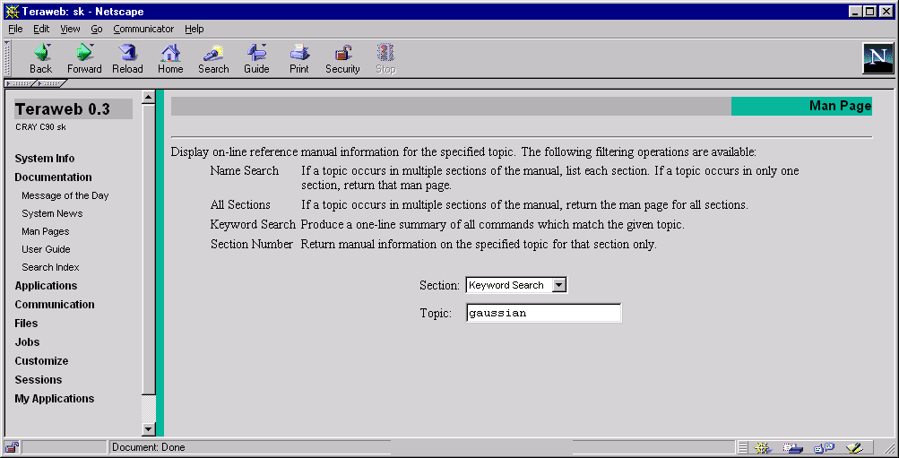
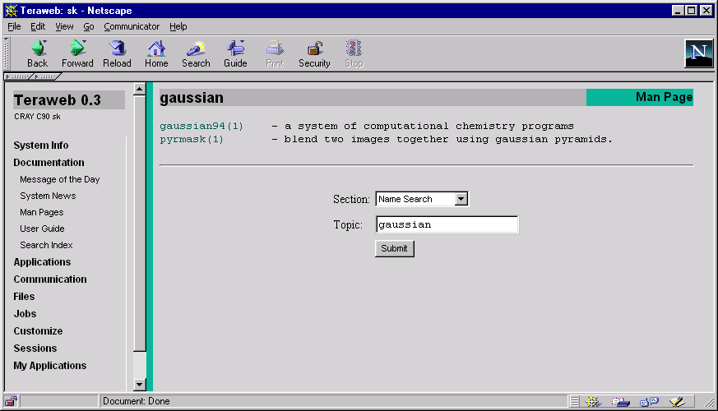
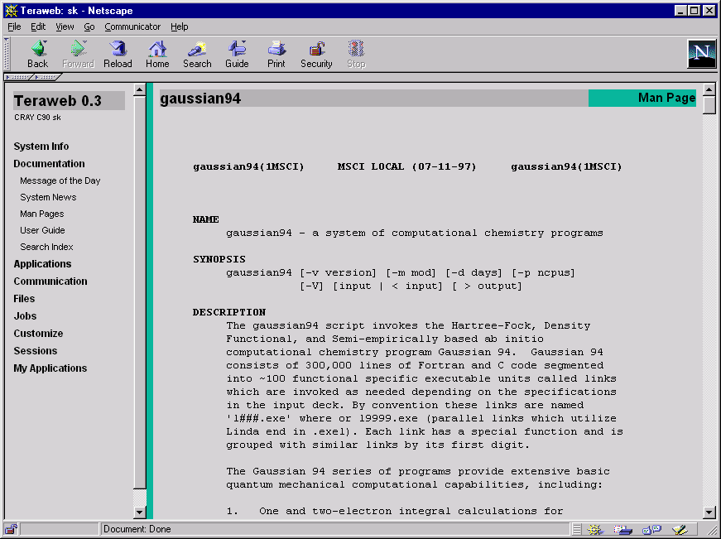

Supported Systems

The Teraweb server is designed to be highly portable. It is built from common, industry standard tools: C, JAVA, Perl, HTML, and CGI scripts. The underlying Browser mechanisms also provide access to various graphics and multimedia formats such as GIF, JPEG, MPEG, WAV, or VRML files.
Teraweb is currently supported on the following operating systems:
OS | Version | Platform
FreeBSD | 2.2.5 | i386
UNICOS | 8.0.3 | C90, Y-MP, J90
UNICOSmk | 2.0.2.29 | T3E
IRIX | 6.4 | Origin2000
AIX | 4.2 | RS6000

The Teraweb login facility is available for the following servers:
OS | Version | Platform | Server
FreeBSD | 2.2.5 | i386 | Apache  Stronghold
UNICOS | 8.0.3 | C90 | Apache

Security

Users need to present authentication information only at the initiation of a Teraweb session. Unlike other Web servers, authentication information is only transmitted once. Once established, a Teraweb session is exclusive: it only accepts requests from the authenticated originator.
Teraweb was engineered to provide enhanced security and each Teraweb user executes out of a dedicated instance of the server software. The Teraweb login facility supports SecurID, kerberos and the secure socket layer (SSL).

Because the Teraweb server runs as the individual user, it inherits the security model of the underlying OS. Therefore, there is no need for setuid programs, as is the case with other HTTP server programs.

