WebWisdom.com Business Plan

Sept 6 1998
Geoffrey Fox

DRAFT Confidential

1. Executive Summary

2. Business and Product Strategy

2.1 Market Opportunities
Quantify with analysis from IDC, Dataquest, AMR, Yankee etc.
- General Collaborative including general meetings now supported by PictureTel
- Asynchronous and/or Synchronous distance education and training in corporate (Centra, Placeware focus), Education and DoD
- Interactive Help Desks
- Enterprise Groupware including briefing of Sales and Marketing staff
- Computer Consultation and computational steering
- Internet Sales assistant (A synchronous guided tour of an asynchronous Web Portal)
- Is it any good for demoing new products or are products like NetMeeting easier to use here as just need to display "framebuffer"

2.2: WebWisdom.com Product Capabilities in a Nutshell

- TangoInteracative: General Collaboration Tool including Audio-Video Conferencing. As a sub-product there is Audio-Video conferencing
- WebWisdom Intelligent Server: XML Database Web Interface supporting client customization and built in XML invoked filters
- WebWisdom Asynchronous: WebWisdom Intelligent Server combined with carefully designed database supporting curricula and personnel information in interactive hierarchical fashion. Provides powerful managed asynchronous resource
- WebWisdom Interactive: Combines 1) and 3) for fully featured synchronous and asynchronous collaborative environment

Now describe the WebWisdom.com value proposition i.e. qualitatively why choices we made are so good!
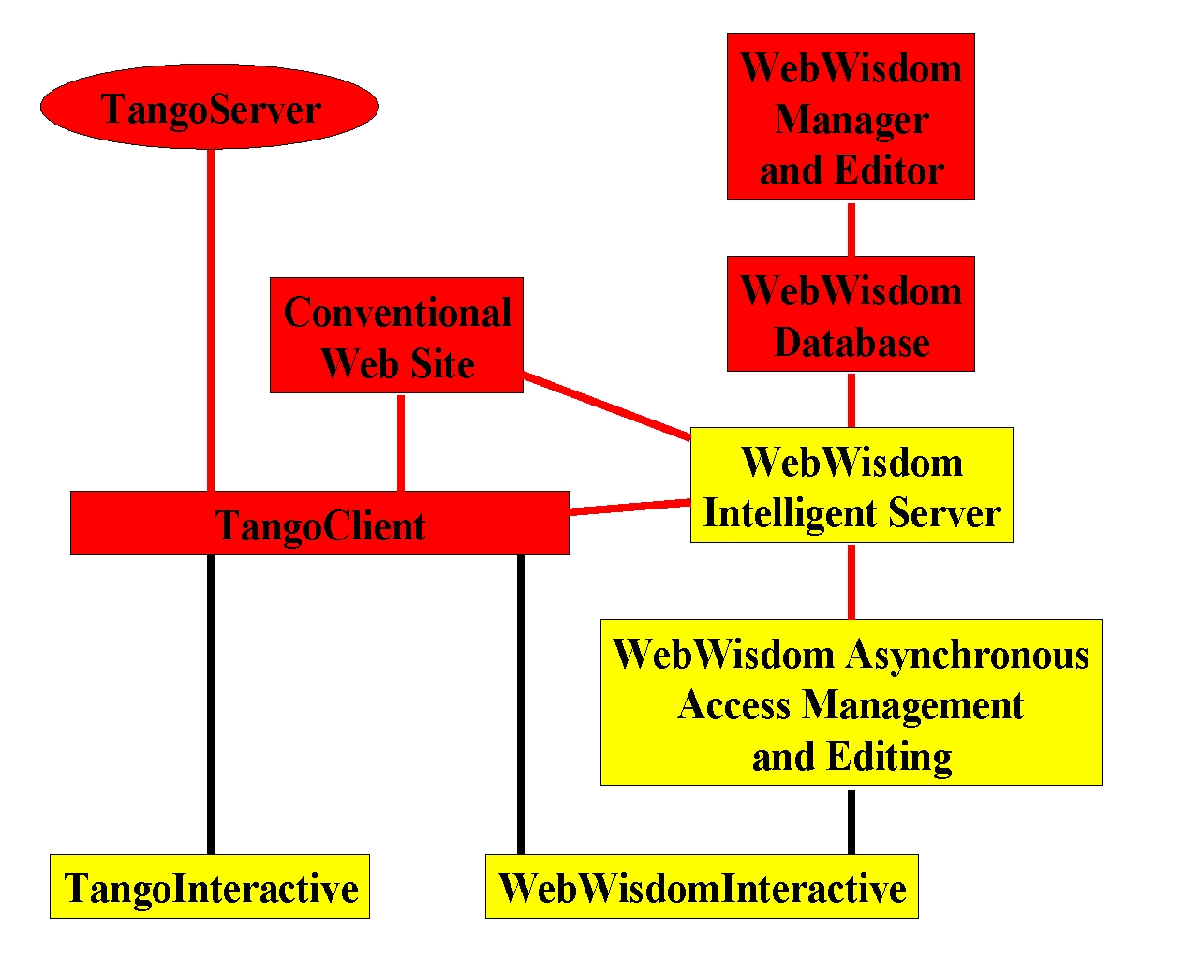
2.3: WebWisdom.com Timeline
Emphasize what we will focus on and what is in reserve for targets of opportunity

2.4 Keys to Success and Basic corporate strategy

2.5: The WebWisdom.com Team
Corporate Organization
List people in words with Resumes in appendix

2.6: Patents and Licensing

3. Marketing and Sales Strategy
3.1: Basic Approach
Education and DoD markets using Web, personal contacts and exhibition at conferences

3.2: WebWisdom.com Partners

NSF DoD Modernization CILT IMS ADL

3.3 Pricing Strategy
3.4 Distribution Strategy
3.5 Estimated Sales and Revenue

4: Risks and Competition
We are not focussed and are under capitalized with no management experience
What are critical hurdles we have to jump

4.2: The Competition: Comparison Table of Products
Put in rows versus features in columns. Can decide into several tables for the major capabilities below:
Authoring -- Composition of Elegant Pages
Training Management: Curricula IMS standards and PAPI
Content Repositories aka Asynchronous Learning Systems
Synchronous or Interactive Collaboration/Delivery
Database: technologies to support web-linked databases

Competing Products
Taken from CENTRA Presentation, IDC Survey, our knowledge
Authoring (We are in Management not Authoring? We should support these with database etc.)
Allen Communications
Aymetrix Learning Systems
Macromedia
Powerpoint
FrontPage NetFusion and HTML Editors
Training Management
Databeam, KnowledgeSoft, Pebblesoft Learning, Saratoga Group
Asynchronous (Content Repositories)
CBT Systems Campus
Docent
Databeam/Lotus LearningServer
Educom IMS
MicroSoft NetShow
Oracle OLA
RealNetworks Real Media (WLS etc.)
WebCT
Synchronous
Centra
Contigo
CUSeeMe
Habanero
ILINC
NetMeeting
Placeware
Unknown Delivery -- (classify later when we study as synchronous or asynchronous)
Eloquent, ONE TOUCH Systems(?), WBT Systems
Database
ColdFusion
Lotus Notes
Netscape (server side JavaScript)

Qualities of Each Product
Some of these are yes/no; otherwise deserve some explanation -- at least for our products

Possible Qualities
General System
Performance
Scalability
Server and client machine requirements; platforms supported
Security
Integration of database, Synchronous and Asynchronous
Open API for all applications

Authoring
Support PowerPoint; HTML; Persuasion; RealPlayer; Director
Support Play lists
Support captioned images (Family Photos, Screendumps, Scanned Information)
Support for image editing

Support for shared Java, JavaScript, C++, LISP

Management
Support IMS and PAPI standards
Database backend to PowerPoint., …
Hierarchical Dynamic Course Structure

Asynchronous
Support for Multi-resolution Images and client customization

Synchronous
Support for Audio Video Conferencing (refine this to particular codecs MPEG1,2,4 H261,263 and the interoperability standard I forget)
Support Telecursor and dynamic annotation
Support replicated data servers

Database
XML Support
Caching

5: Corporate History

6: Finance
Who would partner with/buy out WebWisdom?

Appendix I: Details on Technology
Appendix II: Resumes
Appendix III: Glossary and Definition of Terms
Asynchronous
Collaboration
Groupware
IMS
Metadata
PAPI
Synchronous Learning
XML

