Earthquake Science and Information Technology

Geoffrey Fox
Departments of Computer Science and Physics, School of Informatics
Community Grids Laboratory, Indiana University

Sung-Hoon Ko, Marlon Pierce
School of Computational Science and Information Technology
Florida State University

Ozgur Balsoy, Jake Kim, Sangmi Lee
Computer Science Department, Florida State University

Kangseok Kim, Sangyoon Oh
Computer Science Department, Indiana University

Hasan Bulut, Gurhan Gunduz, Xiaohong Qiu, Ahmet Uyar
Department of Electrical Engineering & Computer Science, Syracuse University

Abstract
We describe an information system architecture for the ACES (Asia-Pacific Cooperation for Earthquake Simulation http://www.quakes.uq.edu.au/ACES/) community. It addresses several key features of the field – simulations at multiple scales that need to be coupled together; real-time and archival observational data, which needs to be analyzed for patterns and linked to the simulations; a variety of important algorithms including partial differential equation solvers, particle dynamics, signal processing and data analysis; a natural three dimension space (plus time) setting for both visualization and observations; the linkage of field to real-time events both as an aid to crisis management and to scientific discovery. We also address the need to support education and research for a field whose computational sophistication is increasing rapidly and spans a broad range. The information system assumes that all significant data is defined by an XML layer which could be virtual but whose existence ensures that all data is object-based and can be accessed and searched in this form. The various capabilities needed by ACES are defined as Grid Services conformant with emerging standards and implemented with different levels of fidelity and performance appropriate for the application. The Grid Services can be composed in a hierarchical fashion to address complex problems. The real-time needs of the field are addressed by high performance implementation of data transfer and simulation services; further the environment is linked to real-time collaboration to support interactions between scientists in geographically distant locations.

Computational Web Portals for Education
A computing web portal is designed to simplify remote access to computing resources. Typically, high performance computing centers are interested in outreach to potential new users. The problem faced in doing this is that many of these users are unfamiliar with the peripheral details of using these machines: using the Unix operating system, creating and submitting batch scripts to queuing systems, transferring files, etc. All of this is in addition to problems associated with learning to use a new code. These difficulties are further compounded by the introduction of grid technologies for distributing jobs among several institutions. None of these problems singularly is insurmountable, but taken together can be very frustrating for new users and force them to become experts in particular computer operating systems instead of allowing them to focus on scientific and engineering tasks.

The problems described apply equally well to the educational community. Computing techniques have become important in a wide range of disciplines, and high-quality commercial and academic codes are available, but instructors must devote time to teaching students esoteric operating system details that would be better devoted to teaching the students about the different computational techniques that are available, the appropriate problem domain for each technique, and the actual business of solving problems with the correct application.

One solution that computing centers have chosen in order to simplify access is the development of Computational Web Portals. Typically these can be grouped as either system portals or application portals. The former is geared towards assisting users remotely login to the computing center through a browser interface, and the latter is a more specialized browser portal devoted to a particular code. Typical services provided by these portals include
- Secure login, access control and authorization
- Information services describing available host computers and applications
- Job submission and monitoring
- File transfer
- Remote file access and manipulation
- Session archiving

We have developed a system portal, called Gateway, for the Department of Defense Modernization Program. Several similar projects are under development and descriptions may be found and the Grid Computing Environments web site [GCE].

These portals can play an obvious role in education. Because they hide the details of using remote computers with a particular operating system behind a browser-based user interface, students can chose applications, submit jobs and analyze output by using a simple point-and-click interface. See for examples Figures 1-5. These portals can also play an important role in distance education, simplifying access for students taking the class remotely.

Gateway in particular has been designed to be application-neutral, making it simple to add new applications to the portal. Gateway tools are also modular with well-defined interfaces, so developers wishing to add more sophisticated user interfaces to create application portals can easily integrate these web pages into our system portal.

Computing portals for education possess a slightly different focus than computing portals for working groups. First, collaboration and shared control of the input pages is important. When giving initial instructions on setting up input decks and running codes, instructors will need to be able to share displays with all students (especially remote students) to show them the steps involved. For post processing and visualization, instructors and students will want to share visualization so that typical problems, such as common mistakes in input decks that produce invalid results, can be identified. Secondly, the portal must have multiple user privilege levels. The instructor, for instance, will need to be able to examine the students’ problem archives and assume control over applications started by students, but students should not be allowed to access instructor areas. Thirdly, problem archiving acquires a new usage and would benefit from different access permission levels. Instructors, for example, will want to create a series of sample input problems for the students to run and modify.

XML Descriptors of Data Structures
A crucial problem for developing information technology-based tools for earthquake science is the definition of data structures that describe and organize the metadata associated with the field. Here it is important to distinguish between the raw data generated either by codes or by scientific instruments and the metadata that describes the raw data. The metadata is appropriately described by a specialized XML dialect. XML has the advantage of being human-readable and hierarchically organized, but is verbose and thus not ideal for very large datasets. Instead it is more often useful to have the XML metadata description point to the location of the data and describe how that data is formatted, compressed, and to be handled.

Let us consider first an example of using XML data from computing portals and then examine some of the specific issues that will need to be addressed by the earthquake science community.

Computational Web Portals are described in more detail in the section “Computational Web Portals for Education” in this paper, but one may consider them in summary to be browser-based systems for accessing computing resources for composing and submitting jobs and monitoring their progress. Numerous supporting services to this basic concept can be defined, such as security, file transfer, resource monitoring and selection, and session archiving. Many computing portal projects are underway and a partial listing can be found at the Grid Computing Environments web site [GCE]. The Gateway Web Portal [GATEWAY] is one such project.

XML metadata descriptions form the basis for Gateway and are used to describe static data about host machines and codes. These data in turn can be used to generate browser forms in the user interface. See for example Figures 2 and 3. Here, static data means data that should remain relatively constant. This is somewhat idealized but is distinguished from dynamic data, which by definition will change every time a user accesses the web portal. For example, the location of the executable for a particular code on a particular machine is static data, but the actual code and machine a user selects in a particular session, as well as his or her input file and code parameters, is dynamic.

Let us now examine this in practice. For Gateway, we have defined three sets of static data: code descriptions, host descriptions, and service descriptions. For the first two we have chosen to use XSIL, an XML dialect for the description of scientific data. We determined that this approach had sufficient flexibility to be extended to the description of codes that would use scientific data, as well as the data itself.

XSIL: A Convenient XML Dialect
In developing our XML descriptions for Gateway we were motivated by a desire to move quickly and so we decided to adopt XSIL (eXtensible Scientific Interchange Language) developed by Roy Williams at CalTech [WILLIAMS]. XSIL is primarily designed to describe scientific data, but we found it to be generally useful and to provide a single solution for both scientific and non-scientific data. XSIL comes with software (in Java) for parsing documents and extracting name-value pairs from the XML data. XSIL also allows you to identify in the XML the piece of Java code that you wish to handle a particular set of tags, which we found to be quite useful.

Application Description
First, we should clarify our use of the word application. We use this term to refer specifically to third party codes, whatever they may be (scientific and engineering codes such as Gaussian, visual analysis tools such as gnuplot or MatLab, and so on). All of these have common characteristics for running on a command line, so in our application description we seek to capture this information. For a particular code, we need to capture at least the following to run it:
- The number of input files the code takes;
- The number of input parameters the code takes;
- The number of output files the code generates.
- The number of output parameters the code generates (for symmetry).
- The input/output style the code uses.
By input and output files, we refer specifically to data files. Parameters are anything else that you might need to pass to the code, such as the version of the code to use, the number of nodes to use in parallel computation, a user-written Fortran subroutine to dynamically link, and so on. I/O style is typically either by standard Unix redirects ,< and >, or C-style command line arguments.

The following is the application description for ANSYS, a structural mechanics code:

<XSIL Name="ANSYS" Type="csm.parseXMLDesc">
<Param Name="NumberOfInParams">0</Param>
<Param Name="NumberOfInFiles">1</Param>
<Param Name="NumberOfOutParams">0</Param>
<Param Name="NumberOfOutFiles">1</Param>
<Param Name="IOStyle">StandardIO</Param>
…

The “Type” attribute of the <XSIL> tag specifies the code that extracts this information from the XML file and makes it available to other components.

We have not attempted to be complete in this description, but rather are motivated by the requirements of the codes we currently need to support. One of the advantages of using XSIL’s “shallow” tree structure is that it is simple to add further parameter tags as we need. Code command line flags are an obvious additional parameter we would want to provide. This is just a parameter again, and the parseXMLDesc code is general and doesn’t care what name and value we provide.

HPC Description
We have described HPC systems from the same viewpoint as our Application Description: we primarily want to capture enough information to generate a queue script so that the code can run on a particular machine. So for example we could describe the ANSYS application on Modi4 at NCSA by the following.

<XSIL Name="Modi4 Type="csm.parseXMLHost">
<Param Name="HostName">modi4.ncsa.uiuc.edu</Param>
<Param Name="QueueType">LSF</Param>
<Param Name="ExecPath">/usr/apps/fe/bin/ansys57</Param>
<Param Name="WorkDir">/scratch</Param>
<Param Name="QsubPath">/usr/local/bin/bsub</Param>
…

Again, we use a shallow tree description. The handler code doesn’t care what name/value pairs we give for a particular parameter, so we can add as many additional parameters to our list as we need. For example, if an application needs to have a number of environment variables set in its queue script file before it can run on a particular host, we can add these to the description list.

Service Description
We have identified a number of generic services that we wish to implement in our portal, such as job submission and file transfer. These are implemented using WebFlow (Java and CORBA-based middle ware). However, we believe the services to be general and so the interface to a particular service should be independent of the implementation. Thus all computational portals could potentially use the same interface description for a particular set of services, and any particular portal could radically redesign its middleware without changing the user interface. It is also the first step towards portal interoperability.

The following is an example of the XML interface we use for job submission. For WebFlow, this must be translated into IDL, which motivated our tag naming.

<interface name="submitJob" extends="BeanContextChild">
<method return="void" name="test"></method>
<method return="string" name="execLocalCommand">
<arg in="string">command</arg>
</method>
<method return="string" name="execRemoteCommand">
<arg in="string">host</arg>
<arg in="string">user</arg>
<arg in="string">command</arg>
<arg in="string">carrier</arg>
</method>
<method return="string" name="copyFileFromBackend">
<arg in="string">options</arg>
<arg in="string">user</arg>
<arg in="string">host</arg>
<arg in="string">remoteFile</arg>
<arg in="string">localFile</arg>
<arg in="string">carrier</arg>
</method>
<method return="string" name="copyFileToBackend">
<arg in="string">options</arg>
<arg in="string">localFile</arg>
<arg in="string">user</arg>
<arg in="string">host</arg>
<arg in="string">remoteFile</arg>
<arg in="string">carrier</arg>
</method>
</interface>

XML Descriptors for Earthquake Science
Successful XML schema development is a community process that is best done under the auspices of standards-setting organizations within a particular field. Problems exist with this approach because there are often multiple stake-holding organizations, introducing the possibility of multiple, incompatible “standards”. Federating these groups presents an additional challenge: large, multiple group consortia often lack the “nimbleness” to quickly develop and test straw man schemas. Smaller groups may possess the required nimbleness but lack the authority to see their schemas widely adopted.

Consider the problem of developing schemas for earthquake science [TULLIS01]. Stake-holding groups include, but are not limited to, ACES, EarthScope, GEM, IRIS, SCEC, and USGS. Any and all of these organizations may develop schemas, but for interoperability and data sharing, these efforts must eventually be standardized. However, a consortium of these groups potentially suffers from the problems outlined above in developing schemas. Perhaps the better procedure is to have smaller, more focused groups develop rapid prototype schemas that they can test and refine. This prototype can then serve as the basis for later, official standards. It is also important that related schemas be considered and adopted if appropriate. For example, related efforts include the Geography Markup Language (GML) and Exploration and Mining Markup Language (XMML). It is important that the new schemas standards build upon earlier efforts and avoid duplication.

Some of the capabilities of XML schemas can simplify the process. First, XML namespaces can be used to resolve potential future conflicts in the tag naming process. For example, if the GEM group decides to develop a prototype schema, it can define its own namespace, say “GEMRP” for GEM Rapid Prototype. All tag definitions within this schema then fall within this namespace. Thus conflicts with other definitions can be automatically resolved. It is also perhaps politically expedient, since it immediately tells anyone viewing marked up data that this is the GEM group’s attempt at a definition of, for example, strainmeter data, and so confusion with other groups’ efforts at standard will be avoided, and there is no presumption that this is the standard definition of strainmeter data. Successful tag definitions can later be promoted to a more official namespace.

Namespaces also have the advantage of allowing other work to be folded into a particular XML data description. For example, developers of a rapid prototype schema for earthquake science will find tag definitions in other schemas such as GML that they will want to use. Namespaces allow these tags to be directly imported into the prototype data descriptions.

Another advantage of using XML schemas for data definitions is their simple inheritance model. This simplifies the prototyping process because tag definitions do not have to be complete. The prototype version can be general, with specific biases towards the developing group’s area of interest. As the schema is refined and moves towards becoming a standard, refined tag definitions can inherit from the prototype definitions without invalidating data described in the prototype’s language. Furthermore, subgroups needing more specialized tag definitions can extend the general schema definitions to adequately represent their more specialized description requirements.

Now we will consider some specific data that must be described. First we will take a holistic approach and consider everything of potential interest [TULLIS01]. This organizational structure can be mapped into an XML data tree.
- Researchers
- Publications
- Institutions
  - Universities
    - Jet Propulsion Laboratory
  - Government Agencies
    - US Geological Survey
  - Research Organizations
    - Jet Propulsion Laboratory
    - Los Alamos National Laboratory
  - Collaborative Groups
    - ACES
    - GEM
  - Scientific Societies
  - For-Profit Corporations
- Data
  - Units
  - Observational Data
    - Seismic
      - Siesmicity
        - Standard Processed Data
        - Reprocessed Data
      - Focal Mechanisms
      - Waveforms
      - Paleoseismic
    - Geodetic
      - GPS
      - INSAR
      - VLBI
      - Surveying
        - Leveling
        - Triangulation
        - Trilateration
      - Creepmeeters
    - Stress-strain
      - Strainmeter Data
      - Stress Measurements
    - Gravity
  - Simulation Data
    - Seismic
      - Seismicity
      - Waveforms
      - Focal Mechanism
      - Paleoseismic
    - Geodetic
      - Displacement and velocity fields
      - Fault Slip Rates
    - Stress-Strain
    - Gravity
- Earth
  - Proper Geographic Names
    - Regions
    - Countries
    - States
    - Cities
    - Geologic Entities with Proper Names
      - Faults
      - Volcanoes
      - Rivers
      - Mountains
      - Basins
    - Earth Structures
      - Point Entities
        - Hypocenters
        - Epicenters
      - Linear Entities
      - Surfaces
        - Faults
        - Strata Boundaries
        - Seismic Discontinuities
      - Volume Entities
        - Seismic Velocity
        - Seismic Attenuation
        - Density
        - Pore Pressure
        - Electrical Conductivity
        - Magnetic Properties
        - Rock Type
    - Geological Events
      - Earthquakes
      - Tsunamis
      - Volcanic Eruptions
- Devices
  - Computer resources
  - Instruments
    - Earth sensors
      - Seismic graphs
      - GPS Receivers
      - VLPB Antennae
      - Creepmeters
      - Strainmeters
    - Laboratory
      - Rock Mechanics
      - Analog Models
  - Observatories
    - Boreholes
- Computing applications
  - Simulation Methods
    - Finite Element Methods
    - Finite Difference Methods
    - Boundary Element Methods
    - Mesh definitions
  - Data Analysis
  - Visualization

Given the expansiveness of information that needs to be described, the next step is to decide the appropriate scope of the prototype schema. The first points to eliminate are areas from the initial effort that have been covered by other groups. Several groups have developed descriptions of people and institutions, publications can be described using the XML standard RDF, and many groups have described computing resources and applications (such as is described in this paper). Suggested areas of concentration, then, are the areas specific to earthquake science, particularly the Data and Devices sections above.

As a gauge for determining what is in scope and what is out, it will also be useful to have specific applications in mind. For example, a potential application might be to use observational data within a specific set of analysis and visualization tools.
In this case, a common data format is needed to serve as a middle ground between measured data and applications. New measurements records may be written into this format directly, and application tools may be modified to accept the standard format. However, legacy formats will have to be supported, so the common data format will need support tools for conversion between it and legacy data representations and input formats.
A related use to consider is the coarse-grained coupling of applications, in which the output of one code can be formatted and used as the input for another code. Here the common data format and conversion tools serve as the glue for the coupling, and future versions of the codes can be redesigned to use the new data format.

References
[GATEWAY] The Gateway Computational Web Portal Home Page: http://www.gatewayportal.org

[GCE] Grid Computing Environments Home Page: http://www.computingportals.org.

[TULLIS01] Terry Tullis, Private Communication.

[WILLIAMS] XSIL: Extensible Scientific Interchange Language: http://www.cacr.caltech.edu/SDA/xsil.

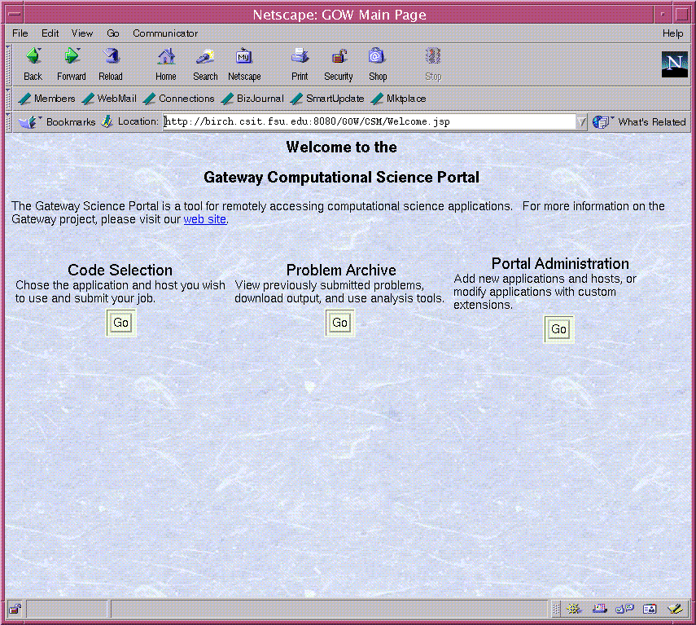

Figure 1: Gateway Welcome page defines tracks for code selection to create new problems, for a problem archive of old sessions, and for an administrative track for editing portal properties.
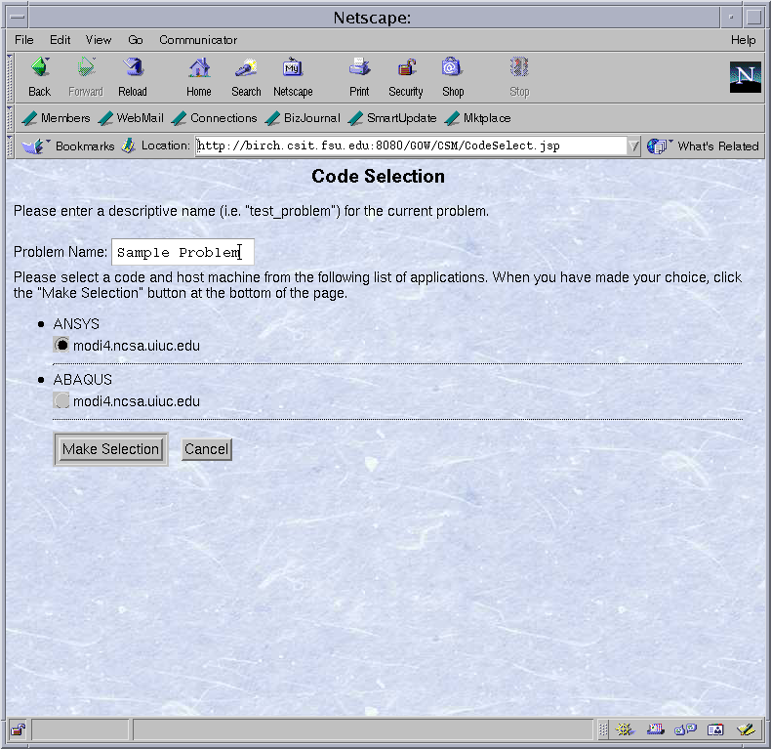

Figure 2: The code selection track allows users to choose applications and host computers for running jobs. This page is dynamically created from XML data records of available codes and machines. The data record can be edited through the administration interface.

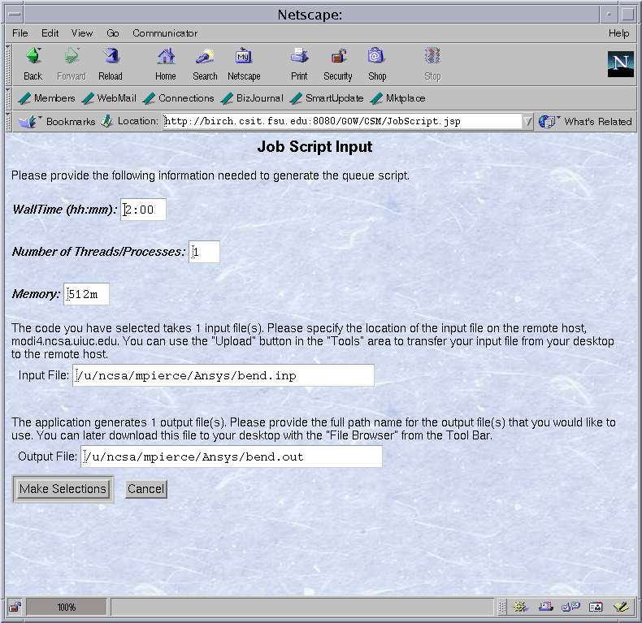

Figure 3: For requested codes, the XML data record is used to generate the forms needed to create a batch queuing script. The script may then be submitted to the selected host through the browser.

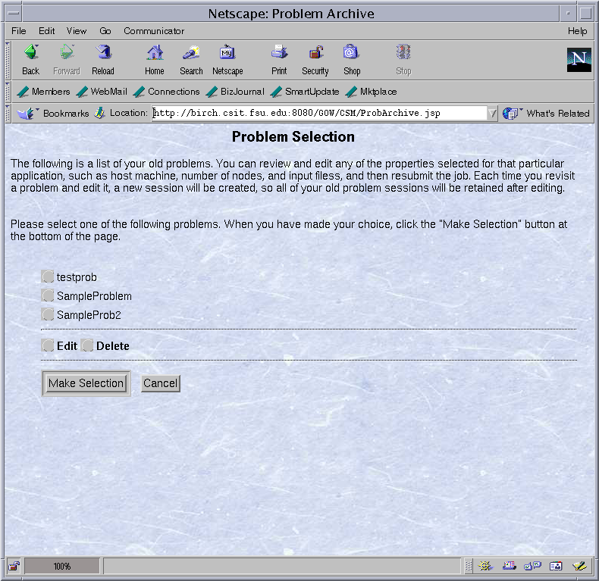

Figure 4: Old user sessions are archived and can be reviewed. Users can edit parameters, such as input files and host machines, and resubmit job requests.

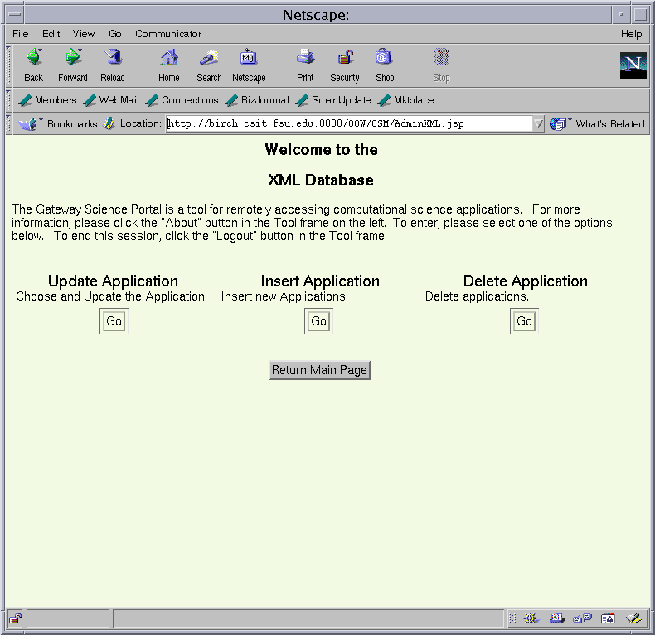

Figure 5: Portal administrators add or delete host machines and applications that are available through the portal. Host and application properties can also be edited.

