

Proposed Revisions to ebXML Technical Architecture Specification v1.0.4

ebXML Business Process Project Team

11 May 2001

Status of this Document

There are three categories of ebXML deliverables:

- Technical Specifications conform to the ebXML Requirements document.

- Technical Reports are either guidelines or catalogues.

- White Papers constitute a snapshot of on-going work within a Project Team.

This White Paper represents a report that has been approved by the Business Process Project Team and has been accepted by the ebXML Steering Committee.

The material in this document constitutes a snapshot of on-going work within this Project Team.

Distribution of this document is unlimited.

This version:
http://www.ebxml.org/specs/bpTAREV.pdf
6. Business Process and Information Analysis Methodology and Meta-model

Analysis teams will use methodologies and metamodels to specify the business processes in an electronic business community. An analysis methodology prescribes the overall process and sub-processes by which teams should proceed when defining business processes. The semantics of the metamodel define the information that needs to be discovered and documented during the analysis process. Methodologies often include patterns to expedite the “design” of the model and help achieve common expression of similar concepts.

While business practices from one organization to another are highly variable, these practices can be decomposed into Business Processes, Business Collaborations, Business Transactions and their related Business Information (documents). This analysis through the modeling process will identify Business Process and Information Models that are likely candidates for re-use and standardization. The ebXML approach looks for standard reusable components at all levels in business process and information models from which to further construct new models. This approach facilitates interoperability through its reuse of well-understood models and sub-models.

ebXML recommends (but does not require) that analysis teams use the methodology specified by the UN/CEFACT Modeling Methodology (UMM). If an alternative methodology is used, it is highly recommended that it be compliant with the UMM so as to have the best opportunity of creating business process models that are compatible with business process models created using the UMM. The ebXML Business Process and Business Information Analysis Overview document describes the process by which enterprises can analyze, identify, and define those business processes and business documents necessary for the conduct of electronic business with other enterprises, within the ebXML framework.

Compliance to ebXML Requirements requires that the business process and business information artifacts generated as a result of the analysis effort be conformant to the semantics defined a single consistent modeling language and methodology. The ebXML Business Process modeling language and methodology of choice is the UML-based UMM and its supporting business process metamodel (UMM Metamodel). This is necessary to give the best assurance of compatibility between business process models and model sub-components. This semantic conformance is necessary to meet the requirement that the models to be usable and re-usable, and be capable of being compared and contrasted. With models that are UMM Metamodel conformant, users and tools can generate runtime XML business process specification instances (e.g. in ebXML Business Process Specification Schema format) and other alternative representations that have the same semantics. Furthermore, the models can be freely shared among ebXML-compliant modeling tools, including, but not limited, to UML tools.

6.1 UN/CEFACT Modeling Methodology Overview

The UMM, which primarily implements the Business Operational View of the Open-edi Reference Model, ISO/IEC 14662, provides the prescription and precision required for predictive results. The UMM is based on Business Modeling, Requirements, Analysis and Design workflows needed to understand the business needs to produce business scenarios, business objects and areas of business collaboration. The use and relationships of the methods, patterns and model artifacts are defined within each workflow. For each workflow a method is applied to a pattern using modelling elements with well-defined semantics. The deliverables of the UMM workflows are shown as artifacts in Figure 2.

Figure 2 UMM Workflows and Artifacts

The UMM Metamodel is organized into the following views so that each process model can be viewed from a number of perspectives.
- The Business Operations Map (BOM) metamodel – the partitioning of business processes into business areas and business categories.
- The Business Requirements View (BRV) metamodel – the view of a business process model that captures the Use Case scenarios, inputs, outputs, constraints and system boundaries for commercial transactions and their interrelationships.
- The Business Transaction View (BTV) metamodel - the view of a business process model that captures the semantics of business information entities and their flow of exchange between roles as they perform business activities.
- The Business Service View (BSV) metamodel - the view of a business process model that specifies the network component services and agents and their message (information) exchange as interactions necessary to execute and validate a business process.

These perspectives support an incremental model construction methodology and provide levels of specification granularity that are suitable for communicating the model to business practitioners, business application integrators and network application solution providers.

6.2 ebXML Business Operation View

[Editor Note: Delete this section. The title of this section is confusing as the contents of this section provide what we have described in the Business Process and Business Information Analysis document (which is referenced above).]

6.3 ebXML Functional Service View

[Editor Note:
- Move this section to be between the current titles 7 and 7.1 and change title of section 7 to read "ebXML architecture overview". Also change figure number of Figure 4 to be Figure 3, as well as decrement all subsequent figure numbers.
- Add the following as the final sentence of the section: “The ebXML architecture corresponds to the Functional Service View of the Open-edi Reference Model, ISO/IEC 14662.”]
Changes to TA section 8.2 (this is a proposal to update/correct section 8.2 by item by item changes, it is not a rewrite – to see actual changes, use Word’s tools-> track changes option:

The changes made are governed by the following rationale:

1. Current TA document makes inaccurate use of the word Meta Model.
Solution: Everywhere in the document change "ebXML Business Process and Information Metamodel" to one of the following dependent on context of each occurrence:

- UMM metamodel
- Business Process and Information Model
- ebXML Business Process Specification
- Business Process

This applies to both text and figures.

2. Current TA document makes inaccurate use of the word Business Process.
Solution:
Everywhere where 'Business Process' refers to the document specifying it, change it, dependent on context, to explicitly say ebXML Business Process Specification.

3. BP Analysis and BP metamodel teams have come to a new viewpoint on the relationship between UMM methodology/metamodel and ebXML. This new viewpoint needs to be reflected consistently in TA, BPSS, and Analysis documents.
Solution: State that UMM is not Mandatory but Recommended
3.a. Using a modeling methodology is optional, and even if you chose to model, UMM is still optional
3.b. The only part of the UMM metamodel that is currently mandatory for BP is the semantic subset represented by the ebXML Business Process Specification Schema.
3.c. As UN/CEFACT finalizes and evolved the UMM, it is anticipated that other parts of the UMM metamodel may also become mandatory.

4. Current TA diagram has left out BPSS of the architecture overview diagram.
Solution: Amend figure 4 to show BPSS explicitly. This could be three boxes BPIM->ModelConversion to XML-->BusinessProcessSpecification.

5. Current TA diagram is unclear on storage format of BPSS. CPP/CPA requires it to be XML
Solution: State that ebXML Business Process Specifications SHALL be expressed in XML, (not just be expressable in XML)

6. Current TA is confusing in the discussion of UMM vs. UML. BP teams feel that TA should concentrate on describing relationship to UMM rather than to UML>
Solution: Remove (or move) the requirement for UML

7. Current TA is not clear in its reference to ebXML Business Process Specification Schema
Solution: Fully spell out ebXML Business Process Specification Schema

8. BPSS issue # 118 needs to be addressed consistently in TA as well
Solution: Use phrase “UMM metamodel supports a set of business process viewpoints “ (rather than requirement/analysis/design viewpoints)

9. BP issue 41 points out inaccuracy in use of word message.
Solution: Replace Message with Business Document

8.2 Business Process and Information Modeling

8.2.1 Introduction
The UMM Metamodel is a mechanism that allows Trading Partners to capture the details for a specific business scenario using a consistent modeling methodology. A Business Process describes in detail how Trading Partners take on roles, relationships and responsibilities to facilitate interaction with other Trading Partners in shared collaborations. The interaction between roles takes place as a choreographed set of business transactions. Each business transaction is expressed as an exchange of electronic Business Documents. Business Documents MAY be composed from re-useable Business Information Objects (see “Relationships to Core Components” under 8.2.3 “Interfaces” below). At a lower level, Business Processes can be composed of re-useable Core Processes, and Business Information Objects can be composed of re-useable Core Components.

The UMM Metamodel supports a set of business process viewpoints that provide a set of semantics (vocabulary) for each viewpoint and forms the basis of specification of the artifacts that are recommended to facilitate Business Process and information integration and interoperability.

An additional view of the UMM Metamodel, the ebXML Business Process Specification Schema , is also provided to support the direct specification of the set of elements required to configure a runtime system in order to execute a set of ebXML business transactions. By drawing out modeling elements from several of the other views, the ebXML Business Process Specification Schema forms a semantic subset of the UMM Metamodel. The ebXMLBusiness Process Specification Schema is available in two stand-alone representations, a UML version, and an XML version.

The only part of the UMM metamodel that is currently mandatory for use in specifying ebXML compliant software is the semantic subset represented by the ebXML Business Process Specification Schema. As UN/CEFACT finalizes and evolves the UMM, it is anticipated that other parts of the UMM metamodel may also become mandatory.

The relationship between the UMM Metamodel and the ebXML Business Process Specification Schema can be shown as follows:

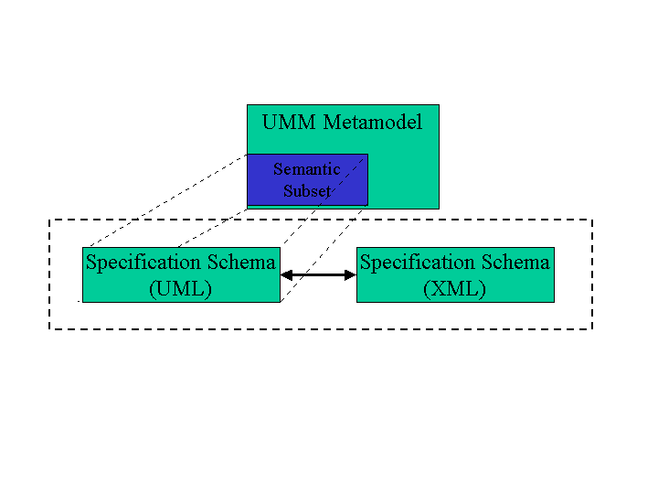
Figure 9 ebXML Metamodel – Semantic Subset
Using Figure 9 above as an illustration, instances of models and specifications would be created as follows:
- A Business Process and Information Model is defined against the UMM Metamodel
- A Business Process Specification is defined against the ebXML Business Process Specification Schema

The ebXML Business Process Specification Schema supports the specification of business transactions and the choreography of business transactions into Business Collaborations. Each Business Transaction can be implemented using one of many available standard patterns. These patterns determine the actual exchange of Business Documents and signals between Trading Partners to achieve the required electronic transaction. To help specify the patterns the UMM provides a set of standard patterns, and the ebXML Business Process Specification Schema provides a set of modeling elements in support of those patterns. The ebXML specification of a Business Process is referred to as a Business Process Specification.
The Business Process Specification serves as primary input for the formation of Collaboration Protocol Profiles (CPP’s) and CPA’s.

This can be shown as follows:

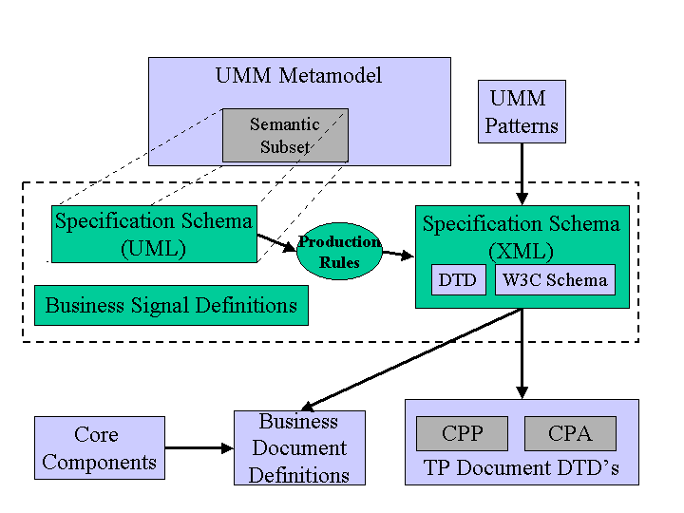

Figure 10 ebXML Business Process Specification Schema

One of the key benefits of using a single consistent modeling methodology is that it is possible to compare models to avoid duplication of existing Business Processes.

To further facilitate the creation of consistent Business Process and information models, ebXML will define a common set of Business Processes in parallel with a Core Library. It is possible that users of the ebXML infrastructure may wish to extend this set or use their own Business Processes.

8.2.2 Formal Functionality
The representation of a Business Process Specification instance SHALL be in a form that will allow both humans and applications to read the information. This is necessary to facilitate a gradual transition to full automation of business interactions.

The Business Process Specification SHALL be storable and retrievable in a Registry mechanism.Business Process Specifications MAY be registered in an ebXML Registry in order to facilitate discovery and retrieval. To be understood by an application, a Business Process Specification SHALL be expressed in XML syntax.

Business Process Specifications are capable of expressing the following types of information:

- Choreography for the exchange of Business Document instances. (e.g. the choreography of necessary Business Document exchanges between two Trading Partners executing a “Purchasing” ebXML transaction.)
- References to Business Documents (possibly DTD’s or Schemas) that add structure to business data.
- Definition of the roles for each participant in a Business Process.

A Business Process Specification:
- Provides the contextual constraints for using Core Components
- Provides the framework for establishing CPAs
- Specifies the domain owner of a Business Process, along with relevant contact information.
[NOTE: the above lists are not inclusive.]

8.2.3 Interfaces

Relationship to CPP and CPA
The CPP instance of a Trading Partner defines that partner’s functional and technical capability to support zero, one, or more roles in one or more Business Process Specifications.

The agreement between two Trading Partners defines the actual conditions under which the two partners will conduct business transactions together. The Interface between a Business Process and Information Model, and the CPA is the Business Process Specification. The theBusiness Process Specification SHALL be instantiated as an XML document representing the business transactional and collaboration layers of the UMM Metamodel according to the ebXML Business Process Specification Schema. The expression of the sequence of commercial transactions in XML is shared between the Business Process Specification and Trading Partner CPP and CPA documents.

Relationship to Core Components
A Business Process Specification SHOULD specify the constraints for exchanging business data with other Trading Partners. The business information MAY be comprised of components of the ebXML Core Library. A Business Process Specification SHALL reference the appropriate Business Documents (possibly DTD’s or Schemas). The mechanism for interfacing with the Core Components and Core Library SHALL be by way of a unique identifier for each component.

Relationship to ebXML Messaging
A Business Process Specification SHALL be capable of being transported from a Registry Service to another Registry Service via an ebXML Message. It SHALL also be capable of being transported between a Registry and a users application via the ebXML
Messaging Service.

Relationship to a Registry System
A Business Process Specification intended for use within the ebXML infrastructure SHALL be retrievable through a Registry query, and therefore, each Business Process Specification SHALL contain a unique identifier.

8.2.4 Non-Normative Implementation Details
The exact composition of Business Information Objects or a Business Document is guided by a set of contexts derived from the Business Process. The modeling layer of the architecture is highlighted in green in Figure 11 below.

Retain Current Figure 12 here, but renumber to Figure 11.

Business Process and Information Models MAY be created following the recommended UN/CEFACT Modeling Methodology (UMM), or MAY be arrived at in any other way. It is recommended they comply with the UMM Metamodel.

Copyright Statement
Copyright © UN/CEFACT and OASIS, 2001. All Rights Reserved

This document and translations of it MAY be copied and furnished to others, and derivative works that comment on or otherwise explain it or assist in its implementation MAY be prepared, copied, published and distributed, in whole or in part, without restriction of any kind, provided that the above copyright notice and this paragraph are included on all such copies and derivative works. However, this document itself MAY not be modified in any way, such as by removing the copyright notice or references to ebXML, UN/CEFACT, or OASIS, except as required to translate it into languages other than English.

The limited permissions granted above are perpetual and will not be revoked by ebXML or its successors or assigns.

This document and the information contained herein is provided on an "AS IS" basis and ebXML DISCLAIMS ALL WARRANTIES, EXPRESS OR IMPLIED, INCLUDING BUT NOT LIMITED TO ANY WARRANTY THAT THE USE OF THE INFORMATION HEREIN WILL NOT INFRINGE ANY RIGHTS OR ANY IMPLIED WARRANTIES OF MERCHANTABILITY OR FITNESS FOR A PARTICULAR PURPOSE.

