
HPJava Demos for SC ‘98

HPJava is an environment for SPMD (Single Program, Multiple Data) parallel programming - especially, for SPMD programming with distributed arrays.
The acronym ``HPJava'' was coined in a draft white paper produced by members of the PCRC consortium early in 1996. NPAC adopted the name for its Java environment for SPMD computing. This environment will eventually contain Java bindings for distributed-array based libraries, general MIMD programming libraries, and a preprocessor for an extended dialect of Java. The HPJava language model was motivated by work on HPF during in the PCRC project - it captures the HPF distributed array model in special syntax, but assumes that the programmer directly calls high-level runtime functions for communication and array manipulation.
In the last year the HPJava language definition has been developed and refined. Work on a translator is in progress. Java bindings of various runtime functions have been implemented. The first useable component of the HPJava environment is the recently released mpiJava binding of MPI.

mpiJava demos
mpiJava is an object-oriented Java interface to the standard Message Passing Interface (MPI). The current release of mpiJava provides the full functionality of MPI 1.1. It is implemented as a set of JNI wrappers to native MPI packages. Platforms currently supported include Solaris using MPICH or SunHPC-MPI, and Windows NT using WMPI 1.1. We are actively developing the release and intend to add new features such as object serialization and support for additional platforms. The Java API is defined in the NPAC document "A Draft Java Binding for MPI".
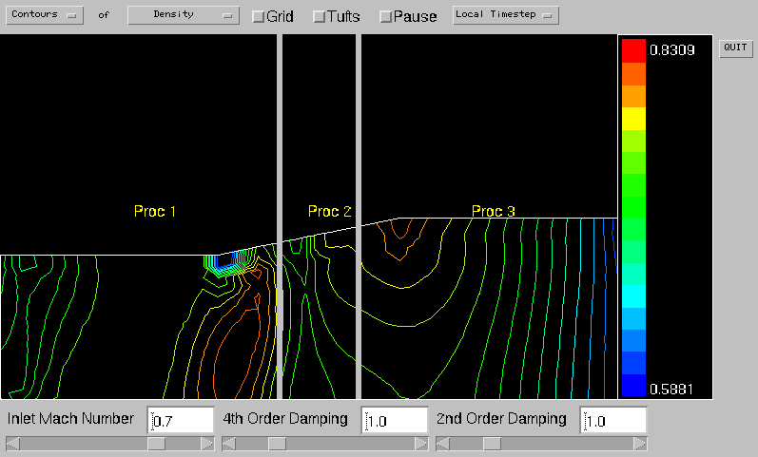

CFD: 2-D Inviscid Flow, Airfoil, and Elliptic Flow Simulations
This CFD system simulates a 2-D inviscid flow through an axisymmetric nozzle, flow over an airfoil as well as an elliptic flow. The simulation yields contour plots of all flow variables, including velocity components, pressure, mach number, density and temperature. The plots show the location of any shock wave that would reside in the nozzle or at the tip of the airfoil. The simulation centers around finding the steady state solution to the 2-D Euler equations. For this, it uses a 4-stage Runge-Kutta time-stepping algorithm and a finite volume central-difference method to come up with the solution. The flow is from left to right across the nozzle over the airfoil. To see the flow through, `tuft’ and `grid’ keys were added. The flow shown here is transonic and the system can be adjusted to have either a subsonic or a supersonic flow. The parallel version being demonstrated here uses mpiJava for communication.
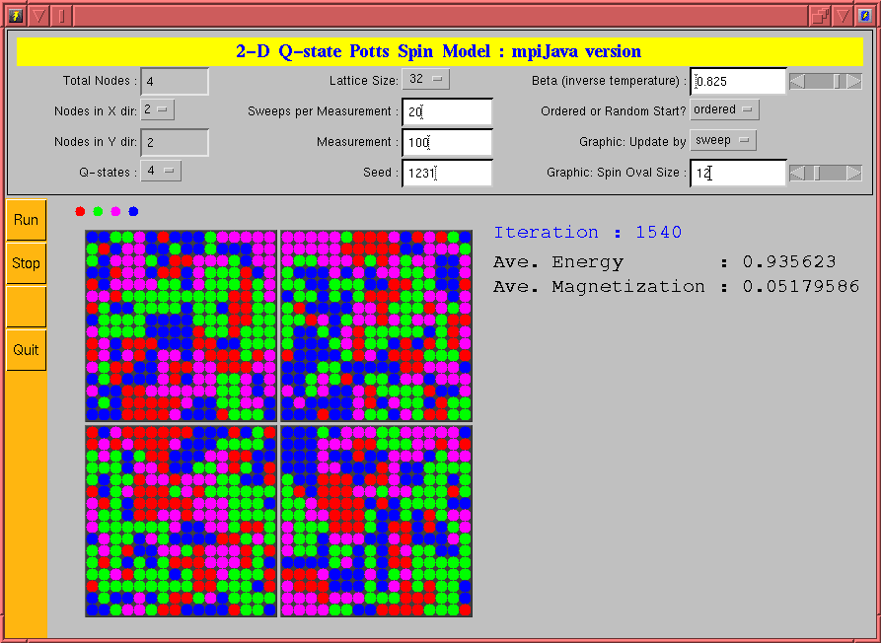

Monte Carlo Simulation: The Potts Model
The Potts model is a generalization of the well-known Ising model of statistical physics. It models the thermodynamics of a two dimensional system of spins. The spins of the q-state Potts model take q possible values, represented by q colors in the display. The parallel demo code uses is written in Java and uses mpiJava for communication and AWT graphics for the display. All parameters of the simulation, including the process grid, can be modified from the control panel. At SC ’98 the demo will be running on a group of connected laptop PCs running Windows NT, with WMPI as the underlying communication layer.

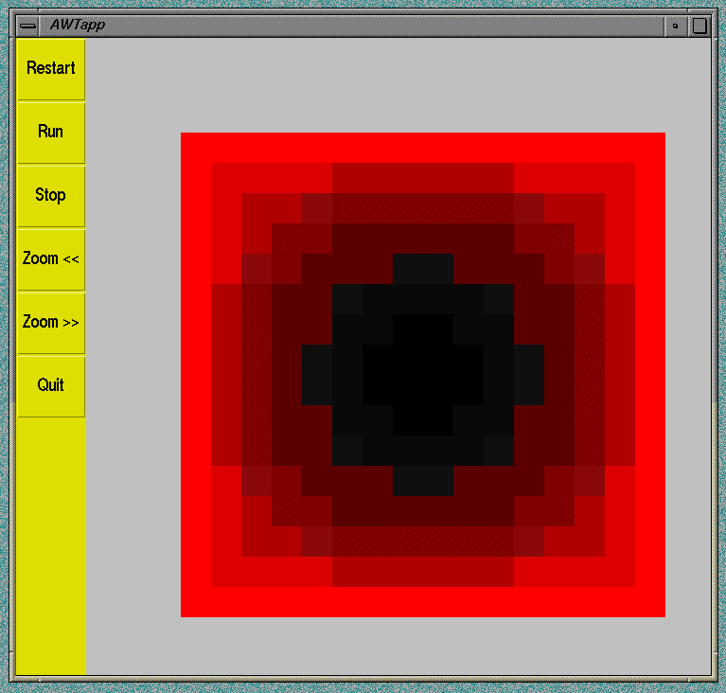

adJava demos

adjava is a Java interface to the NPAC kernel runtime library delivered in the PCRC project. The library was originally designed to simplify translation of HPF. It supports many operations on HPF-like distributed arrays. Fortran and C++ interfaces have been available for some time. The new Java interface supports the HPJava translator.

