Solid Earth Summary
Draft 5/10/02
by
Andrea Donnellan, JPL

Jay Parker (JPL)
John Ries (UT/CSR)
John Rundle (CU, UC Davis)

Report from

ESE Computation Technology Workshop

April 30 – May 2, 2002

State of Solid Earth Science

The field of solid earth science is currently mission and data poor. We anticipate, however, an increasing number of missions and data in the next 10 years. Space technologies will allow us to measure previously unobservable parameters and phenomena, resulting in a new understanding of complex, interconnected solid earth processes. The next great revolution in Earth sciences will involve development of predictive models of these processes. For these models to be successful, particularly for an understanding and forecasting of hazards, high-resolution, global observations with real-time or near-real time data streams and processing will be required. Integrating the huge quantities of data and information to be collected into forecast models will require that information technology resources be developed in concert with advanced sensor and detection capabilities.
The quantification of the computational needs is timely in light of the recent activities of the NASA Solid Earth Science Working Group (SESWG). This group is putting together a vision for solid earth science for the next 25 years (see http://solidearth.jpl.nasa.gov). The group has identified the following six science questions:
- What is the nature of deformation at plate boundaries and the implications for earthquake hazards?
- How is the land surface changing and producing natural hazards?
- What are the interactions among ice masses, oceans, and the solid earth and their implications for sea level change?
- How do magmatic systems evolve and under what conditions do volcanoes erupt?
- What are the dynamics of the mantle and crust and how does the earth’s surface respond?
- What are the dynamics of the earth’s magnetic field and its interactions with the earth system?

The sub-fields of solid earth that relate to NASA goals and must make use of computational resources include: earthquakes, volcanoes, tectonics, geodynamo, mantle dynamics, surface processes, landscape evolution, gravity, magnetic fields, cryosphere and ice modeling, and ecology, hydrology, and vegetation.

Solid-Earth processes often take place on scales of tens to millions of years. Even with the most advanced observational systems, the temporal sampling of such phenomena is poor. In order to understand fully these highly complex systems, simulations must be carried out concurrent with observations so that the entire system can be studied. The observational data can then be assimilated into these computational models, providing constraints and verification of the models. Because solid-Earth processes occur on many different spatial and temporal scales, it is often convenient to use different models. Increasing interoperability and making use of distributed computing can enable system-level science.

Computational Model for Earth Observations

One of the major problems facing scientists today is that the scientific data volumes are increasing at a faster rate than computational power, challenging both the analysis and the modeling of observations. Resources must be put into improved algorithms to simplify processing and to approximate complex phenomena to allow researchers to handle the large volumes of data as well as find the dominant physics in a given data set. Another promising approach to handling large data volumes is to use pattern recognition to focus attention and point out subtle features in the data.

Earth Science is experiencing a major paradigm shift as it enters an era consisting of recursive cycles of: “Monitor-Model-Assess-Predict.” Each new Earth Science mission contributes datasets that increase the value of those previously acquired. New missions will generate 10-20 TB per week. The scientific legacy and long-term value of these data results will depend on the ability to handle complex queries over data sets from multiple instruments and multiple missions.

We propose the development of a Solid Earth Research Virtual Observatory (SERVO), which will enable investigators to seamlessly merge new multiple data sets and models; and create new queries. SERVO will support new discoveries and predictions for decades to come. SERVO will benefit from technology developed for the National Virtual Observatory (NVO), and a post Human Genome Project “Digital Life portal.” Simulation data must be archived together with analysis/animation tools and the original simulation code.

Because of the complexity of the solid-Earth system, high-performance computers are essential requirements for scientific progress. Computations of the systems being studied, from the geodynamo to interacting fault systems, take weeks to months to run on even the most capable of current workstations. Considerable computational technology development will be required to make modeling an effective tool.

The new solid earth missions will continuously measure parameters in space, and use preprocessing to reduce data as much as possible for download. The downlink data transfer requires massive online data storage. The collaborative processing of this earth science data with earth-based measurements will transform the measurements into useful derived products using assimilation processes similar to those used for weather and climate.

The data storage, the science based modeling building, the analysis of data, and the timely use of derived products encompass the computational technology needed to achieve the goals set forth by the SESWG. SERVO, the Solid Earth Research Virtual Observatory, will support the many numerical laboratories proposed for meeting the solid earth science objectives. These numerical laboratories are problem focused, and have basic computational resource requirements. The primary requirements are: data storage, computation, cognitive visualization, and computational codes.

The needs statements for these numerical laboratories are focused on vendor hardware offering for resources. These expected vendor capability improvements have been and will be driven by fundamental industrial processes. The expected gains in the next ten years approach one and a half orders of magnitude. However, to meet the science goals the hardware tools fall short of the program needs, and we must address the science goals by committing intellectual resources to attack the computational problems. History supports the notion that there is as much to gain from program and code improvements as from faster hardware.

Figure 1. Solid Earth Research Virtual Observatory (SERVO) and associated computational framework for supporting solid earth science missions, data, analysis, and modeling.
Numerical Laboratories in the Support of Solid Earth Sciences

The physical processes associated with the solid earth take place on many scales of space and time.
Simulations and theory must account for how these many scales interact. The solid earth is complex, nonlinear, and self-organizing. Recent work suggests strong correlations in both space and time resulting in observable space-time patterns. Recent advances in computational science and numerical simulations enables studies of the complex solid earth system making it possible to address the following critical scientific questions:

- How can the study of strongly correlated solid earth systems be enabled by space-based data sets?
- What can numerical simulations reveal about the physical processes that characterize these systems?
- How can modern Information Technology enable new understanding of the basic physics?
- How do interactions in these systems lead to space-time correlations and patterns?
- What are the important feedback loops that mode-lock the system behavior?
- How do processes on a multiplicity of different scales interact to produce the emergent structures that are observed?
- Do the strong correlations allow the capability to forecast the system behavior in any sense?
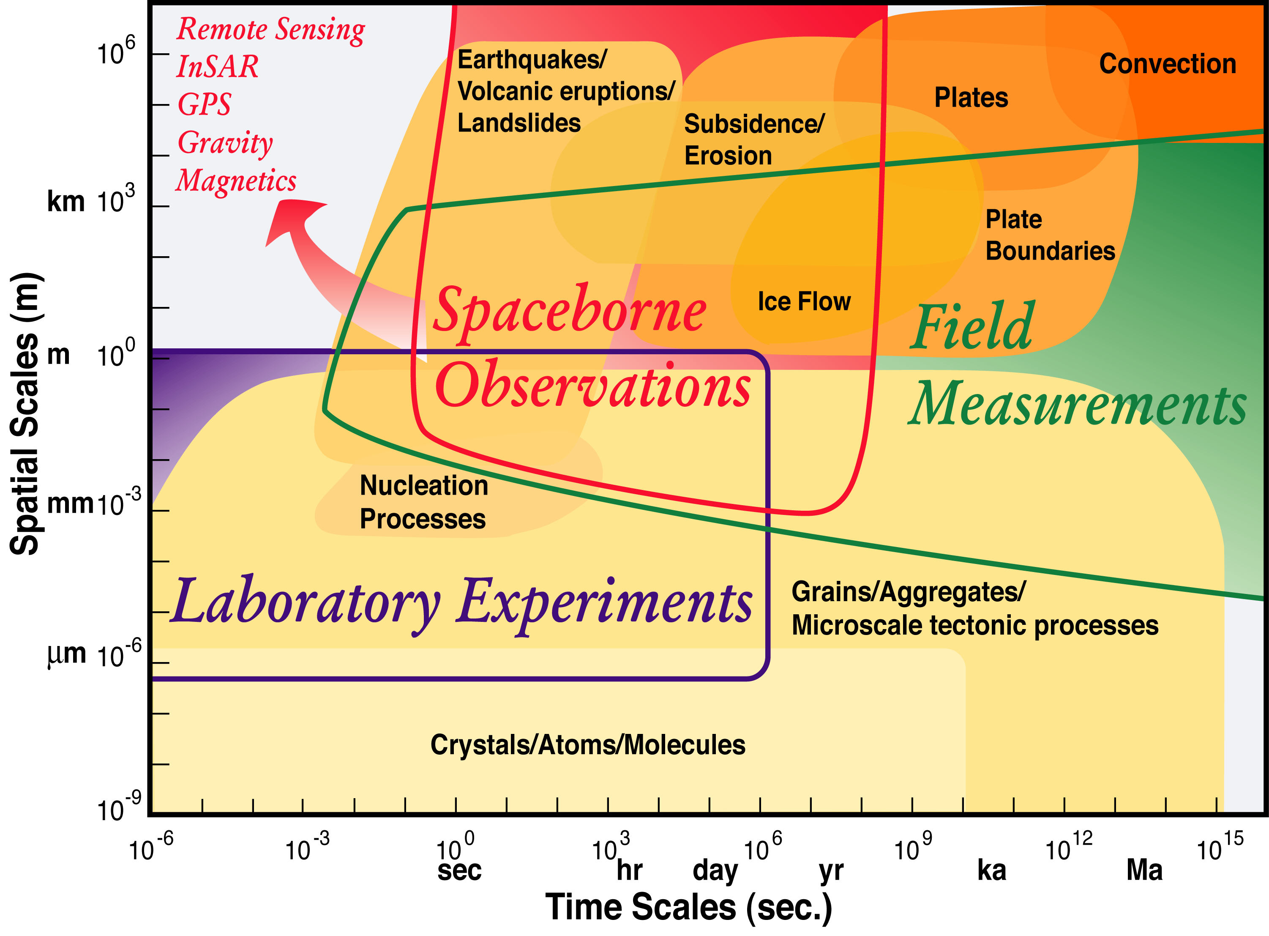
Figure 2. The physical processes associate with the solid earth take place on many scales of space and time. Simulations and theory must account for how these many scales interact.

- Three dimensional solid earth modeling for the gravity, geomagnetic, high resolution visual, and multispectral thermal data is compute intensive. The development of useful problem solving environments (PSE’s) should focus systems approaches to data management, computing and visualization.

- The management of data must meet the accessing time requirements and the long-term storage requirements. The maximum daily input data flow of 100 gigabytes defines several important parameters. The two most important examples are the retention storage and the routine analysis for quality control.

In 2010 we anticipate that multiple solid earth missions will be flying. PetaBytes of data will be gathered every year in a widely distributed fashion. Widely distributed scientists using widely distributed computational resources will analyze this data. There will be a growing need for the incorporation of information from multiple sources on multiple scales into an integrated analysis. The goal is to have worldwide computational systems supporting the gathering, integration, visualization, simulation, and interpretation of several petabytes of data per year. Achieving this goal requires:

Developing a Virtual Observatory
Such a virtual observatory will allow for seamless access to large distributed volumes of data. Data handling and archiving will be part of the framework. It will include tools for visualization, datamining and pattern recognition, and data fusion.

- Developing an Earth Science Problem Solving Environment
The problem-solving environment will allow for model and algorithm development and testing, visualization, and data assimilation. Problems developed within the environment will be scalable to workstations or supercomputers depending on the size of the problem to be solved. It will have compatible numerical libraries existing within a compatible framework. Algorithms within the framework will include PDE solvers, adaptive mesh generators, inversion tools, fast spherical harmonic transforms, wavelet analysis, particle dynamics, ray tracing and visualization preparation, and image processing and spectral analysis.

- Improving Computational Environment
Many of the solid earth problems are extremely computationally expensive, beyond the capability of existing supercomputers. Therefore, the capacity of high-end computers must be increased to PetaFLOPs with Terabytes of RAM. Distributed and cluster computers should be available for decomposable problems, for rapid development and for cost performance. The capacity of networks must be increased and investments should be made in the development of GRID technologies. Computational analysis would also be enabled by more open and seamless access to computational resources.

- Current and Anticipated Space Missions

The global nature of solid Earth science requires a wide variety of observation types, from in situ seismic arrays along faults to constellations of satellites. Increasingly we recognize that any understanding of the Earth will be incomplete if it fails to characterize, understand, and predict the interactions among the different components of the Earth system. Only with an interdisciplinary and global focus can we hope to succeed in understanding the dynamics of our planet. Space observations are uniquely suited to capturing infrequent events in their full richness, including consequences and possible precursors. Major earthquakes and large volcanic eruptions may be relatively rare in any given region, but on a global basis they occur comparatively frequently. To understand such events, which can have enormous impact in terms of both human life and economic disruption, continuous observations on a global scale are required so that these events may be studied completely. Space-based observations enable measurements not only of catastrophic events, but also of the more gradual motions that lead up to them. By measuring the full cycle (of earthquake, volcanoes, and other solid-Earth processes), a complete picture of the solid Earth is drawn.

Several missions are anticipated within the next decade to address these needs, which will produce greatly increased volumes of data (see Table 1). These include gravity field determination missions such as GRACE, GRACE follow-on, GOCE; radar interferometry missions such as ECHO; CHAMP and other magnetic field determination missions, ICESat, a laser altimeter mission; GPS data collection from hundreds of ground stations (SCIGN/PBO) as well as space platforms; and a wide variety of hyperspectral, high resolution visual, multispectral thermal, lidar imaging missions, such as VCL.

In order to estimate computer resources needed for meeting the goals of advancing each science area and substantially enhancing forecast of natural hazards, we lay out a strawman data processing scenario for one of these missions. The components of this scenario are not at operational readiness, but are topics of promising research and serve as examples of methods under current consideration that suggest plausible computational loads.

For ECHO, there will be 100 GB of data per day, which should be fully utilized for forecasting events on the global fault system. We assume missions operations has processed raw data, precise orbits, optimal focusing, and phase connection to produce data in the form geographically registered images of reflectance and phase, and particularly of line-of-sight deformation data, affected by water vapor variability and other errors. Hence before inversion there needs to be a preprocessing stage using multiple image averaging (to deal with water vapor variability), including local weather, resulting in deformation with some characterization of error covariance. This stage is not highly demanding of operations, (roughly 32 global “day” images, 10¹⁰ numbers per image, and 20 operations, come to 0.1 Gflops sustained computing), but taxing for I/O and data transfer rates.
Given the complexity of full forward modeling codes, it will be advantageous to make a quick and rough inversion in terms of earthquake fault slip and change to other deformation sources. An elastic half-space inversion for these sources naively might entail the full daily data set, 2000 iterations, 10⁴ sources and 100 greens-function related operations, hence 200 Tflops. But the iteration process can proceed from initially averaged data and other approximations, and focus on regions of most interest, so this may be reduced to 20 Gflops (sustained).
Accuracy may then be further refined in regions of interest by applying finite element techniques using known variations in rheology. Current work suggests 16 M finite elements can adequately characterize a complex region of high interest, such as southern California. Multiple runs involving iterative optimization techniques indicate the need for 0.1 Tflops rate per region of interest, which we take to be 80; but a single day of observation would cover 10 of these on average. Hence this stage requires 1 Tflops sustained.
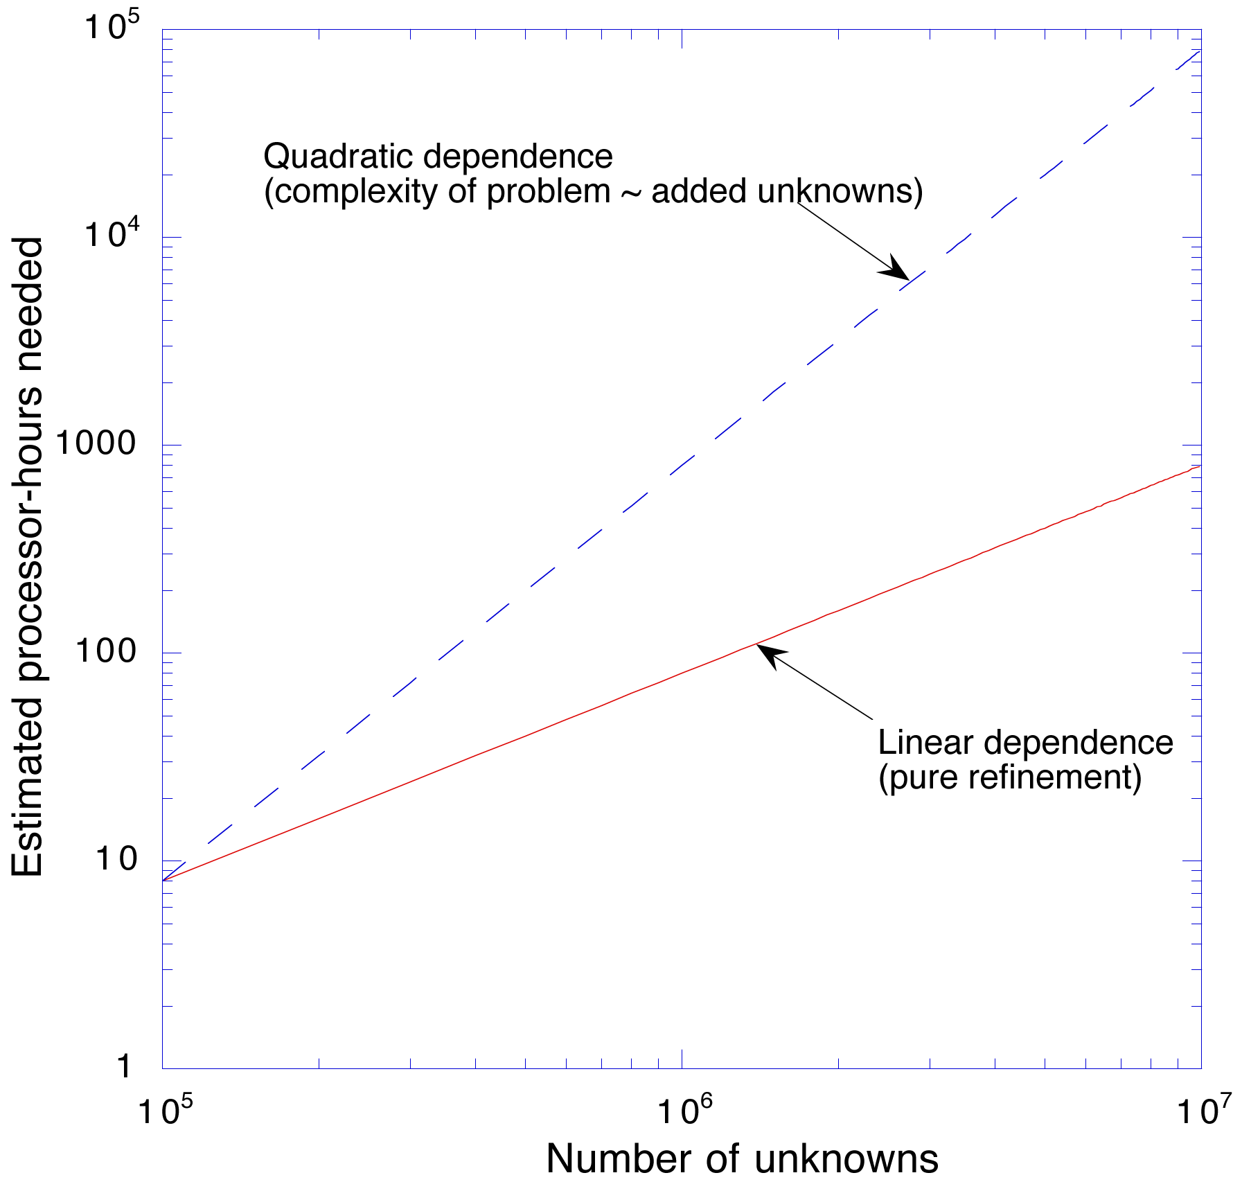
Figure 3. Processor time increases linearly with mesh refinement. Adding complexity increases the unknowns and solution time is quadratic in unknowns.

For forecasting, we require a dynamic model that can span scales larger than a finite element code. Boundary element methods combined with good fault-friction models can fulfill this need in principle, although substantial testing and development remain. Such a system can be coupled efficiently with the finite element regional models; we do not estimate the coupling overhead. Operations count can be estimated from assumptions of regional cost, plus assumptions of multipole coupling between regions; most of the cost is then in the regional interactions. So with 80 regions covered at 10 per day, 10⁵ fault patches per region with hence 10¹⁰ interactions, 100 operations per interaction, 1000 update steps for data-driven corrections (including recent history), and 0.1 computational efficiency, the requirement is 1 Tflops sustained.
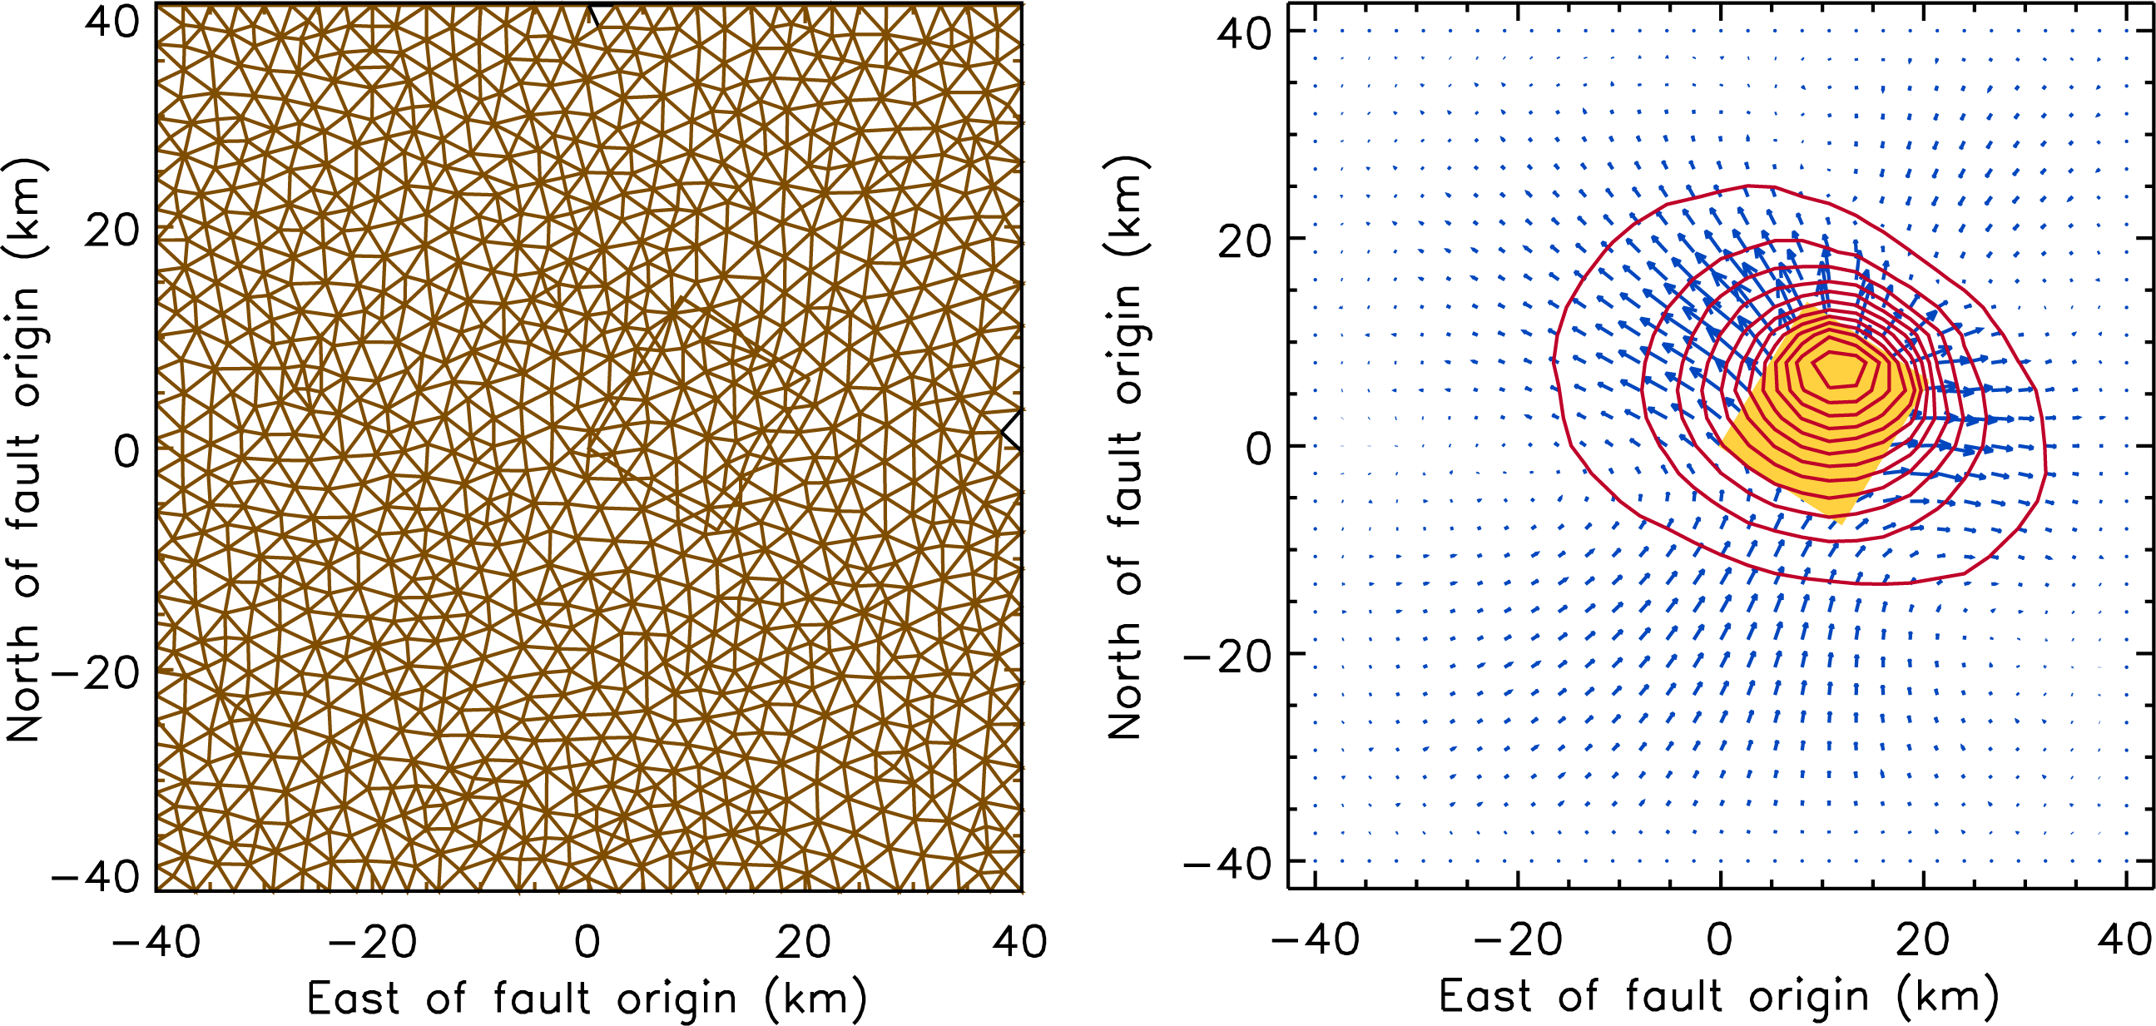
Figure 4. A Northridge class simulation with 100,000 unknowns, and 4000 time steps takes 8 hours on a highend workstation. Modeling the southern California system requires 4 million unknowns thus taking 12,800 processor hours for 1 km resolution. 0.5 km resolution would take 100,000 processor hours or 400 hours (17 days) on a dedicated 256 processor machine.
For better forecasting, eigenpattern rate techniques are needed. For each region, the 10⁵ fault patches imply 10¹⁵ operations to diagonalize local interactions. This may be reduced by focusing on the primary modes, suggesting Lanczos methods. Direct methods indicate 0.1 Tflops sustained.
Finally these pattern rates will be used to daily update an earthquake hazard map. This may be done with vector-oriented updates, and probably does not amount to more than 0.1 Tflops.
End to end, processing ECHO for earthquake forecasting comes to about 2 Tflops sustained rate, implying 10⁴ Petaflops/year.

Table 1. Data Volumes from Observations
Mission | Onboard Volume | Derived Product
GRACE | 50 MB/day onboard | 8GB/day derived product
ECHO | 100 GB/day onboard
SRTM | 12 TB raw data (mission total)
ICESat | 1 GB/day onboard | 2 GB/day derived
SCIGN | 250MB daily; 7.5 GB/day for real time
Airborne observations | LIDAR
VCL | 2 GB/day onboard | 4 GB/day derived
Hyperspectral imagery | 100GB/day raw
Imaging LIDAR | >20 GB/day | >40 GB/day

Table 2. Data Volumes Derived from Models
Model | Today | 2010
Geodynamo model | 1GB of storage for one model run | 5 TB/run with minimal need of 10 runs
General earthquake/lithospheric models | 1TB/run | 10 PB/run (multiple scales combined in many regions)
Gravity | 100 GB/run | 2 TB/run
Mantle convection models | 1 TB/run | 10PB/run
Geomagnetic field models | 32 GB/run | 300 GB/run

Table 3. Computation Environment Metrics
Item | Today | 2010
Processes | Currently none on supercomputers | 1 modeling run/day
Dedicated networks | 1Gb/s sustained | 50Gb/s sustained
Performance | 100s GigaFLOPs | PetaFLOPs
Memory (RAM) | 40 GB | 5 TB

Distributed data access

An important aspect of data collection is to create distributed centers for storing unique data sets and developing the infrastructure to compare, analyze and ingest complementary data sets, such as ice topography and sea level changes. Currently, cooperative federated databases do not exist; the data is heterogenous and widely distributed in a variety of formats. Because of the high volumes of data, now and in the future, datamining and other approaches for interacting with the data must be developed (possibly including more onboard processing). A Solid Earth Research Virtual Observatory (SERVO) is recommended to address this critical need. Such a system would have the following characteristics: distributed data at centers and ground stations; 1000s of sites with volumes of 1 TB – 1 PB; multi-tier architecture for staging of the data; middleware to control integrity and versioning; support standards developed within the community; work within datagrid projects and customize for key NASA solid earth needs; have high performance access of 100 GB files within 40 TB datasets within 5 minutes to user and program to program communication in milliseconds using staging, streaming, and advanced cache replication.

Such a system may be modeled on known centers, such as EOSDIS, the Physical Oceanography Distributed Active Archive Center (PODAAC), The National Virtual Observatory (NVO), and the World Organization of Volcano Observatories (WOVO) systems.

Modeling Complexity
Creating realistic simulations of solid earth processes requires complex models. Multiscale and multicomponent modeling requires that algorithms be developed and/or reengineered for current environments and platforms so that various components can interoperate. At present, no appropriate environment exists for testing, calibration, visualization, and development. Because software programs have been developed on different platforms it is difficult to merge them to integrate scales and components into a more comprehensive model. Real-time modeling poses a problem of both data and computational latency. The complexity of the problem requires high performance computers to realize these integrated models. Both models and algorithms must be developed to efficiently make use of high performance computers. Some algorithms are difficult to parallel requiring an investment in development of algorithms and computational methods. Adjusting the size of the problem to the resource is also difficult. We propose the development of an environment that recognizes the size of the problem to be solved that then farms the job out to the appropriately sized computer.

- Our recommendations in priority order are to:
- Develop a solid earth science Problem Solving Environment to support 10 solid earth sub-fields. This includes a prototyping environment for developing a model in a month; a modular framework for solid earth applications; a collaboratory, which includes teams of scientists and computational experts; visualization and data analysis tools, seamless computer access; and integration of data and multicomponent models.

- Development of improved parallel algorithms/applications (on the order of 100) with a scaled efficiency of at least 50% on large clusters; models and model assessment methods; and data assimilation techniques.

- The computational needs required to address model complexity include 100Tflops sustained rate capability per model, 5 TB total memory per model, and 10^4 Petaflops throughput (3 Tflop per second sustained) per sub-field per year.

Understanding the Data
Understanding the data is critical to meeting the science objective set forth by the SESWG. It is difficult to explore, visualize, and understand the data, and difficult to gain meaningful knowledge out of the large amounts of data, derived products, and model results. The multidimensionality of the data makes interpretation difficult. Another bottleneck lies in registering, map projecting, layering, and displaying the data.
We recommend an investment in visualization tools, methods, and standards for parallel platforms. These tools will include volume rendering in real time (10⁹ volume elements), data fusion, coregistration and layering for 1 TB datasets, and support of distributed visualization of heterogeneous data from about 10⁴ sources. Rendering the data will require specialized parallel graphics hardware/software to provide stereo HDTV at 120 frames/s. The visualization tools will make it possible to sweep through large amounts of three-dimensional data and model output. Three dimensional models are required to model the very heterogenous solid earth including plate tectonics, interacting fault systems, volcanoes, mantle processes, and the geodynamo.
Visualization allows a researcher to build up an intuition of the processes being studied. The development of computational approaches for datamining and data understanding allow for routine tasks to be accomplished efficiently. They also can be used to point out subtle features in the data, and redirect the scientis’ts attention, allowing for a more thorough understanding of the physics. The datamining approaches include pattern analysis of on the order of 10⁶ dimensions, wavelet analysis on the order of 10⁶ scales and inversion techniques involving 10⁶ parameters.
We recommend a combined approach of using both traditional and computerized data analysis. Traditional analysis techniques useful in cases where lots of science knowledge is required and human intuition and larger understanding are valuable. Computerized data understanding
is useful in cases where the important information is subtle, and may evade even an unaided human expert, or there is too much data for human "digestion." Putting the strengths of these two sides together results in the creation of computerized data analysis that can be used as a tool for scientists or data exploration and analysis, or can create a loop where scientists feed data into a system for analysis, look at results, decide on a new analyses to perform, feed data in again, etc.

Risks
A number of hardware and software risks were identified. Not all of these may be realistic, but they could not be casually dismissed. How should NASA build on the
open software model? Will the marketplace continue to support fast fFloating point operations on chips?
Wll performance FORTRAN support surv
Because we anticipate large data volumes in the next decade it is possible that the data won’t be fully utilized unless there is a concerted effort in creating tools to understand the large data volumes. Bandwidth limitations for both ground and space systems may result in critical data being lost. We are only now learning, for example, that an earthquake on one fault can have far reaching effects on the regional deformation field and on other faults. We must be able to freely explore all of the data to discover new processes.

There may be bottlenecks that limit performance but no tools to help identify limiting factors. Performance of future computation platforms is also a risk. It is possible that peak, but not sustained, performance will increase. Memory performance is constrained and is anticipated to be a bottleneck. To address these risks it is important to develop high performance algorithms that have a high reuse of memory, and also encourage innovation in the marketplace.

Roadmaps
Developing the computational environment to address the science goals of the SESWG requires a three-pronged but integrated approach. Investments over the next decade must be made to create a solid earth research virtual observatory (SERVO), create a rich problem solving environment, and an efficient computational environment.
Figure 5. Roadmap for the Solid Earth Virtual Observatory (SERVO).
Figure 6. Roadmap for the problem solving environment.
Figure 6. Roadmap for the computational environment.

