V. Cytoskeleton and Cell Motility

V.1 COORDINATOR:
H. Goodson (Dept. of Chemistry and Biochemistry, University of Notre Dame).

V.2 PARTICIPANTS:
M. Alber (Dept. of Mathematics, University of Notre Dame), B. Baker (Dept. Chemistry and Biochemistry, University of Notre Dame), L. Barabasi (Physics, University of Notre Dame), D. Chen (Dept. of Computer Science and Engineering, University of Notre Dame), C. D'Souza-Schorey (Dept. of Biological Sciences, University of Notre Dame), G. Forgacs (Dept. Physics, University of Missouri, Columbia), J. Glazier (Physics, University of Notre Dame), G. Hentschel (Dept. Physics, Emory University), T. Hinchcliffe (Dept. Biological Sciences, University of Notre Dame), J. Izaguirre (Dept. of Computer Science and Engineering, University of Notre Dame), P. Lee (Dept. Immunology, Stanford University), A. Palmer (Dept. of Chemical Engineering, University of Notre Dame), J. Tang (Dept. Physics, Indiana University, Bloomington), K. Vaughan (Dept. of Biological Sciences, University of Notre Dame).

V.3 SUMMARY:
Subcellular organization underlies essentially all activities of eukaryotic life - polarized growth, cell motility, response to stimuli, and multicellular development. At first glance, the mechanistic origins of this organization seem so complex and diffuse as to be experimentally intractable. However, most aspects of eukaryotic cell organization depend on the cytoskeleton, the dynamic, interconnected array of filamentous polymers that extends over the entire interior of the cell. The cytoskeleton forms the active scaffold that segregates the chromosomes, allows the cell to move in response to stimuli, provides a dynamic highway network for intracellular transport, acts as an integral part of intracellular signal transduction networks, and helps determine and maintain cell polarity. Cell-level organization is an essential prerequisite to the organization of tissues and organisms during development. Thus, to understand the Biocomplexity of development, we must understand in a quantitative and predictive way the properties of the cytoskeleton: how the dynamic interactions of the components form steady-state cytoskeletal structures, how other parts of the cell interact with the cytoskeleton, and how extracellular signals and interactions with the environment alter the behavior of the cytoskeleton, allowing complex behaviors such as chemotaxis, morphogenetic changes, and multicellular development. The specific goals we state below reflect the overall objective of the Center to understand the development of complex patterns and organization that arise in living systems at length scales from molecular to organismal.
Study of cytoskeletal components provides an ideal education for students of Biocomplexity, allowing them to integrate modeling and experiment at all scales. Our understanding of both the actin and tubulin networks is mature enough that modeling is not only possible but necessary to understand the complex interactions between cytoskeletal proteins and the phenomena these interactions cause. Because we can mix clearly defined components with known interaction characteristics either in test tubes or in silico, and compare the results, cytoskeletal components are ideal for developing and tuning quantitative and predictive mathematical models of Biocomplexity.

V.4 SPECIFIC GOALS:

V.4.i Our Goal is to Understand in a Quantitative and Predictive Way How Dynamic Interactions Between Cytoskeletal Components Lead to Steady-State Cellular Architectures:
We will integrate biochemical experiments and computer simulation to develop computational models that reproduce the self-organization of cytoskeletal dynamics. We will use both discrete (cellular automaton) and continuous (reaction-diffusion equations) models to accomplish this goal.

V.4.ii Our Goal is to Understand How the Cytoskeleton Responds to Extracellular Signals and the Specific Mechanisms by which it Participates in Signal Transduction:
Based on our computational models of cytoskeletal architecture, we will explore how extracellular signals affect the spatial organization of the network. We will also use our models to study the mechanisms of cytoskeleton-assisted intracellular trafficking of signaling molecules. This project will target a specific intracellular signaling pathway, the nuclear translocation of β-catenin.

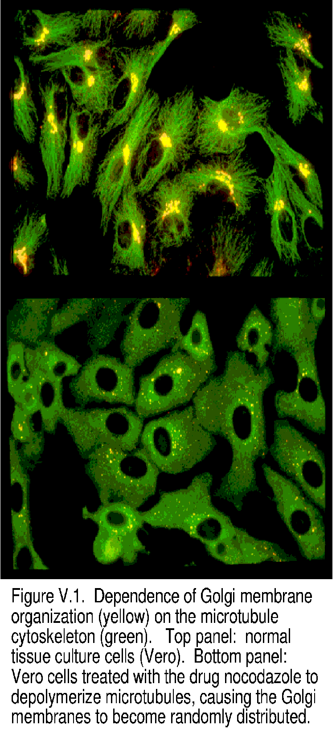
V.5 BACKGROUND AND SIGNIFICANCE:

The cytoskeleton is the network of protein filaments and associated proteins that gives cells their shape and mechanical properties, endows them with the ability to move, and allows them to respond dynamically to their environment (Kreis and Vale, 1999; Rogers and Gelfand, 2000). The cytoskeleton also internally organizes the cell (Drubin and Nelson, 1996). Eukaryotic cells are not “bags of enzymes,” but highly organized – membranous organelles spatially separate and localize to characteristic spaces. Secretion and endocytosis often occur in limited regions of the cell membrane. Many membrane proteins distribute in a polar manner, and processes such as directed motility require activation of specific proteins in specific places at specific times. Drugs or specific genetic alterations that damage the cytoskeleton disrupted this organization (Goodson et al. 1997) (Fig. V.1). One of the most striking examples of cytoskeletally driven subcellular organization is the mitotic spindle – the dynamic protein matrix that aligns the chromosomes during cell division, partitioning them with astonishing precision (Scholey et al., 2001).
Subcellular organization plays a profound role in the organization of tissues, organs, and eventually organisms. We often view development as the regulation of expression of genes inducing differentiation. Gene regulation, resulting in the expression of different complements of specific proteins, obviously plays an important role in the changes of cell properties that occur during development. The spatial organization of cell types and asymmetries necessary to produce functioning multicellular organisms arise from cytoskeletally-dependent subcellular asymmetries in the distribution of proteins. For example, the proper function of an epithelial layer such as the gut depends on polarized distribution of membrane proteins, which in turn depends on the cytoskeleton (Yeaman et al., 1999; Knust 2000). Establishment and maintenance of the polarized RNA and protein distributions that give rise to dorsal and ventral axes in developing animal embryos require specific cytoskeletal proteins (Bashirullah et al., 1998). Directed motility itself is important to development, as morphogenetic movements play a profound role in processes ranging from gastrulation to neuronal pathfinding to pigment development in the human skin (Christiansen et al., 2000; Tam et al., 2001).
The cytoskeleton consists of three main types of proteinaceous filaments – actin filaments, microtubule filaments, and intermediate filaments – together with their associated proteins. These associated proteins range from modulator proteins that control the morphology and behavior of the filament networks, to molecular motors that use the energy of ATP to create tensile force and/or physically move subcellular compartments, to “housekeeping proteins” such as metabolic enzymes that appear to use the cytoskeleton as a means of restricting diffusion (Kreis and Vale, 1999) to signaling proteins which use the cytoskeleton to carry out their specialized functions (Janmey, 1998). We tend to think of these three filament networks as independent modules, partly because of the practical difficulties of working biochemically with more than one type of filament at a time. However, these networks have many physical and regulatory connections (Pfister, 1999; Goode et al., 2000; Fuchs and Karakesisoglou, 2001).
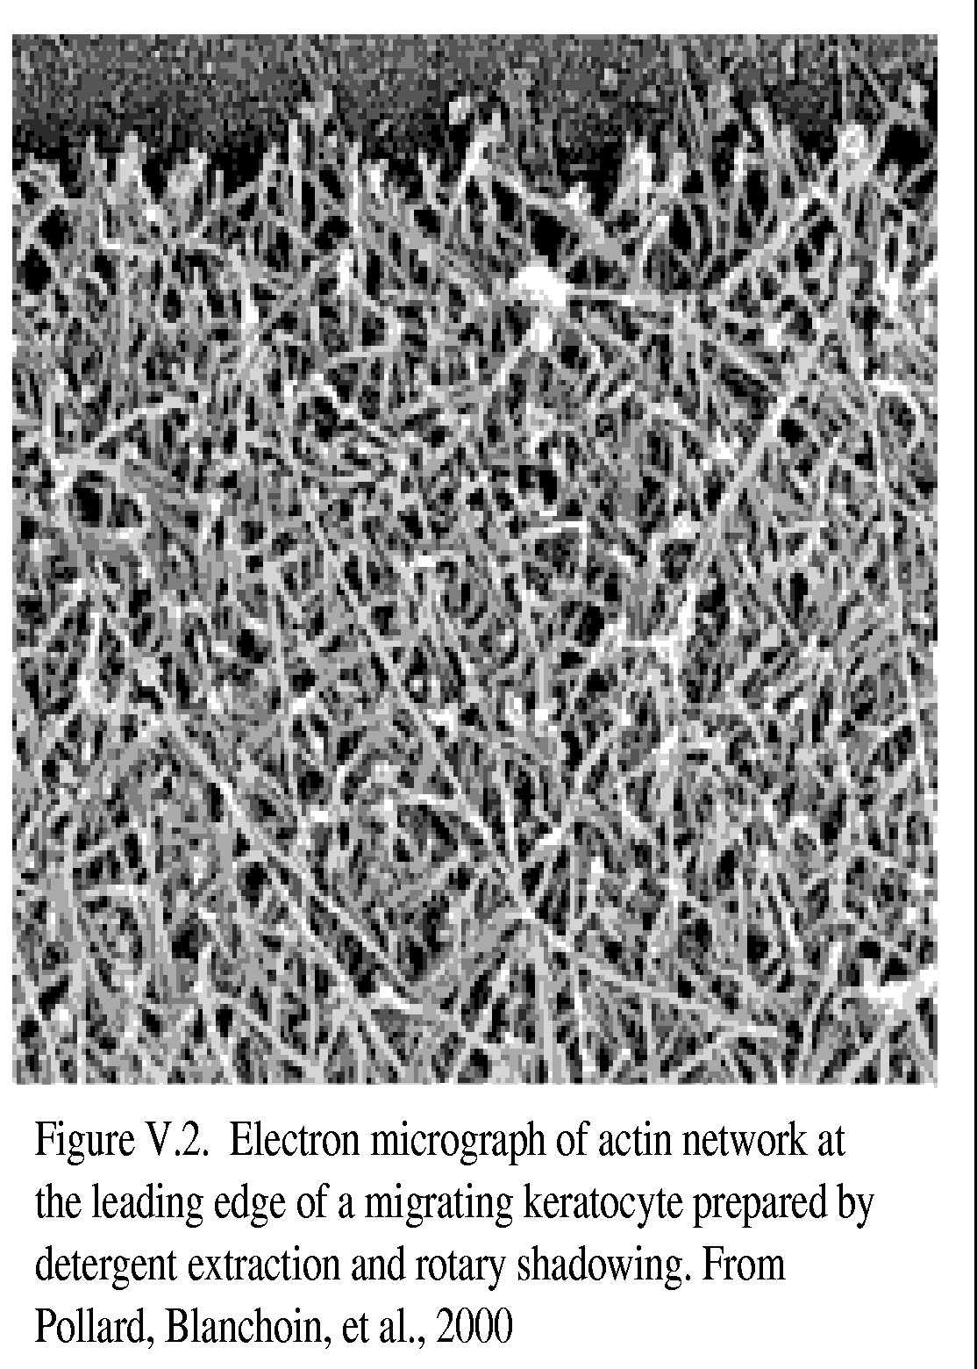
Although the term “cytoskeleton” suggests an inert, rigid matrix, the cytoskeleton is neither inert nor rigid. In most cell types it is a dynamic, responsive network of filaments whose characteristic morphology is the steady state result of dynamic processes. Actin and microtubule filaments constantly polymerize and depolymerize, both in living cells and in vitro. The constant turnover of these two filament networks lies at the heart of the responsiveness of the cytoskeleton, its ability to self-organize, and cell motility.
What drives these dynamics? Actin and microtubule filaments are noncovalent polymers of the proteins actin (forming actin filaments; Fig V.2) and tubulin (forming microtubules; Fig. V.3). Both actin and tubulin bind to nucleotides and hydrolyze these nucleotides (with a short delay) during polymerization (Fig. V.3). XTP polymers are relatively stable, while XDP polymers are unstable and tend to depolymerize. Repeated hydrolysis associated with polymerization/depolymerization seems wasteful at first glance but is actually fundamental to the function and activity of the cytoskeleton.
First, the constant disassembly of “old” polymer and assembly of new polymer ensures the constant turnover, remodeling, and responsiveness of the cytoskeleton. The dynamics of nucleotide hydrolysis is particularly important for the actin cytoskeleton. Actin turnover often takes the form of “treadmilling,” where filaments polymerize at one end and depolymerize at the other. Treadmilling, modulated by a large array of proteins that modulate nucleation, elongation, and branching, plays a fundamental role in cell motility and protrusion of the leading edge (Fig. V.4).
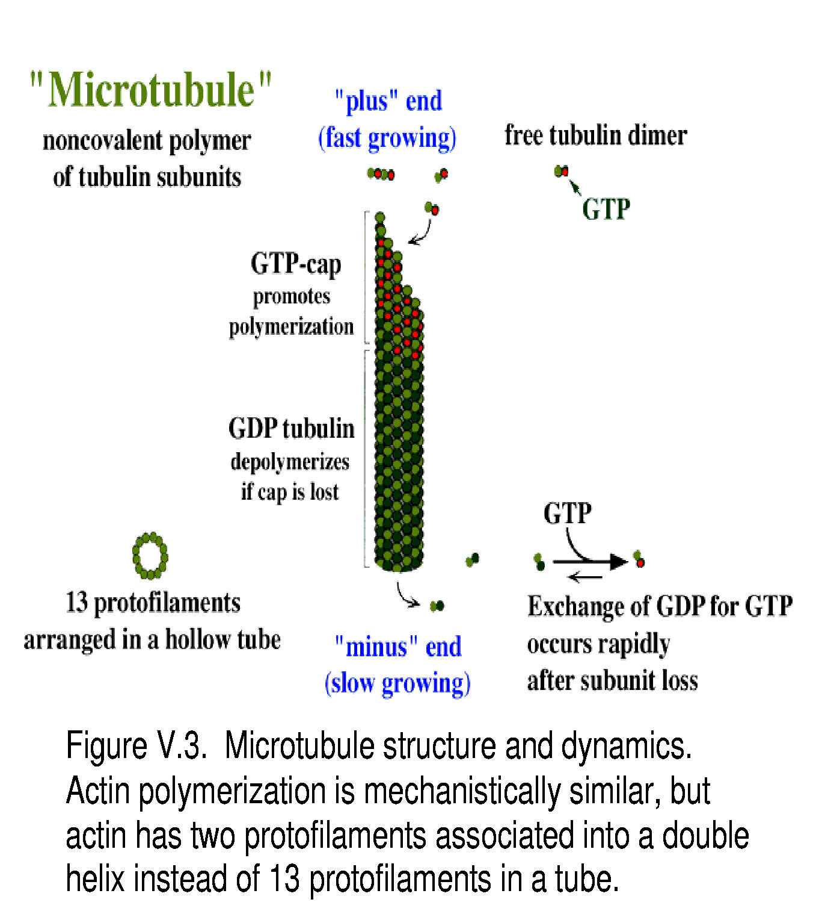
Second, the polymerizing and depolymerizing fibers explore space, an activity that is particularly important for the microtubule cytoskeleton (Desai and Mitchison, 1997). Microtubule filaments tend to have one end, the “minus” end, embedded in the nucleating centrosome while the “plus” end undergoes constant stochastic switches between growth and shrinkage (Fig. V.5). This behavior is known as “dynamic instability” and probably results from loss or acquisition of a stabilizing “GTP cap” (Fig. V.3, V.5). The constant exploratory polymerization and depolymerization may play a central role in cell organization because it allows large and poorly diffusible components like chromosomes to come into contact with microtubule “railroads” for subsequent transport.
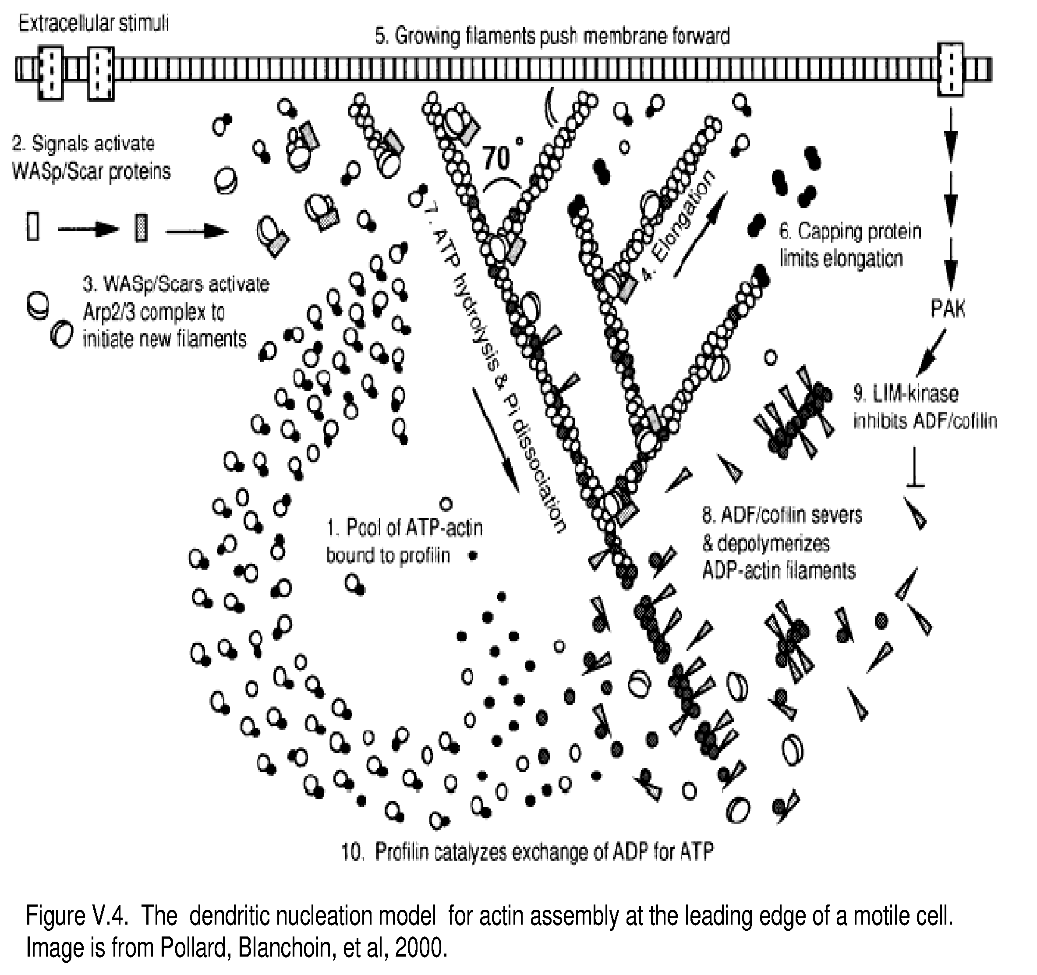

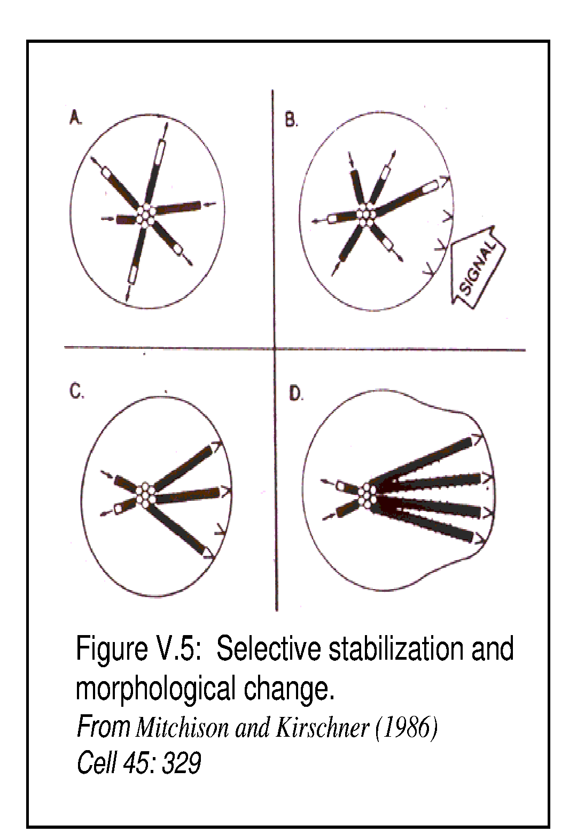
Finally, general destabilization of “old” filaments is important because it allows selective stabilization of specific filaments, leading to formation of stable cytoskeletal structures such as actin fibers in muscle cells or the microtubule bundles in nerve cells.
Selective stabilization is central to the remarkable self-organization of the mitotic spindle (Heald et al., 1996). Selective stabilization of dynamic microtubule filaments may be a key physical mechanism underlying morphological change (Fig. V.5) (Kirschner and Schulze, 1986; Holy and Leibler, 1994).

V.5.i Significance:
The long-term goal of the Notre Dame Center for the Study of Biocomplexity is to develop comprehensive multiscale models of development. To understand development in a quantitative and predictive way, we must understand the origin of the underlying subcellular asymmetries and morphogenetic movements. Because the cytoskeleton underlies essentially all cell organization and motility, this understanding requires a quantitative and predictive description of the cytoskeleton.
To achieve this goal, we must understand the dynamic properties of cytoskeletal networks and how modulatory proteins alter these properties. The complexity of the dynamic interactions in these networks requires computational approaches for eventual comprehensive understanding of problems like control of cell shape, motility, and response to the environment. Indeed, the dynamic behavior of even “simple” mixtures of pure polymerizing filaments is impossible to understand in a quantitative and predictive way without computational modeling. However, modeling is relevant only if it is based on sufficient knowledge of the biological details. Therefore, we will work towards the goal of predictively describing the cytoskeleton by integrating modeling and experiment.
1) Experiments will characterize specific proteins that modulate the actin and microtubule cytoskeletons, especially the actin cross-linking proteins α-actinin and fimbrin and the microtubule plus-end binding proteins CLIP-170, p150, and EB1. We will quantitatively characterize how these proteins alter filament dynamics and how they alter the physical properties of the resulting filament networks. When appropriate, we will determine the affinity of these proteins for different nucleotide states of polymerized and unpolymerized filament proteins. These experiments will establish essential parameters for our models. Analysis of protein and genetic interaction networks (Project 1) will help identify key modulatory proteins.
2) Simulations will initially focus on modeling how modulatory proteins and others derived from the literature alter the dynamic and physical properties of filament networks, carefully building the complexity of the models in line with experiments, with constant feedback between the two. While incorporating biological detail is essential to predictive models, we also wish to identify fundamental principals that are more detail independent. Therefore we will attempt to combine reaction-diffusion and computational geometry methods to model self-organization of dynamic cytoskeletal filaments as seen in in vitro models of the mitotic spindle (Heald et al., 1996) using minimal components and parameters.
A further related goal of the Center is to understand the role of the cytoskeleton in intracellular signaling. The cytoskeleton is an important player in intracellular signaling, anchoring numerous signaling molecules (Mochly-Rosen, 1995; Janmey, 1998). However, we know very little about the specific way the cytoskeleton participates in signaling. We will model cytoskeleton assisted signal transduction using the interconnected character of this filamentous assembly. This project will strongly couple to Project 1, which studies the role of the cytoskeleton in intracellular signaling using protein interaction networks.

V.6 RESEARCH PLAN:

V.6.i Our Goal is to Understand in a Quantitative and Predictive Way How Dynamic Interactions Between Cytoskeletal Components Lead to Steady-State Cellular Architectures.
This goal is significant for understanding development because establishing subcellular asymmetries is essential to forming asymmetries at the tissue level, and because morphogenetic movements are essential to fundamental developmental processes such as gastrulation. The cytoskeleton is a prototypical problem in Biocomplexity: it consists of a large number of components that interact as a dynamic network producing emergent phenomena such as self-organization (like the mitotic spindle) or force generation (like protrusion of the leading edge of a migrating cell).
Because actin and tubulin filaments (as opposed to intermediate filaments) are present in all cell types, are conserved throughout eukaryotic evolution, and play fundamental roles in the organizational and motile processes underlying development, participants will focus on the actin and tubulin filament networks. Because of the practical difficulties of working with combined actin and tubulin filaments, we organize our work around separate analyses of actin and tubulin. However, our goal is to integrate the two cytoskeletal networks into a coherent and inclusive model.
Because any one group can experimentally address only a small set of problems, we will focus on studying proteins that we believe are particularly likely to play important roles in defining cytoskeletal properties and behavior, and on using assays that address the relevant issues while reflecting the strengths of our individual laboratories.

V.6.i.a The Microtubule Cytoskeleton:
The microtubule cytoskeleton has three interrelated functions in eukaryotic cells. Most obviously, it acts an intracellular transport railroad system, serving as the “train tracks” for membrane transport towards and away from the periphery of the cell during, for example, endocytosis and secretion. Secondly, it forms the mitotic spindle, the active matrix that separates the chromosomes at mitosis. Finally, it organizes the cytosol, defining the center of the cell and playing an essential role in the generation and maintenance of cell polarity (Drubin and Nelson, 1996) (Fig. V.1). Because the first two functions are aspects of the third, we can consider cell organization to be the main function of the microtubule cytoskeleton.
To understand how the microtubule cytoskeleton organizes different components of the cytosol (ranging from Golgi membranes to chromosomes), we need to address two questions:
1) How does the microtubule cytoskeleton define itself morphologically?
2) How do other components of the cell interact with the microtubule cytoskeleton?
A physiologically relevant model must identify and quantify the proteins that alter microtubule dynamics, in particular, those involved in selective stabilization (or destabilization). Our experimental efforts concentrate on characterizing biochemically proteins likely affect selective stabilization. The centrosome will be another experimental target because its role in the nucleation and organization of microtubules is fundamental to the architecture of the microtubule cytoskeleton. Finally, we will simulate and predict behaviors observed in the test tube, to explain and predict behavior in cells. In particular, we are interested in modeling the self-organization of dynamic microtubule filaments such in in vitro models of the mitotic spindle (Heald et al., 1996)) using minimal components and parameters.
Specific projects include:

V.6.i.a.1 Characterization of Microtubule Binding Proteins:
Proteins that localize to microtubule plus ends are particularly good candidates for selective stabilizers because structures at microtubule plus ends appear to control the dynamics of individual microtubules (Arnal et al., 2000). Until we have characterized the details of their interactions with different types of tubulin and microtubules we cannot productively model how they alter microtubule assembly. Initial experimental work will focus on three proteins localized to microtubule plus ends: CLIP-170, p150, and EB1 (Fig. V.6) (Schuyler and Pellman, 2001). Although we do not know the microtubule interacting properties of these proteins, genetic and cell biological experiments indicate that they are central role to selective stabilization (Brunner and Nurse 2000; Schuyler and Pellman 2001).
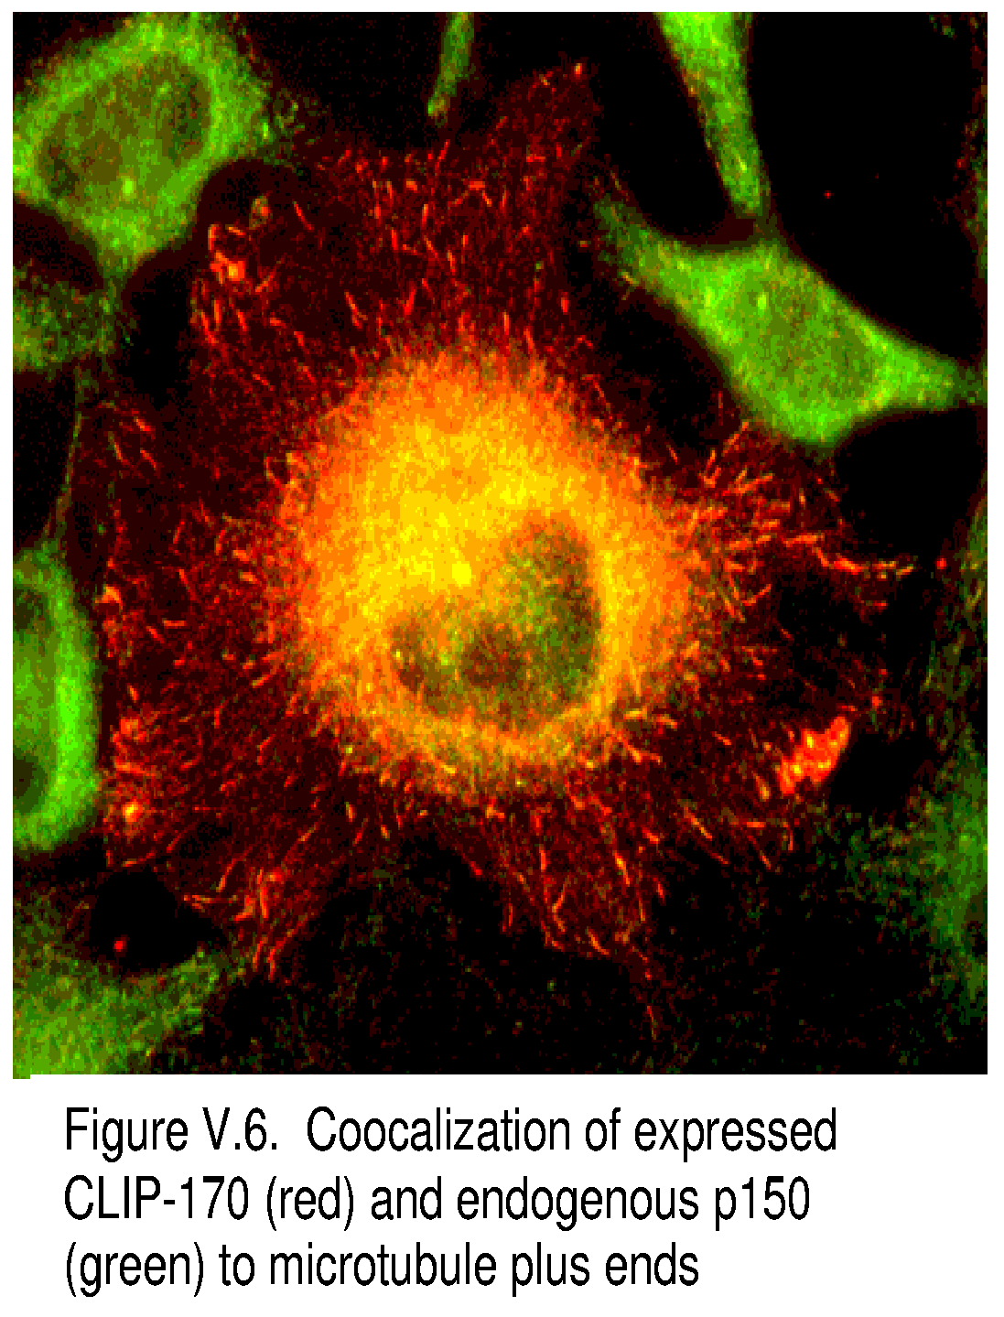
Participants will use bacterially expressed and affinity purified microtubule-binding fragments of CLIP-170, p150, and EB1 in standard biophysical protein-protein interaction assays (fluorimetry, fluorescence anisotropy, co-sedimentation) to quantitatively characterize the interactions between these proteins and tubulin (Diamantopoulos et al., 1999; Diaz et al., 2000). In particular, participants will measure the relative affinity of these microtubule end-binding proteins for different conformational states of tubulin (polymerized vs. unpolymerized, GDP vs. GTP). They will also use video microscopy of in vitro polymerization assays to quantify the effects of these proteins on different parameters of microtubule assembly (Panda et al., 1999; Tournebize et al., 2000).
Measuring of these parameters is essential to our understanding of how these proteins alter the microtubule cytoskeleton. First, the dissociation constants will help to establish the means by which these proteins interact with tubulin. Do they localize to MT plus ends by having a higher affinity for the GTP cap? Do they associate with unpolymerized tubulin and then copolymerize? Knowing these dissociation constants will be essential to computer modeling.
In studies overlapping with Project 1, participants will analyze protein and genetic interaction networks to identify candidate tubulin-interacting proteins and interaction pathways. We can then use biochemical and biophysical assays to analyze their microtubule interactions quantitatively.

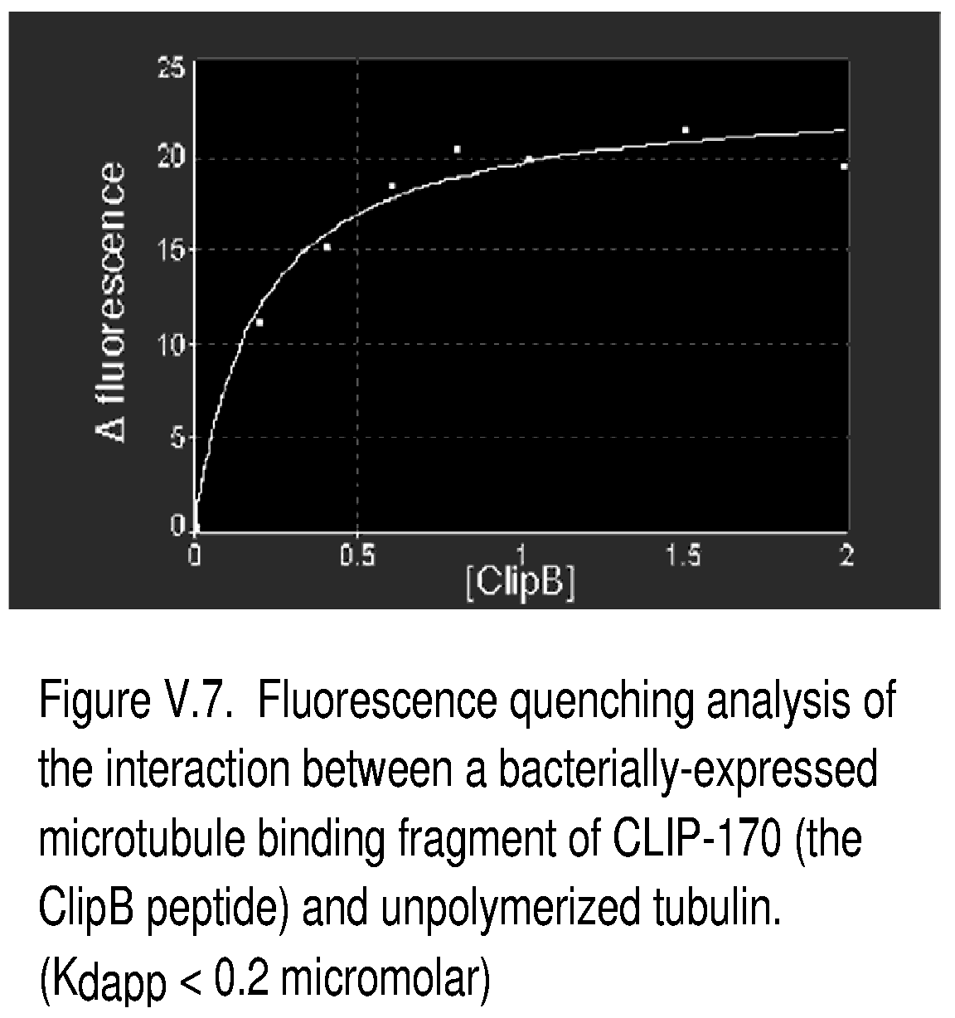
V.6.i.a.2.a Preliminary Results:
We have established expression and purification procedures for a variety of CLIP-170 and p150 fragments. All these biophysical techniques are presently in use in participants’ labs. For example, Fig. V.7 shows preliminary data for the interaction, measured by fluorescence change, between unpolymerized tubulin and an expressed and purified CLIP-170 fragment corresponding to the microtubule binding motif (Kwon and Goodson, in preparation). Given that the concentration of free tubulin in many tissue culture cells is ~10 micromolar (Gard and Kirschner, 1986; Larsson et al., 1999), this value of< 0.2 micromolar for the interaction between CLIP-170 and free tubulin suggests that CLIP-170 targets microtubule plus ends by associating with unpolymerized tubulin and then copolymerizing. Further analysis of CLIP-170 and p150 is in progress.

V.6.i.a.2 Regulatory Alteration of Microtubule Binding Proteins and Microtubule Assembly:
Flux adjustment is essential to the robust function of any complex network, and understanding the regulation of interactions between cytoskeletal components is indispensable to understanding cytoskeletal function. We will study the mechanisms and pathways which regulate the assembly-promoting activities of microtubule binding proteins, again focusing on microtubule plus end-binding proteins.
Inhibitory phosphorylation appears to be the primary mode of regulation for these proteins (Rickard and Kreis, 1991; Vaughan et al., unpublished). Participants will identify phosphorylation sites using tandem mass spectrometry on endogenous or bacterially expressed CLIP-170 or p150, phorphorylated in cell extracts and purified by established methods (Vaughan et al., 2001; Pierre et al., 1992; Bingham et al., 1998). Once they identify phosphorylation sites, they will assay the effects of phosphorylation at these sites on protein interactions using site-specific mutagenesis of proteins expressed in bacteria followed by microtubule interaction and assembly assays.
In addition to collaborative analysis of the microtubule end-binding proteins, the Vaughan group will continue to examine the mechanisms regulating the activity and cargo-binding specificity of molecular motors, focusing in particular on cytoplasmic dynein, a microtubule motor involved in fundamental processes from the mitotic spindle to membrane transport (Vaughan et al., 2001).

V.6.i.a.2.a Preliminary Results:
The Vaughan lab has already published techniques and approaches addressing the intermediate chain component of the microtubule motor, cytoplasmic dynein (Vaughan et al., 2001).

V.6.i.a.3. Computational Modeling of the Microtubule Cytoskeleton:
Given the complex dynamic interactions between microtubule binding proteins, tubulin binding proteins, tubulin, and polymerizing microtubules, a quantitative and predictive understanding of the microtubule cytoskeleton requires computer modeling based on experimental parameters. Simple buffered solutions of pure tubulin and GTP at steady state exhibit complex “dynamic instability.”
Computational models for dynamic instability that are based on reaction-diffusion equations and take these characteristics and experimentally derived rate constants into consideration are already established (Forgac 1992; Flyvbjerg et al., 1994; 1996). An initial aim of the Center will be to include in these models quantitative interaction parameters for specific microtubule binding proteins (as obtained above or derived from the literature). We will add additional layers of complexity from mixture of microtubule binding proteins and inclusion of regulation of microtubule binding and compare the results to experiment.
A second aim will be to model microtubule self-organization in simple mixtures of polymerizing microtubules and molecular motors (microtubule binding proteins that can exert force and produce movement) (Surrey et al., 2001), to model the self-organization of the mitotic spindle (Heald et al., 1996). A good computational simulation study of this model requires the ability to maintain and manipulate the interactions (e.g., the proximity and intersections) of a set of dynamically moving or changing geometric objects such as line segments, curves, and balls in three dimensions using computational geometry algorithms and techniques, such as intersections of objects, nearest neighbors, and advanced data structures for dynamic objects (Arya et al., 1998; Basch et al., 1997).

V.6.i.b The Actin Cytoskeleton:
The dynamic and mechanical properties of the actin cytoskeleton endow the cell with ability to move, change shape, resist stress, and respond to extracellular signals. These properties emerge from the complex interactions between polymerizing actin filaments, free actin subunits, actin monomer/polymer binding proteins, and the signal transduction apparatus that regulates these proteins. To understand the properties of the actin cytoskeleton in a quantitative and predictive way, we must identify the proteins that modulate actin polymerization and experimentally characterize their interaction with actin and their effects on actin polymerization.
A great number of actin modulating proteins are known and at least partially characterized. Their activities range from monomer sequestering proteins to nucleation factors (Fig. V.4). Recent studies have demonstrated the central role of the Arp2/3 complex in forming a dendritic actin network both at the base of the comet tail of Listeria and at the leading edge of several types of animal cells (Fig. V.4; (Rohatgi et al., 1999; Pollard et al., 2000)). The Wiskott-Aldrich Syndrome protein (WASp) acts as a co-factor for the nucleation of a branched actin network by binding to an arp2/3 complex at the base of each branch. Phosphatidylinositol 4,5 bisphosphate (PIP(2)) and the GTP binding protein CDC42 activate WASp (Egile et al., 1999; Higgs and Pollard, 2000), relaying transmembrane signals from the inner leaflet of the plasma membrane to the cytosol. Because we know the actin interactions of many of these proteins in quantitative detail, we can start to imagine building a comprehensive model of the actin cytoskeleton.
However, the mechanism of this pathway is far from complete. For instance, does the branched actin network physically attach to the membrane? If so (Loisel et al., 1999; Kuo and McGrath, 2000), how does it generate force? What are the roles of other proteins that either enhance or inhibit actin dynamics at the leading edge? How do interactions between these and other proteins lead to the observed physical properties of the actin cytoskeleton? Have we identified all the relevant actin-modulating proteins?
To address these questions, we must understand the polymerization of actin itself, how actin-modulating proteins modify its dynamic behavior, and how regulation alters the behavior of the modulating proteins. Such understanding requires additional experiments coupled with simulation.
We propose the following Specific Projects:

V.6.i.b.1 Biochemical Assembly of F-actin: Thermodynamics:

V.6.i.b.1.a Introduction:
To begin to understand the actin cytoskeleton, we must understand actin itself in biochemical and biophysical detail. Self-assembly of globular actin (G-actin) into long and stiff actin filaments (F-actin) is central to the roles that this abundant protein plays in cells (Sheterline, 1994; Stossel, 1984). In vitro assembly of purified actin suggests that actin polymerizes via condensation, much like the gas to liquid phase transition (Oosawa, 1993). In this model, G-actin molecules in solution act like a gas, while actin protomers in F-actin behave as if they were in a liquid or solid condensed state. Thus, actin polymerization would be a first order phase transition, with a certain equilibrium constant at defined ionic conditions. For example, the critical concentration, which is equivalent to the dissociation constant of G-actin from F-actin, is a fraction of a micromolar in a typical solution condition of 100 mM KCl, 2 mM MgCl₂, 0.2 mM CaCl₂, 0.2 mM ATP, and Tris-Cl at pH=8 (Pollard, 1986; Carlier, 1994). Oosawa and colleagues demonstrated that they could separately determine the entropy and enthalpy changes associated with actin polymerization by applying van’t Hoff’s law, following measurements of the critical concentration in the temperature range over which the protein remains stable (Oosawa, 1975). The enthalpy of actin polymerization is approximately 20 kcal/mole, and the entropy change is about 0.1 kcal/mole/K, so actin polymerization is endothermal, i.e., the solution absorbs heat from the environment; but with a large entropy gain, i.e., more random states are available in a solution of F-actin than of G-actin. This counterintuitive picture holds because as G-actin polymerizes it releases a large number of bound water molecules.
However, we need to reexamine these thermodynamic predictions for actin polymerization because the original experiments and analysis preceded the discovery of the coupling of ATP hydrolysis to actin polymerization (Wegner, 1982). When G-actin with one ATP molecule bound in its central cavity attaches to an existing filament, ATP hydrolyzes simultaneously, and a slow release of the phosphate group (pi) follows (Pollard, 1986; Carlier, 1986). Therefore, the simple estimate of both enthalpic and entropic changes due to actin polymerization from critical concentration measurements of ATP actin is incorrect. A correct measurement is essential to understand the coupling of ATP hydrolysis to dynamic actin assembly and eventual force generation at the cell leading edge.
The coupling between actin polymerization and ATP hydrolysis is also important for defining the mechanical properties of F-actin and the actin network. About half of the total actin in the cytoplasm is in filaments. Most of the pre-existing F-actin is in ADP form, which is mechanically and biochemically less stable, whereas newly polymerized filaments are either ATP actin, or ADP-Pi actin since the release of Pi is relatively slow. The mechanical strength of F-actin seems to differ in ATP as opposed to ADP solution (Gershman, 1989; Janmey, 1990). This complex behavior couples with a large array of small auxiliary actin binding proteins, such as profilin (Kinosian, 2000; Vinson, 1998), thymosin-β (Pantaloni, 1993; Carlier, 1993), and actophorin/cofilin/ADF (Maciver, 1994), which regulate cellular actin dynamics by their differential affinity to ADP vs. ATP actin.

V.6.i.b.1.b Project:
To determine the thermodynamics actin polymerization, including changes of enthalpy and entropy, we will carefully measure the critical concentration of ADP-actin as a function of temperature.

V.6.i.b.1.c Preliminary Results:
The relationship between the critical concentration of ADP actin and temperature is surprisingly non-monotonic (Fig. V.8):
Fig. V.8. critical concentration of ADP actin as a function of temperature. We induced polymerization of ADP bound G-actin by adding of 50 mM KCl, and measured the critical concentration by combined ultra-centrifugation and Bio-Rad protein detection assay.
We have confirmed the temperature dependence of the critical concentration with two actin preparations. We also observed similar behavior for ATP bound actin, which contradicts results from earlier biochemical studies using less direct methods. Current experiments to test these findings use independent methods, such as the pyrine fluorescence, and actin samples prepared using different methods to rule out experimental artifacts.

V.6.i.b.2 Network Mechanics of F-actin and Actin Binding Proteins:

V.6.i.b.2.a Introduction:
The unique network formed by actin filaments (F-actin) and actin-binding proteins is the major cytoskeletal component that defines the mechanical properties of the cell (Alberts, 1994). At the leading edge in many types of eukaryotic cells, a dynamic network primarily of actin and actin binding proteins induces motility and locomotion (Condeelis, 1993; Small, 1989; 1995). Characterization of the mechanical and rheological properties of the actin network, when cross-linked by various actin-binding proteins, is therefore an important step towards understanding cell mechanics.
Filamin and alpha-actinin represent two distinct classes of actin cross-linking proteins known to affect the mechanical properties of cells (Stossel, 2001; Lebart, 1993). The 270 kDa large actin cross-linking protein filamin forms a dimer, which then cross-links two actin filaments at wide and variable angles, much like a molecular leaf spring (Gorlin, 1990). An appropriately constituted F-actin/filamin network has the largest elastic modulus among actin gels. In a human melanoma cell line deficient in filamin, cells suffer constant uncontrollable protrusions, a process referred as blebbing (Cunningham, 1995). Alpha-actinin, on the other hand, represents a different class of actin cross-linking proteins, which often induce formation of loose actin bundles, including stress fibers (Blanchard, 1989; Pavalko, 1991). These loose actin bundles are often dynamic in both their size and structural conformation, thus affecting cell properties such as polarity and overall shape.

V.6.i.b.2.b Project:
Our study of actin network properties will initially focus on defining the mechanical roles of two actin-binding proteins that induce formation of morphologically distinct actin networks. We will compare the mechanical strength and response to deformation of actin networks formed by filamin and alpha-actinin, using biophysical techniques including mechanical rheology, fluorescence microscopy and atomic force microscopy (AFM).
To mimic the mechanical properties of the actin network in the cell, we plan to take the novel in vitro approach of characterizing the mechanical properties of large liposomes containing reconstituted actin networks. We will use three approaches to address these problems. First, we will encapsulate different defined mixtures of actin and actin binding proteins in artificial liposomes composed of poly(ethylene)glycol (PEG) conjugated phosphatidylcholine and study these vesicles with a novel, light-scattering-based technique, diffusing wave spectroscopy (DWS), which non-invasively probes linear rheological properties (Petka et al., 1998; Xu, Schwarz et al., 1998; Xu, Wirtz et al., 1998; Palmer et al. 1999). This optical rheometry assay measures the viscoelastic moduli of actin polymer networks less ambiguously than mechanical methods. In particular, DWS exploits the small, random, thermally induced force generated by imbedded microspheres, to avoid possible flow-induced orientation and bundling of polymers. As a second approach, we are developing a setup for particle tracking microrheology, to determine local viscoelasticity by recording the thermal motions of individual micron-sized beads. This new technique has high spatial precision (resolution in the nanometer range, using a quadra detection setup), and frequency response (up to 10kHz). This second method is more useful than DWS if the matrix is non-homogeneous.
Once we obtain valid mechanical properties for actin networks inside liposomes by particle tracking microrheology, we plan to probe the mechanical properties within live cells, especially at the lamella of the leading edge. A number of cell types, such as NIH3T3 and COS7 readily phagocytose and incorporate micron-sized beads, and the beads inside the cell probe of local viscoelasticity. We will use the same method to probe changes of cell stiffness at various stages of cell division, both in the cytosol and in the perinuclear region, in which case the changes are more likely to couple tightly to tubulin dynamics.

V.6.i.b.2.c Preliminary Results:
Dr. Palmer has investigated the effect of various auxiliary proteins on the mechanical properties of actin gels. For solutions of actin polymer, cross-linking protein, and severing protein he could regulate the elasticity of the actin gel between 0.1-100,000 dynes/cm², Fig. V.9. The data also show that α-actinin increases the yield strain at which the network ruptures. For a pure actin network the yield strain is approximately 1%. In the presence of α-actinin, this value increases to 10%. The presence of α-actinin greatly enhances the rigidity of the actin network. This composite of actin polymer, cross-linking protein (α-actinin), and severing protein (actophorin) shows unequivocally that we can accurately engineer the mechanical properties of polymeric actin and hence of liposomes.

Figure V.9. Mechanical properties of F-actin networks crosslinked with 2.4 μM alpha-actinin in the presence of actophorin. Actin was polymerized at 24 μM in the presence of 50 mM KCl, 1 mM MgCl₂, 1 mM EGTA, and 2 mM Tris-Cl (pH 8.0). Symbols     , correspond to the following actophorin concentrations 0, 1.2, 2.4, 4, and 9.6 μM respectively. The control () consists of pure actin in the absence of auxiliary proteins. A, B frequency-dependent storage (G’) and loss moduli (G’’) respectively. C, dependence of G’ () and G’’ (), measured at a frequency of 1 rad/s, on actophorin concentration. Unfilled symbols correspond to the properties of a pure actin gel. D, effect of an instantaneously applied strain on the value of the viscoelastic modulus after 100 s.

V.6.i.b.3 Regulatory Alteration of Actin Binding Proteins:
Diffusible “second messengers” such as calcium and phosphoinositides also regulate the actin cytoskeleton. A variety of signal transduction pathways receiving input from the outside world produce these second messengers. The use of common second messengers by different signal transduction pathways initially seems perplexing, but this commonality and the diffusible character of these second messengers are likely profoundly important to the exquisitely sensitive, reactive and adaptive directed cell motility.
Our goal is to predict how exposing a cell to a particular spatially localized signal results in localized response of the actin cytoskeleton. Considerable descriptive biological work must elucidate the components of the pathway and their characteristics before full modeling chemotaxis will be productive.

V.6.i.b.3.a Project and Preliminary Results:
Participants will focus on biochemical and cell-biological characterization of the parts of the pathway that are closest to the actin cytoskeleton, specifically, production of the second messenger PIP2, a direct regulator of the actin assembly machinery. Techniques will include localization of transfected and endogenous proteins using high resolution light and electron microscopy, biochemical assays to measure membrane trafficking, and biochemical and genetic assays to detect protein-protein interactions. In particular, work will focus on the roles of the Ras-related GTPases of the ARF and Rho families in phospholipid metabolism. Sustained activation of these GTPases activates enzymes responsible for PIP2 generation (Van Aelst and D'Souza-Schorey 1997). However, we need data on the distribution of these proteins relative to the lipid product, PIP2. PtdIns stimulate the dissociation of barbed end filament capping proteins, such as gelsolin and capping protein Z, and inhibition of actin depolymerization by cofilin thus enhancing actin polymerization (Martin 1998; Toker 1998).

V.6.i.b.4 Computational Modeling of the Actin Cytoskeleton:
We will take two different approaches to modeling the actin cytoskeleton:

V.6.i.b.4.a Hybrid Stochastic/Reaction-Diffusion Model:
The dynamic polymerization and depolymerization of the actin cytoskeleton forms a tree-like network in which the angle between the edges is 70 degrees (see Figure V.4). We therefore propose to use a linked binary tree structure to represent the cytoskeleton computationally. Each structure in this tree contains complete information on the number and state of hydrolysis of the actin and tubulin monomers which composed it to represent a polymeric segment. The nodes of the tree form a specific and important subset of the cytoskeleton, where that capping (represented computationally by the state of hydrolysis of the terminating monomers in the segment) polymerization and depolymerization of the nodes occur. The probability of polymerization will depend of the local concentration of tubulin and actin monomers. So the data structures will have to store dynamically the spatial coordinates of the nodes. We calculate the local concentration of free actin monomers at these points by solving the diffusion equation for their concentration subject to no flux boundary conditions at the membrane boundaries and sinks at the cytoskeletal nodes. The source of new actin consists of a distributed intracellular source and the depolymerizing cytoskeleton. To model the addition of new filaments to the cytoskeleton due to extracellular stimuli which activate WASp/Scar proteins to form an Arp2/3 complex and bind to the cytoskeleton to create new branches we will add new data structures stochastically to the tree depending on the local concentration of Arp2/3 complexes which also obey a diffusion equation with a time dependent membrane-localized source, dependent on the strength and duration of the extracellular stimulus.
From the data structure for the tree and the spatial distribution of actin and Arp2/3 complexes we can update the dynamically evolving tree. We need to specify rates for a number of processes including (but not limited to):
1) Addition of actin monomers to the tree nodes, which depends on the local concentration of free monomer.
2) Hydrolysis of ATP to ADP monomers. These rates depend on the state of hydrolysis of the neighboring monomers.
3) The rate of addition of new branches to the dynamically evolving tree, which depends on the local concentration of nucleating Arp2/3 complex.
Very important contributions, which we have neglected thus far, are the effects of localized calcium and mechanical stimulation on cytoskeletal growth. We can view the internal cytoplasm of a cell as composed partly of a polymerized sol-gel network of cross-linked actin microfilaments capable of contraction. Strong mechanical effects will therefore influence the structure, including hydrostatic or osmotic pressure (Lockhart, 1965) and elastic strain (Odell et al., 1981; Oster, Murray and Harris, 1983; Oster and Odell, 1984; Goodwin and Trainor, 1988). The calcium ion concentration will strongly influence the viscoelastic state of the network through calcium-induced regulation of cross-linking, polymer severing, initiation of actomyosin contraction, etc.. Stretch-activated calcium influx (Erxleben, 1993; Chen and Grinnel, 1995) and release from organelles (Tanaka et al., 1994; Chen and Grinnel, 1995) can lead to very nonlinear elastic strain and rheology.
We propose to study how these mechanochemical mechanisms generate spatiotemporal phenomena such as calcium waves and induce morphogenesis when the strain couples to a deformable membrane, by coupling the dynamics of the cytoskeletal growth described above to equations of motion for the elastic displacement u of the cytoplasm. A term of the form $J_{\text{Ca}}(¶u/¶x)$ must also supplement the equation of motion for the calcium flux released by local stores by representing the autocatalytic release of calcium from storage vesicles, which depends linearly on the strain. Membrane stretching may similarly influence currents through the membrane.

V.6.i.b.4.b Minimum Model of the Cytoskeleton:
Here, we describe our efforts to construct a realistic model cytoskeleton to compare to the Center’s experimental results and to predict specific effects, which we can test experimentally. The model relies on published constants (Dufort and Lumsden) and results by Center members (Shafrir et al., 2000; Shafrir and Forgacs, 2001).
A typical eukaryotic cell has 2-15 mg/ml actin and 10 μmolar microtubules. Both actin and microtubules are either monomeric (i.e. G-actin and α and β- tubulin) or filaments. The relative size of the monomeric and polymeric pools depends on cell type and the cell’s phase within the cell cycle. Both types of filaments are polar and dynamic, with + and – ends with different rates of polymerization, and turnover times for actin filaments and microtubules of about 6 and 10 minutes, respectively. The continuous input of energy, provided by the ATP hydrolysis that accompanies polymerization maintains the dynamics. Filaments length stays constant only under special conditions on the rates of polymerization and depolymerization (this phenomenon is particularly relevant for actin and is called treadmilling).
The large number and concentration of different cytoskeletal proteins, prohibit a complete simulation of the cytoskeleton. We construct an initial interconnected cytoskeleton with a fixed concentration of rigid rod filaments and start the dynamic evolution. The rods may represent various cytoskeletal filaments if we choose their diameter appropriately (8 nm and 24 nm respectively for actin filaments and microtubules). The length of the rods follows a uniform distribution. Each rod has six parameters that describe its location in space: Cartesian coordinates for one endpoint, the rod’s length and two angles, for its orientation.
While constructing the network, we observe the following rules. Two rods cannot penetrate each other. Once two filaments are within minimal distance of one another (soft core) a node forms at the point of shortest distance and the two rods are connect. Rods are restricted to the space between the nucleus and the cell surface. Special nodes denote points where a rod end reaches the surface of the nucleus (exit points) or the cell surface (entry point).
This “minimum” model cytoskeleton is the starting point for our simulations (Shafrir et al., 2000). Depending on the particular function of the cytoskeleton we wish to study we “dress up” the model. For example, we can place cross-linkers at the nodes. Special biased deposition rules for constructing the network can model bundling and stress fiber formation: if a filament lands within the soft core of a previously placed filament it aligns with it, forming bundles. Actin and microtubule binding proteins decorate the basic network.
More importantly, the model can include the dynamics of the cytoskeleton to a reasonable degree. Effects and molecules can affect the state of the network. Actin filaments grow or shorten by the attachment or detachment of G-actin monomers, which cannot bind to F actin without a bound cation (Mg²⁺, Ca²⁺) and a bound nucleotide (ATP or ADP). Thus the rate constants of actin polymerization are numerous (depending on the combination of G-actin, cations and nucleotides). The rate constants differ at the two ends (barbed or + and pointed or -) of the filament and vary widely with the ionic salt concentration used to induce polymerization, especially Mg²⁺, Ca²⁺ and KCl. The comprehensive cellular automaton model of Dufort and Lumsden (1993), who studied the dynamics the microfilament network revealed the complexity involved in a quantitative analysis of the actin cytoskeleton. These authors included the effect of profilin (a monomer sequestering protein) and gelsolin (filament capping protein). α-actinin cross-linking of the filaments employed the empirical kinetics. They simulated a volume of radius 0.6 μm for a short time while the typical size of cells is ~10 μm. However, their results indicate that if enough cross-linkers are available, the microfilament network globally interconnects, supporting our algorithm for the construction of the model cytoskeleton.
We incorporate elements of the Dufort-Lumsden model in our simulations. We will model the association and dissociation between F-actin and the cross-linkers (initially α-actinin) with rate constants determined by Meyer and Aebi (1990) (k₊=3.0 (μMs) ⁻¹ and k₋=3.0 s⁻¹ for the association and dissociation of F-actin and α−actinin, respectively). We also allow for the polymerization and depolymerization of microfilaments, but instead of the 8 pairs of (on and off) rate constants listed by Dufort and Lumsden (corresponding to all the combinations of G actin, cations (Mg²⁺, Ca²⁺), nucleotides (ATP, ADP) and barbed and pointed ends) we initially distinguish only the two ends of a filament and average the corresponding four rates. Temporal changes in the network are our extension of the earlier simulations.
Our model cytoskeleton resides in a cell, in an environment with well-defined physical characteristics (i.e. viscosity). The filaments themselves have physical attributes that we eventually will have to incorporate into our model.

V.6.i.c Integration of the Actin and Tubulin Cytoskeletons:
At present modeling the interactions between the actin and tubulin cytoskeletons is impossible because the pathways are still too poorly characterized. However, genetic evidence, cell biological experiments, and logic dictate that these interactions must exist (Goode et al., 2000). Our eventual goal is to assemble the combined evidence into a coherent interaction network connecting the actin and tubulin cytoskeletons. When enough evidence has accumulated to justify modeling these interactions, we will proceed, using this computational modeling to test the proposed interaction network.

V.6.ii. Our Goal is to Understand how the Cytoskeleton Responds to Extracellular Signals and the Specific Mechanisms by which it Participates in Signal Transduction:
The analyses of Specific Aim 1 should elucidate the mechanisms of cell motility, but will not by themselves explain how cells change their behavior in response to extracellular signals. Cells such as leukocytes have a remarkable ability to “chase” a bacterium, efficiently following a chemical gradient orders of magnitude smaller than those that man-made devices can detect. Growing nerve cells follow paths to their correct connections, eventually extending in length not microns but tens of centimeters. What is the mechanism of this remarkable precision?
To answer this question we must understand signal transduction across the plasma membrane, and how this signal transduction alters the local dynamics and properties of the cytoskeleton. We will address how extracellular signals transduced across membranes using T-cell activation as a general and experimentally tractable model (Section V.6.ii.a). We will study the mechanisms by which signals from the interior of the plasma membrane alter the local properties of the cytoskeleton (Sections V.6.ii.b and V.6.ii.c.4). Many of the protein-protein interactions involved in this regulation are still unknown, and the results of Project 1 (protein interaction network analysis) will contribute significantly towards our understanding of the cytoskeletal regulation network. The cytoskeleton actively participates in signal transduction from the cell surface to the nucleus (Davies, 1993; Liu et al., 1999; Nakamura et al., 2000). In Section V.6.ii.b.2 we use our models of the actin cytoskeleton to study cytoskeleton-assisted intracellular trafficking of signaling molecules, focusing on the role of the cytoskeleton in regulating the nuclear translocation of β-catenin.

V.6.ii.a Ligand Binding and Transmembrane Signal Transduction:
Our goal is to model the signal transduction during T-cell activation as a paradigm for transmembrane signaling that occurs during cytoskeletal and developmental regulation. We take T cells as a model because of their experimental tractability and the similarity of their signal transduction systems to other pathways involved in cell motility and development. T cells express unique T cell receptors (TCRs) on the cell surface. TCRs interact with a complex made up of an MHC (major histocompatibility complex) molecule presenting a peptide, peptide/MHC complex (pMHC), expressed on the surface of antigen-presenting cells (APCs) and target cells e.g. virally-infected cells and cancer cells). The interaction of a TCR with pMHC is of surprisingly low affinity, approximately 1000 fold lower than the interaction between an antibody and antigen. The TCR-pMHC interaction appears to be rather degenerate, recent data suggest that a given pMHC may interact productively with up to 100 different TCRs, and the inverse is also likely to be true. An APC typically expresses 150,000-300,000 pMHCs on its surface, representing 10,000-50,000 unique pMHC combinations, creating an astounding potential for cross-reactivity within the T cell network. Furthermore, a number of different ‘costimulatory’ or ‘adhesion’ molecules, e.g. CD28-B7 and ICAM-LFA, stabilize the T cell-APC interaction. These molecules are necessary to activate a naive T cell. Without such additional interactions (often referred to as ‘signal 2,’ with the TCR signal being ‘signal 1’), naive T cells become anergic (functionally silenced) when they detect the TCR (signal 1) alone. We will focus on defining how a T cell integrates the many signals it receives when it contacts an antigen-presenting or target cell. This problem requires modeling and computer simulations due to the large number of different pMHCs on a single cell which makes quantitative conclusions about TCR signaling in experiments using whole cells or isolated molecules difficult.

V.6.ii.b Dissecting the Signal Transduction Pathways Connecting Cell Surface Receptors with the Cytoskeleton:

V.6.ii.b.1 The Microtubule Cytoskeleton:
For selective stabilization of microtubules to induce morphological change (Figs. V.3,V.5), requires signal transduction pathways from the cell surface to the microtubules. The microtubule cytoskeleton does respond to the outside world – for example, the centrosome reorients towards a wound in a monolayer, and microtubules selectively stabilize on the side facing the wound (Palazzo et al. 2001). In mammalian cells, the pathways connecting external signals to the microtubule cytoskeleton are largely uncharacterized or only qualitatively described. However, in the yeast S. cerevisiae genetic analysis has elucidated large parts of a spindle alignment pathway connecting the cell cortex to the microtubule cytoskeleton (Bloom 2000). Given the overall conservation in cytoskeletal function between yeast and mammals and the observation that clear homologs of most yeast proteins exist in humans, the machinery for cortex-microtubule interactions should be conserved in humans.
We will initially focus on characterizing the mammalian version of this pathway, which centers around the protein “Kar9” pathway (Bloom 2000; Lee et al., 2000). Techniques will include cell biology (localization), biochemistry (tests of in vitro interactions between sets of proteins genetically implicated in specific protein-protein interactions), and molecular/cell biology (tests of how mutant versions of these proteins interfere with localization and cell function). This work will complement and overlap the work of Section V.6.i.a.1 because the genetic interactions in yeast indicate that the microtubule plus-end binding proteins are either part of the Kar9 pathway or interact with it genetically (Bloom 2000; Schuyler and Pellman 2001).

V.6.ii.c The Role of the Cytoskeleton in Intracellular Signaling:

V.6.ii.c.1 Introduction:
Strict molecular control of the cytoskeleton is indispensable to coordinate vital cellular processes such as mitosis, cytokinesis, lamellapodium formation, etc. The cytoskeleton must react reliably to extracellular signals. That the cytoskeleton also actively participates in the transduction of the extracellular signals to various intracellular compartments, in particular to the nucleus (Davies, 1993; Liu et al., 1999; Nakamura et al., 2000) is not surprising given the numerous signaling molecules immobilized or transiently bound to the cytoskeleton (Mochly-Rosen, 1995; Janmey, 1998; Schmidt et al., 1998). Despite the importance of the cytoskeleton in signaling, the specific mechanisms by which it transmits information are unclear. Proposals invoking a key role for the cytoskeleton in information transmittance vary from continuum models (Dong et al., 1991) to tensegrity (Ingber, 1991) and percolation structures (Forgacs, 1995). The cytoskeleton might participate in signal transduction by furnishing tracks on which signaling molecules can move without molecular motors. This mechanism could significantly improve the efficiency of signal transfer (Shafrir et al., 2000).

V.6.ii.c.2 Project:
β-catenin also functions in cell signaling as part of the Wnt signaling pathway which is important in early development, in particular in growth and differentiation (Fig. V.10B). Activation of the Wnt pathway results in the cytoplasmic accumulation of β-catenin and its entry into the nucleus (Molenanaar et al., 1996; Salomon et al., 1997; Behrens et al., 1996). Once in the nucleus, β-catenin complexes with the TCF/Lef family of HMG box DNA-binding proteins where it activates transcription of Wnt target genes (van de Wetering et al., 1997; Riese et al., 1997; Testsu and McCornmick, 1999).
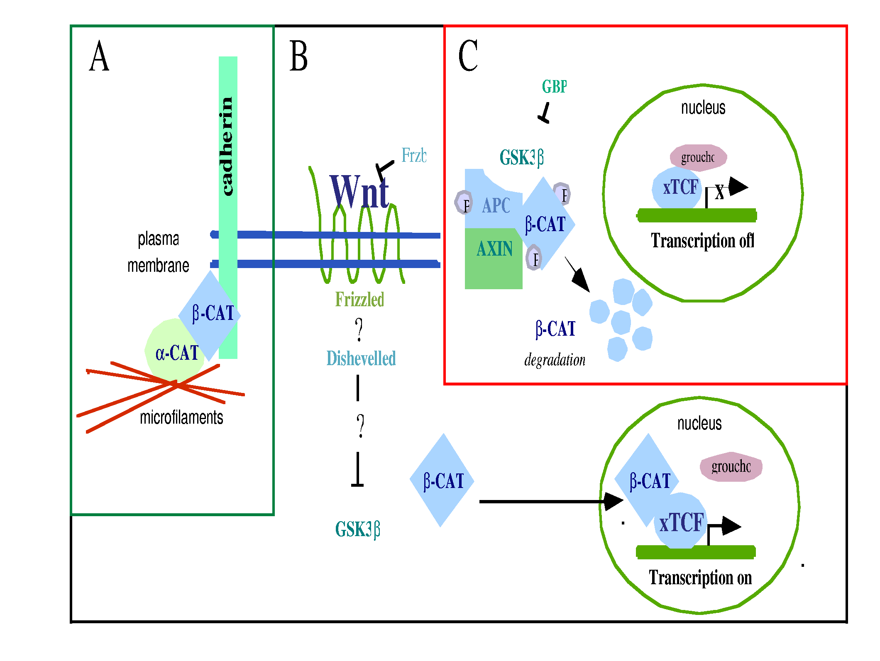

Figure V.10. A. β-catenin as part of the cadherin adhesion complex. B. β-catenin as part of the Wnt signaling pathway. C. The degradation mechanism of free cytoplasmic β-catenin.
Regulation of the multiple functions of β-catenin is only partially understood. The cell tightly regulates the level of free β-catenin. When β-catenin is not associated with the adhesion complex, it is thought to be rapidly degraded by a multi-protein complex (Figure V.10C), which includes the tumor suppressor APC (Su et al., 1993; Rubinfeld et al., 1993), the kinase GSK3 (Rubinfeld et al., 1993), and axin (Hart et al., 1998; Behrens et al., 1996). Phosphorylation by the kinase GSK3 targets β-catenin for degradation. Wnt signaling inhibits the kinase activity of GSK3 and cytoplasmic β-catenin levels rise so that it enters the nucleus. The molecular mechanisms underlying nuclear translocation of β-catenin are poorly understood. The high levels of free cytoplasmic β-catenin that result from inhibiting GSK3 might lead to diffusion of β-catenin into the nucleus.
Another possible mechanism for β-catenin nuclear translocation is through interaction with and transport along the microfilament cytoskeleton. Since β-catenin interacts with the microfilament cytoskeleton in adhesion complexes, it might similarly interact with the microfilament cytoskeleton to translocate to the nucleus. In the cortical region β-catenin does not bind to actin directly but through other proteins such as α-catenin (Rimm et al., 1995). While the interaction between β-catenin and the cytoskeleton at the adhesion complex has been studied in detail, the interaction between β-catenin and the non-membrane cytoskeleton has not been examined.
If β-catenin interacts with the microfilament cytoskeleton to translocate to the nucleus, then we can examine how altering the levels of proteins that bind β-catenin to microfilaments affects nuclear translocation. One possible mediator of β-catenin's interaction with the cytoskeleton is α-catenin, an actin-binding protein that mediates the attachment of F-actin to the membrane adhesion complex (Rimm et al., 1995). Overexpression of α-catenin in the cytoplasm blocks the translocation of β-catenin to the nucleus (Simcha et al., 1998). The studies of Koslov and colleagues (1997) have revealed that β- and α-catenin form a heterodimer in solution. Furthermore, they have identified the β-catenin binding site on α-catenin and measured the corresponding dissociation constant (K_{d}=100 nM). Another actin-binding protein, fascin, interacts with β-catenin and helps regulate β-catenin function outside the adhesion complex (Tao et al., 1996).
We will perform extensive modeling of β-catenin nuclear translocation using the model cytoskeleton of Section V.6.i.b.4.b. We will also study the role of the cytoskeleton in the nuclear translocation of β-catenin experimentally. The experiments will provide important quantitative information for the model, which in will provide experimentally testable predictions.

V.6.ii.c.3 Model for the Nuclear Translocation of β-catenin by the Cytoskeleton:
β-catenin translocates to the nucleus on activation of the Wnt signaling pathway. The simplest mechanism that can account for this movement is diffusion. However, diffusion through the cytoplasm is inadequate to explain the intracellular transport of signaling proteins. β-catenin is a 73 kDa protein (Koslov et al., 1997) so, if it were spherical, it would have a diameter of about 11 nm (the density of proteins is such that each kDa of protein occupies about 1.2 nm³ volume (Howard, 2001)). Assuming that in a 10μm diameter cell, the F-actin concentration is 1 mg/ml (much lower than in typical living cells (Dufort and Lumsden, 1993)) and that each filament is 1μm long. If we further assume that the filaments occupy volume by forming a regular cubic lattice, the distance between them would be less than 1 nm. Even though these considerations can only give a crude estimate, they indicate that an 11 nm globular protein would have serious difficulty diffusing in a crowded intracellular environment, full of organelles. Transport of molecules may take place along the structural elements of the cell’s interior rather than in the intervening cytoplasm (Agutter and Wheatley, 2000), in agreement with experimental findings on the translocation of non-vesicle associated proteins (Kamimura et al., 1995; Galigniana et al., 1998).
We have proposed a model for intracellular transport in which the relevant structural elements are the filaments of the cytoskeleton (Shafrir et al., 2000). The model assumes effectively one-dimensional diffusion along the filaments of the “minimum” model cytoskeleton. Numerical calculations of the First Passage Time (FPT) have shown that for realistic filament concentrations and diffusion constants this transport mechanism is as fast as free diffusion (in the absence of organelles). Including organelles, hinders cytoplasmic diffusion exponentially in the concentration of organelles so the advantages of linear diffusion are obvious. The filaments guiding focused transport. Because the cytoskeleton avoids organelles, movement is less hindered. As many of the cell’s proteins bind to the cytoskeletal mesh it may provide sites of concentrated enzyme activity for biochemical transformation during transport. Unlike molecular motor driven motion, diffusive transport along cytoskeletal components requires no extra source of energy.
Our original model corresponds to the highly oversimplified scenario in which a single β-catenin molecule would diffuse to the nucleus primarily along the cytoskeleton. We will extend this model to provide a realistic description of experiments.
We will first generalize our formalism to calculate FPT for biased diffusion due to the polarity of both actin filaments and microtubules. Second, we will decorate the model cytoskeleton with α-catenin as a representative actin binding molecules, because in solution β-catenin and α-catenin bind with high affinity (K_{d}=100 nM; Koslov, et al., 1997). If β-catenin, while diffusing along a filament, attempts to step into a site occupied by an α-catenin molecule, it attaches to it with probability p, otherwise the move is rejected (p/τ is the rate of attachment, τ is the time to make one step). Likewise, a β-catenin molecule attached to an α-catenin molecule can detach (at each step) with probability p’ (with p’/τ being the rate of detachment). The attachment of β-catenin to α-catenin delays the translocation of the former (existing experimental information gives the ratio p/p’ exactly). We will also treated this effect theoretically using continuous time random walks (CTRW) (Weiss, 1994), where the waiting time between steps is the time that the messenger spends bound to α-catenin. The simulations will use changing concentration of both β-catenin and F-actin and we will compared results to the corresponding experiments.
The model calculations and simulations will be assume for specific concentrations of β-catenin. The total concentration of β-catenin (bound and unbound), C_{β0}, affects the computation in the following way. Let the total concentration of α-catenin be C_{α0}, and let k_{on}, k_{off} be the binding/dissociation constants for α-catenin and β-catenin. The concentration of unbound β-catenin obeys:
(V.1)
Thus, in view of the conservation laws , (C_{α} and C_{αβ} are the concentrations of unbound α-catenin and pairs of α- and β-catenin attached to the cytoskeleton, respectively), the rates of binding and detachment are , and . Since the ratio k_{on}/ k_{off} relates to K_{d}, and we know C_{α0}, C_{β0} and C_{β} (the first two are measured, Eqn. (V.1) gives the third), only one adjustable parameter remains.
V.6.ii.c.4 Cytoskeleton-Assisted Nuclear Translocation of β-catenin: Experiments:
We will examine β-catenin’s interaction with the microfilament cytoskeleton by comparing the levels of β-catenin that cosediment with filamentous actin under conditions that cause nuclear translocation of β-catenin in MDCK cells or SW 480 cells, where we can modify Wnt signaling (Simcha et al., 1998).
We will transiently transfect Canine kidney epithelial MDCK cells and SW480 cells with DNA constructs encoding β-catenin and α-catenin using lipofectamine to examine β-catenin nuclear translocation.
We will ask whether β-catenin is found in the detergent soluble vs. detergent insoluble fraction of cell lines under experimental conditions. If we can demonstrate an increased interaction between β-catenin and the cytoskeleton during nuclearization, we will also examine which known actin-binding proteins cosediment with the β-catenin/actin complex by immunoblotting or immunoprecipitation. We also will determine whether membrane-associated β-catenin varies.
We will track nuclearization of β-catenin by co-expressing a fluorescent β-catenin construct, β-catenin GFP. By simultaneously overexpressing α-catenin with β-catenin, we can determine whether these molecules influence the ability of β-catenin to enter the nucleus. However, since these molecules may also mediate β-catenin's interaction with the adhesion complex, we will examine alterations in membrane-bound β-catenin under these conditions to determine if binding to this cellular compartment increases when these actin-binding molecules overexpress.
If β-catenin requires an intact microfilament array to enter the nucleus, then disruption of the microfilament mesh should block β-catenin nuclear translocation. We will overexpress β-catenin-GFP in MDCK cells and alter cytoskeletal integrity with known microfilament disruption agents such as cytochalasin D or latrunculin (Spector et al., 1983). If β-catenin is able to enter the nucleus in the absence of a microfilament cytoskeleton, then overexpression of β-catenin under these conditions should lead to nuclear fluorescence from the β-catenin-GFP.

V.7 RELATION WITH ORGANOGENESIS (PROJECT 3), AND BIOLOGICAL NETWORKS (PROJECT 1):
Although the experiments described above are self-contained, they related intimately to the problems addressed in Projects 3 and 1 (“Organogenesis” and “Biological Networks”). Morphogenetic change is based to a large degree on the processes which introduce asymmetries and polarities in cells and groups of cells. Cell-level asymmetries occur because of asymmetries at the subcellular level – nonrandom localizations of particular membrane proteins, localized activation of cell motility machinery. The subcellular asymmetries, and indeed cell organization itself, depend on the cytoskeleton, in particular the actin and tubulin cytoskeletons. Therefore, to build a quantitative and predictive understanding of development and organogenesis, we must ultimately understand the properties of the actin and tubulin cytoskeletons.
The cytoskeleton project is applies to the Biological Networks project because the cytoskeleton is itself a biological network. We will use network analysis to examine the cytoskeleton as a whole, to contribute to our global understanding of the cytoskeleton and its properties. Second, the analysis of protein-interaction networks will also contribute to our specific understanding of cytoskeletal mechanics because it will help to identify previously uncharacterized cytoskeletal proteins and previously uncharacterized interactions between known proteins. Finally, our experimental and modeling analysis of cytoskeletal behavior will feed back to on our Network analysis, providing experiments and observations that can test the conclusions of our network analysis.

V.8 Timeline:
Year 1  Experiment | • Determine CLIP-170/p150 binding affinities.  • Measure thermodynamics of actin assembly.
Year 1  Modeling | • Build reaction diffusion model of microtubule assembly (pure tubulin).  • Build models of actin assembly (pure actin).
Year 2  Experiment | • Determine CLIP-170/p150 effects on microtubule dynamics.  • Establish particle tracking microrheology (PTM) assay.  • Establish diffusing wave spectroscopy (DWS) rheology assay.
Year 2  Modeling | • Build reaction diffusion model of microtubule assembly in presence of microtubule binding proteins.  • Begin to incorporate actin binding proteins into models of actin assembly.  • Build model for nuclear translocation of β-catenin.
Year 3  Experiment | • Study regulation of CLIP-170/p150.  • Determine mechanical properties of liposomes containing reconstituted actin network by PTM, DWS.  • Establish effects of regulators on rheology of actin filament networks.
Year 3  Modeling | • Build reaction diffusion model of microtubule assembly in presence of microtubule binding proteins continued.  • Incorporate actin binding proteins into models of actin assembly continued.  • Build model for nuclear translocation of β-catenin continued.
Year 4  Experiment | • Characterize biochemically the novel microtubule binding proteins identified by Project 1 (network analysis).  • Establish mechanical properties of liposomes containing reconstituted actin network by PTM, DWS continued.  • Experimentally test predictions of “model cytoskeleton.”
Year 4  Modeling | • Model self-organization in microtubule cytoskeleton.  • Model mechanical properties of reconstituted actin networks.
Year 5  Experiment | • Characterize biochemically the novel microtubule binding proteins identified by Project 1 (network analysis).  • Test predictions of “model cytoskeleton” continued.  • Probe mechanical properties of living cells using particle tracking microhreometry.
Year 5  Modeling | • Model self-organization in microtubule cytoskeleton continued.  • Model mechanical properties of reconstituted actin networks continued.  • Integration of actin and microtubule cytoskeletons.

