IV. Biological Networks

IV.1 Coordinator:
A.-L. Barabasi (Dept. of Physics, University of Notre Dame).

IV.2 Participants:
G. Forgacs (Dept. of Physics, University of Missouri), J. A. Glazier (Dept. of Physics, University of Notre Dame), G. Hentschel (Dept. of Physics, Emory University), P. Kulesa (Beckmann Institute, California Institute of Technology), D. Chen (Dept. of Computer Science and Engineering, University of Notre Dame), J. Izaguirre (Dept. of Computer Science and Engineering, University of Notre Dame), M. Alber (Dept. of Mathematics, University of Notre Dame) and B. Hu (Dept. of Mathematics, University of Notre Dame), Z. Oltvai (Dept. Pathology, Northwestern University School of Medicine).

IV.3 Summary:
Complex biological functions in living organisms rarely depend on single components. Complex networks govern most functional properties, creating webs of diverse interactions. Networks emerge at different organizational levels, ranging from metabolic and regulatory networks within the cell to intercellular networks. Only recently have we had data on components’ interactions, complete, detailed and reliable enough to allow systematic characterization of functional networks. Network topology reveals general organizing principles which shed light on network function. Our aim is to combine the expertise of several investigators to create a unified research program to explain the architecture of biological networks. We will first focus on metabolic and regulatory networks, developing tools to characterize their topology, function and dynamics and to identify functional modules. We will analyze existing databases on network topology (metabolic and protein interactions) and dynamics (microarray data), and correlate topology and dynamics to determine function. Later, we will apply these techniques to analyze large protein-interaction databases to reveal the chemical architecture of the signaling and cytoskeleton sub-networks, and their interrelations. In addition, the network analysis tools we develop will apply to other networks as well, supporting the other Center Projects.

IV.4 Background and Significance:
Modern biology has provided a wealth of knowledge about individual cellular components and their functions. Typical experiments have carefully examined a limited number of individual components in a biological system, built hypotheses based on empirical observations, and experimented further to test these hypotheses. Researchers have deliberately restricted their analyses to well-defined systems with relatively few components, focusing on the behavior of individual molecules. While researchers have identified many functional modules (or pathways) the search for modules has been haphazard.
Despite the enormous success of this approach, we can only rarely attribute a discrete biological function to an individual molecule. Indeed, most biological functions arise from complex interactions among various components (individual proteins, nucleic acids, small molecules, etc.). We need more comprehensive approaches that address biological complexity more comprehensively. The success of genomics in determining the entire DNA sequences for many organisms allows the definition of their gene portfolios. Extrapolation between genomes has accelerated the definition of what amounts to a “parts catalog” of cellular components in many organisms. Also, large-scale microarray and proteomics studies of the effects of systematic gene disruption and of expression levels of genes under different conditions provide data to validate the predictions of global analyses.
In turn, these advances have created an unprecedented opportunity to develop comprehensive explanations for biological mechanisms, in part through the identification of the fundamental constraints that limit cell behavior. While the datasets available to us are still incomplete, they suffice for analysis, model development and prediction through model simulation. We propose an integrated program to identify these underlying constraints and to model quantitatively the structure and function (including regulatory properties) of the complex biological networks that maintain function in organisms. The emergence of databases containing integrated data on the topology of biologically significant networks and advances in understanding and quantifying the topology of complex (non-biological) networks aid this goal. The tools we will develop to study complex networks will apply to a wide range of topics of interest to the Center’s participants, including chemotactic, neural, metabolic and regulatory networks.

IV.5 Research Plan:
The proposed research is a well-established, truly interdisciplinary effort between a theoretical physicist (A.-L. Barabasi) with experience in characterizing the structure and dynamics of complex networks, biophysicists (G. Forgacs, J. Glazier, G. Hentschel, P. Kulesa) with experience in studying the dynamics of cytoskeleton formation and reaction-diffusion processes, a cell biologist (Z. Oltvai) with experience in studying the topology of metabolic and regulatory networks, computer scientists (D. Cheng and J. Izaguirre) with expertise in clustering algorithms, graph theory and algorithm complexity, and applied mathematicians (M. Alber and B.Hu) with experience in reaction-diffusion equations and stochastic dynamical systems as well as topological characterization of networks.

IV.5.i Specific Subprojects:
We structure our modeling effort into four Specific Subprojects:
- Specific Subproject 1 – Analyze the topology of selected metabolic and regulatory networks to uncover and model their large-scale structure.
- Specific Subproject 2 – Analyze selected metabolic and regulatory networks to determine the existence and identity of their modules.
- Specific Subproject 3 – Topology of signaling protein networks and the cytoskeleton.
- Specific Subproject 4 – Correlate network topology and dynamics, microarray expression data and regulatory interactions to uncover the dynamical rules and constraints that govern the regulation and function of various model organisms.
The flowchart in Fig. IV.1 shows the logical structure of the Subprojects. Successful completion requires understanding the principles and constraints that characterize the dynamic function of organisms. Therefore, Specific Subprojects 1 and 2 focus on exploratory analysis and modeling of the available topological and dynamical experimental data to identify principles and constraints. Specific Subproject 1 will combine tools developed by us or by the metabolic engineering community to explore and model the large-scale topology of complex metabolic networks. An important goal of Specific Subproject 2 will be to develop automated methods to uncover and analyze network modules, particularly in metabolic networks.

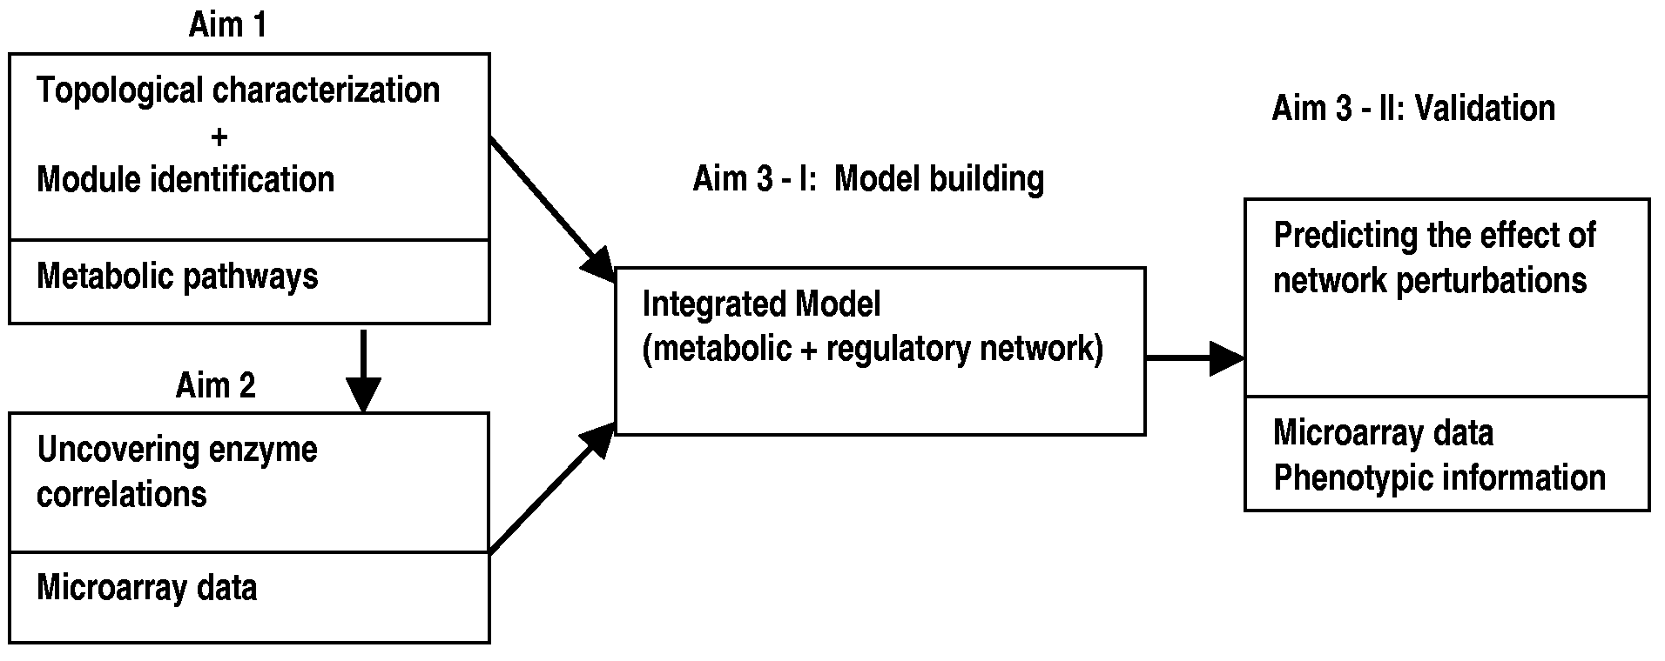
Fig. IV.1. The logical structure of the Subprojects.

IV.5.ii Methodology:
A distinctive feature of our approach is our ability to supplement purely geometric, pathway based methodologies with dynamic information. Indeed, a full cellular network simulation would need to address metabolic kinetics together with the dynamics of the regulatory network. While not possible at this stage, a good model of metabolism will require understanding of the genetic regulatory network. Systematic microarray-based analyses offer important insights into the organization and kinetics of regulatory networks (e.g. in E. coli and S. Cerevisiase). Using data on the expression level of various metabolic enzymes, and their correlations, we can derive unprecedented large-scale information on how different metabolic components work together under various conditions. Specific Subproject 1 analyzes the available microarray data to identify correlations between the various metabolic components of E. coli and S. Cerevisiase. These data offer valuable information on metabolic dynamics neglected in previous models.
Data Collection: In each case we begin by collecting detailed representative datasets for quantities of interest from the literature and on-line databases.
Analysis and Modeling: The key step in our method is to characterize the metabolism of various model organisms in a way that we can extrapolate and generalize to other organisms. This characterization is essential, provides needed insight, and allows the eventual systematic construction of a generic model of cellular metabolism. We will apply a wide set of analytical and modeling methods, drawing on the team’s combined expertise in Biology, Statistical Mechanics, Computer Science and Applied Mathematics.
Validation: The models we develop will only be useful if they make predictions that we can empirically verify with existing phenotypic and molecular data. Available tests include predicting the phenotypic and expression level effects of removing a single metabolic enzyme. We will continuously monitor the biological literature for empirical results that can further validate and improve our models.

IV.6 Preliminary Results:
The Center will focus initially on molecular level networks. Biological networks control important processes necessary to life at all scales from the molecular level to the level of the complete organism: At the molecular scale, genetic switching, reaction kinetics, metabolic and gene control networks determine cell function; at the subcellular scale, cytoskeletal networks control cell shape and motion; at the scale of individual cells, tight junctions transmit signals locally, while nerve fibers can traverse the whole organism; at the tissue level, networks such as heart muscle, lymph nodes and central pattern generators coordinate vital functions; while at the organ level, the brain, the hormonal, and immune systems regulate large scale function and behavior. We intend to expand the work of the Center in these directions, once sufficient resources are available since many of the techniques that we will develop at the molecular level will remain useful at larger scales.

IV.6.i The Topology of Cellular Networks:
The robustness of cellular processes arises from the dynamic interactions among their many constituents (Barkai and Leibler, 1997; Yi et al., 2000; Bhalla and Iyengar, 1999), including proteins, DNA, RNA, and small molecules. Researchers have confirmed the existence of complex interactions among various components of cells and simple microorganisms, but the absence of large-scale databases and a sufficiently developed theoretical framework, prevented meaningful analysis of these interactions. Recent large-scale sequencing coupled with systematic two-hybrid analyses have now provided complete sequence information for numerous genomes and protein interaction (Uetz et al., 2000; Rain et al., 2001) and integrated pathway-genome databases (Overbeek, 2000; Karp et al., 1999; Kanehisa and Goto, 2000) that provide organism-specific connectivity maps of metabolic and, to a lesser extent, other cellular networks. Due to the quantity and diversity of their constituents and reactions these maps are extremely complex, offering only limited insight into their organizational principles.
Recent advances in understanding the generic properties of complex networks have improved our ability to address the structure of cellular networks quantitatively (Barabasi and Albert, 1999; Albert, Jeong and Barabasi, 2000; Strogatz, 2001; Appendix II).
Until recently, complex network models used classical random network theory (Erdos and Renyi, 1960; Bollobas, 1985) which assumes that each pair of nodes (i.e., constituents) in the network connects randomly with probability p. This process leads to a statistically homogeneous network in which most nodes have approximately the same number of links, ⟨k⟩ (Fig. IV.2a,b). On the other hand, recent empirical studies have demonstrated that the World-Wide Web (Albert, Jeong and Barabasi, 1999), Internet (Faloutsos, Faloutsos and Faloutos, 1999), and social networks (Barabasi and Albert, 1999) are scale-free (Barabasi and Albert, 1999) (Fig. IV.2c), in which P(k) follows a power-law, i.e., P(k) ~ k^{-γ} (Fig. IV.2d). Unlike exponential networks, scale-free networks are extremely heterogeneous, a few highly connected nodes (hubs) dominate their topology, linking the remaining, less connected nodes to the network (Fig. IV.1c).
This well-developed theoretical framework combined with detailed biochemical databases allows us to begin to analyze cellular networks. Our first questions include: What is the topological structure of metabolic and other cellular networks? What biologically and topologically relevant quantities characterize them? What structural characteristics are generic to all prokaryotic and eukaryotic cells? The following section summarizes our results on the large-scale structure of biochemical reaction pathways (including metabolic- and information transfer networks), and protein interaction networks.
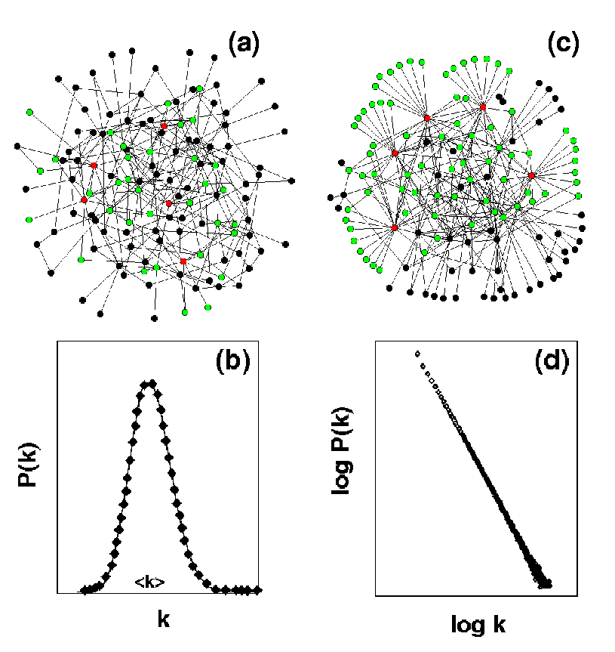

Fig. IV.2. Examples of (a) an exponential and (c) a scale-free network. Connectivity distribution P(k) of (b) exponential and (d) a scale-free network, giving the probability that a given node connects to k other nodes.

IV.6.ii Metabolic Networks:
To address the large-scale structural organization of metabolic networks, we have examined the topology of the core metabolic networks of 43 different organisms using data from the WIT (now ERGO) database (Overbeek et al., 2000). In the metabolic network, nodes are substrates which connect to each other through metabolic reactions. Fig. IV.3a, shows that in E. coli, the probability that a given substrate participates in k reactions follows a power-law distribution, i.e., the E. coli metabolic network is scale-free. Furthermore, we find that metabolic networks in all organisms in all three domains of life are scale-free, indicating the universality of this structural organization. We obtained essentially identical results for the topology of the information transfer pathways of the 43 different organisms based on the "Information transfer" data in the WIT/ERGO database (Appendix II).
Many complex networks have small-world character (Strogatz, 2001; Watts and Strogatz, 1998), i.e., any two nodes in the system connect by relatively short paths along existing links. In metabolic networks these paths correspond to the biochemical pathways connecting two substrates. The network diameter, defined as the shortest biochemical pathway averaged over all pairs of substrates, characterizes the degree of interconnectivity of a metabolic network. In all non-biological networks we have examined, the average connectivity of a node is fixed, implying that the diameter of the network increases logarithmically with the addition of new nodes (Barabasi and Albert, 1999; Watts and Strogatz, 1998; Barthelemy and Amaral, 1999). In contrast, the diameter of the metabolic network is the same for all 43 organisms, irrespective of the number of substrates in the species. This surprising and unprecedented independence of metabolic diameter requires individual substrates in more complex organisms to connect via more links. Increasing connectivity may increase the ability of more complex organisms to respond to external changes or internal errors. For example, time constants involved in changing enzyme concentrations largely govern the transition time between metabolic steady-states (Cascante et al., 1995). Quick transitions require that a few enzymes control many biochemical reactions.

IV.6.iii Protein Interaction Networks
We traditionally characterize proteins by their individual actions as catalysts, signaling molecules, or building blocks of cells. However, recent integrative approaches view them as elements in a network of protein-protein interactions with a “contextual” or “cellular” function within functional modules (Hartwell et al., 1999; Eisenberg et al., 2000). The position of the protein within the protein-protein interaction network reveals its role.
We assessed the topologic characteristics of complete two-hybrid analysis protein-protein interaction networks of the yeast, S. cerevisiae, and the bacterium, H. pylori, (Uetz et al., 2000; Rain et al., 2001; Xenarios et al., 2000). The complete maps of the yeast and H. pylori networks (Fig. IV.3c), are too large to provide visual insight into their structure. Fig. IV.3d, shows that the probability that a given yeast protein interacts with k other yeast proteins follows a power-law (Jeong et al., 2000) with an exponential cutoff (Amaral et al., 2000). Similar results apply for H. pylori, indicating that the protein interactions in both bacteria and eukaryotic cells form highly inhomogeneous scale-free networks. An important consequence of inhomogeneous structure is robustness against random errors and fragility against the removal of the most connected nodes (Albert, Jeong and Barabasi, 2000, Appendix 2).
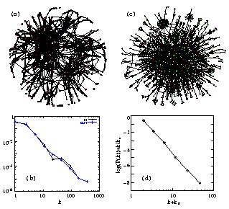

Fig. IV.3. (a) Map of protein-protein interactions in yeast. The color of a node signifies the phenotypic effect of removing the corresponding protein (red=lethal, green=non-lethal, orange=slow growth, yellow=unknown) (b) Connectivity distribution P(k) of interacting proteins giving the probability that a given protein interacts with k other proteins in yeast. (c) Map of the metabolic network in E. coli. (d) Connectivity distribution P(k) for the substrates in E. coli, in a log-log plot, counting separately the incoming (IN) and outgoing links (OUT) for each substrate, k_{in} (k_{out}) corresponding to the number of reactions in which a substrate participates as a product (educt).
If the link between topology and error tolerance is biologically relevant, on average, less connected proteins should prove less essential than highly connected ones. We calculated this correlation and showed that the likelihood that removal of a protein will prove lethal clearly correlates with the protein’s number of interactions (Fig. IV.4a).
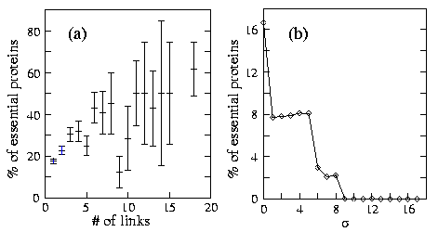
Fig. IV.4. Correlation between lethality and various cellular characteristics. (a) The percentage of lethal proteins of those that have k links in the yeast protein-protein network, indicating that highly connected proteins are more essential to the cell than less connected counterparts. (b) Correlation between the fluctuation in the expression level and lethality in yeast. The plot shows the percentage of proteins that are lethal with standard deviations larger than a given value σ. No proteins are lethal with σ>9, and the likelihood of lethality increases abruptly as σ decreases
For example, while proteins with five or fewer links constitute ~93% of the total, only ~21% of them are essential. In contrast, only ~0.7% of the yeast proteins with known phenotypic profile have more than 15 links but single deletion of ~62% of these proves lethal. Highly-connected proteins with a central role in the network’s architecture are three times more likely to prove essential than proteins with few links to other proteins (Appendix II).

IV.6.iv Synopsis:
Our preliminary analyses suggest that on different levels of hierarchical cellular organization the connectivity of cellular networks follows a scale-free power-law distribution. This common structure suggests evolutionary selection for robust and error tolerant architecture, which is ultimately genome derived, and represents a “genomic” constraint. Statistical analyses of large-scale gene expression profiles can reveal critical functional relations between individual cellular constituents. Thus the simultaneous analysis of cellular networks on different levels of hierarchical organization is a powerful approach to predict constraints on organisms. We have already uncovered significant correlations between a gene’s topological and statistical properties and the lethality of its deletion (Jeong et al., 2001, Appendix II). Our key challenge is to understand in detail the rules and principles which govern this underlying structure and its function.

IV.7 Research Design and Methods:
To understand the cell’s network organization requires computational approaches which simultaneously assess the generic features of living organisms, and the unique features of distinct species. Two networks, often investigated independently, determine a cell’s metabolism. The metabolic network describes the genomic capacity for metabolism. A cell-wide genetic regulatory network controls metabolic enzyme activity. Together, the networks determine the cell’s behavior. The following summarizes our research plans, focusing on metabolic network topology (Specific Subproject 1) and correlations in the regulatory network (Specific Subproject 2).

IV.8 Specific Subproject 1: Large Scale Structure of Molecular Networks:
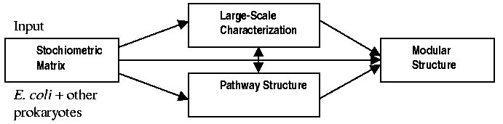
Fig. IV.5 describes the topological analysis of metabolic, regulatory and biological networks to uncover and model their pathway structure and modularity.
Fig. IV.5. Outline of analysis methodology.

IV.8.i Datasource:
Several integrated pathway-genome databases based on genomic and biochemical evidence, include all biochemical reactions found within the E. coli and S. cerevisiae metabolomes. Our analysis will use data deposited in the WIT/ERGO database (Overbeek et al., 2000) plus biochemical reactions which only biochemical evidence reveals (Edwards and Palsson, 2000; Edwards, Ibarra and Palsson, 2001). The new version (v 5.4) of the EcoCyc database (Karp et al., 2000) complements the E. coli database.

IV.8.ii Overview:
An essential step towards modeling cellular metabolism is to understand and quantitatively characterize the topology of the underlying metabolic networks. Specific Subproject 1 will pursue this topological characterization, using as input the available stoichiometric matrix. Due to the richness of the topic, Specific Subproject 1 has two components: Detailed statistical characterization of the large-scale structure of the metabolic network using network analysis tools developed in non-biological contexts, and analysis of its pathway structure using tools developed by the metabolic engineering community.

IV.8.iii Characterizing the Large-Scale Topology and Pathway Structure of Metabolic Networks:
To understand the properties of complex metabolic networks requires mathematical tools to characterize their topology. In general a topological network of N vertices corresponds uniquely to its connectivity matrix M of size N x N, where M_{ij} = 1 if a directed link from node i to j exists and M_{ij} = 0 otherwise (Fig. IV.5). The stoichiometric matrix, S, characterizes the metabolic network more completely. Each element S_{ij} is the stoichiometric coefficient α_{ij} of a metabolite X_{i} participating in reaction j, if we write each reaction $\sum_{\text{reactants}}{(−α_{\text{ij}}X_{i})+\sum_{\text{products}}{(α_{\text{ij}}X_{i})=0}}$ (Reder, 1988). A complete description of the network requires the exact stoichiometric matrix S_{ij}, which automatically provides M_{ij}. However, the data contained in the stoichiometric matrix can be overwhelming, and are inappropriate to characterize the generic properties of the network. Consequently, we plan to develop and assign unique measures to the network elements, which quantify the relative importance of each metabolite (node) and reaction (link). While understanding the large-scale structure of networks is important, experimentally testable predictions need to rely on organism specific functions. An important goal of our research is to distinguish the generic properties of the metabolic network from specific features unique to each organism, through the parallel investigation of several prokaryotic organisms with known metabolic networks. We describe here our first quantitative measures of network topology. As we probe network properties and as experimental results accumulate, we will develop additional measures with direct or indirect biological and/or topological significance. Our main research objectives include:

IV.8.iv Large-Scale Statistical Characterization of Complex Networks:
This research will employ ideas developed in the last few years to analyze other complex networks, including the world-wide web and citation networks (Barabasi and Albert, 1999; Albert, Jeong and Barabasi, 2000; Strogatz, 2001). A first step in this direction was identifying metabolic networks as scale-free (Jeong et al., 2000; Wagner and Fell, 2000). We plan to use several additional quantities, ranging from network diameter to generic robustness measures (Albert, Jeong and Barabasi, 2000), to describe the large-scale structure in detail.

IV.8.iv.a Analyzing Pathway Structure:
While organizing the metabolism of E. coli and other organisms into pathways is convenient, such organization is somewhat arbitrary. Therefore, we need to augment historical pathway classifications with automatic procedures to identify independent pathways starting from the stoichiometric matrix. We define an independent pathway as the smallest set of reactions connecting a single network output to the necessary network inputs, in a way that permits the levels of internal species to reach a stationary state (Klapa et al., 1998; Park et al., 1998; Simpson, Follstad and Stephanopoulos, 1999). Our goal is to use existing methods identify independent pathways (Schuster, Fell and Dandekar, 2000). The detailed picture of the pathway structure will serve as input to our modeling efforts. Insights offered by our large-scale network statistical analysis will augment these methods.

IV.8.iv.b Methods and Procedures:
Some important quantities and methods for characterizing the topology of metabolic and genetic networks (Jeong et al., 2000; Jeong et al., 2001 include the shortest path , giving the set of links that offer the shortest distance between two nodes, the diameter <>, which is the average of  over all pairs of nodes and the path length distribution P().
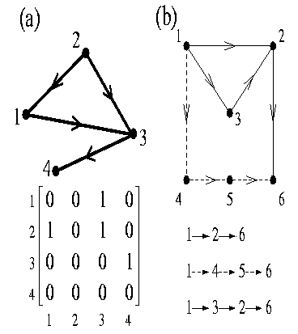
Fig. IV.6. Mapping between a given network topology and the corresponding connection matrix. (a) For binary network, two nodes are either connected (1) or not (0). The connectivity matrix contains the full topological information of the network: for example the first row shows that there is no direct 1→1, 1→2, 1→4 links, since in the position 1, 2, 4 we have a 0 in the matrix. However, there is a 1→3 link, denoted by a 1 in position 3. (b) A small networks illustrating the concept of the shortest path. To get from node 1 to 6, we can use 3 alternative routes: 1→2→6, 1→3→2→6, and 1→4→5→6. Of these, the shortest one is the 1→2→6 path. Also, while compared to each other, the paths 1→2→6 and 1→4→5→6 are absolutely independent, because their common points are only the starting and the end nodes, the path 1→2→6 and 1→3→2→6 are only marginally independent because they share the 2→6 segment.
The set of independent paths that connect two randomly selected components is an important quantity characterizing the robustness of a given metabolic network. We call all paths that connect i and j but do not have common edges (links) and/or nodes, completely independent (Fig. IV.6), while paths connecting i and j which differ at least in one link are marginally independent (Fig. VI.6). The existence of many independent paths increases the robustness of a metabolic network. if only one path links two components (nodes), then damaging or removing any link or node on this path prevents the two components from communicating. Thus, the path structure determines the degree of error tolerance of a metabolic network. We plan to investigate the structure and scaling properties of these paths, and their dependence on other network characteristics. We also plan to correlate the path characteristics with other measures of network topology.
Independent pathways describe functionally relevant subsets of independent paths connecting not randomly chosen but biologically relevant input and output metabolites. We will use the method of Simpson, Follstad and Stephanopoulos (1999) to identify these for E. coli and other organisms. In addition, after identifying the full ensemble of independent pathways, we will attempt a large-scale statistical analysis to determine how the number of the independent pathways scales with the number of participating metabolites and other network characteristics. The context of this analysis will be a comparative study of several prokaryotic organisms.
At a higher level of organization, the structure of the independent paths and pathways relates closely to the concept of elementary modes in metabolic networks (Schuster, Fell and Dandekar, 2000). An elementary mode represents the minimal set of enzymes that could operate in a steady state, with the relative flux they need to carry for the mode to function weighting the enzymes. An attraction of this approach is that we can express any steady state flux pattern as a non-negative linear combination of the various elementary modes. Using a physical analogy, elementary modes allow us to decompose the full metabolism into a mixture of pure, isolated states. The number of elementary modes is an important quantitative characterization of metabolism. However, the number of elementary modes depends on the size of the metabolic subset considered. For example monosaccharide metabolism supports seven modes, but we expect many more if we investigate a larger superset module. The dependence of the number of modes on the size of the module investigated gives important insight into the interdependence of the various metabolic pathways. Such results help identify modules.

IV.9 Specific Subproject 2 – Modular Biology: Automated Identification of Modular Structures from Metabolic Networks:

IV.9.i Datasource:
As in Specific Subproject 1.

IV.9.ii Overview:
As we argued in the Introduction, the study of molecular building blocks alone cannot reveal the emergent properties of biological systems. Our attempt to understand the system properties of cells employs a top-down or ‘reverse engineering’ approach. On the other hand, many researchers believe that the organization of cellular function is modular, with distinct modules containing many species of interacting molecules carrying out cellular functions, such as metabolism (Hartwell et al., 1999). In this model, chemical or spatial isolation separates functions into discrete modules. Indeed, the biological tradition is to group reactions into pathways, which we may view as modules. In addition these pathways group into a hierarchy of large entities, representing the cell’s known functions. For example, we characterize reactions as pertaining to metabolism, information transfer, DNA repair, etc., which we then break into smaller, and again smaller units, eventually arriving at the molecular level. The problem with this approach is that few functions within the cell are completely independent. Most functions share pathways and molecules (e.g., cell cycle vs. DNA repair) both at the substrate and the protein level, so components often participate in more than one module. Thus if modules exist, they are highly coupled and interconnected, making their identification difficult.
Is cell function indeed modular? Would we, if given a full biological wiring diagram and unaware of the prevailing biological tradition, conclude that the underlying structure is indeed naturally modular? Or would we find a hierarchy of nodes and links without any apparent natural grouping into modules? If the components are so interrelated that no objective algorithm can separate them, biology is not modular. That all known metabolic (Jeong et al., 2000; Wagner and Fell, 2000) and protein interaction networks (Jeong et al., 2001) are scale-free supports a non-modular view since any module has an intrinsic scale. However, in cells modularity might somehow coexist with scale-independence.
Determining the presence or absence of modularity is crucial for cellular modeling, as currently we cannot study the cell as a whole at the dynamical level. Thus, the prevailing approaches opt to look at the dynamical behavior of isolated modules. How can we identify modules? If modularity is present, which components can we treat with confidence as relatively isolated entities? Are the modules investigated today natural, or do they only reflect our desire to classify the components of complex systems and the historical evolution of biology?
To address these questions quantitatively, we plan to develop and apply clustering algorithms to analyze metabolic networks. These algorithms may identify fundamental principles that will allow a natural partitioning of cellular function into modules. In addition, they will give us information on the typical module size. We plan to compare the groups provided by different algorithms to the standard biological classification of metabolic pathways and functional categories. Such research requires a truly interdisciplinary environment, as it requires detailed understanding of the biological tradition and nomenclature and a detailed knowledge of clustering mechanisms and algorithms.
Our preliminary studies do support the view that metabolic function in E. coli is modular, at least to the extent that clustering is possible. Fig. IV.7 shows that a simple algorithm we developed could break up the E. coli metabolic network into independent clusters. Similar results obtain for S. cerevisiae. In contrast, the same algorithm did not cluster networks for which such clustering is not natural. When applied to an identically sized exponential or scale-free network, the network structures were left largely intact, indicating that decomposition of these idealized networks models would not naturally create local clustering.
Computer scientists have investigated the network clustering of the World Wide Web (WWW), which, like metabolism, is a directed network (Gibson, Kleinberf and Raghavan, 1998; Adamic and Adar; Adamic, 1999; Larson, 1996). While network clustering is an NP-complete problem (Flake, Lawrence and Giles, 2000; Garey and Johnson, 1979), implying that finding the optimal clusters for large systems is computationally prohibitive, cellular networks are small enough, with several thousand nodes at most, that we can calculate clustering with our current computing resources.

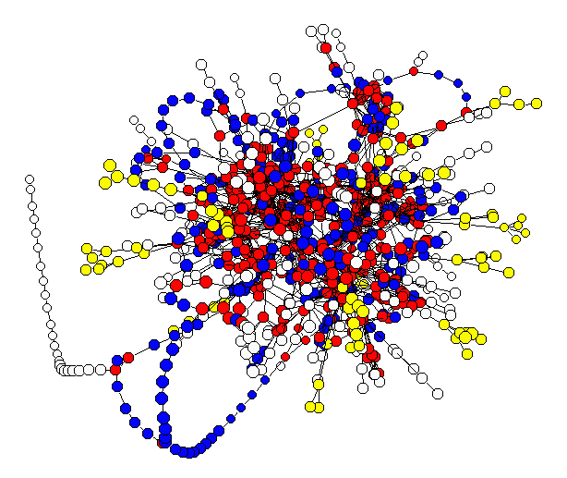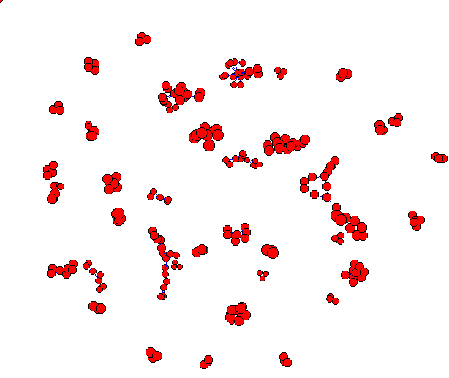
Fig. IV.7.: Identifying potential modules through clustering. On the left we show the topology of the E. coli metabolic network, each node corresponding to a metabolic substrate and each link to a reaction. We removed superfluous substrates, like ATP and H₂O, from reactions in which they only acted as donor or acceptor molecules, respectively. The color codes topologically distinct pathways. On the right, we show the clusters identified by our clustering algorithm. The figure shows aggregated data, and each tiny cluster can contain anywhere from ten to a hundred substrates (not shown).
We expect that clustering algorithms will reproduce to a certain degree known biological modules and pathways. However, the project could offer some surprises as well: an automatic program could uncover relationships between clusters that might not be intuitively obvious. It could find that some traditional modules are not independent or contain independent sub-modules. Our development of clustering methods will accompany detailed analysis of the biological significance of the clusters obtained. Validating the modular hypothesis would have a significant impact on how we model and understand complex biological systems. The current typical modeling paradigm is to isolate and model entities believed, from our historical understanding of cell function, to operate (semi)independently from the rest, treating links to other parts of the cellular networks as boundary conditions. Together with dynamic approaches (Specific Subprojects 3 & 4), network-topology based identification of functional modules using objective, automated algorithms, could offer an unbiased classification of the different metabolic pathways, and could further our understanding of the organization of cellular function.

IV.9.iii Methods and Procedures:
Various data mining applications have motivated extensive investigation of clustering in both applied mathematical and physical contexts. The principle of energy or distance minimization, has led to a series of efficient algorithms. Many of these tools use statistical mechanics techniques, such as Ising or Potts (See the discussion in Section VI.7.i.b) models (Bengtsson and Poivainen, 1995), that, under thermal annealing can explore a significant fraction of the thermodynamically available phase space, effectively optimizing the outcome. In addition, several new clustering algorithms address large networks, such as the WWW or other network-based information architectures. Our goal is to identify from the network topology the existence of underlying communities. As the WWW is a directed network with an underlying scale-free topology, the clustering problem faced by computer scientists resembles very much the issues we face in biochemical networks: finding the natural modules in a directed graph. We plan to implement a selection of these algorithms to search for modularity first in metabolic networks of E. coli and other bacteria and later in eukaryotes. The simultaneous use of several algorithms and clustering criteria is essential to provide measures to test our confidence level in identifying modules.

IV.9.iv Spatial Clustering:
The most popular clustering methods employ “spatial” clustering (Bengtsson and Poivainen, 1995; Jain, Duin and Jianchang, 2000; Ramal, Toulouse and Virasoro, 1986; Chazelle, 2000; Pettie and Ramachandran, 2000; Garay, Kutten and Peleg, 1998; Rose, Gurewitz and Fox, 1990a, 1990b, 1993; Jain and Dubes, 1988; Blatt, Wiseman and Domany, 1996). The number of characteristics assigned to each element determines the dimension of the phase space. The “distance” in this multidimensional space typically characterizes the similarity between a pair of elements with respect to the quantities driving clustering. Each element corresponds to a point in this phase space. Various methods aim to group nearby elements. One common approach builds a minimum spanning tree, whose end nodes are the elements, such that elements close in the phase space root in the same upper level nodes (Chazelle, 2000; Pettie and Ramachandran, 2000; Garay, Kutten and Peleg, 1998; Ramal, Toulouse and Virasoro, 1986).

IV.9.v.a Clustering by Thermal Annealing:
Statistical methods (Bengtsson and Poivainen, 1995; Jain, Duin and Jianchang, 2000; Rose, Gurewitz and Fox, 1990; Jain and Dubes, 1988; Blatt, Wiseman and Domany, 1996) on the other hand, define a “cost” or “energy” depending on the spatial relation of the elements. Starting from a random cluster structure, Monte Carlo simulations minimize the cost function. This minimization should converge to a natural clustering of the elements, though it can trap in spurious local minima. A temperature-like parameter controls the sensitivity of the clustering (see equation VI.5). These statistical methods embed the network in an n-dimensional space (Kamada and Kawai, 1987; Fruchterman and Reingold, 1991; Herman, Melancon and Marshall, 2000), where n is a fitting parameter. Drawbacks of these methods include the lack of a reliable graph drawing algorithm and the uncertainty regarding the unknown dimensionality of the phase space. Furthermore, the identified clusters often depend on the parameters of the statistical method. Such methods detect clusters in any system, whether naturally clustered or not and cannot determine if clustering is indeed natural. For obviously well-clustered networks these methods find the correct clusters, but when clustering is less evident, their reliability is questionable. While systematic methods can address the quality of clustering, we also need to explore approaches that unambiguously fail to group highly homogeneous networks.

IV.9.v.b Network Clustering:
Several recent clustering methods use the link structure of a network directly. These approaches try to infer clusters within a network from the arrangements of the links (Gibson, Kleinberf and Raghavan, 1998; Adamic and Adar; Adamic, 1999; Larson, 1996; Flake, Lawrence and Giles, 2000). Despite competing definitions for “clusters” in networks or "communities" on the WWW (since most studies relate to Internet research (Gibson, Kleinberf and Raghavan, 1998; Flake, Lawrence and Giles, 2000), their common idea is that nodes are more likely to link within a cluster than to outside nodes. The balanced minimum cut algorithm aims to minimize the number of links between clusters while still maintaining a certain minimal cluster size (Garey and Johnson, 1979; Chekuri et al., 1997). The maximum flow method notes that for two nodes from distinct communities the maximum flow is identical to the minimal cut (the number of links that we must remove to eliminate any connecting paths). We apply a polynomial time algorithm (Goldschmidt and Hochbaum, 1994; Saran and Vazirani, 1991) to compute a minimum k-cut in the graph, by removing the subset of edges with minimal weight such that the remaining graph consists of k connected components. After this step, we check whether each connected component is a cluster. The problem of computing a minimum k-cut in a general graph is computationally intractable (NP-complete), but we can achieve a good approximate solution within a factor of less than two of the optimal solution using the algorithm of Saran and Vazirani (1991) (Chen and Wu, 2001; Cvalinescu and Karloff, 2000; Dahlhaus et al., 1994; Karger et al., 1999).
We have developed and are currently testing a method to cluster metabolic networks based on measuring the clustering coefficient of the network (Watts and Strogatz, 1998) and cutting links whose deletion increases it. The assignment of edge weights to the network must reflect the underlying biological properties. We also need some information on the minimal irreducible structure allowed in a cluster. Clusters in different biological networks may contain different irreducible structures, for example closed enzymatic and catalytic cycles. Within a group, metabolites link to each other more frequently than to metabolites outside the group. In this framework, links inside a cluster increase the clustering coefficient, while links between clusters decrease it. If we do not know the clusters beforehand, we can characterize the links according to the effect of their deletion. Our simulations show that repeatedly removing links that increase the clustering coefficient until the clustering coefficient stops increasing produces clusters consistent with our expectations. The algorithm does not cluster random networks, which are not inherently clustered. In particular, this method does cluster the metabolic network of E. coli. Since one method is not sufficient to unambiguously determine clusters we will need to apply other clustering methods to increase our confidence level.

IV.10 Specific Subproject 3 – Topology of Signaling Protein Networks and the Cytoskeleton:

IV.10.i Datasources:
This study relies on the two-hybrid analysis of Uetz et al. (2000) and Ito et al. (2000). These investigators collected extensive data on the interaction between various yeast, S. cerevisiae, proteins (over 3000 out of about 6000). The two-hybrid analysis establishes which pairs of proteins within the cell are likely to interact. These pairing are not definitive, however. Since the results employ in vitro genetic engineering methods, some interactions may not take place under physiological conditions and we may miss other pairwise and higher order interactions.

IV.10.ii Overview:
The cytoskeleton, the cell’s interconnected network of filamentous macromolecules (actin, microtubules and intermediate filaments, see Project 2) is an active component of intracellular signaling pathways (Janmey, 1998). However, we do not know the specific mechanisms by which this network transmits and regulates signals (see Section V.6.ii.b.1). Proposals for the role of the cytoskeleton in transmitting information vary from continuum models (Dong et al., 1991) to tensegrity (Ingber, 1991) and percolation structures (Forgacs, 1995). The cytoskeleton may participate in signal transduction by furnishing tracks on which signaling molecules can move without molecular motors, significantly improving the efficiency of signal transfer (Shafrir et al., 2000). We will discuss this approach in more detail in Section V.6.
The analysis techniques presented in Specific Subproject I for analyzing large networks of interacting biological components allow us not only to investigate the functional consequences of network topology but to gain insight into the specific way the components carry out their biological functions. We have thus begun to apply our experience in the study of large datasets to elucidate the role of the cytoskeleton in intracellular signaling. We currently use yeast as a model, because of the abundant information on its proteome and because it lacks complicating intermediate filaments.

IV.10.iii Hypotheses:
A cell requires constant interaction with its environment for normal function. Membrane-bound receptors continuously receive signals from neighboring cells or the extracellular matrix. A change in their state, either due to biochemical or physical modifications, typically leads to a cascade of signaling events. These may involve further chemical changes (e.g. phosphorylation) or physical processes (e.g. diffusion). We still know very little about signal transmission from the cell surface to a particular cellular compartment in vivo. Most maps of biochemical signaling pathways are partial, with identified beginning and end points, question marks representing unknown intermediary components and arrows symbolizing putative trajectories of molecular movement. Numerous signaling molecules have to arrange reversibly and precisely to carry information (Isenberg, 1996). How do these molecules find each other and react in the correct sequence?
We hypothesize that intracellular signaling relies on the structure of the cytoskeleton. The interconnected cytoskeletal filaments provide a natural means of communication between the distant parts of the cell, in particular the cell membrane and the nucleus. Section V.6.ii.b.1 presents a particular model of this interconnection and its possible role in intracellular signaling. Numerous proteins with diverse functions transiently or irreversibly bind to the cytoskeleton (Mochly-Rosen, 1995; Janmey, 1998; Schmidt et al., 1998). If the cytoskeleton indeed participates in signaling then signaling molecules must strongly correlate with cytoskeletal molecules. The analysis of large scale protein networks allows us to study such correlations.

IV.10.iv Preliminary Results and Research Plan:
Using the existing data on protein-protein interactions in yeast, we have constructed a topological representation of these interactions. The topological map clearly indicates that cytoskeletal and signaling proteins tend to cluster, indicating a significant correlation between these two groups of proteins.
We are currently characterizing this correlation quantitatively. One way is to define an abstract distance measure on the topological map and to analyze the “distance” between the individual proteins. Correlation between two particular proteins would require that the distance between them is shorter than between two randomly chosen proteins. Our preliminary results indicate that the average distance between proteins within the pools of cytoskeletal and signaling proteins is significantly shorter than between other proteins that do not belong to these pools (several proteins belong to both pools), suggesting that proteins associated with the cytoskeleton have correlated functions. The same correlation holds for signaling proteins, which in turn suggests that the various signaling pathways may “communicate” with each other. More significantly, the distance between cytoskeletal and signaling proteins is also shorter than in the rest of the protein pool.
Our preliminary quantitative results on the correlation between these two sets of proteins suggest that the cytoskeleton actively participates in intracellular signaling, but do not specify how the cytoskeleton participates in signaling. We discuss one such model in Section V.6.ii.c.
Our future research will develop other methods to investigate the possible correlation between signaling and cytoskeleton-associated proteins. We will calculate on the topological map, the number of “nearest neighbors” of each cytoskeletal protein that belongs either to the pool of cytoskeletal proteins or to the pool of signaling proteins. We will analyze this nearest neighbor distribution to establish whether signaling proteins preferentially accumulate near cytoskeletal proteins, as we expect.
The distance measure and the number of nearest neighbors, as we discussed in Section VI.8.iv are abstract quantities, which in principle reveal no information on the spatial distribution of proteins inside the cell. However, if the distance between two proteins in the topological map of protein-protein interactions is small, these proteins tend to interact strongly with each other, necessitating their close proximity inside the cell. The larger the distance on the topological map between two proteins, the smaller the probability that they will chemically interact and thus need to be close to each other. Thus distance on the topological map correlates with physical distance between proteins. We will, therefore use our analysis of the topological map’s distance distribution to establish spatial correlations between signaling and cytoskeletal proteins.
The analysis of the distribution of nearest neighbors in the topological map can also provide spatial information. The preferential accumulation of signaling proteins near cytoskeletal proteins in the topological map would further indicate a strong correlation between the proteins in these pools. Therefore, the discussion in the previous paragraph applies also to the number of neighbors. In order to correlate this quantity with the spatial distribution of proteins we will study not only nearest neighbors, but also second and further neighbors.
Our study of the correlation between signaling and cytoskeletal proteins will aim to predict new protein interactions. In particular, we will focus on signaling pathways with some known components to search for as yet unidentified components.
Provided we can unequivocally show correlation between cytoskeletal and signaling proteins in yeast, we will extend our research to other organisms. Interacting-protein maps are under way for Drosophila, which, like yeast, does not have intermediate filaments. Applying our methods to Drosophila will test the generality of our approach. Another organism which we will analyze as soon as appropriate information becomes available is C. elegans, which does have intermediate filaments and thus a more complex cytoskeleton.

IV.11 Specific Subproject 4 – Correlating Network Topology, Microarray Expression Data and Regulatory Interactions to Uncover the Dynamical Rules and Constraints that Govern the Regulation and Function of E. coli Metabolism:

IV.11.i Datasources:

For the E. coli transcriptome, the microarray data (Arfin et al., 2000; Khodursky et al., 2000; Selinger et al., 2000; Zimmer et al., 2000; Wei et al., 2001) are currently available, but the amount of E. coli transcriptome data should substantially increase during the next five years. We plan to experimentally generate a large amount of E. coli transcriptome data. For corollary analyses in the yeast, S. cerevisiae, we will use data deposited in the Stanford Microarray Database (http://genome-www4.stanford.edu/MicroArray/SMD) and those deposited by Friend and colleagues (Hughes et al., 2000).
FIG. IV.8. Flowchart of analysis methodology.

IV.11.ii Overview:
[Stochiometric matrix] (Aim1)
Modules & Pathways
Metabolic network
VALIDATION
Phenotypic prediction &
validation
[Lethality/Growth-rate]
Molecular validation
predicting
gene expression
Emerging experimental
information
Feedback: Model Improvement and Fine Tuning
INTEGRATED MODEL
[Correlation matrix] (Aim2)
Enzyme correlations
Regulatory network
Module
Enzyme

The topological data and approach of Specific Subproject 1 presents a partial snapshot of metabolism. The topology of the metabolic network describes only genome-encoded potential metabolic activity. The metabolic network, however, actually functions through the genetic regulatory network that activates and inactivates various enzymes or groups of enzymes that catalyze biochemical reactions in the metabolic network. Thus, an in-depth characterization of metabolism requires understanding the regulatory network as well. The goal of Specific Subproject 4 is to go beyond topological characterization to evaluate dynamical correlations between metabolic network pathways. An important limitation of any modeling effort is the lack of availability of enzyme kinetic data, making full dynamic characterization impossible. However, available microarray data provides important qualitative information on correlations between the enzymatic activity of different pathways.
Specific Subproject 4 has three components.
- We will use standard clustering methods to uncover correlations between enzyme concentrations on the transcriptome level.
- To obtain biological insight into the origin of the correlations, we will use available information on the genetic regulatory organization of our model organisms.
- Finally, we will use singular value decomposition to uncover the functional limitations of the metabolism.
The outcome of this investigation will be a detailed understanding of cross-correlations between enzymatic activities, as well as a more nuanced and detailed picture of modularity (Specific Subproject 2).

IV.11.iii Integration of Topological and Expression Data:
The activity of a given enzyme affects each biochemical reaction in the metabolic network. Individual enzymes never act independently. Instead, enzymatic activities are highly co-regulated, both through their organization into operons, and through sophisticated feedback mechanisms. Our goal is to apply a variety of methods to discover co-regulated enzymes by examining their gene expression profiles and other data:

IV.11.iii.a Cluster Analysis:
The simplest method for uncovering correlations between enzymes based on gene expression is through simple clustering, using their correlation matrix (Eisen et al., 1998). This technique, starts from the microarray data to determine the correlation coefficient φ_{ij} between each pair of genes i and j, after which energy minimization algorithms or self-organized maps cluster the genes into co-regulated groups. The most widely used clustering method creates a tree, in which co-regulated genes typically lie on the same branch. We also plan to use more sophisticated methods to achieve better clustering (Bittner, Meltzer and Trent, 1999).
Our first goal is to determine the correlations between the metabolic enzymes at a transcriptional level. From the correlation matrix we expect to learn which pairs of enzymes have co-regulated transcription, and their degree of co-regulation. The results of the microarray based enzyme clustering should correlate strongly with the functional modules that Specific Subproject 2 uncovers from the metabolic network topology. This analysis will provide a quantitative picture of regulatory co-dependency, but little biological insight into the origins of the correlations. Further correlating our results with known biological function, such as operon and regulon organization could provided such insight.

IV.11.iii.b Uncovering Dynamical Constraints using Singular Value Decomposition:
To understand the logic of gene expression requires global approaches beyond simple clustering. The numerical algorithm called singular value decomposition (SVD) greatly assists the analysis of microarray expression data (Holter et al., 2000; Alter, Brown and Botstein, 2000; Holter et al., 2001). SVD searches for an optimal set of independent parameters to describe the m measured states of the system. The following simple example illustrates the notion of optimal independent parameters.
Consider a hypothetical biochemical reaction with a protein kinase (K), inorganic phosphate (S), the enzyme target of the kinase (E), and its phosphorylated form (P). The traditional way to describe this reaction is to keep track of all four concentrations as a function of time: cK(t), cS(t), cE(t) and cP(t). In most cases, a smaller number of independent parameters describes the reaction more naturally. In this hypothetical biochemical reaction, the kinase concentration does not change (as it only acts as a catalyst) and inorganic phosphate is abundant in the cell. Suppose that P is the inactive form of enzyme E. Thus, we can discard cK and cS, and consider only cE and cP. Since P and E are merely two different forms of the same protein, the sum and the difference of their concentrations (c1=cE+cP and c2=cE-cP) are more meaningful parameters. Thus the number of independent parameters in this example is two and the two appropriate parameters are linear combinations of the original ones.
SVD makes this search for optimal parameters systematic. More sophisticated methods like Principle Component Analysis further extend our ability to identify fundamental parameters. We will try to determine the presence or absence of constraints on the number of states a transcriptome, and hence the genetic regulatory network, can achieve. We will then attempt to correlate these data to our clustering-based modules (Specific Subproject 2) and the known regulation of E. coli metabolism.

IV.11.iv Methods and Procedures:
While microarray expression data can potentially clarify the dynamics of the E. coli metabolic network, important obstacles remain. Data from expression arrays are inherently noisy, and we need to understand the nature of this “genetic” noise and its effect on data quality. Our knowledge regarding genetic regulatory networks is so limited that the regulation of gene expression seems intractably complex.
To begin to understand the characteristics and constraints of genetic regulatory networks we will initially use two publicly available microarray data sets; one for E. coli (Arfin et al., 2000), the other for S. cerevisiae (Hughes et al., 2000). The first set provides steady state mRNA expression data for wild-type and an integration host factor (IHF) mutant E. coli strain sampled 8 different times. The second set provides steady state mRNA expression data for wild-type S. cerevisiae sampled 63 separate times and 300 single cDNA microarray measurements for a series of externally or internally perturbed yeasts.
The prevailing steady-state hypothesis of transcriptome activity implies that for a given gene i the histogram of its expression level for different arrays should follow a short-ranged distribution, e.g., Gaussian or Poisson. The variability in the expression level of gene i would lie within a certain range. Expression data points for any given gene in the available data sets are too few to determine distributions. However, examining all genes together provides excellent statistics. For similar reasons, good statistics for the comparison of transcriptomes require that we examine all mRNA expression data together. The original analysis of the gene expression data found fluctuations in the expression patterns of many genes (Hughes et al., 2000, Arfin et al., 2000), providing a measure of the magnitude of noise resulting either from slightly altered growth conditions in a given experiment (external noise), or naturally occurring stochastic fluctuations in the expression level of a given gene (internal noise). We then compare the internal (by comparing across genes) and external (by comparing across transcriptomes) noise to the observed fluctuations using standard statistical approaches.
We also plan to investigate the effect of genetic network perturbations. At present only expression profiles for S. cerevisiae cells with single non-lethal gene ablations and pharmacological treatment (Hughes et al., 2000) are available. Deleting a gene alters the underlying genetic network by removing a node. The cells then develop a new steady state, allowing them to function without the deleted gene product. An important question to address will be the degree of difference of the new steady state from that of the wild-type. Some perturbations may result only in small changes in the use of the underlying genetic network architecture with only genes directly interacting with the deleted genes affected significantly. Others may fundamentally reorganize gene expression landscapes across the whole cell.
Our analysis of microarray data sets will use the base 10 logarithmic ratios of their relative gene expression levels. We will first arrange the data sets into matrices, in which the rows represent genes, and the columns individual microarray measurements. Our statistical characterization uses the following notation: The data matrix, e, has N rows (each containing the expression levels of one gene) and m columns (each containing the expression levels of all genes in one experiment, i.e., the given measured transcriptome). The expression level of the ith gene in the jth array is e_{ij}, the average expression level of this gene throughout the m arrays is $A_{i}=m^{−1}\sum{e_{\text{ij}}}$ and the variance of the expression level of the same gene is $V_{i}=\sqrt{m^{−1}\sum{(e_{\text{ij}}}−A_{i})^{2}}$. The average expression level of genes in one array is $a_{j}=N^{−1}\sum{e_{\text{ij}}}$ and the variance of the expression level in the same array is $v_{i}=\sqrt{N^{−1}\sum{{(e_{\text{ij}}−a_{j})}^{2}}}$.
We will apply Singular Value Decomposition (SVD) to the microarray matrices to characterize each of the transcriptomes by a corresponding column vector that simultaneously encompasses all measured relative gene expression levels. We call the jth column vector, corresponding to the jth microarray, c_{j}. The {c_{j}}_{j=1,m} vectors embed in an N-dimensional vector space, R_{N}. so each c_{j} vector has N components.
SVD is a linear transformation that finds within R_{N} an m-dimensional subspace, S_{m}, with basis vectors {b_{j}}_{j=1,m}. S_{m} must fulfill two conditions. It must contain all column vectors of e, i.e., it can fully represent e. Denote the representations of the c_{j} vectors in S_{m} by c_{j}’ and the representation of e by e’. The c_{j}’ vectors are m-dimensional so e’ is an m x m matrix. The columns of e’ are the c_{j}’ vectors. The second condition is that the representations of the {b_{j}}_{j=1,m} vectors in S_{m}, the {b_{j}’}_{j=1,m} vectors, should be orthonormal eigenvectors of e’. Thus SVD performs a subspace search within an N-dimensional vector space, R_{N}, and a principal axis transformation within the computed subspace, S_{m}.
SVD provides the following data. The column vectors of the N x N matrix, u, are the {b_{j}}_{j=1,m} vectors. The diagonal components of the diagonal m x m matrix, w, contain the eigenvalues from the principal axis transformation. The rows of the m x m matrix, v^{T}, are the {b_{j}’}_{j=1,m} vectors. We can summarize the transformation as e = u w v^{T}. The ith diagonal component, w_{i}, of the matrix w defines the relative weight of the corresponding b_{i} eigenvector as $r_{i}=w_{i}^{2}/\sum{w_{j}^{2}}$.

IV.11.v Model Building:
Ideally, on the skeleton of the metabolic network, we would like to construct a model which includes the full reaction kinetics. However, we lack in vivo kinetic data on reaction constants. Also, the computation time is realistic only for smaller modules. However, the relationships the Specific Subprojects reveal between the components allow us to build rather sophisticated semi-quantitative models to predict the constraints limiting the possible behavior of cellular metabolism. Due to the complexity of model building and the need for abundant and reliable data, this Specific Subproject will focus on E. coli. However, the modeling principles will extend to other organisms when data becomes available.
Our goal is to develop an integrated model that includes the following layers:
- The stoichiometric matrix describing the topology of E. coli metabolism. The matrix derives from data of very high quality and forms the basic skeleton of our model.
- The identity of the enzymes associated with each reaction. While both biochemical and genetic identifications exist for most E. coli metabolic reactions, (i.e., they possess an identified ORF) microarray analyses will miss those enzymes with only biochemical identifications. For those with defined ORFs, the enzymes that participate in the same modules and pathways are very likely to co-express. Thus enzymatic information will help integrate the regulatory and metabolic networks.
- The information Specific Subproject 2. reveals about modules in metabolic networks will help us to understand the propagation of perturbations (gene knockouts or changes in external conditions), clarifying the degree to which they affect individual modules.
- The functional relation between different pathways through the coexpression of enzymes that catalyze participating reactions. As we argued in Specific Subproject 2, in addition to direct reaction based relations, different reactions and pathways connect through co-regulation. Microarray data partly detects such co-regulation, providing information on the dynamic interaction between different pathways that metabolic topology cannot provide. We will introduce a correlation matrix describing the co-regulation between each pair of enzymes as a separate layer into our models.
- Clustering based on gene expression data, like clustering based on metabolic network topology, will allow us to see relationships between apparently independent components.
We will continually update the input data for our models from the literature. Since the stoichiometric matrix is well established, we expect only minor corrections. However, several ongoing projects may provide dramatic improvements in the quality and quantity of E. coli microarray data.
Our integrated model will offer a comprehensive, systems-level description of E. coli metabolism. The model should provide predictions beyond those provided by looking at metabolic pathways. For example, in a hypothetical experiment we might culture E. coli with an excess of metabolite X. As a result, the biochemical network will assume a new steady state adapted to the new external condition. This change will affect a certain fraction of the network, for example, by a change in the concentrations of those metabolites that react directly with metabolite X. In addition, whole pathways in which X participates may change, and the perturbations may spread to other parts of the metabolic network. Flux balance analysis (Schilling and Palsson, 1998; Schilling, Edwards and Palsson, 1999; Schilling, Letscher and Palsson, 2000; Edwards and Palsson, 2000), which we will incorporate into the model, will offer information only on changes that propagate along metabolic pathways. However, as the regulatory network controls the metabolic network, the increase in X will affect the expression pattern of the enzymes involved in the selected pathways. Coexpression analysis at the microarray level of the model will reveal the changes these enzymes cause on other enzymes, which in turn affect metabolic activity. Thus changes in the metabolic network should couple tightly to changes in the regulatory networks. Our integrated model will be able to trace both these effects simultaneously. The model will produce a map that indicates the metabolic pathways and components of the regulatory network that the change in X will most affect, together with the degree (likelihood) of the impact. The model should predict the changes a microarray experiment captures allowing direct comparison to experiment. The same scenario applies to perturbations due to gene removal.

IV.11.vi Methods and Procedures:
The skeleton of our model is the stoichiometric matrix Sij, which encodes the topology of the metabolic network. S will be the starting point for analyzing and locating the pathway structure as well as for flux balance analysis. information on the identity of the enzymes that catalyze the appropriate reactions will complement this matrix. The metabolic reactions and enzymes together form a bipartite graph containing two qualitatively different categories of nodes, with nodes in one category linking only to nodes in the other category (Strogatz, 2001). One projection of this bipartite graph recovers the metabolic network, another the enzyme network, in which the metabolites that participate in catalyzed reactions connect enzymes.
If Specific Subproject 2 confirms the modularity of metabolism, we will assign each reaction and metabolite further variables indicating their modules, allowing us to track the extent of metabolic perturbations. In addition a separate enzymatic correlation matrix, E, will carry information about the regulatory correlations between the enzymes that Specific Subproject 4 uncovers from the microarray data to quantify the extent to which changes in one segment of the network diffuse to other components along the regulatory pathways, which, we treat semi-quantitatively as a separate layer. We assign the components of this matrix (which are the enzymes in the bipartite graph) additional variables based on the clustering the expression data uncovers. An important issue is how to couple the regulatory network E matrix to the bipartite metabolic topology network. The regulatory network affects the flux balance by modulating the available number of enzymes that can catalyze reactions. Thus a simple approach is to include regulation imposed limits on the fluxes, wherever we observe a strong suppression or activation correlation in coregulation. We will investigate other sorts of coupling, including nonlinear relationships. In some cases, such as evaluating changes in flux balances under gene knockout, a strong hypothesis about the nature of the coupling between the two layers is essential. However, for evaluating the extent of damage or lethality, the nature of the coupling may not be crucial.

IV.11.vii Validation:
As the utility of the model depends on its ability to predict experiments, validation will be an extensive part of our program:
- Phenotypic validation, aimed at determining whether genes are essential.
- Molecular validation, predicting gene expression for cells under extreme conditions and following the removal of an enzyme's coding region.
- Validation based on emerging experimental information.
Validation will feed back to the model, which will incorporate the additional information the validation generates.

IV.11.vii.a Phenotypic Validation:
To test the reliability of our models we will predict the essentiality of individual genes in E. coli. The inhomogeneous network connectivity of the metabolic and protein networks affects the robustness of metabolic networks. For instance, (Albert, Jeong and Barabasi, 2000) scale-free networks are insensitive if randomly chosen nodes malfunction. However, the price of this robustness is extremely diminished attack survivability. Deleting the most connected nodes, degrades rapidly the ability of the remaining nodes to communicate. For a cell, scale-free metabolism is robust against most random errors, but elimination of a highly connected component is lethal.
In a metabolic network several mechanisms can alter the connectivity. Since enzymes catalyze biochemical reactions, eliminating a particular enzyme (e.g., through gene ablation or pharmacological inhibition) will affect the corresponding link(s) between nodes. Second, as many substrates or products of metabolism require transport for entry (or exit), elimination of their corresponding transporter will directly affect the corresponding substrate (node). Finally, removing a gene can perturb the genetic network, which can affect other parts of the metabolic network. To address the fault tolerance of a metabolic network under these separate attack modes, we propose an integrated experimental and theoretical program.

IV.11.vii.b Fault Tolerance: Removal of Individual Metabolic Enzymes:
To determine the vulnerability of the E. coli metabolic network, we plan to identify and characterize changes in the network structure upon the removal of a single enzyme, E1. Depending on the nature of E1 and the properties of the components (nodes) participating in the reaction it catalyzes, deletion can have different effects. For example, in Fig. IV.9a, if the main product X of the reaction is an authority, i.e., a number of other reactions produce it simultaneously, removing E1 will have practically no effect, since other reactions take up its role. However, if product X is a hub (Fig. IV.9b) and participates in numerous reactions as an educt, the removal of E1 can disrupt a large portion of the metabolic network. Using the available metabolic maps, we plan to characterize the effect of the removal of all individual metabolic enzymes on the substrate connectivity of the metabolic network.
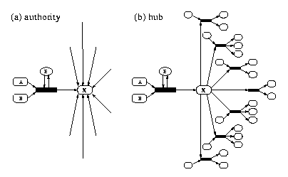

Fig. IV.9. Authorities and hubs in a metabolic network. (a) An authority is a node with many incoming links, i.e., many independent reactions can produce it. (b) A hub is a node with many outgoing links, i.e., it is an educt for many reactions. Nodes (e.g. H₂O) can simultaneously be authorities and hubs.

IV.11.vii.c Correlating the Mathematical Predictions with Gene Disruption Experiments:
To further investigate the effect of eliminating a specific enzyme in different cells, we will correlate our theoretical predictions on the qualitative importance (i.e., essential vs. non-essential) of enzymes with systematic gene disruption data. We will thus be able to distill the topologic characteristics of fatal enzyme removal, providing useful information about the importance or irrelevance of certain disruptions. For example, we might find that an enzyme, though it affects only a few reactions, might be essential because it affects an important set of reactions generating key metabolic intermediates (i.e., hubs). Another enzyme, whose elimination potentially could disrupt a larger fraction of the network, might prove non-essential because it catalyzes the synthesis of components that are less critical for the cell’s immediate survival (i.e., authorities).
Initially we will consider available data on yeast, S. cerevisiae. Two recent studies achieved precise deletion of one of ~2000 ORFs of the S. cerevisiae genome (~ one-third of the ORFs in the genome) (Winzeler et al., 1999; Ross-Macdonald et al., 1999), identifying ~17% of these ORFs as essential for viability, with an additional ~40% showing quantitative growth defects (Winzeler et al., 1999). Since mutated yeast strains can propagate either as diploids or haploids, switching from diploid to haploid accurately distinguishes essential from non-essential genes. We can compare the list of essential and non-essential enzymes in these databases to our theoretical predictions of the importance of an enzyme to the integrity of the metabolic network.
Once we firmly establish our mathematical approaches we will pursue a similar analysis in E. coli. F. Blattner and G. Church, a consortium led by T. Mizuno and K. Isono in Japan, and a consortium in Europe led by M. Masters are independently conducting systematic mutagenesis studies in E. coli. The literature and on-line databases contain substantial data on individual mutants (e.g., the PEC database: http://www.shigen.nig.ac.jp/ecoli/pec/index.html). The recent complete sequencing of the 0157:H7 enterohemorrhagic E. coli strain (Perna et al., 2001) identified distinct differences with the genome of E. coli K12 (our model), suggesting possible differences in the organization of genetic regulatory networks between the two strains. Thus, our manually curated dataset will initially be restricted to individual mutants in E. coli K12, but our analytical approach will incorporate other data as they become available as well.

IV.12 Connection to Specific Projects 2 (Cytoskeleton) and 3 (Organogenesis):
Biological Networks represents a novel approach to the study of complex intracellular gene and protein networks. Instead of following the activity and function of individual proteins, we consider each as an element in an interacting cluster of many components. Project 2 – Cytoskeleton, uses the same analysis of collective behavior to consider another global intracellular network, the interconnected assembly of actin microfilaments, microtubules and intermediate filaments. Thus Projects 1 and 2 to a large extent share methodology.
The specific connection between Projects 1 and 2 appears in the analysis of the role the cytoskeleton plays in intracellular signaling. In Project 1 we investigate the correlation between cytoskeletal and signaling proteins. Even though this study depends on the topological properties of abstract protein networks, our preliminary results also reveal spatial information on the relative distribution of classes of proteins inside the cell. In particular, we find that the abstract measure we introduced on these topological maps yields a distance between proteins whose average value is considerably smaller between cytoskeletal proteins, signaling proteins and cytoskeletal-signaling proteins than between proteins not in these classes. Since this abstract distance reflects the ability of proteins to interact with each other (the larger the distance between two proteins, the smaller the probability that they interact), it should also reflect the physical distance between the proteins within the cell. If two proteins never approach each other they probably need not interact with each other.
The results of our network studies will provide information on new protein interactions. This information is significant for Project 2, where such novel interactions will lead to predictions of new signaling pathways. At the same time, by ranking proteins based on their location in topological maps (e.g. whether they represent hubs or not) Project 1 will predict the relative importance of individual proteins within specific signaling pathways.
Establishing new protein interactions also aids Project 3 (Organogenesis). In Project 3 we will investigate the importance of specific morphogens to the development of the avian limb (as a specific example of organogenesis). A longstanding goal is to identify which morphogens affect this development. TGF-β is one such morphogen. Theoretical studies have revealed that at least one more morphogen with inhibitory effect on TGF-β must exist. Systematic experimental work has recently identified this inhibitor as a member of the FGF protein family. Network approaches and methods will allow us to investigate what other proteins may be relevant morphogens in avian limb organogenesis.

IV.13 TIMELINE:
Year 1 | Data collection and organization.
- Collect and organize database information pertaining to E coli and S. Cerevisiae metabolism and regulatory networks.
- Collect and organize microarray information for S. Cerevisiae and E. Coli.
Year 2 | Topological analysis.
- Analyze the topological properties of the collected metabolic and regulatory graphs.
- Investigate the topological features of the cytoskeleton and information pathways, correlating the two groups of genes based on topological data.
Year 3 | Modular information.
- Develop tools to identify modules from topological data.
- Test and apply the developed methods on the metabolic and regulatory networks.
- Investigate the modularity of the regulatory network, and the overlap between modules, with particular emphasis to signaling and cytoskeletal proteins.
Year 4 | Dynamics of cellular networks.
- Develop tools to analyze the dynamical properties of regulatory networks using microarray data.
- Uncover genetic networks from dynamical data (microarrays).
- Develop integrated models of cellular networks, assembling together topological and dynamical information.
Year 5 | Correlating topology and dynamics.
- Test and validate the integrated model, using lethality information, as well as newly emerging data sets.
- Correlate modular and topological features with dynamics properties collected from microarray data.
- Identify modular information by analyzing jointly the regulatory topology and the microarray data.
- Include into the proposed model newly emerging information (e.g. from proteomics, regulon information, etc.).

