VI. Organogenesis and Tissue Mechanics

VI.1 COORDINATORS:
S. A. Newman (Dept. of Cell Biology, New York Medical College) and G. Forgacs (Dept. of Physics, University of Missouri, Columbia).

VI.2 PARTICIPANTS:
J. A. Glazier (Dept. of Physics, University of Notre Dame), J. Jones (Dept. of Physics, University of Notre Dame), M. S. Alber (Dept. of Mathematics, University of Notre Dame), F. Castellino (Dept. Chemistry and Biochemistry, University of Notre Dame), J. Izaguirre (Dept. of Computer Science and Engineering, University of Notre Dame), G. Hentschel (Dept. of Physics, Emory University), Y. Jiang (Los Alamos National Laboratory), P. Kulesa (Beckman Institute, California Institute of Technology), R. Lansford (Beckman Institute, California Institute of Technology), G. Niebur (Dept. of Aerospace and Mechanical Engineering, University of Notre Dame), Elliot Rosen (Keck Transgene Center, University of Notre Dame), C. Weijer (Wellcome Institute Biocenter, University of Dundee)

VI.3 SUMMARY:
Developing multicellular organisms exhibit dramatic changes in shape and form and successive changes in spatial organization of specialized (differentiated) cell types, e.g. neurons and muscle fibers. How functional and spatiotemporal specialization takes place is an outstanding open question in cell and developmental biology. These events, which generate the body plan and the various organs, depend on regulated gene expression, elaborate interactions among cells, and coordinated cell movement. Differentiation and cell migration may occur simultaneously or sequentially. During development, genetics and biochemistry interact with the physical properties of individual cells creating a multiscale process of enormous complexity. However, we can discover dynamical and organizational rules at various levels.
Every cell of a multicellular organism carries the same genetic information. Nevertheless, through cell-cell, cell-matrix, and cell-growth factor interactions cells differentiate in a spatiotemporal fashion. Through differentiation, cells express different subsets of genes (as analyzed in Project 1) and acquire distinct physico-chemical properties. How do these pattern-forming, morphogenetic and mechanical properties affect the shape and function of the tissues these cells build?
Computer simulations which allow the separate study of individual mechanisms and their reintegration in controlled conditions are essential to disentangle the complex interacting phenomena of both embryonic pattern formation and tissue mechanics. Computer simulation allows integration of these data with experimental results. Ultimately the simulations should quantitatively predict phenomenology.

VI.4 SPECIFIC AIMS:

VI.4.i Our Goal is to Develop Multiscale Experimental and Computational Models for Organogenesis in Several Representative Developmental Systems:
Organogenesis is a multiscale phenomenon. At the scale of the whole organism diffusion gradients, nonlinear reaction-diffusion processes, multistable gene expression patterns, cell adhesion, chemotaxis, and neural pathfinding control important aspects of development. At the scale of the individual cell, in contrast, intracellular signaling controls the information processing and computations that a cell can perform (Purves and Lichtman, 1985). These scales are strongly interdependent, however: extracellular signals such as morphogen gradients can influence cellular differentiation and intracellular signaling, while cells release diffusing activator and inhibitor proteins which control development in response to intracellular genetic switching mechanisms. The size and shape of the domains in which these processes occur strongly influence both scales. We therefore propose to study the effects of geometric confinement at two very different scales in organogenesis: at the scale of the whole organ during development and at the scale of intracellular signaling.
Multicellular organisms depend on specialized structures for specific functions. Organs, while diverse, contain certain common geometrical and topological motifs with specially differentiated cells performing specific functions. Such spatial structures include lumens, epithelial sheets, tubes, branched networks and fibers. Many of these structures require polarized cells, i.e. cells that differ in their properties over the cell surface. Cells can also sense gradients in their environment and move in response. How do different mechanisms of cell migration and cell polarity interact to form complex geometries?
Use of experimental methods such as transfection with DNA promoter-reporter constructs will allow direct quantitative visualization of gene expression during cell migration, aggregation and spatiotemporal patterning in vitro and in vivo. In addition, fluorescently labeled antibodies can determine in vivo the subcellular localization and structural organization of important proteins. Using primarily theoretical methods, participants will study vertebrate primitive streak formation, gastrulation and innervation of the vertebrate limb.
Participants will generate and distribute software to solve the inevitably complex sets of mathematical equations that describe the interplay of genetic and material properties found in animal embryos.

VI.4.ii Our Goal Is To Predict The Functional and Mechanical Properties of Tissues from the Properties of their Component Cells and Extracellular Matrix and to Understand How Mechanical Stimuli Cause Changes in Tissue Characteristics:
Physical properties of tissues depend on the viscoelasticity of individual cells, strengths of cell-cell attachments, and on the properties of the extracellular matrix (ECM) the cells produce. Stresses on the cells in the tissue regulate the production of ECM in many tissues (e.g. bone, tendon, blood vessels). Production of matrix alters the mechanical properties of the tissue. However, the stresses and deformations the cells experience depend on both the applied loads on the tissue and its current mechanical properties. Thus, in healthy tissues, cells experience stresses or deformations, which depend on their mechanical environment, and, in turn, modify that environment. Breakdown of this adaptation causes disease (e.g. heart disease and circulatory obstruction).
We will measure specific cell, extracellular matrix and tissue physical properties (elastic moduli, viscosity, etc.) for model organisms like chicken or mouse in intact tissues and organs, aggregates of their embryonic cells and in genetically modified cell lines derived from these organisms. We will use Magnetic Resonance Elastography (MRE) for quantitative imaging of mechanical properties of live tissues. This technique uses a modified phase contrast MR sequence to directly visualize the mechanical stimulation of tissue (for example, to image propagating acoustic shear wave displacement). We can extract the local shear modulus from images of tissues and cell aggregates. Multiple two-dimensional MRE images reveal the full three-dimensional stress distribution inside complicated tissues or organs. These measurements, combined with data obtained by compression of cell aggregates, will allow us to determine parameters which finite element and extended Potts models of the mechanics of tissue and tissue components require.
We will study the connection between cellular and tissue properties using finite element computer simulations of specific models for interacting cells and ECM and verify our models using experiments on intact and in vitro tissues.

VI.5 BACKGROUND AND SIGNIFICANCE:
Morphogenesis is the molding of living tissues during development, regeneration, wound healing, and various pathologies. During morphogenesis tissue masses may disperse, form internal foci of cell condensation, lengthen or shorten, or acquire lumens. They can also form sheets, which may invaginate or evaginate, or develop one or more internal boundaries, which restrict or prohibit cell mixing. Such compartmentalized tissues can physically separate, or remain attached and engulf, or be engulfed by one another. These processes produce the various body plans and organ forms characteristic of metazoans, as well as tumors, abnormal polyps and fibrotic lesions.
Unlike non-living materials, which only physical forces mold, embryos and tissues seem to obey different rules: their forms seem to result from expression of intrinsic, highly complex, genetic programs. However, embryos, organs, and healing and regenerating tissues assume many forms resembling those that physics produces in nonliving materials. Often genes determine morphogenesis by mobilizing physical forces and properties. We will describe a range of mechanisms which living and nonliving materials share that underlie or contribute to tissue morphogenesis, allowing modeling using variations of computational physics methods. We call such processes “generic” (Newman and Comper, 1990). The systems and mechanisms we describe represent a sample of the research of Center participants.
Cell adhesion is necessary for multicellularity. Since many types of cell-surface proteins are adhesive under various conditions, and since modern organisms use several different adhesion mechanisms, multicellularity probably evolved more than once. Experimentally, a mixture of cell types with different quantities of adhesion molecules on their surfaces will sort out into islands of more cohesive cells within lakes of their less cohesive neighbors. Eventually, through random cell movement, the islands coalesce to establish an interface across which cells do not intermix (Steinberg, 1998) (Fig. VI.1a). Two or more differentially adhesive cell populations present within the same tissue mass, can form automatically multilayered structures, comprising distinct non-mixing “compartments,” spatial domains within a single tissue in which cells do not interchange or mix across a common boundary. The phenomenon resembles what happens when we pour two immiscible liquids, such as oil and water, into the same container.
Epithelioid cells sometimes have uniform adhesive properties over their entire surface; e.g. the blastomeres of the early mammalian embryo. The cells of many epithelioid, and all epithelial tissues, however, are polar in their properties, notably adhesion (Rodriguez-Boulan and Nelson 1993). The targeting of adhesive molecules, or anti-adhesive molecules, to specific regions of the cell surface can have dramatic consequences. A tissue mass consisting of motile epithelioid cells that are non-adhesive over portions of their surfaces will readily develop cavities or lumens. As a result of random cell movement, or loss of cells adjoining the nonadherent surfaces of neighboring cells such spaces come to adjoin one another. Lumen formation may therefore have evolutionary origins as a simple consequence of differential adhesion in cells that express adhesive properties in a polarized fashion (Fig VI.1b). In most existing organisms, however, other cellular mechanisms, such as the contraction of apical actin filaments in a group of cells in a localized domain of an epithelial sheet, contribute to, and may even initiate, lumen formation (Grant et al., 1991; Lincz et al., 1997).
Because cells are metabolically active and thermodynamically open, tissues may behave like physical “excitable media” (Mikhailov, 1990; Goldbeter, 1996). The capacity of single cells or cell aggregates to generate oscillations of gene products or metabolites, and for external effects to trigger such oscillations, is a prime example of excitability.
Consider the consequences of the periodic expression of some molecule becoming linked to the cell's adhesive properties in a confined growth zone of an embryo or organ primordium. If the expression of such an adhesivity regulatory factor has a different period from the cell cycle, cells will be born with periodically recurring adhesive states, and a spatial array of alternating tissue compartments or segments will form (Newman, 1993) (Fig. VI.1c). A mechanism of this sort may be at work in vertebrate somitogenesis (Palmeirim et al., 1997).
For diffusible chemicals, the biochemical kinetics that cause chemical oscillations can cause standing or traveling spatial periodicities of chemical concentration, via Turing’s “reaction-diffusion” instability (1952). Thus the mechanism of sequential segmentation in "short germ band" insects such as beetles (Patel et al. 1989), simultaneous segmentation of Drosophilae (Fig. VI.1c) and vertebrate segmental plate, may have a common evolutionary origin.
Once embryogenesis establishes the body plan, similar processes on a local scale generate organ primordia and establish their characteristic structures. For example, a Turing-type reaction-diffusion mechanism apparently alters local adhesive properties in chicken skin epithelium (Jiang et al., 1999), giving rise to the epithelial placodes that provide the primordia for developing feathers (Chuong and Edelman, 1985). In fish skin a similar mechanism controls pigment production, inducing colored stripes or spots (Kondo and Asai, 1985). Comparative studies of epithelial development in butterflies and fruit flies have shown that the same set of underlying morphogens can regulate either integumentary color pattern or tissue shape, depending on the species (Carroll et al., 1994). Epithelial sheets can bend, evert, invaginate, and form placodes, cysts, and tubules, depending on local and polar expression of adhesive molecules (Newman, 1998) (Fig. VI.1f). Moreover, the physics of fluids (confined to a plane) can account for many details of epithelial sheet morphogenesis (Gierer, 1977; Mittenthal and Mazo, 1983).
In contrast to epithelioid and epithelial tissues, in which cells directly adhere to one another over a substantial portion of their surfaces, connective tissues consist of cells suspended in an ECM. Additional morphogenetic mechanisms depend on changes in the distance between cells, the effects of cells on the organization of the ECM, and the effects of the ECM on the shape and cytoskeletal organization of cells (Project 2), that typically occur in connective, but not epithelioid tissues.
As in epithelioid tissues, immiscible boundaries can develop in connective tissues, such as the interface between the flank of a developing vertebrate embryo and an emerging limb bud (Heintzelman et al., 1978). Since cells in mesenchymal tissues do not contact one another directly, and extracellular matrix can potentially mix across tissue boundaries (unlike the integral membrane adhesive proteins of epithelioid cells) standard notions of sorting by differential adhesion cannot explain immiscibility in embryonic mesenchymes. We have identified two ECM-based mechanisms by which subpopulations of mesenchymal cells can separate out from surrounding tissues.
In mesenchymal condensation, which is often transient in development, mesenchymal cells, initially dispersed in a matrix, move closer to one another. Condensations generally progress to other structures, such as feather germs (Chuong, 1993), cartilage or bone (Hall and Miyake, 1992; 2000; Newman and Tomasek, 1996), or after converting to epithelium, kidney tubules (Ekblom, 1992) (Fig. VI.1d). Suggested cellular mechanisms, include local loss of matrix materials, centripetal chemotactically-driven movement through the matrix, cell traction, and absence of cell movement away from a center (see Newman and Tomasek, 1996 for further references). In vitro studies of limb bud precartilage mesenchyme suggest that differential adhesion to, and accumulation at sites of, altered ECM can initiate condensation (Frenz et al. 1989a; 1989b), in line with predictions from theoretical models (Graner and Glazier, 1992; Graner, 1993; Glazier and Graner, 1993). Moreover, recent studies provide direct evidence that reaction-diffusion-based pattern formation changes the local cellular microenvironment during condensation in vitro (Miura and Shiota, 2000a; 2000b; Miura et al., 2000), agreeing with earlier suggestions (Newman and Frisch, 1979; Newman et al., 1988; Newman, 1996) (Fig. VI.1e). Here, a physical process possibly involved in the origin of body plan morphology acts locally during organogenesis.
Many experiments support (Hall and Miyake, 1992; 2000; Newman and Tomasek, 1996) a mechanism for mesenchymal condensation in which localized patches or domains of extracellular matrix form in an initially homogeneous tissue by one of several possible pattern forming mechanisms. The cells respond to the locally changed matrix by adhering to one another at these sites. Differential adhesion occurs, but no cell sorting takes place. This mechanism requires that the cell response time to the altered matrix be faster than the dispersal of the matrix, a reasonable assumption.
In vitro “matrix-driven translocation” provides a useful model for a second mechanism for mesenchymal boundary formation. Detailed investigations of this morphogenetic effect in model ECMs have shown that subtle differences in the organization of molecular fibers can define distinct physical phases (Newman et al., 1985; 1987; Forgacs et al., 1989; Newman, 1998). In principle, these phases can provide the basis for compartment formation in mesenchymal tissues.
The formation of elaborate cell-ECM adhesive structures in developmentally mature connective tissues permits physical forces originating within cells to contribute to tissue morphogenesis (Newman and Tomasek, 1996). In particular, fibers can transmit intracellular forces necessary for cell shape changes and migration to the surrounding cells and ECM, mechanically stressing the whole tissue (Beloussov et al., 1975; Grinnell, 1994; Ingber et al., 1994). Such cell-generated stresses can lead to contraction, orientation, or assembly of extracellular fibers or cytoskeletal filaments (reviewed in Newman and Tomasek, 1996). In such cases the tissue no longer exhibits liquid-like behavior since the cells are not independently mobile, but rather acts like an (excitable) elastic medium.
Fig. VI.1. (a) Schematic representation of the behavior of intermixed cells and corresponding tissue fragments for two differentially adhesive cell populations (Steinberg, 1998). (b) Schematic view of the formation of a lumen or internal cavity by differential adhesion in an epithelioid tissue consisting of polarized cells (Newman, 1998). (c) Schematic representation of two modes of tissue segmentation that can arise when the tissue's cells contain a biochemical circuit that generates a chemical oscillation or “molecular clock,” and the oscillating species directly or indirectly regulates the strength or specificity of cell adhesivity (Newman, 1993). (d) Schematic representation of mesenchymal condensation, which occurs during skeletal morphogenesis and many other developmental processes. (e) Morphogenesis of connective tissue, such as cartilage rods and nodules, occurs by the interplay of diffusible activators and inhibitors of mesenchymal condensation (Newman, 1996; Newman and Tomasek, 1996). (f) Types of epithelial morphogenesis (Newman and Mülle, 2000).
The linking of cells into an elastic medium, which converts individual cell contractility into global mechanical stress, is another example of new physical processes coming into play in a multicellular setting. Since the resulting elastic media are also biochemically excitable, the stresses generated within them can regulate the active behavior of the subunits. Cells recognize and respond to mechanical stresses by changing their shape, growth, expression of specific gene products, and cytoskeletal organization (Grinnell, 1994; Ingber et al., 1994), as well as by remodeling their extracellular matrix (Lambert et al., 1992; Unemori and Werb, 1986). Specialized structures such as the focal adhesion complex (Kornberg et al., 1992; McNamee et al., 1993; Schaller and Parson, 1994; Seko et al., 1999) and the cytoskeleton (Shafrir and Forgacs, 2001) transduce mechanical forces into chemical signals.
The role of exogenous (to the tissue, not necessarily to the organism) mechanical loads in determining tissue pattern illustrates the importance of mechanical stress in morphogenesis. Mechanical forces arising from blood pressure and flow influence the organization of the cardiovascular system (Hirano et al., 1983). In tendons the mechanical status of fibroblasts modulates the ECMs they produce (Vogel and Koob, 1989). For example, where tendons wrap around bone, compressive forces lead to the expression of the proteoglycans aggrecan and biglycan and the formation of fibrocartilage (Evanko and Vogel, 1993). Similarly, in bone, ECM deposits along lines of eventual tension and compression (Koch, 1917) (see Fig.VI.1).

VI.6 PRELIMINARY RESULTS:
This section describes recent published and unpublished findings on organogenesis and tissue mechanics by researchers associated with the Center. These results provide a general Experimental, Theoretical, and Computational context for the Specific Projects we describe in the following sections. We present details of preliminary findings under the respective project descriptions.

VI.6.i Experimental:
Dr. Newman’s laboratory has established that ectopic expression of the amino-terminal heparin-binding domain of fibronectin enhances or inhibits precartilage condensation formation depending on its level of expression and the initial cell density. They also found that ectodermal fibroblast growth factors (FGFs) act via FGF receptor 2 to mediate lateral inhibition of cartilage nodule formation.
Dr. Weijer’s laboratory has studied the control of coordinated chemotactic cell movement during the multicellular stages of Dictyostelium development and the mechanism by which cell sense signals, polarize and move. They have started to investigate the mechanisms that control cell movement during the formation of the primitive streak in the chick embryo.
Dr. Forgacs’ laboratory is presently re-examining the basic assumption that embryonic tissue aggregates behave like simple liquids. They have used phagocytosis to insert magnetic particles into individual cells and have verified, using confocal microscopy that phagocytosed beads do not simply attach to the cell surface.

VI.6.ii Theoretical:
Dr. Hentschel’s laboratory has derived a set of partial differential equations based on the known biology of avian limb development, including FGFs and TGF-β, capable of creating chondrogenic nodules in vitro. They are now studying the conditions that may allow them to form the basis of a model for in vivo limb development
Dr. Forgacs’ laboratory has built a model, which relates subcellular to supercellular viscoelastic properties.
Dr. Glazier’s laboratory has developed the first ab initio theory for simple two-dimensional viscoelastic materials. This mean-field approach exactly predicts the elastic moduli of complex fluids.
Dr. Newman’s laboratory has continued to elaborate upon our evolutionary biological framework to examine the role of physical determinants in development and their relation to genetic determinants.

VI.6.iii Computational:
Dr. Glazier’s laboratory has used their three-dimensional Potts model code to simulate bursting in Hydra aggregates. These simulations have established that gastrulation and other inversion processes are only possible in three dimensions. Normal development is impossible in a hypothetical two-dimensional world. They have also established that with proper values of adhesion energies and surface constraints, the Potts model correctly reproduces observed cell diffusion constants in cell aggregates.
Dr. Izaguirre’s laboratory has developed and tested solvers for reaction-diffusion partial differential equations, solved linear and quadratic Fitzhugh-Nagumo equations and reproduced results from papers on cAMP signaling in Dictyostelium.
In cellular automaton models for the spatio-angular movement and interaction of two types of cells, which can choose their alignment, Dr. Alber’s laboratory has shown that cells separate to form confluent collections of cells of the same type moving in the same direction.
Dr. Newman’s laboratory has simulated the evolution of model pattern forming genetic networks and applied these results to the evolution of insect segmentation.

VI.7 RESEARCH PLAN:

VI.7.i Organogenesis Modeling:

VI.7.i.a Overview:
Tissue morphogenesis involves many processes (e.g. cell-cell adhesion, cell-matrix adhesion, chemotaxis, mitosis, etc.). Our general modeling strategy is to select known mechanisms (i.e. specific quantitative models), which mimic individual experimental phenomena. Once we understand these mechanisms individually we combine them to develop more comprehensive models of morphogenesis. Finally, we look for novel effects and experimentally testable predictions.

VI.7.i.b Potts Model:

VI.7.i.b.1 Energy Minimization Formalism:
The central element of our tissue modeling is an energy minimization formalism to simulate the movement and properties of spatially extended cells undergoing cytoskeletally driven fluctuations. Extensive quantitative experiments have shown that it successfully reproduces the behavior of simple cell aggregates (Beysens, Glazier and Forgacs, 1998; 2000; Mombach and Glazier, 1996; Mombach et al., 1995; Rieu et al., 2000; Upadhyaya et al., 2000).
The fundamental entities in our model are individual cells. An effective energy E and “fields,” e.g. the local concentration of a diffusant, conveniently describe their interactions, motion, differentiation and division. The effective energy mixes true energies, like cell-cell adhesion, and terms that mimic energies, e.g. the response of a cell to a chemotactic gradient. Given an effective energy we can calculate the resulting cell motion, since differences in energy produce forces, . Since cells in tissues move in an extremely viscous environment, the velocity of the center of mass of the cell, v, not acceleration is proportional to force, with an effective cell mobility, m. Thus ; i.e.,
. (VI.1)
Equation (VI.1) implies that cells move to minimize their total effective energy. In what follows we discuss the various energy contributions and fields we incorporate in our simulations.
We can implement equation (VI.1) in a simulation in a number of ways, using center, vertex, boundary or finite element methods (Graner, 1993, Graner and Sawada, 1994). Up to the accuracy of our approximations all methods yield the same results. We have found that the extended (or cellular) Potts model (CPM), with a cellular automaton approach derived from the lattice based Potts model of statistical physics, optimizes tradeoffs between efficiency, complexity of code and accuracy.
The Cellular Potts Model (CPM) successfully reproduces many biological pattern forming mechanisms including the entire life cycle of Dictyostelium discoideum (Graner and Glazier, 1992; Glazier and Graner, 1993; Jiang et al., 1998; Marée, 2000) (See Fig.VI.5). This model superimposes a lattice on the cells, with each lattice site associated to an index. The value of the index at a lattice site is σ if the site lies in cell σ (Srolovitz et al., 1984; Grest et al., 1988; Glazier, 1989). Finite connected domains in the lattice represent cells. Cell shape changes correspond to deformation of the domains. We select a lattice site at random and propose to reassign it from cell σ to a cell σ' (usually a neighbor). We calculate the change in effective energy caused by the proposed reassignment and accept it according to the usual rules of Monte Carlo simulations (Eqn. (VI.5)) (Graner and Glazier, 1992; Glazier and Graner, 1992). Similarly we discretize any auxiliary fields and evolve them according to appropriate equations. The parameters of each cell evolve according to the equations we define for their internal states (Section VI.7.i.c).

VI.7.i.b.2 Cell Adhesion:
We can describe the net interaction between two cell membranes by an effective cell-type dependent binding energy per unit area, Jτ,τ' (in the CPM a special cell type represents ECM). Jτ,τ' incorporates both specific (e.g. integrins, cadherins) and nonspecific interactions (e.g. elastic effects due to cell deformations, Drasdo and Forgacs, 2000) as measured with laser tweezers (Sato-Maeda et al., 1994), compression apparatus, or micropipette aspiration techniques (Merkel et al., 1999). In the CPM the effective cell-cell interaction energy is:
, (VI.2)
where the Kroneker δ, δ(σ,σ’)=0 if σ≠σ’ and δ(σ,σ’)=1 if σ=σ’, ensures that only surface sites between neighboring cells contribute to the cell adhesion energy.
Based on energy minimization under differential adhesion (DAH) Steinberg (1963) predicted that in an aggregate of two cell types, in which the heterotypic energy is greater than the homotypic, the lowest energy configuration has the less cohesive cell type completely surrounding a sphere of the more cohesive cell type. Many assays have observed this classic cell sorting (Steinberg and Takeichi, 1994). Complications arise because the cell adhesion molecules may change both in quantity and identity, e.g. in Dictyostelium, at least four different adhesion molecules are significant at different stages of aggregation and mound formation (Bozzaro and Ponte, 1995). We model all such changes as variations in cell-specific adhesivity.

VI.7.i.b.3 Cell Volume and Mitosis:
At any time t, a cell, of type, τ, has a volume v(σ,t) and surface area s(σ,t). Since cell volume can fluctuate, e.g., due to changes in osmotic pressure, we describe the cell volume in terms of an effective volume elasticity, λ, and target volume vtarget(σ,t). Since the cell has a roughly fixed amount of membrane we define a membrane elasticity, λ’, and a target surface area starget(σ,t):
(VI.3)
When a cell grows, both v(σ,t) and s(σ,t) increase. When cells are not growing vtarget(t) and starget(t) are constant. Mitosis occurs either when the cell reaches a fixed, type-dependent volume, or when the ratio between cell surface area and cell volume reaches a critical value. The evolution of a supercellular pattern does not depend on the details of the time evolution of vtarget(t) or starget(t) (Drasdo, 1996). For a specific form see Drasdo and Forgacs (2000). We create two daughters with their plane of separation along the parent cell’s longest axis and new target areas vtarget/2, based on experiments that show well-defined orientation of cleavage planes with mitotic spindles aligned according to the positions of neighboring cells (White and Borisy, 1983). We can simulate apoptosis simply by setting the cell’s target volume to zero.
This simple mitosis model reproduces the observed cell arrangements in a variety of plant tissues (Mombach et al., 1993) and avascular tumors (Stott et al., 1999; Drasdo et al., 1995).

VI.7.i.b.4 Extracellular Matrix (ECM):
We model ECM, liquid medium and solid substrates, as cells with special properties. ECM is similar to a secreted signaling molecule except that the secreted material does not diffuse. Instead of treating it as an auxiliary field, we treat it as a new “cell” with the property that its target area is always tracks its current area. If a cell secretes a unit of ECM, the target area increases by one unit. Similarly if a cell absorbs a unit of ECM, its target area decreases by one. If the ECM is solid, then local concentrations of ECM cannot fluctuate or move, if liquid, it behaves exactly like a normal cell. As before, we need to define the interaction energy between each cell type and the ECM.

VI.7.i.b.5 Cell Polarity:
The distribution of cell adhesion molecules is typically nonuniform along the cell membrane, due to cell polarity, which we can incorporate into the CPM. We simulate polarity by defining an orientation vector for each cell and allowing J to vary as a function of the position on the cell surface with respect to the orientation vector. Extremely polar cells characterized by their apical and basal surfaces (Bozzaro and Ponte, 1995; Kuspa et al., 1992; Roberson et al., 1980), contact their neighbors along the lateral part of their membranes to form epithelial sheets. The sheet has a local spontaneous curvature, c_{σσ } at site σ  (Lipowsky, 1991) determined exclusively by the preferred shape of the individual cell at σ. The curvature of a surface at point σ is defined as 1/r_{σ σ} where r is the local radius of curvature. Bending the sheet distorts the membrane, costing energy (Drasdo and Forgacs, 2000):
$E_{\text{Polarity}}=k\sum_{\text{cell membranes}}{{\left(\frac{1}{r_{s}}−c_{s}\right)}^{2}}$. (VI.4)

VI.7.i.b.6 Membrane Fluctuations:
How do cells move? In mixtures of liquid droplets, the thermal fluctuations of the droplet surfaces cause diffusion (Brownian motion) leading to energy minimization. Cytoskeletally driven cell membrane ruffling of a few micrometers (μm) has no need to be thermal and the dynamics might depend sensitively on its fluctuation spectrum. Some cells like keratocytes move in straight lines over long distances. Correlated cell motion can greatly affect the speed of reorganization of a tissue. The simplest assumption is that an effective temperature, T, drives cell membrane fluctuations. We can describe these fluctuations statistically using Monte Carlo Boltzmann dynamics (Metropolis, 1953), where T defines the size of the typical fluctuation. If a proposed change in configuration produces a change in effective energy, ΔE, we accept it with probability:
, (VI.5)
where k is a constant converting T into units of energy.
We have checked that for realistic values of the simulation parameters measured for Hydra cell aggregates, the simulated diffusion constants have the correct value (Rieu et al., 2000). In chick retina, the spectrum of velocities of a single pigmented cell in a neural cell aggregate is identical to that of a simulated cell (Mombach and Glazier, 1996).

VI.7.i.b.7 Correlated Cell Motion:
Our measurements of Hydra cell diffusion indicate that Hydra cells are superdiffusive. That is, the mean squared distance traveled by a cell increases faster than time, due to time correlations in the cell’s velocity of about one minute (Upadhyaya et al., 2000). We can include a constraint on the cell velocity of our usual form to enforce superdiffusivity in our simulations:
, (VI.6)
where V is the instantaneous velocity of a cell due to a spin flip, V_{target} is the velocity of the cell averaged over a time interval (or at the previous time step) and λ’’ is the correlation strength. If λ’’=0 the cells execute Brownian random motion and if λ’’ is very large they move continuously in one direction at fixed velocity.

VI.7.i.b.8 Chemotaxis:
Chemotaxis, an important aspect of Dictyostelium development, requires additional fields to describe the local concentrations of the molecules diffusing in extracellular space (or, in the presence of gap junctions, through cells as well). Let the molecule’s diffusion constant be d, its decay rate Γ, and let it be secreted or absorbed at the surface of cells in a history dependent way, . To model a specific form for this quantity requires experimental measurement of the concentrations of diffusing morphogens in the tissue. The equation for the field then is (Levine et al., 1996; Hofer et al., 1995):
. (VI.7)
We describe the cell's response to the chemotactic field by an effective chemical potential, μ(σ), which may be time dependent, e.g. in a refractory period μ(σ) will be nearly 0. μ(σ)>0 yields repulsion, and μ(σ) <0 attraction. The effective chemical energy, which we incorporate into the CPM is:
. (VI.8)
μ(σ) is the velocity the cell achieves when it experiences a fixed gradient of the chemotactic agent and can be measured experimentally in dynamic flow-through apparatus (H. Levine, personal communication, 2001). The cell executes a biased random walk, which averages to directed motion in the direction of the gradient:
, (VI.9)
which has the same form as equation (VI.1), justifying our energy treatment.

VI.7.i.c Pattern Formation by Reaction-Diffusion:
Besides treating the motion of individual cells we must simulate the diffusion of morphogens, chemoattractants and chemorepellers. Turing (1952) introduced the classic reaction-diffusion equation model of differentiation to treat pairs of continuous fields rather than individual cells. However, his formalism carries over to the CPM. If A and B are diffusing morphogens, which evolve like the diffusants in chemotaxis (Turing, 1952):
. (VI.10)
A is excitatory if and inhibitory if . If A is excitatory and B inhibitory and B diffuses faster than A, dA<dB, then an initial uniform distribution of A and B is unstable and the concentration field will evolve into domains (Turing, 1952). Cells, instead of moving, change their parameters, e.g. the membrane adhesivities and elasticities, in response to A and B, as a function, h, of the surface concentrations of the chemoattractants, where h is defined by a model for the internal state of the cell:
(VI.11)
The Potts model and reaction diffusion equations together are able to simulate the entire lifecycle of Dictyostelium (Fig. VI. 6) (Marée 2000).

VI.7.i.d Modeling the Internal State of the Cell:
The closest link between experimental molecular biology and computation is at the level of the modeling of the internal state of the cell. Modeling the internal state of a cell is necessary to understand how cells differentiate. The program of Project 1 will generate a great deal of data on the regulatory mechanisms that determine the internal cell state.
If cells differentiate primarily as a result of their history and not due to positional signals, as appears to be the case with prestalk/prespore selection in Dictyostelium (Takeuchi et al., 1988), then the cell carries a set of internal variables describing its state, which evolve according to a set of internally defined ordinary differential equations. These states are general logic gates formed by biochemical reaction networks (Arkin and Ross, 1994). The necessary signal to switch on a gene probably depends on a biochemical reaction network (BRN).
On the multicellular level a gradient of a diffusible morphogen based on purely reaction-diffusion mechanisms persists only in small tissues ~ 1 mm, otherwise the time required for diffusive exchange of molecules is too long. In larger organisms and tissues, particular genes have to be activated in response to signals, setting off a gene cascade. This requires autocatalytic activation of genes (Meinhardt, 1978). More complex interactions allow the space-dependent activation of several genes under the influence of a single gradient (Meinhardt, 1978).
Simulations of stochastic gene expression (McAdams and Arkin, 1997) based on studies of biochemical reaction networks by Arkin and Ross (1994) suggest that an activated promoter produces variable numbers of proteins in short bursts at random time intervals. As a result, the time between successive events in regulatory cascades can differ greatly across a cell population.
Many molecules that control genetic regulatory circuits act at extremely low intracellular concentrations in inhomogeneous environments. Resultant fluctuations (noise) in the reaction rates can cause large random variation in rates of development, morphology and the instantaneous concentration of each molecular species in each cell. For regulatory reliability cells use redundancy in genes as well as redundancy and extensive feedback in regulatory pathways (Project 1, Section IV). We shall model such noisy processes in inhomogeneous environments using Monte Carlo techniques (Krauss et al., 1996).
To model spatial variations of BRN inside the cell we need to incorporate the relevant boundary conditions at the cell membrane and nucleus (Hentschel and Fine, 1994; 1996). We can find these heterogeneous concentrations by solving numerically the relevant reaction-diffusion equation subject to biologically plausible conditions for the fluxes at the evolving free boundary of the tissue. We can find the boundary conditions by equating the diffuse flux just internal to the cell to the total flux through the membrane:$−D\vec{Ñ}C(S,t)=j(C(S,t))\vec{n}$. Here j(C(S,t)) is the total flux through the membrane due both to diffusion j_{diff}(C(S,t)) and to active extrusion by pumping j_{pump}(C(S,t)), while $\vec{n}(S,t)$ is the local normal into the cell. Experiments must determine their functional form and magnitude.

VI.7.i.e Model of Tissue Innervation:
While innervation of tissues uses many of the same diffusible signal and adhesion mechanisms as other tissue morphogenesis, it also presents a number of differences. Axonal processes of neurons can connect over large distances, raising new topological issues for modeling, which require explicit algorithms in addition to the CPM.
Many aspects of neural innervation are self-organizing (Segev and Ben Jacob, 1998). In the limb, for example, motor neurons innervate the muscles. The muscle cells migrate in from the somites and make limb-type specific muscles that depend on the skeleton, in particular on the surface connective tissue on each cartilage element (Christ et al., 1977; Chevallier et al., 1977). Innervation involves both chemotaxis (globally) and differential adhesion (locally) (Lance-Jones, 1988).
During the development of the nervous system, neuronal connections form when neurons send out axons, which migrate to their targets. One mechanism which guides migrating axons is the extracellular diffusion of a chemoattractant (e.g., netrins, neurotrophins and neurotransmitters) and chemorepellants such as semaphorins. Molecules in the ECM and on the surface of cells (CAMs, e.g. cadherins) can attract and repel axons, by contact attraction and repulsion (Oberlander and Tuan, 1994; Widelitz et al., 1993). In addition, nerve fibers can themselves secret diffusible factors such as neurotransmitters (Young and Poo, 1983; Zheng et al., 1994), dynamically altering the spatiotemporal distribution of diffusible factors during innervation.
Growing axons often form bundles or fascicles (Nornes and Das, 1972; Jessell, 1991; Dodd and Jessell, 1988). Contact attraction mediated by CAMs on the surface of nerve fibers keeps such fibers together. How do axons come together in the first place? Simulations (Hentschel and Van Ooyen, 1999) have shown that the global pattern of fasciculation depends sensitively on the spatiotemporal distribution of diffusible chemoattractants and chemorepellors.
How does a proper topographic map form between the motor neurons and the various muscle sites that require innervation? Our initial simulations show that bundling and debundling can generate a topographically ordered structure, but that random axon movements tend to disturb this pattern (Goodhill, 1997; 1998). Thus other types of gradients, for example of receptor density on axons that are complementary to those in ligand density on target cells may help form topographical maps.
In the limb bud we propose detailed investigations of how these diffusible cues affect both fasciculation and topographic map formation. To simulate how layers of neurons innervate a developing limb to create a topographic map we propose to model growth of nerve fibers (topologically connected self-avoiding lines) in the presence of biologically plausible concentrations of diffusible chemoattractants and chemorepellors.
Consider, for example, the interaction of two types of diffusible molecules: (1) a chemoattractant, with diffusion constant D_{tar}, and spatial concentration ρ_{tar}(x); which the target cells release at rate J_{tar}, and (2) a chemoattractant with diffusion constant D_{cone}, and concentration ρ_{cone}(x), which axonal growth cones release at rate J_{cone},. More complex models can include chemorepellors to control debundling. For two diffusive fields, the equations for the concentration gradients are:
$\begin{aligned}[Ñ^{2}−k_{\text{cone}}^{2}]ρ_{\text{cone}}\text{=-}[{J_{\text{cone}}}/{D_{\text{cone}}}]\sum_{α}{d(\vec{x}−{\vec{r}}_{α}}(t)) \\ [Ñ^{2}−k_{\text{tar}}^{2}]ρ_{\text{tar}}\text{=-}[{J_{\text{tar}}}/{D_{\text{tar}}}]\sum_{i}{d(\vec{x}−{\vec{x}}_{i}})\end{aligned}$, (VI.12)
where ${\vec{r}}_{α}(t)$ is the position of growth cone α at time t, and the target cells and growth cones behave as point sources. Both chemoattractants degrade in the extracellular space, resulting in finite diffusion lengths $1/{k_{\text{tar}}}$, and $1/{k_{\text{cone}}}$. Nerve fibers move up gradients of the chemoattractants at rates proportional to the gradients (Eqn. VI.1), with perturbations due to random variations in the ECM and random exploration of extracellular space by the growth cone. The total response will be:
$d{{\vec{r}}_{α}}/{\text{dt}}=λ_{\text{cone}}\vec{Ñ}ρ_{\text{cone}}({\vec{r}}_{α}(t),t)+λ_{\text{tar}}\vec{Ñ}ρ_{\text{tar}}({\vec{r}}_{α}(t),t)+x_{α}(t)$, (VI.13)
where α is the position along the cell membrane, $λ_{\text{cone}}$, and $λ_{\text{tar}}$ are the growth rate constants of the axon for the cone and target chemoattractant gradients; and $x_{α}(t)$ simulates the nerve fiber’s stochastic exploration of its environment.

VI.8 SPECIFIC DEVELOPMENTAL EXAMPLES:

VI.8.i Avian Limb Development:

VI.8.i.a Overview:
We study the chick embryo since the embryos are easy to manipulate, relatively translucent and suitable for investigation by optical techniques. The early stages of development resemble those of humans more than other vertebrate models.
Avian (chick) limb development is a classic example of subcellular, cellular and supercellular scales and genetic and physical determinants influencing one another. (Newman and Frisch,1979; Newman and Comper 1990). The embryo produces the raw materials (e.g. proteins, polysaccharides, RNAs) for its development from the available nutrients, according to rules embodied in its genome. Diffusion, spreading, differential adhesion, chemotaxis, etc. transport these materials to specific regions of the organism. The mechanical or chemical changes in concentration, cell shape, adhesiveness and cohesiveness, etc., which occur during transport (Dolmetsh et al., 1997) often modulate gene activity affecting the production of the building material itself.
During development cells differentiate, i.e. become more specialized, through regulated gene expression. Elaborate interactions among cells determine where and when new genes are expressed. In addition, morphogenetic changes require coordinated cell movement. The formation of the avian limb requires the establishment of proximal-distal positional gradients and transverse periodic modulations of morphogens to control the formation of individual and multiple parallel skeletal elements. These morphogen patterns act on limb mesenchyme to promote the formation of precartilage condensations, and ultimately the chondrocytes that give rise to the cartilaginous primordia of the limb skeleton, which bone later replaces. Nerve fibers innervate the limb once the skeleton and its dependent musculature are established.

VI.8.i.b Approach:
Our computer simulations of limb development will concentrate on two aspects of this complex process. First we will investigate how the emergence of individual and multiple skeletal elements during development changes the domain in which reaction-diffusion mechanisms can occur and thus affects the subsequent patterning and self-organization. Such reaction-diffusion mechanisms are important as they can model the variation in spatiotemporal expression of biological molecules in terms of chemotactic fields. Examples of such biologically important molecules include the fibroblast growth factors (FGFs) and transforming growth factor βs (TGF-β), as well as the adhesive extracellular matrix protein fibronectin (Downie and Newman, 1994; 1995) and other proteins important to the initiation of adhesion-mediated pre-skeletal mesenchymal condensation. Second, we will investigate how these same skeletal elements influence neural pathfinding in the avian limb. Nerve fiber growth in the presence of extracellular chemotactic guidance cues will model this innervation.

VI.8.i.c Project 1—Role of Fibronectin in the Formation of Precartilage Condensations:

VI.8.i.c.1 Experiments:
In the developing vertebrate limb, discrete cellular condensations form before cartilage elements, to serve as primordia for the appendicular skeleton. The control of the size and spacing of these condensations is a key aspect of skeletal pattern formation. We have shown that the 29 kDa N-terminal heparin-binding domain of fibronectin (FnNTD) mediates condensation in chicken limb mesenchyme (Frenz et al., 1989a; 1989b; Downie and Newman, 1995). Using PCR in conjunction with published coding sequences for chicken fibronectin (Hirano et al., 1983), we have cloned and sequenced the 5’ coding portion of the chicken fibronectin gene. The initial 843 bp encodes the entire FnNTD and the protein’s 35 amino acid signal sequence. The predicted amino acid sequence of the chicken FnNTD is 86.2% identical to the human sequence, and exhibits 100% conservation of the positively charged motifs in each of the five loops necessary for heparin binding in human protein (Kishore et al., 1997).
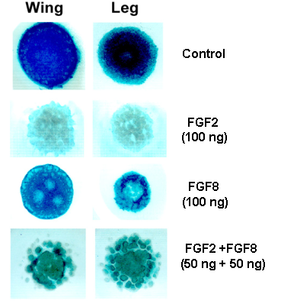
We have inserted this 843 bp fragment into a pBluescript expression vector and have used it to produce capped mRNA using the Clontech Message Machine kit. We introduced this RNA into leg bud mesenchymal cells by electroporation, using a BTX T820 Electroporator equipped with a voltage monitor, and assayed the formation of condensations by Hoffman Contrast Modulation microscopy (Frenz et al., 1989a) (Fig. VI.2).
Fig.VI.2. FGF2 and FGF8 Act Synergistically to Elicit Perinodular Inhibition
We have also constructed several mutant FnNTDs by site-directed mutagenesis, which lack arginines or a lysine in the domain’s Ω-loops, which are necessary for heparin/heparan sulfate interaction (Kishore et al., 1997). Precartilage mesenchymal cell surface contains heparan sulfate-containing proteoglycans (Gould et al., 1995).
The ectopic expression of the FnNTD or its mutated forms may enhance or inhibit the rate and extent of condensation in precartilage limb bud mesenchyme, depending on the level of expression in high density micromass cultures (essentially two-dimensional disks), and whether the transfected tissue derives from fore or hind limbs. Endogenous fibronectin organizes differently in vitro and in vivo and plays different roles in mediating fore and hind limb cell condensations in vitro (Downie and Newman, 1995).

VI.8.i.c.2 Potts Model and Reaction-Diffusion Simulations of Chick Limb Development:
Cell polarity affects tissue morphogenesis in numerous ways. In the developing limb, for example, an ectodermal sheet consisting of polar, cuboidal epithelial cells surrounds the skeletogenic limb mesenchyme. At the distal margin of the limb bud this cuboidal epithelium becomes columnar, forming the apical ectodermal ridge (AER), a source of fibroblast growth factors (FGF’s) required for the limb’s continued outgrowth. The morphology of the AER may focus the activity of the FGFs on the appropriate distal regions of the mesoderm. Eqn. (VI.4) can potentially generate the normal ridge configuration when applied to an ectodermal sheet in which cell polarity varies along a central line of cells, most likely through the action of a diffusible morphogen such as mesodermal FGF-8 involved in limb bud initiation (Vogel et al., 1996).
Diffusible molecules (e.g. retinoic acid and TGF-β) are crucial to tissue morphogenesis, acting as both guidance cues at the extracellular level and as morphogens at the intracellular level, switching the transcription of genes on or off. For the developing avian limb, for example, we need to model TGF-β, which is diffusible and positively autoregulated and the still hypothetical diffusible inhibitor induced by TGF-β. Experimentally TGF-β induces fibronectin and N-cadherin, setting up local patches of enhanced adhesivity.
We have previously modeled the succession of skeletal elements in the developing limb as a reaction-diffusion process but limitations of the analytical methods used confined the description to a series of stationary solutions (Newman and Frisch, 1979; Newman et al., 1988). The computational methods described here will permit a time-dependent representation of transitions to different numbers of parallel elements, and conform more accurately to the continuous unfolding of pattern during limb development.
In Eqn. (VI.10), A will represent the concentration of TGF-ß, an inducer of fibronectin and N-cadherin. B is a putative lateral inhibitor induced by TGF-ß at the sites of precartilage condensation. Experiments in progress in the Newman laboratory indicate that a perinodular inhibitor is released from the sites of condensation by the action of FGFs supplied by ectoderm on the condensed mesenchyme.
Modeling the internal state of a cell is necessary both in order to understand how extracellular signals such as the local concentration of TGF-β switch the genes necessary for fibronectin production and more generally how cells differentiate
We shall investigate how extracellular molecular signals determine when and how often a given gene is transcribed. Specifically, in close collaboration with experiment we shall simulate the known pathways in the BRN for the TGF-β signal including all known second messengers, enzymes, and biochemical parameters such as reaction rates and diffusion constants. We shall identify switches or other logic gates present in this BRN that may switch on genes. Spatially we shall also study under what conditions second messenger signals would reach a critical level at the cell nucleus (Section V.6.ii) in order to switch on transcription.

VI.8.i.c.3 Comparison of Simulation and Experiment:
Analyzing these data, which show apparent nonlinearities in response to levels of ectopic FnNTD, is difficult except by computational methods. The Potts model is especially convenient. We will perform FnNTD mRNA transfection experiments under various conditions and accumulate panoramic Hoffman images of the resulting condensation pattern. We will adapt the Potts model to cells which have a fixed surface adhesive ligand (i.e., heparan sulfate proteoglycan) and locally synthesize one or more secreted extracellular matrix molecules (i.e., fibronectin plus FnNTD). The model will generate patterns to compare to experiment and establish parameter ranges in which ectopic FnNTD should act as an enhancer or dominant negative. This comparison will help explain the quantitative ranges of extracellular matrix molecule expression (and expression of potential competitor molecules for specific cell-matrix interactions) consistent with particular morphological outcomes.

VI.8.i.d Project 2—Activator-Inhibitor Interactions in Skeletal Pattern Formation:
Well-defined developmental axes during limb growth suggest that positional information, in which morphogen gradients create a three-dimensional chemical address is a possible mechanism for skeletal development (Wolpert, 1989; Tickle, 1994). Each cell then differentiates in a manner dependent on its position using a complex genetic program to create the spatial distribution of skeletal elements that appears during development. Another possibility is that reaction-diffusion mechanisms involving biologically relevant molecules such as the FGFs, TGF-βs and fibronectin create a prepattern which induces cell differentiation. For example, a cell might differentiate if the concentration of a specific chemical species were above some critical level. These two scenarios differ profoundly. Positional information requires very simple morphogen gradients and complex genetic programs, while in prepatterns the response of the cell can be very simple and the complexity lies in the bifurcation and segmentation mechanisms that occur in nonlinear reaction-diffusion. Hybrid mechanisms are possible (Newman, 1996), but the question remains which primarily determines the skeletal pattern.
We believe that the best recent evidence suggests that the early stages of mesenchymal condensation and differentiation into cartilage depend on complex nonlinear dynamics involving several growth factors, and differentiated cells with different receptors capable of responding to these factors, ultimately producing tissue domains enriched in fibronectin within which cells accumulate by adhesive interactions. (see reviews in Newman and Tomasek (1996); Hall and Miyake (2000); and in vitro studies (Miura and Shiota, 2000a; 2000b; Miura et al., 2000).
While this earlier work indicates that one or more member of the TGF-β family of growth factors is capable of acting as an activator in a Turing-type reaction-diffusion system which gives rise to quasi-periodic patterns of precartilage condensations (Newman and Frisch, 1979; Newman, 1996), the molecular mechanism of perinodular inhibition, required by this class of models, has been elusive. The following preliminary experimental data is therefore highly pertinent: Limb bud cell cultures grown in the absence of ectoderm form continuous sheet-like masses of cartilage. Including ectoderm in these cultures produces one or more cartilage nodules surrounded by zones of noncartilaginous mesenchyme. Ectodermal fibroblast growth factors (FGF2 and FGF8), but not a mesodermal FGF (FGF7), substitute for ectoderm by inhibiting chondrogenesis, with some combinations of the two ectodermal factors leading to well-spaced cartilage nodules of relatively uniform size. Treatment of cultures with SU5402, an inhibitor of FGF receptor tyrosine kinase activity, prevents FGF induced perinodular inhibition. Inhibition of production of FGF receptor 2 (FGFR2) by transfection of wing and leg cell cultures with antisense oligodeoxynucleotides eliminates ectoderm- or FGF-induced zones of perinodular inhibition of chondrogenesis and, when introduced into the limb buds of developing embryos, led to shorter, thicker, fused cartilage elements (Moftah, et al., submitted). Because FGFR2 is expressed mainly at sites of precartilage condensation during limb development in vivo and in vitro, these results suggest that activation of FGFR2 by FGFs during development elicits a lateral inhibitor of chondrogenesis that limits the expansion of developing skeletal elements.
As a theoretical approach to these questions we have expressed the basic mechanisms of differentiation patterning in the form of reaction-diffusion equations (Eqn. VI.10). These equations model the interplay of several factors, including activators representing TGF-β and lateral inhibitors such as those elicited by FGFs. Together these should lead to nonhomogeneous distributions of fibronectin; followed by cellular condensations modeled by the Potts model in linked simulations. We are now studying the onset of Turing-like instabilities in these systems, and the effect of a variable sized progress zone on the number and shape of cell condensation domains. We hope to understand the conditions under which a humerus bifurcates into a radius and ulna and later segments into metacarpals and digits.
A related question involves the developing domain in which reaction-diffusion occurs. As the limb grows, most cell division occurs in a narrow Progress Zone, a band of decreasing width confined to the distal tip of the limb bud. How do the changing dimensions of the limb and the progress zone in particular, change the pattern of cell condensation? We are developing finite element approaches to solve for the distribution of diffusive factors and nonlinear activator and inhibitor distributions in such domains
Under the reaction-diffusion prepattern scenario the size of the predifferentiated progress zone should significantly affect the prepattern resulting in the limb (Newman and Frisch, 1979; Newman et al., 1988), because the number of standing periods of a heterogeneous distribution of a chemical species formed by a reaction-diffusion mechanism depends both on the scale of the basic pattern and on the space available for the pattern to develop.
Thus the first question we propose to investigate is how the changing size of the progress zone controls the prepattern underlying chondrogenesis. The basic idea computationally is to treat the developing limb as consisting of two parts, a proximal region in which the prepattern already exists and is essentially frozen, and a distal progress zone whose dimensions can change dramatically with time. Initially we shall take the time development of the progress zone to be genetically controlled, though later we will explore epigenetic mechanisms for sudden spurts of growth and contraction of the progress zone (Newman and Frisch, 1979). In the progress zone prepatterning can develop and we hypothesize that the basic structure of the skeletal elements will turn out to be due to bifurcations in the prepattern as a result of dynamic fluctuations in the length of the progress zone.
A second question involves how the skeletal elements themselves, once formed, influence further reaction-diffusion mechanisms in the developing limb. For example how would the existence of digits influence reaction-diffusion mechanisms in the interdigital regions? Such reaction-diffusion mechanisms might be relevant to properly controlled cell death leading ultimately to digit formation (Fig. VI.3).
In Fig. VI.3 we have integrated the Schnakenberg equations as an example of a reaction-diffusion system. In this somewhat artificial situation a preexisting pattern of skeletal elements affects the reaction diffusion-generated pattern, corresponding to the addition of elements distally in the presence of already formed elements. How impermeable obstacles influence reaction-diffusion is thus of developmental relevance. Ordered patterns appear between the skeletal elements when their natural length scale is of the same order as the nodule separation.
Fig. VI.3. Reaction-diffusion patterns around nodes representing skeletal elements. The upper image occurs in the absence of skeletal elements. The lower image shows the influence of the skeletal elements on pattern organization. The image on the lower left shows a pattern on a small scale compared to the limb; On the lower right can be seen self-organization in the case when the pattern is on the scale of the skeletal elements
We must understand how geometric constraints influence reaction-diffusion patterns to approach the main question—can reaction-diffusion representing known cell-factor interactions generate a limb skeletal pattern de novo in an appropriate confined geometry?
To grow a skeletal pattern we will need to include the influence of several variables. The apical ectodermal ridge (AER), which sits asymmetrically at the tip of the growing limb bud is necessary for proximo-distal development. The AER releases Fibroblast Growth Factors (FGFs) which control mitosis of mesenchymal cells expressing growth receptor 1 (R1) to create a progress zone of cell growth. We will use computational models to study how variations in the size of the progress zone influence the distribution of FGFs and consequently differentiation.
We will also incorporate the findings described above concerning the role of FGF receptor 2-mediated release of a lateral inhibitor of chondrogenesis. In a simple first approach we will assume that TGF-β induces the synthesis of FGFR2 in limb bud mesenchyme. We will test this assumption experimentally by quantitative PCR using the LightCycler system.

VI.8.i.e Project 3—Innervation in the Presence of Skeletal Elements:
We have investigated (Hentschel and van Ooyen, 1999) a whole sequence of mechanisms involved in neural network formation including bundling of axons, guidance of axon bundles to their target region, debundling and the final innervation of individual targets (see Fig. VI.4).
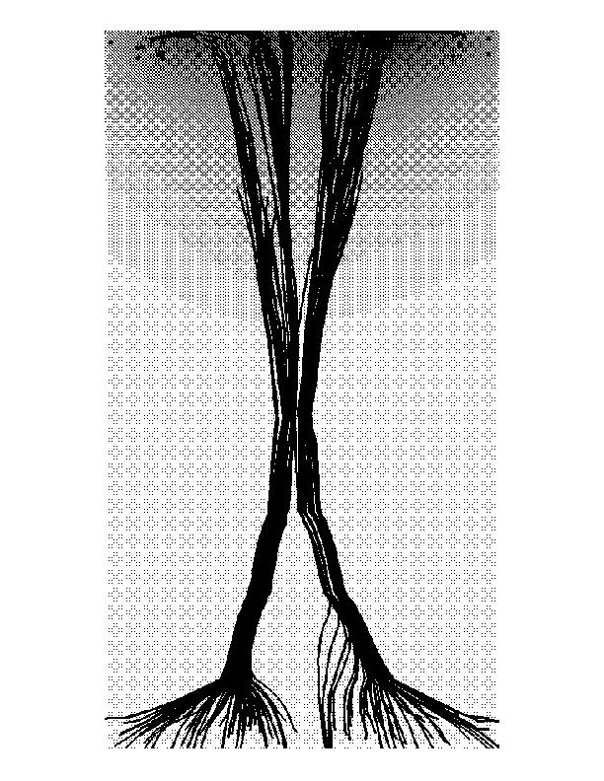
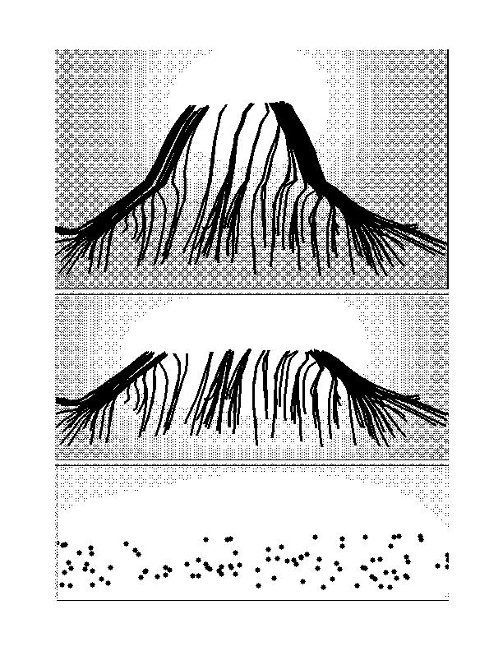

(a) (b)
Fig. VI.4 (a) A complete simulation of axonal migration from a source to a target layer of cells in the presence of a chemoattractant released by the axonal growth cone and a chemoattractant released by the target; (b) Axon bundling in the presence of a chemoattractant released by the growth cone.
Topographic maps describe the tendency of one layer of cells to map in a topographically well-defined manner to another layer of cells. How do layers of neurons create neural networks and topographic maps in the avian limb bud in the presence of perturbing skeletal elements? (see Fig. VI.5, next page).

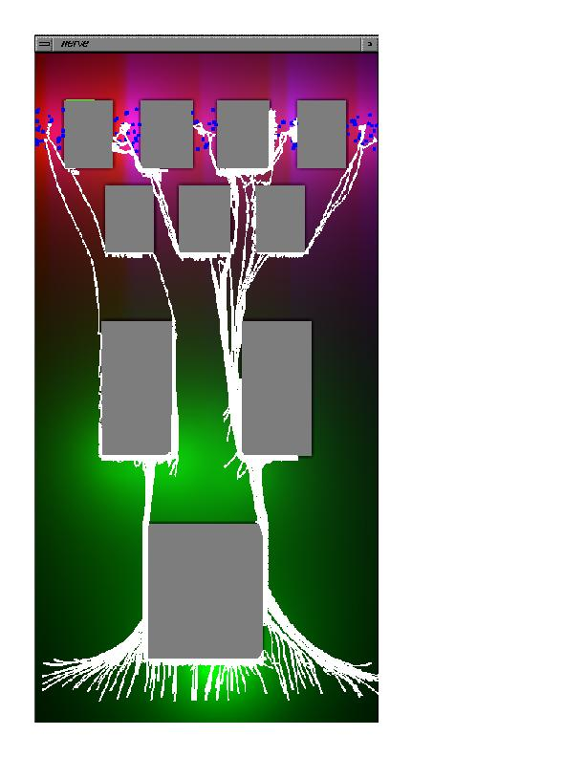
Another important topic that we will investigate is debundling. Initial investigations have shown that debundling and target innervation do not result solely from a breakdown of contact attraction (or indeed active contact repulsion) and the presence of concentration gradients of target-derived chemoattractants. The concentration gradients of target-derived chemoattractant are simply not large enough across the relatively small axon bundle, whether broken up or not, to further separate the axons. A diffusible, axon-derived chemorepellant is necessary for debundling and proper target innervation. In our simulations the target-derived chemoattractant triggers the release of a chemorepellant from the growth cone.
Fig. VI.5. Nerve fibers grown in the presence skeletal elements chemotactically following chemoattractant gradients released by target cells and the growth cones of the fibers

VI.8.ii Cell Motility and Translocation:

VI.8.ii.a Overview:
The following three studies all relate to the developmental effects of cell motility and translocation. They provide a natural connection to the modeling of motility of individual cells described in the cytoskeleton portion of this proposal, but demonstrate the effect of context—both neighboring cells and ECM. These phenomena are well suited to modeling by variations of the methods described earlier in this section, but encompass a variety of distinct experimental and conceptual issues across a wide range of phyla.

VI.8.ii.b Project 1—The Control and Mechanism of Chemotactic Cell Movement during Dictyostelium Development:
We aim to understand the exact interplay between the dynamics of the chemotactic signals controlling cell movement, the resulting cell movement and the mechanisms by which cells detect signals, polarize and move during the multicellular stages of Dictyostelium development. We will analyze cell-cell signaling at the population and single cell level and the resulting cell movement of all cell types in vivo in a large collection of wild type and mutant strains. We will measure some of the physical forces involved in cell-cell and cell-substrate adhesion and the generation of movement and traction forces. Finally we hope to improve our understanding and analysis of these complex interactions by developing models describing them.

VI.8.ii.b.1 Why Dictyostelium?
Development of a vertebrate embryo typically involves the generation of millions of cells that differentiate into hundreds of cell types to form a wide variety of different tissues and organs. Some cell types may arise and differentiate in situ at the right position at the right time of development, however many cell types have to move to their final destination. The signals controlling cell movement are difficult to study in higher organisms and in most cases we know little about the mechanisms involved. We are studying the role and control of cell movement during the development of the amoebae Dictyostelium discoideum, a genetically tractable experimental system (on the list of NIH model organisms). Dictyostelium is a simple organism that stands in evolutionary terms on the threshold between unicellular and multicellular life. It is a convenient model because its genome is almost sequenced and assembled, it has a well worked out molecular biology which allows specific targeting and mutation of all genes and its development is simple compared to that of vertebrates.
Dictyostelium normally live as individual amoebae in the soil feeding on bacteria. Under starvation conditions up to several hundred thousand cells aggregate to form a multicellular slug, in which the cells differentiate into 5-6 different cell types initially in a random spatial pattern. Chemotactic cell sorting generates a simple axial pattern of cell types in the slug. The slug can migrate and when it encounters the right environmental signals undergoes a complex series of morphogenetic movements to form a fruiting body (Loomis, 1982). The fruiting body consists of a stalk supporting a mass of spores. Since the multicellular phase occurs in the absence of food cell division is distinct from development (Weeks and Weijer, 1994), the number of cells doubling at most. Morphogenesis therefore results from the coordinated cell movement of a few emerging cell types.
Propagating waves of the chemoattractant cyclic AMP (cAMP) control cell aggregation. The principles that govern aggregation at the cell level result from the following competencies:
- Periodic cAMP signal generation by cells in the aggregation center.
- cAMP signal relay by all other cells.
- Chemotaxis up a cAMP gradient during the rising phase of the wave.
The result of these behaviors is that starved cells, whether distributed on a substrate or in a compact mass, behave like a classical physical excitable medium which can support a large variety of propagating circular and spiral waves. We have shown using a variety of experimental techniques and mutants that the cells still communicate by propagating waves of cAMP during the multicellular stages of development, when they pack tightly in tissues (Weijer, 1999; Dormann, Vasiev and Weijer, 2000). The waves can now form complex waveforms such as multi-armed spirals and twisted scroll waves (Bretschneider, Siegert and Weijer, 1995). These waves direct the movement of the cells in a cell type specific manner resulting in cell sorting. The interplay between the cells that generate the cAMP resulting in the formation of waves and the relocation of the cells in response to these waves constitutes a very complex dynamical system that governs the morphogenesis.
Open questions include how cells polarize i.e. respond to the chemotactic signal, how they translate this information into directed motion (see Project 2), how cells move in a multicellular tissue, i.e. how they obtain traction through other cells from the substrate, and the role of differential cell adhesion during chemotactic cell sorting? We can investigate many of these questions using simulations in which we can control the relative importance of differential adhesion and chemotaxis (Jiang, Levine and Glazier, 1998) and by including cell polarity models (Alber and Kiskowski, 2001; Marée, 2000).
To understand this morphogenesis requires experimental as well as theoretical analysis. Extensive modeling using both discrete and continuous (fluid dynamics) formalisms has provided some insight into these complex interactions (Vasiev and Weijer, 1999; Vasiev, Siegert and Weijer, 1997). However, we need to extend these calculations to account for the viscoelastic properties of the tissues.

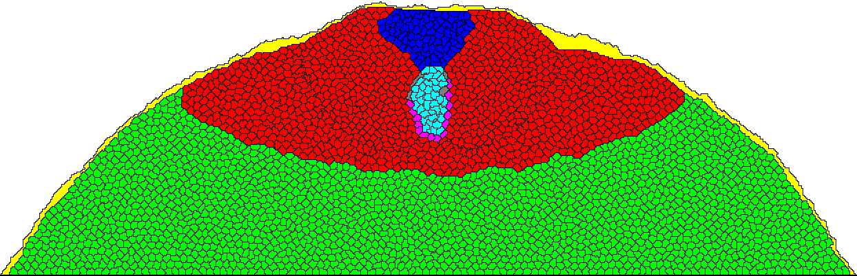
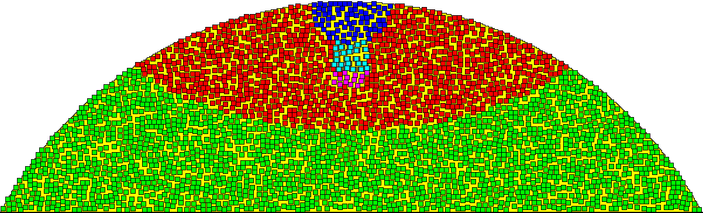

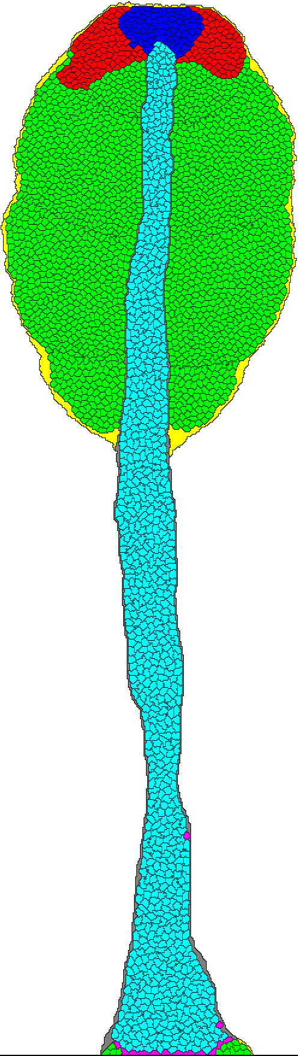
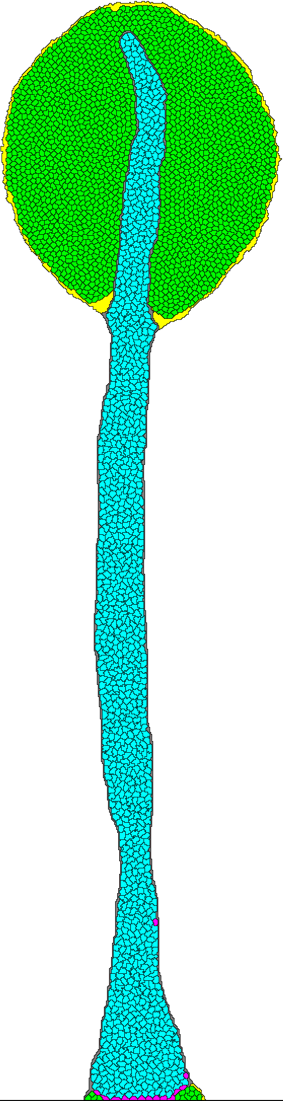
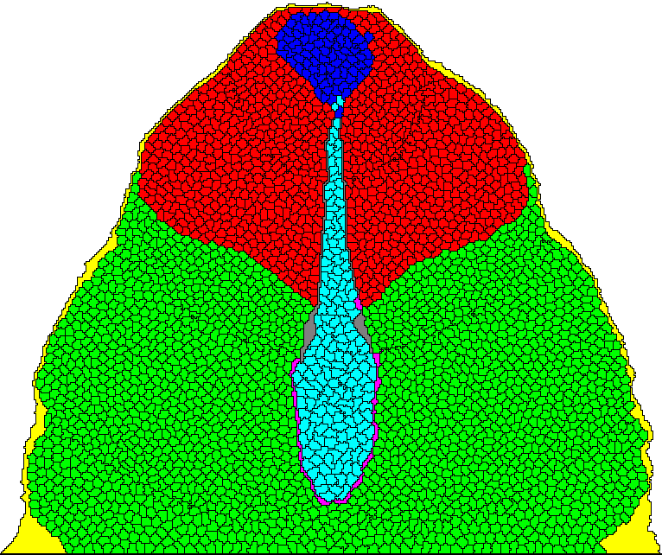

Fig. VI.6. Time sequence of simulation of the process of culmination of Dictyostelium discoideum.

VI.8.ii.b .2 Approach:
We can measure the cell-cell signaling at the population level by measuring the dynamics of the propagation of optical density waves (associated with shape changes during the coordinated movement of groups of cells) in mounds, slugs and culminants (Weijer, 1999). We have established fluorescent microscopic methods, using a combination of conventional, confocal and deconvolution fluorescence microscopy that allow us to measure the dynamics of signal transduction in individual cells in the multicellular stages. We measure the dynamics of translocation of signaling components (PH domain containing proteins) tagged with green fluorescent protein (GFP) from the cytosol to the membrane to form signaling complexes and from the cytosol to the nucleus in the case of transcription factors to initiate developmentally regulated and cell type specific gene expression (Dormann, Vasiev and Weijer, 2000; Dormann et al., 2001). We can follow the movement of all individual cell types in vivo by expressing different spectral variants of GFP under the control of a variety of cell type specific promoters in wild type strains and a large variety of mutant cell lines.
We have isolated and characterized temperature sensitive adenylylcyclase mutants that allows us to switch on and off cAMP production at different stages of development. We have mutants expressing different combinations of GFP tagged cAMP receptors under different cell type and developmentally regulated promoters (Patel et al., 2000; Dormann et al., 2001). We have mutations in three distinct cAMP phosphodiesterases, the enzymes that regulate the breakdown of cAMP in and outside the cell. By comparing these mutants to wild type strains we can effectively titrate the rate of destruction of the cAMP signal and investigate its consequences for development (Sucgang et al., 1997).
We are actively analyzing the role of proteins controlling the actin cytoskeleton and coupling elements of the actin cytoskeleton to cell adhesion molecules (Rivero et al., 1996; Eichinger et al., 1996). We are analyzing knockout mutants in talin and paxillin to show that these cells cannot develop beyond the mound stage. Expression of paxillin under the control of a prestalk specific promoter can rescue development, while expression under a prespore specific promoter cannot, showing that prestalk cells function as the motors during slug formation. We have now started to analyze the role of different paxillin domains (LD and LIM domains) by complementation of the null mutant with different truncated forms of the paxillin protein. We have also started to measure the adhesion of cells to different substrates using a radial flow displacement assay as well as a direct measurement of traction forces generated by chemotactically moving cells via the measurement of the deformation of elastic substrates. These experiments are designed to shed light on how a chemotactic signal translates into cell polarization and directed movement.
Finally we are actively involved in developing both continuous and discrete models of the interaction between cell-cell signaling and cell movement at all stages of development (Vasiev and Weijer, 2000).

VI.8.ii.c Project 2—Cell Movement during Gastrulation:
Gastrulation, when the germlayer, the mesoderm and endoderm take up their characteristic positions inside the embryo and neural induction takes place, is absolutely critical to the development of most invertebrate and vertebrate embryos. Coherent and highly patterned motion of cells over distances large compared to cell dimensions characterizes gastrulation in vertebrate development (Wolpert, 1998). Such large-scale rearrangements are necessary because early cell differentiations leave cells of a given type in the wrong location for their ultimate function. Invagination, radial intercalation, convergent extension, and epiboly are specific types of motions that often occur and all are present in the gastrulation of chicken and the well-studied embryo of the frog Xenopus laevis (Keller and Shih, 1995 and references therein).
We want to know whether the mechanisms central to morphogenesis in Dictyostelium, i.e. propagation of a chemotactic signal via a relay mechanism and chemotaxis, play a role in the control of the extensive cell movements that occur during gastrulation, the formation, extension and regression of the primitive streak.

VI.8.ii.c.1 Experiments on Primitive Streak Formation in Chick:
However, we know very little about the signals controlling these movements. We are investigating whether chemotaxis may help direct cell movement during gastrulation. We first must quantify cell movement patterns in vivo during early streak formation, extension and regression.
We have established methods to electroporate early prestreak chick embryos and get them to express GFP fusion proteins. We can observe the movement of single cells in the embryo for up to 24 hours. We are now combining these observation with positive identification of the moving cells by analyzing their gene expression patterns and are trying to express GFP in a cell-type specific manner using a variety of heterologous promoters. We can thus trace cell movement quantitatively during streak formation to elucidate the mechanisms which form the streak.
We are investigating whether chemotaxis, substrate guided movement or differential adhesion between cells dominate these movements. Movement of the mesoderm cells away from the streak involves both positive and negative chemotaxis to FGFs. We have started experiments to interfere with potential signaling pathways (using protein and lipid kinase inhibitors as well as dominant negative constructs (FGF and frizzled receptors) and the ability of the cells to move, by the expression of dominant negative mutants involved in the organization of the actin cytoskeleton such as WASP and CDC42 (see Section V.6.1.b.4, Cytoskeleton Project) in subpopulations of cells in different regions of the embryo. Using this approach we can selectively immobilize populations of cells in vivo and study the consequences for development.

VI.8.ii.c.2 Models of Gastrulation:
The animal genome, as vast as it is, does not contain enough information to provide a detailed plan or blueprint for the development of an adult animal from a fertilized egg cell. Development must take advantage of natural physical processes that do not require detailed genetic control. A central problem of biophysics is to identify and understand these processes.
We aim to develop models to describe the complex processes of gastrulation. Modeling alternative hypothesis for the interactions between cell signaling, cell division and cell movement will be a tremendous help in guiding further experiments
Various mechanical models (Zajac, Jones, and Glazier, 2000; Weliky et al., 1991; Weliky and Oster, 1990; Odell et al., 1981) have been proposed for these specific types of motion and simulations based on these models seem to show they suffice to explain the specific motions of isolated groups of cells, at least in planar arrays. In gastrulation, however, all of these types of motion occur in a highly coordinated way in several thousand cells arranged in a three-dimensional geometry. No models or simulations of this complete process are available.
Despite formidable obstacles, such a model may now be within reach. A principal motive for modeling early to mid-gastrulation cell movements of the embryo is to address the question of “how do cells know where to go?” Some sort of genetically controlled signaling, originating in the vegetal region of the early embryo, affects early differentiation of cells (Wolpert, 1998). However, specific cell movements are less likely to be under genetic control. Indeed, if they were, the pattern of genetic signaling, would have to be as complex as the resulting pattern of cell motion. While possible, it would only exchange the problem of understanding a complex set of cell motions for that of understanding an equally complex set of genetically controlled signals. A more attractive option, from both an explanatory and an evolutionary viewpoint, would be that a simple set of genetic signals produces an initial instability triggering motions that are just the natural mechanical response to this instability. The challenge is to create a physically plausible model of this process that we can simulate with present computing capacity.
Our general approach will be similar to the CPM used, so successfully, to explain cell sorting (Steinberg, 1963; Graner, 1993; Graner and Glazier, 1992; Glazier and Graner, 1993). The picture is that cell motions are highly dissipative and proceed towards states of lower cell-cell interaction energy in the presence of random motions representing metabolically driven cell motility. The first step is to identify those cell properties likely to be important and sufficient for the modeling. Both experiment and previous simulations suggest that cell polarity, cell deformation, cell-cell surface adhesive interactions, chemotaxis and cell motility are important, as are their relationships with each other. A physically plausible dynamic model using these cell properties should be possible. The only feasible way to investigate the motions predicted by such models is through numerical simulation.
The most successful simulations of cell sorting, for example, use the CPM (Graner and Glazier, 1992; Glazier and Graner, 1993) model where each cell is represented by several hundred sites on a lattice, allowing for very detailed representation of the cell geometry and cellular properties. However, for a system of several thousand cells the number of degrees of freedom in this model becomes very large. In addition, the cell-cell interactions in gastrulation are likely more complicated than in the typical cell sorting situation so the computation required per simulation time step is much larger, as in simulations of convergent extension (Zajac, Jones and Glazier, 2000). We need a much simpler description of the cell that still incorporates the important properties.
At the coarsest level we will try a quasi-hydrodynamic approach, neglecting individual cells and regarding the embryo as a viscoelastic shell with certain material properties. A local order parameter similar to that used in the hydrodynamics of nematic liquid crystals can represent cell polarity. Cell-cell interactions appear phenomenologically as an energy functional as in the Density Functional theory of liquids and solids (Jones, 1987). Cell motility arises from random forcing terms in the dynamic equations. We abandon a detailed description of cell geometry except in some average sense. Present day computers can simulate a plausible model of this type.
A somewhat more detailed approach is to describe each cell by its center of mass position and a director related to cell deformation or polarity. Since each cell has only a few degrees of freedom simulations of several thousand cells are possible. Position and director dependent potential energy functions represent cell-cell interactions. Because the shape and volume of the cells are not directly represented, as they are in lattice models, the interaction potentials have to mimic the effect of (nearly constant) cell volume. Surface adhesion and chemotaxis rather than position dependent potentials mediate cell-cell interactions. We have made some progress choosing such potentials. The natural dynamics would be a (highly dissipative) molecular dynamics of the Langevin type with random forcing to represent cell motility. This type of model easily accommodates correlations between polarity and motility.

VI.8.iii Tissue Mechanics:
To understand and model the motion of cells we must know their viscoelastic mechanical properties. However, knowing the properties of the cells does not suffice to predict the mechanical properties of a complex tissue containing cells, ECM, fibers and potentially other materials in a highly structured inhomogeneous geometry. The following sections address measurements of cell and tissue properties both to apply to the models discussed above and to serve as elements for large-scale tissue simulations. Our goal would be to predict tissue properties from a knowledge of the properties and geometrical arrangement of their components. Measuring the mechanical properties of cells reliably is difficult and we have developed several techniques to do so. Still more difficult is the characterization of the mechanical properties of the cytoplasm, which is itself highly inhomogeneous because of the cell’s cytoskeleton and internal membrane structure.

VI.8.iii.a Project 1—Viscoelasticity of Cells and Tissues:

VI.8.iii.a.1 Experimental Methods:
We will measure liquid and viscoelastic properties of genetically transformed cell populations and embryonic chicken tissues using the parallel plate apparatus schematically illustrated in Fig. VI.12. Upon compression of a cellular aggregate, the initial magnitude of the compressive force relaxes to equilibrium in a manner typical of viscoelastic materials (Forgacs et al., 1998). The equilibrium value of the compressive force and the shape of the compressed aggregate determine the surface tension (the interfacial tension between the tissue and the surrounding tissue culture medium) through Laplace's equation (Rowlinson and Widom, 1989). We have used this method to determine the surface tension of embryonic chicken tissues (Foty et al., 1994, 1996) and will evaluate the surface tension of cultured cells. We have obtained preliminary results for genetically transformed L-cell aggregates.
We will measure the interfacial tension between two aggregates of different composition using two similar-sized spherical aggregates placed in contact in the compression chamber. Laplace's equation, evaluated along the common interface yields the value of the interfacial tension. We estimate the interfacial tension σ_{AB} between phases A (more cohesive phase) and B (less cohesive phase) using Young's equation at complete wetting (Rowlinson and Widom, 1989). This estimate is based on the final configuration, phases A and B attain after sorting and leads to σ_{AB}=σ_{A}- σ_{B}, where σ_{A} and σ_{B} are the surface tensions of A and B.
Tissue surface tension measurements can estimate the binding strength between pairs of cell adhesion molecules. The tension σ_{AB} contains information on the cohesiveness of the fluid. Simple dimensional analysis suggests (Forgacs et al., 1998) that σ_{AB} ~JN, where N is the number of bound cell adhesion molecules per unit area of the cell surface and J is the effective strength of binding between a pair of such molecules. Preliminary results support the linear dependence of σ_{AB} on N for cadherin-transfected L cells.

VI.8.iii.a.2 Mathematical Background:
Most real materials, in particular cell cytoplasm and bulk tissues, are viscoelastic. No general theory exists for viscoelastic materials. The standard governing equations are known for elastic solids (continuum elasticity theory) and ideal fluids (Navier-Stokes Equation) only. Attempts to generalize these equations to the intermediate viscoelastic regime have failed. In conjunction with Prof. F. Graner and Prof. M. Aubouy of the University Joseph Fourier, Grenoble, France, we have developed a mesoscopic statistical theory that can treat deformations and flows of simple viscoelastic materials in two dimensions. We are currently working to extend this theory to three dimensions and to more complex materials. Eventually, we hope to be able to write generalized constitutive relations to describe the properties of biological materials. Such a theory is an essential prerequisite for accurate modeling of cell and tissue mechanical behavior.

VI.8.iii.b Project 2—Bone Adaptation:
Adaptation of tissues to external stress is a prominent feature during both embryonic development and maintenance of adult organs. Part of this adaptation is generic and passive—the expected response of any viscoelastic material to the physical environment. However, tissues are also excitable media: the cytoskeletal networks of their constituent cells can store chemical and mechanical energy which they can release under appropriate circumstances, and extracellular matrices have unusual rheological properties and are repositories of structural information that feeds back on cell physiology. Tissues are therefore unique physical media and bone is among the most unusual and experimentally accessible of these materials.

VI.8.iii.b.1 Overview:
Trabecular bone (Fig. VI.7) is a major load bearing structural material in the skeleton. Decreased density of trabecular bone due to aging and disease causes fractures (Lotz et al., 1991a; 1991b) and implant loosening (Cheal et al., 1987). Over 100 years ago, Wolff observed that trabecular bone adapts to align itself with applied loads. However, with aging and disease this adaptation can fail, decreasing bone density and a concomitantly increasing fracture risk. Expenditures for the treatment of age related fractures exceed $10 billion annually in the US alone. The financial costs are minor in comparison to the impact on the quality of life for individuals, with over 420,000 people hospitalized and over 175,000 admitted to nursing homes annually.
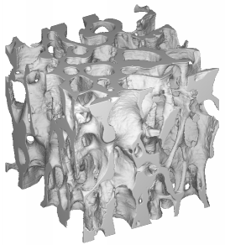
Fig. VI.7. A rendering of a 5 mm cube of human femoral trabecular bone. This bone was harvested along the loading axis of the bone, so that the trabecular struts are primarily oriented along the vertical axis of the cube.
The mineralized bone tissue that forms the solid phase of trabecular bone consists of an extracellular matrix of collagen and hydroxyapatite. Three types of cells maintain this matrix, osteoclasts which resorb bone, osteoblasts which create new bone, and osteocytes which trap within the mineralized matrix (Fig. VI.8). The activity of these cells depends on the mechanical loads transmitted to them through the mineralized matrix, which the cells in turn resorb and reform. Thus, in a closed control loop the matrix modulates mechanical signals and transmits them to the cells which, in turn, modify the surrounding matrix to maintain a preferred state of mechanical loading.
Fig. VI.8. An SEM image of human vertebral trabecular bone. Cells located within the lacunae on the surface and within the mineralized matrix control the adaptive response of bone to mechanical loads.
Potential pathways for transmission of stress or strain from the macroscopic level to the bone cells lying within the matrix include chemical and electrical streaming potentials (Zeng et al., 1994; Cowin et al., 1995), and induced fluid flow (Weinbaum et al., 1994; Gardne et al., 2000; Knothe Tate and Knothe, 2000; Steck et al., 2000). We do not know which, if any, actually occur. However, recent advances in high-resolution imaging techniques and computational modeling provide a unique means to evaluate the transmission of mechanical stimuli to the cells through the extracellular matrix (Van Rietbergen et al., 1998; 2000; Ulrich et al., 1999; Jaasma et al., 2001; Niebu et al., 2001a; 2001b; Niebur and Keaveny, 2001).
Computational simulations have investigated whole bone strength in a variety of situations, neglecting adaptation (Lotz et al., 1991a; 1991b; 1992; 1995; Keyak et al., 1995; Cody et al., 1998; Keyak et al., 1998; Cody et al., 1999; Keyak 1999; Oden et al., 1999; Keyak and Rossi 2000). Enhanced models simulate bone remodeling as a phenomenological consequence of mechanical stimuli to predict changes in bone structure due to mechanical loads (Hart et al., 1984; Jacobs et al., 1992; Prendergast and Taylor, 1992; 1994; Levenston et al., 1994). Thus, these models provide little insight into the biological and biochemical processes that activate the basic multi-cellular units responsible for bone remodeling.
Knowing the mechanisms by which mechanical, electrical, or chemical stimuli are imparted to the cell is only one component of understanding development and damage repair in bone. We know little about the response of the cell to these stimuli, and how this response fits in the overall chain of events that results in cell differentiation and activation. Cell apoptosis is one possible response to mechanical stimuli (Noble and Reeve, 2000). In this model, the apoptotic cell releases growth factors and other proteins into the surrounding bone. Damaged trabecular bone releases TGF-β, which is plentiful in bone matrix (Pfeilschifter et al., 1998; Fyhrie et al., 2001). Increased levels of parathyroid hormone (PTH) enhance stress induced bone formation in rats (Kim et al., 2001). The pathways by which these biochemicals affect bone formation are unknown, but they may diffuse into the interstitial fluid of the bone and cause differentiation of macrophages into osteoclasts, the initial cells in the activation, removal and filling cycle of bone adaptation and remodeling. Incorporating these factors into computational models should provide insight into the biology of bone remodeling, and provide a framework for similar investigations in other tissues that respond to mechanical stimuli such as blood vessels, cartilage, and muscle.
Recent evidence suggests that bone remodeling and adaptation relate to the repair of microscopic damage incurred daily. Hence, damage can affect whole bone strength inconsistently. At the macroscopic level, it changes stiffness, redistributing loads within the bone that may increase fracture susceptibility (Kopperdahl et al., 2000). At the microscopic level, damage may stimulate remodeling (Burr, 1993; Mori and Burr, 1993) causing trabecular bone to increase its stiffness and strength with respect to the applied macroscopic loads (Prendergast and Taylor, 1994; Levenston and Carter, 1998). Thus, damage may be detrimental in the short term, but in the long term can reduce overall fracture risk. In the healthy skeleton, repair and adaptation maintain a delicate balance. However, with aging this balance breaks down, resulting in a net loss of bone, leading to osteoporosis and increased risk of fracture. We need an improved understanding of the relationship between macroscopic loads, microdamage, and the resulting biological processes to better understand the mechanisms underlying damage stimulated bone remodeling. We do not know the mechanism which initiates damage repair or how it results in the functional adaptation of trabecular bone architecture. One possible stimulus for damage repair and adaptation is the release of biochemical growth factors from damaged bone matrix that provide either an activation or targeting signal to the basic multicellular units responsible for bone remodeling.
This project will focus on one potential biochemical reaction: the release of growth factors from the mineralized bone matrix when microdamage occurs, specifically Transforming Growth Factor (TGF)-β₁. Growth factors are present in bone mineral matrix (Pfeilschifter et al., 1998), and mechanical damage releases TGF-β₂ from trabecular bone (Fyhrie et al., 2001). The growth factors may come from the exposed surfaces of the mineral matrix as microdamage occurs, or from interstitial fluid in the canaliculi and lacunae as microdamage exposes these pore spaces to the surface.
The results of this research are intended to lay groundwork for incorporation of hormonal and biochemical factors into large scale finite element models of bone formation and damage repair (Niebur et al., 2000; 2001a; 2001b; Niebur and Keaveny 2001). These models will provide a basis for incorporating biological response into macroscopic simulations of bone remodeling and adaptation (Hart et al., 1984; Prendergast and Taylor 1992; 1994; Levenston and Carter 1998). Such models can aid the design of orthopedic devices, and the evaluation of protocols for the diagnosis and treatment of osteoporosis as well as the study of the interactions between macroscopic loading and cellular response in bone remodeling.

VI.8.iii.b.2 Hypothesis 1: Damage Localization in Trabecular Bone Microstructure:
Different locations within the trabecular bone architecture suffer damage depending upon the mode and orientation of macroscopic loads with respect to the principal trabecular orientations.

VI.8.iii.b.3 Specific Aim:
Histologically, we will measure the amount of microdamage in the solid bone matrix due to overloading using differential staining to identify damage caused by each of a sequence of applied compressive and shear loads. We will correlate the locations and amounts of damage with the applied mechanical load.

VI.8.iii.b.4 Hypothesis 2: Relationship between Mechanical Damage and Biochemical Signals:
The mechanical damage following overloading of trabecular bone correlates with the amount of growth factors that the bone matrix releases which depends on the applied damaging load.

VI.8.iii.b.5 Specific Aim:
We will quantify the release of growth factors from trabecular bone during monotonic damaging loads. We will correlate the release of growth factors to decreases in modulus and to histological measurements of microdamage in the bone tissue matrix.

VI.8.iii.b.6 Micro Damage Measurements:
We will quantify microscopic damage within the mineralized bone matrix using differential staining techniques. We will study thirty specimens of bovine tibial trabecular bone divided into three groups. We will successively load each group to a macroscopically damaging level either tension, compression, or shear. We will then successively strain the specimens in the remaining two modes. Bulk staining of the specimens using chelating agents (Lee, Arthur et al. 2000; Lee, O'Brien et al. 2000) will identify regions of damage associated with each loading type. Following each damaging load, we will bulk stain the specimens using either calcein, calcein blue or xylenol orange to differentiate cracks due to each loading mode (Lee, Arthur et al. 2000). We will quantify the regions of damage using fluorescence microscopy on thin slices both parallel and perpendicular to the loading directions, to classify damage as pre-existing, new, and propagating for each loading case based on the differential staining patterns. This data will determine whether damage regions in trabecular bone are specific to the applied loading cases, and quantify the amount of physical damage associated with each.

VI.8.iii.b.7 Growth Factor Release from Damaged Bone:
We will quantify the release of growth factors from the mineralized bone matrix during damage for both compressive and shear loading. Three groups of specimens will receive different damaging loads. Initially, we will scan each specimen using micro-computed tomography to ascertain the principal mechanical orientation of the trabecular bone (Van Rietbergen et al., 1998) and to quantify the volume fraction and surface area of the mineralized matrix. Following damage due to an overload, we will washed the specimens in phosphate-buffered saline (PBS) solution, collect the wash and assay it for TGF-β. We will apply three different damaging loads: on-axis compression, transverse compression, and shear. We will quantify the reduction in the apparent moduli for each specimen. We will compare the quantity of growth factors released from the matrix to the expected amount of damaged mineral matrix, based on the previous experiments and the changes in mechanical properties. In addition, we will compare the quantity of growth-factors to the overall volume fraction and total surface area of mineralized tissue and use multiple regression analysis to determine the dependence of the release of growth-factors on these parameters.

VI.9 RELATIONSHIP TO CYTOSKELETON (PROJECT 2) AND BIOLOGICAL NETWORKS (PROJECT 1):
The Organogenesis and Tissue Mechanics project integrates the aims of all three projects described in this proposal. The avian limb skeletal development and gastrulation projects, for example, must assume an underlying genetic network in each mesenchymal cell that is subject to regulation by a signaling network that contains both intracellular and extracellular components. Both the Potts model representation of the energetics of precartilage condensation and the reaction-diffusion model of morphogen patterns depend on knowledge of the articulation of these two networks—their characteristic dynamical modes and the modularity, or lack thereof, of key regulatory components of skeletogenesis. Similarly, for the mathematical representations of gastrulation and innervation.
The Dictyostelium project, as well as the skeletogenesis project, depend on assumptions concerning cell’s motile responses to extracellular signals, and in turn will draw on the models of cytoskeletally-based mechanisms of cell locomotion and protrusive activity generated from the work on the cytoskeleton described in Section V..
Cell movement through the primitive streak in the vertebrate embryo involves concerted translocation of cells, for which the mechanism must be based both on the viscoelasticity of tissues as well as the aforementioned cytoskeletal dynamics. Finally, studies on the interaction of the structural matrix networks and signaling networks in bone described in this section will benefit from insights gained in the formal studies of networks described under Project 1.

VI.10 TIMELINE:
- Year 1  - Experiment | - Initial data acquisition from wing cultures and leg cultures using existing fibronectin amino-terminal domain wild type and mutant constructs.  - Test Effect of initial cell density on whether transfected RNAs promote or inhibit condensation will also be tested.
- Simulation | - Initial simulations of chondrogenesis and nerve innervation in static domains in the presence of simple nodular structure.  - Investigate geometry and biochemistry on form and function.  - Develop stable fast solvers for the reaction-diffusion equations.
- Year 2  - Experiment | - Construction of additional mutants in putative heparan sulfate binding regions of the fibronectin amino-terminal domain.  - Develop clones encoding other segments of fibronectin.  - Data acquisition from wing cultures and leg cultures transfected with these constructs.
- Simulation | - Study the influence of evolving limb geometry on chondrogenesis and nerve innervation.  - Develop models of cytoskeletal growth.  - Study the development of vasculature in the avian limb..
- Year 3  - Experiment | - Digital encoding and statistical analysis of Hoffman images. Hypothesis testing using Potts model simulations.
- Simulation | - Combine the software developed at Emory with other modules developed at Notre Dame.
- Year 4  - Experiment | - Integration and continuation of the above projects
- Simulation | - Investigation of continuous limits of Potts model
- Year 5  - Experiment | - Integration and continuation of above projects
- Simulation | - Prepare for public release of multiscale modeling software

