Gateway Components

I. Background:

Seamless computing
Seamless computing is what a majority of the users really want (as opposed to meta-computing) NSF views seamless computing as trivial. DoD views it as difficult and realizes that no one has addressed it appropriately yet. Seamless computing means that users submit a job and don't care what machine the job is actually run on (i.e. IBM SP, SGI Origin 2K, Intel Clusters etc.) The Big Q system will find available resources on _one_ of these platforms and start the job there. The user will see (probably through a web interface) a single queue and the status of there job. This is very challenging technically because it requires a resource management and scheduling system that can handle resources whose availability may change at any time and a development language that can be run on any architecture or easily be recompiled to run on any architecture. Another difficult challenge is handling multiple security domains. Need to link to PBS Resource Manager

TeraWeb(Network Services Minn.) UNICORE WebSubmit(NIST) Sweb (Cornell)

Meta-computing
Major US HPCC metacomputing activities are Globus and Legion. Cornell was developing ARMS for this but currently project is on hold. Metacomputing includes the same issues as seamless computing but it also includes the scheduling and resource management of heterogeneous devices and handles running jobs simultaneously across these devices. For example a job that uses multiple IBM SP's, SGI Origin 2000's and a Cave to interact with the program in real time. While this is technically very challenging and interesting, it is not currently what the majority of users want. We believe that most users now want seamless computing. Of course one can build metacomputing infrastructure around seamless interfaces. In particular the Globus group is very interested in setting up seamless interface standards.
Globus Legion Arcade

Performance Estimation and Modeling

Pablo(Illinois) PetaSIM(NPAC) POEMS(Texas) PACE(Univ. Warwick UK)

II. Java Grande Forum
Led by Geoffrey Fox. Its purpose it so investigate ways and issues to make Java the best multipurpose high performance computing language. It is made of two core groups:

1) Numerics: floating point, complex, multi-dimensional problems.
Some Key Players: Kahan(Berkeley), MathWorks, NIST, NAG, Visual Numerics

2) Concurrency: RMI Performance and MPI binding
Some Key Players(RMI): Michael Phillipsen
Some Key Players(MPI): Bryan Carpenter, Vladimir Getov, Tony Skjellum

The Java Grande Forum encourages Community activities such as
- Benchmarking computational science codes to identify JavaVM issues. Generate community benchmark set.
- Seamless Computing Interface: Java Framework for Computation (part of concurrency working group). Argonne meeting October 98

III Gateway Components

1. Gateway Control
Seamless Interfaces including Security for a PBS Scheduling environment. ASC/CEWES use PBS. ARL uses GRD which is E-Systems enhancement of CODINE.
SWeb (Cornell)

2. JINI
New SUN technology, which is a part of Java. Includes resource registration
and discovery mechanism. (Likely to be a useful component in Big Q technology)

3. NetSolve JWORB and other Servers
Java CORBA and Web Servers
NetSolve leader at Tennessee is Terry Moore
Software Repositories

4. Security Model
Needs to span Seamless Interface Collaboration etc.

5. Gateway Services
- Visualization
- Java DX(Cornell/IBM)
- EnSight (CEI Commercial product)
- NCSA Cave/ImmersaDesk, VTK, CUMULVS, Java3D
- DICE (ARL)
- PV3 (MIT)
- SciVis/SV2(NPAC)

- Collaboration
Habanero (NCSA), Tango (NPAC) including Collaborative Visualization (see Bock presentation at MAPINT 98)
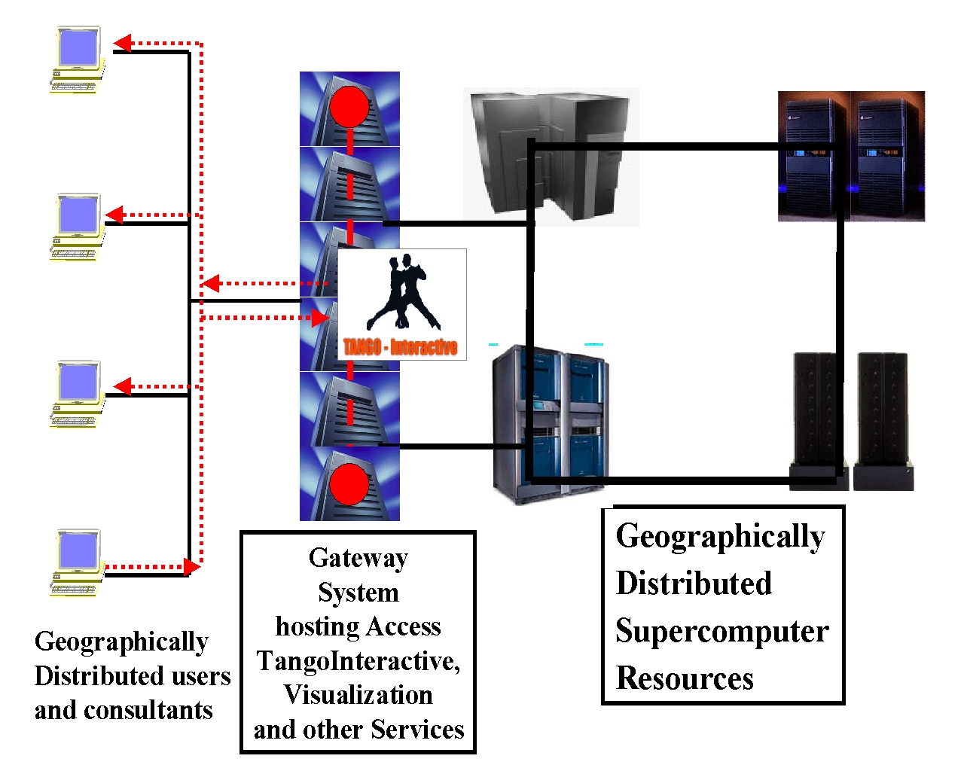4 Supercomputers hosted by a Gateway system illustrating TangoInteractive Collaborative Service

- Other Programming Tools
Performance Visualization

6 Problem Solving Environments

These are application Specific systems built on top of above toolkit
- Chemistry (OSC)
- CFD (Soni)
- Training and multimedia repositories (NPAC)
- Linear Algebra and Computational Libraries (Tennessee)
- Datamining (NCSA)
- Others such as COMET

7 Testbeds

Work with ASC and OSC to develop a non-production testbed environment to enable testing and evaluation of systems like the Gateway.
Benchmarks:
- Performance Optimization and Scalability (Tennessee)
- Java Grande

IV. Short Cornell NPAC Proposal for "Big Q" or Gateway Control System

Introduction (Plans and Goals)
We at CTC, NPAC and many other advanced computing centers believe that the next logical step toward truly distributed computing is seamless computing. We define seamless computing as a distributed resource management and scheduling system which masks the complexity of distributed heterogeneous computational resources and provides a user friendly interface where users submit jobs to a intelligent queue, we call the Big Q. The Big Q finds available resources on a particular system and runs the users job on that system. This differs from meta computing in that the entire job is executed on a single machine (single node, or parallel architecture). The Big Q handles the technical challenges of managing different security domains and ensuring that there is an appropriate binary executable for the user's job before starting it on any particular platform. Optimally, portable programming languages like Java perform well enough to be used in Big Q systems. Groups like the Java Grande Forum will be instrumental in making this happen. If designed appropriately the Big Q could be expanded in the future to address meta-computing.

Initial Roadmap to the Big Q

Start - 6 months:

- Recruit and hire systems engineer to work for NPAC at OSC/ASC
- Early prototype
- Single security domain / multiple computer architectures
- Investigate the use of JINI (try early implementation if trivial)
- Investigate Java Grande seamless interface (web based view of Queue & Resources)
- Identify an OSC Chemistry application (NPAC will port so that it is compatible with NPAC's approach to distributed objects)
- NPAC will deliver resulting system after 6 months.
- CTC will develop prototype system at CTC and meet with OSC & NPAC to discuss machine (computer architecture) preferences, local scheduling preferences and security model preferences for first 6 months.
- Test deployment at OSC – need appropriate host hardware and installation of PBS

6 months - 1 year:

Have a meeting including CTC, NPAC, and OSC to decide which of the following paths to take:

- Transfer OSC installation to ASC.
- Start to address multiple security domains (** Must be addressed)
- Extend early system to support multiple applications
- Concentration on seamless interface
- Incorporate JINI if found to be relevant

