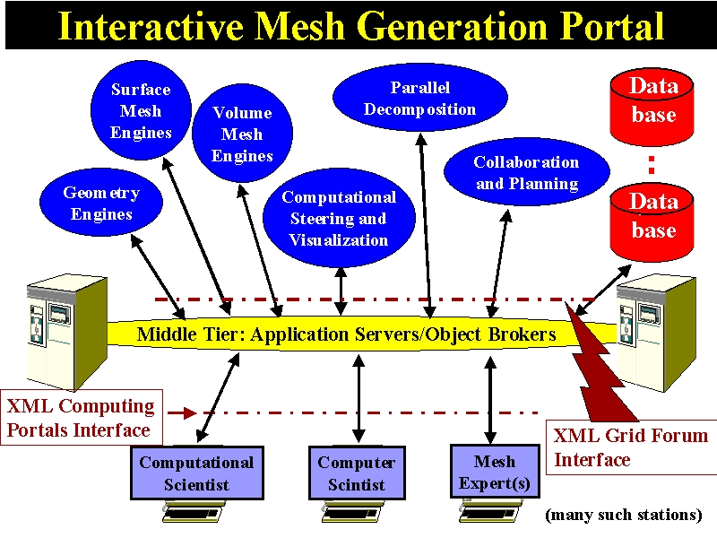
Fig 1: Coarse Grain Structure of Interactive Mesh Portal
The project will produce novel mesh generation systems supporting two distinct distributed object paradigms. The coarse grain model will be supported by a commodity approach similar to the Gateway System. This will control "whole programs" such as the components shown in the figure above. This will be used for initial operational systems LegacyMesh built from the composition of existing programs and form the overall architecture of the new ComponentMesh system. The ComponentMesh is built in terms of Meshlets, which are built using a Javabean framework and with compatible XML and Java interfaces. Meshlets are defined hierarchically and can be as large as an aircraft or as small as a single finite element. Java is used essentially as the software to glue meshlets together and to specify those parts of the mesh that are best defined by embedded software. The latter include handlers to define refinement strategies and interpolation schemes. A mesh can in this way be considered as a set of Java objects, which could be registered and used through the Jini mechanism or displayed using Java3D. Alternatively we can map the mesh into a set of XML files that is stored in a dynamic XML database or persistently in your favorite object relational database. This XML can be translated into X3D (VRML standard expressed in XML) or other emerging XML based graphics standards such as VML. Our use of the twin XML-Java pragmatic object web standards allows us to take full advantage of the renderers and filters supporting them. For instance, the collaborative white board could immediately display the Java representation if projected by a filter into two dimensions.
In the ComponentMesh, one can either define a mesh conventionally as a set of nodal points and elements or in terms of the software needed to generate the same or most interestingly as a combination thereof. The implicit software-based definition is the most efficient and flexible approach and one would use this where possible with meshlets representing user generated points at any level of the mesh hierarchy. The software specification will allow particularly efficient algorithms for associated tools like parallel decomposition and visualization.
Whereas the current Gateway approach using CORBA is sufficient for high performance implementation of the LegacyMesh, a different lighter weight web object model is needed. The situation is rapidly changing but currently two attractive distributed Java object models are Ninja from an impressive group at UC Berkeley and the very recent e-Speak system from Hewlett-Packard. These provide infrastructure supporting (to differing degrees) necessary services such as security, fault tolerance, and naming (registration and lookup). Ninja has also clearly addressed scaling to a very large number of heterogeneous clients. We plan on evaluating these and other possible base object web systems during the next few months so that we will be read to go when the project is funded. In particular, we will set up multiple PC or workstation clusters (at FSU and MSU) as the distributed redundant home base infrastructure to support persistent storage.
The figures shows two key interfaces – middle tier-backend and client-middle tier – whose systematic use allows modular design as shown in our Gateway project. It has already allowed us to straightforwardly change the original Gateway custom Java Server middle tier to the current CORBA based solution with XML specifications being mapped dynamically into CORBA IDL. We have defined coarse grain component and event models for Gateway which can if appropriate be migrated to either the new CORBA proposals in this area or to Enterprise Java bean solutions as offered in commercial solutions like i-Planet from Sun. We note two community activities devoted to establishing appropriate standards for generic computing portals. The Grid Forum ( www.gridforum.org) is setting key resource standards for computing, network and software resources. This is complemented by the Computing Portals group (www.computingportals.org) whose preliminary abstract task definition has been adopted in Gateway. We will continue our active involvement in these projects monitoring of commercial products and incorporate their results in this project.
Our project will contribute understanding both from the new ComponentMesh system and from a new model of mesh generation involving geographically distributed collaboration between computational scientists, computer scientists and mesh experts. This collaboration is an archetype of general research collaboration and a particularly good case to study, as it is well known that high quality meshes often require expert user intervention. Such mesh expertise is often absent at a given location and our proposed distributed solution seems the most practical approach. We will initiate this part of our project with the LegacyMesh where we will use existing mesh technology to build a prototype interactive mesh portal. This will exchange data streams using XML based data structures, which will be a prototype of those to be used in the ComponentMesh.
We have studied existing collaborative systems and have extensive experience with two – Habanero and TangoInteractive – used by the Alliance and DoD PET projects. Technology has changed so rapidly that it is not interesting to re-use these systems but rather we intend to design a new system whose internal design will be built on the ideas of the Collaborative Web Portal (CWP) recently proposed by Fox. Rather than the custom servers and protocols of the earlier systems, we will build on the emerging distributed software infrastructure discussed above. Again Ninja from UC Berkeley seems attractive as the second generation version available in early 2000 has excellent support for robust distribution and queuing of events which is needed by the shared event models of collaboration. CWP integrates shared event and shared display models by supporting “all events” from user actions (mouse motion etc.), programmatic state changes and pixel changes in a display. This allows us to immediately share all applications with the shared display mode of collaboration and where necessary augment with the more powerful shared event model which can require nontrivial changes to the application. We will further integrate asynchronous and synchronous collaboration models by using the strategy familiar from pagers where either mode is driven from an event (message) queue, which also plays the role of session archive. The situation in digital audio-video conferencing is changing rapidly and again we will monitor and choose from systems such as the Access Grid (from the NCSA Alliance), Buena Vista from TangoInteractive as well as commercial approaches such as White Pines (CUSeeMe) and Microsoft Netmeeting.

Research Issues
For this project, a key research area will the general issues concerning integration of coarse grain and fine grain objects in the ComponentMesh – can one still achieve the needed performance, security and robustness goals that we demonstrated in Gateway. Note that the mesh generation application has the interesting feature that changes in the fine grain structure (adding new Meshlets) is associated with user input and so has performance goals that are important but not as severe as those associated with processing existing components. This feature will be shared with other applications such as general computational steering. The more difficult problem of high performance execution of relatively fine grain software components is being tackled by the DoE CCA (Common Component Architecture) activity and we will follow this work closely. For some portal applications, scaling to many users is important but that will not be a key problem for the mesh generation problem. We will research issues concerning scaling of client interfaces from those in hand held devices to PC’s to the CAVE (available at MSU). In these areas of distributed system research, we will focus on the mesh problem but draw conclusions for more general applications. Support of our new concept of meshlets, which is applicable to all grid-based applications (generation, execution and visualization) will of course be a major focus. Thus we will investigate in this specific important case the issues of mobile code and the tradeoffs between XML (data structure) and Java (programmatic) specification of information – this is a typical question underlying the different approaches to the pragmatic object web.
Another major research focus will be support of the distributed collaboration between computational scientists, computer scientists and mesh experts. Here we will again focus on the special features of interactive mesh generation as we have reasonably good understanding of general collaboration tools but poor understanding as to which shared capabilities are important to support distributed computing. We will first develop a collaborative version of the interactive user-driven mesh specification and visualization tool. This will use the full shared event capabilities as customization of the shared control of this seems certain to be important as it the vehicle for collaboration between the mesh expert and users. This part of the project will start with the coarse grain LegacyMesh approach and we will initiate use and evaluation of the collaborative environment by using the simple shared display version. We will follow this approach with other tools (such as specialized visualizers for the different portal engines shown in the figure) with quick evaluation using a shared display version being followed if necessary by a customized true shared event implementation. This part of the project will teach us which tools of what architecture support this mode of collaboration and how the general distributed system architecture of CPW performs. For example what is the relative performance of the different collaborative models and will the queued event architecture lead to serious overheads?

