IVF Problem Solving Environments

IVF.1 Introduction

Problem Solving Environments have been studied over the last 30 years and have always suffered from a certain impreciseness in their definition. However we can follow a pioneer in this field (John Rice from Purdue) and use his 1994 description at http://www.cs.purdue.edu/research/cse/pses
"A PSE is a computer system that provides all the computational facilities needed to solve a target class of problems. These features include advanced solution methods, automatic and semiautomatic selection of solution methods, and ways to easily incorporate novel solution methods. Moreover, PSEs use the language of the target class of problems, so users can run them without specialized knowledge of the underlying computer hardware or software. By exploiting modern technologies such as interactive color graphics, powerful processors, and networks of specialized services, PSEs can track extended problem solving tasks and allow users to review them easily. Overall, they create a framework that is all things to all people: they solve simple or complex problems, support rapid prototyping or detailed analysis, and can be used in introductory education or at the frontiers of science."

This definition first appeared in "Computer as Thinker/Doer: Problem-Solving Environments for Computational Science" by Stratis Gallopoulos, Elias Houstis and John Rice (IEEE Computational Science and Engineering, Summer 1994). According to these authors, the birth of PSEs can be traced to the 1963 proposal of Culler and Fried for an "Online Computer Center for Scientific Problems". This was followed in 1967 by an ACM conference with over 300 attendees on a PSE as an "Interactive System for Experimental Applied Mathematics". There have been important examples of PSEs of which the best known is probably Matlab, which has been a popular commercial system in the linear algebra and signal processing fields. Khoros is another well-known PSE in the latter field. Purdue also produced a high level interface PDElab to solving 2D and 3D partial differential equations. However in general the PSE area languished for some twenty years as it was realized that such complex systems were outside the scope of available hardware and software. The situation has changed recently for not only has hardware obviously increased dramatically in performance but the Web has both provided the needed rich information resources and given in Object Web technology, a powerful software framework. In fact using a popular parlance, a PSE is naturally implemented as a Web Portal to Computational Science. Other essentially equivalent terms to PSEs are Scientific Workbenches or Toolkits.

In discussing PSE's, one can usefully distinguish the PSE itself which is typically aimed at a particular scientific computing domain, from a PSE Toolkit which is the bag of technologies within some software architecture that can build multiple PSE's. In this chapter we discuss two CRPC contributions to the PSE Toolkit -- Netsolve from the University of Tennessee and WebFlow from Syracuse University. Although both are Web-based, we will see that they address different needs and have in mind rather different computational models. In each case, we will discuss some of the several application areas to which these two PSE toolkits have been applied to build domain-specific PSE's.

PSE's require several major subsystems supporting capabilities such as language/programming support, access to existing libraries and applications, intelligent aids to both the science and the computer science. All of this must be tied together with a "software bus or glue". The rest of the chapters in section IV discuss many of the components, which are linked together in a PSE. PSE's support interfaces to tools, ability to request particular load-balancing algorithms, mesh generation, linkage of libraries and other services such as access to job status and most importantly security. Input and output data should be specified and possibly many applications need to be linked together to solve a single problem. Here we describe how the two toolkits enable the convenient flexible integration of these services. In chapter IVA and IVB, we discuss computational grids and the Globus toolkit. Comparing systems like Globus with NetSolve and Legion, we see different views of the same dream of building a geographically dispersed linked set of resources to support computational science grand challenges. Globus starts at the basic hardware and software capabilities and builds out to the user; NetSolve and WebFlow start with the user and build inwards. These complementary roles will be seen later when in specific examples, one finds both NetSolve and WebFlow providing high level interfaces to computational grids constructed with Globus. Both the systems described adopt a similar 3 tier approach; client--server--service shown below in fig IVF.1.

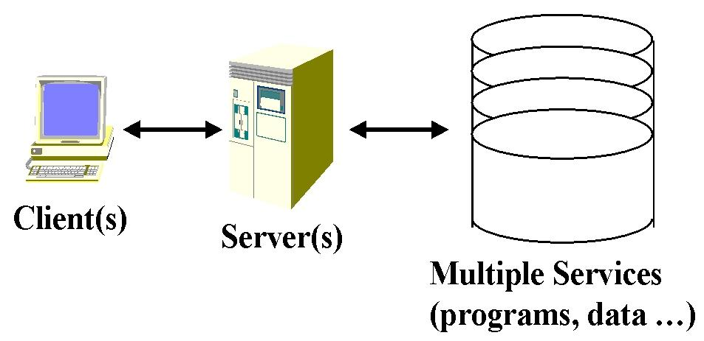
Fig IVF.1: Idealized 3-Tier Computing Model
NetSolve uses agent technology to allow clients to choose the most appropriate service provider for a networked solver such as a parallel matrix algebra package. Diverse clients are supported including web browsers as well as library calls from user code or packages such as Matlab. WebFlow supports a distributed object for program and data components and uses Java or CORBA object brokers for the server layer. The client level is a web interface to the distributed objects and supports a visual or scripted specification of the composition of computational objects. WebFlow separates control functions implemented in the server layer from computation and high performance data transfer in the back end service layer. This strategy avoids well-known performance limitations in CORBA by only using this commodity object technology to control proxies for coarse grain HPCC components.
In section IVF.2 we describe NetSolve and IVF.3 WebFlow. The wrap up section IVF.4 contrasts these systems with other approaches to computational grids and so called seamless (web browser) interfaces to back end compute resources.

<!DOCTYPE HTML PUBLIC "-//W3C//DTD HTML 4.0 Transitional//EN" "http://www.w3.org/TR/REC-html40/loose.dtd">IVF.2: NetSolve: Network-enabled Solvers

IVF.2.1 Motivation and History
The current software usage model entails three basic phases: i) obtaining the software (locating and/or purchasing, investigating licensing, import and export restrictions, etc.) ii) installing the software, and finally, iii)using the software. In addition to these mundane tasks, maintenance of the software system is also necessary to ensure that the latest versions are being used and to attain patches and bug fixes. The NetSolve project, underway at the University of Tennessee at Knoxville and the Oak Ridge National Laboratory had very humble beginnings. Its original goal was to alleviate domain scientists of this tedium when trying to use numerical software, particularly on multiple platforms. And so it began, a sole interface, Matlab, with access to solver routines from the LAPACK library. The first major release of NetSolve was in 1995.
Today, NetSolve has evolved into one of the leading research projects in the area of Grid computing. Its various interfaces provide uniform access to an assortment of software toolkits and libraries. These libraries come from a diverse sphere of influence, ranging from mathematical solvers to more eclectic domains like microbiology and image visualization. Currently at version 1.2 released in the fall of 1998, the NetSolve system receives continual enhancements and feature upgrades. A beta version of 1.3 will be available in the fall of 1999 with a non-beta distribution slated for release in the early spring of 2000. The NetSolve software is freely available and can be downloaded, along with additional documentation and related papers, at:
http://www.cs.utk.edu/netsolve

IVF.2.2 The NetSolve Philosophy
As research scientists continue efforts to harness as much computational resources and power as possible, NetSolve continues to position itself in the midst of it all. As the system becomes more enhanced and, unfortunately, more complicated, there are certain fundamentals that we try to maintain in our NetSolve system. The first and foremost is that the system is very easy to deploy and use. The thing that should be furthest from the thoughts of the middleware user is how to incorporate software that in and of itself, he is not interested in. What he really wants is the software and hardware resources that the middleware makes available to him. Although simplicity is of the essence, the interface must still be intricate enough to meet the full needs of its users. NetSolve exerts much effort to do the impossible; be simplistic yet complicated at the same time. We have managed to achieve what we believe to be an adequate, if not perfect, balance between the two.
Another perspective of NetSolve concerns the integration and usage of other Grid computing infrastructure. As opposed to re-inventing the wheel, we try to leverage on the accomplishments of the Grid computing community at large. But all our designs ensure that we are dependent on none of these systems. Should their resources be available in any of our users' domains, we gladly take advantage of them, but the NetSolve system can and most often does stand alone without infrastructure native to the NetSolve system.

IVF.2.3 NetSolve Infrastructure

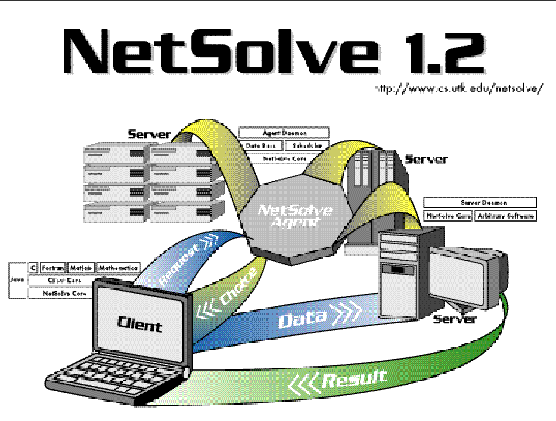
Figure IVF.2: The NetSolve System

IVF.2.3.1 The Big Picture
As depicted by Fig. IVF.2, NetSolve is of a client/agent/server design in which the client issues requests to agents who allocate servers to service those requests; the server(s) then receives inputs for the problem, does the computation and returns the output parameters to the client. The NetSolve client-user gains access to limitless software resources without the tedium of installation and maintenance. Furthermore, NetSolve facilitates remote access to computer hardware, possibly high-performance supercomputers with complete opacity. That is to say that the user does not have to possess knowledge of computer networking and the like to use NetSolve. In fact, he/she does not even have to know remote resources are involved. Features like fault-tolerance and load balancing further enhance the NetSolve system. In the sections below, we offer a brief discussion of the three aforementioned components.

IVF.2.3.2 The Client Interfaces
A major concern in designing NetSolve was to provide several interfaces for a wide range of users and flexibility. NetSolve can be invoked via C, Fortran, MATLAB and Mathematica interfaces (the Mathematica interface is available only on Win32 client platforms). In the past, we supported a Java Application Programming Interface (API) and web-based Graphical User Interface (GUI) and are undergoing efforts to upgrade these interfaces to the current version of NetSolve. Another concern was to implement interfaces that were as simple as possible yet while being meticulous enough to allow the user to control execution of the remote procedure as much as possible. For all the interfaces involved, we provided two basic functions. The first allows for synchronous or blocking requests that do not return until remote execution is complete (or failure is detected). The second is a more non-traditional asynchronous or non-blocking request that returns immediately giving the user a "handle" which he can use to query the readiness of and/or obtain the solution set. In addition to these, we provide in the API functions to do error reporting. We also provide the capabilities to dynamically query a NetSolve system to receive information about either the hardware or software resources. These are used primarily to determine which problems are available and the number, type and description of the input and output parameters each problem requires. In the case of command line interpreters like Matlab and Mathematica, these are in the forms of functions. For the compiled interfaces, C and Fortran, these are compiled executables.

IVF.2.3.3 The NetSolve Agent

The Agent as a Database
Keeping track of what software resources are available and on which servers they are located is perhaps the most fundamental task of the NetSolve agent. The agent keeps a database that maps software resources to hardware components in the NetSolve system thus having an complete picture of the capabilities of both the individual servers and the NetSolve system on a whole. The agent can report this information to the client via the interfaces (see above) which will then aid the user in setting up his problem on top of the NetSolve middleware. The protocol which NetSolve uses to maintain this database is fairly straightforward: Upon initialization, a new server sends a "problem description" for each problem it can solve to the agent it was configured to register with. This description, among other things, contains the location of the server and the particulars of the function(s) being contributed. Eventually the server is integrated into the system and can be used to service users' requests.

The Agent as a Resource Broker
In order to expeditiously service user requests, it is necessary that the agent use certain criteria to choose the best-suited computational server for each incoming request. There are two basic choices: i) static scheduling where at compile time the agent is programmed to use some a priori scheme like round-robin scheduling and ii) dynamic scheduling where the agent uses run-time information to decide which server component should be used to service a request. NetSolve uses the latter. In actuality, it combines both static and dynamic information. Static information includes speed and number of processors and complexity of the solution algorithm. Dynamic information includes server loads, network delays and transmission rates, and input data sizes. The agent then uses this information to rank the servers from best to worse. This list is passed to the client and the client makes its request to each server in turn until either the problem has been successfully solved or the list has been exhausted.

Fault Tolerance and Load Balancing
The protocol described in the resource brokerage section above has its primary goal rooted more in high throughput than balancing load amongst the servers. Consider a scenario where there is a high performance supercomputer acting as a NetSolve server along with other stand alone mediocre workstations, with several simultaneous requests. Then most of the requests will be sent to the supercomputer (as long as the supercomputer is determined to be the component that will finish the service quickest). In a scenario where all server resources are of essentially the same rating, however, this same paradigm will balance the load evenly amongst the servers since this scenario will then yield highest throughput.
For fault tolerance, NetSolve ensures that a user request will be completed unless every single resource capable of servicing the request has failed. As explained above, when a client sends a request to a NetSolve agent, it receives a sorted list of computational servers to try. When one of these servers has been successfully contacted, the computation starts. If the contacted server fails during the computation, then another server is contacted and the computation restarts. This entire procedure is transacted independently of, and possibly unbeknownst to, the client user. Though effective, this primitive fault-tolerant mechanism needs to be enhanced. In the next section where we discuss current developments, we describe our research to employ more advanced fault-tolerance.

IVF.2.3.4 The Computational Server
One of the challenges when building the NetSolve system was to design a suitable model for the computational servers. For the user to be able to invoke numerical software directly through our servers, three major features seemed to emerge as mandatory for the servers:
Uniform access to the software: The NetSolve servers should present the interfaces with an illusion of uniformity amongst the various integrated packages. The critical point is to try as much as possible to maintain high levels of consistency amongst and within the different sets of subroutines/functions provided to the user. This allows the user to focus on the particular problem he is trying to solve rather than the peculiarities of the software package he is using to aid his investigations. This also eliminates long learning phases when using new functionalities.
Configurability: The server should not be confined to any particular software. It was, therefore, essential that we provide a framework that permitted the addition of functionality to a computational server. This framework should be as intuitive as possible and general so that one can integrate any software toolkit with NetSolve servers and make them accessible to the client interfaces.
Pre-installation: As stated in the last section, we wished to ease the user of the burden of software installation. Therefore, in the NetSolve paradigm, the client user is not responsible for installing any software directly. The software is made available via the NetSolve servers in a read-to-use fashion. It is also possible in some scenarios for the NetSolve system to dynamically install and compile routines without any intervention at the user-level.
The NetSolve server addresses and successfully resolves all these issues. Mainly through the use of what we call a problem description file (PDF), the server can be configured with a set of pre-installed software libraries to provide uniform access to the sub-routines provided. The PDF in essence describes the particulars of a function to be added. Some of the information that is described in this file are the name to be given to the problem, the calling sequence to the NetSolve client interface, the libraries or archives containing the underlying functions being integrated and other things. The PDF really describes a wrapper that is used to receive or send input and output parameters from and later back to the client interface. In the midst of these networking transactions is a call to the routine from the underlying library to actually do the service that was requested. Although network interactions are involved, neither the client nor the writer of the PDF needs be concerned with this. The NetSolve system carefully encapsulates and hides these interactions from the user. These wrappers are parsed and compiled into source codes which are compiled with the library archives into NetSolve specific executables. The appropriate executable is initiated by the server daemon whenever it needs to service a client request.
.

IVF.2.4 Some Applications of NetSolve
In this section, we give a brief description of the integration of NetSolve into Grid Computing systems. We describe some of the applications that have taken advantage of what NetSolve has to offer. We later discuss in sec. IVF.4, some of the other metacomputing resources that NetSolve has used to leverage itself.

MCell
MCell is a general Monte Carlo simulator of cellular micro physiology. MCell uses Monte Carlo diffusion and chemical reaction algorithms in 3D to simulate the complex biochemical interactions of molecules inside and outside of living cells. MCell is a collaborative effort between the Terry Sejnowski lab at the Salk Institute, and the Miriam Salpeter lab at Cornell University. NetSolve is very well suited to MCell's need and this project aims at writing a NetSolve-based framework to support large MCell runs. One of the central pieces of that framework is a scheduler that takes advantage of MCell input data requirements to minimize turn-around time. This scheduler is part of the larger AppLeS at the University of California, San Diego. The use of NetSolve isolates the scheduler from the resource-management details and allows researchers to focus only on the design of the scheduler.

IPARS
IPARS is a framework described already in chapter IIID, for developing parallel models of subsurface flow and transport through porous media. It currently can simulate single phase (water only), two phase (water and oil) or three phase (water, oil and gas) flow through a multi-block 3D porous medium. IPARS can be applied to model water table decline due to overproduction near urban areas, or enhanced oil and gas recovery in industrial applications. IPARS is being made into a fully functional NetSolve server. The goal of this project is to allow this server to be accessible via a web browser using the Common Gateway Interface on top of NetSolve's C interface. The server will also render animated graphics via a destination web-page. This total web-accessibility will allow those wanting to see IPARS simulations to do so with nothing but simple input parameters defining the simulation.

SCIRun
SCIRun is a scientific programming environment that allows the interactive construction, debugging and steering of large-scale scientific computations. SCIRun can be used for interactively: i)Changing 2D and 3D geometry models (meshes), ii) Controlling and changing numerical simulation methods and parameters and iii)Performing scalar and vector field visualization. Currently, NetSolve is being integrated into SCIRun as the broker for computational resources. This integration will allow for increased parallelism and performance in the SCIRun paradigm.

LUCAS
LUCAS is a system that uses computer modeling to integrate biological and socioeconomic data of land areas to help natural resource specialist evaluate the consequences of alternative land management scenarios. It uses the Geographic Information System, GRASS, to represent and manipulate spatial data on workstations. There is an on-going effort to integrate NetSolve to harness the computational cycles for LUCAS. This will prove especially useful when LUCAS is used to spawn several "replicates" which normally would compute in serial on the local machine. Using NetSolve, the computations would be done in parallel, possibly on machines specialized for High Performance Computing.

DIPS
DIPS is a software tool, developed at the Computer Graphics and Vision unit of the Graz University of Technology in Austria, which allows remote computing for image processing. DIPS extends the Image/J Java image processing application to provide remote access to the high-performance ImageVision library by Silicon Graphics. At its core, DIPS uses NetSolve as its metacomputing resource to provide unprecedented computing power by aggregating distributed resources on the Internet to a single system.

IVF.2.5 Current Developments and Future Research

IVF.2.5.1 Dynamic Server-software Enhancements
In the current NetSolve design and implementation, there is a tight coupling between the server's hardware and software components. The server is statically configured (at compile time) to solve a particular problem set. Although we have provided the tools to allow this problem set to be easily expanded, this can only be done initial configuration, so to increase a running servers capability entails a shutdown, reconfigure and restart loop. This will not be the case in the next major release of NetSolve. We are providing the capability of storing NetSolve specific software binaries (See Sect. IVF.2.3.3) in a software repository whose location is known to the NetSolve agent. At request time, should a particular server not possess the appropriate binaries, it will be directed to the repository for a download. This paradigm will not replace, but will enhance, the current protocol where the server is statically binded with software.

IVF.2.5.2 Fault Tolerance
As explained in Sect. IVF.2.3.3, the fault tolerance possessed by the NetSolve system incorporates only a retry and restart mechanism. We are presently developing servers enhanced with checkpointing capabilities. As they run, the servers will take frequent checkpoints (via a core dump mechanism); should one of these servers fail, they will be restarted not from the beginning, but from the state represented by the core image of the most recent checkpoint. Homogeneous migration will also be possible, meaning that it will be possible to restart the process on a different machine of similar architecture and operating system. As this feature becomes more advanced, we will investigate heterogeneous migration and possibly checkpointing parallel programs.

IVF.2.5.3 Request Sequencing
We recently finished research that would allow us to minimize the network traffic between client and servers in a single client program that made numerous requests to NetSolve. We noticed that, in many cases, there exist data dependencies between these requests. We have implemented a feature that allows the client user to bracket together multiple requests to NetSolve. The NetSolve system then analyzes data dependencies and only sends to the servers the minimal data necessary. Inputs to later requests that were outputs of a previous request(s) need not be obtained from the client again. The server makes this data persistent and uses it across all requests as necessary. In our current model, all requests must execute on a single server. Future research will yield a model that will investigate using systems like the Internet Backplane Protocol (IBP) and other distributed storage facilities to stage data as requests are serviced on multiple servers.

IVF.2.5.4 Win32 Servers
The Distributed Component Object Model (DCOM) is a protocol that enables software components to communicate directly over a network in a reliable, secure, and efficient manner. DCOM is based on the Open Software Foundation's DCE-RPC and is a standard similar to that of the Common Object Request Broker Architecture (CORBA). We will be developing a version of the NetSolve server that acts as a gateway to problem solving libraries and systems optimized for the NT platform. The server will be built using the DCOM protocol to manage its networking interactions.

IVF.3 WebFlow Object Web Computing

IVF.3.1 Overview of WebFlow System
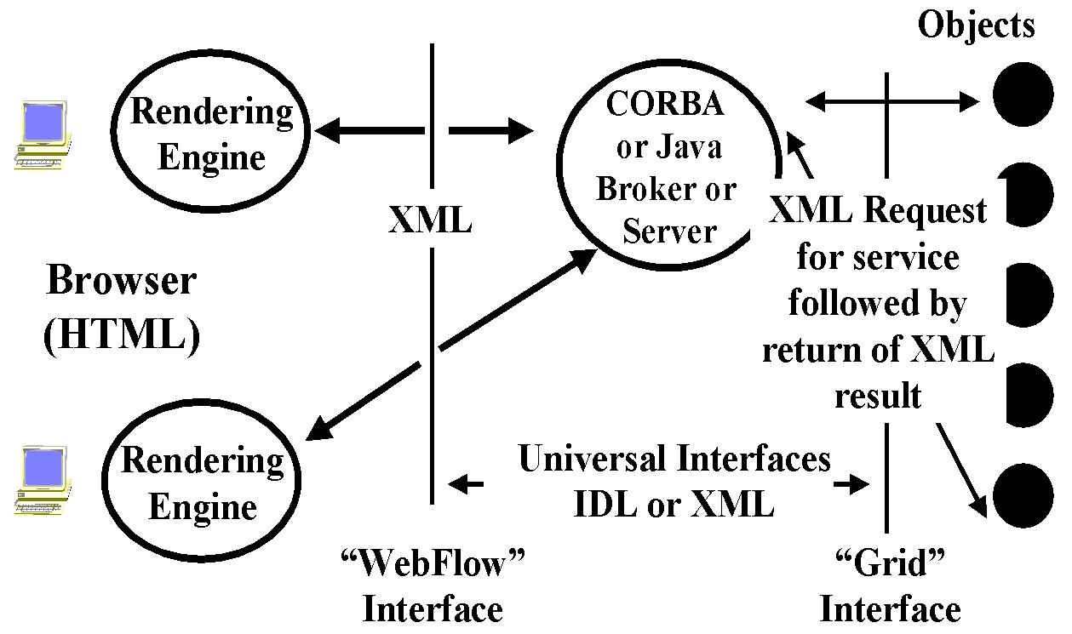
Fig IVF.3 More Detailed 3 Tier Architecture
In fig. IVF.3, we expand the basic network server picture in fig. IVF.1 to show how one of more middle tier servers acts as a broker between any client and a collection of interesting services. Note that we view the services as being provided by a collection of (distributed) objects. We adopt what we call the pragmatic Object Web philosophy where realistic systems are likely to involve aspects of the four leading distributed object technologies: CORBA, COM, Java and XML. Appropriate middleware allows these different approaches to interoperate. In particular, WebFlow now uses XML to specify all object interfaces and these are termed the WebFlow and Grid Interfaces for the user and system view respectively. This two-interface model was adopted at meetings of the DATORR group in 1998-1999. As an example, the WebFlow Interface defines an abstract task such as “run a chemistry problem using an HPF simulation code with given data” and the middle tier server matches this with the backend objects. The latter are defined by the Grid Interface, which can use the Globus resource language RSL. This matching then instantiates a real job to solve the chemistry problem on one or more of the backend resources. WebFlow originally used Java Servers but now uses CORBA object servers. One simply takes the XML object specifications and uses this to generate the appropriate RMI or CORBA Interfaces necessary for the chosen middle tier. This use of XML object specification linked to different object runtimes is very common in modern commercial systems. Fig. IVF.3.4 below takes the general architecture of the previous diagram and highlights the capabilities of WebFlow in each of the three tiers. This will be described in more detail in Sec. IVF.3.2 later.
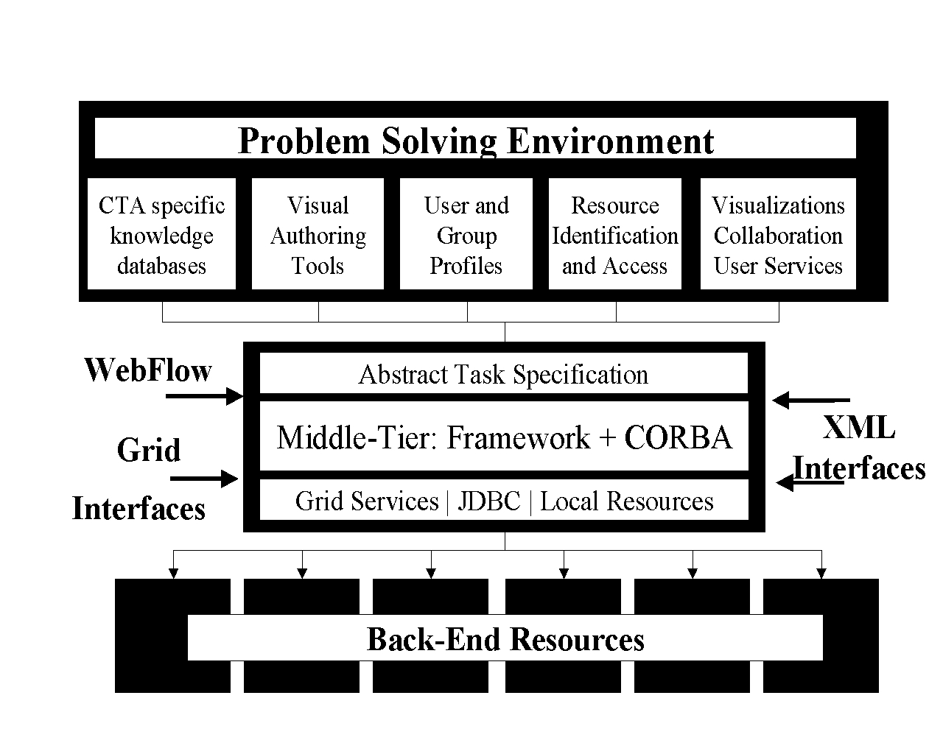
Fig IVF.4: WebFlow system architecture
In the three tier diagram, WebFlow contributes to the client and middle tier as these are the PSE layers where one integrates the components composed of the basic HPCC tools, algorithms and applications. The WebFlow client tier can and has been constructed in several ways but one distinctive capability (which gives the system its name) is the WebFlow composition tool. Here a WebFlow front-end editor applet offers an intuitive click-and-drag metaphor for instantiating middleware or back-end modules, representing them as visual icons in the active editor area, and interconnecting them visually in the form of computational graphs, familiar to AVS and Khoros users. WebFlow middleware was originally given by a mesh of Java web servers, custom extended with servlet-based support for the WebFlow session implementing Module and Connection Managers. These then implemented the middleware logic to support both this general distributed dataflow computing model as well as a more general linked object model. Both models are represented as abstract tasks in XML allowing scripted as well as visual invocation of programs. This computational paradigm is very popular in some fields (such as signal processing with Khoros) and is seen in research systems like Arcade from ICASE designed to support multidisciplinary applications such as you get with structures and fluid flow programs controlled by an optimization module. The WebFlow toolkit also includes the general capability to link to backend resources as illustrated by its support of Globus.
Note that WebFlow only uses CORBA (or more generally commodity distributed object technology) to manipulate proxies for backend entities and thus is not impacted by performance limitations of commodity technology. WebFlow’s front end supports visual proxies to specify the problem while the middle tier functional proxies support needed control logic. WebFlow relies on classic HPCC back-end capabilities for high performance computing and communication.
This WebFlow toolkit has been applied to build several problem solving environments. In Sec. IVF.3.3, we describe two focussed examples – one LMS did not use the composition tool but rather a custom Java applet front end to control particular linked applications for environmental modeling. A second application of the WebFlow is Quantum Monte Carlo Simulations developed in collaboration with the NCSA Condensed Matter Physics Laboratory. Here simulations are linked together and the results stored on many different computers. The output file of one application in the chain is the input of the next one, after a suitable format conversion. This was a natural place to use the WebFlow composition tool.
Recently we have used WebFlow technology in the so-called Gateway project for the DoD High Performance Computing program. Gateway is designed to build a seamless access to the suite of different machines in a computer center. In this case, we needed to address security and fault tolerance more carefully and so re-implemented the WebFlow middle-tier using the industry standards distributed-object technologies, JavaBeans and CORBA and industry standard secure communication protocols based on SSL.

IVF.3.2 WebFlow Architecture
The WebFlow system is implemented as an Object Web three-tier system, as shown in Fig. IVF.4. Tier 1 is a high-level front end for visual programming, steering, run-time data analysis, and visualization, that is built on top of the Web and OO commodity standards. A distributed object-based, scalable, and reusable Web server and Object broker Middleware forms Tier 2. Back end services comprise Tier 3. In particular, high- performance services are implemented using the metacomputing toolkit of Globus.

Front End
Different classes of applications require different functionality of the front end. We have therefore designed the WebFlow system to support many different front-ends: from very flexible authoring tools and problem solving environments (PSE) that allows for dynamical creation of meta-applications from pre-existing modules, to highly specialized and customized front-ends to meet the needs of specific applications. Also, we support many different computational paradigms, from general object-oriented to data-flow to a simple “command line” approach. This flexibility is achieved by allowing as a WebFlow front end any program implementing the WebFlow API described below.

WebFlow and Grid Interfaces (API’s)
The WebFlow API allows the user’s task to be specified in the form of an Abstract Task Descriptor (ATD), following the current DATORR recommendations. The ATD is constructed recursively and may comprise an arbitrary number of subtasks. The lowest level, or atomic, task corresponds to the atomic operation in the middle tier, such as instantiation of an object, or establishing interactions between two objects through event binding. In many cases such details should be hidden from the end-user and even the front-end developer, thus the WebFlow API provides interfaces to higher-level functionality, such as submitting a single job or making a file transfer.
When specifying a task, the user does not have to specify the resources to be used to complete the task, but instead may specify requirements that the target resource must satisfy in order to be capable of executing the job. The identification and allocation of the resources is left to the discretion of the system. Typically, the middle tier delegates it to the metacomputing services (such as Globus) or and external scheduler (such as PBS). Once the resources are identified, the abstract task descriptor becomes a Job Specification.

Middle Tier
A mesh of CORBA-based WebFlow servers (WS) currently gives the WebFlow middle tier. One of these: a dedicated gatekeeper server as shown in Fig.IVF.5 facilitates a secure access to the system. A general WebFlow server maintains the sessions within which the users create and control their applications. The middle-tier services provide the means to control the life cycles of modules and to establish communication channels between them. The modules can be created locally or on remote hosts. In the latter case the task of module instantiation and initialization is transparently delegated to a peer WebFlow server on the selected host, and the communication channels are adjusted accordingly. The services provided by the middle tier include methods for submitting and controlling jobs, methods for file manipulating, methods for providing access to databases and mass storage, as well as methods to query the status of the system, status of the users’ applications, and their components.

Gatekeeper Server
The gatekeeper comprises three logical components: a (secure) Web Server, the AKENTI server, and a CORBA-based WebFlow server. The user accesses the WebFlow system through a portal web page from the gatekeeper web server. The portal implements the first component of WebFlow security: user authentication and generation of the user credentials that eventually will be used to grant access to resources. The AKENTI server controls the authorization process. For each authorized user, the web server creates a session (that is, it instantiates the user context in the WebFlow server, as described below) and gives permission to download the front-end applet. The applet is used to create or restore, run, and control user applications. The applet, using IIOP protocol, communicates directly with the CORBA-based WebFlow server.

Front End

WS

WS

WS

WS
https
IIOP
IIOP

SS

A
SECIOP

Back End

Services

Back End

Services

Back End

Services

Back End

Services

Fig IVF.5 WebFlow Middle Tier with Computational Servers (WS); Secure Web server (SS) and Authentication (AKENTI) Server A
To implement the WebFlow server we use the ORBacus (formerly known as OmniBroker) secure ORB, for which we have obtained a free research license. The security services are implemented on top of the IAIK SSL library, which is already used by the Jigsaw Web server.

WebFlow Server
The WebFlow server initializes the ORB and several generic CORBA and specific WebFlow services. The main functionality of the WebFlow server is managing WebFlow sessions. A session is established automatically after the authorized user is connected to the gatekeeper by creating a user context. The user context is a container object that stores the user applications. The application is another container object that stores components of the user application. The application component is either a single WebFlow module or another, finer-grain application context. This way, the WebFlow server can simultaneously manage many sessions, and within each session, the user can define many applications hierarchically composed of many modules.

WebFlow Modules

The WebFlow modules are CORBA objects conforming to the JavaBeans model whose implementation is described in detail in the Syracuse Ph.D. thesis of E. Akarsu. The functionality of a module is implemented either directly in the body of the module or the module serves as a proxy of specific back-end services, such as database or HPCC services. We expect to support the standards for HPPC back-end services under development by the Grid Forum. For databases we support the industry standard JDBC (Java Database Connectivity).

Interactions between WebFlow Modules
The WebFlow modules follow the JavaBeans model, and they interact with each other by using JavaBeans methods through event binding, property binding, and vetoable property binding. With JavaBeans, events are used to communicate information about the changing state of a bean. Events form a core component of the JavaBeans architecture in that they are largely responsible for enabling beans to be plugged together as building blocks in an application builder. Event notification in Java works using method invocation. The object that is a source of an event calls a method on the destination object for one event when the event is triggered. The destination of the message must implement the method (or methods) to be notified when the event occurs. The event object encapsulates all the information about an event.
Event targets are connected to event sources through a registration mechanism. WebFlow applications are created dynamically from independently developed WebFlow modules. Therefore, we provide support for a dynamical event binding based on the standard CORBA dynamic interface invocation (DII) and dynamic stub invocation (DSI) mechanisms. This is implemented by introducing an event adapter associated with the application context. The adapter maintains a binding table to associate the event sources with the actual event destinations. Note that we choose not to use the important commodity Enterprise JavaBean middle tier containers as currently they appear difficult to implement consistently with our security requirements.

IVF.3.3 WebFlow Applications

IVF.3.3.1 WebFlow Application: Land Management System (LMS)
The LMS project was sponsored by the U.S. Army Corps of Engineers Waterways Experiment Station (ERDC) Major Shared Resource Center (MSRC) at Vicksburg, MS, under the DoD HPC Modernization Program, Programming Environment and Training (PET).
The application can be idealized as follows. A decision maker (the end user of the system) wants to evaluate changes in vegetation in some geographical region over a long time period caused by some short term disturbances such as a fire or human’s activities. One of the critical parameters of the vegetation model is soil condition at the time of the disturbance. This in turn is dominated by rainfall that possibly occurs at that time. Consequently as shown in fig IVF.6, the implementation of this project requires:
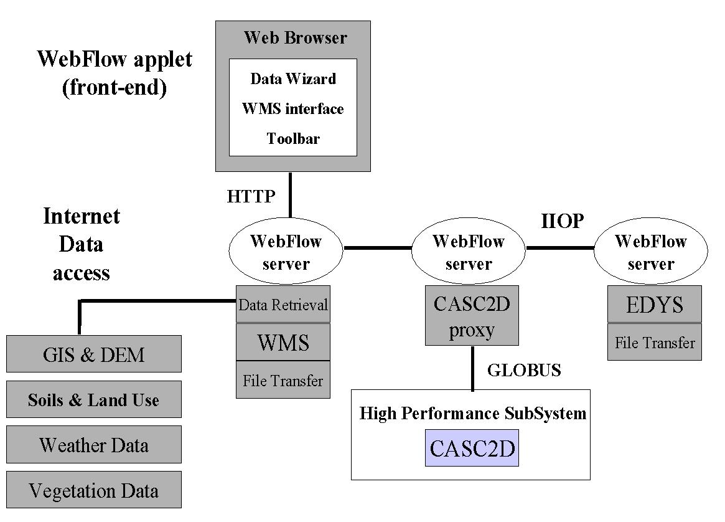
Fig IVF.6: LMS Problem Solving Environment
- Data retrieval from remote sources including DEM (data elevation models) data, land use maps, soil textures, dominating flora species, and their growing characteristics, to name a few. The data are available from many different sources, for example from public services such as USGS web servers, or from proprietary databases. The data come in different formats, and with different spatial resolutions. Without WebFlow, the data must be manually prefetched.
- Data preprocessing to prune and convert the raw data to a format expected by the simulation software. This preprocessing is performed interactively using WMS (Watershed Modeling System) package.
- Execution of two simulation programs: EDYS for vegetation simulation including the disturbances and CASC2D for watershed simulations during rainfalls. The latter results in generating maps of the soil condition after the rainfall. The initial conditions for CASC2D are set by EDYS just before the rainfall event, and the output of CASC2D after the event is used to update parameters of EDYS and the data transfer between the two codes had to be performed several times during one simulation. EDYS is not CPU demanding, and it is implemented only for Windows95/98/NT systems. On the other hand, CASC2D is very computationally intensive and typically is run on powerful backend supercomputer systems.
- Visualization of the results of the simulation. Again, WMS is used for this purpose.
One requirement of this project was to demonstrate the feasibility of implementing a system that would allow launching and controlling the complete simulation from a networked laptop. We successfully implemented it using WebFlow with WMS and EDYS encapsulated as WebFlow modules running locally on the laptop and CASC2D executed by WebFlow on remote hosts. Note that the existing codes were not modified but rather the WebFlow PSE used object wrappers to construct a powerful integrated application specific environment. Further the applications involved showed a typical mix of HPCC and computationally less demanding PC codes.
For this project we developed a custom front-end that allows the user to interactively select the region of interest by drawing a rectangle on a map. Then one could select the data type to be retrieved, launch WMS to preprocess the data and make visualizations, and finally launch the simulation with CASC2D running on a host of choice.

IVF.3.3.2 WebFlow Application: Quantum Simulations (QS)
A major goal of the QS activity was to demonstrate the feasibility of layering WebFlow on top the Globus metacomputing toolkit. This way WebFlow serves as a job broker for Globus, while Globus (or more precisely, GRAM-keeper) takes responsibility of actual resource allocation, which includes authentication and authorization of the WebFlow user to use computational resources under Globus control.
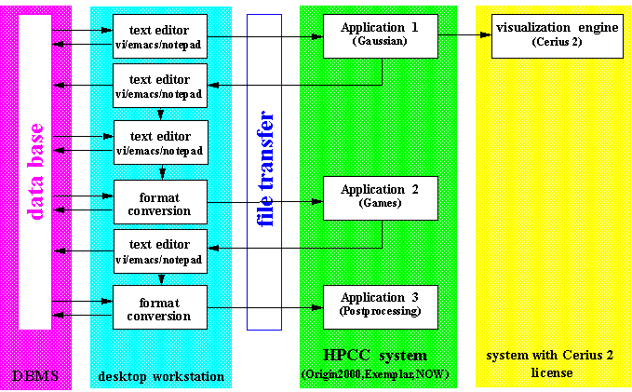
Fig IVF.7: Functional architecture of Quantum Simulation application
This application can be characterized as follows. A chain of high performance applications (both commercial packages such as GAUSSIAN or GAMESS or custom developed) is run repeatedly for different data sets. Each application can be run on several different (multiprocessor) platforms, and consequently, input and output files must be moved between machines. Output files are visually inspected by the researcher; if necessary applications are rerun with modified input parameters. The output file of one application in the chain is the input of the next one, after a suitable format conversion. The logical structure of the application is shown in Fig. IVF.7. GAUSSIAN and GAMESS are run as Globus jobs on Origin2000 or Convex Exemplar at NCSA, while all file editing and format conversion a performed on the user’s desktop.
Unlike LMS, for QS we are using the WebFlow program composition editor as the front-end. This WebFlow editor provides an intuitive environment to visually compose (click-drag-and-drop) a chain of data-flow computations from preexisting modules (as shown in Fig. IVF.8). In the edit mode, modules can be added to or removed from the existing network, as well as connections between the modules can be updated. Once created the network can be saved (on the server side) to be restored at a later time. The workload can be distributed among several WebFlow nodes (WebFlow servers) with the interprocessor communications taken care of by the middle-tier services. Moreover, thanks to the interface to the Globus system in the backend, execution of particular modules can be delegated to powerful HPCC systems. In the run mode, the meta-application represented by the visually constructed graph is passed to the middle-tier by sending a series of requests (module instantiation, intermodule communications) to the middle tier services.

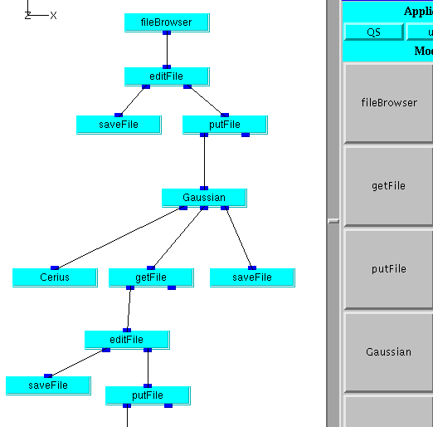

Fig IVF.8: Fragment of Quantum Simulation WebFlow Composition Tool

The control of the module execution is exercised not only by sending relevant data through the input ports of the module. Rather the majority of modules we developed so far requires some additional parameters that can be entered via "Module Controls", which are Java applets displayed in a card panel of the main WebFlow applet. The communication channels between the backend implementation of a module and its front-end Module Controls are generated automatically during the instantiation of the module.

IVF.3.3.3 WebFlow Application: Gateway Seamless Access
Exploiting our experience developing the WebFlow PSEs described above, we designed a new system, Gateway, to provide seamless and secure access to computational resources at DoD modernization sites – in particular first at the ASC Major Shared resource Center at Wright Patterson airforce base in Dayton. While preserving the original three-tier architecture, we re-engineered the implementation of each tier in order to conform to XML based standards indicated in figures IVF.3 and IVF.4. In particular, we developed for this application the CORBA and the JavaBeans model to build a new middle tier, which facilitates seamless integration of commodity software components. The security system supports the Kerberos and SecurID system adopted by DoD for their modernization program. This new technology is being retrofitted to the initial applications described above and used in other applications being developed now.
Gateway’s architecture includes provision for visualization where we are working with NCSA (VisBench) and ARL (DICE) to design visualization subsystems supporting the WebFlow distributed object model. In the first two PSE’s discussed above we have integrated existing visualization systems such as WMS (for LMS) and Cerius (for QS case) with WebFlow. We have also prototyped XML specifications of collaboration which when combined with the WebFlow API can generate collaborative portals to computing.
Initially Gateway is designed with a custom chemistry front-end developed by OSC. This uses job submission (to the scheduler PBS via Globus), choice of multiple applications and basic WebFlow file services. The front end is arranged in layers: Entry, Problem Description, Code and Results with well defined (XML) interfaces. This approach appears to generalize to other applications.

IVF.3.4 WebFlow Summary
Let us wait till nearer publication date for this. We should add in our work on using WebFlow for Texas and other applications.

IVF.4 Other Grid Computing Environments

IVF.4.1 NetSolve WebFlow and Other Metacomputing Resources

Globus
Globus is a software system that provides infrastructure for computations that leverage distributed computational and informational resources. It is being developed at the Argonne National Laboratory and the University of Southern California's Information Sciences Institute. Currently, the NetSolve system uses a component of Globus referred to as the Heart Beat Monitor (HBM.) The HBM allows NetSolve to easily detect failed server hosts and update the agent's database. We are also testing a new NetSolve proxy-client that allows Globus-enabled NetSolve client users to access and use Globus computational resources through the NetSolve interface. We have discussed extensively the integration of WebFlow with Globus.

CONDOR
The CONDOR system, of the University of Wisconsin, takes advantage of the fact that many CPU cycles go wasted on idle workstations at times when the primary user is not using his or her machine. The system assigns tasks submitted to the CONDOR system to "registered" host machines as long as these machines are idle. Should an owner return to his machine, the task is immediately halted and assigned to another host. CONDOR pools can be used as NetSolve servers. In essence, the request for service is forwarded to the CONDOR system, which then assigns the task to an idle workstation for completion. CONDOR has not yet been used with WebFlow but it should be straightforward to use CONDOR at the back-end tier in the manner Globus is used in examples of Sec. IVF.3.3

Ninf
Ninf is a system very similar to NetSolve. Developed at the Electrotechnical Laboratory in Tsukuba, Japan, it too provides an interface that allows for remote execution of functional components. In a collaborative effort, a NetSolve-Ninf bridge has been built that allow both systems to utilize servers provided to the other. Administrators of NetSolve and Ninf systems can then join forces to create an even bigger computational Grid.

Legion
Legion is an object-based metasystems software project at the University of Virginia. Its goal is to tie together host systems with high-speed links and present the illusion of a single computer with access to varied physical resources. The NetSolve client-user can use the NetSolve interface while leveraging metacomputing resources of Legion. The NetSolve client side uses Legion data-flow graphs to keep track of data dependencies. We hope to study the linkage of Legion and WebFlow but as both have object models, the integration is not as straightforward as for Globus and WebFlow.

IVF.4.2 Gateway and Related Approaches to Seamless Access and Application Integration
There are several other projects addressed to solving the problem of seamless access to remote resources. A comprehensive list of these is available from the JavaGrande and DATORR web sites. Here we mention the three that are most closely related to the Gateway project.
The UNICORE project introduces an excellent model for the Abstract Task Descriptor that most likely will strongly influence the DATORR standard and, consequently, we are taking a similar approach. The UNICORE middle tier is given by a network of Java web servers (Jigsaw). The WebSubmit project implements web access to remote high-performance resources through CGI scripts. Both projects use https protocol for user authentication (as we do), and implement custom solutions for access control. The ARCADE project is aimed at multidisciplinary applications, and its designers intend to use CORBA to implement the middleware. As of now, there is no available description of the ARCADE security model.

References
- G. C. Fox, W. Furmanski, “High Performance Commodity Computing” in “The Grid. Blueprint for a New Computing Infrastructure”, a book edited by C. Kesselman and
I. Foster, Morgan-Kaufmann Publishers, Inc., San Francisco, 1998;
- Geoffrey C. Fox, Wojtek Furmanski, Hasan T. Ozdemir and Shrideep Pallickara, “High Performance Commodity Computing on the Pragmatic Object Web” , report to be published by RCI (http://tapetus.npac.syr.edu/iwt98/pm/documents/ )
- D. Bhatia, V. Burzewski, M. Camuseva, G. C. Fox, W. Furmanski, G. Premchandran, “WebFlow – A Visual Programming Paradigm for Web/Java based coarse grain distributed computing”, Concurrency: Practice and Experience, 9, 555-578 (1997)
(http://tapetus.npac.syr.edu/iwt98/pm/documents/ )
- E. Akarsu, G. C. Fox, W. Furmanski, T. Haupt, “WebFlow - High-Level Programming Environment and Visual Authoring Toolkit for High Performance Distributed Computing”, in proceedings of Supercomputing ’98 (http://www.npac.syr.edu/users/haupt/WebFlow/papers/SC98/INDEX.HTM)
- Tomasz Haupt, Erol Akarsu, Geoffrey Fox, Alexey Kalinichenko, Kang-Seok Kim, Praveen Sheethalnath, Choon-Han Youn, “The Gateway System: Uniform Web Based Access to Remote Resources”, published in Proceedings of ACM Java Grande Conference June 1999.
- Erol Akarsu, Geoffrey Fox, Tomasz Haupt, Alexey Kalinichenko, Kang-Seok Kim, Praveen Sheethaalnath, and Choon-Han Youn, “Using Gateway System to Provide a Desktop Access to High Performance Computational Resources”, HPDC8 Conference August 1999.
- WebFlow project home page http://www.npac.syr.edu/users/haupt/WebFlow/demo.html
- Tomasz Haupt, Erol Akarsu and Geoffrey Fox, Web Based Metacomputing, Special Issue on MetaComputing for the FGCS International Journal on Future Generation Computing Systems.
- T. Haupt, E. Akarsu, G. Fox, A. Kalinichenko, K-K .Kim, P. Sheethalnath, C-H. Youn, “The Gateway System: Uniform Web Based Access to Remote Resources”, High Performance Computing and Networking’ 99, Amsterdam, April 1999.
- Gateway Project Home page, http://www.osc.edu/~kenf/theGateway/
- Globus Metacomputing Toolkit, home page: http://www.globus.org
- Java Grande Forum, home page: http://www.javagrande.org
- Grid Forum Home Page http://www.gridforum.org/
- S. S. Mudumbai, W. Johnston, M. R. Thompson, A. Essiari, G. Hoo, K. Jackson, Akenti – A Distributed Access Control System, home page:
http://www-itg.lbl.gov/Akenti
- Object Oriented Concepts, Inc., ORBacus SSL, home page: http://www.ooc.com/ssl/
- DATORR WebSite maintained by Gregor von Laszewski: http://www-fp.mcs.anl.gov/~gregor/datorr/datorr.html
- UNICORE: Uniform Access to Computing Resources,
home page: http://www.fz-juelich.de/unicore
- WebSubmit: A Web-based Interface to High-Performance Computing Resources,
home page: http://www.itl.nist.gov/div895/sasg/websubmit/websubmit.html
- ARCADE, home page: http://www.icase.edu:8080
- WMS, EDYS and CASC2D codes has been made available to us by ERDC Vicksburg. EDYS is written by Michael Childress and CASC2D is written by Fred Ogden, http://www.wes.hpc.mil
- Quantum Simulations , http://www.ncsa.uiuc.edu/Apps/CMP/cmp-homepage.html
- Distributed Interactive Computing Environment DICE at ARL Aberdeen, Md. http://www.arl.hpc.mil/SciVis/dice/index.html
- VisBench and NCSA Visualization Activities. http://www.ncsa.uiuc.edu/SCD/Vis/
- Advanced Visualization System, http://www.avs.com/
- Khoros Home Page http://www.khoral.com/khoros/

