Jay Alameda
Mary Pietrowicz
Balaji Veeraraghavan

Scenarios for Requirements Analysis of Problem Solving Environments

Current Operation: Managing Computations

Scientific portals are going to need the flexibility to access and run legacy applications, extensions to the legacy apps, and new apps. The description below shows how the popular application, “Gaussian” is used.

Gaussian runs on shared memory supercomputers, unix machines, and NT. It takes as input formatted ascii text, and binary (machine dependent) checkpointing data. The ascii data represents molecule geometry, computational methods, functionality (e.g. Energy, Geometry) , and properties (e.g., Heat of Formation, Heat Capacity). The checkpoint data represents an intermediate state of a previous computation that the application can read in and continue computation from that point forward. During computation, Gaussian writes its output in text format, so the chemist can view the state of the computation and computation results as it is running. It also writes checkpoint files, which can be used to restart Gaussian computations from a given state. Computations are expensive, often taking 500 hours or more on a supercomputer, so the ability to save the state periodically (from checkpoint files) and then later restart is important.

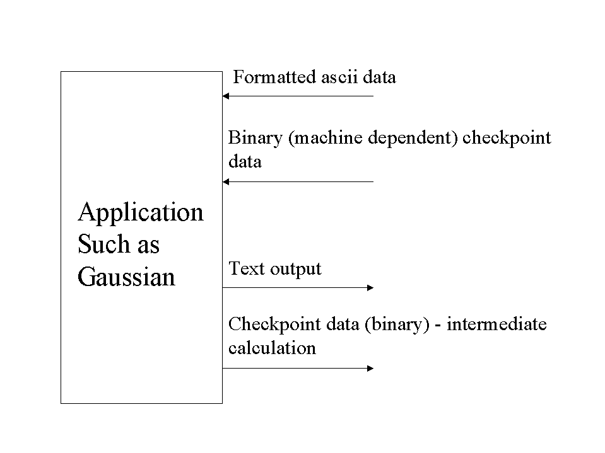
A number of commercial programs are available for generating ascii input files for Gaussian. These “front-ends” run on the desktop machines and provide nice GUIs for visually building a molecule. The chemist will buy, install, and select the favorite front-end GUI programs, use them to create Gaussian input files, and manually ftp the files to the supercomputer for computation. At this point in time, the GUI programs come in a variety of languages for a variety of desktop platforms. NT and Unix are the most popular platforms, but there are some Mac front-end programs also. Java GUI programs are just beginning to show up on the market. The GUI apps are best run on the desktop platform – way too slow over the network.

The front-end GUI programs can also accept checkpoint data from Gaussian. Since the checkpoint data is machine-dependent binary, either the GUI program has to run on the same platform as the version of Gaussian used to generate the checkpoint file, or the user must run a conversion utility to convert the binary checkpoint data to ascii format.

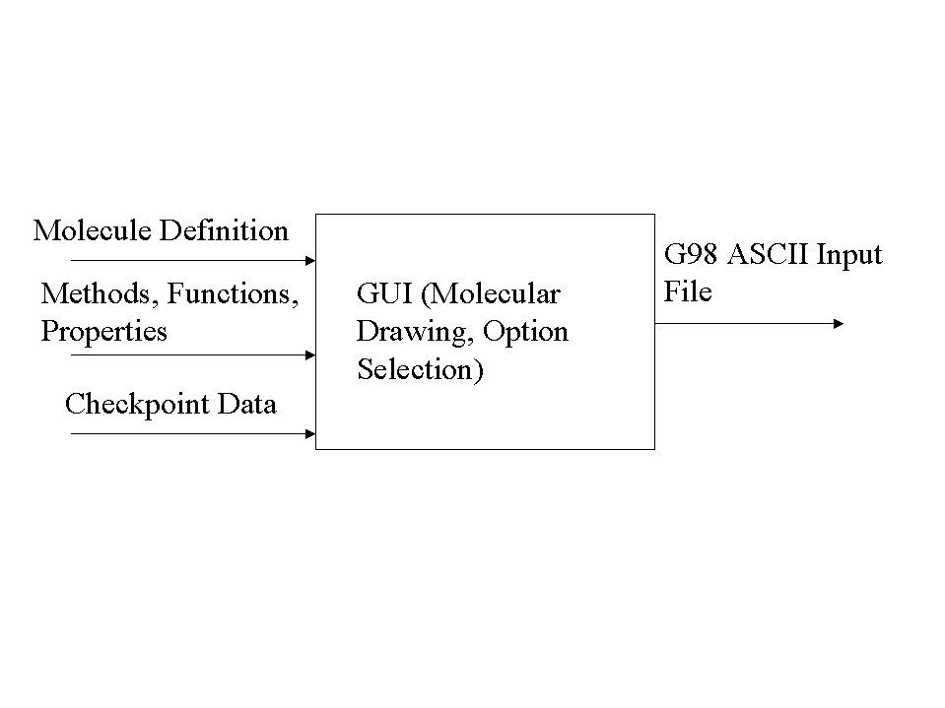

After the input file has been manually ftp’ed over to the supercomputer, the chemist has to manually run the job, manually monitor its progress, intervene as necessary (stop, edit the input file, re-ftp, re-run the job, etc.). Monitoring the progress of the job is important. It is possible that the job could be on a path of computing forever and never converging. Alternately, the job could have already converged, and the chemist would want to stop the computation.

When the computation is complete, the chemist can manually analyze the ascii output file. The requested results, as well as a computation trace, will be in the file. A chemist may write a program that analyzes the output data for particular kinds of computation runs, but commercial software that does generic analysis on the output file is not available.

The text files are “small” (<100K), and are easy to handle on a wide variety of platforms with many different editors. The binary checkpoint files can be small or large (50 MB or so), so these may present data management issues.

Since Gaussian and the GUI front-ends are commercial tools, users have to be licensed to use them. NCSA has a site-license for Gaussian. GUI front-ends are typically purchased by individuals and installed on desktop machines.

A user submitting a job to the supercomputers must currently specify the queue name. The queues themselves are not bound to a single physical machine, but are under the control of software that manages jobs across many machines. The queues are typically targeted for different kinds of jobs or users (e.g., large or small jobs, industrial users, etc.). The load management software will assign the job to a machine based on the current state of the machines and the characteristics of the computation. This process is mostly transparent to the user, who sees the output files generated in the current directory. The output files are physically located on the machine that performed the calculation. Output is kept for only a short time, to make room for new calculations. Users who want to keep the results must ftp them to another location.

Desired Operation: Managing Computations and Problem Solving

The process of manually ftp’ing the input file, initiating the computation, monitoring it, manually refining the computation specifications (input file), re-initiating the computation, manually monitoring it, etc. is cumbersome. We would like to automate this process. The chemist should be able to define a multi-step aggregate computation, define the input file (or files), submit the request for computation, and wait for the results.

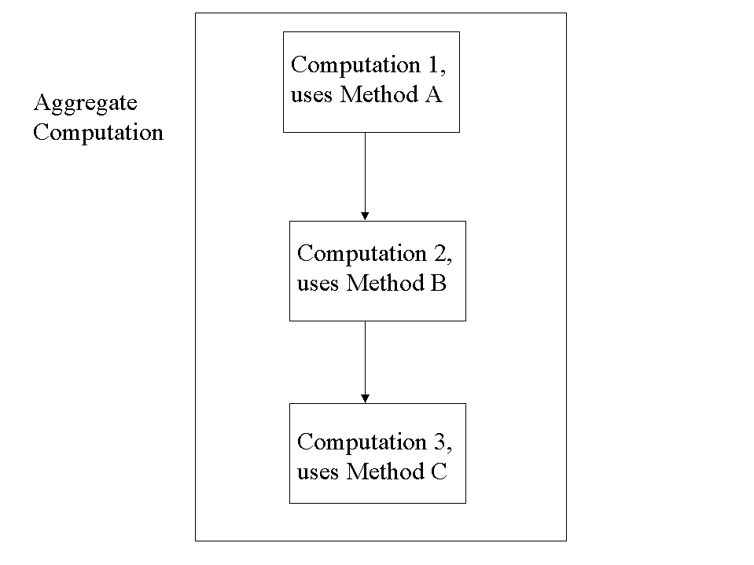
This implies that the CPA must
- Provide a standard way to describe specific computations, computation services, and computation data so that they can be discovered and accessed on the grid (e.g., describe “Gaussian”, an aggregate Gaussian computation definition, a particular kind of Gaussian input file, etc.). XML? There is an existing standard for Chemistry, CML, that should be investigated.
- Treat computations and computation services as components so that there is a way to find the service, determine programmatically what the computation is, know what input the computation requires, know what output it generates, and determine whether two computations (services) can be connected as shown in the figure above. In other words, we need to put in place everything necessary to generate builder tools for computations.
- Provide a way to save and manage all of the computations that users define. These computation definitions should be available for other scientists to discover and use.
- Provide a way to monitor computations for success (convergence). This will require development of middle-tier common event monitoring and notification services, which are described later in this document. It also requires monitors (agents) specific to legacy applications that can talk to the common event services, and development of interfaces to the event services for future applications.
- Provide a way to report errors and recover from non-fatal errors.

We could demonstrate these capabilities with the following demos:
- Support a Gaussian computation that has multiple stages, that runs refining computations on previous results.
- Connect the Fidap application with a Classical Monte Carlo application.

It would be even better for think in terms of “projects” instead of sequential computations. A sample project might be to improve a product such as a color dye for film. A group of people would start with an existing chemical compound, and consider ways to change the compound to produce different properties. The chemists might consider different substituents in a molecule, and classify them into different groups (electron withdrawing, electron adding, or some other kind of classification). Then the group might divide up the analysis into smaller tasks that individuals could investigate with the goal of improving a given property (quality, quantity produced, cost, etc). The work of one individual might provide input for subsequent tasks. This is a mix between designing a computation and project planning and tracking.

To draw a comparison to the software development world – many people work together on a project toward a common goal. The work has to be planned, divided up amongst the developers, coordinated, and tracked. The output of one software deliverable is required “input” to begin development of other software deliverables. The results are saved and made available for other to use, and incorporated into the whole.

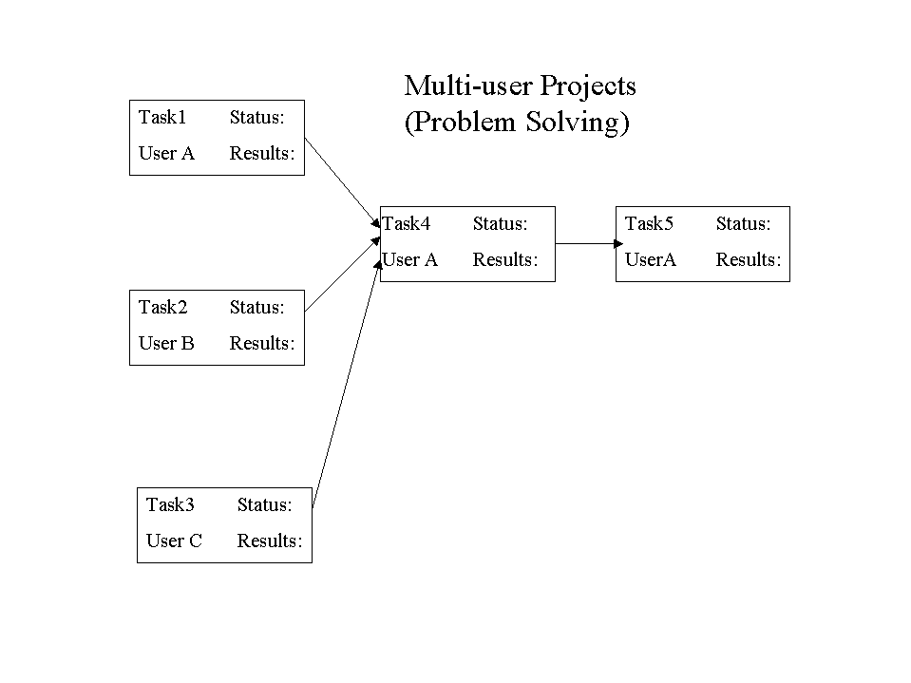

Current Operation: Manual Job Monitoring

Users monitor jobs manually now, and use domain and application specific knowledge to see whether a computation is converging or not. For example, they check the data in the Gaussian output file.

There are 3 granularities for monitoring:
- The network or grid view (status of a machine on a grid)
- The system or admin view (status of jobs on a machine – running, complete, etc)
- The user or computation view (status of job as it relates to the problem under investigation)

Users most need to monitor the status of their work, the jobs of interest to them. They do need information at the network and system levels occasionally, but they most need to know the technical details about how their work of interest is going. For example, is their Gaussian computation converging? Today, users must apply domain and application specific knowledge to track things manually. They manually check for the existence of the Gaussian output file and evaluate the data in it.

Desired Operation: Automated Job Monitoring and Recovery

Users would like automated monitoring. For example, they want to receive events including job starting, job completing, intermediate computation data at periodic or strategic points in the computation, job converging, job diverging or failing to converge. Many of the events of interest are specific to the given application, and many of the applications are legacy apps. This is going to require the development of application-specific monitors or agents that export events concerning the progress of the computation. The events are forwarded to a middle-tier notification and event service in the CPA. The clients interact with the middle-tier service, not the application –specific agents. The events will need to be transported in a language and system independent way, possibly via an xml based protocol.
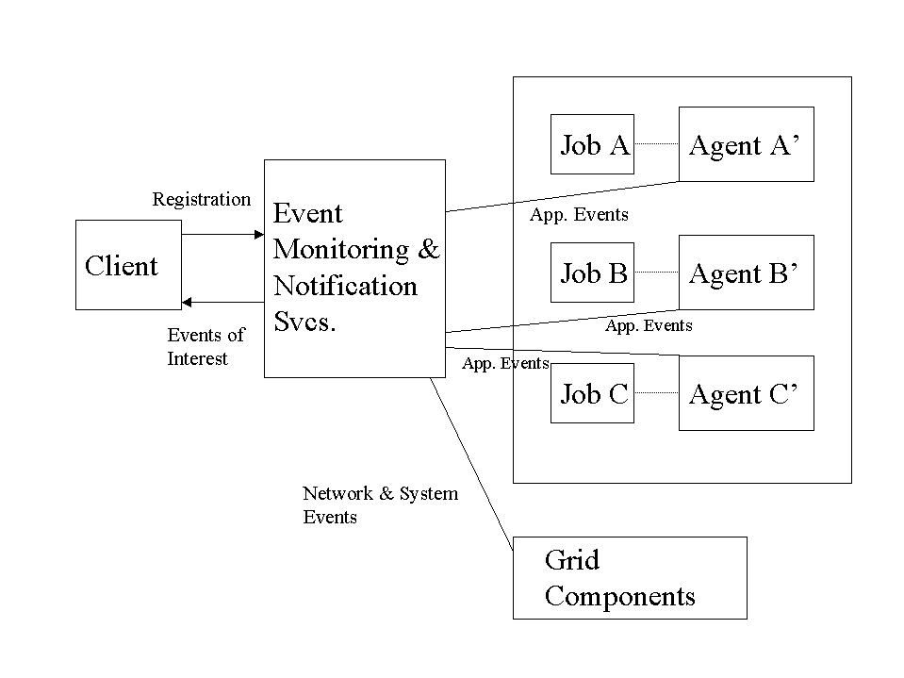
The presentation of the events to the user is going to be important. Simply sending the event to email won’t be sufficient if the user needs to act on the event right away. For example, a “non-converge” event is useless unless the user can take action, there is a pre-defined automatic response to the event, or there is an agent acting on the behalf of the user. Possible ways to bring critical events to a user’s attention might include an “active monitoring GUI” that is always up on the user’s client, routing the event to a paging system, or routing the event to a user’s pda (such as a PalmPilot). Alternatively, users may define automated responses to events as they register interest in them, such as automatically killing a job that will never converge.

Some of the events reflect error conditions. How can we respond to errors, correct errors, and help the users find ways to “debug” computational problems? Some ideas include:
- Provide data or event traces for computations, while the computation is active, and after it completes.
- Provide application-specific error-recovery. An example of this might be to automatically try a different computation method if the current computation fails to converge. This should be user-definable (as registration of interest in a particular event and associated action is), but there could be common “recovery patterns” that a user could point to and use in response to a particular kind of failure event. This should integrate directly into the event/action services.
- Provide an expert system for error recovery.

It may be useful to provide hierarchical event reporting so that the users will see the low-level details of events only if the request it (e.g., click on it for more info).

Problem Solving Environment Requirements Overview

The two scenarios above show that the current architecture is insufficient to meet the needs of next-generation Problem Solving Environments (PSEs). The example desired operation scenario above suggests that there are requirements in four key areas:

- Security
- Software Lookup and Discovery Services
- Event Services
- Data Management Services

These areas will be explored in more detail to uncover a basic understanding of both user and technical requirements.

