New Traffic Signs

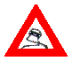
I was riding when I saw a We fooled around until she was ready
my bicycle woman lying down.

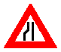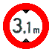
First she opened Then the other. I put it in. She complemented me
one leg. on my size

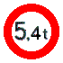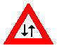
and weight. After a lot of we tried different and speeds.
coming and going styles

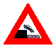
When I reached the she shouted She said she My excitement died.
point of no return , “STOP!” wasn’t on the Pill.

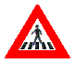
Nine months later I was a father. My world collapsed. I now walk.
she phoned from
the hospital.

