- Final Project on CSE791 Data Mining and Knowledge Discovery in Databases -

Project Report

3 Dimensional Visualization
for HTTP server log databases

prepared by Jungkee Kim, Kieun Kim and Yong-Jae Kim
July 24, 1998

- Introduction

The goal of this project is to practice Data Mining skill for making some decision and to implement data pattern using 3 dimensional visualization tool. An HTTP server acquires some files to record who is visiting which page at what time and several other information. In the huge HTTP web pages, it is so difficult to analyze all the access data. If we visualized these raw data, the generated graphs would be useful to decide the future strategies or plans particularly on commercial web site like on-line bookstores or virtual shopping malls. For the limitation to get appropriate site and system usage, we used a day log file on NPAC web site which has many visitors and several pages, and used the visualization tool, Scivis. As a result, the visualization gave us different patterns that are hard to find from the recent HTTP statistics analyzer which usually shows simple counts that ordered by the number of visiting or total transferred size.

- General Description

- HTTP Server Access Logs

Most WWW servers execute NCSA’s Hypertext Transfer Protocol daemon(http). In turn, each copy of this daemon maintains four logs (accesses, agents, errors, and referers) that are written on the local disk of the associated workstation server.
In 1994, a group of server and analysis developers came up with the Common Log Format(CLF). This is a well-defined set of facts about each hit that a Web server processed. The CLF contains lines of eight fields as the follow table.

Item | Contends
Host | Client host name or IP address
Ident | Identity (user name) if available
Authuser | Authorization user ID
Date-time | day/month/year:hour:minute:second
Zone | Timezone: +dddd or –dddd
Request | The first line of the request, e.g. “GET / HTTP/1.0”
Status | Response status from server
Bytes | Number of bytes transmitted

Table 1. Common Log Format

Each field is separated by a single space. If a field is not known or available, a dash(“-”) is used as the field value instead. The ident field is rarely used, and authuser is only used at sites that require registration.

- Data Description

The data used on our projects are host, date-time, and request. The status item also used for noise eliminating because the status makes it possible to the access was successful or not. If an access tried to access the non-exist page and it would produce the failure code. That kind of access is a noise, so we can remove the noise when we check the status item. The status codes are classified as table 2 and 3.

Success Code |  | Failure Code
200 | OK | 400 | Bad Request
201 | Created | 401 | Unauthorized
202 | Accepted | 402 | Payment Required
203 | Partial Information | 403 | Forbidden
204 | No Response | 404 | Not found
300 | Redirected | 500 | Internal Error
301 | Moved | 501 | Not Implemented
302 | Found | 502 | Overloaded Temporarily
303 | New Method | 503 | Gateway Timeout
304 | Not Modified

Table 2. HTTP Server status Codes

Code Range | Response Meaning
100 ~ 199 | Informational
200 ~ 299 | Client request successful
300 ~ 399 | Client request redirected, further action necessary
400 ~ 499 | Client request incomplete
500 ~ 599 | Server errors

Table 3. HTTP Server Response Code Group

The host item shows the remote host which visited the web. The request item has a method, the visiting page and HTTP version. We extracted only the visiting page information. The date and time information is also used. So, the remote host, access page, and access time are used as three dimensional visualization data.

- Oracle Database

Oracle is used as the base database for this project. The data produced by a Perl program are used as the input file of Oracle and loaded by “sqlload”. The table of database is consists of three fields, RemoteHost, AccessDate, and AccessPage. Each type of fields is varchar2(50), date, and varchar2(100).
Using JDBC java program, we generated a distinct remote host name file and a distinct access page file. Those files are added numbers with order from 1 to the number of each items. When making Scivis ASCII input file with a Perl program, the access time converted to a minute number. For example, 01:03 converted to “60 x 1 + 3”, that is “63”.
Those processes make the access data to a numbered data which can be only accepted as a Scivis ASCII input file. The Scivis input file format will be explained in the next section.

Visualization Method and Tool

- Visualization Tool

We found a scientific data visualization tool so called Scivis developed
by NPAC in Syracuse University. This has been designed a collaborative scientific data visualization package that will aid researchers from distant, diverse locations to work together in developing scientific codes, providing them with a system to analyze
their scientific data. This infrastructure is written in JAVA and has a lot of visualization techniques by taking advantage of a JAVA's graphics power.
Scivis has a sluggish performance when the software renders 3D color-mapped surface plots. This tool can be improved if we had hardware acceleration for graphics. We are going to use the Java3D API when it is available in the future releases.

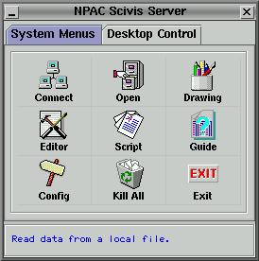

fig. 1 NPAC Scivis Server

- ASCII Scivis File format

Scivis provides the ASCII file format and we used this type of data. The structure of Scivis ASCII format is as follow:

Dimension (3D is 2)
Time (We used only one)
X value | Y value | Z value

Table 4. The Structure of Scivis ASCII data file

- Knowledge Discovery in Databases (KDD) Process

We applied the KDD process on our project and progress it as KDD steps. The flow chart of our data processes are shown figure 2.

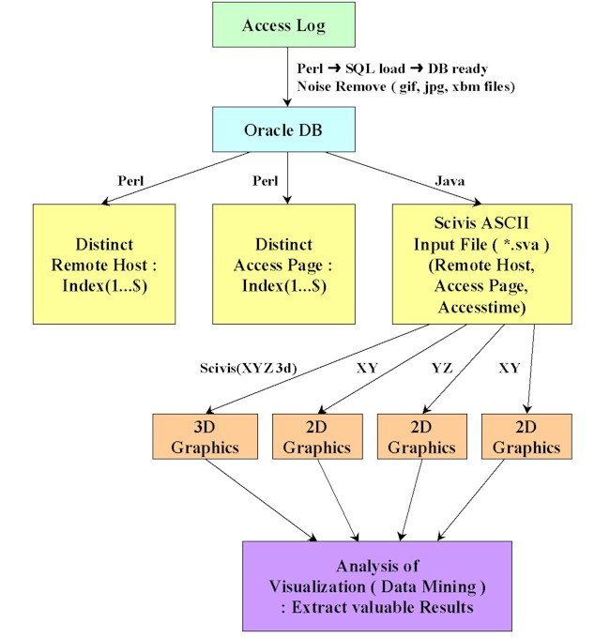

fig. 2 Flow Chart of KDD on HTTP Server Log Databases

Using a simple Perl program, the access log file can be change to a database input file. When extracting the proper data, the noise can be eliminated with pattern match. The status code checking routine also remove the redundant data. As a web page has many graphic ornament files. That would be necessary to remove such files, so they are eliminated. The detail Perl codes are listed in appendix.

The KDD process of our project can be classified as follows:

Learning the application domain – Concerning the static statistics on NPAC server, the application domain is studied sufficiently.

Creating a target data set – One day (June, 30th, 1998) access log file of NPAC web is used as a data set.

Data Cleaning and preprocessing – This process is done by removing some noises and ornament graphic accesses such as logos and graphic buttons. Some accesses tried to get non-exist page and used double slash. Those data are removed or modified as single slash. “gif, GIF, jpg, JPG, jpeg, xbm, bmp” extension file accesses are ignored as an input.

Data reduction and projection – As the structure of database is so simple, there was no such process needed. However, the data were reduced before getting input of the database with checking the status and ignoring failure status accesses.

Choosing the function of data mining – As mensioned before, Scivis visualization tool is selected as a data mining tool.

Choosing the data mining algorithms – Sorting the remote hosts and access pages which was automatically executed by Oracle SQL. The numbering the sorted remoted hosts and access pages is used for the visualization input because Scivis only allows the real number input.

Data mining – Visualization is executed. A three dimensional graph and three two-dimensional graphs are generated.

Interpretation – Some interesting patterns of visualization are found and analyzed in the next section in detail.

Using discovered knowledge – This step is not be applied to our project.

Results and Graph Analysis

We obtained 17,368 points and the three dimensional graphs are displayed in figure 3 and figure 4. Figure 3 has some labels and different from figure 4 because Scivis adjusted the ratio of each axis automatically when showing scale labels.

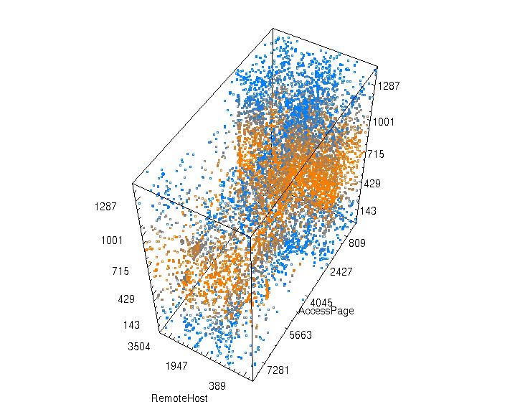

fig. 3 Three dimensional graph of a day accesses

As shown figure 3 and figure 4, some interesting pattern are found. Some remote hosts accessed whole of web pages, some other remote hosts accessed some particular web pages within a short time, and many remote hosts usually accessed web pages in the work time.
To analyze the graph in detail, we made three dimensinal graphs as displayed in figure 7, 8 and 9.
Figure 7 shows the remost host and access page two dimensinal graph. It has some vertical and hrizontal lines. A vertical line means a particular remote host accessed the whole web page. It can be interpreted as a robot site scanned the whole web site. For example, “scooter.pa-x.dec.com” is well-known robot site as Alta Vista search engine. A horizontal line can be interpreted as it is accessed from a variety of remote hosts. The most famous web site “kidweb” draws a sound line.

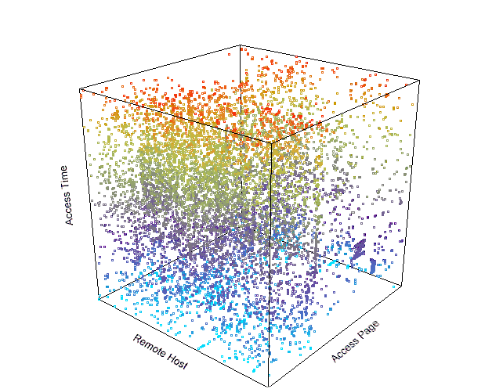

fig. 4 Three dimensional graph without scale labels

Figure 8 denotes the relation between access time and remote host. The long lines show some typical robots sites like Alta Vista, Web Crawler, Lycosidae, and Infoseek. Some short density lines show that some remtes hosts accessed many times within a short time period. They are also kinds of robot site which were turned on in a short time.
The relation between access time and access page is shown as a graph in figure 9. It also has some vertical lines which mean that some web pages are accessed continually. The most frequent referred web sites Visual human and kids web can be indicated as popular pages. The reason why the “robots.txt” is accessed open is that it is usually accessed when a robot visits. That file guide to the robot where is allowed to visit or which robot agent cannot access which pages. Some interesting patterns are also found not a line form but some geometrical shapes. The “Z” shape means some consecutive pages are access one by one within a short time. The rectangular shape tagged as “I” showed the java tutorial materials are accessed one by one.

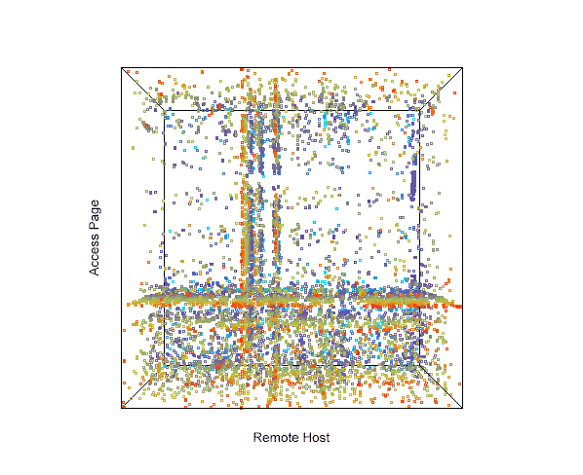

fig. 5 3D graph with XY plane front

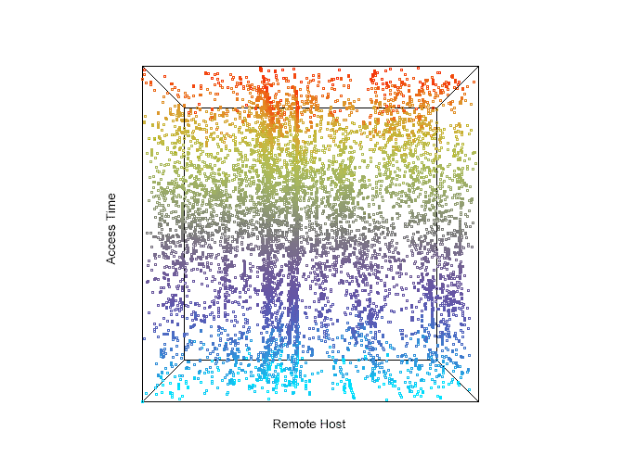
fig. 6 3D graph with XZ plane front

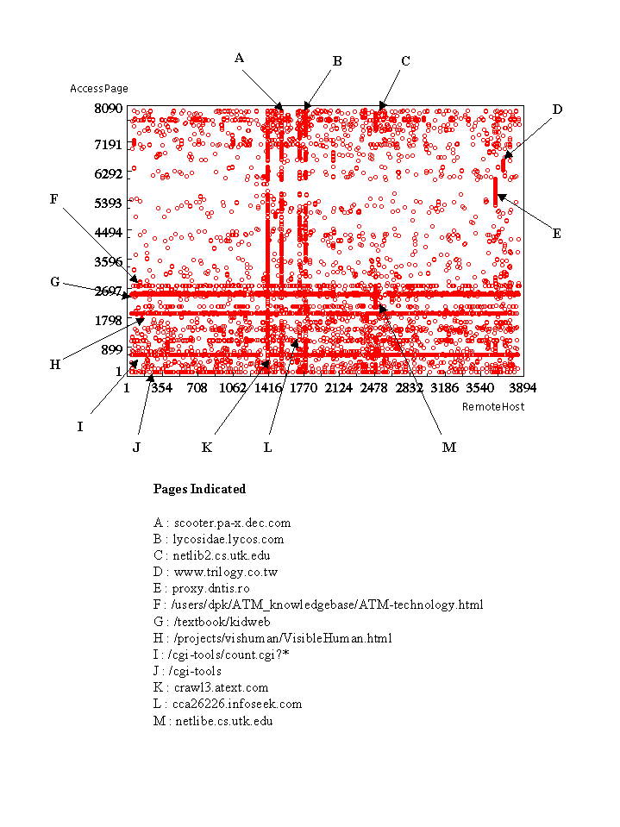
fig. 7 Two dimensional graph between remote host and access page

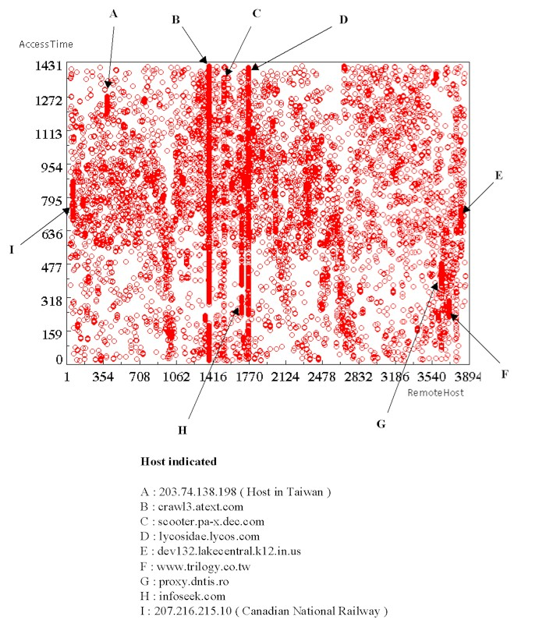

fig. 8 Two dimensional graph between access time and remote host

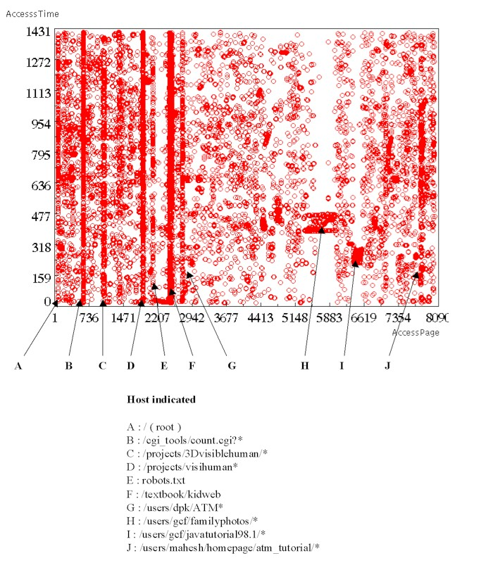

fig. 9 Two dimensional graph between access time and access page

Conclusion

Visualization techniques are a very useful method of discovering patterns in data sets. Due to too many points in the 3D graphs, it is difficult to find some interesting clusters in that graph. However, some explicit patterns are visualized in the graph and we decided to divide it as 2D graphs which enable to get a particular point. Some vertical and horizontal lines have been showed up and can be interpreted as a particular meaning. The same processes can be done on the commercial sites and it will produce very useful information to decide the future policy. That would be why the data mining gets the spot light recently.

