Making Applets with control page
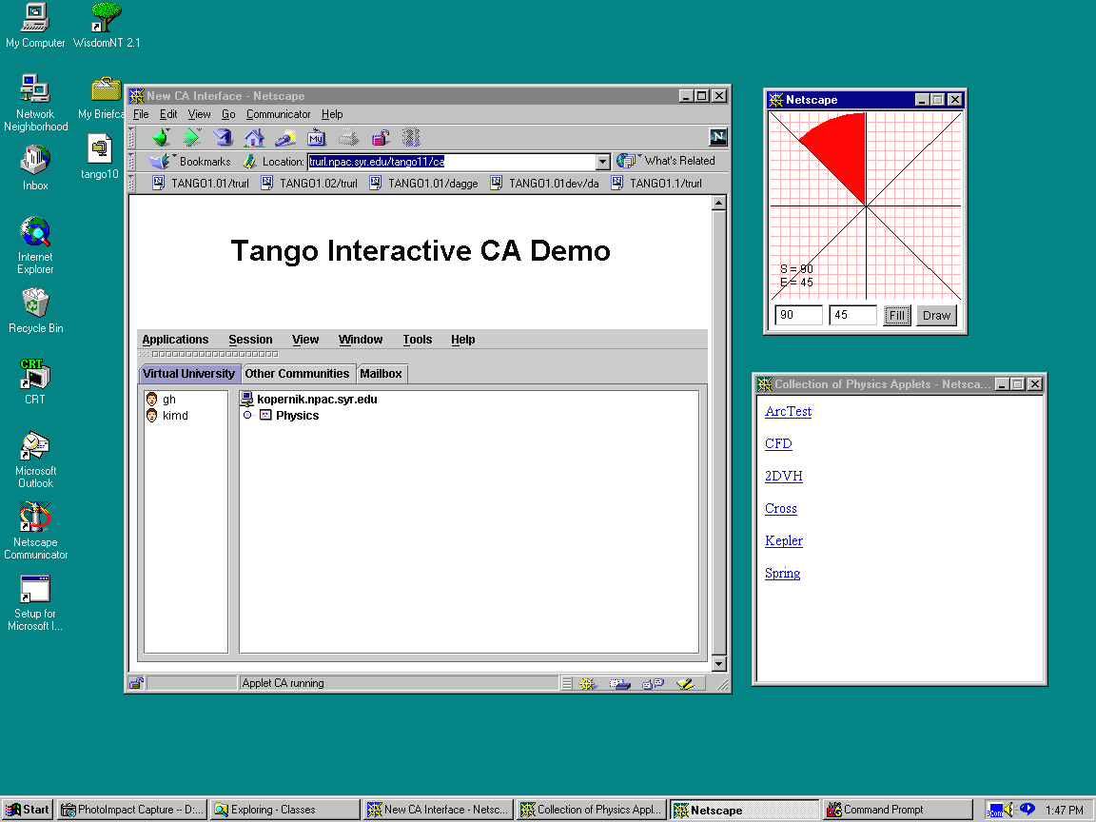
The applets with control page is the one of the tango application that contains many of related applets in the window. As shown in the figure above, the window on right lower side is one of the tango applications that are invoked from the tango. Once the control page is shown, clicking the appropriate link can activate applets. The right upper window is one of the sample applet – called ArcTest invoked from the control page.

The application contains 3 html files and the directory structure is like following:

Directory structure
applets/
main/
ArcTest/
ArcTestScriptFrame.html
ArcTestScript.html
ArcTest.class
ArcCanvas.class
ArcControls.class
main.html

main.html
This file shows some documentation as well as the link to the applets and invokes them by clicking the appropriate link. In this file, the tango agent is registered and passed to each tango script (ArcTestScript.html) when they are invoked.
The following is main.html source code.

1 <html>
2 <title> Collection of Applets </title>
3 <body onUnload="Tango_exit()">
4 <script language="javascript">
5 var openedApplet=0;
6 var initialized=false;
7 var isMaster=true;
8 var codeBaseURL=null;
9 var Tango_agent=null;
10 var totalApplet=1;
11 var winApplet = new Array();
12 var appletURL = new Array();
13 var appletName = new Array();
14 var appletArgs = new Array();
15
16 function Tango_send(data) {
17 if (Tango_agent != null ) {
18 print("<script> Send Data : " + data);
19 Tango_agent.sendJS(data);
20 }
21 }
22
23 function initThis() {
24 for ( var i = 0 ; i < totalApplet ; i++ ) {
25 winApplet[i]=null;
26 }
27 appletURL[0] = "ArcTestScriptFrame.html";
28 appletName[0] = "ArcTest";
29 appletArgs[0] = "scrollbars=no,width=204,height=230";
30 isMaster = Tango_agent.isMaster();
31 if ( !isMaster ) {
32 var sendData = "i";
33 Tango_send(sendData);
34 }
35 else {
36 initialized = true;
37 }
38 codeBaseURL = document.URL;
39 var arrayURL = codeBaseURL.split("/");
40 codeBaseURL = null;
41 codeBaseURL = "http://";
42 for ( var i = 2 ; i < arrayURL.length - 1 ; i++ ) {
43 codeBaseURL = codeBaseURL + arrayURL[i] + "/";
44 }
45 }
46
47 function Tango_register(win) {
- Tango_agent =
49 Packages.webwisdom.tango.TAgentJS.createTAgentJS(win);
50 if (Tango_agent != null) {
51 Tango_agent.setDbgModeJS(true);
52 Tango_agent.addTDataListenerJS(win);
53 Tango_agent.addTControlListenerJS(win);
54 }
55 }
56
57 function Tango_masterChanged(isM, mNa) {
58 isMaster = isM;
59 }
60
61 function Tango_participantJoined(pNa) {}
62
63 function Tango_participantleft(pNa) {}
64
65 function Tango_audioRequested(isR) {}
66
67 function Tango_exit() {
68 for ( var j = 0 ; j < totalApplet ; j++ ) {
69 if ( winApplet[j] != null ) {
70 winApplet[j].close();
71 winApplet[j]=null;
72 }
73 }
74 if ( Tango_agent != null ) {
75 Tango_agent.exit();
76 }
77 }
78
79 function Tango_receive(data) {
80 // protocol :
81 // 1st string
82 // c : close applet
83 // o : open applet
84 // i : initial request
85 // a : all applet info.
86 // 2nd string
87 // number of applet in action
88 // from 3rd string
89 // applet index
90 itemRecv = data.split(' ');
91 if ( itemRecv[0] == 'c' ) {
92 setClear(itemRecv[2]);
93 }
94 else if ( itemRecv[0] == 'o' ) {
95 openNewWindowRemote(itemRecv[2]);
96 }
97 else if ( itemRecv[0] == 'i' ) {
98 if ( !isMaster ) {
99 return;
100 }
101 var sendData = "a " + openedApplet;
102 for ( var i = 0 ; i < totalApplet ; i++ ) {
103 if ( winApplet[i] != null ) {
104 sendData = sendData + " " + i;
105 }
106 }
107 Tango_send(sendData);
108 }
109 else if ( itemRecv[0] == 'a' ) {
110 if ( initialized )
111 return;
112 if ( isMaster )
113 return;
114 for ( var i = 0 ; i < itemRecv[1] ; i++ ) {
115 openNewWindowRemote(itemRecv[2 + i]);
116 }
117 initialized = true;
118 }
119 }
120
121 function openNewWindow(index) {
122 if ( !isMaster )
123 return;
124 if ( winApplet[index] != null ) {
125 return;
126 }
127
128 openedApplet++;
129 var fullURL = codeBaseURL + appletURL[index];
- winApplet[index] =
- window.open(fullURL, appletName[index], appletArgs[index]);
132 var sendData = "o 1 " + index;
133 Tango_send(sendData);
134 }
135
136 function openNewWindowRemote(index) {
137 if ( winApplet[index] != null ) {
138 return;
139 }
140 openedApplet++;
141 var fullURL = codeBaseURL + appletURL[index];
- winApplet[index] =
- window.open(fullURL, appletName[index], appletArgs[index]);
144 }
145
146 function scriptReady(index) {
147 winApplet[index].frames[0].initScript(Tango_agent, isMaster);
148 }
149
150 function setClear(index) {
151 if ( winApplet[index] != null ) {
152 winApplet[index].close();
153 winApplet[index]=null;
154 openedApplet--;
155 }
156 if ( isMaster ) {
157 var sendData = "c 1 " + index;
158 Tango_send(sendData);
159 }
160 }
161
162 Tango_register(window);
163 initThis();
164
165 </script>
166 <A HREF="javascript:openNewWindow(0);"> ArcTest</A> <P>
167 </body>
168 </html>

- This java script starts with registering the tango agent (line 47 ~ 55) and initializing the variables (line.23 ~ 45).
- When the link is clicked (line 166), new window is opened (line 121 ~ 134) with appropriate URL, and the “open” information is broadcasted to all the users in that session (line 132 ~ 133).
- The new opened window calls the function scriptReady() with its own index when it is ready, and in return, registered tango agent and master information is passed to the new window (line 146 ~ 148).
- When an applet is closed, the function setClear() (line 150 ~ 160) is called from the applet side java script, and the “close” information is broadcasted (line 156 ~ 159).
- When a new user joins the session, the new user requests the initial status (line 31 ~ 34), and the master replies with all the opened applet information (line 97 ~ 108).

ArcTestScriptFrame.html
This file is used to remove the margin between Netscape window and the applet.

1 <!DOCTYPE HTML PUBLIC "-//W3C//DTD HTML 3.2//EN">
2 <HTML>
3 <frameset rows="100%,*" frameborder=no>
4 <frame BGCOLOR="#C0C0C0" src="../ArcTest/ArcTestScript.html" name="baseframe" scrolling=no marginheight=0 marginwidth=0 noresize>
5 </frame>
6 </frameset>
7 </HTML>

ArcTestScript.html
This file is the bridge between main page and an applet (ArcTest.class).
The following is the source code.

1 <html>
2 <title> ArcTest </title>
3 <body onUnload="exitThis()">
4 <script language="javascript">
5 var Tango_agent=null;
6 var initialized=false;
7 var isMaster=false;
8 var ArcTestIndex=0;
9 var ArcTestChannel=10;
10
11 function exitThis() {
12 var a;
13 a = 0;
14 if ( !parent.opener.closed ) {
15 parent.opener.setClear(ArcTestIndex);
16 }
17 }
18
19 function initScript(arg, master) {
20 Tango_agent = arg;
21 isMaster = master;
22 }
23
24 function appletReadyJS(a) {
25 initApplets();
26 }
27
28 function initApplets() {
29 var ma = 0;
30 if ( initialized )
31 return;
32 initialized=true;
33 while (Tango_agent == null) {}
34 if (Tango_agent.isMaster())
35 ma = 0;
36 else
37 ma = 1;
- document.applets.ArcTest.initTangoJS(Tango_agent, ArcTestChannel, ma);
39 }
40 parent.opener.scriptReady(ArcTestIndex);
41 </script>
42
- <center>
44 <applet name="ArcTest" codebase="." archive="ArcTest.jar" code="ArcTest.class" width=200 height=230 mayscript>
45 <param name=interface value="javaScript">
46 </applet>
47 </center>
48 </body>
49 </html>

- This javascript starts with calling the function scriptReady() in the main.html (line 40).
- The registered tango agent and master information are received from the main page (line 19 ~ 22).
- The applet is invoked when this file starts (line 44 ~ 46), the function appletReadyJS() is called by the applet (line 24 ~ 26), and registered tango agent, channel number, and master informatin are passed to the applet (line 28 ~ 39).
- The window is closed in 2 cases – one is that only this window is closed, and the other is that this main page closing makes this window closed. When this window is closed, it check the main page and clean its data in the main page if the main page is not closed (line 11 ~ 17).

ArcTest.java
This applet is the sample applet shown in JDK 1.1.6 ArcTest.java.
It is converted to tango applet.

/*********************************************************
ArcTest.java
An interactive test of the Graphics.drawArc and
Graphics.fillArc routines.
*********************************************************/
import java.awt.*;
import java.applet.*;
import java.lang.*;
import java.io.*;
import java.net.*;
import java.util.*;
import webwisdom.tango.*;
import netscape.javascript.JSObject;

1 public class ArcTest extends Applet implements TControlListener, TDataListener {
2 TAgent agent = null;
3 private int channel = 100;
4 private boolean javaOnly = true;
5 boolean inTango = true;
6 boolean isMaster = true;
7 boolean fromScript = false;
8
9 ArcControls controls;
10
11 int saved_start;
12 int saved_end;
13 int saved_filled;
14
15 public void init() {
16 String arg = null;
17 try {
18 arg = getParameter("interface");
19 inTango = true;
20 }
21 catch(Exception e) {
22 inTango = false;
23 }
24
25 if (arg == null) {
26 inTango = false;
27 }
28 if (inTango)
29 setTango(arg);
30 initThis();
31 }
32
33 public void initThis() {
34 setLayout(new BorderLayout());
35 ArcCanvas c = new ArcCanvas();
36 add("Center", c);
37 add("South", controls = new ArcControls(c, this));
38 controls.enable();
39 if (inTango) {
40 isMaster = agent.isMaster();
41 initApplet();
42 }
43 }
44
45 public void initApplet() {
46 if ( !isMaster ) {
47 String send_data = "Initial";
48 sendMessage(send_data);
49 }
50
51 }
52
53 public void commJava() {
54 try {
55 agent = new TAgent(new TLAgentApplet(this));
56 }
57 catch(TangoException e) {
58 e.printStackTrace();
59 }
60 }
61
62 public void commJavaScript() {
63 JSObject jsWin = JSObject.getWindow(this);
64 Object[] args = new Object[1];
65 args[0] = this;
66 jsWin.call("appletReadyJS", args);
67 }
68
69 public void setTango(String arg) {
70 if ( arg.equals("javaApplet") ) {
71 fromScript = false;
72 commJava();
73 }
74 else if ( arg.equals("javaScript") ) {
75 fromScript = true;
76 commJavaScript();
77 }
78
79 while ( agent == null ) {}
80 agent.addTDataListener(channel, this);
81 agent.addTControlListener(this);
82 isMaster = agent.isMaster();
83 }
84
85 public void setTango(String args[]) {
86 try {
87 agent = new TAgent(new TLAgentApplication(args));
88 }
89 catch(TangoException e) {
90 e.printStackTrace();
91 }
92 agent.addTDataListener(channel, this);
93 agent.addTControlListener(this);
94 }
95
96 public void initTangoJS(TAgent a, Number ch, Number ma) {
97 channel = ((Number) ch).intValue();
98 if ( ((Number) ma).intValue() == 0 )
99 isMaster = true;
100 else
101 isMaster = false;
102 agent = a;
103 }
104
105 public void sendMessage(String send_data) {
106 if (!inTango)
107 return;
108 agent.send(channel, stringToBytes(send_data));
109 }
110
111 public void destroy() {
112 if ( fromScript ) {
113 agent.removeTControlListener(this);
114 agent.removeTDataListener(this);
115 return;
116 }
117 if (agent != null) {
118 agent.exit();
119 }
120 super.destroy();
121 }
122
123 public boolean handleEvent(Event e) {
124 if (e.id == Event.WINDOW_DESTROY)
125 System.exit(0);
126 return false;
127 }
128
129 public void receive(byte b[]) {
130 StringTokenizer recv_data = null ;
131 boolean filled;
132 int filled_int;
133 int start;
134 int end;
135 String r = bytesToString(b);
136 // master sends the inital value of filled, start, end
137 if (r.startsWith("Initial")) {
138 if (isMaster) {
139 // make one string data to be sent,
140 // convert to byte, and send it
141 String send_data = saved_filled +
142 " " + saved_start + " " + saved_end;
143 sendMessage(send_data);
144 }
145 return;
146 }
147 // parse the received String
148 recv_data = new StringTokenizer(r);
149 filled_int = (Integer.valueOf(recv_data.nextToken())).intValue();
150 start = (Integer.valueOf(recv_data.nextToken())).intValue();
151 end = (Integer.valueOf(recv_data.nextToken())).intValue();
152 if ( filled_int == 1 )
153 filled = true;
154 else
155 filled = false;
156 controls.draw_canvas(filled, start, end);
157 controls.s.setText(String.valueOf(start));
158 controls.e.setText(String.valueOf(end));
159 }
160
161 private byte[] stringToBytes(String s) {
162 int l = s.length();
163 byte[] t = new byte[l];
164 s.getBytes(0, l, t, 0);
165 return t;
166 }
167
168 private String bytesToString(byte t[]) {
169 return new String(t, 0);
170 }
171
172 public void masterChanged(boolean isMaster, String masterName) {}
173
174 public void participantJoined(String participantName) {}
175
176 public void participantLeft(String participantName) {}
177
178 public void audioRequested(boolean isREquested) {}
179
180 }

class ArcCanvas extends Canvas {
int startAngle = 0;
int endAngle = 45;
boolean filled = false;
Font font;

public void paint(Graphics g) {
Rectangle r = bounds();
int hlines = r.height / 10;
int vlines = r.width / 10;
g.setColor(Color.pink);
for (int i = 1; i <= hlines; i++)
g.drawLine(0, i * 10, r.width, i * 10);
for (int i = 1; i <= vlines; i++)
g.drawLine(i * 10, 0, i * 10, r.height);
g.setColor(Color.red);
if (filled)
g.fillArc(0, 0, r.width - 1, r.height - 1, startAngle, endAngle);
else
g.drawArc(0, 0, r.width - 1, r.height - 1, startAngle, endAngle);
g.setColor(Color.black);
g.setFont(font);
g.drawLine(0, r.height / 2, r.width, r.height / 2);
g.drawLine(r.width / 2, 0, r.width / 2, r.height);
g.drawLine(0, 0, r.width, r.height);
g.drawLine(r.width, 0, 0, r.height);
int sx = 10;
int sy = r.height - 28;
g.drawString("S = " + startAngle, sx, sy);
g.drawString("E = " + endAngle, sx, sy + 14);
}

public void redraw(boolean filled, int start, int end) {
this.filled = filled;
this.startAngle = start;
this.endAngle = end;
repaint();
}
}

class ArcControls extends Panel {
TextField s;
TextField e;
ArcCanvas canvas;
ArcTest test;

public ArcControls(ArcCanvas canvas, ArcTest test) {
this.canvas = canvas;
this.test = test;
add(s = new TextField("0", 4));
add(e = new TextField("45", 4));
test.saved_start = 0;
test.saved_end = 45;
test.saved_filled = 0;
add(new Button("Fill"));
add(new Button("Draw"));
}

public boolean action(Event ev, Object arg) {
String send_data = null;
int button_action;
int int_start;
int int_end;
boolean filled;
if (ev.target instanceof Button) {
String label = (String)arg;

filled = label.equals("Fill");
if (filled)
button_action = 1;
else
button_action = 0;
int_start = Integer.parseInt(s.getText().trim());
int_end = Integer.parseInt(e.getText().trim());
test.saved_start = int_start;
test.saved_end = int_end;
test.saved_filled = button_action;

// make one string data to be sent,
// convert to byte, and send it
send_data = button_action + " " + int_start + " " + int_end;
test.sendMessage(send_data);
canvas.redraw(filled, int_start, int_end);
return true;
}
return false;
}

public void draw_canvas(boolean filled, int start, int end) {
canvas.redraw(filled, start, end);
}
}

- To get the tango agent, the method commJavaScript() calls the function appletReadyJS() in ArcTestScript.html (line 62 ~ 67). By calling the function appletReadyJS(), the javascript knows that the applet is ready.
- Once the function appletReadyJS() is called, the method initTangoJS() is called from the javascript – ArcTestScript.html so that the registered tango, channel, and master information are passed (line 96 ~ 103).
- The method setTang() (line 69 ~ 83) gets the tango agent. Especially Line 79 would be useful that the applet is waiting for getting the tango agent from the javascript.
- The method destroy() (line 111 ~ 121) is called when the applet is closed. Even the applet is closed, the tango agent is still used in other applets. So instead of calling the method exit(), just remove the TDataListener and TControlListener (line 112 ~ 116).

