MASTERS THESIS

By

MERYEM ISPIRLI
B.S. Syracuse University, 199
M.S. Syracuse University, 199

August 1999

Approved _______________
Professor Geoffrey Fox

Date ___________________

VITA

NAME OF AUTHOR: Meryem Ispirli

PLACE OF BIRTH: Izmit, Turkey

DATE OF BIRTH: February 09, 1972

GRADUATE AND UNDERGRADUATE SCHOOLS ATTENDED:
LeMoyne College, Syracuse, New York
Syracuse University, Syracuse, New York

DEGREES AWARDED:

Bachelor of Computer Engineering, 199, Syracuse University

AWARDS AND HONORS:

PROFESSIONAL EXPERIENCE:

Copyright 1999 Meryem Ispirli

All rights Reserved

Java Academy Development Environment (JADE)

JADE Instructions
Under classes directory there is a file called run.bat. You need to edit this file and replace C:\jdk1.2.1\bin\java with where your jdk is. Nothing else needs to be done to run it. Then
just type run from command prompt.
Steps you need to follow:
- Click on Configure Editor from File menu.
- You will not have default parameters on the bottom half of the Configuration window if it's your first time using. So you need to give paths for Java Compiler by clicking on BrowseC button and also Web Browser path by clicking on the BrowseB button. You only need Compiler and Browser path for now.
- Then click on OK. The configuration window will disappear.
- Then open files into the editor with Browse under File menu.
- The files you open will be added to Recent Files menuItem under File menu. So you can switch between java code and html file.
- When you're ready to compile, choose Compile under Java menu or Compile Java Button in the Toolbar located on the South part of the editor. Be sure to have the code in the text editor when doing this.
- When you're ready to run, choose Run under Java menu or Run Java Button in the Toolbar located on the South part of the editor. Be sure to have the html file in the text editor when doing this.
- To change properties of the editor you can go to Configure Editor under File menu. Then choose "Properties Set Up" tab on top of Configuration window.

The true colors are lost during screendump.
OLD Screendumps new screendumps are not all completed yet.

Start

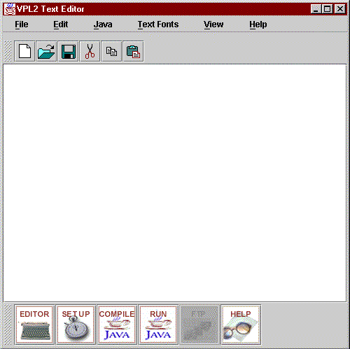

File Menu
- New:
- Open:
- Save: Saves the active file with its current filename, location and file format.

- Save As...: You can save the active document you are working on, whether it is new or existed previously. We are currently working on the option of being able to save all open documents at the same time. You can save a copy of the active with a different name or in a different location as well. To save a new, unnamed document.

Click Save from the File menu or disk icon PUT ICON HERE from the toolbar.
- To save a document in a different folder, click a different drive in the Save box, or double click a different folder in the folder list.
- Click OK.
- Print: When you print to a file, you must first select the printer that will ultimately print the file.
- On the File menu, click Print.
- In the Name box, click the printer with which you’ll print the file.
- Select the Print to file check box, and then click OK.
- In the File name box, type a file name.
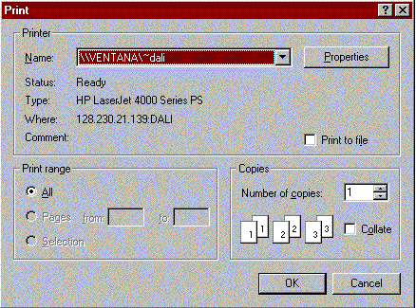
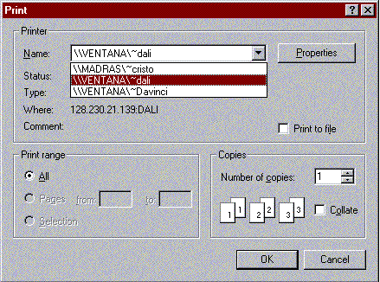

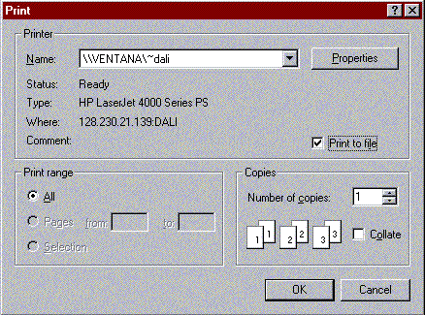

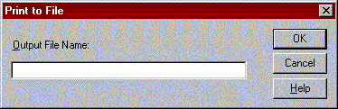

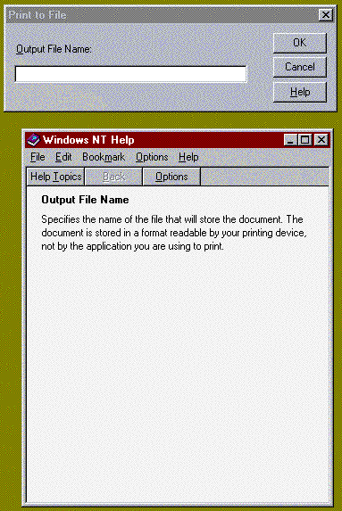
- Configure Editor:
- Recent Files:
- Exit

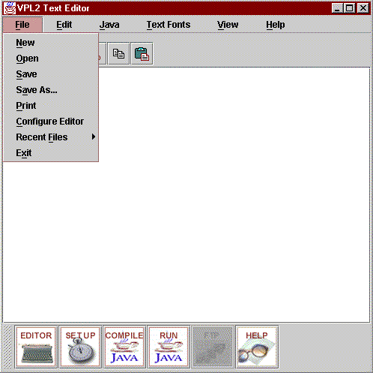

Edit Menu
- Undo:
- Cut:
- Copy:
- Paste:

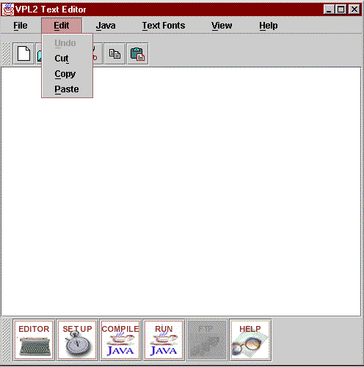

Java Menu
- Compile:
- Run:
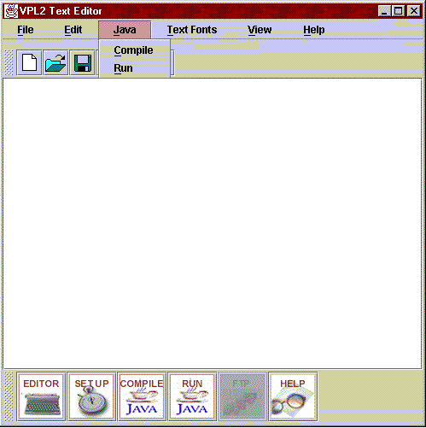

Font_Options Menu
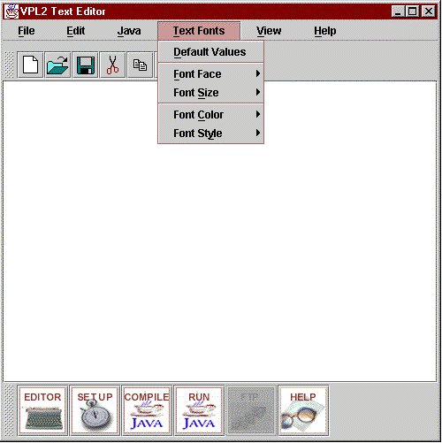

Font Options --> Font Style Menu
Setting text colors within the editor is done in two ways. Here we will concentrate on setting text color directly from the editor window, menus.
- On the Text Fonts menu, click Font Color.
- Select the color you want.
The color you set by using the Font Color command become the default color for the text in the current editor only.
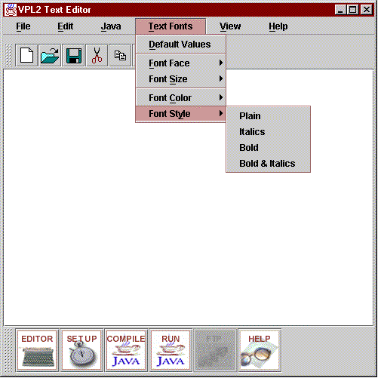

View Menu
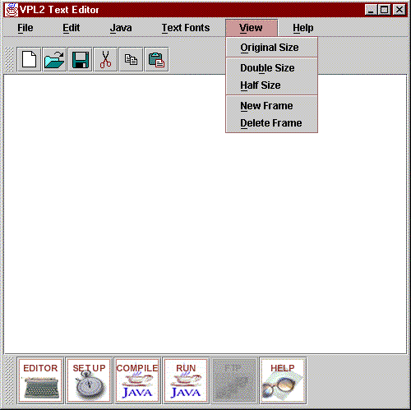

Help Menu

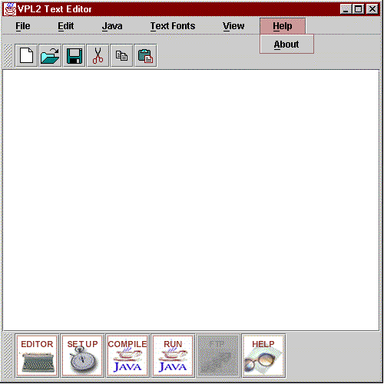

Recent Files Menu Vector empty.
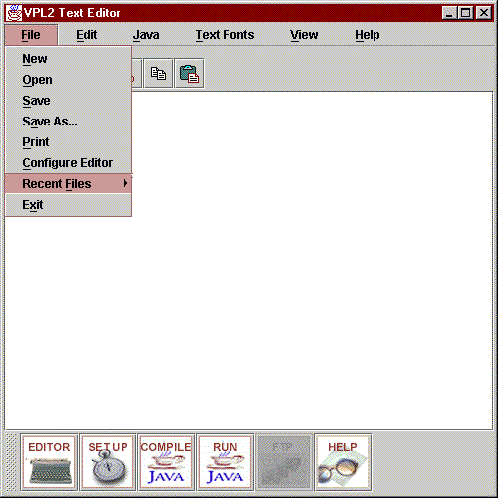

Recent Files Menu Vector filled.
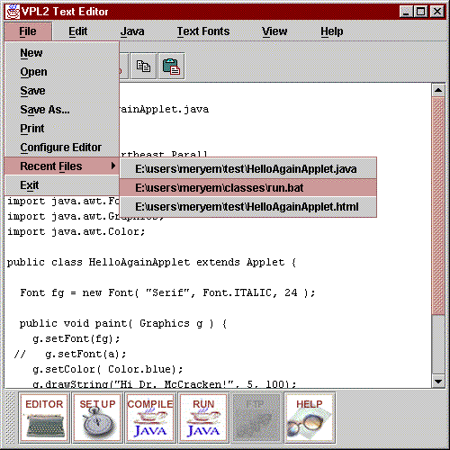

Configuration of External Applications

- Configuration:

- External Applications: External Applications allows you to set paths for web browser, appletviewer, java compiler and classpath

- Properties Set Up: Customizing the colors and fonts of your editor. You may set the background, foreground and caret color of your editor. You may set the font face, font type and font size of your editor.

- Help:

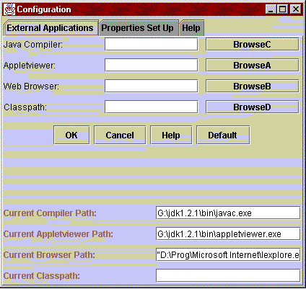

Using Default Values
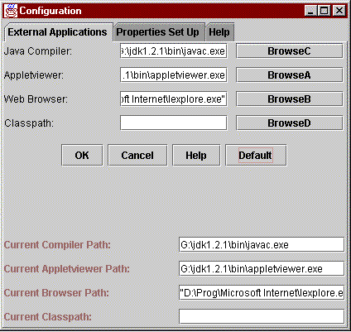

Setting paths, updating Default paths
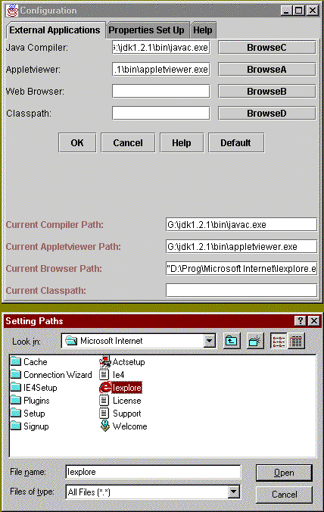

ToolTips
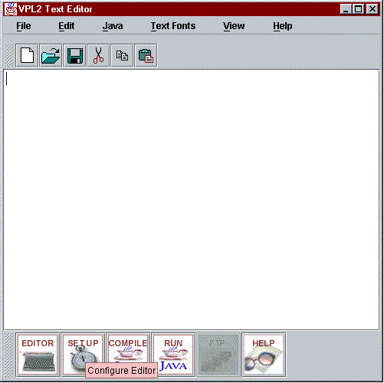

ToolTips
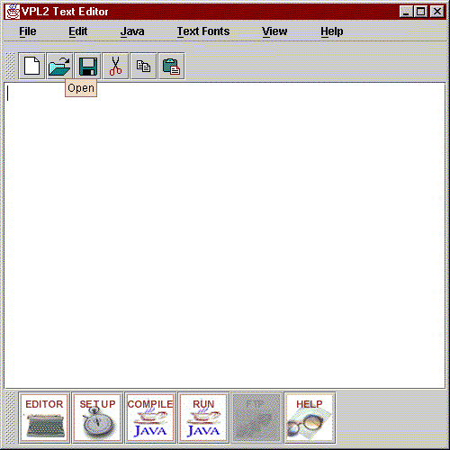

Help - About

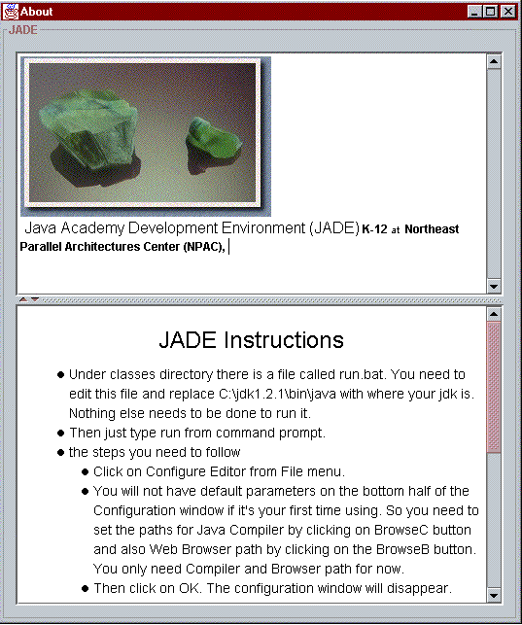

Properties Set Up

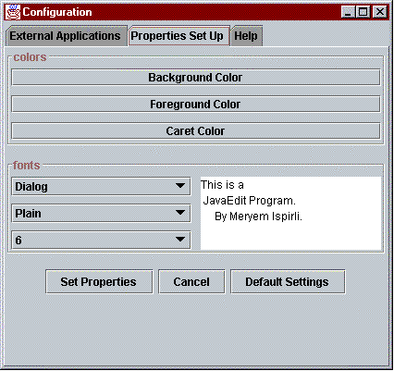

Colors: Background Color

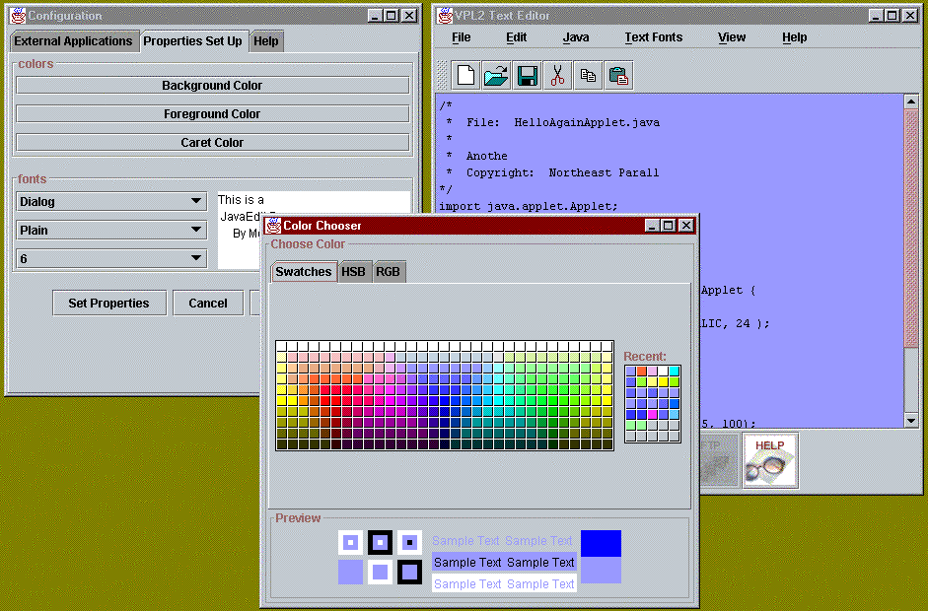

Colors: Foreground Color

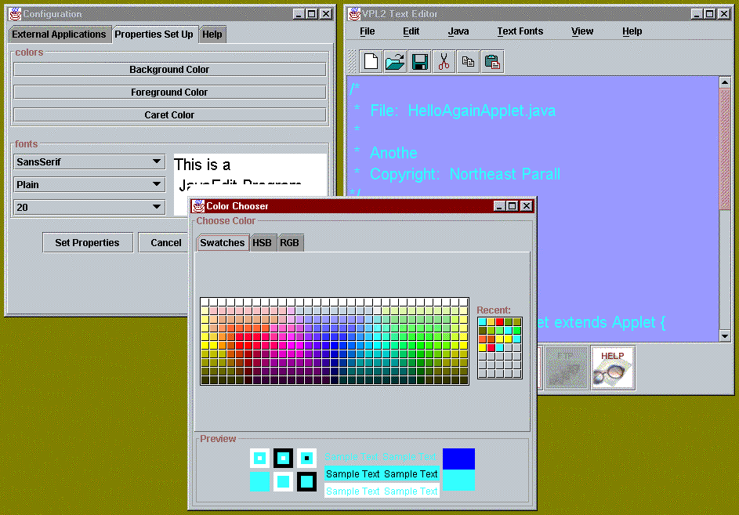

Color: Caret Color

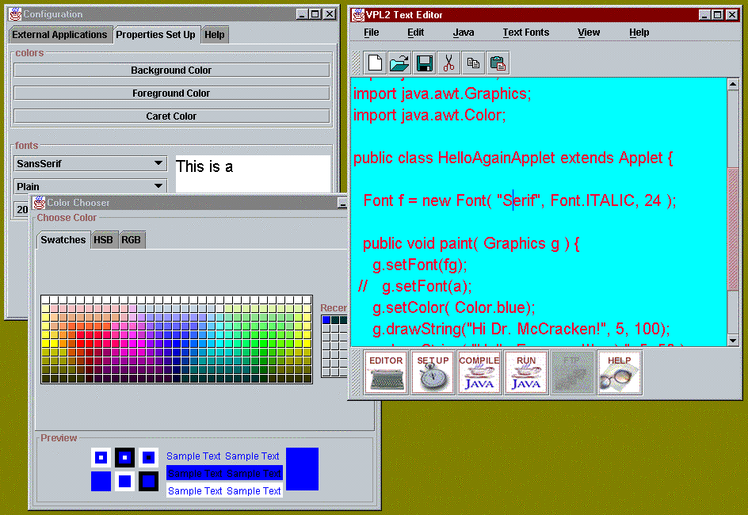

Compilation with errors
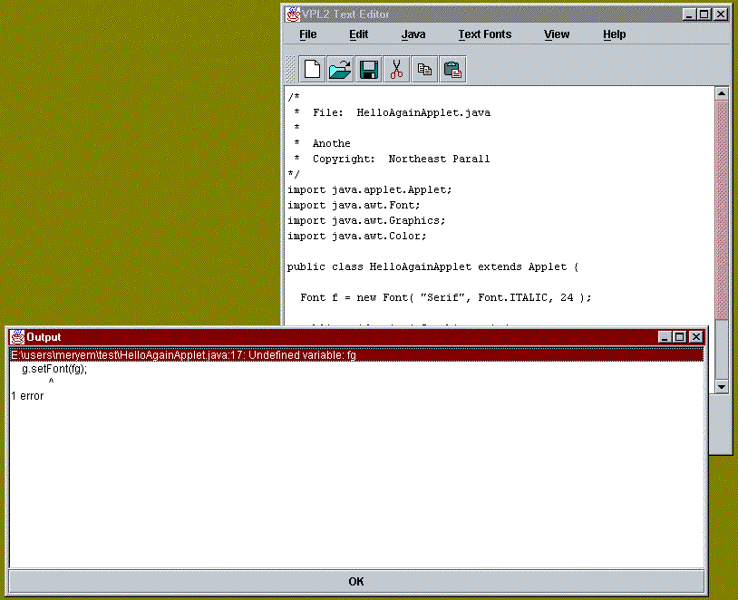

Compilation with no errors
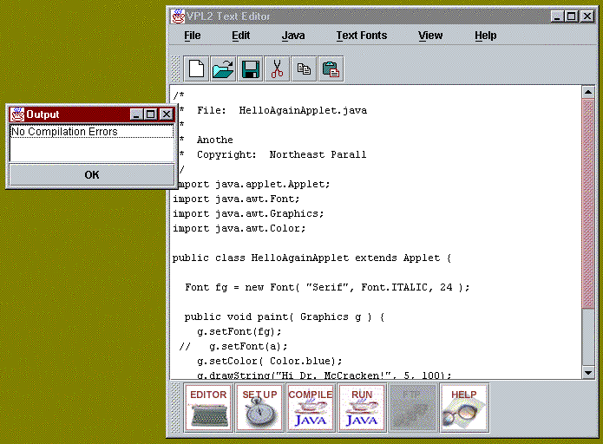

Run

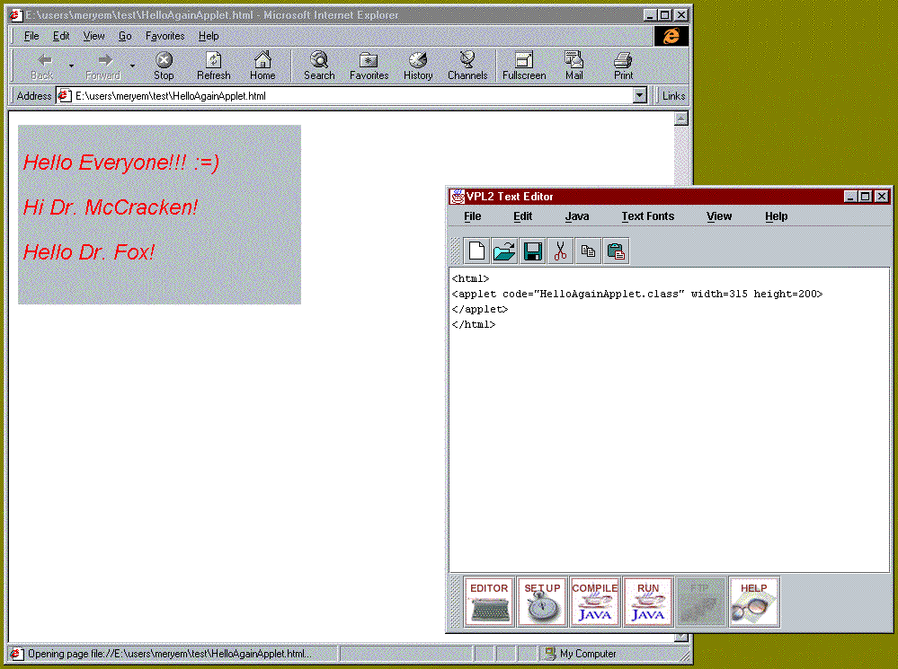

1 Overview

1.1 Structure of Document
The VPL Specifications document is divided into 3 primary sections. The first part is an introduction to the impetus behind the project and an overview of the project goals, the requirements and design assumptions.
1.2 Comments
This document is in draft. Comments should be directed to mispirli@npac.syr.edu. This documentation is available at file:/home/T11D/mispirli/MT/SPEC/index.html.
http://www.npac.syr.edu/users/gcf/meryem/JADE/

2 Introduction

2.1 Statement of Need
Virtual Programming Laboratory tool enables you to publish, write, compile and execute web applications composed of HTML, Java, JavaScript and CGI using a web interface. The user may create, edit, and execute files through the Web browser interface. We concentrate on accessing user space through the Web and the Web related system security issues. Once the user starts his/her own instance of the server, he/she does not need to be logged into a UNIX account or be worried with any Unix commands. Once they supply the required password, they are logged into their accounts and can use the facilities through the Web Interface.

3 Implementation

3.1 Interface

3.2 Server Component

3.2.1 Server Details
- VPLServer runs as the user and is started up by the user.
- Determines a free port - searches from port 2000 on osprey7 till port 4000.
- Generates an html page with this information (i.e. puts a parameter port with the corresponding available port id) and places this html page within the user htdoc space.
- It also generates an authentication string and writes it to the screen.

3.2.2 Use of VPL Server - Instructions
The way it all works is the following:
- Students log into their account on osprey7.npac.syr.edu.
- Students start their own instance of the VPLServer - so the VPLServer is running with the students UID/GID.
- At the moment the students start up the VPLServer, but in the future the students accounts could be configured so this happens automatically.
- VPLServer finds an un-used port for itself and starts listening.
- Then it generates the html page that, have applet references that point to the server at this port.
- This html page is put in the development web server on osprey7 under the student's space.
- Currently, the location is specified by a command line arguments userid which then places the html document under base_path_htdocs + userid. In future, this can be an environment variable that is set at the time of login.
- VPLServer generates a string and sends it to standard out. This string will be used as an authentication string. Currently, the user has only one chance in entering this string. However, before the string is processed we launch a flashy confirmation dialog box to make sure the user has a chance to re-check what is entered.
- Students then reloads the webpage that gives access to student's server.
- The applet then connects to the VPLServer running out of students account (recall that the port number are encoded in this dynamically generated html page).
- The applet puts up an authentication request
- The student enters in the authentication string generated by the VPLServer.
- The applet sends this string to the VPLServer and the VPLServer compares the incoming string to the one it generated.
If they are the same, it grants access and if they are not, it denies access.
- The student is now using the VPLServer to manipulate their own files.
3.2.3 Security Issues
- The string that is generated by the VPLServer is different each time.
- After a successfull connection all further connections are refused.
Both of these make it so that it does not matter whether the authentication string is passed in clear text as it can only be used once.
- If the wrong authentication string is received, the server terminates.
This even further prevents network sniffers from finding the password and using it to their advantage.
- When the applet disconnects from the VPLServer, the VPLServer automatically dies. To start another session the students must re-start the VPLServer.
Currently, from the applet we are sending a message to the VPLServer every 5 minutes saying "I'am alive" and once the user exits and the server stops receiving message, it is terminated.
4 Not sure what it is yet

4.1 HTML
The HyperText Markup Language (HTML) is a simple markup language used to create hypertext documents that are portable from one platform to another. HTML documents are SGML documents with generic semantics that are appropriate for representing information from a wide range of applications.
4.2 Forms
Forms provide a method for a Web viewer to send information back to the server of the HTML document. <form action="URL"> . . . </form>

4.3 CGI
CGI is the Common Gateway Interface and is the scheme to interface other programs and systems to the HTTP Web protocol, using the same data protocols as the HTTP clients and servers.
4.4 JavaScript
JavaScript (originally called LiveScript) is an interpreter for Web documents Client-side JavaScript facilitates rapid prototyping and is more responsive than CGI JavaScript is particularly useful for frameset documents and HTML forms.
JavaScript 1.0 debuted in NN 2.0 (Feb 96) JavaScript 1.1 appeared in NN 3.0 NN 4.0 (aka Communicator) supports JavaScript 1.2 MSIE 3.0 introduced JScript 2.0, a subset of JavaScript 1.1 JScript 3.0 is supported in MSIE 4.0 Both JavaScript 1.2 and JScript 3.0 are ECMA-compliant [ECMA Standard 262]
New features in JavaScript 1.2 (NN4.0):
- Event object and event capturing
- Ten new event handlers
- Nested functions; new Number() and String() functions
- New statements: switch and do...while
- Many new methods and properties (especially for Window, String, and Array objects)
- Perl4-compatible regular expressions
- Signed script security model
New features in JScript 3.0 (MSIE4.0):
- Conditional execution (meta-statements)
- New statements: switch and do...while
- Two new identity operators (=== and !==)
- Perl4-compatible regular expressions
- Debugger support
JScript documentation is scarce, however
Sun's Java is fast becoming a broad industry standard Java is well designed and documented Java is object-oriented with (single) inheritance JavaScript is primarily supported by Netscape JavaScript has neither of these qualities JavaScript is object-based with no class structure
Java applets are distinct from HTML Java is strongly typed with static (compile-time) binding Java bytecodes are interpreted (or "Just In Time" compiled) on the client JavaScript is tightly coupled with HTML JavaScript is loosely typed with dynamic (run-time) binding High-level JavaScript source code is interpreted on the client

4.5 Java

7 Difficulties in implementing the VPL1.0

7.1 File manipulations by main server
The ownership and file manipulations being executed by a main server was a security problem as the server had to run as root.
Several approaches were taken to go around this:
- Each student starts up their own instance of the VPLServer.

7.2 File dialog
Since our application was an applet, we were restricted due to security issues in accessing local files. Applets have additional restrictions such as they cannot read or write to the local computer's file system, except through the browser mechanism.
Several approaches were taken to go around this:
- Implementing our own file dialog. We implemented our own filedialog which was a very tedious work. Still the end result was not comparable with the filedialog provided with jdk. This resulted in looking for other options.
- Next, we looked into helper applications. We defined a vpl extension which would invoke appletviewer. When the html page (front-end) is generated by the server and put in the student's space the file name extension will be vpl. When the user points his/her browser to this location, appletviewer will be launched. Since our applet will run within an appletviewer, we have access to local computer's file system. When we tried to test this under PC environment, we were faced with problems. The only way to go around this was hardcoding the path to appletviewer. However, from PC to PC this would change and this resulted in this option being a failure.
- Next, we looked into Digital Signatures.
7.3 Unix, PC, Mac
The main difficulty we had was having one applet to work the same under Unix, PC and Mac environment. We should have from the beginning decided to have three versions. Our time was wasted by trying to solve one problem after another since we could never get it to work the same on all platforms.
8 VPL2.0

8.1 The New Approach
The main difference between VPL1.0 and VPL2.0 is VPL1.0 was an applet whereas VPL2.0 will be an application.
8.2 Technologies Used in VPL2.0
- JDK1.2beta3
- JFC/Swing Package

8.2.1 JDK1.2beta3
The Java Development Kit 1.2 contains new features and enhancements to the Java platform. Some of the new features include:
Core Platform
- Security Enhancements
- Swing (JFC)
- Java 2D (JFC)
- Accessibility (JFC)
- Drag & Drop (JFC)
- Application Services (JFC)
- Collections
- Extensions Framework
- JavaBeansTM Enhancements
- Input Method Framework
- Version Identification
- RMI Enhancements
- Serialization Enhancements
- Reference Objects, including weak references
- Audio Enhancements
- Java IDL
- Performance Enhancements
- JAR Enhancements
- JNI Enhancements
- Reflection Enhancements
- Java Virtual Machine Debugger Interface
- JDBC Enhancements
Standard Extensions
- Java Servlet API
Tools
- Javadoc Doclets
8.2.2 JFC/Swing Package
- Swing is a new set of GUI components with a "Pluggable Look and Feel" that are implemented in 100% Pure Java, and based on the JDK 1.1 Lightweight UI Framework.
- Pluggable Look and Feel lets you easily design a single set of GUI components that can automatically have the look and feel of any OS platform (Windows, Solaris, Macintosh).
- Swing Components include both 100% Pure Java versions of the 1.1 AWT component set, plus a rich set of higher level components. The complete set includes borders, buttons, checkboxes, combo boxes, icons, labels, lists, list boxes, menus, menubars, menu items, popup menus, radio buttons, progress bars, scroll panes & viewports, scrollbars, tabbed panes, tables, text areas, text components, text fields, trees and HTML viewers.
8.2.3 JFC/Swing Components Used in VPL
This section will give an overview of all the JFC/Swing Components used in VPL.

8.2.3.1 Progress Bars (JProgressBar)
Technically speaking, a JProgressBar displays an integer value within a bounded interval. Realistically speaking, you use a JProgressBar to display the progress of a long-running task. JProgressBar is for display purposes only. To allow the user to set a bounded integer value, use JSlider.
Shown below is a picture of how it is used within VPL.

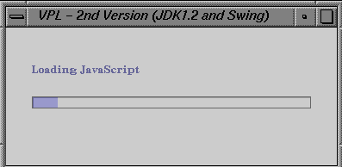
Below is the code from S_VPL.java that creates and sets up the progress bar

public class S_VPL extends JPanel {
...
public static int currentProgressValue;
public static JLabel progressLabel = null;
public static JProgressBar progressBar = null;
...

public S_VPL(java.applet.Applet anApplet) {
...
currentProgressValue = 0;
...
progressLabel.setText("Loading HTML");
progressBar.setValue(++currentProgressValue);
...
}

public static void main(String[] args) {
...
JPanel progressPanel = new JPanel() {
...
}
progressPanel.setLayout(new BoxLayout(progressPanel, BoxLayout.Y_AXIS));
frame.getContentPane().add(progressPanel, BorderLayout.CENTER);
...
S_VPL.progressBar = new JProgressBar();
S_VPL.progressBar.setAlignmentX(CENTER_ALIGNMENT);
S_VPL.progressBar.setMinimum(0);
S_VPL.progressBar.setMaximum(S_VPL.totalPanels);
S_VPL.progressBar.setValue(0);
S_VPL.progressBar.getAccessibleContext().setAccessibleName("S_VPL loading progress");
...
//add the progress bar to the windows progressPanel
progressPanel.add(S_VPL.progressBar);
...
}

...
}

8.2.3.2 Tabbed Panes (JTabbedPane)
With the JTabbedPane class, you can have several components (usually JPanel objects) share the same space. The user can choose which component to view by selecting the tab corresponding to the desired component. If you want similar functionality without the tab interface, you might want to use the CardLayout layout manager instead of JTabbedPane.
To create a tabbed pane, you simply instantiate JTabbedPane, create the components you wish it to display, and then add the components to the tabbed pane using the addTab method.
Shown below is a picture of how it is used within VPL.

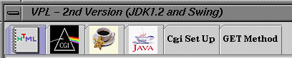
Below is the code from S_VPL.java that creates and sets up the tabbed panel

public class S_VPL extends JPanel {
...
public JTabbedPane tabbedPane;
public ImageIcon cgiImg;
public JPanel cgiPanel;
public JPanel cgiSetUpPanel;
...

public S_VPL(java.applet.Applet anApplet) {
...
// Create a tab pane
tabbedPane = new JTabbedPane();

// Add magic key to enable timer logging
tabbedPane.registerKeyboardAction(new ToggleLogging(), KeyStroke.getKeyStroke('l', InputEvent.ALT_MASK), WHEN_IN_FOCUSED_WINDOW);

// Add the tab to the center
add(tabbedPane, BorderLayout.CENTER);
...
cgiPanel = new CGIPanel(this);
tabbedPane.addTab(null , cgiImg, cgiPanel);
cgiSetUpPanel = new InternalWindowPanel();
tabbedPane.addTab("Cgi Set Up", null, cgiSetUpPanel);
...
}

** Image loading **/
void loadImages() {
...
cgiImg = loadImageIcon("images/cgi.gif", "The CGI symbol");
...
}

...
}

8.2.3.3 Dialog (JDialog)
Swing provides support for dialogs -- windows that are dependent on other windows -- with the JOptionPane<PICTURE: documentation) reference API the (in and JDialog<PICTURE: documentation) reference API the (in classes.
If you're writing a modal dialog -- one that blocks the application's UI until the dialog's dismissed -- you should generally use JOptionPane. JOptionPane provides templates that let you easily create the most common kinds of modal dialogs. JOptionPane's facilities, such as layout support and access to the look-and-feel's standard icons, can also be useful when you create a custom modal dialog. If you're creating a non-modal dialog or a custom dialog that doesn't need any support from JOptionPane, you can use the JDialog class instead.
Shown below is a picture of how it is used within VPL.

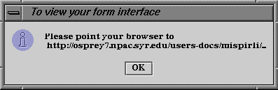
Below is the code from S_VPL.java that creates and sets up the dialog box, specifically informational dialog box.

class Notepad extends JPanel implements UndoableEditListener {
...

class ViewFormInterfaceAction extends NewAction {
ViewDialog viewDialog;
//JFrame frame;
Frame frame;
...
public void actionPerformed(ActionEvent e) {
frame = getFrame();
viewDialog = new ViewDialog(frame);
}
}

class ViewDialog extends JPanel {
JLabel label;
ImageIcon icon = new ImageIcon("metal-Inform.gif");

public ViewDialog(Frame frame) {
frame = frame;

Border padding = BorderFactory.createEmptyBorder(20,20,5,20);
JOptionPane.showMessageDialog(null, "Please point your browser to \n http://osprey7.npac.syr.edu/users-docs/mispirli/...", "To view your form interface", JOptionPane.INFORMATION_MESSAGE);
}
}

...
}

8.2.3.4 Tool Bars (JToolBar)
A tool bar starts out as a row of buttons, generally at the top or bottom of its container. [PENDING: check whether it should be a column when it starts out on the left/right; currently, it isn't] By default, the user can drag the tool bar to a different edge of its container or out into a window of its own. Tool bars are implemented by the JToolBar class.
Shown below is a picture of how it is used within VPL.



Below is the code from Notepad.java that creates and sets up the tool bar.

class Notepad extends JPanel implements UndoableEditListener {
...
JPanel panel = new JPanel();
...

Notepad() {
...
panel.setLayout(new BorderLayout());
panel.add("North",createToolbar());
...
}

/**
* Create the toolbar. By default this reads the
* resource file for the definition of the toolbar.
*/
private Component createToolbar() {
toolbar = new JToolBar();
String[] toolKeys = tokenize(getResourceString("toolbar"));
for (int i = 0; i < toolKeys.length; i++) {
if (toolKeys[i].equals("-")) {
toolbar.add(Box.createHorizontalStrut(5));
} else {
toolbar.add(createTool(toolKeys[i]));
}
}
toolbar.add(Box.createHorizontalGlue());
...
return toolbar;
}

...
}

Notepad properties text file (Notepad.properties)
# @(#)VPL_Editor.properties 1.2 98/05/22
#

Title=VPLEditor
ViewportBackingStore=false

# menubar definition
#
# Each of the strings that follow form a key to be
# used to the actual menu definition.
menubar=file edit

# file Menu definition
#
# Each of the strings that follow form a key to be
# used as the basis of a menu item definition.
#
# open -> Notepad.openAction
# new -> Notepad.newAction
# save -> Notepad.saveAction
# saveAs -> Notepad.saveAsAction
# exit -> Notepad.exitAction

file=new open save saveAs viewFormInterface - exit
fileLabel=File
openLabel=Open
openImage=images/open.gif
newLabel=New
newImage=images/new.gif
saveLabel=Save
saveImage=images/save.gif
saveAsLabel=Save As...
saveAsImage=images/save.gif
viewFormInterfaceImage=images/view_s.gif
viewFormInterfaceLabel=View Form Interface
exitLabel=Exit

# edit Menu definition
#
# cut -> JTextComponent.cutAction
# copy -> JTextComponent.copyAction
# paste -> JTextComponent.pasteAction
edit=cut copy paste - undo redo
editLabel=Edit
cutLabel=Cut
cutAction=cut-to-clipboard
cutImage=images/cut.gif
copyLabel=Copy
copyAction=copy-to-clipboard
copyImage=images/copy.gif
pasteLabel=Paste
pasteAction=paste-from-clipboard
pasteImage=images/paste.gif
undoLabel=Undo
undoAction=Undo
redoLabel=Redo
redoAction=Redo

# toolbar definition
#
# Each of the strings that follow form a key to be
# used as the basis of the tool definition. Actions
# are of course sharable, and in this case are shared
# with the menu items.
toolbar=new open save saveAs - cut copy paste viewFormInterface
newTooltip=Create a new file
openTooltip=Open a file
saveTooltip=Save to a file
saveAsTooltip=Save as to a file
viewFormInterface=view form interface
cutTooltip=Move selection to clipboard
copyTooltip=Copy selection to clipboard
pasteTooltip=Paste clipboard to selection

8.2.3.5 Tool Tips (JToolTip)
Creating a tool tip for any JComponent is easy. You just use the setToolTipText method to set up a tool tip for the component. When the user of the program pauses with the cursor over any of the program's component that have a tool tip set up, the tool tip for the component will come up.
Shown below is a picture of how it is used within VPL.

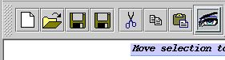

Below is the code from Notepad.java that creates and sets up the tool tips on the toolbar.

class Notepad extends JPanel implements UndoableEditListener {
...

protected JButton createToolbarButton(String key) {
...

String tip = getResourceString(key + tipSuffix);
if (tip != null) {
b.setToolTipText(tip);
}
...
}

...
}

Notepad properties text file (Notepad.properties)
# @(#)VPL_Editor.properties 1.2 98/05/22

...

# toolbar definition
#
# Each of the strings that follow form a key to be
# used as the basis of the tool definition. Actions
# are of course sharable, and in this case are shared
# with the menu items.
toolbar=new open save saveAs - cut copy paste viewFormInterface
newTooltip=Create a new file
openTooltip=Open a file
saveTooltip=Save to a file
saveAsTooltip=Save as to a file
viewFormInterface=view form interface
cutTooltip=Move selection to clipboard
copyTooltip=Copy selection to clipboard
pasteTooltip=Paste clipboard to selection

8.2.3.6 Editor Pane (JEditorPane)
A text pane to edit various kinds of content, such as html and rtf. This component uses implementations of the EditorKit to accomplish its behavior. It effectively morphs into the proper kind of text editor for the kind of content it is given.
The content type that editor is bound to at any given time is determined by the EditorKit currently installed. If the content is set to a new URL, its type is used to determine the EditorKit that should be used to load the content.
Shown below is a picture of how it is used within VPL.

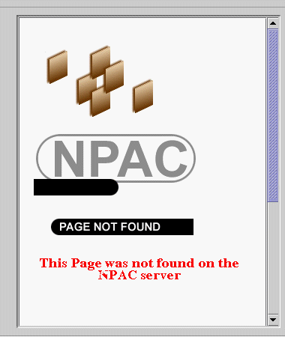
Below is the code from HtmlPanel.java that creates and sets up the html editor pane.

public class HtmlPanel extends JPanel implements HyperlinkListener {
...
JEditorPane html;
...

public HtmlPanel(Notepad notepad) {
...

try {
URL url = new URL(notepad.javaDocPath + "/docs/packages.html");
html = new JEditorPane(url);
...
JViewport vp = scroller.getViewport();
vp.add(html);
...
}
}

...
}

8.2.3.7 Split Panes (JSplitPane)
Shown below is a picture of how it is used within VPL.
Below is the code from S_VPL.java that creates and sets up the

8.2.3.8 Scroll Panes (JScrollPane)
Shown below is a picture of how it is used within VPL.
Below is the code from S_VPL.java that creates and sets up the

8.2.3.9
Shown below is a picture of how it is used within VPL.
Below is the code from S_VPL.java that creates and sets up the

8.2.3.10
Shown below is a picture of how it is used within VPL.
Below is the code from S_VPL.java that creates and sets up the

8.2.3.11
Shown below is a picture of how it is used within VPL.
Below is the code from S_VPL.java that creates and sets up the

8.2.3.12
Shown below is a picture of how it is used within VPL.
Below is the code from S_VPL.java that creates and sets up the

8.2.3.13
Shown below is a picture of how it is used within VPL.
Below is the code from S_VPL.java that creates and sets up the

8.2.3.14
Shown below is a picture of how it is used within VPL.
Below is the code from S_VPL.java that creates and sets up the

8.2.3.15
Shown below is a picture of how it is used within VPL.
Below is the code from S_VPL.java that creates and sets up the

9 Glossary
- Applets - An application interface where referencing (perhaps by a mouse click) a remote application as a hyperlink to a server causes it to be downloaded and run on the client.
- Common Gateway Interface (CGI) - CGI is the Common Gateway Interface and is the scheme to interface other programs and systems to the HTTP Web protocol, using the same data protocols as the HTTP clients and servers.
- Clients -
- Databases - SQL, JDBC, 2-Tier & 3-Tier Models.....
- Digital ID - Netscape's Digital Signature......
- Forms - Forms provide a method for a Web viewer to send information back to the server of the HTML document.
The FORM element allows you to create a fill-out form: the user reading the HTML document will see the FORM elements as user input elements -- he or she can then type information into the fields or select from buttons and pull-down menus to input their data. WHen the user submits the FORM, the data are encoded and transmitted to a server, where it must be interpreted and processed by a program.
- HyperText Markup Language (HTML) - HTML stands for HyperText Markup Language. It is defined using SGML (Standard Generalized Markup Language) and provides tags to identify document structure for later formatting and links to other documents.
- HyperText Transport Protocol (HTTP) - A stateless transport protocol allowing control information and data to be transmitted between web clients and servers.
- Internet - A complex set of interlinked national and global networks using the IP messaging protocol, and transferring data, electronic mail, and World Wide Web.
- Java - An object-oriented interpreted programming language frum Sun, suitable for Web development due to the built-in portable support for mobility, networking, multithreading and GUI.
- Java JDK (Java Development Kit) - Java Development Kit, including Java API for the language foundation classes and the base software development tools such as Java compiler or native class interface generator.
- JavaScript - JavaScript (originally called LiveScript) is an interpreter for Web documents. Java-like but typeless and truly interpreted scripted language developed by Netscape and used for dynamic HTML programming both at the client (Navigator) and server (LiverWire) sides
- Java Database Connection (JDBC) - A set of interfaces (Java methods and constants) in the Java 1.1 enterprise framework, defining a uniform access to relational databases. JDBC calls from a client or server Java program link to a particular "driver" that converts these universal database access calls (establish a connection, SQL query, etc.) to particular syntax needed to access essentially any significant database.
- MIME (Multipurpose Internet Mail Extension) - The format used in sending multimedia messages between Web Clients and Servers that is borrowed from that defined for electronic mail.
- Perl - PERL is an interpreter (written by Larry Wall) and is a cross between C, the UNIX shell, sed, and awk. I certainly consider it easier to use than all four of these, since PERL produces clearer code (than especially the UNIX Shell) which is easier to write and debug.
- Servers - This is usually a program which listens to a specific port, and accepts (processes) invocations from objects at remote locations.
- Socket - Tool for network communications, specifies end-points of a communication. Sockets identify the origin and destination of messages.
- SQL - Structured Query Language. The language most commonly used to create database queries.
- Swing - Swing is the part of the Java Foundation Classes (JFC) that implements a new set of GUI components with a pluggable look and feel. Swing is implemented in 100% Pure Java, and is based on the JDK 1.1 Lightweight UI Framework. The pluggable look and feel lets you design a single set of GUI components that can automatically have the look and feel of any OS platform (Windows, Solaris, Macintosh). Swing components include both 100% Pure Java versions of the existing AWT component set (Button, Scrollbar, Label, etc.), plus a rich set of higher-level components (such as tree view, list box, and tabbed panes).
- URL - A URL is a Uniform Resource Locator. Think of it as a networked extension of the standard filename concept: not only can you point to a file in a directory, but that file and that directory can exist on any machine on the network, can be served via any of several different methods, and might not even be something as simple as a file: URLs can also point to queries, documents stored deep within databases, the results of a finger or archie command, or whatever.
- Virtual Reality Modeling Language (VRML1) - A standard network protocol for 3D scene description based on a subset of the ASCII Open Inventor format.
- Virtual Reality Modeling Language (VRML2) - Extends VRML 1.0 towards interactive 3D worlds by adding Sensor nodes that detect user events, routes that connect user events with the scene graph nodes, and Script nodes that describe interactive behavior of the scene graph objects using a scripting language such as Java, JavaScript, Tcl etc.
- Virtual Programming Laboratory (VPL) - Virtual Programming Laboratory (VPL) is an environment that enables one to publish, write, compile and execute web applications composed of HTML, Java, JavaScript and CGI using a web interface.
- Web Clients - Originally Web Clients displayed HTML and related pages but now they support Java Applets that can be programmed to give web clients the necessary capabilities to support general enterprise computing. The support of signed applets in recent browsers has removed crude security restrictions, which handicapped previous use of applets.
- Web Servers - Originally Web Servers supported HTTP requests for information - basically HTML pages but included the invocation of general server side programs using the very simple but arcane CGI - Common Gateway Interface. A new generation of Java servers have enhanced capabilities including server side Java program enhancements (Servlets) and support of stateful permanent communication channels.
- File - n. A complete, named collection of information, such as a program, a set of data used by a program, or a user-created document. A file is the basic unit of storage that enables a computer to distinguish one set of information from another. A file is the "glue" that binds a conglomeration of instructions, numbers, words, or images into a coherent unit that a user can retrieve, change, delete, save, or send to an output device.
- Font - n. A set of characters of the same typeface (such as Garamond), style (such as italic), and weight (such as bold). A font consists of all the characters available in a particular style and weight for a particular design; a typeface consists of the design itself. Fonts are used by computers for on-screen displays and by printers for hard-copy output. In both cases, the fonts are stored either as bit maps (patterns of dots) or as outlines (defined by a set of mathematical formulas). Even if the system cannot simulate different typefaces on the screen, application programs may be able to send information about typeface and style to a printer, which can then reproduce the font if a font description is available. See also bit map, font generator.
- Foreground¹ - adj. Currently having control of the system and responding to commands issued by the user. See also multitasking. Compare background¹.
- Foreground² - n. 1. The color of displayed characters and graphics. Compare background² (definition 1). 2. The condition of the program or document currently in control and affected by commands and data entry in a windowing environment. Compare background² (definition 4).
- Front-End - n. In applications, software or a feature of software that provides an interface to another application or tool. Front ends are often used to supply a common interface for a range of tools produced by a software manufacturer. A front end generally offers a more user-friendly interface than that of the application running "behind" it.
- FTP¹ - n. 1. Acronym for File Transfer Protocol, the protocol used for copying files to and from remote computer systems on a network using TCP/IP, such as the Internet. This protocol also allows users to use FTP commands to work with files, such as listing files and directories on the remote system. See also TCP/IP. 2. A common logon ID for anonymous FTP.
- FTP² - vb. To download files from or upload files to remote computer systems, via the Internet's File Transfer Protocol. The user needs an FTP client to transfer files to and from the remote system, which must have an FTP server. Generally, the user also needs to establish an account on the remote system to FTP files, although many FTP sites permit the use of anonymous FTP. See also FTP client, FTP server.
- FTP client - or ftp client n. A program that enables the user to upload and download files to and from an FTP site over a network, such as the Internet, using the File Transfer Protocol. See also FTP¹ (definition 1). Compare FTP server.
- FTP commands - n. Commands that are part of the File Transfer Protocol. See also FTP¹ (definition 1).
- FTP server - n. A file server that uses the File Transfer Protocol to permit users to upload or download files through the Internet or any other TCP/IP network. See also file server, FTP¹ (definition 1), TCP/IP. Compare FTP client.
- Caret - n. The small, upward-pointing symbol (^) typically found over the 6 key on the top row of a microcomputer keyboard. In some programming languages, the caret is used as an exponentiation operator. For example, the expression 3 ^ 2 represents the number 3 raised to the second power. The caret is also used to represent the Control key on the keyboard. For example, ^Z means "hold the Control key down and press the Z key."

