- Description of Laplace Applet
http://www.npac.syr.edu/users/gcf/cps615laplace97/foilsepimagedir/002IMAGE.html#buttons

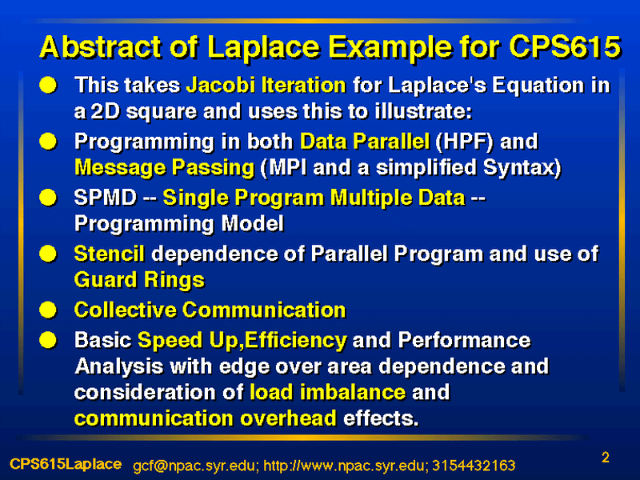
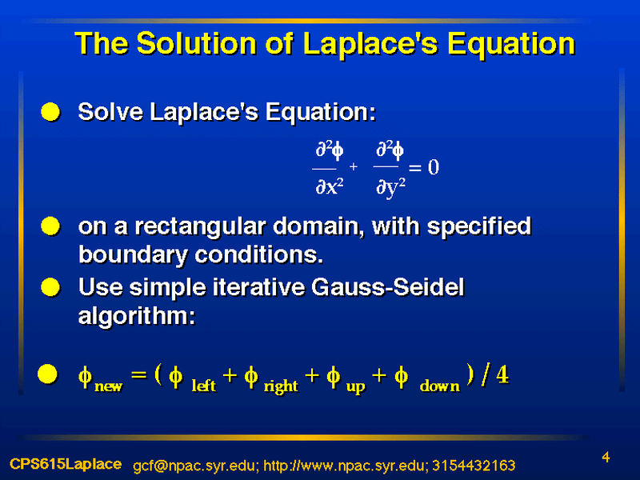
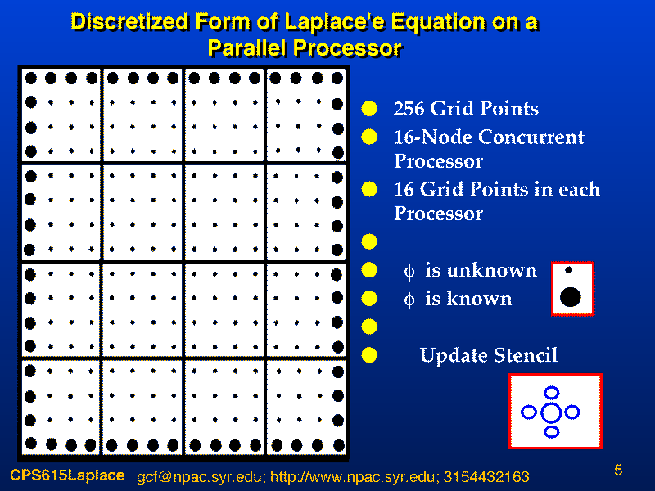
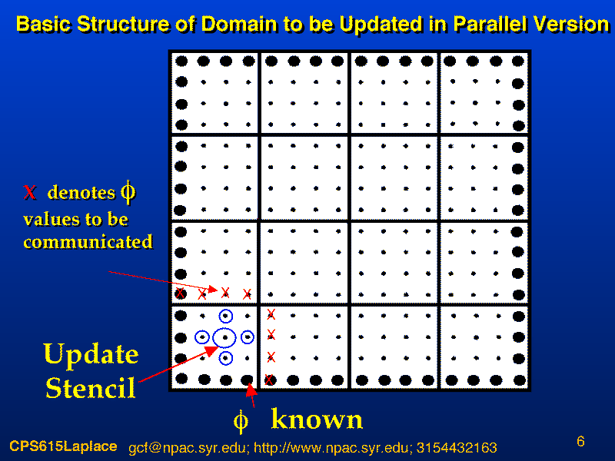
- Control and Usage

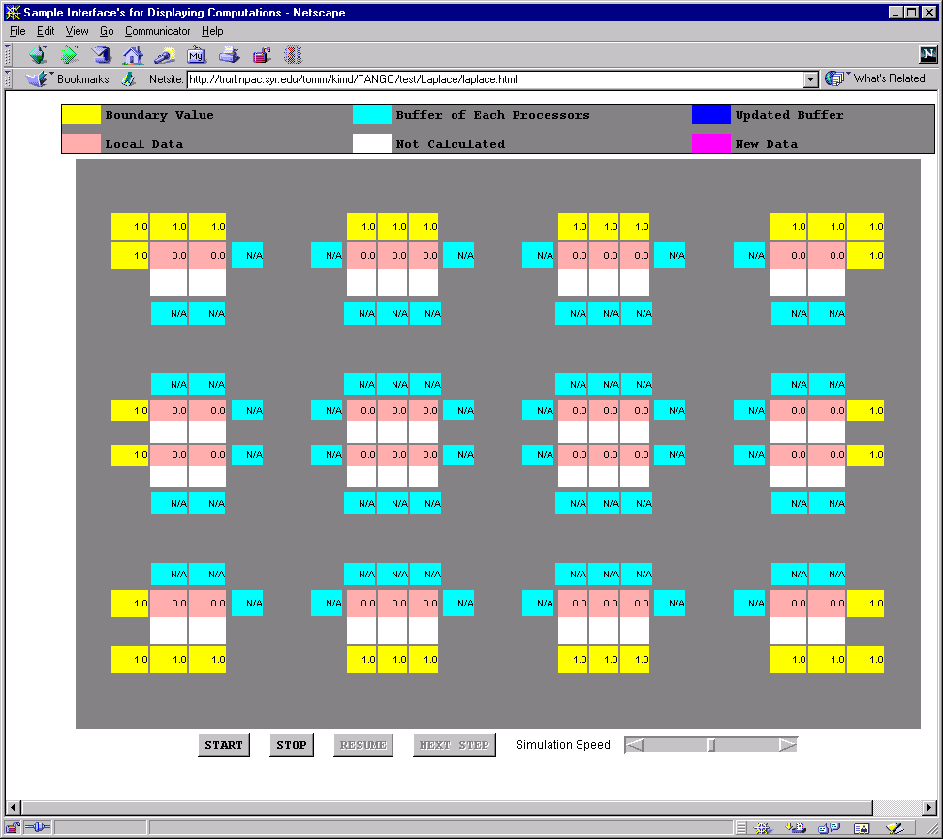

- START : start the simulation
- STOP : stop the simulation until RESUME button is pressed
- RESUME : resume the simulation
- NEXT STEP : simulate to the next step and stop
- Simulation Speed : change the simulation speed

- Description of Laplace Applet

  - The meaning of Boxes
- Yellow Box : represents the boundary values of Laplace equation.
- Cyan Box : represents the buffer values which are edge values of the processor’s neighbor.
- Blue Box : represents that the buffer is updated (received from its neighbor).
- Pink Box : represents the current matrix values that each processor has.
- White Box : represents that the value is not updated yet.
- Red Box : represents the new matrix values using Pink Box values.

  - Laplace Applet
    - Computation
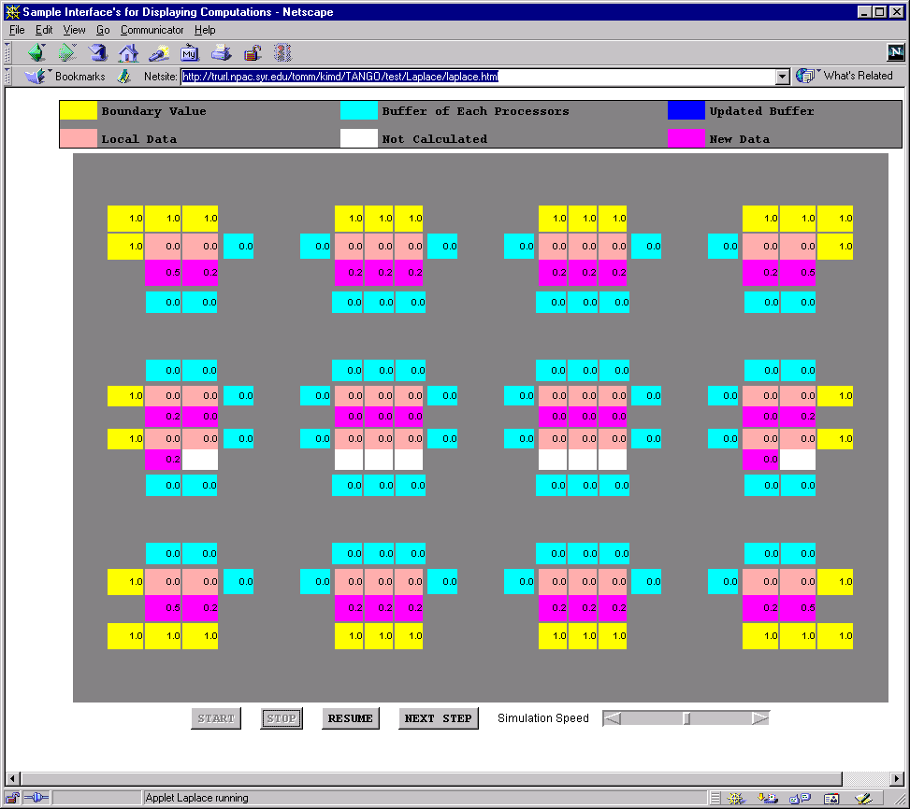

- Each processor computes new values using old values.
- The color of new calculated values is changed from white to red.

    - Sending Data
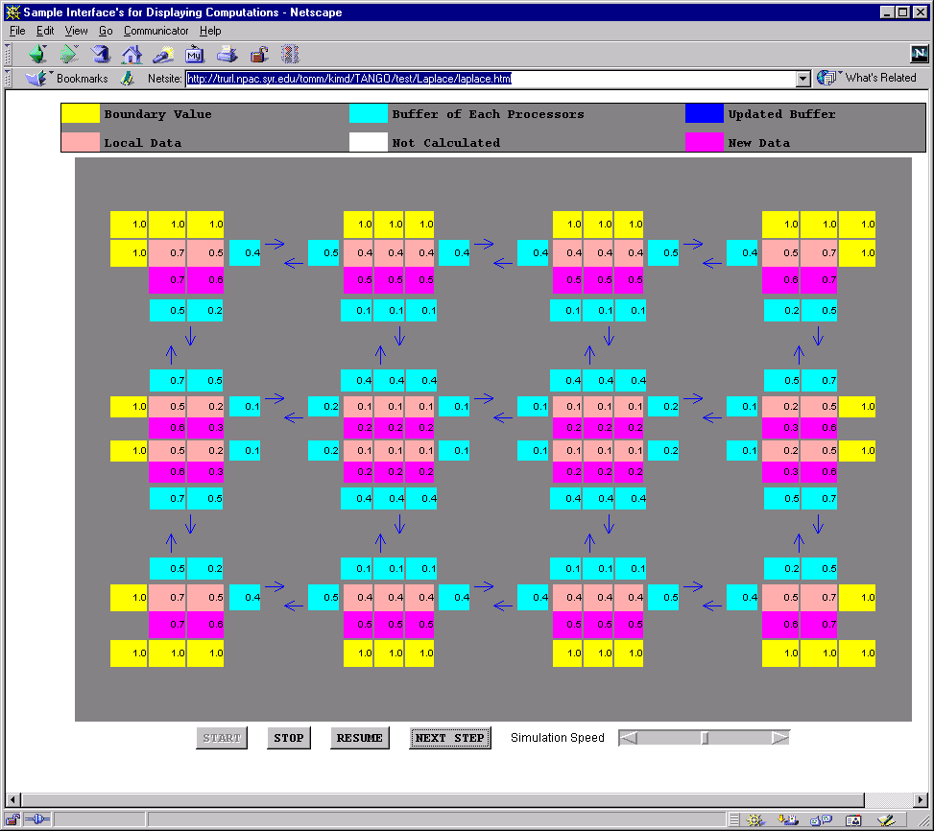

- After the computation is done, each processor send its edge values to its neighbors.
- The arrow represents the sending of data.

    - Receiving Data
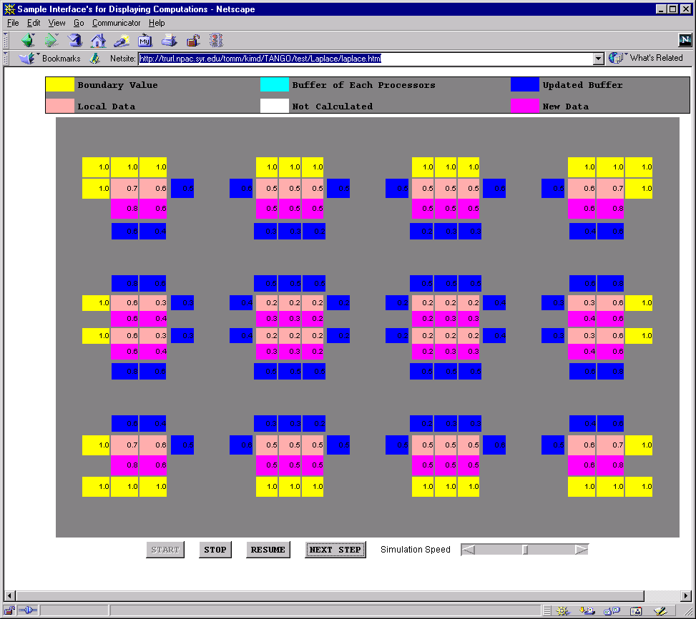

- The data receiving is represented by changing color (cyan to blue).

    - Next Computation
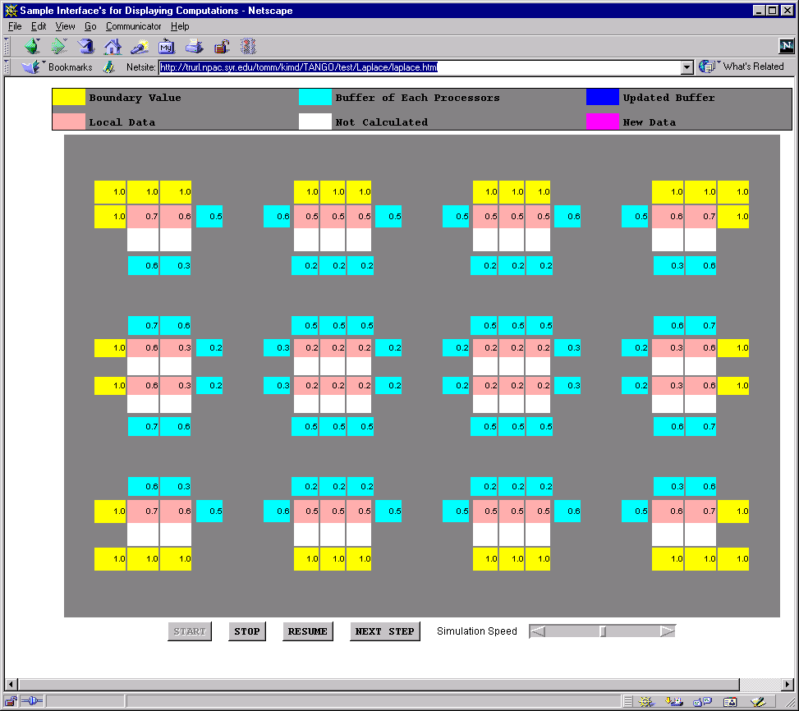

- After receiving the data, each processor is ready to compute.

