January 06, 2000

Yuping Zhu
338 Jamesville Ave. Apt. 3M
Syracuse, NY 13210

Dear Yuping:

We appreciated the opportunity to discuss our vision for MicroStrategy and how your experience and expertise will be beneficial to our organization as we continue to grow. It is clear that you have the skills, technical insight, and the motivation to become a valued, contributing member of the MicroStrategy team. I am therefore pleased to extend to you an offer to join MicroStrategy in the position of Senior Solutions Consultant. Following are the details of our offer, which we trust you will treat with confidentiality.

Your starting salary will be at a bi-monthly rate of $2,833.33, annualized at $68,000, and you will be eligible for an annual performance-based bonus of up to $8,000.00. Our performance reviews occur annually. Your first formal review will take place in the first review period prior to the anniversary of your hire date and future reviews will take place every 12 months thereafter.

MicroStrategy requires all employees to sign an agreement covering intellectual property rights, confidential information, conflicts of interest, and non-solicitation. This offer of employment is contingent upon your signing the MicroStrategy Agreement, which will be provided to you on the first day of your employment. All potential employees must also provide proof of eligibility to work in the United States. Additionally, employment is contingent upon successful completion of MicroStrategy’s training program will be scheduled upon acceptance of this offer. The company provides a full range of benefits, which currently includes medical insurance, life insurance, and short and long-term disability insurance, dependent care spending accounts, a 401(k) plan, and an Employee Stock Purchase Plan.

As part of your compensation, we are pleased to offer you the option to purchase 1,500 Shares (on a post split basis) of Class A Common Stock in MicroStrategy, Incorporated. Your option price will be based on the closing price of our stock as quoted on NASDAQ on the last market trading day prior to your date of hire. These incentive stock options vest over 5 years, 20% per year on the anniversary of your vesting commencement date. Vesting commences at the end of the quarter after date of hire, with the first 20% being vested 12 months thereafter. These options will be granted under and subject to the MicroStrategy Incorporated 1999 Stock Option Plan. Our Human Resources department will provide you with additional information regarding your stock options approximately 60 days after your grant price has been determined. In all, your potential first year compensation comes to $76,000.00 plus these stock options.

Yuping, given our environment and your skills, we feel that you have the intelligence, energy, and commitment to succeed at MicroStrategy, and we look forward to you joining us as soon as possible. You must respond to our offer by signing a copy of this acceptance letter and faxing it to our recruiter Sandy Pawlowski at 703-714-1060 or by contacting her directly at 703-873-1154. It is important that we receive your letter prior to January 31, 2000. If you have any questions, please don’t hesitate to call me.

Congratulations! Together, we can build the world's finest eBusiness Intelligence Company.

Sincerely,
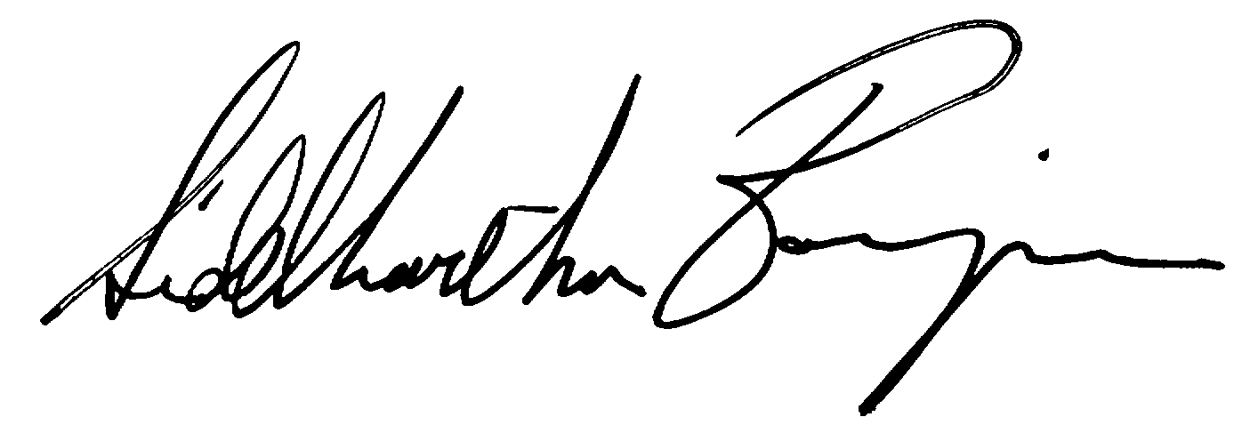

Sid Banerjee
Corporate Vice President
Consulting Services

