Homework 1
CIS 321 Fall 1999
Tuesday, September 14

Problem 1.
Plot an appropriate stem-and-leaf display for the melting points of biphenyl given below
and comment on the results. Discuss any interesting features. If possible, propose reasons
for these features. Also construct a boxplot and comment on your results. Discuss any
interesting features. What insights does the boxplot cover above the stem-and-leaf display?

The National Bureau of Standards tests 14 samples of biphenyl measured on a differential
calorimeter calibrated with two standards in order to establish this substance's melting point
in o C. Here are the data:
343.0 342.4 343.4 343.1 343.3 343.7 343.5
343.1 343.3 343.4 343.8 343.3 343.3 343.3

Answer
****** Minitab ******
Worksheet size: 100000 cells

Character Stem-and-Leaf Display

Stem-and-leaf of C1 N = 14

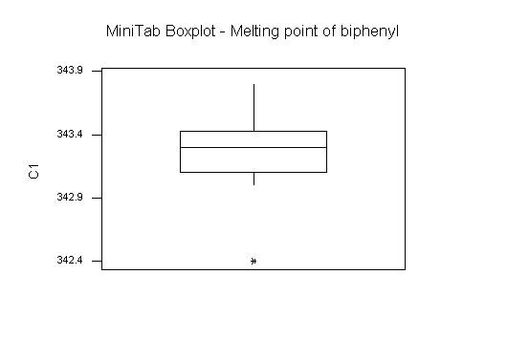
Leaf Unit = 0.10

1 342 4
1 342
1 342
4 343 011
(5) 343 33333
5 343 445
2 343 7
1 343 8

From stem-and-leaf plot, it is observed that the frequency of melting points of biphenyl is highly concentrated around 343.3. There are three outliers. Among them, 342.4 is likely due to erroneous measurement while 343.7 and 343.8 could be either due to statistical fluctuation or erroneous measurement. Remove the largest point 343.8 and the smallest point 342.4, the mean of the data set is 343.3. So, the melting points of biphenyl is approximately 343.3.

From boxplot, it is observed that the first quartile, third quartile and the median value are 343.1, 343.4 and 343.3 respectively. Compared with stem-and-leaf plot, boxplot is a effective graphical portray for comparisons among observation sets. It is easy to understand and have a high visual impact.

Problem 2.
These are the outside diameters (in inches) of the barrels of a popular felt-tip marker:
0.379 0.376 0.379 0.379 0.378
0.378 0.377 0.378 0.377 0.379
0.378 0.377 0.377 0.379 0.378
0.377 0.377 0.378 0.379 0.378
0.379 0.380 0.379 0.378 0.379
0.380 0.378 0.379 0.379 0.379
0.379 0.380 0.380 0.381 0.379
Plot an appropriate stem-and-leaf display and comment on your results. Discuss any interesting
features. If possible, propose reasons for these features.

Answer
****** Minitab ******
Worksheet size: 100000 cells

Character Stem-and-Leaf Display

Stem-and-leaf of C1 N = 35
Leaf Unit = 0.00010

1 376 0
7 377 000000
16 378 000000000
(14) 379 00000000000000
5 380 0000
1 381 0
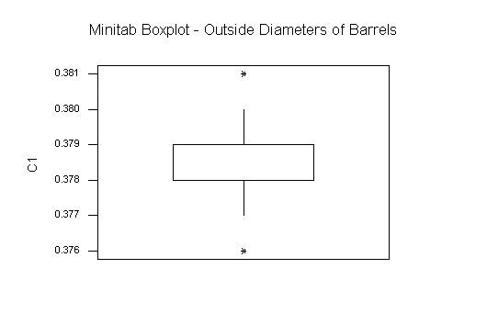
From the stem-and-leaf plot, it is observed that this data set shows a typical statistical distribution. There isn’t any outliers, as the largest point and the smallest point could be a real reflection of the distribution of diameters of barrels. Remove the two end points, the mean of the data set is 0.379.

