GIS Service Oriented Architecture

There are lots of services available over the internet. However it is not possible for individual standalone services to meet all the service requirements of many users. Such service requests could be met by dynamically chaining multiple services provided by single and multiple service providers. The Service Oriented Architecture (SOA) recognizes this and tries to construct a distributed, dynamic, flexible, and re-configurable service system over Internet that can meet information and service requirements of many different users.

The key component in the SOA is services. A service is well defined set of actions. It is self contained, stateless, and does not depend on the state of other services. Stateless means that each time a consumer interacts with a service, an action is performed. After the results of the service invocation have been returned, the action is finished.

The SOA can be implemented at many different network environments. The major two include the Web and the Grid. The implementation of SOA in web environment is called Web Services. In GIS Visualization Project our major focus will be on Web Services Service Oriented Architecture.

In order to create SOA architecture for the GIS services we need to create Web Service correspondences of each GIS services. GIS services can be grouped into three categories:

- Data Services: These types of services are tightly coupled with specific data sets and offer access to customized portions of that data. Web Feature Service (WFS), Web Mapping Service (WMS) and Web Coverage Service (WCS) can be considered in this group. WMS produces maps as two-dimensional visual portrayals of geospatial data. WCS provides access to un-rendered geospatial information. WFS provides geospatial feature data encoded in Geography Markup Language (GML).
- Processing Services: These type of services provide operations for processing or transforming data in a manner determined by user-specific parameters. They provide generic processing functions such as projection and coordinate conversion, rasterization and vectorization. Coverage Portrayal Service (CPS), Coordinate Transformation Service (CTS), and even WMS can be considered in this group.
- Registry or Catalog Service: These types of services allow users and applications to classify, register, describe, search, maintain, and access information about Web Services. Web Registry Service, Web Catalog Service, and our implementation of registry catalog service, Fault Tolerant High Performance Information Service (FTHPIS), are considered in this group.

The basic operations in SOA include publish, find, bind and chain. To be able to integrate any GIS services into SOA architecture, they should provide at least one of the SOA’s major operations.

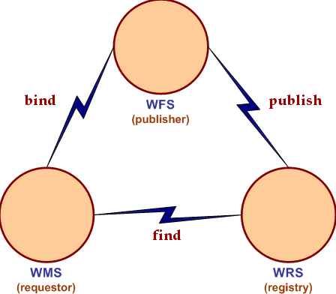

Figure 1: Web Services representation with three major functionalities.

There three types of key actors in SOA, these are service requestor, service provider and service matchmaker. Matchmakers’ names can vary from application to application. It can be called registry service, catalog service, or binding service or clearinghouse or broker but their functionalities are almost same in most of the applications, they help the requestors to find the right services. When a service provider sets up a service over the internet and wants the users to use his service, he needs to publish his service descriptions to a broker. When a requestor requests a service, the requestors and service brokers need to collaborate to find the right services. After the right service is found, requestor and provider negotiate as to format of the request and some other protocol issues. After all the requestor can access and invoke services of the provider (bind).

