SensorGrid: High Performance Web Service Architecture for Geographic Information Systems

Galip Aydin

1. Geographic Information Systems

Advances in Internet and distributed systems helped academia, governments and businesses to gain access to substantial amount of data, including geospatial data. However several significant problems cause limitations general users or applications to easily access and assimilate geospatial data. We note these limitations as following:
- Lack of universal standards: Over the years organizations have produced geospatial data in proprietary formats and developed services by adhering to different methodologies,
- Distributed nature of geospatial data: Because the data sources are owned and operated by individual groups or organizations, geospatial data is in vastly distributed repositories,
- Lack of interoperable services: Computational resources used to analyze geospatial data are also distributed and they lack the ability to be integrated when necessary.
Traditionally geospatial data analysis starts with assembling required data from repositories and involves experts extracting information from it with the help of specialized applications. This mode of operation is significantly expensive as it requires specialized applications, sufficient resources for accommodating and analyzing large volumes of data, and experts to analyze it. Additionally, most of the data collected so far have never been analyzed because of the large volumes of input. As a result Geographic Information Systems (GIS) community lacks the advantages that might have been gained from understanding the available geospatial data products.
We identify several problems with traditional approach:
- Problems with assembling data: Because of the distributed nature of geospatial data, users are required to utilize different tools to access data in various FTP or HTTP servers, relational or XML databases etc. In addition to the archived data real-time data providers employ different communication and data transport protocols which further complicates access.
- Data format problems: Depending on the user’s choice of software, applications that digest geospatial data require input in different formats. Users spend significant amount of time converting data from one format to other to make it available for their purpose.
- Amount of resources for processing data: After the data is collected and converted into an understandable format, enough hardware and software resources need to be allocated for analyzing the data. In most cases the amount of collected data reaches to an amount in the order of gigabytes or even terabytes, handling this data becomes a challenge for most users and organizations. Also, simulation and visualization software used in conjunction require high performance computing platforms which are unreachable for common users.
In recent years several organizations and academic institutions started developing data standards and implementation specifications for geospatial and location based services in a bid to make geographic information and services neutral and available across any network, application, or platform.
We describe some of these standards in the next section.

2. Open GIS Standards

The major initiative for defining geospatial standards is executed by Open Geospatial Consortium, Inc (OGC) [1]. The OGC is an international industry consortium of more than 270 companies, government agencies and universities participating in a consensus process to develop publicly available interface specifications. OGC Specifications support interoperable solutions that "geo-enable" the Web, wireless and location-based services, and mainstream IT. The specifications empower technology developers to make complex spatial information and services accessible and useful with all kinds of applications [1]. OGC has produced many specifications for web based GIS applications such as Web Feature Service (WFS) [2], Web Map Service (WMS), and Web Coverage Service (WCS). Geography Markup Language (GML) [4] is widely accepted as the universal encoding for geo-referenced data.
Some of the related standards are discussed here.

a. GML- A common language to speak about geospatial data or services
GML is an XML grammar written in XML Schema for the modeling, transport, and storage of geographic information including both the spatial and non-spatial properties of geographic features; it provides a variety of kinds of objects for describing geography including features, coordinate reference systems, geometry, topology, time, units of measure and generalized values.

Just as XML helps the Web by separating content from presentation GML does the same thing in the world of Geography. GML allows the data providers to deliver geographic information as distinct features. Using latest Web technologies, users can process these features without having to purchase proprietary GIS software.

By leveraging related XML technologies such as XML Schema, XML Data Binding Frameworks, XSLT, XPath etc. a GML dataset becomes easier to process in heterogeneous environments.

b. Observations & Measurements
An observation is considered to be an act or event through which a number, term or other symbol is assigned to a phenomenon. An observation has a timestamp. The observation uses a procedure, which is often an instrument or sensor.
The term “observation” is used for the general concept, with “measurement” reserved for cases where the result is a scalar quantity.

In the scope of this project we use SensorML to describe sensors such as GPS stations, Seismic Sensors etc. and Observations & Measurements Schemas to encode measurements gathered using them.

c. SensorML [5]
SensorML provides an XML schema for defining the geometric, dynamic, and observational characteristics of a sensor.

The purpose of SensorML is to:
- provide general sensor information in support of data discovery
- support the processing and analysis of the sensor measurements
- support the geolocation of observed values (measured data)
- provide performance characteristics (e.g. accuracy, threshold, etc.)
- archive fundamental properties and assumptions regarding sensor.

The information provided by SensorML includes:

Observation characteristics
- Physical properties measured (e.g. radiometry, temperature, concentration, etc.)
- Quality characteristics (e.g. accuracy, precision)
- Response characteristics (e.g. spectral curve, temporal response, etc.)
Geometry Characteristics
- Size, shape, spatial weight function (e.g. point spread function) of individual samples
- Geometric and temporal characteristics of sensor and sample collections (e.g. scans or arrays) that are required for metric exploitation
Description and Documentation
- Overall information about the sensor
- History and reference information supporting the SensorML document.

3. GIS and Web Services

GIS applications developed by various vendors and academic institutions have become more complex as they are required to process larger data sets, utilize more computing power and in some cases need to collect data from distributed sources. Traditionally GIS applications are data centric, they deal with archived data but with sensor based applications gaining momentum the need of integrating real-time data sources such as sensors, radars, or satellites with high end computing platforms such as simulation, visualization or data mining applications introduces several important distributed computing challenges to GIS community.

Although commercial GIS applications provide various solutions to these problems, most of the solutions are not open to public or they are based on more traditional distributed computing paradigms such as static server-client approaches. Traditional point to point communication approaches tend to result in more centralized, tightly coupled and synchronous applications which results in harder management practices for large scale systems. Modern large scale systems on the other hand require more flexible asynchronous communication models to cope with the high number of participants and transfer of larger data sets between them [6].

One of the major challenges GIS community faces today is lack of collaboration between data sources, application providers and end users. We have plenty of data and high performance assimilation tools to analyze it but they are mostly disparate, locally owned and operated or standalone business applications. Most of the time we need more than one data source and multiple services to solve a complex problem which is not easy to manage with traditional GIS approaches. These kinds of problems are exactly what SOA tries to solve.

SOA is a software architectural style whose aim is to build distributed systems by providing loose coupling among disparate services. Essentially a SOA is a collection of interacting services. Interaction between services can involve either simple data passing or coordinating two or more services for some activity.

A service is defined as a self contained, stateless unit of work or a well-defined set of actions offered by a service provider to achieve desired end results of a service customer.

SOA achieves loose coupling between services by employing two simple constraints [7]:
- Services must use a small set of simple and ubiquitous interfaces.
- Services should communicate using descriptive messages constrained by an extensible schema delivered through the interface.

A Web service is self-describing and modular application that can be published, discovered, and invoked over the internet. Also current XML standards allow Web services to be developed as loosely coupled application components regardless of the platform, communication protocol or programming language which makes Web services technology well suited for implementing SOA [8].

We employ WS+I approach for building Grid of Web Services. This allows us to enhance our Grid environment by adding new specialized Web Services.

We use OGC standards to describe scientific data and build conformant services for data access and manipulation. However current OGC specifications are not based on WSDL-SOAP based Web Service approach. Rather they utilize HTTP Get and Post methods.

3.1 A Common Data Format
The first step for building such services is to decide appropriate encodings for describing the data. The importance of the data format lies in the fact that it becomes the basic building block of the system which in turn determines the level of interoperability. Use of a universal standard like XML greatly increases the number of users from different backgrounds and platforms who can easily incorporate our data products into their systems.

Furthermore services and applications are built to parse, understand and use this format to support various operations on data. So in a sense the type and variety of the tools being used in the development and data assimilation processes depend on the format initially agreed.

For these reasons we use GML, the universally accepted XML based encoding for geospatial data, as our data format in GIS related applications. One important fact about GML is that, although it offers particular complex types for various geospatial phenomena, users can employ a variety of XML Schema development techniques to describe their data using GML types. This provides a certain degree of flexibility both in the development process and in the resulting data products. For instance, depending on the capability of the environment schema developers may exclusively use certain XML Schema types and choose not to incorporate more controversial ones because of incompatibility issues. As a result a particular geospatial phenomenon can be described by different valid GML schemas.

By incorporating GML in our systems as de facto data format we gain several advantages:

- It allows us to unify different data formats. For instance, various organizations offer different formats for position information collected from GPS stations. GML provides suitable geospatial and temporal types for this information, and by using these types a common GML schema can be produced. (See http://www.crisisgrid.org/html/servo.html for sample GML schemas for GPS and Seismic data)
- As more GIS vendors are releasing compatible products and more academic institutions use OGC standards in their research and implementations, OGC specifications are becoming de facto standards in GIS community and GML is rapidly emerging as the standard XML encoding for geographic information. By using GML we open the door of interoperability to this growing community.
- GML and related technologies allow us to build general set of tools to access and manipulate data. Since GML is an XML dialect, any XML related technology can be utilized for application development purposes. Considering the fact that in most cases the technologies for collecting data and consecutively the nature of the collected data product would stay the same for a long period of time the interfaces we create for sharing data won’t change either. This ensures having stable interfaces and libraries.

3.2 Data Binding
Establishing XML or some flavor of it as the default message/data format for the global system requires consideration of a Data Binding Framework (DBF) for generating and parsing (marshalling and unmarshalling) XML messages.

Being able to generate XML instances and parsing them in a tolerable amount of time is one of the criteria while choosing such a framework, because message processing time would affect overall system performance as well as the performance of the individual XML processing component.

Another criterion to consider is the ability of the Framework to successfully generate valid instances according to the Schema definitions. This is a major problem for DBFs since not all of the XML Schema types can be directly mapped to Object Oriented Programming constructs. Some of the XML Schema types (such as Substitution Groups which are heavily used in GML Schemas) do not correspond to types in Object Oriented world and this causes difficulties while processing the XML documents. Various Data Binding Frameworks offer different solutions, some of which are more elaborate than the other and depending of the nature of the data a suitable framework must be chosen.

3.3 Data Services
GIS systems are supposed to provide data access tools to the users as well as manipulation tools to the administrators. In principle the process of serving data in a particular format is pretty simple when it is made accessible as files on an HTTP or FTP server. But additional futures like query capabilities on data or real-time access in a streaming fashion require more complicated services. As the complexity of the services grows client’s chance of easily accessing data products decreases, because every proprietary application developed for some type of data require its own specialized clients. Web Services help us overcome this difficulty by providing standard interfaces to the tools or applications we develop.

No matter how complex the application itself, its Web Service interface (WSDL document) will have standard elements and attributes and the clients using this interface can easily generate methods for invoking the service and receiving the results. This method allows providers to make their applications available to others in a standard way.

Usefulness of Web Services is constrained by several factors. They can be used in several cases such as:
- where the volume of data transferred between the server and the client is not high. Actual amount of data can be transferred depends on a number of factors like the protocol being used to communicate or maximum allowed size by the HTTP etc.
- where time is not a determining factor. Despite the obvious advantages Web Services offer current implementations do not provide desirable results for the systems that require fast response and in turn high performance. This is simply due to the delays caused by data transfer over network, network constraints, request-response overhead etc.

Most Scientific Applications that couple high performance computing, simulation or visualization codes with databases or real-time data sources require more than mere remote procedure calls pure Web Services has to offer. These applications are sometimes composite systems where some of the components require output from others and they are asynchronous, it may take hours or days to complete. Such properties require additional layers of control and capabilities from Web Services which introduces the necessity for a messaging substrate that can provide these extra features.

4. Streaming with NaradaBrokering

Community Grids Lab has been developing NaradaBrokering [9]; a distributed messaging infrastructure which goes beyond the remote procedure call methodology pure Web Services approach is based on. It provides two related capabilities. First, it provides a message oriented middleware (MoM) which facilitates communications between entities (which includes clients, resources, services and proxies) through the exchange of messages. Second, it provides a notification framework by efficiently routing messages from the originators to only the registered consumers of the message in question.

NaradaBrokering facilitates the idea of loosely coupled systems by supporting asynchronous communication and it can be used to support different interactions by encapsulating them in specialized messages called events. Events can encapsulate information pertaining to transactions, data interchange, method invocations, system conditions and finally the search, discovery and subsequent sharing of resources.[9]

Some of the important features of NaradaBrokering can be summarized as follows [9]:

- Ensures reliable delivery of events in the case of broker or client failures and prolonged entity disconnects.
- Provides compressing and decompressing services to deal with events with large payloads. Additionally there is also a fragmentation service which fragments large file-based payloads into smaller ones. A coalescing service then merges these fragments into the large file at the receiver side.
- Provides support for multiple transport protocols such as TCP (blocking and non-blocking), UDP, SSL, HTTP, RTP, HHMS (optimized for PDA and cell-phone access) and GridFTP with protocol chosen independently at each link
- Implements high-performance protocols (message transit time of 1 to 2 ms per hop)
- Order-preserving optimized message delivery
- Quality of Service (QoS) and security profiles for sent and received messages
- Interface with reliable storage for persistent events, reliable delivery via WS-Reliable Messaging.[10]
- Discovery Service to find nearest brokers /resources

NaradaBrokering has been used extensively in several projects that require real-time streaming data access. Because of its relevancy to our topic we summarize GlobalMMCS here;

4.1 GlobalMMCS
Global Multimedia Collaboration System [10] is designed to provide scalable videoconferencing services to a diverse set of users. The system uses NaradaBrokering as the media distribution medium. Topics provided by NaradaBrokering serve as the messaging channels among participants in a session to exchange data [30].

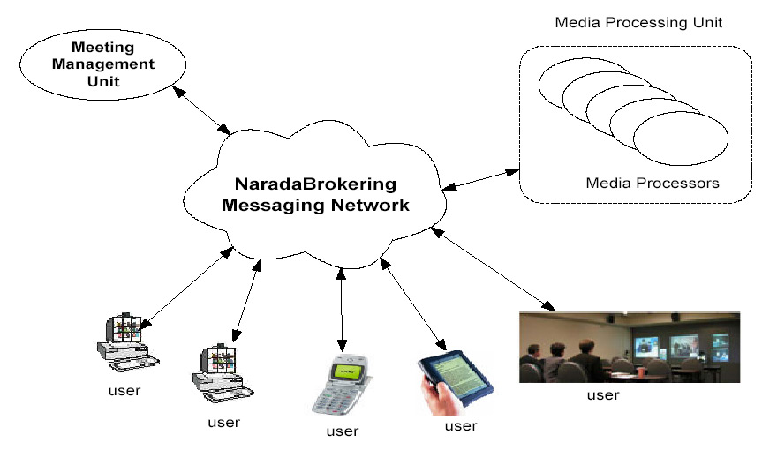
Figure 1 - Main Components of GlobalMMCS architecture [30]

NaradaBrokering has proved to be very efficient in delivering audio and video streams to a group of participants in a meeting.

The topic based publish-subscribe system works as follows: The source user or the data provider publishes copy of a stream to a topic and the broker network delivers this stream to all the subscriber of this topic by duplicating whenever necessary. To save network bandwidth NaradaBrokering avoids sending multiple copies of the same stream on the same link. Additionally it calculates the near-optimal routes from sources to destinations by organizing the brokers in hierarchical cluster architecture.

This architecture provides a scalable and flexible framework to distribute media processing units. Additional futures of NaradaBrokering allow the system to be dynamic; the capacity of the system can be increased by easily adding new computing resources and new processing services can be integrated to support ever changing needs of end users.

Performance of the GlobalMMCS system is investigated extensively and the results show that the system exhibits high performance for audio/video meetings.

We think that the nature of GPS data is similar to that of audio/video and a Service Oriented Architecture which employs NaradaBrokering should exhibit high performance for GPS Services.

5. SensorGrid
SensorGrid is a Service Oriented Architecture to support integration of archived and real-time geospatial data with scientific applications such as simulation, visualization or data mining software.

Scientific applications that require processing of huge data sets are increasing in number with the evolution of computing resources, network bandwidth, and storage capabilities etc. At the same time some of the applications are being designed to run on real-time data to provide near-real time results; such applications are gaining ground in systems like Crisis Management or Early Warning Systems because they allow authorities to take action on time. Earthquake data assimilation tools are good examples of this group since they use data from Seismic or GPS sensors. However most of these tools currently consume data from repositories and they do not have access to real-time data due to several reasons.

SensorGrid architecture will couple data assimilation tools with real-time data using GIS standards and Web Services methodologies. The system will use NaradaBrokering as the messaging substrate and this will allow high performance data transfer between data sources and the client applications. SensorGrid will inherit features supported by NaradaBrokering which will give the system a dynamic nature. Standard GIS interfaces and encodings like GML will allow data products to be available to the larger GIS community.

Figure 2 shows the major components of SensorGrid.

5.1 SensorGrid Components

SensorGrid Agent
This service provides interfaces for clients to access/query available data products. It may have both visual (maps) and textual (HTML forms) elements to help users construct queries. The basic idea behind this service is to simplify clients’ communication with the SensorGrid. A scientist may use this agent to request sensor observations for a particular geographical region and time. For instance by selecting a rectangular region on an interactive map and entering time boundaries we can construct queries such as “Get GPS measurements for San Diego County for September 2005”. In addition to helping users construct queries for archived geospatial data SensorGrid Agent displays available real-time sensors as well. We are researching use of Google Maps to provide visual user interfaces.

Information Service
Web Services are stateless; they do not keep session related information. We need to use additional services to provide session support.
SensorGrid architecture consists of multiple independent Web Services which do not keep any information about each other. The Information Service is used to keep several futures of the services in the system to make easy access to these services possible. For instance all OGC conformant data services provide some sort of capabilities document that describes the types and constraints of the data they can serve. The IS can be thought of as a registry through which the users can locate available services in the system and discover their futures.

We will use FTHPIS (Fault Tolerant High Performance Information Service) [11] which has GIS specific extensions appropriate for our architecture.

Web Feature Service
WFS provides a repository for GIS archival data. The specification provides the common framework for an HTTP GET/POST based implementation. We have implemented a Web Service version but because of several performance problems we are building a streaming version. We will investigate using binary XML to provide highly efficient XML representations that should provide significant performance enhancements in current services.

Sensor Collection Service
OGC Sensor Web Enablement is intended to be a revolutionary approach for exploiting Web-connected sensors such as flood gauges, air pollution monitors, satellite-borne earth imaging devices etc. The goal of SWE is to creation of Web-based sensor networks. That is to make all sensors and repositories of sensor data discoverable, accessible and where applicable controllable via the WWW [12].

Sensor Collection Service [13] is a service to fetch observations from a sensor or constellation of sensors. Provides real time or archived observed values. Clients can also obtain information that describes the associated sensors and platforms. This is the intermediary between a client and a sensor collection management environment. We will research using publish/subscribe based systems for real-time data delivery using SCS.

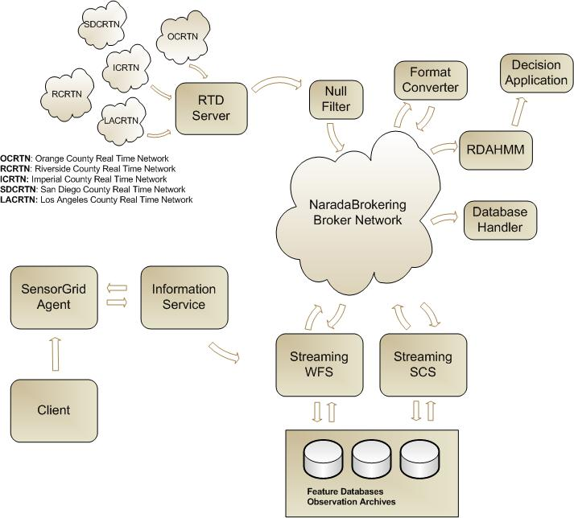

Figure 2 – Major Components of SensorGrid architecture

Filter Chains
To process sensor streams in real-time we are researching use of publish/subscribe based messaging system. We will test deploying geoprocessing applications and format converters as successive filters. We can leverage NaradaBrokering topics for publishing for this purpose.

GIS applications consume data in different formats. To support various types of geoprocessing tools we need to provide data in different formats, for this reason we can deploy format converters successively on the NaradaBrokering topics.

Typical Query Scenario:
The client makes a sensor observation request with some spatial and temporal constraints, i.e. “Get GPS positions for San Diego County for September 2005”. Depending on the nature of the query IS may take two actions; if the query is for archived sensor data then it requests data from the Observation Archives using WFS and returns it to the client. But if the client wants to access real-time data then it returns a data handler which contains the broker information and topic name for the sensor. Also depending on the size of the archived data SCS may choose one of two options for data transfer; if the result size is relatively small then it is returned via SOAP message, otherwise NaradaBrokering is used. SCS also keeps information about the sensors themselves. This information is encoded in SensorML. After receiving the broker address and the topic name, client may subscribe to the NaradaBrokering server to receive real-time data.

5.2 SOPAC GPS Services-Real time streaming support for position messages
Recent technological developments have allowed sensors to be deployed in a variety of application domains. Environmental monitoring, air pollution and water quality measurements, detection of the seismic events and understanding the motions of the Earth crust are only a few areas where extent of the deployment of sensor networks can easily be seen. Extensive use of sensing devices and deployment networks of sensors that can communicate with each other to achieve a larger sensing task will fundamentally change information gathering and processing. [14]. However rapid proliferation of sensors presents unique challenges different than the traditional computer network problems.

Several studies have discussed the technological aspects of the challenges with the sensor devices, such as power consumption, wireless communication problems, autonomous operation, adaptability to the environmental conditions etc [15]. Here we describe service architecture to support real-time information gathering and processing from GPS sensors by leveraging SOA principles and open GIS standards.

GPS Networks
Global Positioning System has been used in geodesy to identify long-term tectonic deformation and static displacements while Continuous GPS (CGPS) has proven very effective for measurement of the interseismic, coseismic and postseismic deformation. [16]. Today networks of individual GPS Stations (monuments) are deployed along the active fault lines, and data from these are continuously being collected by several organizations. One of the first organizations to use GPS in detection of the seismic events and for scientific simulations is Southern California Integrated GPS Network (SCIGN) [17]. One of the collaborators in SCIGN is Scripps Orbit and Permanent Array Center (SOPAC) [18] which maintains several GPS networks and archives high-precision GPS data, particularly for the study of earthquake hazards, tectonic plate motion, crustal deformation, and meteorology [18]. Real time sub-networks maintained by SOPAC include Orange County, Riverside County (Metropolitan Water District), San Diego County, and Parkfield. These networks provide real-time position data (less than 1 sec latency) and operate at high rate (1 – 2 Hz). Raw data from the GPS stations are continuously collected by a Common Link proxy (RTD server) and archived in RINEX files.

The data collected from the GPS stations are served in 3 formats:
- RAW: For archiving and record purposes, not interesting for scientific applications, not available in real-time.
- RTCM: Published real-time and no records are kept. This is useful for RTCM capable GPS receivers as reference.
- Positions: Positions of the stations. Updated and presented every second. GPS Time Series can be produced using these positions and they can be in different epochs such as hourly, daily etc.

The most interesting of these formats to scientists is position information which can be used in scientific calculations, simulation or visualization applications. The RTD server however outputs the position messages in a binary format called RYO. This introduces another level of complexity on the client side because the messages have to be converted from binary RYO format.

To receive station positions, clients are expected to open a socket connection to the RTD server. An obvious downside of this approach is the extensive load this might introduce to the server when multiple clients are connected.

After the RTD server receives raw data from the stations it applies some filters and for each network generates a message. This message contains a collection of position information for every individual station from which the position data has been collected in that particular instant. In addition to the position information there are other measurements in a message such as quality of the measurement, variances etc.

For each GPS network, RTD server broadcasts one position message per second through a port in RYO format.

To make the position information available to the clients in a real-time streaming fashion we used NaradaBrokering. Additionally we developed applications to serve position messages in ASCII and GML formats.

Chain of Filters
Since the data provided by RTD server is in a binary format we developed several filters to decode and present it in different formats. Once we receive the original binary data we immediately publish this to a NaradaBrokering topic (null filter), another filter that converts the binary message to ASCII subscribes to this topic and publishes the output message to another topic. We have developed a GML schema to describe the GPS position messages. Another filter application subscribes to ASCII message topic and publishes GML representation of the position messages to a different topic. This approach allows us to keep the original data intact and different formats of the messages accessible by multiple clients in a streaming fashion.

The GML Schema we wrote is based on RichObservation type which is an extended version of GML 3 Observation model [19]. This model supports Observation Array and Observation Collection types which are useful in describing SOPAC Position messages since they are collections of multiple individual station positions. We follow strong naming conventions for naming the elements to make the Schema more understandable to the clients.

Decoding RYO Messages
RYO Message Type 1 starts with a 5-byte Header which is followed by a 47-byte GPS Position message. Three types of optional blocks may follow the Position Message and a 2-byte checksum is located at the end of the message.

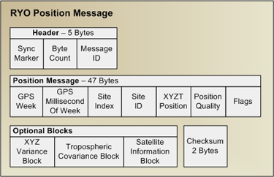

A non-blocking Java Socket connection is made to RTP server to collect RYO messages. We use thread programming techniques for this purpose.

We wrote an RYO Decoder application which uses binary conversion tools to convert RYO messages into text messages.

Furthermore since we do not expect clients to know about the GPS time format we convert GPSWeek and GPSmsOfWeek values to Gregorian calendar format (i.e. 2005-19-07/04:19:44PM-EST). Additionally since we anticipate some clients to expect position information in terms of Latitude and Longitude, we calculate Latitude, Longitude and Height values from XYZT Position.

GML Schema for Position Messages and Data Binding
We developed a GML conformant Schema to describe Position Messages. The Schema is based on RichObservation type which is an extended version of GML3 Observation model. [19]

This model supports Observation Array and Observation Collection types which are useful in describing SOPAC Position messages since they are collections of multiple individual station positions. We follow strong naming conventions for naming the elements to make the Schema more understandable to the clients.

We used Apache XML Beans for data binding purposes.[20]
We created an application that reads ASCII position messages and generate GML instances using the code generated by XML Beans.

SOPAC GML Schema and sample instances are available here: http://www.crisisgrid.org/schemas

Integrating NaradaBrokering
After we have position information in three different formats we used NaradaBrokering to provide real-time access to data. We wrote methods to publish RYO, ASCII and GML formatted position messages to different NaradaBrokering topics. Clients can subscribe to any of these topics to receive position messages in that particular format.

Following figure depicts use of NaradaBrokering Topics in the system.

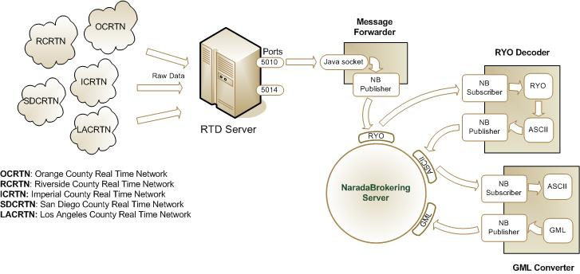
Figure 3 - SOPAC GPS Services

Currently the system is being tested for 5 GPS networks. Following tables show the current NaradaBrokering Server and topic names for San Diego County Network:

NaradaBrokering Server address: xsopac.ucsd.edu:3045

Format | Topic Name
RYO | SOPAC/GPS/Positions/SDCRTN/RYO
Text | SOPAC/GPS/Positions/SDCRTN/ASCII
GML | SOPAC/GPS/Positions/SDCRTN/GML

6. Negotiation Framework for Web Services to Support High Performance Data Transport

Several studies [21, 22] have shown that transport of XML and SOAP messages encoded in conventional “angle-bracket” representation is too slow for applications that demand high performance (please see [23] for a more detailed discussion). At the same time several groups are developing ways of representing XML in binary formats for fast message exchange, such as Fast Web Infoset [24] , bnux [25], Millau [26] and BXSA [27]. Some groups are focusing their research on developing binary XML formats for particular area of interest, for instance BXML [28] by CubeWerx is being developed for and Open GIS standard and targets geospatial data, Millau is for business community while BXSA targets scientific use cases such as large arrays of numbers, sensor data streams.

Current state of the developments in this area shows that in a relatively short period of time we will have several mature binary XML formats for different areas. However what is missing for Web Services is a way to decide which representation to use when transporting a stream of messages.

We are developing a framework for Web Services to negotiate several aspects of the data transportation such as representation scheme (bnux, BXSA etc.) and transport protocol (TCP, UDDI) [23]. We are investigating binding SOAP to topic based messaging systems to virtualize representation and protocol. In this framework converting XML messages to different representations and supporting different transport protocols will be provided by handlers. The particular handler that is responsible for determining negotiation protocol or representation will start the negotiation with the other end-point to find a common solution. If one side only supports conventional representation or protocol then the negotiation will stop and communication will be done in traditional way. Initial negotiation will be done using standard angle-bracketed messages to determine the supported representation and transport capabilities. Once the services agree on the conditions of the data exchange, handlers will convert XML data into an appropriate binary format and stream it over a high performance transport protocol (such as UDDI) using publish/subscribe messaging system.

We will investigate using WS-Context [29] to store metadata about the communication methodology and specific parameters.

10. References

[1] The Open Geospatial Consortium, Inc. web site: http://www.opengeospatial.org/

[2] Vretanos, P (ed.) (2002), Web Feature Service Implementation Specification, OpenGIS project document: OGC 02-058, version 1.0.0.

[3] de La Beaujardiere, Jeff, Web Map Service, OGC project document reference number OGC 04-024.

[4] Cox, S., Daisey, P., Lake, R., Portele, C., and Whiteside, A. (eds) (2003), OpenGIS Geography Markup Language (GML) Implementation Specification. OpenGIS project document reference number OGC 02-023r4, Version 3.0.

[5] Botts, Mike, Sensor Model Language (SensorML) for In-situ and Remote Sensors, OGC document reference number 04-019r2

[6] Liu,Y., Plale B., Survey of Publish Subscribe Event Systems

[7] Hao He, What is Service-Oriented Architecture? http://webservices.xml.com/lpt/a/ws/2003/09/30/soa.html

[8] Mark Endrei et al., IBM Red Books, Patterns: Service-Oriented Architecture and Web Services
http://www.redbooks.ibm.com/redbooks/SG246303/wwhelp/wwhimpl/java/html/wwhelp.htm

[9] The NaradaBrokering Project at the Community Grids Lab: http://www.naradabrokering.org

[10] GlobalMMCS project web site http://www.globalmmcs.org/

[11] FTHPIS project web site http://grids.ucs.indiana.edu/~maktas/fthpis/index.html

[12] OGC Sensor Web Enablement Web page http://www.opengeospatial.org/functional/?page=swe

[13] OGC Sensor Collection Service specification, document reference number 03-023r1

[14] D. Estrin, R. Govindan, J. Heidemann and S. Kumar, “Next Century Challenges: Scalable Coordination in Sensor Networks,” In Proceedings of the Fifth Annual International Conference on Mobile Computing and Networks (MobiCOM '99), August 1999, Seattle, Washington.

[15] Akyildiz, I. F., Su, W., Sankarasubramaniam, Y., and Cayirci, E., “A Survey on Sensor Networks” IEEE Communications Magazine, August 2002.

[16] Bock, Y., Prawirodirdjo, L, Melbourne, T I. : “Detection of arbitrarily large dynamic ground motions with a dense high-rate GPS network” GEOPHYSICAL RESEARCH LETTERS, VOL. 31, 2004

[17] Southern California Integrated GPS Network web site: http://www.scign.org/

[18] Scripps Orbit and Permanent Array Center web site: http://sopac.ucsd.edu/

[19] Open Geospatial Consortium Discussion Paper, Editor Simon Cox: “Observations and Measurements”. OGC Document Number: OGC 03-022r3

[20] Apache XML Beans project web site http://xmlbeans.apache.org/

[21] Chiu, K., Govindaraju, M., and Bramley, R.: Investigating the Limits of SOAP Performance for Scientific Computing, Proc. of 11th IEEE International Symposium on High Performance Distributed Computing HPDC-11 (2002) 256.

[22] Daniel Andresen¤, David Sexton, Kiran Devaram, Venkatesh Prasad Ranganath, LYE: a high-performance caching SOAP implementation

[23] Oh, S., Bulut, H., Uyar, A., Wu, W., Fox G., Optimized Communication using the SOAP Infoset For Mobile Multimedia Collaboration Applications. In proceedings of the International Symposium on Collaborative Technologies and Systems CTS05 (2005)

[24] Sun. Fast infoset. http://asn1.elibel.tm.fr/xml/finf.htm.

[25] Nux OverView. http://dsd.lbl.gov/nux/.

[26] M. Girardot and N. Sundaresan. Millau: an encoding format for efficient representation and exchange of xml over
the web. Available from http://www9.org/w9cdrom/154/154.html

[27] Kenneth Chiu, Tharaka Devadithya, Wei Lu, and Aleksander Slominski. A binary xml for scientific applications. In e-Science 2005, 2005.

[28] C. S. Bruce. Cubewerx position paper for binary XML encoding.
http://www.cubewerx.com/main/HTML/Binary_XML_Encoding.html.

[29] Bunting, B., Chapman, M., Hurley, O., Little, M., Mischkinky, J., Newcomer, E., Webber, J., and Swenson, K.,
Web Services Context (WS-Context), available from http://www.arjuna.com/library/specs/ws_caf_1-0/WSCTX.pdf.

[30] Uyar, A., Scalable Service Oriented Architecture for Audio/Video Conferencing PhD Thesis, Syracuse University PhD March 23 2005

