Building and Applying Geographical Information System Grids
Galip Aydin^{1,2}, Ahmet Sayar^{1, 2}, Harshawardhan Gadgil^{1,2}, Mehmet S. Aktas^{1,2}, Geoffrey C. Fox^{1,2,3}, Sunghoon Ko¹, Hasan Bulut^{1,2},and Marlon E. Pierce¹
¹Community Grids Laboratory
²Department of Computer Science
³ Department of Physics
Indiana University
{maktas, gaydin, hbulut, gcf, hgadgil, mpierce, asayar}@cs.indiana.edu
shko@grids.ucs.indiana.edu

Abstract: We discuss the development and application of Web Service-based Geographical Information System Grids (GIS). Following the WS-I+ approach to building Grids upon Web Service standards, we have developed data grid components for both archival and real-time data, map generating services that can be used to build user interfaces, information services for storing both stateless and stateful metadata, and service orchestration and management tools. Our goal is to support dynamically assembled Grid service collections that combine both GIS services with more traditional Grid capabilities, such as file transfer and remote code execution. We are applying these tools to problems in earthquake modeling and forecasting, but we build general purpose tools using and extending appropriate standards.

Introduction: Information Architecture for the Data Deluge
As Grid technologies [20][21][9][6] and applications mature, a common theme in many projects has been the recognition that distributed data access is at least as important as scientific computation. Data access is often thought of as large data archives and their replicas [74][73][4], but in this paper we argue that data streaming, especially for real-time applications, is also essential. In general we see the future of many Grid applications as being dominated by data stream filtering, management, event detection, and data mining on data streams from sensors. The connection between sensor data sources and Geographical Information Systems (GIS) is particularly strong. Developing a Web Service architecture that allows us to manage these data sources, connect them to filters and applications, and deliver them to users in a comprehensible fashion serves as our focus in this paper. This subject thus naturally encompasses GIS service implementations, information systems, streaming data management software, messaging substrate technology, and workflow. We will present our work on these topics in this paper.

Sensor Filter Grids
In later sections of this paper we will address specific development work and research issues for GIS Grids, we wish to emphasize in this introduction that we believe our approach is fundamental and can be generalized to other problem domains besides GIS applications. We discuss here a common Grid infrastructure for data analysis and other applications in both distributed scientific research and those like Homeland Security with an architecture termed Sensor Filter Grids (SFG). These Grids are built around streams supported by a powerful messaging system to achieve high interactivity and performance for distributed analysis. The approach is applicable to management and analysis of general distributed information resources including those found in data analysis as well as the documents and presentations associated with a scientific activity. Our approach exploits the multi-tier federated and hierarchical structure of most problems of the type sketched in Figure 1.
A Sensor Filter Grid can support the scenario of Figure 1. One can define a particular Sensor Filter Grid to correspond to a particular workflow linking services together and produce the associated support for this workflow. Figure 2 shows what we call the macroscopic workflow in Sensor Filter Grid federating different information sources together. Different instances of this paradigm correspond to different configuration parameters and to different choices of component application services in the workflow. The different instances share the overall paradigm of workflow, sensors and filters as well as general Grid system services. We discuss implementations of these ideas in Sections 5-7.
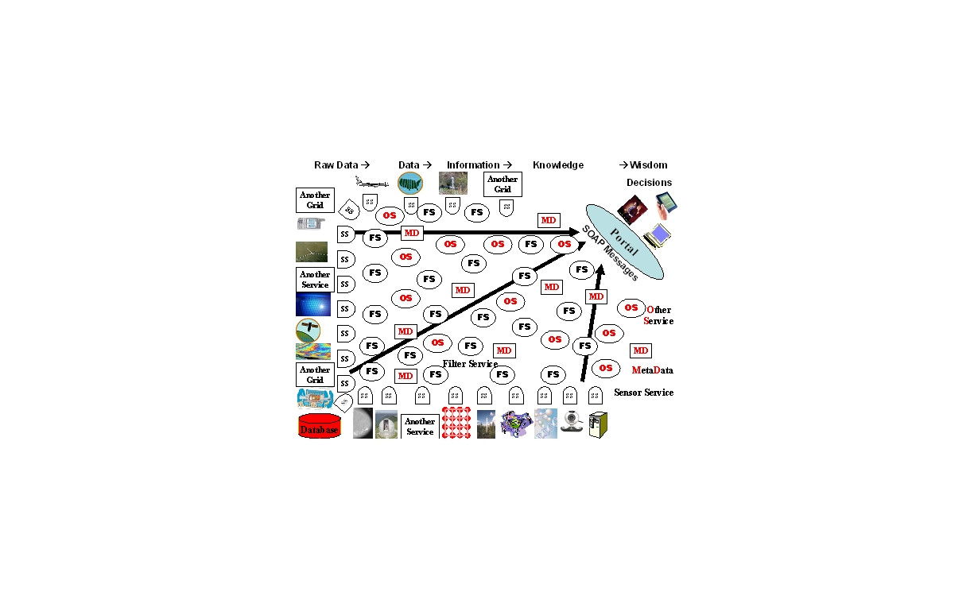
Figure 1 Vision of Sensor Filter Grid with filters (FS) shown from many fields, processing SOAP messages from sensors (SS), Grid(let)s and services controlled by meta-data (MD) and supported by other services (OS).
Sensor Filter Grid is built around three distinctive features – information services that present data through traditional service interfaces; filters that accept data with these interfaces, transform them and present them with the same interfaces; streaming connections between all services that provide on the fly archiving, high-performance transport, security and fault tolerance. A very common feature is that the filters are composable in a distributed federated hierarchical fashion. We suggest that scientific data analysis has this characteristic whereas for example distributed simulations would typically not be composable in this fashion.
As shown in Figure 3, Sensor Filter Grid is built from information services and filters that support identical service interfaces. The source, structure and processing of data in information services is opaque while filters transform or aggregate data from other filters or information services. Figure 2 shows how full filter services are built from basic filter services using application dependent dataflow. We term this the microscopic workflow as it is embedded in the Gridlets shown in Figure 4. The filters in this Grid style combine hierarchically e.g. in information retrieval one can merge ranked lists to obtain a new ranked list while in statistical analysis, moments and histograms can easily be combined.
Figure 2 A Filter Service is a general workflow (the microscopic workflow) of Basic Filter Services
Figure 3 Sensor Filter Grid is built from Information resources wrapped as Web Services and Basic Filters that either transform or aggregate Information. Information Services and Filters support identical Service Interfaces
This composability of the filters supports natural scaling and federation algorithms and defines the Sensor Filter Grid structure. Note that superimposed on the tree of filters and information sources one has a Grid of system services like security and reliability which are shared between the different applications. One supports this paradigm with an interactive administrative interface allowing system configuration, information sources and filters to be defined. The system can be elegantly virtualized so that in specifying the information sources, one can either give very specific resources or Semantic Web style specifications for a discovery service. Of course this type of support is independent of the Sensor Filter Grid application area; one must just distinguish service specification from the location and number of services. Note that there is no implication that all filter actions are identical; one will design the messages on the datastreams between filters so they are self describing. Thus in information retrieval the filter services are designed so they can accept full documents (specified by a URI), title or simple metadata. This flexible construction allows filter trees to be built that don't depend on number and exact features of information resources.

Role of Streams
A critical feature of the architecture is the use of a powerful messaging infrastructure NaradaBrokering [49][22] for linking between the services in Figure 3 and Figure 4. This allows all services to be linked by managed reliable streams. NaradaBrokering can be deployed as a distributed set of brokers, and (in the latest release in June 2005) as Apache Axis handlers. This release supports WS-ReliableMessaging [50], WS-Eventing and WS-Notification [51]. These capabilities allow fault tolerance and asynchronous messaging with publish-subscribe semantics [24]. We are developing a sophisticated management environment that controls and monitors all streams in a Grid [25][26] and extends fault tolerance across streams, services and message brokers. The latter allows one to control the flow of data into filters so that there is no overflow. NaradaBrokering supports the subscription of redundant services to aid in fault tolerance. The Web Service messages flowing in NaradaBrokering can be archived at any link. This provides for dynamic caching to support system performance and is also used in message throttling. This NaradaBrokering archiving service replaces the replica management familiar from current particle physics Grids [4]. The archive service is of course supported by a metadata catalog to manage it.
NaradaBrokering supports software multicast and so it is straightforward to build collaborative sessions by multicasting the links. NaradaBrokering has been successfully used for audio-video conferencing and other collaborative tools in the commercial Anabas product [Anabas] and the open source GlobalMMCS project [16][23]. A current successful use of this technology is for integrating seismic archives with data assimilation techniques [7] for medium-range (5-10) earthquake forecasting. We are also developing real-time GPS sensors used by NASA for Earthquake monitoring [26]. We deploy simple versions of the architectures proposed here with sensors, filters and data mining codes linked by real-time streams. These time sensitive applications spurred the development of several interesting technologies including a metadata catalog that supported (with different implementations but the same interface) both scalable large scale access and low latency access needed for interactive use by the relatively small number of services involved in an individual workflow.
We need to ensure that our architecture streams information as fast as possible between services while retaining the advantage of Grids and Web Services. This can be achieved as all service messages are handled by the “system” through NaradaBrokering which formally one “binds” to SOAP as the transport. There are two important aspects that need to be optimized – the transport protocol and the representation of the information in the message. For the protocol we exploit NaradaBrokering’s ability to support general protocols which can be chosen independently of the application with in a service model the last handler in a container choosing the protocol. UDP, TCP, parallel TCP, HTTP, HTTPS are currently supported. One should also investigate the FAST kernel [77]. NaradaBrokering can also link to network monitoring tools and here we should study links to the MonALISA agent-based global monitoring and control system [76]. This is widely deployed in the physics community and now part of the Virtual Data Toolkit [78].
Now we turn to the wire-representation used in the messaging. Several studies have shown that transport of XML and SOAP messages encoded in conventional “angle-bracket” representation is too slow for applications that demand high performance. At the same time several groups are developing ways of representing XML in binary formats for fast message exchange [17][9][55]. We are developing [46] a Web Service negotiation language for higher performance Web Services to negotiate both the protocol described above as well as the representation scheme such as choice between Fast and Binary XML. Initial negotiation will be done using standard SOAP angle-bracketed messages to determine the supported representation and transport protocol capabilities. We will employ handlers to take care of the conversion and transport issues, which will make the negotiation and transport process transparent to the services. Once the services agree on the conditions of the data exchange, handlers convert XML data into an appropriate binary format and stream it over a high performance transport protocol using NaradaBrokering.
Figure 4 A Gridlet is defined by combining information services and filters. The Multiple IS in a Gridlet can be explicitly defined or generated by IS virtualization using Sensor Filter Grid directory and Metadata services

Overview of Paper
In this paper we describe our efforts to implement the general architecture outlined above, with specific applications to our SERVOGrid project. Our general approach is based on the “WS-I+” approach [6] to building Grids: we start from core Web Service standards (SOAP, WSDL, UDDI) and build outward on other applicable World Wide Web Consortium and OASIS standards. General overviews of Grid technology are available from [20][9].
The major components of our efforts are detailed in separate sections. We begin with two sections describing our work to build and extend Web Services to support basic Open Geospatial Consortium standards: the Web Feature Service and the Web Map Service. These are foundation components for GIS Grids. The feature service is a basic Data Grid component that provides access to data and metadata about geographic features. This work is described in Section 2. As we have discussed in the introduction, Data Grids must depend on both archival and real-time data. We discuss our architecture and implementation of real-time data services for Global Positioning Systems in Section 3. The Web Map Service is used to build user interface components for GIS Grid components. Distributed map services render maps from overlays that may be created from feature data as well as other map service components. We describe our efforts to build “pure” Open Geospatial Consortium (OGC) [47] map services as well as map services and clients that combine Open Geospatial Consortium and Google map approaches in Sections 3 and 4. We conclude with two sections on “glue” activities that bind these services into Grids and Grid applications (see Figure 2 and Figure 4). Our Information System approach (Section 6) is based on the Web Service standards UDDI and WS-Context. Finally, Web Service-based Grid systems must be managed, and services may be combined into composite applications that integrate GIS and more typical Grid services for code execution. This is described in Section 7. Finally, Section 8 proposes that GIS Grid and Web Services may be usefully abstracted and applied to other, non-GIS domains. More extensive technical documentation on this project is available from the SERVOGrid Technical Documentation report [60]. More information and project downloads are available from [75].

Web Feature Services to Support Data Grids
Geographical Information Systems standards provide useful data models and specifications for data transport. In this section we concentrate on support for archival data storage and access through Web Service protocols. We use this to provide access to Global Positioning System records, earthquake fault descriptions, and seismic activity records. More detail on supported formats and available data can be found in [60]. Support for real-time streaming data is addressed in Section 5.

Building Web Feature Services with Web Service Principals
The Open Geospatial Consortium Web Feature Service (WFS) [69] implementation specification defines interfaces for data access and manipulation operations on geographic features using HTTP as the distributed computing platform. Via these interfaces, a web user or service can combine, use and manage geographic data from different sources by invoking several standard operations.
As a minimal requirement a basic Web Feature Service should be able to provide requested geographical information as Geographic Markup Language [18] feature collections. However, more advanced versions also support “create, update, delete and lock operations”. Three operations must be supported by a basic Web Feature Service: GetCapabilities, DescribeFeatureType and GetFeature.
Web Feature Services allows clients to access and manipulate the geographic features without having to consider the underlying data stores. Clients’ only view of the data is through the WFS interface which allows the data providers to integrate various types of data stores with one WFS instance. Clients interact with a Web Feature Service by submitting database queries encoded in Open Geospatial Consortium Filter Encoding Implementation and in compliance with the Open Geospatial Consortium’s Common Query Language.
According to the Open Geospatial Consortium’s Web Feature Service implementation specification, hosts implementing HTTP are the only explicitly supported distributed computing platform. Employing HTTP as the default transport protocol requires use of one of the two request methods: GET and POST. However using HTTP protocol introduces significant limitations for both producers and consumers of a service. In contrast, Grid Web Services provide us with valuable capabilities such as providing standard interfaces to access various databases or remote resources, ability to launch and manage applications remotely, or control collaborative sessions. Developments in the Web Service and Grid areas provide us with significant technologies for exposing our resources to the outer world using relatively simple yet powerful interfaces and message formats. Furthermore, we need to access several data sources and run several services at the same time for solving complex problems. This is out of scope for HTTP but is a part of rapidly developing workflow technologies for Web and Grid Services. For these reasons we have based our WFS implementation on Web Services principals.
We have initially implemented a Web Services version of basic WFS which supports the three mandatory operations through a WSDL interface. Each operation takes an XML document as argument and returns another XML document as response. While implementing these operations in a Web Service context, we had to choose appropriate types corresponding to the programming world. Ideally, we would define these in the <wsdl:type> section of our WSDL service definition, but unfortunately support for structured types in Apache Axis (our deployment framework) is limited. Since the requests and responses are well-defined XML documents one possibility is to create object representations of these in our favorite programming language, i.e. we can create a Java Object for each GetFeature request document and the returning Geographic Markup Language document can be another Java object. That is, we will make the service itself (rather than the container) responsible for XML serialization and de-serialization.
In this case the communication between WFS and the client is based on exchanging Java objects. However this approach severely undermines the interoperability with clients who might use other programming languages such as C++ or Python to communicate with our service. As a simpler solution we have used strings as argument and return types in these operations. This allows clients who use other programming APIs to communicate with our Web Service to simply send and receive XML documents without any format conversions. However this method also has a significant shortcoming; since the Web Service returns the resulting XML document as an <xsd:string>, this has to be constructed in memory and the size will depend on several parameters such as the system configuration and memory allocated to the Java Virtual Machine etc. Consequently there will be a limit on the size of the returned XML documents.
We have tested our Web Service implementation of WFS in several scenarios such as producing fault maps of Southern California, displaying seismic history of particular regions on the map etc. A very interesting application domain was integrating our GIS services with Pattern Informatics [64] code to forecast future seismic activities in a selected geographic region. This is described in more detail in [7].
To measure the performance of our WFS implementation we made several tests using seismic catalog for year 1992 (the most eventful year) from Southern California Earthquake Data Center (SCEDC). Tests were performed for the following lower bounds with seismic event magnitudes: M=5.0, 4.5, 4.0, 3.5, and 3.0. These correspond to increasing data file size, as shown in Table 1. The entire catalog from 1932 to 2004 has 401,403 entries.
Table 1 SCEDC entries for test year 1992
Event Magnitude Lower Bound | Number of  Seismic Events | GML  Result Size (KB)
5.0 | 19 | 11
4.5 | 67 | 36
4.0 | 209 | 106
3.5 | 587 | 287
3.0 | 1790 | 880

The Web Feature Service starts processing user requests by extracting the database query from the request (encoded as a GML Filter) and uses this to construct a corresponding MySQL query. The results of the database querying process are used to create a GML FeatureCollection which usually contains multiple features (1790 features for magnitude 3 and larger). We measure WFS performance by timing the steps required to process GetFeature requests. The tests are made over 15 runs. Data from 1/1/1992 to 12/31/1992 were requested and latitude/longitude bounding box (-117.0, 32.0)-(-114.0-37.0) was used. Table 2 shows the results of the performance tests. Measurements are in milliseconds.
Table 2 Web Feature Service performance.
Event Magnitude Lower Bound | Database Query Time | Building GML Object | Total Request Processing Time | Data Transport Time | Total Response Time
3 | 3632 | 335 | 3992 | N/A | N/A
3.5 | 3616 | 131 | 3774 | 1412 | 5185
4 | 3615 | 31 | 3664 | 558 | 4222
4.5 | 3612 | 14 | 3639 | 214 | 3853
5 | 3609 | 6 | 3627 | 80 | 3707

For each event magnitude we make five different measurements. Although there are few other steps involved in the process such as initialization of the Java objects and extraction of the database query from the user request, they do not take significant amount of time and are not determinative in the total response time. Database query time displayed in column 2 is the major contributor to the total response time and demonstrates a similar value for all the data sizes. Building GML objects from database query results was another major time consuming process in our previous tests [7] especially for larger GML payloads however with the new improvements this process only takes about 10% at most and can be ignored for the larger event magnitudes. “Total Request Processing Time” column shows the total amount of time spent on the server side for processing a user request. From the client’s point of view the performance of the WFS is simply the amount of time between submission of the request and the retrieval of the result. For this reason we also measure the data transport times between the WFS server and client which are displayed in column 5.
These results demonstrate significant improvement from our earlier results discussed in [7]. Although the previous results did not include the data transport time and total response time since they were computed by another system component, we can say that the internal optimizations made in WFS to better handle GML creation gave significant results.
Performance tests teach us valuable lessons in terms of the capabilities and limits of our implementation. From the above result we draw following conclusions. First, for small data payloads the response time is acceptable. However for larger data sets the performance decreases sharply and the response time is relatively long. Second, there exists a maximum threshold for the amount of data to be transported.
In our further tests we found that for event magnitude lower than 3 the WFS does not return any results and throws an out of memory exception due to the fact that it is not possible to create an in memory string representation of the resulting GML document

Streaming Web Feature Services
Scientific applications such as Pattern Informatics [64] and RDAHMM [34] require large amounts of data to be transferred between servers and clients. Our Web Services-based WFS implementation proved to be appropriate for transporting smaller data payloads; however for large data sets either the performance is low or the system does not work. For these reasons we have investigated alternative ways for data transport and researched use of topic based publish-subscribe messaging systems for streaming the data. Our research on NaradaBrokering shows that it can be used to stream large amount of data between nodes without significant overhead. Additional capabilities such as reliable messaging and support for different transport protocols already inherent in NaradaBrokering show that it is a powerful yet easy to integrate messaging infrastructure. For these reasons we have developed a novel Web Feature Service that integrates Open Geospatial Consortium specifications with Web Service-SOAP calls and NaradaBrokering messaging system.
Our streaming Web Feature Service works similarly with the non-streaming version, however instead of using HTTP as the transfer medium we publish the results to a NaradaBrokering topic. The clients make the requests with standard SOAP messages but for retrieving the results a NaradaBrokering subscriber class is used.
The ability to stream the results over NaradaBrokering topics also gives us another opportunity for improving the performance: we utilize MySQL’s ability to stream results from database row by row and create the GML feature members as they become available. This allows us to start publishing the results after a short query submission time without waiting for the whole result set to be returned from the database as in the conventional implementation.
Initial performance test results for out streaming-WFS implementation is discussed in brief in [27]. Here we give a detailed description of the test scenario and compare both WFS versions.
The performance tests are made with the same parameters used for testing the non-streaming version; we used SCEDC seismic catalog for year 1992 and queried data for seismic event magnitudes M>5.0, 4.5, 4.0, 3.5, and 3.0. Table 3 shows the timings taken for various steps. All measurements are in milliseconds.
Table 3 Streaming Web Feature Service performance measurements for seismic records (in millisecond) are reported.
Event Magnitude Lower Bound | Database Query Time | Building GML Object | Request Processing Time | Data Transport Time | Total Response Time
3 | 2545 | 449 | 3095 | 710 | 4494
3.5 | 2552 | 153 | 2795 | 177 | 3976
4 | 2542 | 72 | 2705 | 218 | 4064
4.5 | 2527 | 16 | 2621 | 164 | 3962
5 | 2530 | 6 | 2611 | 11 | 3754

The results show that by streaming query results from the database we reduce the database query time by around 30%. Perhaps the most interesting result of this test is that the data transport time does not significantly affect the overall system performance. Even for the largest data payload the transport time is only 17% of database query time. Overall the streaming-WFS outperforms non-streaming version by a significant margin for large data payloads and demonstrate an equal or better performance for smaller data sizes. Another important point is that there is no data size limit in streaming version which is a major advantage. The following graphics visualize the performance measurements for both WFS versions.
Figure 5 Performance of streaming Web Feature Service
Figure 6 Performance of non-streaming Web Feature Service

Web Feature Service Future Work
Although we have improved the performance of our initial WFS implementation and solved the data payload size limit by developing a streaming version, we still have to investigate further improvements. One interesting field to explore is binary XML representation schemes [17][9][55]. We are currently developing a framework for Web Services to negotiate various characteristics of their communication for better performances. We will apply our research in this area to WFS to negotiate transport protocol and binary XML format for encoding GML feature collections. We think that by encoding XML in a binary format we will be able to reduce the size of the data significantly and by using alternative transport protocols such as UDP we will be able to transfer data faster.

Visualization Web Services for Geographical Information Systems
In previous sections we addressed the problems of accessing data sources using Geographical Information Service data models and services. GIS standards such as the Open Geospatial Consortium’s Web Map Services (WMS) [8] introduce methods and environments to visualize, manipulate, and analyze geospatial data using maps. These map servers typically compose maps as layers. These layers may come from distributed sources: Web Feature Services provide abstract feature representations that can be converted to images, and other map servers may contribute map images. These supporting services must be found using information services and metadata descriptions. Thus, map generation services provide interesting problems in distributed service coordination.
Map generation is also obviously where GIS services meet user interfaces. In this section we exmine several issues: how do we implement a Web Map Server to support Web Service standards, how do we integrate this server with other (data and information) services, and what approaches should we use to create client interfaces and manage the client-service interactions.

Challenges in GIS Visualization Systems
To provide context for our distributed map service research and development work, we begin with a discussion of general challenges in building these systems
Interoperable and easy to integrate services (Web Services): The emergence of Web Services overcomes provides cross-platform and cross-language support in distributed environments. Web Services Architecture [79] establishes a standard interconnection rules between services and information clients that support the dynamic integration of data, which is the key to creating a spatial data infrastructure. By introducing Web Services, distributed GIS services from different vendors can be dynamically integrated into the GIS applications using the interoperable standard communication protocols of the Web Services [57].
Efficient data representation and information extraction: The Open Geospatial Consortium’s Geographic Markup Language (GML) is an XML structured data representation format. Using XML as data representation format gives several advantages including manipulating, extending, querying and navigating geospatial data. The most important drawback of using XML as data representation is that it increases the original size of the data. This increase causes delays in the response construction and transfer time. For the manipulation and information extraction of the XML structured data, we use the XML Pull Parser [80]. Pull parsing does not provide any support for validation. This is the main reason that it is much faster than its competitors. If you are sure that data is completely valid, or if validation errors are not catastrophic to your system, or you can trust validation on the server, then using XML Pull Parsing gives the highest performance results.
Supporting legacy and Web Service messaging and transport: Open Geospatial Consortium specifications for the Web Map Services must support both HTML Get/Post and SOAP over HTTP protocols. Each of these access methods uses HTTP as its underlying transport protocol. Although Web Services can operate over almost any internet protocol, HTTP is the preferred protocol for legacy GIS applications. The most well-known drawback of the HTTP protocol is the lack of support for asynchronous messaging. On the other hand, Web Services provide valuable capabilities such as providing standard interfaces to access various remote resources, ability to launch and manage applications remotely, or control collaborative sessions etc.
Streaming of XML data transfers: Web Services communicate with each other via XML based messaging enveloped with SOAP. SOAP provides a much more structured format to the messages then the HTTP Get/Post, but translating each message call to SOAP and the translating the results back to a native format is time consuming. In order to be able to overcome this drawback we use streaming over messaging middleware. Streaming Web Feature Services are discussed in Section 2. The streaming Web Map Service is complementary, since it must construct graphics based on information from the feature service.
Quality of services: Web Map Service users can select different combination of run time properties according to their needs. These properties are related to streaming and Catalog-Registry services. Depending on users settings of the variables in the properties file users will end up with four different modes of mapping servers. These running modes are basically; Streaming & Registry Enabled, Streaming & Registry Disabled, Non-streaming & Registry Enabled, Non-streaming & Registry Disabled.
Bridging between multiple Map Servers: In addition to providing supports for both HTTP Get/Post and SOAP protocols, we must be able to aggregate and provide capabilities from different mapping services running on different distributed computing platforms. These are referred to as Cascading Web Map Services. In that context, a map server acts like a client to another Web Map Service and as a server to the clients. The client does not need to keep track of several Web Map Service servers; it only has to be aware of one. The cascading Web Map Service reports the capabilities of the other Web Map Service as its own and aggregates the contents and capabilities of several distinct Web Map Service servers into one service. In our project [7], we have been using Landsat 7 satellite imagery map from Web Map Service at NASA OnEarth [45][53].

Different Approaches to Web-Based Client Architectures
Web application client solutions can range from simple “thin clients” browsers to more capable “thick client” implementations that combine broad levels of data collection, manipulation, and presentation.
In the thin client model, most of the processing is done on the server side. The client is responsible only for rendering the display. All computations are performed on the server (typically developed with Java Servlets, PHP, or similar technologies). Thin clients must go back to the server to process any user interface events (like button clicks and form submissions). In contrast, a thick client model assumes some non-trivial data processing on the client side. These clients can do some processing of data (such as form validation or event handling) without making a request back to the server. Thick client examples include Java applets and Java Web Start applications as well as JavaScript.
We have examined map clients using both of these approaches. We are currently examining a hybrid approach. By this way we take advantage of both approaches’ advantages. In order to achieve this, we create a middle proxy server for the “real” map server. Each client makes its request to this middle server. The middle server must implement caching and session information for each connected clients. This prevents unnecessary, repeated data transfers and increases transaction performance. In this scenario, the workload comes from integration of images produced from caches and newly coming data. A drawback is the storage limit in the middle server keeping cached image data.
In this proposed approach system take advantage of both thin client and thick client approaches to Web based client applications. The most important advantages of these two approaches are listed above. In general Open Geospatial Consortium compatible mapping services are stateless and caching is not available. Our generic middle server infrastructure is easy to integrate to any Open Geospatial Consortium compatible GIS Visualization systems.
We have also investigated the integration of Asynchronous Java Script and XML (AJAX) [30] approaches for building map clients. Google Maps are an example of a high performance AJAX based application. AJAX uses JavaScript’s XMLHttpRequest object for the message transfers.
Web Services use Simple Object Access Protocol (SOAP) as a communications protocol. In order to be able to integrate these two different computing environments using different message protocols, we created a new framework converting message formats from one computing environment to another. This framework is designed for browser based web applications using Web Services. It enables users to utilize AJAX and Web Services advantages.

Creating Map from Geographic Data
Web Map and Feature Services cooperate to create map images. XML-represented geographical features obtained from Web Feature Services are converted by Web Map servers into images using matrix-pixel (raster data), or points, lines and polygons (vector data). The basic operations related to mappings include discovering the physical address of the data providers, transferring the data from data servers and rendering it to create a map. A map is not the data itself. Maps create information from raw geographic data, vector or coverage data. Maps are generally rendered in pictorial formats such as JPEG (Joint Photographic Expert Group), GIF (Graphics Interchange Format), PNG (Potable Network Graphics). Web Map Service also produces maps from vector-based graphical elements in Scalable Vector Graphics (SVG).

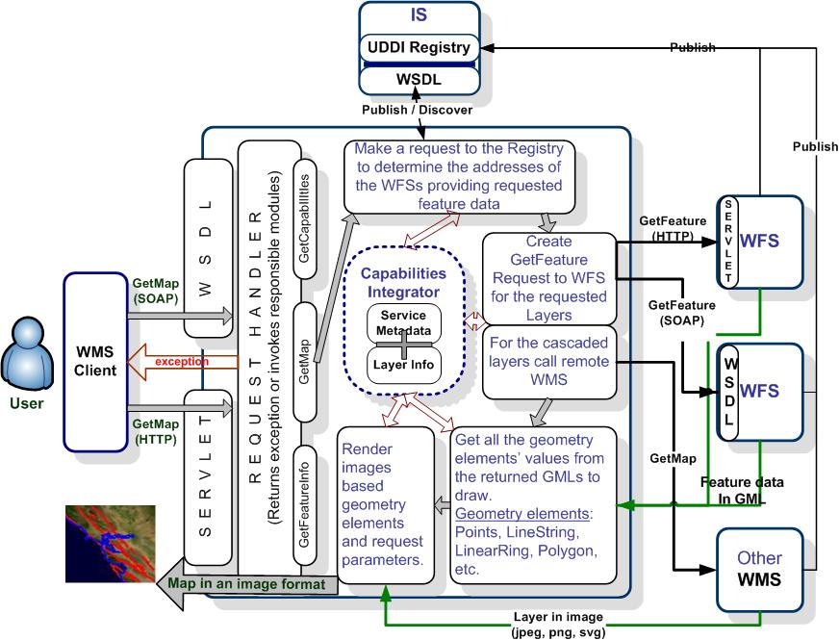
Figure 7 Brief Architecture showing basic servers and interactions to create maps

A Web Map Service provides three main services: getCapabilities, getMap and GetFeatureInfo. GetCapabilities and getMap are required to produce a map, and GetFeatureInfo is an optional metadata service. In this section, we only give information about the workflow of producing maps. For more details about our Web Map Service implementation, please see [56].
Maps are created upon a specific request (getMap) from the clients. Chained processes to produce maps are illustrated in Figure 7. After getting the getMap request, the Web Map Service goes over the flow depicted in Figure 7 and if everything succeeds, then returns the result as an image in a format defined in the getMap request. All the supported image formats are defined in Web Map Service capability document. Requests for the image formats should be made in accordance with the Web Map Service’s capability file. Clients should make first getCapabilities request to be able to set appropriate parameters for their getMap requests.
Web Mapping Services are provided over the HTTP Get/Post and SOAP/HTTP protocol. Each of these access methods uses HTTP as its underlying protocol. The image is returned back to the Web Map Service Client as a SOAP attachment; the client invokes getMap through the Web Service interface. If the Web Map Service encounters any problem during handling of the request, it sends an exception message back to the Web Map Service Client. If the request is well formed, then the Web Map Service first parses the parameters and gets their values from the getMap. Depending on these parameters, Web Map Service might need to make some requests to some other Web Map Service services. Web Map Service first determines what layers are requested, in which bounding box, in which form, and so forth. After determining all the request parameters, it makes find_service and getAccess_point requests to IS to determine the WFS providing requested feature data. These requests are done as SOAP messages to IS service interfaces which are implemented as Web Services. GetAccess_point returns the Web Service access point address of the WFS that provides the requested feature. Web Map Service makes getFeature request to the returned Web Feature Service and gets the requested feature data in GML format. The Web Map Service derives geometry elements from the GML file to visualize the feature data. These geometry elements in GML are Point, Polygon, LineString, LinearRing, MultiPoint, MultiPolygon, MultiGeometry, etc. At each step of the process displayed in the figure, Web Map Service modules are checked against the Web Map Service’s capabilities file. Capabilities file keeps information about the service metadata and provided layers.

AJAX Approaches
This section explains the integration framework which is designed for browser based web applications using Web Services. It enables users to utilize AJAX and Web Services advantages. For the detailed information about the architecture and advantages of the system please see [57][Sayar_ajax2005].
AJAX uses HTTP GET/POST requests (through JavaScript’s XMLHttpRequest) for the message transfers (see (A) in Figure 8). Web Services use Simple Object Access Protocol (SOAP) as a communications protocol (see (B) in Figure 8). In order to be able to integrate these two different message protocols, we must converted the message format from one protocol to another. Since there is no ready to use common protocol to handle messages communications between AJAX and Web Services, we implemented a simple message conversion technique (see (C) in Figure 8). This essentially works by having the XMLHttpRequest communicate with a servlet, which in turn acts as a client to a remote Web service. This allows us to easily convert between SOAP invocations and HTTP POSTS. It also has the benefit of avoiding JavaScript sandbox limitations: normally the XmlHttpRequest object in the browser can only interact with its originating Web server.

Figure 8: (A) PureAJAX Approach, (B) Web Services Approach, and (C) Hybrid (AJAX + Web Services) Approach

Integrating Google Maps into Web Mapping Servers
As it is mentioned before, Web Map Service returns maps in the form of images such as JPEG, GIF and PNG. Web Map Service clients get the maps in image formats and overlays them. Ordinary Web Map Service clients cannot use maps coming from Google Map Servers. To solve this problem and use high performance Google maps in our Web Map Service applications and overlay different map layers coming from the common Web Map Service with the Google Maps, we created an intermediary Google Mapping Server. It takes Web Map Service compatible requests from the Web Map Service clients, converts these requests into a new form that real Google Map Server can understand. In contrast to Open Geospatial Consortium compatible getMap requests, Google Map server uses requests with different parameters such as zoom level, tile numbers and tile width.
In case of using intermediary Google Mapping Server (described in 4), cascaded proxy Web Map Service should be able to transform map layers from intermediary Google Server and other Web Map Service into a number of different projections and image formats (see Figure 9). So that it offers an integrated and dynamic view of geospatial data in a distributed environment.
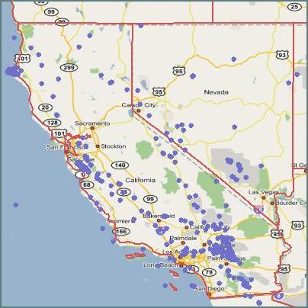
Figure 9: Google Map is overlaid California Earthquake seismic data and state boundary layers from the Web Feature Service. Seismic events locations (in response to calls to a Web Feature Service) are represented with points.

Integrating Open Geospatial Consortium and Google Maps
In the previous section, we discussed our efforts to build a) Open Geospatial Consortium (OGC) compatible Web Map Server, and b) methods for building clients to this service. The key division is between the thin client model (which requires requests for each user interaction) and the thick client model (which allows some processing and event handling on the client side). The former approach is more commonly seen with standard Web Map Service systems, while Google Maps exemplifies the latter. We discussed how we can integrate both techniques.
In this section, we take a look at a slightly different problem: using Google Maps as a Web Map Server. This requires reverse engineering the Google Map API. It has the advantage that it allows us to treat Google Maps as just another map server in a larger, integrated Geographical Information System deployment: the Google Maps themselves are wrapped and accessed through services rather than clients. This is useful for non-interactive processing that does not involve Web Browser clients.
Google Maps is a free web map server application and technology provided by Google at http://maps.google.com. It was first introduced in early 2005 and provided high resolution satellite images along with hybrid view which combines the illustrated map and satellite view. Google Maps client has a simple interface and creates map images using a large amount of JavaScript. As the user drags the map, the grid squares are downloaded from the server performing asynchronously network requests with JavaScript and XML (i.e. AJAX). The Google Maps features of providing user-interactive interfaces, a map API [31] and rich map images have been attractive to many third party areas [14] including scientific applications. However, Google Maps is not Open Geospatial Consortium compliant and, to our knowledge, there are no current Open Geospatial Consortium standard interfaces for layering, combining, or importing and exporting data between Google Maps and open mapping environments. Besides publishing Google Maps images through Web Map Service, others have introduced adding Open Geospatial Consortium based Web Map Server layers to Google Map client [33].
In this section, we introduce a Google Maps connector which provides Open Geospatial Consortium standard interfaces for higher interoperability in Grid computing environment. To accomplish this, we first investigate Google Maps mapping procedure. This information is meant for the proof of concept of Grid of Grids approach for seamless integration of real-world GIS systems. Some use cases that involve scraping the map images from Google’s servers may be against the terms of service, so it is advised that these be reviewed. For more information on the inner workings of Google Maps, see [42][32].

Map Tiles
Google Maps are made of dozens to thousands of tile images, depending on the zoom level. Google Maps uses 256x256 pixel tiles for their map images. Each Google tile has corresponding latitude, longitude and zoom Value. These are represented by x, y, and zoom. Here is what a tile path from Google showing San Francisco looks like:
http://mt.google.com/mt?v=w2.6&x=20&y=49&zoom=10 (A)
The x and y coordinates specify the location at the given zoom level; zoom = 0 is the highest possible, and zoom is a logarithmic scale. The value ‘v=’ is version number and as of the date of this paper, it is w2.6. To get the x, y tile number, we compute the address of the tile which contains the given coordinates and zoom level, as well as their pixel address on the entire map. Next, based on the tile number and zoom level, find the minimum and maximum x, y pixel on the entire map. The later is used to crop part of a map image before outputting to the requestor. Computing zoom level will discuss later in this section.
Processing satellite maps is totally different than Google illustrated map. The satellite map tiles are also encoded as 256x256 jpegs and its URL showing San Francisco is look likes:
http://kh.google.com/kh?v=3&t=tqtsqrqt (B)
A satellite URL ‘v=’ parameter value is v=3 as of the date of this paper. The last parameters of the satellite URL is a string of letters encoding the location of a particular map square. This simple hierarchical structure is known as quad tree. Google labels the four quadrants q, r, s & t. The topmost tile contains the entire world map, and is referenced with an address of t, adding an s to this selects the bottom-right quadrant of the map, adding r to the top-right of that map, and adding q to the top-left. This continues inside each quadrant until the maximum detail is reached. Since we know the x, y, zoom values of the Google Map tile, it is easy to find corresponding q, r, s, t based on their quad tree characteristic. The detailed conversion information between these is available at [72].
A Google Map connector provides a parameter layers to distinguish illustrated and satellite map. The form of the URL-encoded request showing satellite map of California with bbox values is as follows.
http://GoogleMapsConnectorServer/cgi-bin/wms.cgi?layers=satellite& height=500&width=400&bbox=-124.85,32.26,-113.56,42.74 (C)
The width and height values are optional. If these are omitted, a returned map image is not cropped or resized.

Bounding box and zoom level
We need at least bbox, width and height interfaces to comply with Web Map Server specifications. The bounding box (bbox) is a set of four comma-separated decimal, or integer values. When the map projection is a Platte Carre of longitude and latitude coordinates, X refers to the longitudinal axis and Y to the latitudinal axis.
Based on the given bounding box value, finding the matching zoom level of the Google Map is necessary to compute tile coordinates. Information explaining a selection box for Google Maps is available at [39]. Based on this script file, an array of 18 zoom-level-area data is used to determine the correct zoom level of the Google Map. With given bbox values, the size of the (pixel) area is
areaSize = abs{($maxX-$minX)*($maxY-$minY)}.
When
zoomLevelAreaData[i] < areaSize < zoomLevelAreaData[i+1],
the corresponding index i is the zoom level. For instance, the size of the bbox of above URL-encoded request (C) is 118.3192 and its zoom level is 11. Here is a sample of area data;
zoomLevelAreaData = (0.000044782205316291115, 0.00017912880077214252, 0.0007165152014842625, 0.0028660594751396392, 0.01146422704873143, 0.04585681809304249, 0.18342716717851734, 0.7337069855714002, 2.9348010091822907, 11.738430973389503, 46.94408531995497, 187.64344725577126, 748.5823131256056, 2961.473356669126, 11242.849261491675, 36095.54334444813, 86649.85238489839, 177134.48041308092)

Implementation Details
We have implemented Open Geospatial Consortium compliant Google Maps connector using XAMPP [71] to facilitate the installation of a free cross platform Web server able to serve dynamic pages. This software package contains Apache, MySql, PHP and Perl. To crop, resize and convert map images, PerlMagick is adopted. PerlMagick is a free graphics module designed to be used online. It is based upon the ImageMagick library and uses the module to read, manipulate, or write an image or image sequence from within a Perl script. This makes it very suitable for Web CGI scripts and can be used for the automated and interactive manipulation of images.
Map tiles can be fetched with wget, or from a Perl script, etc. All accessed map tile images including satellite are cached each time on the Google connector server to run to save time on future runs. After grabbing all corresponding tiles, combining these together is needed. There are couples of script files available providing this feature on the web [62]. Based on this, a Perl script using ImageMagick command has been used to gather and stitch image together. However, this script needs additional functions to crop and resize the map images based on the tile pixel and given width and height values.
To return a map image to the requestor, it must be treated as binary mode otherwise some part of image is garbled. We use Perl's built-in function binmode to indicate that we are outputting binary data. System command call inside Perl script is not working on Windows when it is used as CGI in Tomcat. Therefore Fedora 4 has been used for the web server and CGI scripts.
One must be careful when integrating maps with different projection conventions. As discussed at the end of previous section, NASA’s OnEarth map service is based on Plate-Carree projection and Google Maps are based on Mercator map projection. For relatively small areas (a bounding box with sides of few hundred kilometers, such as is required to show the western coast of the United States, Figure 9), the difference is relatively small area comparing a whole earth, and the gap of the map layers between these two projections is negligible. However, transforming between those two to support general GIS application should be provided for the large area maps or more precise multilayer display in the future.

Streaming Services for GPS and Other Data
Recent technological developments have allowed sensors to be deployed in a large variety of application domains. Environmental monitoring, air pollution and water quality measurements, detection of the seismic events and understanding the long-term motions of the Earth crust are only a few areas where the extent of the deployment of sensor networks can easily be seen. Extensive use of sensing devices and deployment of the networks of sensors that can communicate with each other to achieve a larger sensing task will fundamentally change information gathering and processing [19]. However, the rapid proliferation of sensors presents unique challenges different than the traditional computer network problems.
Several studies have discussed the technological aspects of the challenges with the sensor devices, such as power consumption, wireless communication problems, autonomous operation, and adaptability to the environmental conditions [3][37]. Here we describe service architecture to support real-time information gathering and processing from GPS sensors by leveraging SOA principles and open GIS standards.
Most scientific applications that couple high performance computing, simulation or visualization codes with databases or real-time data sources require more than mere remote procedure calls that typical Web Services rely upon. These applications are sometimes composite systems where some of the components require output from others and they are asynchronous--it may take hours or days to complete. Such properties require additional layers of control and capabilities from Web Services which introduces the necessity for a messaging substrate that can provide these extra features. In the next section we discuss the application of NaradaBrokering (a topic based publish-subscribe messaging system that can provide us several useful capabilities) for managing and serving real-time streaming data.

Streaming with NaradaBrokering
NaradaBrokering [49][22] provides two related capabilities. First, it provides a message oriented middleware which facilitates communications between entities (which includes clients, resources, services and proxies) through the exchange of messages. Second, it provides a notification framework by efficiently routing messages from the originators to only the registered consumers of the message in question.
NaradaBrokering facilitates the idea of loosely coupled systems by supporting asynchronous communication and it can be used to support different interactions by encapsulating them in specialized messages called events. Events can encapsulate information pertaining to transactions, data interchange, method invocations, system conditions and finally the search, discovery and subsequent sharing of resources.
Some of the important features of NaradaBrokering can be summarized as follows:
- Ensures reliable delivery of events in the case of broker or client failures and prolonged entity disconnects.
- Provides compressing and decompressing services to deal with events with large payloads. Additionally there is also a fragmentation service which fragments large file-based payloads into smaller ones. A coalescing service then merges these fragments into the large file at the receiver side.
- Provides support for multiple transport protocols such as TCP (blocking and non-blocking), UDP, SSL, HTTP, RTP, HHMS (optimized for PDA and cell-phone access) and GridFTP with protocol chosen independently at each link
- Implements high-performance protocols (message transit time of 1 to 2 ms per hop)
- Order-preserving optimized message delivery
- Quality of Service (QoS) and security profiles for sent and received messages
- Interface with reliable storage for persistent events, reliable delivery via WS-Reliable Messaging.
- Discovery Service to find nearest brokers /resources
In summary, NaradaBrokering supports many-to-many messaging for distributed systems, where messages may range from SOAP envelopes to binary packets. The connections between publishers, brokers, and subscribers are “virtualized” in that we can choose between different protocols for delivery and between different qualities of service (guaranteed delivery, once-only delivery, replayed delivery, secure delivery, and so forth). For a general discussion of messaging substrates for Grids and Web Services, see [22][24].
In the following sections, we describe how NaradaBrokering stream management software may be used to deliver real-time data through successive filters to consuming applications. We are developing this particularly with the goal to support on-line versions of the RDAHMM application [34], which may be potentially be used to detect aseismic events in GPS data streams.

Sensor Grid Components
We now examine the components for integrating geographical sensor sources with NaradaBrokering. The architecture is summarized in Figure 10. In summary, the core of the system is to implement filter chains that convert or otherwise process the incoming data streams. These filters serve as both subscribers (data sinks) and publishers (data sources). Topics are used to organize different data stream sources into hierarchies.
Sensor Grid Agent: This service provides interfaces for clients to access/query available data products. It may have both visual (maps) and textual (HTML forms) elements to help users construct queries. The basic idea behind this service is to simplify clients’ communication with the SensorGrid. A scientist may use this agent to request sensor observations for a particular geographical region and time. For instance by selecting a rectangular region on an interactive map and entering time boundaries we can construct queries such as “Get GPS measurements for San Diego County for September 2005”. In addition to helping users construct queries for archived geospatial data Sensor Grid Agent displays available real-time sensors as well.
Information Service: Web Services are stateless; they do not keep session related information. We need to use additional services to provide session support. Sensor Grid architecture consists of multiple independent Web Services which do not keep any information about each other. The Information Service is used to keep several futures of the services in the system to make easy access to these services possible. For instance all Open Geospatial Consortium conformant data services provide a capabilities document (in XML) that describes the types and constraints of the data they can serve. Information services provide a registry through which the users can locate available services in the system and discover their futures. For more on our information services work, see Section 6 and [2]. This has GIS specific extensions appropriate for our architecture.
Web Feature Service: WFS provides a repository for GIS archival data and is described in Section 2. In addition to the streaming support described there, we are investigating using binary XML to provide highly efficient XML representations that should provide significant performance enhancements in current services.
Sensor Collection Service: Open Geospatial Consortium Sensor Web Enablement is intended to be a revolutionary approach for exploiting Web-connected sensors such as flood gauges, air pollution monitors, satellite-borne earth imaging devices etc. The goal of SWE is to creation of Web-based sensor networks. That is to make all sensors and repositories of sensor data discoverable, accessible and where applicable controllable via the WWW [63][13].

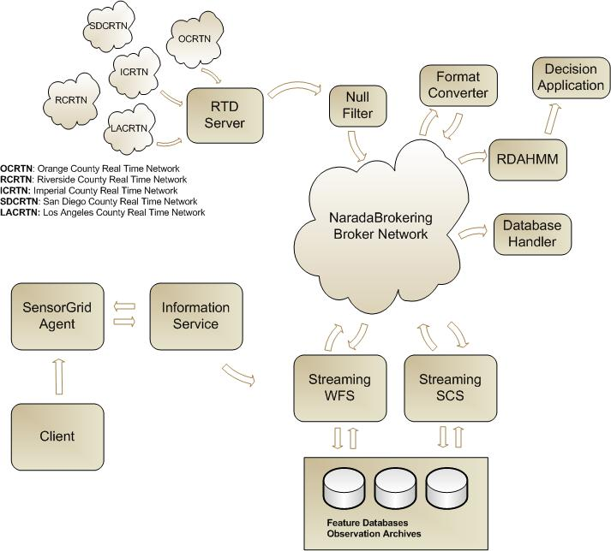
Figure 10 Major Components of Sensor Grid architecture are shown: filters are used to convert data formats obtained from the GPS RTD server and can be delivered to numerous clients, including data analysis applications (RDAHMM), archival feature servers, and user interfaces. Clients control subscriptions through information services.
Sensor Collection Service [58] is a service to fetch observations from a sensor or constellation of sensors. Provides real time or archived observed values. Clients can also obtain information that describes the associated sensors and platforms. This is the intermediary between a client and a sensor collection management environment. We will research using publish/subscribe based systems for real-time data delivery using the Sensor Collection Service.

Filter Chains
To process sensor streams in real-time we are researching use of publish/subscribe based messaging system. We will test deploying geo-processing applications and format converters as successive filters. We can leverage NaradaBrokering topics for publishing for this purpose.
GIS applications consume data in different formats. To support various types of geo-processing tools we need to provide data in different formats, for this reason we can deploy format converters successively on the NaradaBrokering topics.

Typical Query Scenario
The client makes a sensor observation request with some spatial and temporal constraints, i.e. “Get GPS positions for San Diego County for September 2005”. Depending on the nature of the query IS may take two actions; if the query is for archived sensor data then it requests data from the Observation Archives using WFS and returns it to the client. But if the client wants to access real-time data then it returns a data handler which contains the broker information and topic name for the sensor. Also depending on the size of the archived data SCS may choose one of two options for data transfer; if the result size is relatively small then it is returned via SOAP message, otherwise NaradaBrokering is used. SCS also keeps information about the sensors themselves. This information is encoded in SensorML [13]. After receiving the broker address and the topic name, client may subscribe to the NaradaBrokering server to receive real-time data.

Real time streaming support for GPS Networks
The Global Positioning System has been used in geodesy to identify long-term tectonic deformation and static displacements while Continuous GPS has proven very effective for measurement of the interseismic, coseismic and postseismic deformation. [12]. Today networks of individual GPS Stations (monuments) are deployed along the active fault lines, and data from these are continuously being collected by several organizations. One of the first organizations to use GPS in detection of the seismic events and for scientific simulations is Southern California Integrated GPS Network (SCIGN) [59]. One of the collaborators in SCIGN is Scripps Orbit and Permanent Array Center (SOPAC) [61]which maintains several GPS networks and archives high-precision GPS data, particularly for the study of earthquake hazards, tectonic plate motion, crustal deformation, and meteorology. Real time sub-networks maintained by SOPAC include Orange County, Riverside County (Metropolitan Water District), San Diego County, and Parkfield. These networks provide real-time position data (less than 1 sec latency) and operate at high rate (1 – 2 Hz). Raw data from the GPS stations are continuously collected by a Common Link proxy (RTD server) and archived in RINEX files.
The data collected from the GPS stations are served in 3 formats:
RAW: For archiving and record purposes, not interesting for scientific applications, not available in real-time.
RTCM: Published real-time and no records are kept. This is useful for RTCM capable GPS receivers as reference.
Positions: Positions of the stations. Updated and presented every second. GPS Time Series can be produced using these positions and they can be in different epochs such as hourly, daily etc.
The most interesting of these formats to our application scientist collaborators is the position information, which can be used in scientific calculations, simulation or visualization applications. The RTD server however outputs the position messages in a binary format called RYO. More importantly, RTD signals include all GPS stations (typically 5-15) in a particular network.
To receive station positions, clients open a socket connection to the RTD server. An obvious downside of this approach is the extensive load this might introduce to the server when multiple clients are connected, so the many-to-many publishing style discussed above also addresses this problem.
After the RTD server receives raw data from the stations it applies some filters and for each network generates a message. This message contains a collection of position information for every individual station from which the position data has been collected in that particular instant. In addition to the position information there are other measurements in a message such as quality of the measurement, variances, etc.

Chain of Filters
We have developed several filters to decode and present the original RYO data in different formats. Once we receive the original binary data we immediately publish this to a NaradaBrokering topic (null filter), another filter that converts the binary message to ASCII subscribes to this topic and publishes the output message to another topic. We have developed a GML schema to describe the GPS position messages. Another filter application subscribes to ASCII message topic and publishes GML representation of the position messages to a different topic. This approach allows us to keep the original data intact and different formats of the messages accessible by multiple clients in a streaming fashion.
We have developed a GML Schema to encode the data streams. This is based on RichObservation type, which is an extended version of GML 3 Observation model [48]. This model supports Observation Array and Observation Collection types which are useful in describing SOPAC Position messages since they are collections of multiple individual station positions. We follow strong naming conventions for naming the elements to make the Schema more understandable to the clients. An example is given in the Appendix of this paper, and more detail is available from [60].
Decoding RYO Messages
RYO Message Type 1 (Figure 11) starts with a 5-byte Header which is followed by a 47-byte GPS Position message. Three types of optional blocks may follow the Position Message and a 2-byte checksum is located at the end of the message.
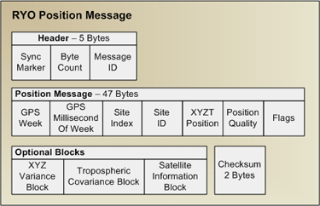
Figure 11 RYO Type 1 Message Parts
A non-blocking Java Socket connection is opened to RTP server to collect RYO messages. We use thread programming techniques for this purpose. We have developed an RYO Decoder application which uses binary conversion tools to convert RYO messages into text messages. Furthermore, since we do not expect clients to know about the GPS time format we convert GPSWeek and GPSmsOfWeek values to Gregorian calendar format (i.e. 2005-19-07/04:19:44PM-EST). Additionally since we anticipate some clients to expect position information in terms of Latitude and Longitude, we calculate Latitude, Longitude and Height values from XYZT Position.

GML Schema for Position Messages and Data Binding
We developed a GML conformant Schema to describe Position Messages. The Schema is based on RichObservation type which is an extended version of GML3 Observation model [48]. This model supports Observation Array and Observation Collection types useful in describing SOPAC Position messages since they are collections of multiple individual station positions. We follow strong naming conventions for naming the elements to make the Schema more understandable to the clients.
We used Apache XML Beans for data binding purposes and created an application that reads ASCII position messages and generate GML instances using the code generated by XML Beans. SOPAC GML Schema and sample instances are available here: http://www.crisisgrid.org/schemas. We give a sample XML instance created according to the above schema from GPS station measurements in Appendix 10.1.

Integrating NaradaBrokering
After we have position information in three different formats we used NaradaBrokering to provide real-time access to data. We wrote filters to publish RYO, ASCII and GML formatted position messages to different NaradaBrokering topics. Clients can subscribe to any of these topics to receive position messages in that particular format. Figure 12 depicts use of NaradaBrokering Topics in the system, and provides a zoomed-in view of Figure 10.

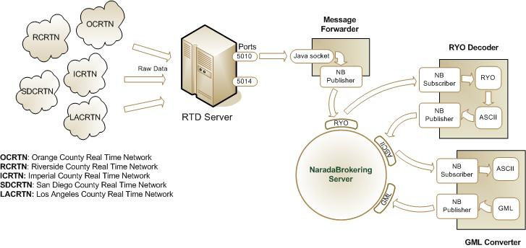
Figure 12 SOPAC GPS Services

GPS Station Messages and Filters
As discussed above, station messages collected from GPS stations have several sub-sections. We have developed several filters that simplify or convert the messages since not all the parts of a position message are needed by most clients. We describe such a client that displays real-time station positions on Google Maps in the next section. Here we give sample output messages from different filters:
The first filter in our architecture is a null filter which forwards original RYO binary messages from RTD server to a NaradaBrokering topic. The output of this filter is a binary message.
The second filter is called ryo2ascii which converts RYO messages to ASCII and publishes to a NB topic. An example of the decoded RYO message is shown in Appendix 10.2. The ryo2ascii filter converts the whole RYO message and does not filter out anything.
Most of the information included in a position message is unnecessary for many clients, so we can apply further filtering. For instance we have developed a user interface to display the current positions of the stations on a map. For this particular application we only need station names and their positions in terms of latitude and longitude. For this client interface we have developed ryo2pos filter which converts RYO messages to simple position messages. Following is a sample output message from ryo2pos filter:
LEMA 2005-12-12 03:58:37PM-EST 36.29202028791537
-119.78237425030088 35.90217063464758

Here we only include Station name, date-time and latitude, longitude and height values in the message. This small application is an example of how individual filters can be chained using NaradaBrokering to achieve specific tasks. Another example application integrated using this approach is RDAHMM which only requires X, Y, Z or Lat, Lon Height values for a given station. We can easily write a filter to strip unwanted parts from the message and output only the position information.

Current System Configuration
Currently the system is being tested for eight GPS networks with only one NaradaBrokering server installed on xsopac.ucsd.edu:3045. However we are planning to deploy multiple, distributed brokers for further performance tests. Table 4shows the latest information about these networks.
Table 4 Supported GPS networks.
Network Name | RTD Server Address | Stations
LACRTN | 132.239.154.69:5014 | vtis, hbco, cvhs, lors, tabl, ucsb, azu1, csdh, dyhs, vdcy, uclp, cit1, lapc
PARKFIELD | n/a | hogs, pomm, mida, crbt, carh, land, mnmc, lows, rnch, cand, masw, tblp, hunt
OCRTN | 132.239.154.69:5010 | oeoc, cat2, whyt, trak, sacy, mjpk, scms, sbcc, fvpk, blsa
SDCRTN | 132.239.154.69:5013 | p486, monp, raap, mvfd, p472, sio5,  dvlw, pmob, p480, dsme, oghs
IMPERIAL | 132.239.154.69:5012 | slms, crrs, usgc, dhlg, glrs
DVLRTN | 132.239.152.72:8001 | dvle, dvne, dvsw, dvse, esrw, dvls, dvnw, ese2
CVSRN | 132.239.154.69:5015 | coma, rbru, lema
RCRTN | 132.239.154.69:5011 | pin2, widc, kyvw, psap, cotd, pin1,  mlfp, cnpp, bill, ewpp, azry

Table 5shows the NaradaBrokering topic names for several filters.
Table 5 GPS station topics for RYO and ASCII formats.
Network Name | RYO Topic  (null filter Publishes to) | ASCII topic  (ryo2ascii filter Publishes to)
LACRTN | /SOPAC/GPS/LACRTN/RYO | /SOPAC/GPS/LACRTN/ASCII
PARKFIELD | /SOPAC/GPS/PARKFIELD/RYO | /SOPAC/GPS/PARKFIELD/ASCII
OCRTN | /SOPAC/GPS/OCRTN/RYO | /SOPAC/GPS/OCRTN/ASCII
SDCRTN | /SOPAC/GPS/SDCRTN/RYO | /SOPAC/GPS/SDCRTN/ASCII
IMPERIAL | /SOPAC/GPS/IMPERIAL/RYO | /SOPAC/GPS/IMPERIAL/ASCII
DVLRTN | /SOPAC/GPS/DVLRTN/RYO | /SOPAC/GPS/DVLRTN/ASCII
CVSRN | /SOPAC/GPS/CVSRN/RYO | /SOPAC/GPS/CVSRN/ASCII
RCRTN | /SOPAC/GPS/RCRTN/RYO | /SOPAC/GPS/RCRTN/ASCII

Similarly the ryo2pos filter subscribes to the appropriate RYO topic and publishes to for instance /SOPAC/GPS/LACRTN/POS topic.

Displaying GPS Station Positions Using AJAX Methods
To demonstrate the technologies discussed earlier we have developed several JSP based client interfaces leveraging AJAX techniques. The user interfaces we discuss here demonstrate use of a topic based publish-subscribe messaging for managing and serving real-time data coupled with several real-time data filters.
AJAX or Asynchronous JavaScript and XML is a relatively new web development technique for creating highly interactive web interfaces. AJAX is not a technology by itself rather a name for using a collection of several well-known technologies together. It employs XHTML or HTML, JavaScript, DOM and XMLHttpRequest. XMLHttpRequest is originally developed by Microsoft and available since Internet Explorer 5.0. This object is used to exchange data with the server asynchronously.
Traditionally user’s every action generates an HTTP request; in the case of AJAX these requests are JavaScript calls to the server side which allows only the related portion of the web pages to refresh instead of whole page to be submitted to the server and refreshed. This technique allows creation of powerful user interfaces and uninterrupted browsing experience for the users.
For this demo architecture we use an online XML document (an RSS-like feed) provided by SOPAC to retrieve up-to-date list of available GPS stations [36]. This document contains several properties of each station:
<station>
<network>
<name>LACRTN</name>
<ip>132.239.154.69</ip>
<port>5014</port>
</network>
<id>vtis</id>
<longitude>-118.294</longitude>
<latitude>33.713</latitude>
<status>up</status>
</station>

This format is much more simplistic than the GML encoding discussed earlier, but it may be easily integrated with the JavaScript DOM parser used in AJAX. Figure 13 shows all of the GPS stations managed by SOPAC. The GPS networks are color-coded.
Our user interfaces first retrieves the XML document from SOPAC and creates a form table for the user to select a network. Once the user selects a network and clicks the Submit button a server side Java Bean subscribes to the appropriate NaradaBrokering topic and starts receiving position messages at the same time user is forwarded to the second JSP page which contains a Google Map. Figure 14 depicts the use of AJAX techniques to update station positions on the map and display the actual real-time latitude-longitude values. GPS stations which did not publish a position message in the previous epoch are represented with red markers while online stations are green.

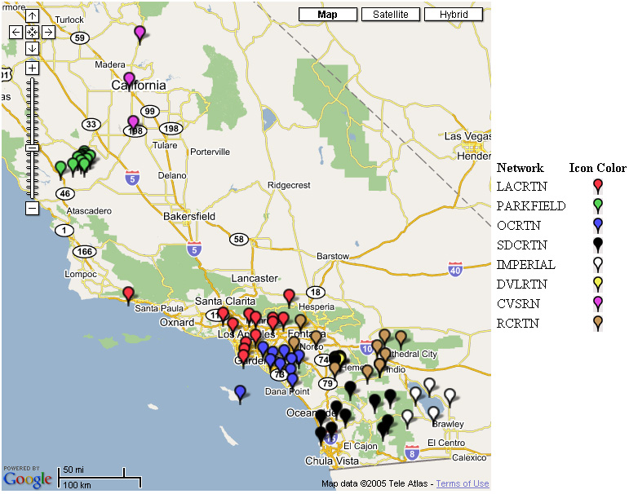
Figure 13 SOPAC GPS networks in Southern California
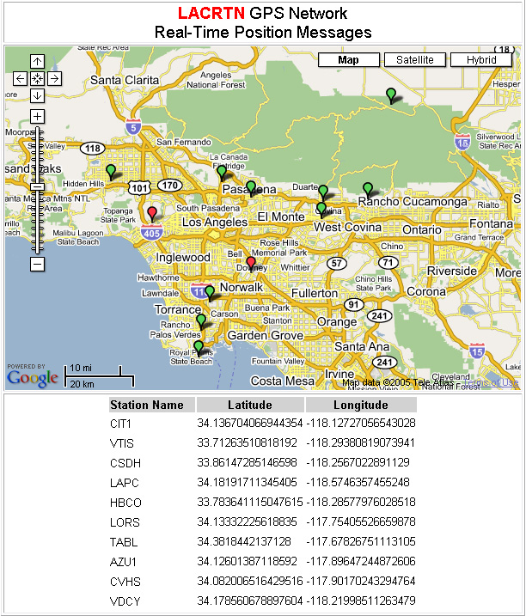
Figure 14 Status and positions of GPS stations data streams are displayed using Google mapping techniques.

Conclusion and Future Work
The work described in this section will form the foundation of many future applications. The simplest of these (shown in Figure 14) is useful as a heartbeat monitor for GPS networks. However, this is primarily a proof of concept and verification that the fundamental system described above is operational. We are currently integrating individual GPS network station feeds with the aforementioned RDAHMM event-detection code (itself wrapped as another filter). Our hope is to be able to use RDAHMM for the near real-time detection of GPS signal changes near earthquake faults.

Information Services to Support Geographical Information System Grids
Geographical Information System-based Grid applications introduce a large amount of services managed by different organizations or individuals to let users acquire, process and share geospatial-data, resources and geo-processing applications.
As Web Service Architecture principles [79] have gained importance, an emerging need has appeared for methodologies to locate desired services that provide access and data mining capabilities to geospatial data. Also, as these services interact with each other within a workflow session to produce a common functionality such as earthquake forecasting [64], another emerging need has also appeared for storing/querying transitory metadata needed to describe session state information.
In service-oriented Grids, Information Services support the discovery and handling of both static and session-related, transitory metadata associated to services. Here, we discuss the limitations in existing Information Services and introduce a novel system as a solution. We design a hybrid Information Service supporting both large amounts of relatively slowly varying data and rapidly updated, dynamically generated information. To do this we use and extend the following two Web Service standards: Universal Description, Discovery, and Integration (UDDI) and Web Services Context (WS-Context) in our design.
We utilize existing UDDI Specifications [65] and design an extension to UDDI Data Structure and UDDI XML API to be able to associate both prescriptive and descriptive metadata with service entries. There have been some solutions introduced to provide better retrieval mechanism by extending existing UDDI Specifications. UDDIe [66] project introduces the idea of associating metadata and lifetime with UDDI Registry service descriptions where retrieval relies on the matches of attribute name-value pairs between service description and service requests. UDDI-M^{T} [67] improves the metadata representation from attribute name-value pairs into RDF triples. A similar approach to leverage UDDI Specifications was introduced by METEOR-S [44] project which identifies different semantics when describing a service, such as data, functional, quality of service and executions. In our design, we also extend the UDDI Information Model, by providing an extension where we associate metadata with service descriptions similar to existing solutions where we use name-value pairs to describe characteristics of services. Apart from the existing methodologies, we provide both general and domain-specific query capabilities. An example for domain-specific query capability could be XPATH queries on the auxiliary and domain-specific metadata files stored in the UDDI Registry.
The main intended use of our approach is to support information in dynamically assembled workflow-style Grid applications where services are tied together in a dynamic workflow to solve a particular problem. Our particular approach to service orchestration is described in Section 7. There are varying specifications, such as WSRF, WS-Context, WS-Transfer, and WS-Metadata Exchange, introduced to define stateful interactions among services. Among them, we choose WS-Context Specifications [70] to create a metadata catalog system for storing transitory metadata needed to describe distributed session state information. Unlike the other specifications defining service communications, WS-Context models session metadata repository as an external entity where more than two services can easily access/store highly dynamic metadata.
We highlight the following problems in Information Services supporting Grid Applications. First, classic Grid Information Services are not built along a model that can support dynamically assembled services. Second, existing solutions to Information Services, i.e., data-hosting systems, focus on storing information on pre-defined locations and ignore changing user demands when making decisions on metadata access and storage. Third, classic Grid Information Services do not provide a uniform programming interface for publishing and discovery of both dynamically generated and static information.
We therefore see this as an important area of investigation. Here, we research/investigate a novel architecture for fault tolerant and high performance Information Services, maintaining dynamic session-related metadata of widely distributed services and providing uniform interface to both interaction-independent and session-related context.

An Integrated Information System Architecture
We designed and built a novel architecture [1] for a WS-Context complaint metadata catalog service supporting distributed or central paradigms. The main intended use of our approach is to support information in dynamically assembled Grids where services are tied together in a dynamic workflow to solve a particular problem. Also, the intended scale for our design is in the order of thousand entities that are participating in a workflow session.
We based the programming interface of our system on two widely used specifications: WS-Context and Universal Description, Discovery and Integration (UDDI). We extend both specifications to provide advanced capabilities to support handling and discovery of not only quasi-static, stateless metadata, but also session related metadata. Our approach is to utilize the existing state-of-art systems for handling and discovering static metadata and address the problems of distributed management of dynamic metadata.
Our architecture consists of various modules such as Query and Publishing, Expeditor, Access, Storage and Sequencer Modules. The Context Query and Publishing Modules receive/process client requests through a uniform Web Service interface for publishing/discovering dynamic and static metadata. The Expediter Module is a generalized caching mechanism. One consults the expediter to find how to get (or set) information about a dataset in an optimal fashion. The Access Module supports request distributions by publishing messages to topics in a topic-based publish-subscribe based brokering network. It locates the nodes that are closest in terms of network distance with lowest load balance from the node requesting access to the communal node in question. The Storage Module runs storage algorithm which decides whether a metadata is to be replicated. If the metadata is decided to be replicated, then Storage module advertise this replication by multicasting it to available peers through publish/subscribe mechanism. The Sequencer Module ensures that an order is imposed on actions/events that take place in a session. The Sequencer Module interacts with Storage Module and labels each metadata which will be replicated in this replicated metadata hosting environment. For further detail reading on design details and architecture of Information Services, we refer the reader to another paper [1].

Implementation of UDDI and WS-Context complaint XML Metadata Services
We implemented a centralized version of Information Services handling discovery of both static and dynamic, session related metadata. We use/extend both UDDI and WS-Context specifications in our design.
The Information Service applies following programming logic to serve client requests, upon receiving querying/publishing metadata requests. First, the system separates dynamic and static portions of the metadata. Here, static metadata could be throughput or location of a service whereas dynamic metadata could be session identifier pointing to a workflow session in which the service is participating. Second, the system delegates the task of handling and discovery of static portion of the metadata to one of the existing state-of-art technologies handling with static metadata such as UDDI, a widely accepted and WS-I compatible standard. As for the UDDI Service, we use our own implementation of Extended UDDI XML Metadata Service. We refer the reader to another paper [2]. Third, the system itself provides handling and discovery of dynamic metadata, using session-related portions of the metadata query.
Here, session related metadata is short-lived and dependent on the client. The Information Service keeps track of context information shared between multiple participants in Web Service interactions. The context here has information such as unique ID and shared data. It allows a collection of action to take place for a common outcome.
Each session is started by the coordinator of an activity. The coordinator service publishes the session metadata to Information Service and gets a unique identifier in return. The uniqueness of the session-id is ensured by the Information Service. Sessions can obviously be composed from other “sub” sessions hierarchically. Here, each session is associated with the participant services of that session. Dynamic session information, i.e. context, travels within the SOAP header blocks among the participant entities within the same activity. In order to correlate (collective) work participants may propagate more contexts using the same session-id created by the coordinator.
Upon receiving the system response to a request for session creation, the user can store the context associated to the unique session identifier assigned by the Information Service. This enables the Information Service to be queried for contexts associated to a session under consideration. Each context is stored with a lifetime as the Information Service is being used as third-party repository for dynamic information.

Example Usage
In order to present the applicability of our system, we outline the following example usage scenarios. The first example use domain is the Pattern Informatics GIS Grid. This example illustrates a workflow based GIS Grid Application where session metadata needs to be managed to enable services to better interact with each other for common outcome. The second usage is as a persistent metadata storage repository for user interactions with a computational Web portal. The user’s interactions with the browser interface must be stored for later retrieval and can be used to establish the provenance of certain results. The third usage domain is the Hand-Held Message Service and Handheld Flexible Representation Project [46]. This project investigates a fast Web Service communication model in collaborative mobile computing environment.
In the first example usage domain, Information Services are used for storing transitory metadata needed to describe distributed session state information. In the current test system, it is used to store information needed by a workflow engine (HPSearch) to orchestrate system interactions. The HPSearch is simply a scripting environment for managing distributed workflows. Also, geospatial data sources are available online through GIS enabled data services (WFS). These data services provide different data and data formats with varying spatial coverage. Here, Information Services provide domain specific metadata catalog for GIS domain and enable users to pose queries to locate GIS data.
In the second example application, Information Services are used as a lightweight, Web Services based archival data store. Typical Grid portal project such as our SERVO Project provide a computational Grid environment where users may upload input data to execute scientific applications on remote computers. The input data is usually given trough input form pages which are tedious to fill out and it is more likely that uses will have minor changes on the input parameters to a particular job and resubmit it later. The input data can be preserved as serialized Java Bean Objects to be reused later in user-system interaction. Here, each Java Bean Object is simply being stored as “context”, i.e., metadata associated with a session into WS-Context Information Service. Contexts may be arranged in parent-child relationships. When storing a context, we first create a session in the WS-Context Information Service. Here, a session can be considered an information holder; in other words, it is a directory where contexts with similar properties are stored. Similar to an access control list in a UNIX file system, each session directory may have associated metadata, called “session directory metadata.” Session directory metadata describes the child and parent nodes of a session. This enables the system to track the associations between sessions. One can create a hierarchical session tree where each branch can be used as an information holder for contexts with similar characteristics. This enables the WS-Context compliant Information Service to be queried for contexts associated to a session under consideration. Each context is stored with unlimited lifetime as the Context Store is being used as an archival data store.
The third example use scenario is fast Web Service communication model in mobile communication environment. These techniques may also potentially be used in improving the performance of more traditional Web Services. In this scenario, a user has a PDA, which is running a video conferencing application packaged as a “lightweight” Web Service. Such service could be a conferencing, streaming, or instant messaging service. Here, the Information Service is being used as a third party transitory metadata store, to store/maintain redundant parts of the SOAP messages which are being exchanged between the mobile service and its clients. This way, the size of SOAP messages is being minimized to make the service communication much faster. The redundant parts of a SOAP message can be considered as XML elements which are encoded in every SOAP message exchanged among two services. These XML elements are stored as “context”, i.e. metadata associated to a conversation”, into WS-Context store. Each context is referred with a system defined URI where the uniqueness of the URI is ensured by the Information Service. The corresponding URI replaces the redundant XML elements in the SOAP messages which in turn reduce the size of the message for faster message transfer. Upon receiving the SOAP message, the corresponding parties in service conversation interact with WS-Context compliant Information Service to retrieve the context associated with the URIs listed in the SOAP message.

Managing and Scripting Web Services: HPSearch

Introduction
As we discussed in the previous section and the introduction, Web Services provide atomic functionality for distributed systems, but to integrate a collection of such services into a Grid, we need to address problems of interaction, information, and orchestration. Recently, the Web Service community has developed different languages to address the question of invoking multiple related Web Services, collectively termed as workflow. Various languages such as BPEL [15] and tools such as Triana [68] and Kepler [40] have demonstrated success in connecting disparate services together. Data transfer between services is typically handled by transferring files using tools such as GridAnt [35].
A growing number of applications involve real-time streams of information that need to be transported in a dynamic, high-performance, reliable and secure fashion. Critical infrastructure applications also mandate real-time processing of data and visualization of results. [Section 5.3] is an example of application that uses real-time inputs from distributed sensors. Assuming that the sources, sinks and data processing elements for these data streams are Web or Grid Services, we need to transparently manage shipping of data in a streaming fashion through a chain of these services. This would enable existing data processing applications to be utilized as Web Services possibly with minor modifications.
HPSearch [28] primarily addresses this requirement of data stream management. HPSearch has been used to demonstrate [29] the use of this system for processing real-time data for critical infrastructure applications. HPSearch also enables connecting disparate services for data analysis in real-time. In the sections to follow we show how HPSearch uses a scalable, fault-tolerant middleware, NaradaBrokering, to construct Web Services that can process data in streaming fashion.
As mentioned earlier, HPSearch uses NaradaBrokering to route data in streams. However, to setup the distributed application, one needs to setup and deploy a broker network topology. Typical characteristics of this network topology is providing alternate connection points, multiple interconnect routes and failure detection. To help manage these characteristics, HPSearch provides management tools for deploying and managing the broker network at runtime. Further to access various services in the routing substrate such as replay of events, special configuration might be necessary.
Thus, HPSearch provides dual functionality: 1) it provides a high-level language suitable for application developers to program workflows in a Grid that utilizes the messaging middleware, and 2) it provides tools to manage the messaging middleware.

Architecture
HPSearch uses a scripting based architecture to provide management console functionality. The basic HPSearch architecture is shown in Figure 15.
Broker
Network
(Distributed Brokers)
WSProxyClient
WFE
Resource
DB Connector
Request Handler
WFE
WFE
Flow Handler
WSProxy
Wrapped
Service
WSProxy
Wrapped
Service
WSProxy
Wrapped or programmed service
HPSearch Shell
…
...
Figure 15 HPSearch architecture consists of a shell for creating workflow scripts, a workflow engine(WFE) that processes the scripts, and Web Service proxy wrappers that provide NaradaBrokering ports as well as more traditional HTTP ports . See text for a full description of the system components.
The HPSearch kernel consists of a Mozilla Rhino [54] Javascript based console application along with a FlowHandler and Work Flow Engine (WFE) component and other system objects. These system objects are bound to the scripting language to provide specific functionality. This includes objects to manage the brokering network, setup distributed workflows and other tasks such as reading / writing to a context service [1].
Workflow engine component of the HPSearch kernel is responsible for managing the flow. Multiple workflow engines may exist to control multiple flows and for load balancing purposes and these engines communicate through the brokering network using a set of predefined messages. This communication is represented by black double-headed arrows. The HPSearch suite also contains a special wrapper proxy service called WSProxy for enabling streaming data processing. The WSProxy exports a Web Service interface and handles all data communication (shown by green double headed arrows) on behalf of the wrapped service. Instantiation of such a service and its operation (shown by the thick dashed line) can be done by sending simple SOAP requests.
WSProxy [Figure 16] encapsulates a service using two interfaces (Runnable and Wrapped). Runnable is suited to quickly creating data filtering applications and provide more control on the life-cycle operations of the service. Wrapped provide less control on the lifecycle of the service but allows us to wrap an existing code for creating a pluggable component and exposing it as a Web Service. Wrapped service provides best results if the service being wrapped reads data from STDIN and writes data to STDOUT.
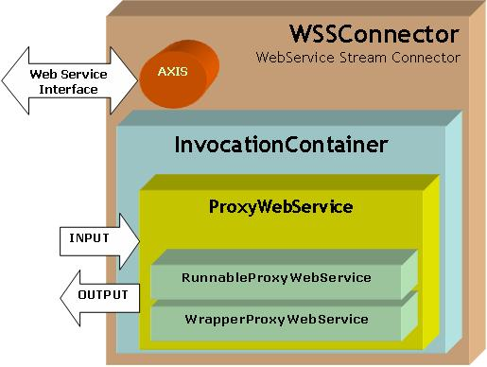
Figure 16WSProxy Architecture
We can compose a distributed data-flow by joining multiple WSProxy wrapped services and setting the correct input and output streams. The brokering network is used to handle the data communication between the services.

Geophysical Application Example: Pattern Informatics
Pattern Informatics [64] tries to discover patterns given past data to predict probability of future events. The process of analysis involves data mining which is made using results obtained from a Web Feature Service. The Web Map Service is responsible for collecting parameters for invoking the PI code. These parameters are then sent to an HPSearch engine which invokes the various services to start the flow. The process is diagrammatically illustrated in Figure 17. The Code Runner Service is a sample wrapper service that invokes the Pattern Informatics application.
As shown in the figure, the Web Map Service submits a flow for execution by invoking the HPSearch Web Service. This request also includes all parameters required for execution of the script. The HPSearch system works in tandem with a context service [70] for communicating with the Web Map Service. The context service is a distributed, high performance registry service useful for storing session and other context related data. Once submitted, the HPSearch engine invokes and initializes the various services, namely the Data Filter service, that filters incoming data and reformats it to the proper input format as required by the PI executable, and the PICode Runner service that actually runs the PI analysis program on the mined data. Once initialized, the HPSearch engine then proceeds to execute the WFS Web Service with the appropriate GML (Geographical Markup Language) query as input. The WFS then outputs the result of the query onto a topic specified by HPSearch. This stream of data is filtered as it passes through the Data Filter service and the result is accumulated by the PI service. The PI Service then executes the PI code on the data and the resulting file is sent to a publicly accessible Web server. The URL of the generated file is then written to the context service by HPSearch.
The Web Map Service, constantly polls the context service to see if the execution has finished. Once it is signaled that the execution is finished, the Web Map Service downloads the result file from the web server and displays the output by plotting on the graph.
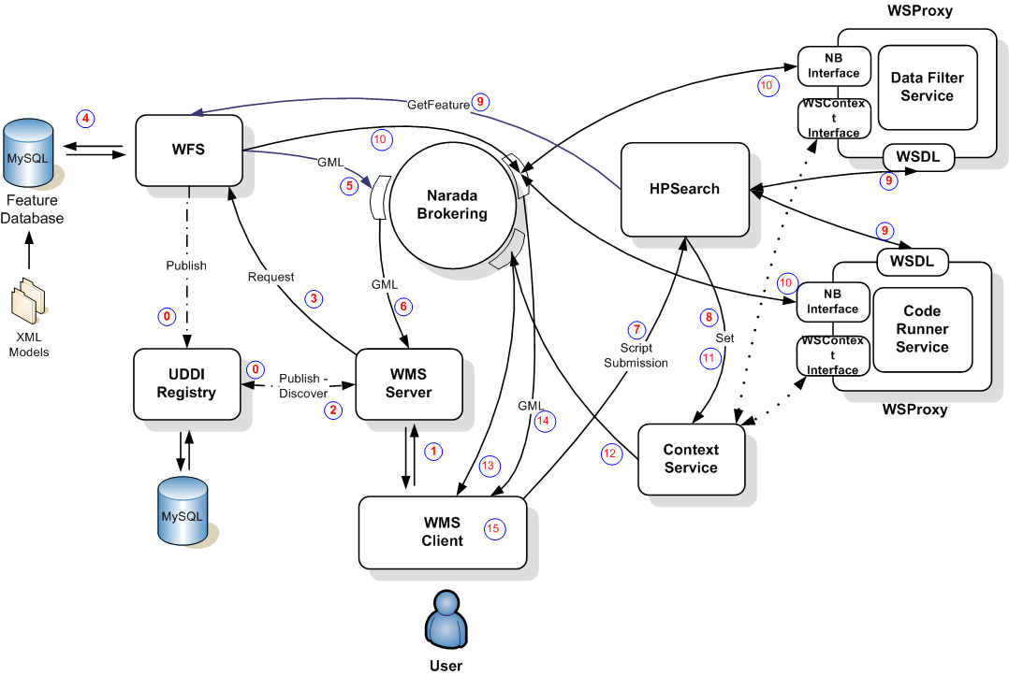
Figure 17 A general GIS Grid orchestration scenario involves the coordination of GIS services, data filters, and code execution services. These are coordinated by HPSearch.

Future Work
We are currently working on making management, standards compliant and global. Web Services community has recently introduced two competing management specifications, namely WS-Management and WS-Distributed Management. We are currently investigating, making management compatible with these standards. Further management is restricted by presence of firewalls and Network Address Translation (NAT) routers. We are also investigating how we management can span these restrictions and can be made more administratively scalable.

Summary and Conclusion: Abstracting GIS for General Information Grid Systems
We have described in this text various approaches that we have taken to integrate Geographical Information System components into Web Service-based Grids, following the WS-I+ approach. The implementation of basic data services for both real time and archival data were discussed, as were techniques for generating human-comprehensible maps that represent the data. These services are bound into Grids using information services and orchestration techniques. We illustrated the integration of geophysical applications together with all of these tools.
We would like to conclude, however, on a more general note. We believe that the approach we have adopted can be extended to other domains besides Geographic Information Systems.
As stressed by Birman [11], Web Services provide key low level capability but deliberately do not define an information or data architecture but rather leave this to domain specific specification activities such as CellML/SBML for biology, and Web Map Services/Web Feature Services/GML for Geographical Information Systems. The Semantic Grid uses web extending basic meta-data and service discovery capabilities with data-mining and reasoning. Here we generalize the architecture of Geographical Information Systems GIS have been hugely successful in all fields that study the earth and related worlds. GIS services have been defined by the industry consortium Open Geospatial Consortium and implemented by CGL, Open Geospatial Consortium defines a geography language syntax (GML) and ways to store, access, query, manipulate and display geographical features. In a service-oriented architecture, GIS corresponds to a domain specific XML language and a suite of services for the needed functions. Ee suggest that one can define a GIS-style information model in many application areas. This leads to concepts like Biological Information Systems (BIS); Service Infrastructure Information System (SIIS) for the overall system; and one should also add concepts like the Physics Analysis Information Systems (PAIS).
Figure 18ASIS Information Architecture for an Application Specific (AS) Sensor Filter Grid
n each application, there are some services like discovery and notification that do not need to be made application specific. We will need the domain-specific equivalent of the Web Feature Service for metadata and data. We call this generalization the Application Specific Feature Service (ASFS). We also need to define the generalization of the Geography Markup Language, which is a language expressing the domain specific features. We call this Application Specific Language, or ASL. One will need a set of basic tools, Application Specific Tools and Transformations (ASTT), to manipulate information expressed in language and key data of application which correspond to coordinate transformations for GIS. For a PAIS, conversions between event types would be in the PATT, the extension of ASTT for the physics domain.
We note that the ASL must support data sources such as sensors (in analogy to Open Geospatial Consortium metadata and data sensor standards) and repositories. Further sensors need support of streams of data which can be common across applications. Queries in the ASIS, need to support archived (find all relevant data in past) and streaming (find all data in future with given properties) styles. Note that all AS Services behave like sensors and all sensors are wrapped as services as shown in Figure 2 and Figure 3. We finally introduce Application Specific Visualization Services (ASVS) generalizing the Web Map Service to both visualize information and provide a way of navigating ASFS compatible databases (cf. GetFeatureInfo for GIS). The ASVS can itself be federated and presents an ASFS output interface. All user and system services will input and output data in ASL using filters to process raw data into ASL. The high performance Web Service techniques described earlier allow one to combine high performance with the expressivity of ASL.
For our purposes this analysis shows that our architecture is general and can be customized for application domains by designing a few key services as well the core language ASL expressing the primitives of the domain. For particle physics, the primitives are the properties of the events and the statistics operations used in their analysis.
This work is supported by the NASA Advanced Information Systems Technology program. We thank Yehuda Bock and Michael Scharber at SOPAC for help developing and deploying GPS sensor grid services.

References
- Mehmet S. Aktas, Geoffrey C. Fox, Marlon Pierce Information Services for Dynamically Assembled Semantic Grids Proceedings of 1st International Conference on Semantics, Knowledge and Grid Beijing China November 27-29 2005.
- Mehmet S. Aktas, Geoffrey Fox, Marlon Pierce Managing Dynamic Metadata as Context Istanbul International Computational Science and Engineering Conference (ICCSE2005) June 2005 http://grids.ucs.indiana.edu/ptliupages/publications/maktas_iccse05.pdf
- Akyildiz, I. F., Su, W., Sankarasubramaniam, Y., and Cayirci, E., “A Survey on Sensor Networks” IEEE Communications Magazine, August 2002.
- Data Management and Transfer in High Performance Computational Grid Environments. B. Allcock, J. Bester, J. Bresnahan, A. L. Chervenak, I. Foster, C. Kesselman, S. Meder, V. Nefedova, D. Quesnal, S. Tuecke. Parallel Computing Journal, Vol. 28 (5), May 2002, pp. 749-771.
- Anabas e-learning and Web conferencing http://www.anabas.com
- Malcolm Atkinson, David DeRoure, Alistair Dunlop, Geoffrey Fox, Peter Henderson, Tony Hey, Norman Paton, Steven Newhouse, Savas Parastatidis, Anne Trefethen and Paul Watson.Web Service Grids: An Evolutionary Approach UK e-Science Technical Report July 13 2004 published in a special issue of Concurrency&Computation: Practice&Experience 17, 377-389, 2005.
- Galip Aydin, Mehmet S. Aktas, Geoffrey C. Fox, Harshawardhan Gadgil, Marlon Pierce, Ahmet Sayar SERVOGrid Complexity Computational Environments (CCE) Integrated Performance Analysis Proceedings of Grid Computing Conference, 2005. The 6th IEEE/ACM International Workshop 13-14 Nov. 2005. Page(s): 256 - 261 DOI
- Jeff De La Beaujardiere, OpenGIS Consortium Web Mapping Server Implementation Specification 1.3, OGC Document #04-024, August 2002.
- R. Berjon, chair, “XML Binary Characterization Working Group Public Page.” Available from http://www.w3c.org/XML/Binary/
- Grid Computing: Making the Global Infrastructure a Reality edited by Fran Berman, Geoffrey Fox and Tony Hey, John Wiley & Sons, Chichester, England, ISBN 0-470-85319-0, March 2003. http://www.grid2002.org.
- Ken Birman, Robert Hillman, Stefan Pleisch, Building network-centric military applications over service oriented architectures SPIE Conference on Defense Transformation and Network-Centric Systems at Orlando Florida 31 March 2005.
- Bock, Y., Prawirodirdjo, L, Melbourne, T I. : “Detection of arbitrarily large dynamic ground motions with a dense high-rate GPS network” GEOPHYSICAL RESEARCH LETTERS, VOL. 31, 2004
- Botts, Mike, Sensor Model Language (SensorML) for In-situ and Remote Sensors, OGC document reference number 04-019r2
- Web GIS in practice III: creating a simple interactive map of England's Strategic Health Authorities using Google Maps API, Google Earth KML, and MSN Virtual Earth Map Control. International Journal of Health Geographics 2005, 4:22
http://www.ij-healthgeographics.com/content/4/1/22#B2#B2
- Business Process Execution Language, Available from:
http://www-106.ibm.com/developerworks/library/ws-bpel/
- Hasan Bulut, Wenjun Wu, Geoffrey Fox, Ahmet Uyar, Shrideep Pallickara, Harun Altay: A Web Services Based Streaming Gateway for Heterogeneous A/V Collaboration. International Conference on Internet Computing 2004: 493-502.
- Chiu, K., Govindaraju, M., and Bramley, R.: Investigating the Limits of SOAP Perform-ance for Scientific Computing, Proc. of 11th IEEE International Symposium on High Per-formance Distributed Computing HPDC-11 (2002) 256.
- Simon Cox , Paul Daisey, Ron Lake, Clemens Portele, Arliss Whiteside, Geography Language (GML) specification 3.0, Document #02-023r4., January 2003.
- D. Estrin, R. Govindan, J. Heidemann and S. Kumar, “Next Century Challenges: Scalable Coordination in Sensor Networks,” In Proceedings of the Fifth Annual International Conference on Mobile Computing and Networks (MobiCOM '99), August 1999, Seattle, Washington.
- The Grid 2: Blueprint for a new Computing Infrastructure, edited by Ian Foster and Carl Kesselman, Morgan Kaufmann 2004.
- I. Foster, Globus Toolkit Version 4: Software for Service-Oriented Systems. IFIP International Conference on Network and Parallel Computing, Springer-Verlag LNCS 3779, pp 2-13, 2005.
- Geoffrey Fox, Shrideep Pallickara, Marlon Pierce, Harshawardhan Gadgil, Building Messaging Substrates for Web and Grid Applications to be published in special Issue on Scientific Applications of Grid Computing in Philosophical Transactions of the Royal Society of London 2005 http://grids.ucs.indiana.edu/ptliupages/publications/RS-CGL-ColorOnlineSubmission-Dec2004.pdf
- Geoffrey Fox, Wenjun Wu, Ahmet Uyar, Hasan Bulut, Shrideep Pallickara: Global multimedia collaboration system. Concurrency - Practice and Experience 16(5): 441-447 (2004)
- Geoffrey Fox, Sang Lim, Shrideep Pallickara, Marlon Pierce: Message-based cellular peer-to-peer grids: foundations for secure federation and autonomic services. Future Generation Comp. Syst. 21(3): 401-415 (2005).
- Geoffrey Fox, Alex Ho, Shrideep Pallickara, Marlon Pierce, Wenjun Wu: Grids for the GiG and Real Time Simulations. DS-RT 2005: 129-138 28
- Geoffrey Fox, Galip Aydin, Harshawardhan Gadgil, Shrideep Pallickara, Marlon Pierce, Wenjun Wu: Management of Real-Time Streaming Data Grid Services. GCC 2005: 3-12
- Geoffrey C. Fox, Mehmet S. Aktas, Galip Aydin, Hasan Bulut, Harshawardhan Gadgil, Sangyoon Oh, Shrideep Pallickara, Marlon E. Pierce, Ahmet Sayar, and Gang Zhai Grids for Real Time Data Applications Invited talk in proceedings of PPAM 2005 – 6th International Conference on Parallel Processing and Applied Mathematics Poznan Poland September 11-14 2005
- Harshawardhan Gadgil, Jin-Yong Choi, Bernie Engel, Geoffrey Fox, Sunghoon Ko, Shrideep Pallickara, Marlon Pierce: Management of Data Streams for a Real Time Flood Simulation Technical Report June 2004
- Harshawardhan Gadgil, Geoffrey Fox, Shrideep Pallickara, Marlon Pierce, Robert Granat: A Scripting based Architecture for Management of Streams and Services in Real-time Grid Applications. (To Appear) In Proceedings of the IEEE/ACM Cluster Computing and Grid 2005 Conference, CCGrid 2005, Cardiff, UK
- Jesse James Garret, Ajax: A New Approach to Web Applications. Available from http://www.adaptivepath.com/publications/essays/archives/000385.php
- Google Maps API. http://www.google.com/apis/maps/.
- Google Maps Hacks. Rich Gibson, Schuyler Erle. O'Reilly ISBN: 0-596-10161-9 http://www.oreilly.com/catalog/googlemapshks/
- Google Maps API and WMS Servers.
http://www.spatialdatalogic.com/cs/blogs/brian_flood/archive/2005/07/11/39.aspx.
- Robert A. Granat: Regularized Deterministic Annealing EM for Hidden Markov Models, Doctoral Dissertation, University of California, Los Angeles, June, 2004
- Kaizar Amin, Gregor von Laszewski, Mihael Hategan, Nestor J. Zaluzec, Shawn Hampton, Albert Rossi: GridAnt: A Client-Controllable Grid Work.ow System. HICSS. 2004 See also “GridAnt: A Grid Workflow System. Project page: http://www-unix.globus.org/cog/projects/gridant/”.
- XML feed provided by SOPAC available at
http://sopac.ucsd.edu/input/mapServer/mapFiles/gps_rt_rss.xml
- Flexible Power Scheduling for Sensor Networks. Barbara Hohlt, Lance Doherty, Eric Brewer. Proceedings of the third international symposium on Information processing in sensor networks. Pages: 205 – 214, 2004
- ImageMagick. http://www.imagemagick.org/script/index.php
- Implementing a selection box for Google Maps: http://weblogs.asp.net/rajbk/archive/2005/07/23/420315.aspx
- I. Altintas, C. Berkley, E. Jaeger, M. Jones, B. Ludscher, S. Mock: Kepler: Towards a Grid-Enabled System for Scientific Workflows, In the Workflow in Grid Systems Workshop in GGF10 - The Tenth Global Grid Forum, Berlin, Germany, March 2004.
- Laits Projects at George Mason University http://laits.gmu.edu/.
- Google Mapki. http://mapki.com
- Interactive Album of Map Projections. http://projections.mgis.psu.edu/.
- Verma, K., Sivashanmugam, K. , Sheth, A., Patil, A., Oundhakar, S. and Miller, J. “METEOR–S WSDI: A Scalable P2P Infrastructure of Registries for Semantic Publication and Discovery of Web Services” , Journal of Information Technology and Management.TM03-006.pdf
- Project OnEarth at NASA JPL (Jet Propulsion Lab) http://onearth.jpl.nasa.gov/
- Oh, S., Bulut, H., Uyar, A., Wu, W., Fox G., Optimized Communication using the SOAP Infoset For Mobile Multimedia Collaboration Applications. in proceedings of the Interna-tional Symposium on Collaborative Technologies and Systems CTS05 (2005). http://grids.ucs.indiana.edu/ptliupages/publications/OptSOAP_CTS05.pdf
- The Open Geospatial Consortium, Inc. web site: http://www.opengeospatial.org/.
- Open Geospatial Consortium Discussion Paper, Editor Simon Cox: “Observations and Measurements”. OGC Document Number: OGC 03-022r3
- Shrideep Pallickara, Geoffrey Fox: NaradaBrokering: A Distributed Middleware Framework and Architecture for Enabling Durable Peer-to-Peer Grids. Middleware 2003: 41-61.
- Shrideep Pallickara, Geoffrey Fox, Sangmi Lee Pallickara: An Analysis of Reliable Delivery Specifications for Web Services. ITCC (1) 2005: 360-365.
- Shrideep Pallickara, Geoffrey Fox: An Analysis of Notification Related Specifications for Web/Grid Applications. ITCC (2) 2005: 762-763.
- PerlMagick. http://www.dylanbeattie.net/magick/
- Lucian Plesea, “Remote Access to Very Large Image Repositories, A High Performance Computing Perspective”, ESTC2005, June 2005.
- Mozilla Rhino: Javascript for Java. Project Website: http://www.mozilla.org/rhino
- Paul Sandoz, Alessando Triglia, and Santiago Pericas-Geertsen, “Fast Infoset.” Available from http://java.sun.com/developer/technicalArticles/xml/fastinfoset/.
- Sayar A., Pierce M., Fox G., “Developing GIS Visualization Web Services for Geophysical Applications” ISPRS 2005 Spatial Data Mining Workshop, Ankara, Turkey.
- Ahmet Sayar, Marlon Pierce and Geoffrey Fox “Integrating AJAX Approach into GIS Visualization Web Services”, Proceedings of IEEE International Conference on Internet and Web Applications and Services ICIW'06 February 23-25, 2006 Guadeloupe, French Caribbean.
- OGC Sensor Collection Service specification, document reference number 03-023r1
- Southern California Integrated GPS Network web site: http://www.scign.org/
- Mehmet Aktas, Galip Aydin, Geoffrey Fox, Harshawardhan Gadgil, Marlon Pierce and Ahmet Sayar, SERVOGrid Technical Documentation. Technical Report for the NASA AIST project. Available from http://www.servogrid.org/slide/iSERVO/SERVO/SERVOTechDocuments/SERVOTechReportAll.pdf.
- Scripps Orbit and Permanent Array Center web site: http://sopac.ucsd.edu/
- Stitch together Google Map tiles.http://mapki.com/index.php?title=Stitch_together_Google_Map_tiles
- OGC Sensor Web Enablement Web page http://www.opengeospatial.org/functional/?page=swe
- Tiampo, K. F., Rundle, J. B., McGinnis, S. A., & Klein, W.: “Pattern dynamics and forecast methods in seismically active regions”, Pure Applied Geophysics 159, 2429-2467 (2002).
- Bellwood, T., Clement, L., and von Riegen, C. (eds) (2003), UDDI Version 3.0.1: UDDI Spec Technical Committee Specification. Available from http://uddi.org/pubs/uddi-v3.0.1-20031014.htm.’
- Ali ShaikhAli, Omer Rana, Rashid Al-Ali and David W. Walker.., UDDIe: An Extended Registry for Web Services, Proceedings of the Service Oriented Computing: Models, Architectures and Applications, SAINT-2003 IEEE Computer Society Press. Oralndo Florida, USA, January 2003
- Miles, S., Papay, J., Dialani, V., Luck, M., Decker, K., Payne, T., and Moreau, L. Personalized Grid Service Discovery. Nineteenth Annual UK Performance Engineering Workshop (UKPEW'03), University of Warwick, Conventry, England, 2003.
- The Triana Project, http://www.triana.co.uk/
- Vretanos, P. (ed.), Web Feature Service Implementation Specification (WFS) 1.0.0, OGC Document #02-058, September 2003.
- Bunting, B., Chapman, M., Hurlery, O., Little M., Mischinkinky, J., Newcomer, E., Webber J, and Swenson, K., Web Services Context (WS-Context), available from http://www.arjuna.com/library/specs/ws_caf_1-0/WS-CTX.pdf
- XAMPP. http://www.apachefriends.org/en/xampp.html
- Simple Analysis of Google Map and Satellite Tiles.
http://dunck.us/collab/Simple_20Analysis_20of_20Google_20Map_20and_20Satellite_20Tiles.
- Wide Area Data Replication for Scientific Collaborations. A. Chervenak, R. Schuler, C. Kesselman, S. Koranda, B. Moe. Proceedings of 6th IEEE/ACM International Workshop on Grid Computing (Grid2005), November 2005.
- The Data Grid: Towards an Architecture for the Distributed Management and Analysis of Large Scientific Datasets. A. Chervenak, I. Foster, C. Kesselman, C. Salisbury, S. Tuecke. Journal of Network and Computer Applications, 23:187-200, 2001 (based on conference publication from Proceedings of NetStore Conference 1999).
- Geographical Information System Research at the Community Grids Laboratory Project Web Site: http://www.crisisgrid.org.
- Harvey B. Newman, I. C. Legrand, Philippe Galvez, R. Voicu, C. Cirstoiu: MonALISA : A Distributed Monitoring Service Architecture CoRR cs.DC/0306096: (2003).
- C. Jin, D. X. Wei, S. H. Low, G. Buhrmaster, J. Bunn, D. H. Choe, R. L. A. Cottrell, J. C. Doyle, W. Feng, O. Martin, H. Newman, F. Paganini, S. Ravot, S. Singh, "FAST TCP: From Theory to Experiments", IEEE Network, 19(1):4-11, January/February 2005.
- The Virtual Data Toolkit Web Site: http://vdt.cs.wisc.edu/index.html.
- David Booth, Hugo Haas, Francis McCabe, Eric Newcomer, Michael Champion, Chris Ferris, and David Orchard, Web Services Architecture, W3C Working Group Note 11 February 2004. Available from http://www.w3.org/TR/ws-arch/.
- XML Pull Parsing Web Site: http://www.xmlpull.org/; See also JSR 173: Streaming API for XML (StAX): http://www.jcp.org/en/jsr/detail?id=173

Appendices

Sample Position Messages Encoding for SOPAC GPS Stations
<?xml version="1.0" encoding="UTF-8"?>
<sopac:PositionMessage xmlns:sopac="http://www.crisisgrid.org/sensorgrid" xmlns:gml="http://www.opengis.net/gml" xmlns:om="http://www.opengis.net/om" xmlns:xsi="http://www.w3.org/2001/XMLSchema-instance" xsi:schemaLocation="http://www.crisisgrid.org/sensorgrid/schemas/om/sopacGPS.xsd">
<gml:timeStamp>
<gml:TimeInstant>
<gml:timePosition>
2005-19-07/04:19:44PM-EST
</gml:timePosition>
</gml:TimeInstant>
</gml:timeStamp>
<gml:resultOf>
<gml:CompositeValue>
<gml:valueComponents>
<sopac:XYZTPosition>
<gml:valueComponents>
<sopac:X uom="">-2483933.959009682</sopac:X>
<sopac:Y uom="">-4692210.903343215</sopac:Y>
<sopac:Z uom="">3522794.2822901704</sopac:Z>
<sopac:T uom="">2.3280574187794465</sopac:T>
</gml:valueComponents>
</sopac:XYZTPosition>
<sopac:XYZVarianceBlock>
<gml:valueComponents>
<sopac:Scale uom="">0.0653659</sopac:Scale>
<sopac:Xvar uom="">0.0471768</sopac:Xvar>
<sopac:Yvar uom="">0.1301267</sopac:Yvar>
<sopac:Zvar uom="">0.085100</sopac:Zvar>
<sopac:YXcovar uom="">0.0736906
</sopac:YXcovar>
<sopac:YZcovar uom="">-0.098750
</sopac:YZcovar>
<sopac:ZXcovar uom="">-0.056698
</sopac:ZXcovar>
</gml:valueComponents>
</sopac:XYZVarianceBlock>
<sopac:SatelliteInfoBlock>
<sopac:SatelliteCount>
<gml:Count>8</gml:Count>
</sopac:SatelliteCount>
<sopac:GDOP>
<gml:Quantity uom="">3.186955808173595
</gml:Quantity>
</sopac:GDOP>
<gml:valueComponents>
<sopac:SatelliteInfo>
<gml:valueComponents>
<sopac:PRN_Value uom="">3
</sopac:PRN_Value>
<sopac:PRNFlags uom="">7
</sopac:PRNFlags>
<sopac:Elevation uom="">29
</sopac:Elevation>
<sopac:Azimuth uom="">-50
</sopac:Azimuth>
</gml:valueComponents>
</sopac:SatelliteInfo>
<!-- Remaining entries deleted for brevity -->
</gml:valueComponents>
</sopac:SatelliteInfoBlock>
</gml:valueComponents>
</gml:CompositeValue>
</gml:resultOf>
<sopac:PositionQuality method="">
<om:Description>00010010</om:Description>
</sopac:PositionQuality>
<om:relatedFeature>
<sopac:Site>
<gml:name>SACY</gml:name>
<sopac:SiteCount>15</sopac:SiteCount>
<sopac:SiteIndex>2</sopac:SiteIndex>
</sopac:Site>
</om:relatedFeature>
</sopac:PositionMessage>

Example Global Positioning System RYO Data
This Appendix shows the RYO output of a typical GPS station in the Southern California Integrated GPS Network.
Message time
Date | Time
2005-12-12 | 03:23:16PM-EST

Station Metadata
Station Name | Station Number | Station Count
LEMA | 2 | 3

XYZT Position
X | Y | Z | T
2556508.624797094 | 4467101.665687391 | 3754378.932770622 | 2.295049246581960

Latitude-Longitude-Height Position
Latitude | Longitude | Height
36.29202035061081 | 119.78237412236496 | 35.929088668037025

Position quality : L1/L2
Flags: Phase
Optional blocks present in this message: XYZ variance block + Satellite info block
XYZ variance block
Scale | Xvar |  | Yvar
0.06901739184684381 | 0.0377138796649775 |  | 0.10830764487854985
Zvar | YXvar |  | YZvar
0.08631783233709235 | 0.06057192662251049 |  | -0.09281413763791896
ZXvar
-0.05338606394765551

Satellite Info Block
Satellite No | 1 | 2 | 3 | 4 | 5 | 6 | 7 | 8
PRN | 2 | 4 | 5 | 7 | 9 | 24 | 26 | 28
PRN Flags | 7 | 7 | 7 | 7 | 7 | 7 | 7 | 7
Elevation | 42 | 61 | 23 | 50 | 55 | 35 | 5 | 17
Azimuth | 179 | 117 | -54 | 45 | -75 | 54 | -142 | 104

