USER MANUAL

1. Common Mapping Tools and Interface

Here is the common user interface mapping tools. Depending on the selected project and/or main layers such as Patter Informatics or Virtual California, there might be additional interface frames to get required parameter entries from the users.

Sub layers of selected main layer. These are defined in capabilities file of the WMS
Coordinate Values, dynamically updated
Main layers based on the project names and/or initially connected master WMS capabilities file

Changes in the list of sub layer to take effect

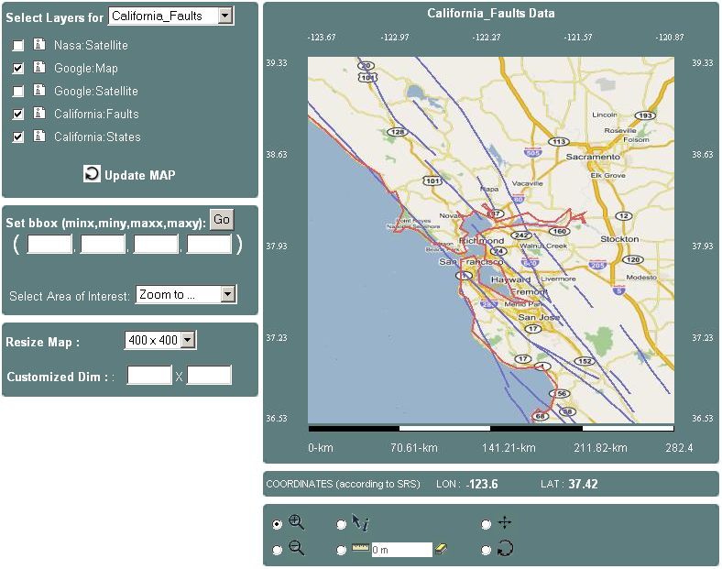
Like a terrain service. Predefined regions listed in names
Resizing the map. Two options- predefined and customized

Distance scale, dynamically updated based on coordinates and bounding box

Optional, if you want to get a map in a specific bounding box values. Click ‘Go’after selection
Latitude and longitude values of the mouse on the map. Dynamically updated
Map tools, they can be selected one at a time

Map Tools
Select and click on the map: Each click starts loading the map automatically.

 | Zoom-in | To get more detailed map in smaller bounding box values. Smaller area.
 | Zoom-out | To get a map in smaller bounding box values. Wider area.
   | Get Feature Information | To get further information in text format about the selected feature element. Click on the exact point on the map.
 | Measure Distance | To measure the distance between two points in km. Points are given by the user by clicking one at a time.
 | Erase Distance Val | To erase the previous distance value from the display screen.
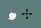 | Drag and Drop | To slide the map to a different bounding box values with the same dimensions.
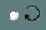 | Refresh to Initial map | To get the map created initial settings. Initial settings show the California State.

Some more details

Project Based Main Layers | Predefined map sizes - dimensions
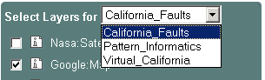 | 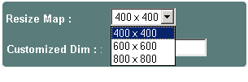
Predefined Area of Interests for the initial map in California State region
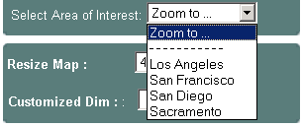

2. Project Based additional interfaces

We have three ongoing distributed geophysics projects. These are
- California Faults (not exactly a project)
- Pattern Informatics
- Virtual California

2.1. California Faults

There is no additional interface, same as common interface illustrated in chapter 1.
For the California Fault layer, feature information enabled. So Clients can get further information in text about the specific feature on the map. Sometimes you can not get any info, please change your zoom level or click on some other very close points.

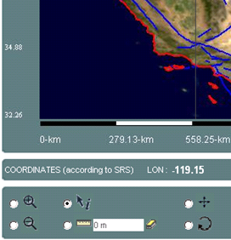
Select “i”
Click just on a fault

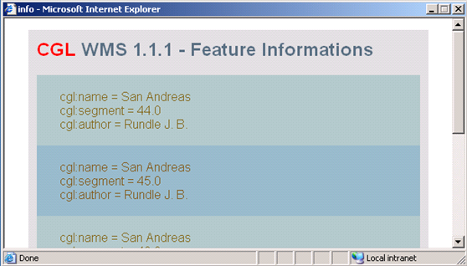
Result – sample pop up screen for San Andreas Fault

2.2. Pattern Informatics

Initial selections and creating map:
Pattern Informatics project works on seismic data. It is earthquake related.

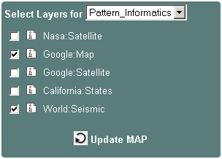
Select Pattern Informatics Layer
Select World:Seismic
Sub layer
Click on
Update Map

2.2.1. Overlay Interface

Additional parameter entries and running distributed simulation code:

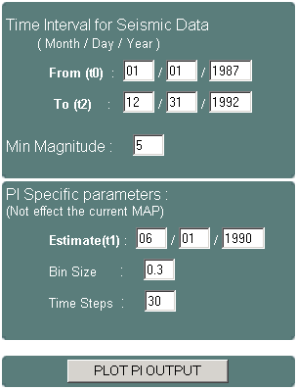
to < t1 < t2
to-t1: training data
t2-to: forecasting data
Earthquake measured magnitude value. Layer will be created with seismic data of min magnitude value 5.
These two are related to the format of output data. Returned data is matrix data. Bin-Size and Time Steps define the resolution of the map and dimension of the each cell in the matrix
Click on, to invoke workflow engine and overlay the output of the Pattern Informatics simulation code.

2.2.2. Movie Interface

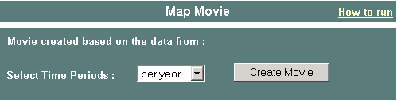
Defines frame and data frequencies, such as “per year”, “per month” etc.

In order to be able to run the demo map movies, you first should have a client to display movie streams. If you want to use JMFStudio to display the movie streams, follow the below steps.
- Download and install jmf-2.1.
- After installing, go to program directory and,
- Replace the jmf.jar in the jmf lib directory with this one.
- Download this exe file and run it on your machine.
- Runtime settings:
- Run your newly installed JMFStudio, and Click on <File><Open RTP Session>
- Enter the values of Address, Port and TTL values.
- Sample values corresponding above parameters <233 2 171 233> <59914> <16>
- WMS Server automatically publishes its movie streams to these port and multicast IP. < interface. user the from defined be will it future>
If the above links are broken go to http://gf8.ucs.indiana.edu:8092/aaa/geoappl/movie_howtorun.jsp for instructions.

2.3. Virtual California
(Not completed for a full demo)

Initial selections and creating map:
Virtual California project works on seismic data. It is earthquake related.

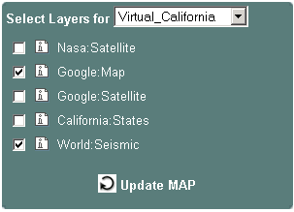
Select Virtual California Layer
Select World:Seismic
Sub layer
Click on
Update Map

2.3.1. Overlay Interface

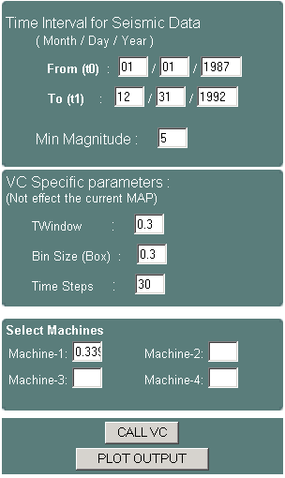
Click on to calculate “best cost”
Alternative machines and machine specific parameters. These are used to calculate best costs
Earthquake measured magnitude value. Layer will be created with seismic data of min magnitude value 5.
These two are related to the format of output data. Returned data is matrix data. Bin-Size and Time Steps define the resolution of the map and dimension of the each cell in the matrix

2.3.2. Movie Interface

Everything is same as Section 2.2.2.

