SRB (Storage Resource Broker)
Prepared by Ahmet Sayar

Why SRB?

Scientific applications have lots of data-intensive computations and the data mostly come from the heterogeneous resources. Scientific applications need high performance I/O to massive data to get efficient results. Regarding the intermediary computations outputs, the output of the scientific applications is currently all stored as flat files. These files are often distributed over a number of machines and/or different types of media. Hence there are two data management problems associated with this scenario, first the data is organized physically rather than logically and secondly the data is all stored in different file formats. Scientists need to access all the available data just by using single API. They might need to integrate and federate data and resources residing on multiple hosts, multiple OS platforms. These are the main issues SRB deals with.

What is SRB?

The main goal of SRB is using a single interface and authorization mechanism to access data across multiple hosts, multiple OS platforms and multiple resource types and mediating access to distributed heterogeneous resources.

SRB is collaborative client-server middleware that federates distributed heterogeneous resources and data using uniform interfaces and metadata. It provides a simple tool to integrate data and metadata handling – attribute-based access. Its services and routines can be accessed from command line and GUI Browser. It is under continual development since 1997 by SDSC.

SRB provides remote file storage with file and directory structure, to which users can attach metadata. SRB can be metadata enabled by using MCAT (Metadata Catalog Service). MCAT manages two types of metadata associated with data collections and system resources. Descriptive metadata describe contents of entire data collections, individual data items. System metadata provides location and access control information. MCAT enables SRB to store and retrieve metadata about system entities and provides location transparency. It also enables attribute based data access.

Architecture

SRB is basically a middleware improving operating environment for scientific applications that have the requirement to access and process many data sets. SRB interacts with different types of storages by uniform storage interface. SRB provides a mapping from defined storage interface to native interface which is supported by each underlying storage resource via resource specific drivers. In order to support attribute-based access to data-collections, items, resources and other system resources SRB uses MCAT. But user does not have to use MCAT to be able to use just storage access. MCAT is a service package enabling and enhancing SRB functionalities. MCAT provides a set of APIs for querying and updating metadata catalog. Data and resources are defined by the physical and logical terms. Physical location is distinct from the logical collection hierarchy. MCAT makes mapping between these terms to define and locate the data and resources. MCAT is basically used for recording location information for physical storage resources and data items and for describing the contents of the data items and collections.

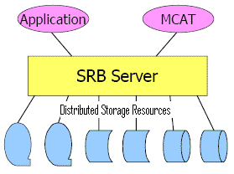
Figure 1: SRB is middleware

The way data stored in SRB is organized in collections, sub-collections. For example a collection contains ≥ 0 data items and ≥ 0 sub-collections, a sub-collection contains ≥ 0 data items and ≥ 0 sub-collections, and a data item is a file or binary large object (BLOB). Data items belonging to same (sub-) collection can be stored in physically distributed heterogeneous storage resources.

In the architecture there should be at least one SRB master daemon processes defined by hostname and port number. Each controls a distinct set of PSR (Physical Storage Resources). These processes monitor their ports for connection requests from clients. Communication is done via sockets. As you see in Figure 2, there is an SRB agent in the architecture. SRB agent uses MCAT metadata service to obtain necessary system metadata needed for processing client storage requests. According to architecture, application makes its request to SRB Master. SRB master forks an agent and returns connection information to application. All the subsequent communications are done via the agent. Agen is actually a dispatcher module monitoring incoming requests. After handling requests with its request handlers, it returns the result back to client.

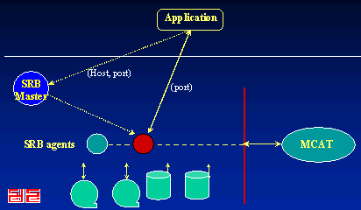
Figure 2: SRB Process Model – connection Processing (image is from http://www.npaci.edu/Research/DI/Talks/SRBSIPNEW/sld003.htm)

SRB is also a federated server system with each SRB server managing/brokering a set of storage resources. Federated SRB implementations provide location transparency, improved reliability and availability, fault tolerance, integrated data access, and persistence (see Figure 3). A federation of SRB servers provides access to distributed storage resources. Each SRB server controls a distinct set of PSRs. One SRB server can act as a client to another. So a client application can access data stored anywhere.

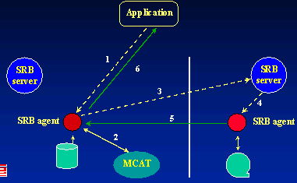
Figure 3: Federated SRB Operation (image is from http://www.npaci.edu/Research/DI/Talks/SRBSIPNEW/sld004.htm)

USAGE

From the applications point of view, functionalities are defined by the client API. API enables querying or updating metadata. Client API also allows applications to manage metadata associated with data collections, data items, users, user groups, storage resources. If the user has privilege, API allows users to create data items, and enables open, read, write and delete operations on the data items.

In general users can use command-line executables such as Sls, Sput, Sget, Schmod and Smeta. These commans are available in Unix, Linux and Windows. For the easy to use and test purposes SRB has a couple of software available. These are InQ (an SRB windows browser), MySRB (A web interface browser) and srbBrowser (a JAVA browser using JNI in Unix).

InQ is a browser/query tool for SRB which offers the traditional file and directory functionality of the old SRB Browser as well as support for metadata and nested queries on both collections and datasets. Metadata, access rights, and queries can be viewed along-side collections and datasets in inQ's 'Windows Explorer-like' interface. inQ is multithreaded and has drag and drop support.

MySRB is a web-based interface to SRB. It provides functionalities for collection and file management, metadata handling and, access and display of files and metadata. MySRB uses https protocol with 128-bit RSA authentication. MySRB uses file-browse mechanism of web browsers to identify local file that need to be ingested.

The SRB Browser is a Java client program. The GUI of the browser was implemented using Java but most SRB specific functions were implemented with existing C library call through the JNI interface. This was a prototype implementation at one point, is fairly basic.

SRB also has jargon JAVA API to be able to integrate SRB functionalities JAVA based Grid applications such Kepler. Jargon is basically a JAVA client API for the Data Grid. Jargon provides Data Grid applications with transparent replication, archiving, caching heterogeneous storage and aggregating data movement.

A usage scenario:
JPL yourSky : yourSky server receives mosaic request from user and retrieves 2MASS images from SDSC SRB and launches mosaic code via Globus on IPG machine at ARC. Application requires no local disk to mirror data. Application supports “run anywhere, access SRB anywhere”. yourSky server access to full release of 2MASS Atlas images in SRB at SDSC. There are nearly 2 million images and each image is almost 2MB. Total SRB is about 4TB.

