Storage Resource Broker (SRB) with MCAT Install Note

Author: Michael Doherty (m.r.doherty@rl.ac.uk)
CCLRC e-Science Data Management Group
Rutherford Appleton Laboratory
Chilton
Didcot
Oxfordshire
OX11 0QX

Document Version: 1.0
Date: May 2003

Storage Resource Broker (SRB) with MCAT Install Note 2
1. Overview 4
2. Pre-Installation Tasks 5
2.1 Pre-installation checklist 5
2.2 RDBMS Software 7
2.3 Create an empty database 7
2.4 Create the MCAT tablespace in the empty database 7
2.5 Create the SRB admin group 8
2.6 Create the SRB User account 8
2.7 Setup Linux SRB User account to access the new database. 9
2.8 Create the MES RDBMS account 9
2.9 Obtain PGP encryption software 10
2.10 Obtain the SRB source code 10
2.11 Decrypt and unpack the SRB Server software 10
2.12 Install the Java Development Kit version 1.4 11
3. Installation tasks 12
3.1 Configure the make file 12
3.2 Build the SRB software 12
3.3 Configure the SRB Server 13
3.4 Populate the MCAT database with the SRB data model 14
3.5 Verify results of populating MCAT database 14
3.6 Recovering from problems populating the MCAT database 15
3.7 Create a privileged SRB account using the pre-defined 'srb' application user: 15
3.8 Configuring the Linux user for SRB 16
3.9 Install the SRB Software 16
4. Post installation tasks 18
4.1 Starting the SRB System 18
4.2 Securing the SRB default account 18
5. Basic SRB administration and Usage 20
5.1 Create a new location 20
5.2 Create a new resource 20
5.3 Create a new user 21
5.4 InQ 22
6. Appendix A: TNSNAMES.ORA and SQLNET.ORA 24
6.1 SQLNET.ORA 24
6.2 TNSNAMES.ORA 24

Overview
In order for an SRB domain to function, it stores persistent metadata (the data about the data) information in a Relational Database Management System (RDBMS). An SRB domain may be made up of many SRB servers. However one these servers must communicate with the RDBMS. This is known as the MCAT Enabled Server (MES) and is the key to the domain.
The MES server has to run a special version of the SRB server software, so that it may talk directly to the RDBMS. Each server (MES or not) will contain the SRB client libraries, SRB server libraries and SRB utilities. The MES will have additional software and database scripts over other SRB servers. The MCAT software is a library that interfaces to a database management system. To build and install an MCAT Enable SRB server , you need complete the following key tasks:
- Install RDBMS software.
- Create an empty database (using RDBMS software)
- Build the MES server software
- Initialize the empty database
- Install the MES server software
- Setup other SRB servers.
Note the MES need not be located on the same physical machine as the RDBMS, however many systems do run this way. If your MES is not installed on the same machine as the RDBMS, then you will have to install the RDBMS client software on the MES node.
The tasks above broken down into 3 major categories below Pre-installation, Installation and Post-Installation. Detailed steps are given for each category.
The install note here is based on using a Redhat Linux system to run the SRB server. Oracle9i is used as the database.
Please note RDBMS configuration is complex and if you have no background in this area, you will require assistance from a Database Administrator (DBA).

Pre-Installation Tasks

Pre-installation checklist
The following tables gives the names of various parameters and their description used throughout this script. Please use the table as a point of reference and also to record the various account information, file locations and other variables used your installation.
This first table describes all parameters relevant to the Linux or UNIX environment.
Parameter | Description | Example used | Your value
OS SRB admin group | Linux user group designated for SRB administrators | srbag
OS SRB admin user | Linux user designated for running SRB software. | srbusr
SRB_ROOT | Linux environment variable representing the location of the top level directory for the SRB source code. Optional. | /home/srb/SRB_0_1rel
ORACLE_HOME | Linux environment variable representing the location of the main directory for the Oracle. | /ora01/app/oracle/product/9.2.0
ORACLE_SID | Linux environment variable representing the name give to the Oracle SID | mcatdb
http_proxy | Linux environment variable representing location you internet proxy server (if used) | http://cache.rl.ac.uk:8888/
SRB install directory | Final location of SRB software used in runtime. | /usr/local/srb
jdkhome | Input variable to SRB “configure script” Location of the top level directory for the Java 1.4 development kit | /opt/j2sdk1.4.1_02

The following table describes parameters relevant to the Oracle environment.
Parameter | Description | Example used | Your value
SID | Oracle Database System Identifier. Represents name given to instantiation of Oracle database. | mcatdb
Database name | A unique name to represent a data store (IP domain often appended to SID for uniqueness in a distributed environment) | mcatdb.esc.rl.ac.uk
SYSTEM password | Password for the Oracle RDBMS SYSTEM account. SYSTEM is the Oracle account analogous to UNIX root. | system_passwd
db_connect_string | TNS (Transparent Network Substrate) alias for the database. Used by Oracle for network communications | mcatdb.esc.rl.ac.uk
MCAT data tablespace name | Logical unit of the database where MCAT database tables are stored. Maps to one or more physical files | srbmcat
MCAT index tablespace name | Logical unit of the database where MCAT database indexes are stored. Maps to one or more physical files. Used to increase performance. | srbmcat_indx
MCAT Schema | The Oracle RDBMS user under which MCAT data is stored and accessed | MCAT
MCAT password | Password for the Oracle RDBMS MCAT schema | mcat_passwd

This final table describes parameters relevant to the SRB application environment.
Parameter | Description | Example used | Your value
SRB host | The IP name of the machine that will run the SRB server | srbhost.esc.rl.ac.uk
SRB domain | The unique name given to identify a set of SRB servers connecting to a single MCAT. | srbdom
SRB admin user | The SRB username used for application administration | srbadm
SRB admin password | The SRB password for the SRB admin user | srbpasswd

RDBMS Software
In the current release of SRB, the following databases are supported:
- Oracle http://www.oracle.com/ip/deploy/database/oracle9i/
- IBM DB2 http://www-3.ibm.com/software/data/db2/
- Sybase http://www.sybase.com/products/databaseservers/ase
- PostgreSQL http://www.postgresql.com/
Note that only PostgreSQL is open source. All other RDBMS systems must be licensed.
You should install the RDBMS software prior to any further steps. You must be competent in using this software as failure to do so can result in both installation and operational problems.

Create an empty database
How to create the empty database will depend on your RDBMS. If using Oracle, use the Database Configuration Assistant (dbca) is recommended. This should be run from the Linux oracle account. Be very careful to note the System Identifier (SID) and FULL database name you select during the creation of the database. The database name must be 8 characters or less for Oracle and may be appended with the IP domain name to ensure uniqueness in a distributed environment. The SID describes the instantiation of the Oracle database, whereas the database name is a unique name to describe the data store. Typical examples would be:
- Database Name mcatdb.esc.rl.ac.uk
- SID mcatdb
The fully qualified database is not strictly necessary i.e. you could use mcatdb instead of mcatdb.esc.rl.ac.uk for the Database Name. However using this will give you additional Oracle functionality should distributed RDBMS features ever be used. The General Purpose database template is sufficient if creating an Oracle database using dbca. You can then leave all the options at default values.

Create the MCAT tablespace in the empty database
Now you need to create an empty tablespace to hold the MCAT data. This should be run from the Linux oracle account in order to avoid any database datafile file protection problems.
Using the Linux oracle account, enter the following command
#echo $ORACLE_SID

Confirm this matches the SID for the database you have just created. Now connect to the database using Oracle SQL*Plus as SYSTEM and use the following syntax to create the data tablespace:
#sqlplus SYSTEM/system_passwd

sql> create tablespace srbmcat datafile
'/ora01/app/oracle/oradata/mcatdb/mactdb_srbmcat01.dbf'
size 198M autoextend on NEXT 10240K MAXSIZE UNLIMITED
extent management local online;

It is also recommended that a separate table space is created for indexes on a separate physical volume. Indexes are used to improve RDBMS data access performance.

sql> create tablespace srbmcat_indx datafile
'/ora02/app/oracle/oradata/mcatdb/mactdb_srbmcat_indx01.dbf'
size 198M autoextend on NEXT 10240K MAXSIZE UNLIMITED
extent management local online;

You can replace srbmcat and srbmcat_indx with other names if you prefer.
Line 2 should reflect the path and filename of the new datafile to be created on your system. The syntax used is applicable to Oracle8i and Oracle9i. You can also choose to locate the files to a convenient place on your system, however you should still ensure that data and index tablespaces span different physical volumes.

You can verify the commands were successful with the following SQL syntax:
sql> select tablespace_name from dba_tablespaces;

Then exit SQL*Plus:

sql> exit;

Create the SRB admin group
On a Linux system where you intend to run the MES, log on as root and create the SRB administration group as follows:
#groupadd srbag

You can change the name of this group as desired.

Create the SRB User account
This is the operating system account that will actually run the SRB software on you system.
On a Linux system where you intend to run the MES, log on as root and create the account under which the software will run. This can be achieved with following command:
#useradd -d /home/srbusr -m –g srbag srbusr
#passwd srbusr

You can change the name of this account as desired. For security reasons, this account should NOT be part of any dba groups.
You should also create a directory for the SRB software to be installed once you have built it. The default is /usr/local/srb. You should therefore create this directory as follows:
mkdir /usr/local/srb
chown srbusr.srbag /usr/local/srb

Setup Linux SRB User account to access the new database.
This step ensure the Linux MES account can successfully connect to the new Oracle database as the MCAT RDBMS account. This assumes the Oracle Optimal Flexible Architecture (OFA) directory structure is in use. The following Linux environment variables must be set in the profile of Linux MES user (.bash_profile in the home directory):
ORACLE_BASE=/ora01/app/oracle
export ORACLE_BASE
ORACLE_HOME=$ORACLE_BASE/product/9.2.0
export ORACLE_HOME
PATH=$PATH:$ORACLE_HOME/bin
ORA_NLS33=$ORACLE_HOME/ocommon/nls/admin/data
export ORA_NLS33
ORACLE_SID=<your SID e.g. mcatdb>
export ORACLE_SID
export http_proxy="http://cache.rl.ac.uk:8888"
LD_LIBRARY_PATH=$LD_LIBRARY_PATH:$ORACLE_HOME/lib
export LD_LIBRARY_PATH
NLS_LANG="english_united kingdom.we8iso8859p1"
export NLS_LANG

Note ORACLE_SID should be changed to whatever your SID was set to when creating the database. http_proxy should only be set if you use a proxy server to connect to the internet. You should contact your network administrator if you are unsure of this.
You should log out and then back in again as srbusr to confirm the variables are picked up correctly.
Setting the above values should allow check that you can connect to the Oracle database as follows:
#sqlplus SYSTEM/system_passwd
#sqlplus SYSTEM/system_passwd@db_connect_string

db_connect_string is the TNS (Transparent Network Substrate) alias for the database. This is almost always the same as the fully qualified database name. The first command checks a local connection to the database and the second checks a network connection. If these generates any errors, please review the profile where you set the environment variables and the following files:
$ORACLE_HOME/network/admin/sqlnet.ora
$ORACLE_HOME/network/admin/tnsnames.ora

See Appendix A for example files.

Create the MES RDBMS account
You must now create the account (Schema) used by the MES:
Using the Linux srbusr account, log on to Oracle SQL*Plus as SYSTEM and execute the following commands:
#sqlplus SYSTEM/system_passwd
sql> create user MCAT identified by mcat_passwd
default tablespace srbmcat temporary tablespace temp;

sql> alter user MCAT quota unlimited on srbmcat;

sql> alter user MCAT quota unlimited on srbmcat_indx;

sql> grant connect to MCAT;

sql> exit;

You should replace mcat_passwd with a password relevant to your local security policy. However please note that use of special characters such as “@”, “$” etc in the password are likely to cause problems. You are therefore advised to use alphanumeric characters. The default tablespace should be the data tablespace created previously.

Obtain PGP encryption software
You will need this obtain software to decrypt the files from SDSC. More information can be found at:
http://web.mit.edu/network/pgp.html

You can use a PC version of this software and then copy the decrypted files over to the Linux system if you wish.

Obtain the SRB source code
SRB is supplied as source code, which you must build for your system. Download the software from
http://www.npaci.edu/dice/srb/tarfiles/main.html

Move the software to a location on the Linux system owned by the srbusr created above.
Note: You must contact SDSC and request a PGP public key to decrypt the software. This will be given to you verbally, so please leave a contact number!

Decrypt and unpack the SRB Server software
Using the PGP software obtained in 2.9, decrypt the file from SDSC into a location on the Linux system owned by the srbusr. Once this is done, unpack the software as follows:
#tar xvf SRB2.tar

This will create an SRB root directory in ./SRB2 with a structure as follows:
admin | java | proxy
bin | MCAT | readme.dir
COPYRIGHT | mk | src
CVS | NT | tape
data | obj | test
errMsg | preload | utilities

Important directories are listed in bold above. You should always check the readme.dir for any last minute changes
At this stage is it worth setting an environment variable for the location of the top level directory called SRB_ROOT. If you prefer to enter this variable interactively use:
#export SRB_ROOT=/home/srbusr/SRB2

Otherwise, edit the .bash_profile and enter the following after the Oracle definitions:
export SRB_ROOT=<srbuser’s home dir>/SRB2

SRB_ROOT will be used in the following notes.

Install the Java Development Kit version 1.4
You need to install the 1.4 version of the Java Development Kit. This can be downloaded from
http://java.sun.com/

Once this is download, install the software as per the instructions supplied. Please note you should edit the scripts in /etc/profile.d on Linux to redefine the versions of Java in use.

Installation tasks

Configure the make file
This version uses the configure script to configure the build. Most of the configurable parameters for building the SRB server and client can be configured using the ./configure script. Run ./configure --help for more information.
All configurable parameters for building the SRB server and the client library, including those set by the configure script, are defined in the $SRB_ROOT/mk/mk.config.in file. (The configure script automatically generates a third file, $SRB_ROOT/mk/mk.config, using $SRB_ROOT/mk/mk.config.in as a template.).
Those parameters that cannot be modified via the configure script (because flags for those parameters have not yet been implemented) are set by directly editing the $SRB_ROOT/mk/mk.config.in file prior to running ./configure. Comments in the $SRB_ROOT/mk/mk.config.in file make it clear whether or not a particular parameter can be set through the configure script, and if so, how to do so. An example in HOST_BASED_AUTH, discussed later in this note.
NOTE: The configure script does a number of self tests before the configuration is carried out. One of the test it does is the compiler test which it assumes gcc as the default compiler.
To run ./configure, cd to the main $SRB_ROOT directory. The following syntax will run the ./configure with the appropriate settings for an Oracle build:
#cd $SRB_ROOT
#./configure --enable-oramcat --enable-oraver=920_32bit
--enable-oraconn=mcatdb.esc.rl.ac.uk --enable-oralobj --enable-javagui=yes
--enable-orahome=$ORACLE_HOME
--enable-jdkhome=/opt/j2sdk1.4.1_02

You must change the values above to match those on your system. Specifically change enable-oraconn and enable-jdkhome. enable-oraconn is the db_connect_string described in section 2.1 and is usually the fully qualified database name you used when creating your database. However you may omit esc.rl.ac.uk if the NAMES.DEFAULT_DOMAIN is set in your SQLNET.ORA file (see Section 6).
Note: Should you wish to create a new install directory for the code other than /usr/local/srb, please use the --enable-installdir flag in ./configure above.

Build the SRB software
To build the SRB software, cd to the $SRB_ROOT directory and type in
#cd $SRB_ROOT
#gmake clean
#gmake

This will build the software under the SRB root directory.
Note: The makefile contains various other options to make and clean all or a subset of the build.
gmake | build all.
gmake clean | clean all.
gmake srb | build only the SRB server and client.
gmake clean_srb | clean only the SRB server and client.
gmake util | build only the utilities (S commands). See README.utilities for more details.
gmake clean_util | clean only the utilities.
gmake browser | build only the java srbBrowser GUI. See README.srbBrowser for more details.
gmake clean_browser | clean only the java srbBrowser

Configure the SRB Server
With the software now built. You must setup the configuration files for your system. Use vi or your preferred editor to create each file and enter the text supplied matching that relevant to your system.
#cd $SRB_ROOT/data
#vi hostConfig
localhost srbhost srbhost.esc.rl.ac.uk

srbhost should reflect the name of the system you are installing on to (see 2.1).
#vi mcatHost
srbhost.esc.rl.ac.uk
ENCRYPT1

#vi MdasConfig
MDASDBTYPE oracle
MDASSCHEMENAME <name of the schema create above i.e. mcat.>
MDASDBNAME <name of the database created above i.e. mcatdb>
MDASINSERTSFILE <install directory>/data/mdas_inserts>
METADATA_FKREL_FILE metadata.fkrel
DB2INSTANCE <name of the database created above i.e. mcatdb>
DB2PASSWORD <mcat user database password i.e. mcat_passwd>
DB2USER <name of the schema create above i.e. mcat>
DB2LOGFILE <install directory>/data/logfile
DBHOME <$ORACLE_HOME i.e. /ora01/app/oracle/product/9.2.0>

You must change the values above to match your system settings. DBHOME is the location pointed to by the $ORACLE_HOME environment variable. Please consult section 2.1 if you are unsure of any values. Note the “.” character after the MDASSCHEMENAME. This must be included. You must populate parameters referring to DB2, even if this is not in use.
If you wish to use host based authentication to restrict the hosts that can connect to the SRB Server, the hostAuthConfig file must be created. Firstly you must be enable this feature by setting the HOST_BASED_AUTH switch in $SRB_ROOT/mk/mk.config.in. This should be uncommented in the file. You must then rebuild the SRB software after this change (see section 3.2). Create the file as follows:
#vi hostAuthConfig
all 130.246.0.0 0.0.255.255

Note the all line represents the IP domain your system is in. You should change the values to match your network. Please contact your network administrator if you are unsure of any values.
These files have world read access by default. You may wish to consider changing the protection here to prevent passwords being compromised i.e.
#chmod 640 mcatHost
#chmod 640 MdasConfig
#chmod 640 hostAuthConfig

Populate the MCAT database with the SRB data model
This stage creates all the tables necessary to create the MCAT data model in your empty database. This is achieved by running SQL scripts against the MCAT database. In the Oracle install documented here, we use SQL*Plus to do this.
#cd $SRB_ROOT/MCAT/data
#sqlplus mcat/mcat_passwd@mcatdb @catalog.install.ora >& myinstall.results.ora

This runs SQL*Plus, taking the input commands from catalog.install.ora. After running the SQL*Plus script, please compare the results with the install.results.ora file in the $SRB_ROOT/MCAT/data directory as follows:
#cd $SRB_ROOT/MCAT/data
#diff myinstall.results.ora install.results.ora

This command should show only explainable changes such as version differences in Oracle and timestamps.

Verify results of populating MCAT database
You must then compare the output from a test script run against the MCAT database to expected results provided by SDSC as follows:
#cd $SRB_ROOT/MCAT
#gmake
#cd bin
#export PATH=$PATH:.
#../data/test.catalog >& ../data/mytest.results.ora
#cd ../data
#diff mytest.results.ora test.results.ora

Make sure the differences are explainable between the 2 results files. Error messages in the results file are normal parts of this test. In fact, the tests are designed to see that correct errors are returned when appropriate. So you can't just look through the results file for errors, but instead must compare it with the provided reference file. To convert error codes to descriptions, use Serror. For example, to explain error code -3219:
#../../utilities/bin/Serror -3219
DATA_SUBCOLLECTION_NOT_UNIQUE: DATA_SUBCOLLECTION_NOT_UNIQUE

So this means that, most likely, one is attempting to insert an item into the database that already exists.

Recovering from problems populating the MCAT database
If the first command in the previous section failed (test_srb_mdas_create_user), then there is probably a basic communication problem with the RDBMS. Recheck the above setup descriptions and README.databases in $SRB_ROOT/readme.dir.
Note that you cannot run test.catalog script twice and get correct results (unless all commands fail), as some items (such as users) are created and not deleted.
If there was a problem, use the catalog.cleanup.ora file, which provides the necessary SQL statements for dropping the MCAT tables as follows:
#cd $SRB_ROOT/MCAT/data
#sqlplus mcat/mcat_passwd@mcatdb @catalog.cleanup.ora >& myinstall.cleanup.ora

You should review myinstall.cleanup.ora for any major problems. Once this is complete, you are free to redo the steps staring from section 3.4.

Create a privileged SRB account using the pre-defined 'srb' application user:
This step creates an SRB administration user within the SRB application itself and also the SRB domain. Do not confuse this with the Linux username or database schema.
Choose a domain name for your SRB system (srbdom below), an Admin user name for your domain (srbadm below), and a password for the admin account (srbpasswd below).
Then set up environment variables as the srbusr exactly as follows:
#export srbUser=srb
#export srbAuth=CANDO
#export mdasDomainName=sdsc

Now create your domain:
#cd $SRB_ROOT/MCAT/bin
#./ingestToken Domain srbdom home

Replace srbdom with the desired name of your SRB domain. home is a pre-defined token that can be used as the parent to create your domain.
Now create the SRB administration user:
#./ingestUser srbadm srbpasswd srbdom sysadmin '' '' ''

Replace srbpasswd with the new password for this account. Note you may also change the name of the account by replacing srbadm. Replace srbdom with the domain name you entered above. Please consult section 2.1 if you are unsure of any values.
Finally, unset the environment variables:
#export srbUser=
#export srbAuth=
#export mdasDomainName=

It is also be possible to create this account with the Srb Admin Tool, but the above is easier, since you would then have to start the SRB server using the default privileged account (srb@sdsc), then stop and restart the SRB after creating and changing to the admin user.

Configuring the Linux user for SRB
The last part of the user admin procedure is to set up the SRB specific environment files for starting SRB. Please use the definitions defined in the previous step to replace srbdom and srbadm. This is done as follows using the srbusr Linux user:
#mkdir ~/.srb
#cd ~/.srb
#vi .MdasEnv
mdasCollectionHome '/home/srbadm.srbdom'
mdasDomainHome 'srbdom'
srbUser 'srbadm'
srbHost 'srbhost.esc.rl.ac.uk'
defaultResource 'srb-cclrc'
AUTH_SCHEME 'ENCRYPT1'

#vi .MdasAuth
srbpasswd

The srbHost is the IP name of the server that will run as the MES. Note that the value of defaultResource is not important at this time as no resources have been registered. It is possible to use GSI authentication here, in which case the files above would be different. However the approach taken in this note only considers ENCRYPT1 authentication. Consult the SRB documentation for further details.
Please consult section 2.1 for reference when creating the above files.

Install the SRB Software
All the SRB software is now built and configured. You now have to move it to a permanent location for operational usage. This is the SRB Install Directory and this step places it in either /usr/local/srb or the alternative directory specified by the —enable-installdir in $SRB_ROOT/configure
#cd $SRB_ROOT
#gmake install

The following files are placed under the SRB Install Directory:
bin/runsrb | The script that starts the SRB
bin/srbMaster2_0_0 | The front end server.
bin/srbServer | The backend server (forked by the srbMaster1_0 for each client connection)
bin/libSrbClient.a | The client library
data/hostAuthConfig | The optional (needed only if HOST_BASED_AUTH in the mk.config file is set) host based authorization configuration file
data/mcatHost | This file identifies the host on which the MCAT enabled SRB server is running
data/hostConfig | This is the optional SRB host configuration file. It is only needed when you want to add aliases to your local hostname
data/hpssCosConfig | This is the optional HPSS Class of Services configuration file. It is only needed if HPSS in the mk.config file is set
data/hpssNodceAuth | The file contains authentication info for nondce
HPSS | It is only needed if the HPSS and NO_DCE flags in the mk.config file are set
data/MdasConfig | The MDAS configuration file
data/metadata.fkrel | This file defines the foreign key relationship between the MDAS catalog tables and is used internally by the SRB for query generation. This file should not be changed between releases
data/LobjConfig | The database configuration file for the DB Large Object driver. Basically, it contains the userID and password for accessing each database server

After completing this step, the SRB server code is now built and installed.

Post installation tasks

Starting the SRB System
You now are in a position to start the server. You MUST do this from the SRB Install Directort/bin directory. You should do this as follows:
#cd /usr/local/srb/bin
#./runsrb

Note if you installed the software somewhere other that /usr/local/bin, please change the location. This command should result in the server stating successfully. A log file called srbLog, can be found in /usr/local/srb/data
If you want to start the SRB Server using a different IP port for listening (default is 5544), you can change the value for srbPort in the runsrb file. Note you may have to uncomment that line if it is commented out. Also if you want the SRB system to use a set of ports for interacting with the users after establishing connection (by default the ports for the client-server interface are chosen by the OS) please use the following flags when running the configure script
--enable-commports (overrides default port range)
--enable-commstart=65000 (first port in range
--enable-commnum=255 (number of ports open after the first port)
You will have to build the SRB Server software again after making these changes. Follows from Step 3.1 on.
Note you can test the connection using any of the SRB client tools .

Securing the SRB default account
Once the SRB server starts up, use the SRB Admin Tool (SAT) to change the password of the user 'srb' (the bootstrap admin user). To do follow the steps below:
#export DISPLAY=< X server on you PC i.e. mypc.esc.rl.ac.uk:0.0>
#cd $SRB_ROOT/MCAT/java
#gmake run

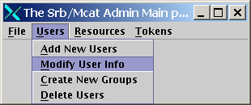
Select the sdsc domain and srb user as below:
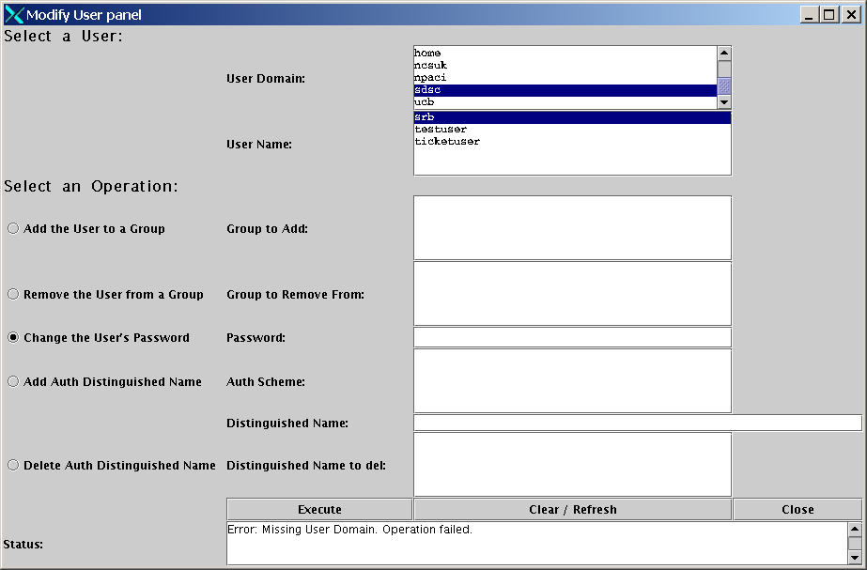
Change the password as required and click Execute.
You can now use the SAT to create resources, add users and groups, etc. See $SRB_ROOT/readme.dir/README.MCAT.ADMIN. A basic description of usage is given in the next section.

Basic SRB administration and Usage

Create a new location
The step creates a new SRB location. The equates to the server running SRB. Run the SRB Administration Tool as follows:
#export DISPLAY=< X server on you PC i.e. mypc.esc.rl.ac.uk:0.0>
#cd $SRB_ROOT/MCAT/java
#gmake run

Select Add New Location
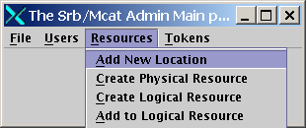
Now enter a name for the location (any you like), a parent location (choose home), domain (domain you created i.e. srbdom ) and user (your SRB admin user i.e. srbadm) as indicated below:
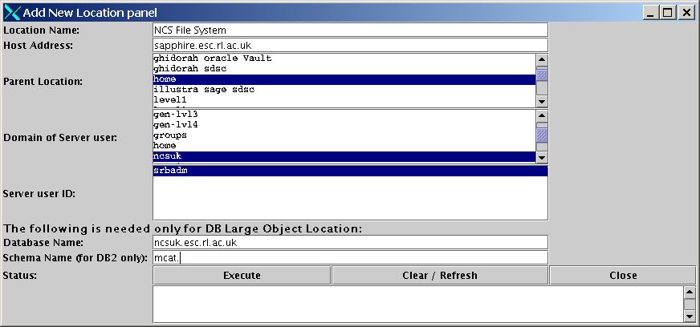

Create a new resource
In the step, you will make a directory on the SRB Linux server available for SRB use.
In SAT, select Create Physical Resource
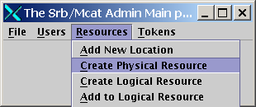
Now fill in details for the Resource Name (any you like), Vault path (Linux directory), Location (from previous step i.e. NCS File System), Resource Type (Linux Unix File System) and Resource Class (chose permanent).
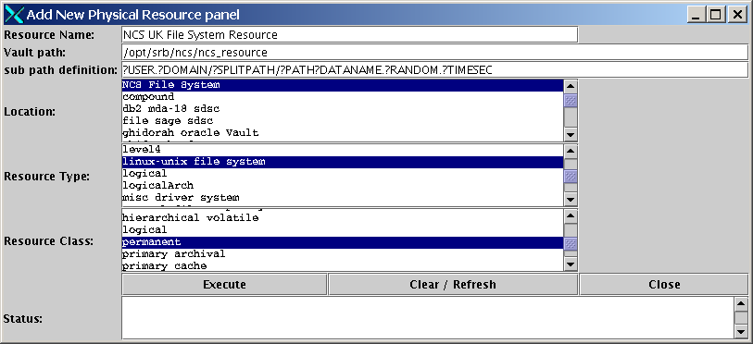

Create a new user
In this step we create a regular user for using SRB. In SAT select Add New Users
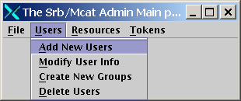
Now create a new user (any name you like ) for your domain (i.e. srbdom)as below. You can give them a User Type. Chose the most appropriate definition.
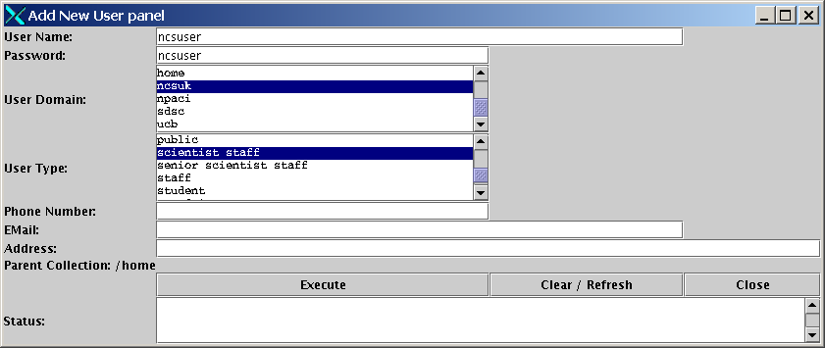
You are now ready to use SRB as an end user.

InQ
InQ is the Microsoft Windows client for SRB. You can downloaded this from
http://www.npaci.edu/dice/srb/tarfiles/main.html

This is a simple install whereby you extract the files from the zip archive into a relevant directory and click on the executable. Please read the short tutorial file enclosed with the distribution.
The InQ login screen looks as below:
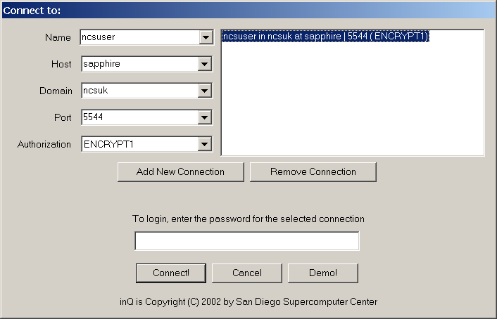
Fill in details relevant to your server. You will then be presented with the main screen below:
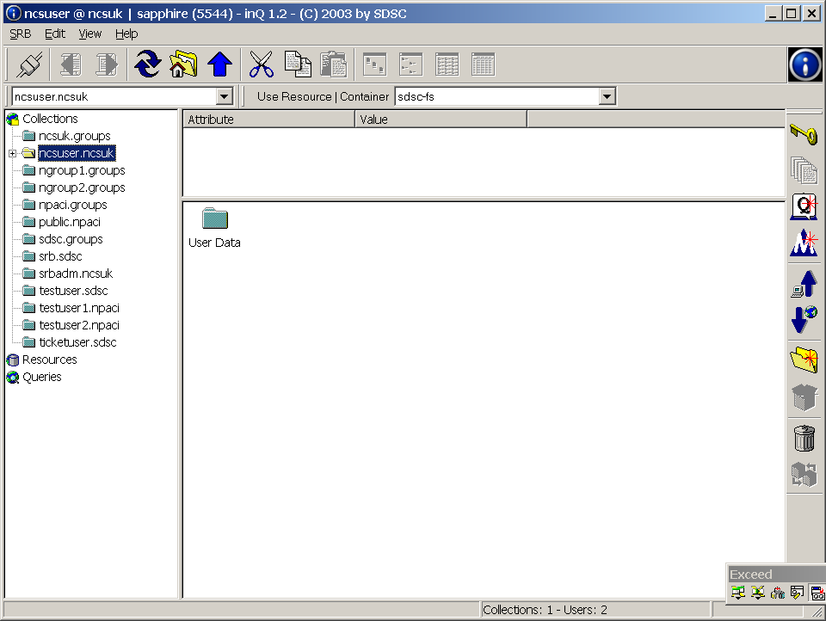
Follow the steps in the InQ tutorial supplied with software to upload and download files etc.

Appendix A: TNSNAMES.ORA and SQLNET.ORA
Example files are given here. These are located in $ORACLE_HOME/network/admin

SQLNET.ORA

/opt/oracle/ora01/app/oracle/product/9.2.0/network/admin/sqlnet.ora.domino
# Generated by Oracle configuration tools.
NAMES.DEFAULT_DOMAIN = esc.rl.ac.uk
NAMES.DIRECTORY_PATH= (TNSNAMES, ONAMES, HOSTNAME)

TNSNAMES.ORA

MCATDB.ESC.RL.AC.UK =
(DESCRIPTION =
(ADDRESS_LIST =
(ADDRESS = (PROTOCOL = TCP)(HOST = srbhost)(PORT = 1521))
)
(CONNECT_DATA =
(SERVER = DEDICATED)
(SERVICE_NAME = mcatdb.esc.rl.ac.uk)
)
)

