Beginner’s User Guide
to inQ and SRB

version 1.2

PART I: Q&A 5
About the author 7
Who is this tutorial for? 7
What is inQ anyway? 7
Okay, what is SRB then? 7
Why is that a good thing? 7
What is replication? How is it different from copying? 8
What is metadata? 8
SRB: Your Swiss Army Knife for Data Management 8
Yes, but what does SRB actually stand for? 8
I understand what SRB is, now back to inQ… 8
What’s the difference between inQ and SRBBrowser? 9
What’s with all these version numbers? 9
What does inQ mean, and how do you pronounce it? 9
Someone once mentioned something called MCAT – What is that? 9
PART II: A Demonstration 11
Take a ride with demouser! 13
Baby steps 13
On smiling faces: Users, Domains, and Access Permissions in brief 14
Dial M for Metadata: Metadata in brief 15
More on content-view 15
More on metadata-view 16
From SRB to you: Downloading, Copy & Pasting, and Drag n’ Drop 16
Your first query 16
Round round get around, I get around… 18
The Current Item Stack Selector 18
PART III: Easy Data Management 19
Collections, Datasets, and other SRB jargon demystified 21
Getting an SRB account 21
Logging in 21
On being a resourceful SRB user 23
Containers: Digital Cardboard Boxes 23
Managing your data with collections 24
Uploading 24
Access Permissions 24
Metadata 26
Deleting Collections 26
Managing your datasets 26
Power-Management: Creating new containers and syncing them 27
The bride of Tree-View Revisited 28
Creating containers, the easy way 28
That’s everything but the kitchen synch… 29
That’s all folks! 29

PART I: Q&A

About the author

Charles Cowart is a software engineer working at the San Diego Supercomputer Center. He is a member of the SRB development team within the Data and Knowledge Systems group. He is also the creator of inQ.

More information on Charles can be found at http://www.sdsc.edu/~charliec.

Please visit inQ’s homepage at http://www.npaci.edu/dice/srb/inQ/inQ.html.

Who is this tutorial for?

This reference is meant to be your friendly, approachable guide to SRB and inQ. It can be a good resource for people new to them and need to get up to speed in a hurry. Unnecessary computer science jargon and concepts are left out and whatever’s left is explained in a way that the average computer user should be able to understand.

What is inQ anyway?

The short answer is, "inQ is a program that people use to talk to SRB." Thus, to get an idea of what inQ can do you for you, you first have to know what SRB can do for you.

Okay, what is SRB then?

SRB is software that sits on top of different storage devices, taking different pieces of storage hardware and treating them as a single large storage system or data grid. SRB presents you with a directory tree just as you would find on a regular UNIX system or standard personal computer; this allows you to group data logically, as you would on a normal computer system. Underneath the "virtual file system" however, lies any number of different physical storage devices including hard disks found your PC or on a server, tape silos, or databases to name a few.

Why is that a good thing?

Since SRB sits on top of other storage devices, files in any given directory in SRB may actually be stored in different devices throughout the country or the world! This allows you to organize data not only logically, but place them physically according to an entirely different set of criteria. Faster physical storage can be used for more frequently accessed items. Important data can be stored on more reliable storage. Data stored on a device attached to SRB can also be 'replicated' to other attached devices with one keystroke. Following the events of September 11th of 2001, features such as these are perhaps more important than ever.

Simply having a virtual file system isn't enough when managing the large amounts of data that SRB can manage. How much data does SRB manage, you ask? As of May 2002, over 28 terabytes of data are stored in SDSC-managed SRBs; that's over 28,000 gigabyes, 28,000,000 megabytes, or roughly 20 million floppy disks! That's a stack of floppies nearly 40 miles high! Searching for a needle of data in that haystack would be impossible without extra functionality such as metadata queries.

What is replication? How is it different from copying?

Replication is a stronger version of copying. SRB can create and manage exact duplicates or replicas of your data as opposed to simply copying it to another location and forcing you to do the accounting. With SRB, you don’t have to remember that file Y is a copy of file X or that they are the same version. When you back up data through regular copying, if file X becomes damaged you would have to retrieve file Y yourself. Once file X is damaged it’s also too late to verify file Y is the same version, and perhaps copy over Y if not.

What is metadata?

Metadata is data about your data. Unlike with a regular file system, with SRB you can attach metadata such as keywords or attribute/value pairs to your data. For instance, you might author hundreds of documents affecting all areas of your enterprise. Within the labyrinth of your organization's data hierarchy it might prove quite arduous to find a given document. By attaching a metadata pair such as Author and Charles Cowart, and another Description pair, locating the appropriate document becomes much easier because you can now search for it.

SRB: Your Swiss Army Knife for Data Management

With SRB you get the power of a search engine or napster married to a networked file and archive system. That’s why SRB is better than any of those solutions by themselves. Only SRB gives you all of the features you need to manage very large amounts of data commonly found in audio/visual applications, scientific research, simulations, and digital libraries.

Yes, but what does SRB actually stand for?

For the technical, SRB stands for Storage Resource Broker. It really doesn't matter a whole lot; most people refer to it as SRB or "Serb".

I understand what SRB is, now back to inQ…

In a nutshell, inQ provides a familiar file-manager-like interface that SRB users can use to manage their data stored on SRB; actually it’s more like a file-manager interface on steroids. inQ looks and acts a lot like Windows Explorer or Nautilus – but also throws in features found in several web browsers like Internet Explorer or Netscape Navigator. It offers an easy way to manage metadata and access permissions, as well as a query builder capable of performing nested queries. It also throws in friendly, context-sensitive buttons that show you which actions can be performed on any given item in SRB.

What’s the difference between inQ and SRBBrowser?

There’s a couple of SRBBrowsers floating around, actually. One was written in Java and one was written for the MS Windows platform. inQ’s functionality is a superset of that found in the older SRBBrowsers, which is one reason we elected to change the name.

What’s with all these version numbers?

With the introduction of inQ, we also decided to change our versioning scheme. Since inQ, SRBBrowser, Scommands, and MySRB are clients for SRB, a new version of the client must be made every time a new version of SRB comes out. The clients themselves are software and two to three upgrades of a client may be released in the same span as one release of SRB. Thus, instead of having three versions of SRBBrowsers released for SRB 1.1.8, each labeled SRBBrowser 1.1.8, build xx.xx.xx, each version of inQ is released for a version of SRB, but with its own version number on the CD cover as well. For example, inQ 1.0 and 1.1 were released for SRB 1.1.8, while inQ 1.2 was released for SRB 2.0 only.

What does inQ mean, and how do you pronounce it?

inQ is pronounced “ink”. inQ is short for inQuisitor, a parody on names such as Explorer, Navigator, Konqueror, Browser, and Communicator, without evoking images of religious persecution.

Someone once mentioned something called MCAT – What is that?

MCAT stands for Metadata CATalogue and it’s a part of the SRB software. It acts as the brain of an SRB, which is why we gave it its own name. It’s not something that the SRB user interacts with directly however, so it’s not something new users need to worry about.

PART II: A Demonstration

Take a ride with demouser!

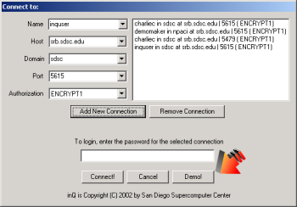
Double-click on the inQ icon to run the program. When the ‘connect to:’ window appears, ignore everything else and press the ‘Demo’ button at the bottom of the window. The Demo button connects you to an SRB Server as our anonymous guest user, ‘demouser’.

Demouser doesn’t have write access to its own home directory so as demouser it will not be possible to upload new files into SRB, nor is it possible to delete anything stored there.

It is possible to do many other operations, however, and it’s also worth noting that demouser will always have copies of our papers, presentations, and the latest versions of inQ.

Baby steps

Once you are logged in as demouser, you’ll notice that like Windows Explorer, there are left and right hand views; the left displays a tree representing SRB’s directory tree. The right hand view represents the contents of the item selected in the left hand view.

You’ll also notice another view above the content-view; this is the metadata-view, where metadata associated with the item selected in the tree-view is displayed.
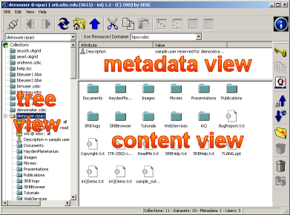

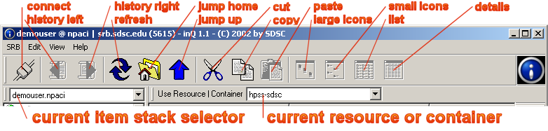
More on tree-view

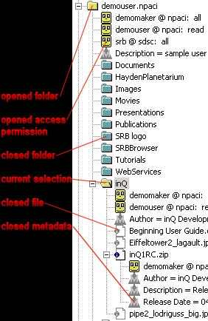
The tree-view should look very familiar to you; in it, the entire contents of an SRB are laid out in a hierarchy of file folders. You will quickly notice that inQ’s tree view contains more than just a hierarchy of file-folders; files, metadata, and access permissions are also displayed with sub-folders. This is because in SRB, directories are not the only things that can be ‘opened’; files can be opened to display their metadata and access permissions. As you read on, you’ll discover that other SRB-centric items such as containers and resources can also be opened. In inQ therefore, the tree-view isn’t just the current directory selector; it’s the current item selector, which can be a directory or folder, a file, or something else entirely.

This expanded tree view is very helpful when managing large amounts of data that often need to be annotated with metadata and shared with other users. As the collection of data you’re managing grows larger and larger and is shared with more and more people, it becomes much more important to have ‘up-front’ a more detailed description of the data.

The tree view also makes use of shading that while very useful, may be unfamiliar to some users. Items that have never been opened are shaded a dull green while items that have been opened previously appear unshaded, whether or not the item is currently expanded or collapsed. inQ doesn’t attempt to pre-open every directory in SRB as this is a time-consuming process and many items will never need to be opened. With the shading system, the user can tell the difference between an empty directory, and one that hasn’t been opened yet. Just as closed items are shaded green, an open folder, or a green-highlighted item usually denotes the currently selected item.

On smiling faces: Users, Domains, and Access Permissions in brief

SRB uses a two part naming convention to identify users on an SRB system. The user’s name is the component everyone should be familiar with, but the second part, the user’s domain, may appear mysterious at first to some users. The domain name is a way to break up users of an SRB into groups; this way, operations can be performed on groups of users, but users from different domains can still share information with each other. With domains it’s also possible to have users from two different domains have the same name. For example, the marketing and engineering departments of a company might have two employees named bill; but instead of giving them cryptic user names, it’s possible to have bill@marketing and bill@engineering.

Whenever you open up a folder or a file, you will be able to see who has access to the particular item. Each access permission is displayed with a ‘smiling-face’ icon and text in the format of name@domain: permission.

The root or base of the SRB tree almost always contains ‘home directory’ folders for each of its users only. These folders are almost always in the format user.domain. For example, when you first login as demouser you’ll notice you are currently in the directory ‘demouser.npaci’. The npaci user demomaker has full access (demomaker@npaci: all) while demouser itself has only access to read the contents of the directory (demouser@npaci: read).

Dial M for Metadata: Metadata in brief

The demouser.npaci folder should also contain a metadata pair labeled, “Description = sample user reserved for demonstration.” In inQ, a metadata pair is made up of an attribute, in this case ‘Description’, and a value, which is the description that follows. Metadata will be covered in more detail later. With respect to the tree-view it is sufficient to say that metadata is denoted with an icon labeled M with blue triangle in the background.

More on content-view

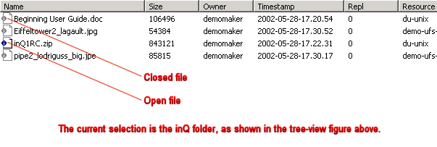
As the name implies, the content-view shows you the contents of the currently selected item. If the currently selected item is a file folder it is quite often the case that something will appear in this window. When the item is a file or metadata on the other hand, nothing will appear in this window. In the future this window will show very detailed view of the item when a file or metadata is selected.

Unlike the tree-view, any one of a number of items may be selected, or none at all. Often it is possible to perform an operation on multiple items, and the tool bar will reflect which operations are available for the group of items selected. Certain operations such as download will operate on the current item if the content-view is selected, but none of its contents are.

Single-clicking an item will select it for a possible operation. Double-clicking a file folder will open it in the tree-view and make it the currently selected item. Double-clicking on a file however, presents you with a menu that allows you to either open the item as you would a file folder, or execute the item.

Executing an item downloads a copy of the item to inQ’s temporary directory, and starts the application on your Windows machine registered to accept files of that type. For instance, executing a Microsoft Word document will load Microsoft Word, Internet Explorer or Netscape Navigator for an HTML document, and so on.

More on metadata-view

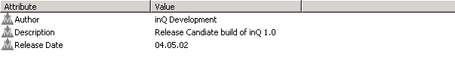
The metadata view displays the metadata contents of the currently selected item just as the content-view displays its data contents. Currently you can’t drag and drop metadata from one item to another, although this is planned in a future release. Like the content-view, the metadata-view can switch from between four viewing modes.

From SRB to you: Downloading, Copy & Pasting, and Drag n’ Drop

 Inside demouser.npaci there is a subdirectory called inQ. Open the directory and then open its ‘samples’ subdirectory. From the tree-view you can select any one directory or file and click on the ‘Download’ button; a dialog will appear asking you where to store the data.

  You can cut or copy the selection for pasting or simply drag it out onto the desktop. Note that not every application accepts file data for pasting.

The content-view behaves much the same as the tree-view except that you may select any number of collections and/or files. When transferring data to your local machine from SRB the file being copied, percentage completed, and a progress bar all appear on the status line, no matter which method is used.

Your first query

 inQ can perform a number of different query operations on items with metadata attached to them. To begin a query, you must first select the range of data you want to query on. You do this by selecting a directory from the tree-view; the query will check all items in this directory as well as its subdirectories. Thus, the farther down the tree you select the narrower your search will be.
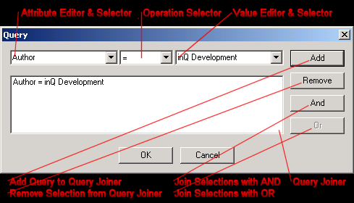

Select demouser’s home directory: demouser.npaci. Press the Query button on the toolbar. In the attribute box type ‘Author’, select ‘=’ from the operations menu, and enter ‘inQ Development’ in the value box. Press Add and the query will be added into the list box below. You can also add other queries if you wish, using = or some other operation.

Once you’re done adding queries, you must join them into one statement before pressing ‘OK’. This is how you build more complicated queries from simple ones. SRB 2.0 supports ‘OR’ operations, but this functionality has yet to be implemented in inQ. In the future, inQ will support this operation and the ‘OR’ button will be enabled.

Once you press OK the results of your query will appear in the tree and content views. The query itself will appear as metadata in the metadata-view. Here are a few tips to keep in mind when the current item is a query:

Opening an item in a query will take you back to the collection in which it’s a part of. Pressing the History Back button at this point can take you back to the query.

Pressing the up button will take you back to the directory queried on.

You cannot add metadata to a query. However, in SRB you can nest queries; that is, you can select a query and press the Query button and the query you make will be performed on the results of the parent query.

Round round get around, I get around…

Inq has a lot of navigation shortcuts to help you get around. Some of these may appear familiar to Netscape Navigator or Internet Explorer users:

 The home collection button takes you back to your home directory from the currently selected item.

 The up arrow changes the currently selected item from the current item to the item’s parent. For example, from a metadata item to its associated directory or file, or from a file to the directory it’s contained in. This button will become inactive if the currently selected item is the top of the collection or resource tree.

The history back and history forward buttons can take you back and forth through the past ten items you’ve selected. When an item is moved or deleted, the history is reset. These buttons turn on and off depending on whether you have a history and are cycling through it.

Depending on whether the content-view or metadata-view has been selected, the four icon-view buttons will present the view in either icon view, small icon view, list view, or detailed view. The default state for the content-view is icon view. The default state for the metadata-view is detailed view.

The Current Item Stack Selector

The Stack selector is similar to pull-down menus found on many MS Windows and MacOS dialog boxes; each node or step in the tree, from the root item to the current item, is listed.

PART III: Easy Data Management

Collections, Datasets, and other SRB jargon demystified

Okay, now that we’ve completed the first leg I have to admit something to you: I’ve been lying to you all this time. I’ve been telling you about SRB’s file and directory structure when really I should have been calling it dataset and collection structure. Why do we call directories collections and files datasets? I suppose it just sounds more logical; in the end, they look and behave the same so don’t feel like you missed something when someone mentions their SRB collection, they’re just using the official jargon.

In SRB, uploading is also called ingesting or importing, while downloading is called exporting. This is because it’s PhDs that write the papers and invent the names; but since this is ‘the reference to see for the non-PhD’, I’ll refrain from using them and thus giving you extra stuff to remember.

Getting an SRB account

If you are reading this guide because your organization is using SRB, please contact your SRB administrator and ask to have an account created for you. This will allow you to follow the following examples.

If you’re reading this because you’ve picked up one of our demonstration CDs, please contact us at srb@sdsc.edu and we’ll create an account for you on one of our SRBs to let you better preview our product.

Logging in

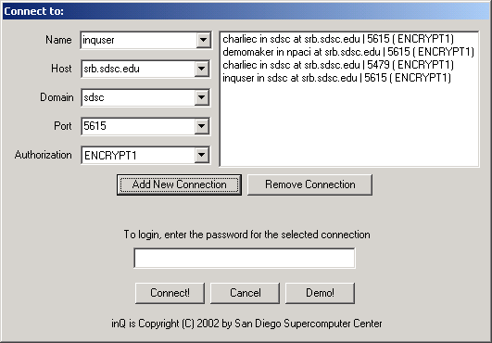

Quit and restart inQ or press the connect button at the left-most side of the toolbar. At the ‘Connect to:’ screen enter your user information.

- Name: Your user name.

- Host: This is the domain name of the server running SRB. For SDSC-managed SRBs this is usually srb.sdsc.edu.

- Domain: Can be thought of as your user group or in general a qualifier to your user name. For SDSC-managed SRBs sdsc, npaci, and birn are common domains.

- Port: The port that SRB is listening on at the above host. Your SRB administrator will tell you which number you need to enter. As an alternative, you may check http://www.npaci.edu/dice/srb for a list of SRB ports used by SDSC-managed SRBs.

- Authorization: The method by which SRB uses to verify that you are really you. SRB can use one of several methods, including SEA and GSI, but inQ currently uses one of the following two methods:

  - ENCRYPT1: The more secure method of the two. Generally you’ll want to use this one.

  - PASSWRD_AUTH: Your password is passed in the clear to the SRB Server. This works well for verifying that you are you, but also lets those putting an ear to the network see your password.

If you press the ‘Add New Connection’ button after entering your connection info, the information will be stored as a profile for future use and will appear in the listbox to the right; passwords are not stored as a part of these profiles. Note that each connection field is also a pull-down menu which lists possible values from your list of saved profiles.

You can remove a profile by selecting it and pressing ‘Remove Connection’.

After entering your password you can press ‘Connect!’ to connect to SRB or Cancel to exit the application.

The title bar will always reflect your connection status, specifying your user name, domain, SRB host, and port number when connected. It will also indicate when it is in the middle of connecting to SRB, and when it is disconnected.

On being a resourceful SRB user

You might remember reading in the beginning of this guide about how SRB can put data into collections without having to actually store them in the same place. Two different datasets can be uploaded into the same collection, but actually be stored on two entirely different devices. An original document can have several copies or clones (called replicas in SRB-speak) of itself in a collection, and each one can be stored in a different device far away from the rest! In SRB terminology these devices are called ‘resources’.

Thus, when you upload, move, copy and paste, or replicate data you must specify a resource to store the data in as well as a collection to reference it in. It’s a lot like having a folder on your desktop filled with shortcuts to your programs, images, documents, etc. You’re using the folder with its shortcuts to organize your data, but each shortcut actually points to a program or a piece of data stored somewhere else on your computer.

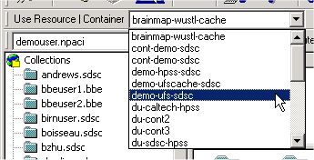

It’s not actually as hard to do as it sounds. Beneath the toolbar are a group of pull-down menus; one of them is labeled ‘Use Resource | Container’. This menu contains a list of all resources (and containers, but we’ll get to that a little later) available on the SRB. Whenever you perform one of the above operations, it will use the resource selected above.

It’s worth noting that resources registered with SRB are not required to be active at all times, that is in working order, turned on, etc. If you find yourself with an error-message when attempting one of the above operations try a different resource or contact your SRB administrator regarding which resources are available.

Containers: Digital Cardboard Boxes

Containers are a ‘power-user’ feature in SRB. You don’t need to understand containers to use SRB. Containers are useful in grouping a large number of small datasets that are often related for storing in resources which specialize in pushing and pulling large amounts of data at a time.

For instance, performance isn’t affected by accessing large numbers of small images from a disk. The same can not be said if one were doing the same from a tape-library. For any resource registered on SRB, a user can create a container in that resource and it will become available in the Resource | Container selector. By selecting the named container, items you upload, etc. will be stored in the container instead of an ordinary resource.

Managing your data with collections

 Before you upload any data into SRB, you’ll probably want to create a new collection to put it in. Selecting a collection to be the parent and pressing the ‘New Collection’ icon on the toolbar can create new collections. After entering a name and pressing ‘OK’ the new collection should appear. Since collections are purely logical, there is no need to select a resource when creating one.

Uploading

 Whatever you upload is placed logically into the collection you specify, but it’s being stored physically in whatever resource or container is specified in the Resource | Container dialog. Other than that, uploading behaves much the same as downloading with progress bar on the bottom of the screen and so on; it’s merely going from you to SRB, instead of vice-versa.

The preferred way to upload directories and files into SRB is to simply drag them in or paste them in from Windows Explorer. There is also the upload dialog which brings up a generic menu with which you can select a small number of files. The second method is not preferred due to the limitations of the dialog; these limitations will be addressed in the next release.

Access Permissions

 An access permission is like a sticker that can be affixed to, changed, or peeled off of a collection or dataset by its owner. The sticker in this case has an SRB user’s name and a short description about what the owner will let them do to the collection or dataset. Once you stick an access permission onto your collection or dataset, SRB can act as a policeman and stop a user from doing things you haven’t allowed them to do. In this case, the short description is not something you make up but something you select from a list of possible choices created by your SRB administrator.

Users familiar with UNIX or Windows NT operating systems will understand at least read, write, and execute permissions; these permissions specify whether the specified user can read the data, write new data to the file, or execute it.

SRBs can have many more access permissions than most file systems however, and these can change from SRB to SRB. Typically most SRBs will have the first three mentioned, plus all and null; these represent the highest level of permission one can bestow and no permission at all, respectively. Many SRBs will also have one or several annotate permissions – which allow the user to annotate or attach notes to the dataset or collection, but not always change the data itself.

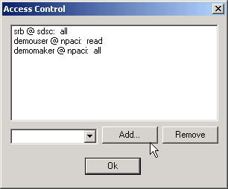
You can easily add a new access permission by selecting a dataset or collection and pressing the Access Control button on the toolbar.

Select the ‘Add’ button. The left-hand window of the access control dialog displays all the domains available on your SRB. Once you select a domain, the user names of that domain will appear in the right-hand window. Once you select a name, choose permission from the pull-down menu below and press ‘OK’
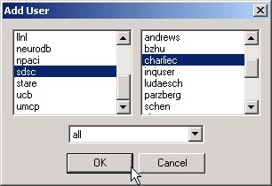

You can see the new access permission has been added to the list.

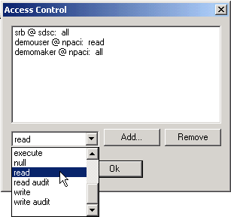
You can change the access level of one or more permissions simply by selecting them and then selecting an access permission from the pull-down menu in the lower left corner. Likewise, selecting them and pressing ‘Remove’ can remove any number of permissions.

For a specific list of access permissions and what they mean, you should contact your SRB administrator.

Metadata

In inQ, metadata are word pairs that can be added to your collections and datasets to help you describe them and search for them later. Metadata appears both in the tree-view under the collection or dataset, and in inQ’s metadata-view. In formal terms, the word pair is called an ‘attribute-value pair’ and is displayed in the tree-view as ‘attribute = value’ and in the metadata-view in separate columns.

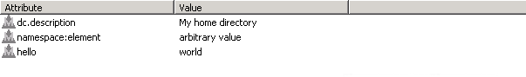
 First, open the collection (or dataset) to add metadata to it. Click on the ‘Add New Metadata’ button and an edit box appears in the attribute column. After typing a value and pressing return or clicking outside the box, a second edit box will appear in the value column. Add a value for the ‘value’ component and press return (or click outside the box again) and the your new metadata item will appear in both the tree and metadata views.

To change a collection’s metadata, click on the value in value column that you wish to change and an edit box will appear. After you press return or click outside the box, the changes will appear in the tree and metadata views.

To delete metadata from a collection, simply select the metadata in either the tree or metadata view and press the ‘Delete’ button on the toolbar. (In the metadata view it’s best to click on either the icon or in the attribute column since clicking in the value column will begin the edit process.)

Deleting Collections

 Deleting a collection is a straightforward affair. Select the collection(s) you wish to delete and press the ‘Delete’ button on the toolbar; this will remove all datasets and sub-collections contained within the collection as well.

Managing your datasets

Performing uploading, downloading, cutting and pasting, deleting, metadata, and access permission modifications on datasets is pretty much the same as it is for collections. Datasets can also be renamed, which is also a straightforward process.

There’s also another operation that can be performed on datasets and you might have heard me mention it before; it’s called replication.

 To replicate one or more datasets, choose a resource or container from the Resource | Container pull-down menu. Select the dataset(s) you wish to replicate to that resource and press the ‘Replication’ button on the toolbar.

SRB 2.0 does not support replication of items in containers; this will be addressed in a future release.

Power-Management: Creating new containers and syncing them

If you’ve been with us the whole time, congratulations; you’re almost at the top! You pretty much know everything a user has to know about SRB. A container isn’t a feature that helps you manage your data; it’s a feature that enhances SRB performance when using certain types of resources. Containers are a power-users feature; but before I start teaching you how to use them, I’m going to pay another visit to your best friend in all of SRB-space:

The bride of Tree-View Revisited

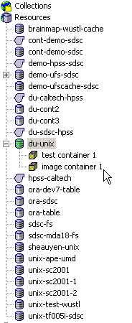
If you haven’t tried building the sample query from Part II, you probably haven’t noticed that the tree-view not only displays a tree representing every collection and dataset in SRB, but a couple of other trees as well. The second tree displays each resource available on the SRB, with each container listed under the resource it was created in. The third tree displays each query you’ve performed since you’ve logged in; naturally with nested queries appearing underneath the parent query.

When you log into SRB, it’s the Collections tree that is expanded while the other two are collapsed. To view another tree, scroll down to it and if nothing is listed underneath the tree, double-click on it and the tree will expand. Double-clicking on the tree again will close the tree. More than one tree can be opened at one time, although I often find it easier to navigate if I close one tree before opening another; when you close one, one or both of the others often appear. This saves you the trouble of having to scroll up and down, should the trees be large.

Creating containers, the easy way

 To create a container, open the resource tree in the tree-view, select a resource, and then press the ‘New Container’ button in the toolbar. You’ll see the new container appear underneath the resource. It will also be added to the Resource | Container pull-down menu; if you wish to use this new container right away, select it from the pull-down menu.

That’s everything but the kitchen synch…

 Once you’ve created a container, it becomes attached to a resource; all of the files you stuff into it are sitting somewhere, maybe on a disk, or maybe on a tape-drive. When you request one of the datasets stored in a container, the entire contents of the container are retrieved from the resource and stored in a cache; the data you actually selected is then sent to inQ or whatever other client you’re using.

When you make a change to that dataset, it will reflect on the one in the cache, instead of the original. To update the original you need to synchronize the containers. To synchronize a container, select the container from a resource in the resource tree. Press the “Synchronize Container” button on the toolbar and the original will be updated from the cached copy.

That’s all folks!

That’s it! You’re a certified inQ guru! Thanks for taking the time to flip through this tutorial and if you have any comments or questions, please don’t hesitate to send them to srb@sdsc.edu. So long!

Specifically, SRB is known as ‘middleware’ – a software product which glues two layers of software together and passes data between them. Middleware can be thought of as plumbing for computers.
This doesn’t include SRBs managed by other organizations.
Expanded items show their children and are displayed with a + sign before them. Collapsed items do not show their children and have an – sign associated with them.
This functionality was also included in some earlier releases of SRB 1.1.8 including 1.1.8w, but not the 1.1.8p ‘production release’. Now aren’t you glad we finally made the jump to 2.0?
SRB also has many truly advanced features, but because they are advanced and because inQ does not currently support them, they are beyond the scope of this tutorial. =)

