THESIS PROPOSAL

FEDERATED SERVICE ORIENTED INFORMATION MANAGEMENT

Author: Ahmet Sayar
Indiana University
Computer Science Department

Advisor: Prof. Geoffrey Fox
Indiana University
Department of Computer Science
Department of Physics
School of Informatics

CONTENTS

ABSTRACT 3

1. Introduction 4

2. Literature Review 6
2.1. Matching ASIS Components to the Components in Major Science Domains 7
2.2. Scientific Data/Information Grid 8
2.3. Data Access and Federation 9

3. Problem Statement 10

4. Proposed Methods and Architecture 11

5. Preliminary Results and Discussions 17
5.1. Application Use Domains 20

6. Conclusions 21
6.1. Research Issues 21
6.2. Expected Contributions 22

REFERENCES 23

ABSTRACT

The users (scientists and decision makers) want the scientific information and knowledge to be ready to use in their specific applications, rather than the raw data. However, current scientific information management systems can not provide ready to use user specific scientific information and knowledge to broad user and decision maker communities.

Geographically distributed heterogeneous data is administrated by different people and provided in different format via heterogeneous kind of Database or file systems. Accessing and integrating different data from different providers using different heterogeneous technologies is a cumbersome and even impossible task with the current technologies.

Our ultimate goal is creating an architectural framework solving the above common scientific data/information federation problem at the application level, and listing requirements and challenges for creating that architecture. Our main approach to the problem solution is using domain specific XML interfaces and metadata enabled Web Service [32] based filter services. The whole proposed architecture is a Web Service implementation of a Service Oriented Architecture model.

We develop a general Grid architecture [15, 16] based approach to distributed heterogeneous data, information, and knowledge (which are provided by different repositories and producers) in an efficient and robust manner. Federation is the core structure of this Grid architecture. Federation is accomplished through the metadata (in XML based capabilities document) enabled filter services. Filter federation is done at the information level. The composability of the filters supports natural scaling and federating and adding load balancing and caching capabilities in the filters. Caching and load balancing enable handling large scientific data in an efficient and robust manner. Adding metadata to the filters also provides loose coupling and chaining of filters, and binding of services into pipelines with or without human intervention.

Introduction

In science applications, scientists (end users and decision makers) need to access data provided by different administrative domains remotely. Data might be raw data coming from real-time sensors or instruments or information and knowledge which are processed and interpreted by a chain of services defined statically or via workflow systems.

Scientific data is complex and heterogeneous, even if they come from the same domain; different vendors provide data in different formats. For example, the same data can be represented in ASCII, byte array, or string. In that case, federating and searching the data requires a lot of extra application and data specific implementation work. In order to solve these heterogeneity and complexity problems (at least in a specific domain), some standard bodies (such as Open Geospatial Consortium (OGC) [2] in the Geographic Information Systems (GIS) domain and International Virtual Observatory Alliance (IVOA) [3] in the Astronomy domain) have created some standards for the online services and data models. In order to provide interoperability across the platforms, operating systems, and programming languages, standard bodies define: required services and their interfaces, functionalities each service provides, message formats and supported communication protocols, data annotation and metadata formats and concepts, etc. Standard bodies for science domains mostly do not define specifications for the data federation but their definition of data model enables federation indirectly. Among these data models are Geographic Markup Language (GML) [5] for GIS and Virtual Observatory Tables (VOTable) [17] for IVOA.

Information federation is constructed on top of the data/data-federation services. There is no clear separation line between data and information; it changes from application to application. We use DIKW to describe the hierarchy of Data-Information-Knowledge-Wisdom that we are attempting to support. Information is the meaning that is currently assigned to data by means of the conventions applied to these data. Knowledge is an organized, integrated collection of facts and generalizations [4]. Wisdom is super extraction from information and knowledge. In order for the scientific data to be useful, information has to be extracted and converted to wisdom decisions or at least knowledge. However, because of the complexity, heterogeneity and multidisciplinary nature of the scientific data, it is difficult to extract knowledge and draw wisdom decisions from them without complex chained processes. In our approach to the problem solution, each process in the chain is wrapped as a Web Service and called as “Filter”.

Filter Services are information sources (not data – see previous paragraph) that enable federated information management through their predictable input/output interfaces defined by capability documents. A capability document is an XML based document that provides metadata about the filters and their functionalities. A Filter Service inputs DIKW from other Grids or Services and outputs DIKW – perhaps converting data to information etc.

Services in the science domains or in any other domains take some parameters as inputs and after processing/transforming return something as outputs. For the sake of generality we call these services as filters after adding some specific functionalities, service ports and metadata capabilities. Raw data might go through several filtering operations that transform and analyze it before the scientists and end users see it. Basic filter applications typically include simple transformation operations and predictable data extraction operations (which extract out known parts of the data stream). Filters are typically grouped into chains of dependent operations that produce specialized data products through a process commonly called ‘workflow’, but this is out of scope the scope of our research work. Filters are basically Web Services. So, they are chainable together to create more complex services by using any third party workflow machines and languages such as Business Process Execution Language (BPEL) [18]. In our initial proposal, we use static chaining of filters instead of using any workflow systems.

Information management is accomplished through the federation of Filter Services in the Service Oriented Environment. In our architecture framework, Service Oriented Architecture is based on Web Services. In other words, each Filter Service is a Web Service. Being a Web Service enables Filter Services to publish their interfaces, locate each other and chain together easily. Extending systems and applications with a new Filter Service is also easy.

We call our federated information management ASIS (Application Specific Information System). In ASIS, Filter Services come up in two different names: Application Specific Feature Service (ASFS) and Application Specific Visualization Service (ASVS). ASFS and ASVS talk to each other in Application Specific Language (ASL). ASL is a common data model structured in XML. XML based hierarchical data model enables common language and communication across operation system and platforms to exchange and federate information. In order to make the proposed architecture feasible, all the data should be converted to ASL through an adapter deployed database end Filter Service such as Web Feature Service (WFS) [6] in GIS domain. Filter Services provide data in consistent formats and define these formats and the ways to access them in their capability documents.

We created the Interactive Decision Support (IDS) [19] tools for the geosciences applications in the SERVO [8] project. We will use IDS tools for investigating the interesting general problems of information transformation and service federation. The decision support user needs human readable outputs such as images and animations and statistical information such as plotting, graph, and pie charts. When using IDS tools, users don’t need to know data and application specific parameters and query settings for querying the heterogeneous data providers. They just use the tools to query and get the information and knowledge in human readable formats from the system to make wisdom decisions. We also created movie and animation tools for querying and creating animation on time series data.

We also propose but do not guarantee some quality of services for Filter Services. These are dynamic filter interaction to upgrade integrated cascaded capabilities metadata files, and streaming connection between all services that provide on the fly archiving, high-performance transport, authentication, authorization and fault tolerance.

On our way to achieve this ultimate goal, we expect to encounter some challenges. These are representing, transforming, integrating and displaying data and information/knowledge, and defining common annotation and metadata structures to enable attribute based data search and display. We define common concepts and characteristics for data, metadata, query facilities and services in our proposed general architecture, ASIS.

As methodology, we first create ASIS for the GIS domain, and then create client/end-user tools to enable usage of the proposed architecture by the scientists. After proving that it works for GIS, we extend and define the general architecture requirements for the other domains, defining the challenges, and general characteristics and/or requirements for ASIS.

In Chapter 2, we present literature survey about first, how strongly ASIS architecture (or Federated Service Oriented Information Management) matches to major science domains such as GIS, Astronomy and Chemistry, second, well known scientific data-grid projects such as LEAD (Linked Environment for Atmospheric Discovery) [20], Geophysics Network (GEON) [21, 22], and third, major data access and federation projects in Grid environment. In Chapter 3, we summarize the problem statement. In Chapter 4, we propose the methods and architecture of the Federated Service Oriented Information Management. In Chapter 5, we present preliminary results and discussions. Chapter 6 consists of conclusions. It covers research issues and expected contributions in its subsections.

Literature Review

This section is composed of three parts. One is regarding possible science domains to which ASIS is applicable. This section gives a general idea about how strongly ASIS fits to different major science domains. The following subsection is about some related well known data-grid projects. This section gives idea about the general picture of what we are trying to achieve and what the ultimate goal in the scientific data-grid. The last subsection is about the data access and federation in Grid. We examine two well known data-grid projects. These are Open Grid Service Architecture – Data Access and Integration (OGSA-DAI) [23, 24], and Storage Resource Broker (SRB) [25, 26].

Our motivation domain is GIS. GIS is a system for creating and managing spatial data and associated attributes. OGC is a standard body for the GIS domain. It defines publicly available online services and data model specifications. Its goal is to make geographic information and services neutral and available across any network, application, or platform. We implemented OGC compatible Web Feature Service (WFS) (implemented by Aydin, G.) and Web Map Service (WMS) [7] for our proposed ASIS architecture. We also use Geographic Markup Language (GML) as common data representation tool (we call it ASL in the ASIS). WFS is a feature service and provides vector data such as lines, polygons and points. WMS is a map server and provides data in the form of images and some other formats such as SVG, PNG, and text files. These formats are defined in their capability documents. In the next section, you will see the comparison between proposed ASIS architecture components and major science domain requirements.

Our federated Service Oriented Architecture is Web Services oriented. All the filters building the system are Web Services. The Web Service technique overcomes the shortcomings of the traditional Distributed Object technique and provides the interoperable capability of cross-platform and cross-language in distributed net environments. The Web Service architecture establishes standard interconnection rules between services and information clients that nicely support the dynamic integration of data, which is the key to creating federated information management architecture. Wrapping Filter Services such as ASFS and ASVS from different vendors as Web Services enable them to be integrated into federated information management systems easily.

2.1. Matching ASIS Components to the Components in Major Science Domains
- OGC GIS, Chemistry and Astronomy

All these science domains have some common characteristics and this motivates scientist to work in the same or similar directions. These characteristics/challenges can be summarized below;
- Distributed nature of scientific data
- Proprietary data formats, and service methodologies
- Annotation and metadata formats and boundaries between data and metadata
- Lacking of interoperable services
- Federating/assembling data from distributed sources
- Format conversions
- Amount of resources for geo-processing
- Modular extensible visualization tools

Table 1: Matching ASIS components to well known science domains
 | ASL | Filters  ASFS ASVS |  | Metadata
GIS | GML | WFS | WMS | capability.xml schema
Astronomy | VOTable, FITS | SkyNode | VOPlot  TopCat | VOResource
Chemistry | CML | NO | NO standard  JChemPaint | NO

For a simple scientific data/information grid, we need data, a data/information provider, and a data/information displayer (See Figure 1). In our proposed immature ASIS architecture, we represent data in ASL, the data/information provider is ASFS and the data/information displayer is ASVS. After our long literature survey, we saw that other main science domains also have similar online services serve for the same/similar purposes (see Table 1). Not all the domains have specifications for all the services, data models and metadata definitions in their field. For example in Chemistry, specifications for distributed scientific applications are very immature, moreover, they have just data model specification (CML in Table 1) which is not widely accepted and used.

We think that our proposed Federated Service Oriented Information Management Architecture can be applied to these sample domains. ASIS architecture proposals and methods will be given briefly in Chapter 4.

2.2. Scientific Data/Information Grid

Here we talk about some major data-grid applications for various major science domains such as LEAD, GEON, MyGrid [12, 13], and National Virtual Observatory (NVO) [14]. Please see Figure 1 for the simplest case of their relations to our proposed architecture, ASIS. These major data-grid applications use projects mentioned in Chapter 2.3 for achieving the data access and integration.

We will not go into detail and explain all these sample projects but rather will give a summary of their general characteristics from our proposed architecture’s point of view. All application grids that we surveyed have similar features. All use Web Service architecture. All have service families: data services, application execution services, information services, and workflow. We also use similar features in our application grid.

LEAD seeks to provide on-demand weather forecasting in meteorology domain. GEON provides ontology enabled applications mostly based on data registration, discovery, manipulation and display in the GIS domain. MyGrid is basically a combination of Grid, Web Services, and semantic web efforts in the bioinformatics domain. NVO is a data-grid project in the Astronomy domain.

Figure 1: Related projects and where we are in the related research world.

2.3. Data Access and Federation

The related works at the data access and federation level (See Figure 1) are SRB and OGSA-DAI. SRB puts more emphasis on managing and maintaining data files, while OGSA-DAI puts more emphasis on data retrieval in Grid environment. In contrast to OGSA-DAI, we are tackling DIKW to describe the hierarchy of Data-Information-Knowledge-Wisdom that we are attempting to support. We are closer to SRB in capability managing data integration than OGSA-DAI with some differences. In order to integrate any data to the system, we convert it to ASL. ASL is XML based common data format. In order to make this conversion, we use adaptors in end-filter services deployed at the service invocation points of Databases. We can leverage the advantages and powers of OGSA-DAI and SRB services by adding extra filters in front of their service invocation points.

SRB provides uniform access to distributed heterogeneous data resources by attributes. It uses MCAT (Metadata Catalog Service) [27] to enable attribute based querying and data access. We use a capability based metadata approach. Capabilities have predefined XML schema that differ from domain to domain. SRB also provides location transparency for the data, and data access is done through the authentication and authorization. We are not dealing with the replications and location transparency (at least for the time being). SRB can be leveraged in ASIS. BIRN and NVO are sample projects using SRB.

OGSA-DAI emphasizes the Database layer, whereas we are tackling the application specific DIKW. OGSA-DAI can be leveraged in ASIS. OGSA-DAI enables access to heterogeneous data via common interfaces on the Grid. The catalog service is MCS (Metadata Catalog Service) [10, 11]. Sample projects using OGSA-DAI are LEAD and MyGrid.

Problem Statement

Because of the complexity and multidisciplinary nature of scientific data and lacking of a general solution to data-grid architectures, it is difficult to extract useful knowledge from the geographically distributed data and information without sophisticated processes. These processes mostly belong to different administrative domains and are deployed on various kinds of different platforms and might be written in any language. There is no clear cut solution to the common architecture to handle this heterogeneity of data and services to be used by scientist and decision makers in the scientific applications. There are some solutions to the problems related to the distributed nature of data-grid applications, but there is still a problem with the common data models and relating different data in different formats from different providers in an application (see Figure 2). In order to solve this problem, annotation and metadata come up. OGSA-DAI and SRB are the well known projects about attribute based data access using annotation and metadata concepts.

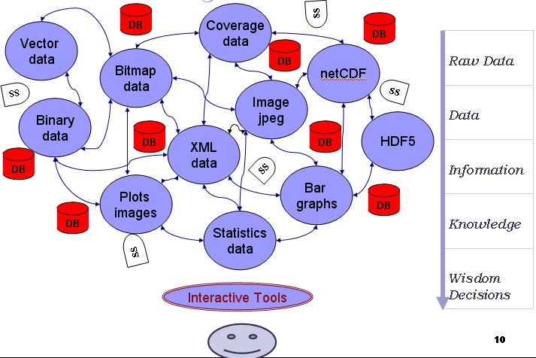
Figure 2: Scientific data world – interaction – conversion in DIKW

We depict the general problem in Figure 2. Each circle is a process in the federated information management concept and provides some data/information (processed or raw data). Since each one take data as input and (after processing) sends out as output, we call them filters. In real life, data perception (such as raw, information, knowledge, or wisdom) changes from person to person or application to application. We use DIKW to describe the hierarchy of Data-Information-Knowledge-Wisdom that we are attempting to support. Some filters are edge filters that just have adaptors to get data from Database or Sensor Service (SS) and send them to the next filter or an end user. Other filters are intermediary -getting data from one filter and sending it to another. A filter might be both an edge and an intermediary filter.

In order to be able to create such an architecture framework, we need some services such as service/data discovery and notification in addition to filters. Services like discovery and notification do not need to be made application specific but their interfaces need to be defined in the Service Oriented Architecture and implemented as Web Services to be able to integrate them into the SOA based systems.

Instead of making complex queries, users want to use just easy to use interactive tools in a human readable form such as “give me the map for California”. These type of queries will be interpreted by the filters and it will create complicated (if needed cascaded) queries to its own Database or to other filters which it is in contact with. Currently, we keep connections static, later we will be working on making on these interactions dynamic through the Registry/ Catalog services.

We will be creating this type of architecture first for the GIS domain as a solution to the problems mentioned above. After, we will extend the architecture and define the general requirements for the other domains. If the domain changes, then choices, Database requirements, data format, core service requirements, attributes and metadata context changes. What the common concepts and characteristics for data, metadata, query language, services, and communication language are, in order to drive information / knowledge from the heterogeneous data/information sources in any application domains, is the other problem that remains to be solved.

Proposed Methods and Architecture

Based on the general picture of the problem statement (see Figure 2), we proposed an architecture framework to implement Federated Service Oriented Information Management, and called it ASIS. Here we basically talk about the required components of the architecture and define the functionalities and ultimate goal to create this architecture.

We already started and implemented some parts of the architectural concepts and explained them in Chapter 5 (Titled Preliminary Results and Discussions). Here we describe the research design and procedures to be used to accomplish the specific aims of the proposal defined in Chapter 3 (titled Problem Statements).

First, we create the basic fundamental architecture framework and general aims of ASIS as a Federated Service Oriented Information Management Architecture in the GIS domain. Then, we generalize it for the general science domains. For that purpose, we define general characteristics of the science domains, data-metadata concepts and their separation in different domains, and requirements for federation of data/information.

Generalization from GIS to any domain:

General Science Main
GIS Domain -ASIS Functionality
GIS . . . . . . . ASIS . . . . . . . . (Science Domain)
GML . . . . . . . ASL . . . . . . . . . (Representing)
WFS . . . . . . . ASFS . . . . . . . . . (Storing-Resource)
WMS . . . . . . ASVS . . . . . . . . . (Displaying)
Capa.xml . . . . Metadata . . . . . . . (Integrating)
SOAP over HTTP . . . . . . . . . . . . . (Communication Protocol)

ASL: Application Specific Language. ASL is an XML based hierarchical data representation language, and provides communication cross language, platform and operating system
ASVS: Application Specific Visualization System. ASVS is the last filter before the decision maker. IDS tools interact with this filter. ASVS provides information/knowledge in human readable formats.
ASFS: Application Specific Feature Service. ASFS stores and provides common ASL.

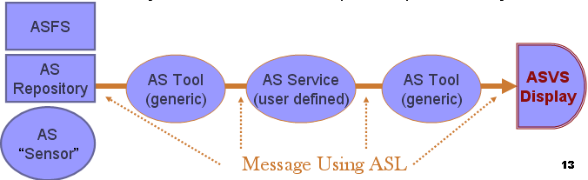
Figure 3: ASIS Architecture enabling Federated Service Oriented Information Management

We generalize our experience with GIS and define an architecture framework for the Application Specific Information Systems. In each application, there are some services like discovery and notification that do not need to be made application specific. However we will need a generalization of the WFS from GIS that can be applied to domain specific data and metadata models. Operations of this service include search/store/access functions. We call this generalization Application Specific Feature Service (ASFS).

We also need to define an analogy of the Geography Markup language, which expresses the domain specific data in GIS. Its correspondence in ASIS is ASL We note that the ASL must support data sources such as sensors (in analogy to GIS metadata and data sensor standards) and repositories. Further, sensors need the support of streams of data which can be common across applications. Queries in the application domain’s information system need to support archived (all relevant data in past) and streaming (all data in future with given properties) styles.

We finally introduce Application Specific Visualization Services, generalizing OGC’s WMS to both visualize information and provide a way of navigating Application Specific Feature Services and their underlying Databases (cf. the “GetFeatureInfo” operation for the OGC’s WMS). The Visualization Service can itself be federated and presents an output interface. As in Figure 2, all user and system services will input and output data in the appropriate domain-specific XML language using filters to process raw data.

In Table 2, we explain interfaces of ASFS and ASVS required for the ASIS architecture to create Federated Service Oriented Information Management system. Each one has three different routines for different purposes. In the following paragraphs, you will see the brief explanations about each routine.

Table 2: ASIS Components (ASVS, ASFS) interfaces
ASFS |  |  | ASVS
Routines | Return types |  | Routines | Return types
GetCapability | Capability file XML |  | GetCapability | Capability file XML
DescribeData | XML-schema |  | GetVis | Images, SVG, PNG..
GetData | ASL |  | GetDataInformation | HTML, Text, XML

GetCapability: Enables learning which feature types ASFS can service and what operations are supported on each feature type. It allows the server to advertise its capabilities such as available layers, supported output projections, supported output formats and general service information. After invocation of this request, ASFS and/or ASVS return an XML document with the metadata about themselves. This capabilities file is kept in the local file system. The capabilities file is an XML structured metadata file defining service metadata, description of services and content, and acceptable request parameters.

DescribeData: An ASFS should be able, upon request, to describe the structure and type of any data/information it provides. The function of the “DescribeData” operation is to generate a schema description of feature types serviced by an ASFS implementation. The schema descriptions define how an ASFS implementation expects feature instances to be encoded on input and how feature instances will be generated on output. In response to a “DescribeData” request, where the value of the output format attribute has been set to XMLSCHEMA, an ASFS implementation must be able to present an XML Schema document that is a valid GML application schema and defines the schema of the feature types listed in the request.

GetData: The “GetData” operation allows retrieval of features from ASFS. A “GetData” request is processed by an ASFS and an XML document containing the result set is returned to the client. The <GetData> element contains one or more <Query> elements, each of which in turn contains the description of a query. The results of all queries contained in a “GetData” request are concatenated to produce the result set. The “outputFormat” attribute defines the format to use to generate the result set. Data might be cascaded data, I mean not directly provided by first hand ASFS, but that ASFS should communicate with some other ASFS in order to get that data and respond to requesting client.

GetVis: The “GetVis” routine allows the retrieval of the data display in a defined format in the request. It is done after finishing the “GetCapability” request to ASVS and defining the available layers provided by that specific ASVS. All the supported image formats are defined in an ASVS capabilities document. Requests for the image formats should be made in accordance with the ASVS’s capabilities file. The image is returned back to the ASVS Client as a SOAP attachment.

GetDataInformation (optional): It is used only when a user needs further information about any data on the interactive display screen. This routine is an ASVS specific filter routine. After getting the collections of data from the ASFS corresponding to a specific query, ASVS extracts all the non-geometry elements (not for display related tag elements in ASL) and attributes in the returned ASL and convert it to HTML or plain text depending on a specific request parameter. This conversion is done using ASL specific XSL file and generic XSLT transformation machine.

Each service needs to support a “GetCapability” interface. It provides a set of metadata (a capabilities document) describing the service, the behavior, contents, and binding information. Capabilities (metadata) are composed of 3 sections, see the sample capabability.xml file given in Figure 4.
- Service vendor and server
- Scientific data provided
- Functions on data

All the interactions are done through SOAP over HTTP. Each routine is published in the WSDL, invoked based on predefined request schema and put into a SOAP body.

<SOAP:Envelope>
<SOAP:Body>
<request to routine>
<request body/>
</request to routine>
<SOAP:Body>
<SOAP:Envelope>
<request to routine> …..<request body/>
</request to routine>

Different domains require different metadata schema (different tag elements and attributes) and different data models. So capability schema need to be changed when the domain changes. When attributes change, requests for querying data/information need to change. Here we define a general architectural approach to scientific information federation but not generic capability schema and data models. Data models define data attributes and capability defines the system and data attributes and functionalities each component provides.

Services will know the capability schema and ASL (common data model). If they know these at the beginning, they will know how to handle requests, extracting attributes, recreating cascaded requests, and handling return types. If they know the ASL, they can create appropriate querying and handle expected outputs.

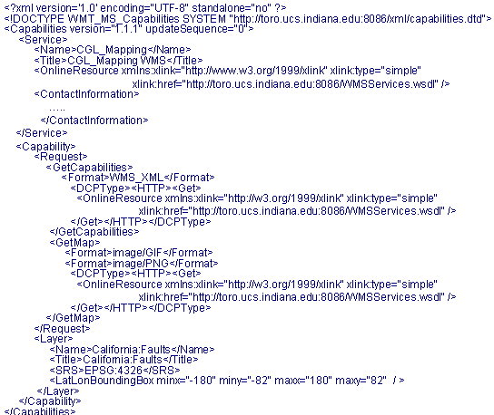
Figure 4: Sample capability.xml file used as metadata in ASIS filter services, ASVS and ASFS.

Figure 5 illustrates a sample scenario explaining what ASIS looks like, how to federate data/information through ASFS and ASVS using capability based metadata, where the user is in the proposed system, and how they utilize the proposed system. In other words, the figure also illustrates how decision makers utilize data/information at the application level via filters. To summarize, ASFS and ASVS are two services called filters. ASFS provide ASL, ASVS provide human readable information such as text, graphs (scalable vector (SVG) or portable (PNG)) and images. Filters have common ports and interfaces to enable federating information in Service Oriented Architecture and enable chaining for creating more complex data and information. Since they are Web Services, Filters are easily published, located and invoked over the internet.

In order to understand the proposed architecture, we give a sample scenario in the detailed steps in Figure 5. This scenario shows how a decision maker makes a request and displays the data/information A and E. We use data/information interchangeably.

- Each filter publishes its metadata through the capabilities file in the static mode (current)
- Initially Filter 2 provides information A, filter 3 provides information D, filter 4 provides information B and C, filter 5 provides information E and filter 6 provides information F.
- Filters are statically linked (application based) and the capability aggregation cycle is done through the “GetCapability” interface of the filters.
- Each filter updates the data/information they provide by aggregating interacted filters capabilities. For example after the capabilities aggregation cycle, filter 2 sees that it can provide data/information A, B and C.
- A client to the IDS tools makes the “GetCapability” request automatically once he/she opens the interface to the filter 3 (ASVS).
- After the invocation, IDS tools see that A, B, C, D, E and F are available information provided by filter 3 to the clients.
- The decision maker makes a “GetVis” request (invokes “GetVis” routine of the ASVS) to filter 3 to display A and E with specific attributes for querying through IDS tools. “GetVis” is defined in an XML schema file and instances are created based on that schema to be understood by the ASVS. In case of cascaded data, successive query creation and information handling are done at the appropriate filters. Whether the information is cascaded or not is defined in the capability file of the Filters.
- Successive requests are done without user involvement. The appropriate request chains are created in accordance with the filters’ capabilities published and aggregated before.

ASIS is composed of filters. Filters come in two different forms of service. These are ASVS and ASFS. Filters keep their metadata in their local file systems. Common data (ASL) is maintained in ASFS and ASFS should enable querying on ASL they provide. In a given domain every filter speaks in ASL. ASVS both visualize information and provide a way of navigating ASFS and their underlying Database. ASVS can itself be federated through its input/output interface.

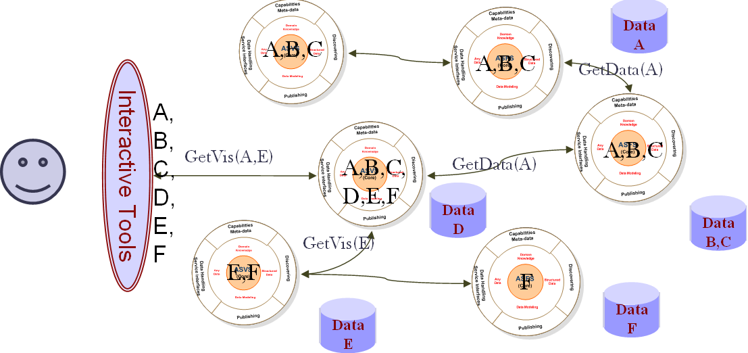
1
2
4
3
6
5
A
E
Figure 5: Successive requests are done, user is not involved. These request chains are created based on the filters’ capabilities that published before

The metadata should be maintained and kept up-to-date to be functional. We propose two ways to do that, one is dynamic metadata update via Registry/Catalog Services (any service we can use with minor changes in the configuration) another way is doing static updates by using properties files (initially we will be using this) or changing capabilities of ASIS service manually.

The goal is to enable binding of filters with or without human intervention to achieve federated information management. Services describe their interfaces through the Web Service Description Language (WSDL) and each service has one WSDL file publicly available. Data goes through filtering operations in which they are processed, transformed, and analyzed. Filters include simple transformation and predictable data extraction operations. Filters are characterized by the certainty of their outputs such as Images (by WMS in GIS), GML (by WFS in GIS), CML [30, 31], and ASCII files (by WMS or WFS in GIS). They also provide data mining, statistical analysis and other adaptive services.

Preliminary Results and Discussions

On our way to creating the federated information management architecture for scientific data/information grid applications, we first selected a science domain to work on and prove our concept and approaches. GIS is our motivating domain that introduces methods and environments to visualize, manipulate, and analyze geospatial data. The nature of the geographical applications requires seamless integration and sharing of spatial data from a variety of providers. To solve the interoperability problems, the OGC has introduced standards by publishing specifications for the GIS services. ASIS is the name of our proposed federated information management architecture for the scientific data/information grid. To create a rough working draft as ASIS we implemented basic fundamental online services defined by OGC specifications. These are WFS and WMS. After having finished implementing OGC compatible services we converted them into Filter Services as ASFS and ASVS correspondingly by wrapping them as Web Services and adding some additional ports required in ASIS architecture (explained in Chapter 4). For a data model, we used GML whose specifications and descriptions are defined by OGC.

We have developed a portlet-based IDS tools interface to our proposed Federated Service Oriented Information Management system for testing and demonstration purposes. A sample interface is shown in Figure 6. Several capabilities are implemented for the user to access and display geospatial data. Tools enable the user to zoom in, zoom out, measure the distance between two points on the map for different coordinate reference systems, get further information by making some “GetFeatureInfo” requests for the attributes of the features on the map, and drag and drop the map to display different bounding boxes. Users can also request maps for the area of interest by selecting predefined options, clicking the drop-down list. The user interface also allows the user to change the map sizes from the drop-down lists or enable them to give specific dimensions. Zoom-in and zoom-out features let the user change the bounding box values to display the map in more or less details.

Our implementation of IDS tools are generic and application independent in the OGC compatible GIS domain. They can support more than one geophysics application at the same time with some application based extensions. Each geophysics application is bound to a set of layers. These bindings are defined in a structured XML formatted properties file. Users navigate over the applications by selecting a set of layers from the dropdown list. A set of layers in the dropdown list is created according to communicated ASVS. Binding properties are updated based on the set of supported layers of the communicated ASVS.

In the initial implementation, ASIS Filter Services are stateless services. Since each Filter Service wrapped as Web Service and interactions are done through the SOAP over HTTP, at each interaction, all the state information and environment parameters are renewed. In the future, we plan to add caching and load balancing capabilities to the filters, in order to make them partially state-full at the application level. If the same client wants the same data in the same session, instead of redundant repeating jobs, filters do read from the cache and send to the client in a faster and fault tolerant way.

The GIS standard map servers (WMS is called ASVS in our ASIS framework) produce static images, but many types of geographic data are time dependent or/and time series data. In order to understand geographic phenomena and characteristics of temporal data it is necessary to examine how these patterns change over time for these types of data. We therefore investigate the problems of creating streaming video map servers based upon appropriate standard collaboration technologies.

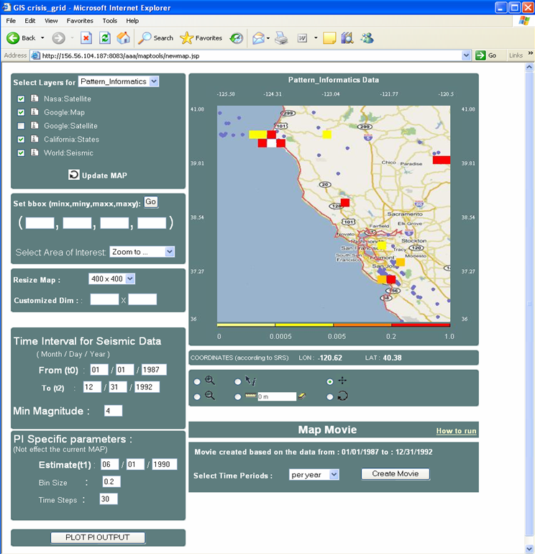
Figure 6: A snapshot from Interactive Decision Support Tools Interface. Sample snapshot is from Pattern Informatics Demo.

In addition to creating static maps, IDS tools have the ability to display time series data as movies or animations (see a sample snapshot from a demo Figure 7). Movies or animations are created by getting set of successive static images (movie frames) and playing them successively. Each frame represents a static map that corresponds to a time frame defined in the requests. We have created movies and animation for Pattern Informatics and Virtual California projects in ServoGrid [1].

For the performance issues, we developed a streaming version of data transfers. Streaming data transfer is done by using Community Grids Lab’s Naradabrokering [28, 29] messaging middleware. The Naradabrokering messaging substrate enables scalable, fault-tolerant, distributed interactions between entities, and is based on the publish/subscribe paradigm. The Naradabrokering substrate provides support for transport protocols such as TCP, Parallel TCP, UDP, Multicast, HTTP and SSL; it also facilitates communications across NAT and firewall/proxy boundaries.

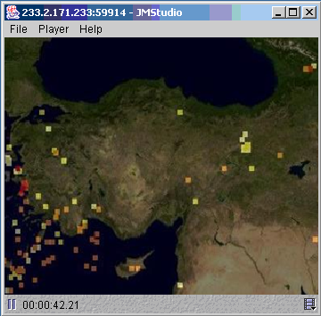
Figure 7: Sample JMF movie client subscribed to RTP Session opened by our IDS tools.

5.1. Application Use Domains
We have been working on some projects related to the data-grid and information management. These are mostly in the GIS domain but in the near future, we will be working on the Chemistry domain and applying our already started framework into that domain. In that section, we explain briefly some projects that we have been working on and applying proposed ASIS framework to.

ServoGrid Projects in the GIS domain:
- Pattern Informatics (PI):
PI is a technique developed at The University of California, Davis for analyzing earthquake seismic records to forecast regions with high future seismic activity. The PI analysis technique is formulated based on the physical and theoretical understanding of complex, nonlinear fault systems to isolate emergent regions of coherent, correlated seismicity prior to their occurrence in Southern California. Please see the Figure 6 for a sample demo snapshot.
- Geophysical Finite Element Simulation Tool (GeoFEST):
GeoFEST is a two- and three-dimensional finite element software package for the modeling of solid stress and strain in geophysical and other continuum domain applications. GeoFEST uses stress-displacement finite elements to model stress and strain due to elastic static response to an earthquake event in the region of the slipping fault, the time-dependent viscoelastic relaxation, and the net effects from a series of earthquakes.
- Virtual California (VC):
“The VC approach to earthquake forecasting is similar to the computer models used for weather forecasting” said John Rundle, director of the UC Davis Computational Science and Engineering Center, who has developed the model with colleagues from the Jet Propulsion Laboratory and other institutions. A previous forecast of earthquake hazards, the Working Group on California Earthquake Probabilities, used records of past earthquakes to calculate the probability of future ones.

The Interdependent Energy Infrastructure Simulation System (IEISS):
This is a Home Land Security Project at Los Alamos National Labs (LANL) [9]. IEISS simulates the physical and operational behavior of interdependent energy infrastructures during incidents and disruptions. It can identify and rank critical components across energy infrastructures, estimate outages, and quantify feedback.

Possible Future Projects might be in the Chemistry and Astronomy domains.

Conclusions

6.1. Research Issues

Here we summarize briefly what the issues are on our way to create the ASIS framework for Federated Service Oriented Information Management.

In order to provide attribute based querying of information and capability aggregation we need to define metadata in capabilities. In that concept, we define the functionalities of the capabilities in the system to federate the filters.

We define the general architecture of the information sources (Filter Services). Filter Services are grouped into two categories: ASFS and ASVS. We define the common ports to communicate, locate and bind each other to create more complex information.

The federated information management architecture filters (ASFS, ASVS) talk to each other in ASL (such as GML and CML). ASL is a common data representation format. We define requirements and schema for ASL and its functionalities in the system to federate the information sources.

We create a common information management framework for application level data/information federation which can be applied to any domain. We define common characteristics, differences and extensions needed from domain to domain and/or application to application.

We integrate the ASIS system with the application science simulations (Pattern Informatics, Virtual California and GeoFEST in ServoGrid) through IDS tools. IDS tools are created for utilizing integrated filter services. We have created tools for map animation, map movies, images, and interactive query support to get further information on the image and/or animation.

We plan to enable binding of services into pipelines with or without human intervention through metadata. Currently, we bind them statically before runtime.

In order to handle large scientific data in an efficient and robust manner, we plan to introduce application-level caching and load balancing into the ASIS to handle large scientific data in an efficient and robust manner.

6.2. Expected Contributions

We formalize the Federated Service Oriented Information Management Grid (ASIS) through capabilities metadata, defining all the data/information sources as interacting Web Service filters with standard metadata service ports. GIS is our motivating domain. We will demonstrate proof of concepts for other domains (such as chemistry and astronomy). We provide Data/Service federation through capabilities metadata as distinct from data/Database federation/replication approaches.

We define requirements and instructions about how to build ASL and metadata in XML based capability documents for the application sciences and specific information system (ASIS). We also create an architectural framework for federating multiple filters with capability and speaking ASL.

We define possible bottlenecks and optimization and enhancement opportunities for the distributed heterogeneous information management systems. In that context, the composability nature of our filters enables caching and load balancing for obtaining enhanced service outcomes. Capability aggregation and dynamic capability exchanges and updates are the other issues serving optimization and architecture enhancement purposes.

We also provide enhanced decision support with domain specific metadata languages and interactive mapping tools with query capabilities. We propose an architecture framework to transform heterogeneous and dispersed data into human readable forms (such as maps in GIS) and integrate multiple information sources into interactive user interfaces such as digital photography, demographic information, and information from simulations.

REFERENCES

- Project home page http://complexity.ucs.indiana.edu/~asayar/gisgrids/
- OGC web site http://www.opengeospatial.org/
- IVOA web site http://www.ivoa.net/
- Liping Di, “Distributed Geospatial Information. Services-architectures, Standards, and Research Issues”, XXth ISPRS Congress, 12-23 July 2004 Istanbul.
- Simon Cox , Paul Daisey, Ron Lake, Clemens Portele, Arliss Whiteside, Geography Language (GML) specification 3.0, Document #02-023r4., January 2003.
- Vretanos, P. (ed.), Web Feature Service Implementation Specification (WFS) 1.0.0, OGC Document #02-058, September 2003.
- Jeff De La Beaujardiere, OpenGIS Consortium Web Mapping Server Implementation Specification 1.3, OGC Document #04-024, August 2002
- Mehmet Aktas, Galip Aydin, Andrea Donnellan, Geoffrey Fox, Robert Granat, Lisa Grant, Greg Lyzenga, Dennis McLeod, Shrideep Pallickara, Jay Parker, Marlon Pierce, John Rundle, Ahmet Sayar, and Terry Tullis “iSERVO: Implementing the International Solid Earth Research Virtual Observatory by Integrating Computational Grid and Geographical Information Web Services” Technical Report December 2004, to be published in Special Issue for Beijing ACES Meeting July 2004.
- http://www.lanl.gov/ LANL web site.
- MCAT, "MCAT - A Meta Information Catalog (Version 1.1). http://www.npaci.edu/DICE/SRB/mcat.html
- Singh, G., S. Bharathi, A. Chervenak, E. Deelman, C. Kesselman, M. Manohar, S. Patil, and L. Pearlman. A Metadata Catalog Service for Data Intensive Applications. Proceedings of the Supercomputing Conference, November 2003.
- MyGrid web site, http://www.mygrid.org.uk/
- Carole Goble Putting Semantics into e-Science and Grids in Proc E-Science 2005, 1st IEEE Intl Conf on e-Science and Grid Technologies, Melbourne, Australia, 5-8 December 2005.
- National Virtual Observatory (NVO) web site, http://www.us-vo.org/
- Fran Berman, Geoffrey C, Fox, Anthony J. G. Hey., Grid Computing: Making the Global Infrastructure a Reality. John Wiley, 2003.
- Foster, I. and Kesselman, C., (eds.) The Grid 2: Blueprint for a new Computing Infrastructure, Morgan Kaufmann (2004).
- VOTable web site and documentations http://www.us-vo.org/VOTable/
- F. Curbera, Y. Goland, J. Klein, F. Leymann, D. Roller, and S. Weerawarana Business Process Execution Language for Web Services, Version 1.1. Specification, BEA Systems, IBM, Microsoft, SAP, Siebel, 05 May 2003. http://msdn.microsoft.com/library/default.asp?url=/library/enus /dnbiz2k2/html/bpel1-1.asp
- IDS User Manual http://complexity.ucs.indiana.edu/~asayar/gisgrids/docs/usermanual.pdf
- LEAD web site http://lead.caps.ou.edu/
- GEON web site, http://www.geongrid.org/
- Bhatia, Karan, Ashraf Memon, Ilya Zaslavsky, Dogan Seber, Chaitan Baru, “Creating Grid Services to Enable Data Interaoperability: An Example from the GEON Project”, GSA Annual Meeting in Seattle, WA November 2-5, 200.
- Ogsa-DAI web site, http://www.ogsadai.org.uk/
- Mario Antonioletti, Neil Chue Hong, Ally Hume, Mike Jackson, Amy Krause, Jeremy Nowell, charaka Palansuriya, Tom Sugden, and Martin Westhead. Experiences of designing and implementing grid database services in the ogsa-dai project. In Global Grid Forum Workshop on Designing and Building Grid Services, September 2003.
- SRB web site, http://www.sdsc.edu/srb/index.php/Main_Page
- Implementing and using SRB, Proc UK e-Science All Hands Meeting 2003, © EPSRC Sept 2003, ISBN 1-904425-11-9. Available at http://www.nesc.ac.uk/events/ahm2003/AH MCD/ahm_proceedings_2003.pdf
- MCAT web site, http://www.sdsc.edu/srb/index.php/MCAT
- Shrideep Pallickara and Geoffrey Fox. NaradaBrokering: A Middleware Framework and Architecture for Enabling Durable Peer-to-Peer Grids. Proceedings of ACM/IFIP/USENIX International Middleware Conference Middleware-2003.
- Shrideep Pallickara and Geoffrey Fox. A Scheme for Reliable Delivery of Events in Distributed Middleware Systems. Proceeding sof the IEEE International Conference on Automatic Computing, 2004.
- CML web site, http://www.xml-cml.org/
- Murray-Rust, Peter. "Chemical Markup Language: A Simple Introduction to Structured Documents." Pages 135-147 in XML: Principles, Tools, and Techniques. Guest Edited by Dan Connolly. World Wide Web Journal Volume 2, Issue 4. Sebastopol, CA.
- Booth, D., Haas, H., McCabe, F., Newcomer, E., Champion, M., Ferris, C., and Orchard, D. “Web Service Architecture.” W3C Working Group Note, 11 February 2004. Available from http://www.w3c.org/TR/ws-arch.
- Ahmet Sayar, Marlon Pierce, Geoffrey Fox OGC Compatible Geographical Information Services Technical Report (Mar 2005), Indiana Computer Science Report TR610
- Geoffrey C. Fox, Mehmet S. Aktas, Galip Aydin, Andrea Donnellan, Harshawardhan Gadgil, Robert Granat, Shrideep Pallickara, Jay Parker, Marlon E. Pierce, Sangyoon Oh, John Rundle, Ahmet Sayar, and Michael Scharber Building Sensor Filter Grids: Information Architecture for the Data Deluge IEEE Proceedings of 1st International Conference on SKG2005 Semantics, Knowledge and Grid Beijing China November 27-29 2005.

