***Scalability Tests for Map Services and “Geo-Science Grids” Integration Architecture***

***Ahmet Sayar***

***Introduction***

We basically investigate the problems of distributed map processing and rendering of scientific data and information, and the integration of Map servers with the Geo-Science Grids from the interoperability, scalability and performance points of view. Besides being interoperable through Web Services and standard specifications, Map Services should also have some other quality of services to fulfill Science Grids requirements. These might be summarized as being dynamic and up-to-date, being federate-able and being scalable. Dynamicity, updatability and federate-ability are explained in another document. Here we first explain the brief integration architecture, and then explain the tests to test the scalability.

We will implement the Open Geospatial Consortium’s (OGC) Web Map Service (WMS) and Scientific Plotting Web Services (Sci-Plotting) by using Dislin scientific libraries and will integrate them with GIS and other services for data access and information management. This will involve cooperation with other lab research projects in GIS and will be integrated with geophysical applications from the ServoGrid project. The GIS services will be described with capability metadata that will test our proposed framework. We will demonstrate WMS federation and Map-Plotting service integration. Based on this work, we will design experiments that will illustrate capability “meta-querying” and service aggregation and federation into “super-services” described above. We will compare and contrast the performance results obtained from the basic Map Services and the one enhanced with workload management and fault tolerance. We will make our tests via our implementation of smart map tools. Smart map tools allow users to create interactive queries and, analyze, display and animate (such as movies for time series data) the geo-spatial information and the data.

***Brief Architecture -Tests will be applied on***

Integration is done at the layer level. Therefore, the Geo-Science Grids outputs and Map Servers outputs should be represent-able in layers and synchronized as well. Our OGC compatible Map services provide their data in layers. We also use Google Map servers as Map services by using a middleware. This is explained in another document.

Regarding Geo-Sciences’ outputs, we need to convert them into layers to integrate (overlay) them with the Map Services’ layers. In order to do that we created Scientific Plotting Web Services. It is based on Dislin plotting libraries. After having wrapped them as Web Services, we enabled these libraries to be used by Science community.

There are three set of layers used to build a map with scientific data and information. Layer order is important to create reasonable and human interpretable maps. Please see the Figure-1. Layer-1 is the bottom layer created from raster data such as Google Earth and coverage data in image format (comes from Web Map Services). Layer-2 is created from vector data such as state boundaries and rivers (comes from Web Feature Services), and Layer-3 is created from interpreted and processed data coming from simulation output of the Geo-Scientific applications. Layer-3 is created at Sci-Plotting Server.

Science simulation output

Science data in vector

Map image raster data

(Layer-3)

(Layer-2)

(Layer-1)

Figure 1: These layers are displayed in the user portal and illustrated in Figure-2 and 3.

Geo-Science grids (or applications) are based on the data (called as features, spatial data or temporal data) related to the earth. They are defined by coordinates, bounding boxes, spatial reference systems, projections, geometry elements and, some other geo-related attributes and elements.

Layer-3 Processed data depending on the application simulations and user provided parameters

2

3

1

**User Portal**

Layer-1. Maps in images –coverage data provided by other WMSs or WCS

Layer-2.Feature data (unprocesd raw and archived in DBs) such as state-boundary lines and rivers provided by WFS in GML format

3

2

1

1

Application specific interfaces integrated with Map services. It Integrates OGC GIS Grids with Science Grids. See the sample interface at Figure-4

Figure 2: Information comes from the Map Services and Plotting Services in the form of layers in order to get more detailed and comprehensible information.

There are three different groups of layers and three main components in the architecture. Layers are explained above. Regarding the components, there are Map Services, Sci-Plotting Services and User Portal (see the Figure-2) in the system. Layer-1 and 2 come from Map Services and Layer-3 comes from Sci-Plotting services.

Figure-2 shows the architecture roughly without digging into the creation of layers. If you want to see how layers are created in WMS and Sci-Plotting Services, see Figure-3.

Detailed architecture:

1

**User Portal**

1

Galip @CGL

**Job Manager**

***OGC Standards***

Harsh @CGL

2

1

3

3

2

1

Ex. NASA WMS

For lyr2

Figure 3: A snapshot from Interactive Decision Support Tools Interface. Sample snapshot is from Pattern Informatics Demo. This is a snapshot from the user portal displayed in Figure-2 and 3.

Web Feature Service provide requested geographical information as Geographic Markup Language (GML) feature collections. Data is kept in relational DB and upon request; WFS convert it to GML and returns. WMS interact with a Web Feature Service by submitting database queries encoded in Open Geospatial Consortium Filter Encoding Implementation and in compliance with the Open Geospatial Consortium’s Common Query Language.

WMS enables visualizing, manipulating analyzing geospatial data through maps. Map Servers typically compose maps as layers. Layers may come from distributed sources: Web Feature Services provide abstract feature representations that can be converted to images, and other Map Servers may contribute map images. WMSs can be federated and cascaded to create more detailed and comprehensible map images.

Sci-Plotting Services: For the core functionality we use Dislin scientific-data plotting libraries. Dislin is a plotting library containing functions for displaying data graphically as curves, graphs, pie-charts, 3-D color plots, surfaces and contours. All these services are wrapped as Web Services and integrated into the general visualization system as illustrated in Figure 3.

Job Manager and Geo-Science Grids: As a Job Manager we use HPSearch. It is simply a scripting environment for managing distributed workflows. Different projects (IEISS or Pattern Informatics) require different set of parameters for the application users to trigger the job manager. This set of parameters and their order are known earlier. Users enter required parameters through the projects’s user interface module deployed in to the user portal. After the application or science grids finish the task, job manager send the output link to the user waiting at the user portal. Then the user requests layer-3 from Sci-Plotting server which is created based on the data located at the link job manager returned.

***Approaches to increasing the System’s Scalability and Performance:***

The system should be able to handle high volume and high rate data transport and processing. Increasing layer number (which means involving more WFS and WMS) or adding more science grid access nodes should not degrade system’s overall performance. In order to increase the scalability and performance of the overall system, we plan to apply load balancing, working window and caching techniques, and use topic based streaming data transfer.

***Topic based streaming data transfer***: We use topic based messaging middleware in order to transfer large data from WFS to WMS.

**Load Balancing**: We have our own map (WMS and Google) and feature (WFS) services. Therefore we can investigate the problem of distributed rendering of GIS information.  We imagine a test scenario in which identical copies of WMS and WFS are spread around the world (we can get accounts around the US, in the UK and Australia (Probably Turkey also).  These are basically worker nodes waiting to fulfill requests of a manager WMS.  For a specific request, the rendering can be farmed out to worker WMS, which themselves need to find the best WFS.

Four worker nodes’ maps merged in the manager WMS. Initial request to manager is cut into four sub requests and returned pieces (a, b, c and d) are merged to create a map as a result to initial request.

**map**

**a** **b**

**c** **d**

The WMS workers probably fall into two main subgroups: basemap generators (layer-1) and overlay generators (layer-2).  It may be worth distinguishing these for the practical reason that the base map servers (Sunghoon's and Zao's Google Maps servers) require a lot of data in hand (photograph jpegs), whereas the overlay map servers generate their images using data from remote Web Feature Services. Data comes in XML based GML format. Transferring, parsing and rendering GML feature collections are bottleneck of the system performance.

***Working Window and Caching***: The most recently used bounding box values and corresponding map images are stored by Map Server for the successive requests. Successive requests are handled using the information stored previously. By doing this, sometimes WMS does not need to access the data stored in WFS to create map images. Each user has different session and working window kept in the Map Server.

Below Figure shows the different combinations of successive requests. Boxes 1 and 2 represent requests for the result map. The box-1 is the first and the box-2 is the successive requests.

1

1

1

2

2

1

2

2

A (rare case) B (move) C (zoom-in) D (zoom-out)

In case of box-2, actual requests are done for the grey parts. C represents the full performance gain and A represents the zero performance gain through caching. In C, there is no data transfer between WMS and WFS.

***Summary of Tests:***

After finishing implementation of the approaches mentioned in previous chapter we will test our system. Tests are roughly summarized as below.

Measuring the performance of the basic system

- *We will measure the time to create whole display consisting of three different sets of layers.*

*-We will measure the time to create movies (or GIF animations) from the time series data such as earthquake seismic records. Each frame is a static map consisting of set of layers.*

Standalone server tests: Each server will be tested alone

-Web Map Server: measuring time to create maps (Layers-1 and 2)

-Scientific Plotting Server: measuring time to create plots (Layer-3)

*Depending on the data size we will measure end-to end data transfer time. Data is transferred from Feature Server to Map Server.*

*-Through messaging middleware (NaradaBrokering)*

*-As SOAP messages and attachments.*

***Test Interface- User Portal***

***Interactive-Smart Map Tools:***

Layer-1 and 2 are manipulated through the parts A, C, D and E. Layer-2 is manipulated through part B and utilize the parameters given in part A. Part C is the output screen and enables interactive manipulation of the layers and interactive query of the data rendered in layer-2. If the data rendered in layer-2 is time series data, then part E enables creating movies. Part A enables users to set bbox, map size, specific region to zoom-in, and the layers to be overlaid and project to work with. Part D consists of map tools enabling zoom-in, zoom-out, drag and drop, and data query of the map displayed in Part C. Part B enables users to enter parameters specific to scientific projects. For example for the project “Pattern Informatics”, users should enter the parameters “bin-size” and “time-steps”. Users can easily move to another project that they want to work by using drop-down list at the top-left corner.

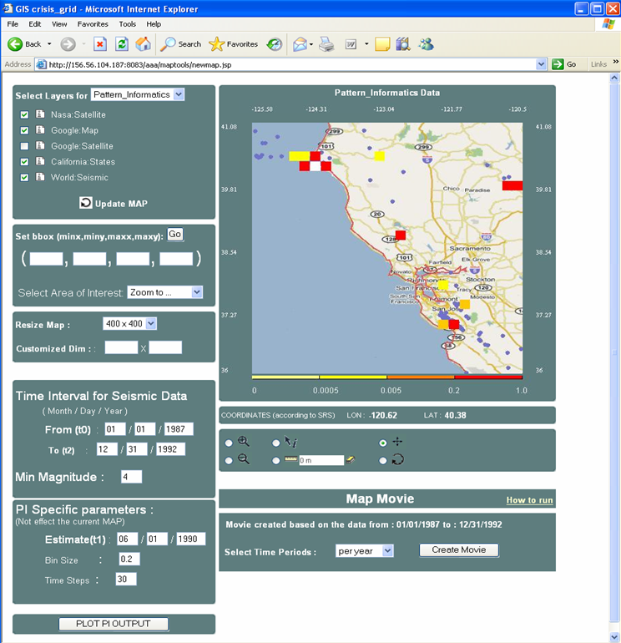

**E**

**D**

**C**

**A**

**B**

Figure 4: A snapshot from Interactive Decision Support Tools Interface. Sample snapshot is from Pattern Informatics Demo. This is a snapshot from the user portal displayed in Figure-2 and 3.

For more detailed information about using the interfaces for the different Geo-Science projects please see the user guide available at <http://complexity.ucs.indiana.edu/~asayar/gisgrids/docs/usermanual.pdf>