Supporting Event-based Unified Data Access/query over Integrated Data-views for Decision Making in Geographic Information Systems

A. Sayar ^{a,b.} *, G. C. Fox ^{a,b,c}, M. Pierce ª
ª Community Grids Laboratory, Indiana University
501 N. Morton Suite 224, Bloomington, IN 47404
{asayar, gcf, mpierce}@cs.indiana.edu
^{b} Computer Science Department, School of Informatics, Indiana University
^{c} Physics Department, College of Arts and Sciences, Indiana University

KEY WORDS: Decision making, GIS, federation, Web Services, information rendering, Service Oriented Architecture

Abstract
Geographic information is critical to effective and collaborative decision making for building disaster planning, crisis management and early-warning systems. Decision making in Geographic Information Systems (GIS) increasingly relies on analyses of spatial data in map-based formats. Maps are complex structures composed of layers created from distributed heterogeneous data and computation resources belonging to the separate virtual organizations from various expert skill levels.
This chapter presents a distributed computing infrastructure based on service-oriented architecture principles for understanding and managing the production of knowledge from distributed observation, simulation and analysis through integrated data-views in the form of multi-layered map images. Our infrastructure is based on a common data model and standard GIS Web-Service components that are federated through metadata. This federation aggregates GIS services and enables unified data access/query and display over integrated data views. Integrated data views are defined in federator’s capability metadata as composition of layers provided by standard GIS Web-Services.

Introduction

The World Wide Web and associated Web programming models have revolutionized accessibility to geospatial information sources. However, in the same time, numerous incompatible data formats, data heterogeneity, and machine un-readability of this data have caused many problems. Data heterogeneity is related to both the data types and storage formats. As geospatial data is stored in a variety of systems and formats, one important issue for geospatial information applications is service interoperability and data heterogeneity. In other words, the seamless integration and sharing of data from distributed heterogeneous data sources has been the major challenge of the information system communities and decision support systems.
Due to the complexity of their formations and the multidisciplinary nature of geospatial data, it is difficult to extract useful information from them without sophisticated processes. The traditional way for geospatial information extraction involves, with help of computers, the trained specialists who are the experts on the specialized area. On the other hand, society is lacking of up-to-date geospatial information and knowledge for management and decision-makings.
Moreover, because of the data ownership issues (various data provided by geographically distributed various virtual public/private organizations) and large data volumes, it is impossible to put all geospatial data into one large data center. In addition, the computational resources associated with those data centers are naturally distributed. Furthermore, decision making requires these distributed heterogeneous data sources to be shared, and represented/rendered to extract useful knowledge that can be understood by anybody joining the decision making process. Specifically for GIS, since there must be people from different expert and skill levels the best way to represent data and extract knowledge is creating multi-layered map images.
Thus, as we see, map-based services are both a crucial application for decision making as well as an interesting area for researching problems in distributed service architectures. Our proposed federated service-oriented information system framework supports collaborative decision making over integrated data views, described in layer-structured hierarchical data. The users access the system as though all the data and functions come from one site. The data distribution and connection paths stay hidden and formulated as hierarchical data defined in federator’s capability metadata. The users access the system through integrated data-views (maps) with the event-based interactive mapping display tools. Tools create abstract queries from the users’ actions through action listeners and communicate with the system through federator.
The framework is based on standard GIS Web Service components providing standard service interfaces defined by Open GIS standards and developed in accordance with Web Service Interoperability Organization’s standards ("Web Service Interoperability (WS-I)," 2002). Federator federates standard GIS data services through aggregating their standard capability metadata, and enables unified data access/query. Moreover, although the proposed framework is designed for GIS, our experiences with GIS have shown that it can be generalized to many application areas such Chemistry and Astronomy. We give blueprint architecture in terms of principles and requirements in section 4.
GIS particularly used in emergency early-warning systems like homeland security and natural disasters (earthquake, flood etc) and crisis management applications require quick responses. However, because of the distributed systems’ nature, interoperability requirements (compliance costs), characteristics of geo-data (large and variable sized) and time-consuming rendering processes, the performance and responsiveness stand as the toughest challenges in distributed modern GIS applications. Thus, despite the advantages of Web service federation, we have to go beyond naïve implementations to address problems in scalability and performance. This has led us to investigate novel strategies including performance enhancing client-based caching, load balancing, and parallel processing techniques through attribute based query decomposition.

Background
Geographic Information Systems (GIS) ("GIS Research at Indiana University Community Grids Lab.," 2006) are systems for creating, storing, sharing, analyzing, manipulating and displaying geospatial data and associated attributes. GIS introduce methods and environments to visualize, manipulate, and analyze geospatial data. The nature of the geographical applications requires seamless integration and sharing of spatial data from a variety of providers.
The general purpose of GIS is modeling, accessing, extracting and representing information and knowledge from the raw geo-data. The raw data is collected from sensors, satellites or other sources and stored in databases or file systems. The data goes through the filtering and rendering services and is ultimately presented to the end-users in human recognizable formats such as images, graphs, charts etc. GIS is used in a wide variety of tasks such as urban planning, resource management, emergency response planning in case of disasters, crisis management and rapid response etc.
Over the past two decades, GIS has evolved from traditional centralized mainframe and desktop systems to collaborative distributed systems. Centralized systems provide an environment for stand-alone applications in which data sources, rendering and processing services are all tightly coupled and application specific. Therefore, they are not capable of allowing seamless interaction with the other data or processing/rendering services. On the other hand, the distributed systems are composed of autonomous hosts (or geographically distributed virtual organizations) that are connected through a computer network. They aim to share data and computation resources collaborating on large scale applications.
Modern collaborative GIS requires data and computation resources from distributed virtual organizations to be composed based on application requirements, and accessed and queried from a single uniform access point over the refined data with interactive display tools. This requires seamless integration and interaction of data and computation resources. The resources span over organizational disciplinary and technical boundaries and use different client-server models, data archiving systems and heterogeneous message transfer protocols
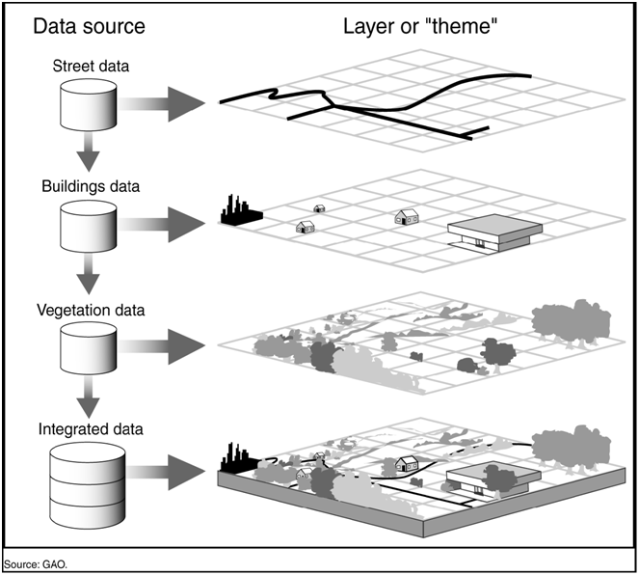
Figure 1: Layered display – a map is composed of distributed multiple set of layers. Figure is from (Koontz, 2003)

The primary function of a GIS is to link multiple sets of geospatial data and graphically display that information as maps with potentially many different layers of information (see Figure 1). Each layer of a GIS map represents a particular “theme” or feature, and one layer could be derived from a data source completely different from the other layers (Koontz, 2003). As long as standard processes and formats have been arranged to facilitate integration, each of these themes could be based on data originally collected and maintained by a separate organization. Analyzing this layered information as an integrated entity (map) can significantly help decision makers in considering complex choices.
Open GIS Standards and GIS Web Services
In order to achieve such a layered display (Figure 1) whose layers come from autonomous/heterogeneous data resources provided by various virtual organizations, the domain-specific common data models, standard service functionalities and interfaces need to be described and widely adopted. There are two well-known and accepted standard bodies in GIS domain aiming these goals. These are Open Geospatial Consortium ("The Open Geospatial Consortium, Inc (OGC)," 1994) and the Technical Committee tasked by the International Standards Organization (ISO/TC211).The standard bodies’ aim is to make the geographic information and services neutral and available across any network, application, or platform by defining common data models and online service descriptions.
The standard bodies specify methods, tools and services for data management, accessing, processing, analyzing, presenting and transferring such data in digital/electronic form between different users and systems. ISO/TC211 defines a high-level data model for the public sector, such as governments, federal agencies, and professional organizations (Peng & Tsou, 2003). On the other hand, OGC is interested in developing both abstract definitions of Open GIS frameworks and technical implementation details of data models and to a lesser extent services. They are both compatible with each other. ("Joint Advisory Group (JAG)," 1999)
OGC’s standards definition for data model (Geographic Markup Language -GML) (Cox, Daisey, Lake, Portele, & Whiteside, 2003) and online data services are well-known and widely adopted. As more GIS vendors are releasing compatible products and more academic institutions use OGC standards in their research and implementations, OGC specifications are becoming de facto standards in GIS community, and GML is rapidly emerging as the standard XML encoding for geographic information.
Web Map Service (WMS) (Beaujardiere, 2004; Kolodziej, 2004) and Web Feature Service (WFS) (Vretanos, 2002) are two major services defined by OGC for creating a basic GIS framework enabling information rendering of heterogeneous data sources as map images. WMS is the key service to the information rendering/visualization in GIS domain. WMS produces maps from the geographic data in GML provided by WFS. It also enables attribute/feature based data querying over data display by its standard service interfaces. OGC’s WFS implementation specification defines interfaces for data access and manipulation operations on geographic features. Via its standard service interfaces, a web user/client can combine, use and manage geo-data from different sources by invoking several standard operations (Vretanos, 2002). By creating an interoperable standard GIS framework by adopting Open GIS standards (using GML and standard online services WMS and WFS), we open the door of interoperability to this growing community.
In addition to the domain-level interoperability and extensibility, information systems need cross-language, operating system and platform interoperability to enable data sharing/federating and analysis over autonomous heterogeneous resources provided by various virtual organizations. Web Service standards (Booth et al., 2004) are a common implementation of Service Oriented Architectures (SOA) ideals giving us a means of interoperability between different software applications running on a variety of platforms, and Grid computing (Foster & Kesselman, 2004; Fox, 2004) has converging requirements. By implementing Web Service versions of GIS services, we can integrate them directly with scientific application Grids (Atkinson et al., 2005; Aydin et al., 2008).
A Web Service is an interface that describes a collection of operations that are network accessible through standardized XML messaging (Kreger, 2001). Web Services collectively are a software system designed to support interoperable machine-to-machine interaction over a network. A typical service has an interface described in a machine-processable format called Web Service Description language (WSDL) (Christensen, Curbera, Meredith, & Weerawarana, 2001). Other systems interact with the Web service in a manner prescribed by its description using SOAP-messages (Simple Object Access Protocol), typically conveyed using HTTP with an XML serialization in conjunction with other Web-related standards. Representational State Transfer (REST) (Fielding & Taylor, 2002; Khare & Taylor, 2004) is a variation of this architecture that replaces WSDL with standard HTTP operations (GET, POST, PUT, DELETE). REST can be used to transmit SOAP messages as well as other formatted transmissions such as RSS, ATOM, or JSON.
The major difference between the Web Services and the other component technologies is that the Web services are accessed via the ubiquitous Web protocols such as Hypertext Transfer Protocol (HTTP) and Extensible Markup Language (XML) instead of object-model-specific protocols such as Distributed Component Object Model (DCOM) (Redmond, 1997) or Remote Method Invocation (RMI) (Java Remote Method Invocation Specification, 1998) or Internet Inter-Orb Protocol (IIOP) (Kirtland, 2001). One typically builds services to be stateless and places the distributed system state in a single state machine that aggregates clients to services. This simplifies several well-known problems in distributed object systems (such as fault tolerance), enabling Web service-based systems to have better scalability.
Adopting GIS Open Standards to Web Service standards and implanting Web Service versions of standard GIS services make applications span cross-language, platform and operating systems. It also enables application developers to integrate the third party geospatial functionality and data into their custom applications easily.

Federating GIS Web Service Components
The framework proposes infrastructure for understanding and managing the production of knowledge from distributed observation, simulation and analysis through integrated data-views in the form of multi-layered map images. Infrastructure is based on common data model, OGC compatible standard GIS Web-Service components and a federator. Federator is actually an extended WMS federating GIS services and enabling unified data access/query and display over integrated data-views.
By the federation, we mean providing one global view over several data sources and let them processed as one source. There are three general issues here. The first is the data modeling (how to integrate different source schemas); the second is their querying (how to answer to the queries posed on the global schema); and the third is the common presentation model of data sources, i.e. mapping of common data model to a display model enabling integration/overlaying with other data sets (integrated data-view). The first two groups of research issues are related to lower level (database and files) data format/query/access heterogeneities summarized as semantic heterogeneity. In the proposed framework we take them as granted by applying Open Geographic Standards specifications for data models (GML) and online services (WMS and WFS).
The proposed extended standard GIS Web Service components are integrated to the system through a federator which is actually a WMS extended with capability aggregating and state-full service capabilities to enable high performance support for responsive GIS applications. This section presents view-level information presentation through federation of standard GIS Web Service components. The framework is fine-grained for GIS domain; however we present the generalization architecture in terms of principles and requirements at the end of the section.

Geo-Data and integrated data-view
The geo-data is provided by geographically distributed various kinds of different vendors in different formats, stored in various different storage systems and served through heterogeneous service API and transport protocols. The heterogeneity of geographic resources may arise for a number of reasons, including differences in projections, precision, data quality, data structures and indexing schemes, topological organization (or lack of it), set of transformation and analysis services implemented in the source.
These issues have been tried to be solved by domain-specific open standard bodies, OGC and ISO/TC-211. The specifications for data models and online service descriptions define compliance requirements at data and service API level. In brief, according to the standard specifications there are three general groups of data services: Web Map Services,Web Feature Services and Web Coverage Services (Evans, 2003). WMS provides rendered data in maps in mime/image formats. WFS provides annotated feature-vector data in XML-encoded GML, and WCS provides coverage data as objects or images. Since they have standard service API and capability metadata about their services and data, they can be composed/chained by capability exchange and aggregation through their common service API called “getCapability”.
This idea inspired us to develop an infrastructure for creating and managing the production of knowledge from distributed observation, simulation and analysis through integrated data-views in the form of multi-layered map images (see Figure 2) enabling unified data access/query/display from a single access point. As is shown in the figure, the geo-data is accessed through federator and data is always kept in its originating resources. They are integrated to the system with user’s on-demand querying (just-in-time federation). That enables easy data maintenance and autonomy.
There is three-level hierarchy of data. Upper levels of data flow are mostly occupied by WMSs (render/display services) and lower levels are occupied by WFSs (feature data level- annotation). However, Web Map Servers may also be at this level, creating intermediate images that are delivered to the federator. At the bottom level mediators are located handling resource/data specific query/response conversions. They are a part of WFSs, and WFSs play the role of wrappers in the mediation system. They provide the data heterogeneous data in common data model GML with standard service interfaces as defined in Open GIS standards.
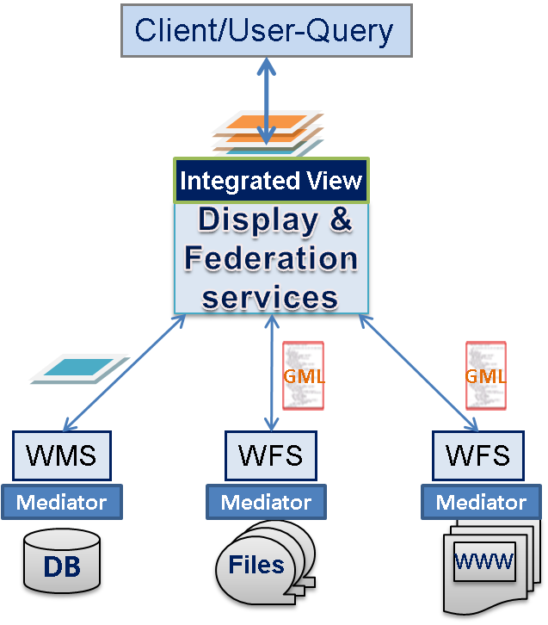
Fine-grained view-level service composition
Standard GIS Web-service components
Unified data access/query and display over integrated data-view from a single access point
Extended WMS

Figure 2: Data life-cycle and integrated data-view creation.

Heterogeneous data sources which form the bottom layer of the hierarchy are integrated to the system through mediators. Mediators provide an interface of the local data sources and, play the roles of connectors between local source backgrounds and the global one. The principle of integration is to create non-materialized view in each mediator. These views are then used in the query evaluation. Mapping rules that express the correspondence between the global schema (GML) and the data source ones are essential. The problem of answering queries is another point of the mediation integration – a user poses a query in terms of a mediated schema (such as getFeature to WFS), and the data integration system needs to reformulate the query to refer to the sources. Therefore, information integration architecture emerges based on a common intermediate data model (GML) providing an abstraction layer between legacy storage structures and exposed interfaces. In our system we use OGC to enable these interfaces. GML provides a semantic abstraction layer for data files and is exposed through higher level data delivery service called WFS.
There are several advantages in adopting the approach shown in Figure 2. First of all, the mediators-wrappers enable data sources integrated to the system conform to the global data model (such as GML in GIS), but enable the data sources to maintain their internal structure and, at the end, this whole mediator system provides a large degree of autonomy. The integration process does not affect the individual data sources functionality. These nodes can continue working independently to satisfy the requests of their local users. Local administration maintains the control over their systems and yet provides access to their data by the global users at the federation level.
The remaining of the chapter focus on upper levels (view-level) of dataflow and query refinements illustrated in Figure 2. Since the OGC’s standard services are developed as Web Service components, they can be chained/orchestrated with some web service workflow tools (such as Kepler (Ludäscher et al., 2006) and Taverna (Turi, Missier, Goble, Roure, & Oinn, 2007)), but, we don’t deal with those issues in this chapter, instead focus on the definition of service compositions and integrated data views as presented in the following sections..
Hierarchical data definition as multi-layer maps:
Hierarchical data is defined as an integrated data-view in the federator’s capability metadata. It actually defines a static workflow starting from the federator and ending at the original data sources (WFS serving GML or WMS serving map layers). The services are linked through the reference-tags defined in their capability metadata. Decision makers’ interactions with the system are carried over the integrated data views through event-based interactive map tools. Integrated data-views are defined in the hierarchical data format as explained below:
Map -> Layer -> Data {GML / binary images} ->Raw data (any type).
A map is application-based, human-recognizable, integrated data display and is composed of layers. A layer is a data rendering of a single homogeneous data source. Layers are created from the structured XML-encoded common data model (GML) or binary map images (raster data). Heterogeneous data sources (raw data) are integrated to the system as GML or binary map images through the resource specific mediators. The mediators have resource specific adaptors for request and response conversions and appropriate capability metadata describing the data and resources.
Applications have different interests of maps composed of different data-layers in different numbers and combinations (Figure 3). Maps are multi-layered complex structures whose layers come from distributed heterogeneous resources, and rendered from any type of data. This type of multi-layered map image is defined and managed in the federator with utilization of its cascading WMS properties and inter-service communication between the components are accomplished through exchanging capabilities via standard Web Service interfaces. Hierarchical data creation through distributed GIS Web Services’ capability aggregation is presented in section 3.3.

Federation Framework
Our federation framework is built over a service-oriented GIS framework and its components (WMS and WFS). Federation is based on federating service-oriented standard GIS Web Services’ capabilities metadata and their standard service interfaces for accessing, querying and rendering data. We do not define common data models, online standard service components and their capability metadata definitions in GIS. These are already defined by Open Geographic Standards (OGC). We instead have developed the components according to the open standard specifications for online services and data model and applied them to our proposed information system framework by defining required extensions at implementation and application levels in compliance with WS-I Web Service standards. They also serve as a test bed for implementing and testing general concepts in service architectures.
This section presents a federation framework based on common data models (GML), standard Web Service components, federator and event-based interactive decision making tools over integrated data views in the form of multi-layered map images. The general architecture is illustrated in Figure 3. This figure presents the proposed federation framework with a sample application using earthquake seismic data (from WFS) and NASA satellite map images (from WMS). WMS is located at Jet Propulsion Laboratory (JPL) in California and WFS is located at Community Grids Labs at Indiana University.
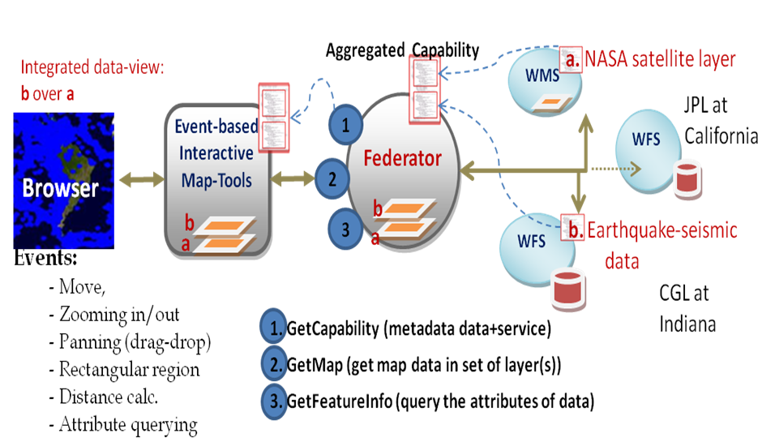
Figure 3: Fine-grained federated GIS framework

The framework enables users (say, decision-makers) to access the system as though all the data and functions come from one site. The data distribution and connection paths stay hidden and formulated as hierarchical data defined in federator’s capability metadata. The users access the system through integrated data-views (maps) with the event-based interactive mapping display tools. Tools create abstract queries from the users’ actions through action listeners and communicate with the system through federator.
As it is shown in Figure 3, the federator is actually a WMS (Kolodziej, 2004) with extended capabilities and functionalities. It enables state-full service access over the stateless GIS Web Service components, and results in better performance for responsive GIS systems. These issues are presented in Section .
The federation framework is based on a two-stage process. The first stage is the setup stage. The second stage is application run-time stage. In the setup stage, an integrated data-view (in the form of multi-layered map image) is defined in the federator’s aggregated capability metadata. The federator searches for standard GIS Web Service components (WMS or WFS) providing required data layers and organize them into one aggregated capability file (Section 3.3). This is shown as dotted lines in the above figure. There is no client/user interaction with the system in this first stage. In the second stage (run-time stage), a user/client interacts with the system through browser that provides event-based interactive display and query tools over the integrated data-view. This is shown as green arrows in the figure.
Interactive information visualization tools provide researchers with capabilities to support discovery. We developed these tools for interacting with standard WMS providing OGC compatible online services such as getMap, getFeatureInfo and getCapabilities. Since the federator is also a WMS, clients still use getMap service interface to display multi-layered map images and/or query it through getFeatureInfo service interface.
The system removes the burden of accessing each data source with ad-hoc query languages such as SQL for MySQL source, and enables interactive feature based querying besides displaying the data. It also enables easy data-maintenance and high degree of autonomy.

Service federation through Capability Aggregation
Capability is a metadata about the data and services together defined by Open Geospatial Consortium (OGC). It includes information about the data and corresponding operations with the attribute-based constraints and acceptable request/response formats. It supplements the Web Service Description Language (WSDL) (Christensen et al., 2001), which specifies key low-level message formats but does not define information or data architecture. These are left to domain specific capabilities metadata and data description language (GML). Capabilities also provide machine and human readable information that enables integration and federation of data/information. It also aids the development of interactive, re-usable client tools for data access/query and display. We use the open standard specifications’ definitions and present the required extensions for the federation through hierarchical data creation by service chaining.
The integrated data-view in multi-layered map images is defined in the federator’s aggregated capability metadata. There are two major issues here: a) definition of aggregated capability metadata and b) definition of multi-layered map images.
As mentioned earlier, the federation framework is built over the standard GIS Web Service components and federator concept is inspired from OGC’s cascading WMS definition (Beaujardiere, 2004). In this respect, federator is actually a WMS with cascading and some other related and extended capabilities not deteriorating the Open Standards requirements. In the following sections we describe how we apply OGC’s ideas related to the service chaining and aggregation and define multi-layered map images in the aggregated capability metadata.

Cascading WMS as a Federator
A "Cascading Map Server" is a WMS that behaves like a client of other WMSs and behaves like a WMS to other clients. A Cascading WMS is a WMS that can read other WMS (and WFS) and display layers from them. For example, a Cascading Map Server can aggregate the contents of several distinct map servers into one service. Furthermore, it can even perform additional functions such as output format conversion or coordinate transformation on behalf of other servers.
There are two possible ways to chain the services to be able to create a federator framework and application specific hierarchical data in integrated data-view. One is extending the WMS capability file by giving the reference to the service access points providing the required layer (WMS) and/or feature data (WFS), and another way is using Web Map Context’s standards defining chaining in a context document (described below). In any case, we utilize the cascading WMS definitions to develop a federator providing information/knowledge in multi-layered map images.
Federating through Context document:
OGC’s WMS and WFS services are inherently capable of being cascaded and chained in order to create more complex data/information. In order to standardize these issues, the OGC has introduced Web Map Context (WMC) (Sonnet, 2005) standard specifications. Before that, OGC recommended application developers to extend their services’ capabilities for the cascading. WMC is actually a companion specification to WMS.
WMC is needed when a map comprising layers from several distinct servers being built up in one viewer client, the creation of a platform-independent description of that map, the retrieval of that description by an entirely different Client, and the display of the map in the second Client. The present Context specification states how a specific grouping of one or more maps from one or more map servers can be described in a portable, platform-independent format for storage in a repository or for transmission between clients. This description is known as a "Web Map Context Document," or simply a "Context." Presently, context documents are primarily designed for WMS bindings. However, extensibility is envisioned for binding to other services.
A Context document is structured using XML and its standard schema is defined in the WMC specifications (Sonnet, 2005). A Context document includes information about the server(s) providing layer(s) in the overall map, the bounding box and map projection shared by all the maps, sufficient operational metadata for client software to reproduce the map, and additional metadata used to annotate or describe the maps and their provenance for the benefit of end-users.
There are several possible uses for context documents besides providing chaining and binding of services. The context document can provide default startup views for particular classes of user. For example specific applications require specific list of layers. The context document can store not only the current settings but also additional information about each layer (e.g., available styles, formats, SRS, etc.) to avoid having to query the map server again once the user has selected a layer. Finally, the Context document could be saved from one client session and transferred to a different client application to start up with the same context. In this document, we just focus on its binding functionalities.
Federating through aggregated WMS capability
In order to define hierarchy of federation we utilize the WMS’s capability document and describe the links to cascaded (or chained) services in capability’s layer tag as an alternative to the approach given in previous section. Each layer defines data and corresponding standard GIS Web Service components with their limitations, restrictions and attributes. Second one is extending WMS capabilities file for the cascaded layers.
Data providing in WMS is called “layer” and defined in layer tags in capability metadata with attributes and features according to the standard WMS capability schema (Beaujardiere, 2004). Service chaining is accomplished through cascaded layer definition. A Layer is said to have been "cascaded" if it was obtained from an originating server and then included in the Capabilities XML of a different server. The second server may simply offer an additional access point for the Layer, or may add value by offering additional output formats or spatial reference systems.
If a WMS cascades the content of another WMS then it must increment the value of the cascaded attribute for the affected layers by 1. If that attribute is missing from the originating WMS's Capabilities XML (means layer has not been cascaded before), then the Cascading WMS insert the “cascade” attribute to layer tag and set it to 1. Default value of cascading is 0 (Kolodziej, 2004).
In order to make service federation more clear, we can give a real geo-science application. For example, in Pattern Informatics (PI) application, decision makers need to see earthquake forecast values and seismic data records plotted on satellite map images. Satellite map images are provided by NASA OnEarth project’s WMS at JPL (Jet Propulsions Labs) and earthquake seismic data records are provided from WFS at Community Grids Labs at Indiana University. Federator aggregates these services standard capability metadata and creates an aggregated one as if those data sets are its own. The users access the system as though all the data and functions come from the federator. The data distribution and connection paths stay hidden and formulated in federator’s aggregated capability metadata.

High-performance Support in Distributed Geo-Data Rendering

General Performance issues in interoperable Service-oriented Geographic Information Systems
Distributed GIS systems typically handle a large volume of datasets. Therefore the transmission, processing and visualization/rendering techniques need to be responsive to provide quick, interactive feedback. There are some characteristics of GIS services and data that make it difficult to design distributed GIS with satisfactory performance.
Furthermore, in order to provide interoperable and extensible framework, we adopted domain-specific standard specifications for data model (GML) and online-services from OGC, and Web Services specifications from WS-I ("Web Service Interoperability (WS-I)," 2002) On the other hand, these adoptions degrade the performance even worse for large scale applications because of using XML-encoded data model and Web Services’ XML-based SOAP protocol. These issues and proposed enhancement approaches are presented in the following sections. The aim is turning compliance requirements to competitiveness and creating a responsive information system framework providing map images for interactive decision making tools.
Distributed Nature of Data:
The data ownership issues (various data provided by geographically distributed various virtual public/private organizations) and large data volumes make it impossible to put all geospatial data into one big data center. In addition, the computational resources associated with those data centers are naturally distributed. Furthermore, decision making requires these distributed heterogeneous data sources to be shared, and represented/rendered to extract useful knowledge giving sense to anybody joining the decision making process.
Although we mostly concentrate on the performance issues related to compliance requirements such as using XML-encoded data model GML and Open GIS compatible Web Service components, throughout the section we touch the general issues briefly mentioned above.
Using Semi-structured Data Model:
OGC recommends using GML data. GML carries content and the presentation tags together with the core data. That enables the data sources to be queried and displayed together (ex. Map images interactively query-able through interactive map tools). Querying and displaying data in GML format needs parsing and rendering tools to extract requested tag elements such as geometry elements to draw map or non-geometry elements to answer content-related queries.
Structured data representations enable adding some attributes and additional information (annotations) to the data. Those resulting XML representations of data tend to be significantly larger than binary representations of the same data. The larger document size means that the greater bandwidth is required to transfer of data, as compared to the equivalent binary representations.
In addition, due to the architectural features (integration of autonomous resources), the system spends a lot of time on query/response transformations for Relational-to-GML database mappings. WFS enable mediation of autonomous databases and serving the data in common data model through the standard service interfaces and message formats. However, it consumes a lot of time because of the requirements for query and response conversions (getFeature to SQL, and relational tables to GML).
Advantages of using structured/annotated data come with its costs.

Though Data Characteristics:
Geo-data is described with its location ((x, y) coordinates) on the earth. Based on the location attribute, geo-data is un-evenly distributed (such as human-population and temperature distributions) and variable sized. In addition, geo-data collected from sensors are dynamically changed and/or updated over time.
R1
R2
R3
R4
(c,d)
(a,b)
((a+c)/2, b)
(a,b)
(c,d)
(a)
(b)
(c, (b+d)/2)
(c, (b+d)/2)
((a+c)/2, b)
Figure 4: Unbalanced load sharing. Server assigned R2:“( (a+b)/2, (b+d)/2 ), (c, d)” gets the most of the work

Because of these stringent characteristics of data, it is not easy to make load balancing and parallel processing over the unpredictable workload. Figure 4 illustrates this problem. The work is decomposed into independent work pieces, and the work pieces are of highly variable sized.
In the following sections (3.5 and 3.6), we present our solution approaches.

Extending Open GIS standards with streaming data transfer capability.
The OGC’s initial standard WMS and WFS specifications were based on HTTP Get/Post methods, but this type of services have several limitations such as the amount of data that can be transported, the rate of the data transportation, and the difficulty of orchestrating multiple services for more complex tasks. Web Services help us overcome some of these problems by providing standard interfaces to the tools and applications we develop (Aydin, 2007).
Our experience shows that although we can easily integrate several GIS services into complex tasks by using Web Services, providing high-rate transportation capabilities for large amounts of data remains a problem because the pure Web Services implementations rely on SOAP (Gudgin et al., 2007) messages exchanged over HTTP. This conclusion has led us to an investigation of topic-based publish-subscribe messaging systems for exchanging SOAP messages and data payload between Web Services. We have used NaradaBrokering (Pallickara & Fox, 2003) which provides several useful features besides streaming data transport such as reliable delivery, ability to choose alternate transport protocols, security and recovery from network failures.
NaradaBrokering is a message oriented middleware (Tran, Greenfield, & Gorton, 2002) system that facilitates communications between entities through the exchange of messages. This also allows us to receive individual results and publish them to the messaging substrate instead of waiting for whole result set to be returned. In case of using streaming, the standard Web Service interfaces are used for handshaking, the actual data transfer is done between subscriber and publisher deployed in proposed GIS Web Service components respectively.
Besides giving better performance in general, streaming data transfer technique enables data rendering and processing even on partially returned data. It can even be applied to the real-time data rendering.

Federator-oriented Design Approaches
The proposed system supports fully distributed, decentralized, just-in-time, on-demand data fetching and rendering in which data sources are heterogeneous and autonomous. Autonomy in this context means keeping the data in their originating sources all the time. Originating sources are autonomous and control their own data definitions. Autonomy indirectly results in scalability and enables decentralized data maintenance. On the other hand, it has performance and reliability drawbacks coming from accessing/querying the heterogeneous data sources through WFS-based mediations. Mediators perform time consuming query/response conversions to provide GML data in standard service interfaces.
In the following sections we present techniques to reduce the negative effects of time-consuming query and data response conversions and data transfer latencies. We focus on the issues at the upper level of data handling. That is view-level data handling at the federator.
The main idea behind the performance enhancement design is enabling state-full service capabilities by developing client-based caching, and parallel data fetching and processing for un-cached data queries. Since the data is kept only in its originating sources and not stored in intermediary places, this architecture provides consistency and strong autonomy.

Adaptive Client-based Caching
OGC Open Standard’s GIS services are inherently stateless and based on on-demand processing. They don’t maintain state information between message calls. Introducing a federator service over the OGC’s WMS and WFS data services enable state-full service capabilities. Federator’s state-full service capabilities also have inspired us to develop novel caching, load balancing and parallel processing approaches in distributed data access/query/display from a single access point. This is presented in the following section.
Client-based caching keeps the attributes and layer-data requested last time, and store it as a session-class object. Client’s cache is kept up-to-date as in working window concept in operating systems. Server differentiates the clients based on their IDs defined in the request.
Adaptive client-based caching helps make efficient load balancing over the unpredictable workload by utilizing the locality (Denning & Schwartz, 1972) and nearest neighborhood (Dasarathy, 1991) principles. It also helps us to find out the most efficient number of partitions for parallel processing and reducing the overhead timings for handling unnecessary number of partitions by differentiating dense data regions from sparse regions. By the “locality principle”, we mean that if a region has a high volume of data, then the regions in close neighborhood are also expected to have high volume of data. The human population data across the earth can be given as an example. The urban areas have higher human population than the rural areas. Clustering techniques (Buyya, 1999; Pfister, 1998) provides a more precise way for determining this if one has access to data, but in our architecture we must treat the data servers as black boxes.
Processing from the cache gives the best performance results instead of going to the remote data resources or even to the local disk. However, for large scale applications it might be impossible to cache whole data at intermediary servers because of the physical storage limitations. Client-based caching tries to find an intermediate way giving high performance with the limited storage capabilities.
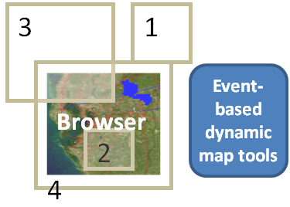
Figure 5: Positioning of the successive main query and cached data

In Figure 5, cached data is shown as browser (user interacts with). Un-cached regions (shown as white regions in grey boxes 1, 3 and 4) are processed from remote resource through novel distributed load-balancing and parallel processing techniques mentioned in the following section.

Load-balancing and parallel processing through query decomposition
Federator inherently makes workload sharing by fetching the different data layers from separate resources to create multi-layered map image. We call this vertical load balancing. This is a natural load balancing and parallel processing result from the architectural features.
In addition to layer-based natural load-balancing, a layer (in the multi-layered map image) itself can be split into smaller bounding box tiles and each tile can be farmed out to a worker WFSs/WMSs. Layer-based partitioning is based on attribute-based query decomposition in which the attribute is the bounding box defining the requested data’s range in a rectangular shape. This section focuses on individual layer partitioning and gives the architectural details in Figure 6.
In our federator framework, the load balancing and parallel processing techniques are applied over the un-cached regions of the main query. Queried regions overlapping with cache is met from the users’ cached data.
The parallel processing is based on the main query partitioning. The main query for a map is called range query defining a rectangular region surrounding set of geo-data whose location attributes fall in that region. Range queries are defined as bounding box . It is the main query attribute in all the geo-data queries.
Partitioning the main query bounding box (BBtotal), and fetching and rendering the data in parallel (see Figure 6):
The main idea is decomposing un-cached region’s bounding box defined in main query and creating small sub-regions defined again in bounding boxes. After having partitions in small bounding boxes, each partition is assigned to separate thread of work, and the results to partitions are merged to create final response for the main query. The partitions are assigned to threads in round-robin fashion in case of having bigger number of partition number than the worker WFSs.
Figure 6 shows a sample case in which there are 3 WFS worker nodes and 5 partitions. BBtotal is the main query’s bounding box. Bb1, bb2, bb3, bb4 and bb5 are the partitions obtained from partitioning BBtotal.

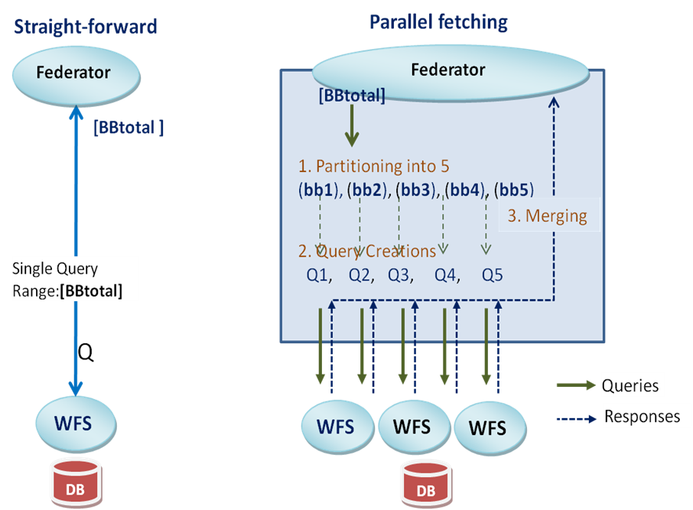

Figure 6: Architectural comparisons of parallel fetching (5-partition) with straightforward single thread fetching. BBtotal=bb1+bb2+bb3+bb4+bb5.

Overall evaluation of the system performance:
The overall performance results changes considerably depending on the cached data available and queried region, and their positioning to each other. Here we analyze those affects on overall performance results. In Figure 5, “browser” shows the previous request’s answer to user (cached data in federator) and boxes 1, 2 and 3 show the user’s successive query region.
Here we analyze end-to-end response times based on all possible cases of query and cached data ranges positioning (see Figure 5). Overall performance changes depending on cached data and main query positioning. Queries and cached data can be positioned in three possible ways. These are:
  - Main query range falls in outside of cache data ranges [worst case]
  - Main query range falls in cached data ranges [best case]
  - (4) And partially overlapping [in between]
First group of requests are mostly first time queries. Federator does not have priori state information about them. In such cases, federator fetches whole data falling in the requested ranges from remote databases through WFSs.
Second group of requests are mostly coming from users zooming-in or panning (cutting a rectangular region over the display map) actions over the event-based interactive map tools. In such cases, the query falls in the cached data ranges and it gives the best performance result. In that case federator does not need to make successive queries to fetch the required data from the remote distributed databases through WFS-based mediators. Cache meets the whole requested ranges. Cached data is GML data kept in federator from the previous request. It is used to create the map image shown as “browser” in Figure 5.
The third group of requests is mostly coming from moving (drag and drop) and zooming-out actions over the event-based interactive map tools displaying the previous map images. In such cases, cache cannot meet the whole requested range. This is called partially overlapping with cache.
Test setup is shown in Figure 3: The system is evaluated on real Geo-science application, Pattern Informatics (PI) (Nanjo, Holliday, Chen, Rundle, & Turcotte, 2006). Performance results are obtained with two-layer map images for simplicity. The bottom layer is from NASA satellite map images provided by OnEarth project’s WMS ("NASA OnEarth Project Web Map Service," 2007), and the top layer is earthquake seismic data provided by WFS for Geo-science application.
We run the test in Local Area Network (LAN). We have used machines having 2 Quad-core Intel Xeon processors running at 2.33 GHz with 8 GB of memory.
For the partitioning process we use 6 WFS workers to which partitions are assigned in round-robin fashion. In case of increasing the number of WFS, performance will be increasing.

Table 1: Average response times and standard deviations for response times in different possible cases. The values are in milliseconds and the test setup was run 50 times to get each value in the table. How many measurements were made?
Data MB | (No-Cache)  (No-PRT) Single process | StdDev | (No-cache)  (PRT) multi-process partition to 10 (1) | StdDev | (Cache) (No-PRT) Cache meets whole query (2) | StdDev
0.01 | 1,808.13 | 140.32 | 2,329.50 | 131.46 | 1,040.33 | 233.24
0.1 | 2,635.46 | 313.48 | 2,760.00 | 104.35 | 1,148.44 | 233.11
0.5 | 5,001.29 | 238.94 | 3,460.40 | 120.24 | 1,369.90 | 443.66
1 | 8,225.73 | 200.27 | 4,640.53 | 106.42 | 1,687.44 | 421.92
10 | 64,506.78 | 283.24 | 23,118.42 | 941.83 | 2,785.37 | 282.39

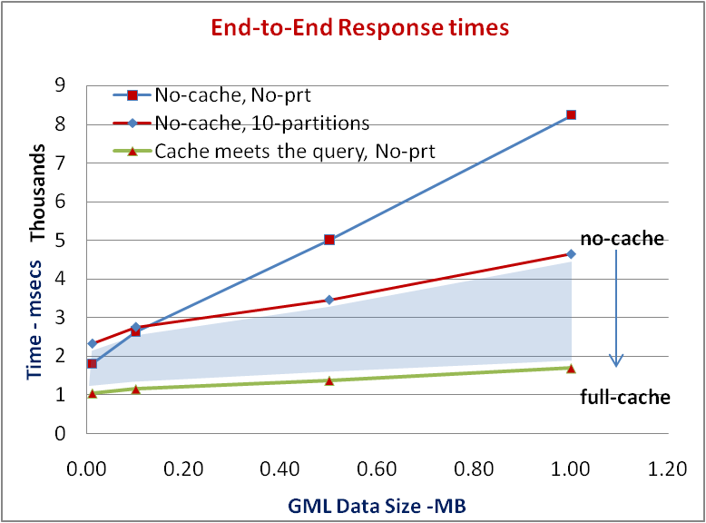
-Figure 3
Figure 7: End-to-end response times according to possible query cases. Figure 3 is test setup.

Figure 7 shows that state-full access to OGC’s stateless data services through the federator, and resulting parallel processing through query decomposition and caching techniques enhanced the system responsiveness to a great extent. The performance results are end-to-end response times in which one end is database and other end is user (say decision makers).
Depending on how much portion of main query is met from cache, the performance changes in region-3 between line 1 and 2. As the overlapped portion increases, the performance gain increases and gets close to line-2. When they fully overlap, the response times becomes line-2. The performance results also show us that as the data size increases, the performance gain from the proposed techniques increases.

.

Abstraction of the Framework for the General Domains
Our experiences with GIS have showed that federated service-oriented GIS-style information model can be generalized to many application areas such Astronomy and Chemistry. We call this generalized framework Application Specific Information System (ASIS) and give blueprint architecture in terms of principles and requirements. Developing such a framework requires first defining a core language (such as GML) expressing the primitives of the domain, second, key service components, service interfaces and message formats defining services interactions, and third, the capability file requirements (based on core-language) enabling inter-service communications to link the services for the federation (see Figure 8).
GIS is a mature domain in terms of information system studies and experiences. It has standard bodies defining interoperable online service interfaces and data models such as OGC ISO/TC211, but many other fields do not have this. In order to see the applicability of the GIS-style information model given in Figure 3, we surveyed two science domains (Astronomy and Chemistry). Table 3 presents the results briefly in terms of service counterparts (ASIS vs. science domains).
Astronomy has a standard body called International Virtual Observatory Allience (IVOA) defining data formats and online services somewhat analogous to the OGC standards. FITS (Flexible Image Transfer), Images and VOTable (Williams et al., 2002) are the data models. SkyNodes is a Database server with an ADQL (Astronomy Distributed Query Language) based SOAP interface returning VOTable based results. VOPlot and TopCat are the services to visualize the astronomy data in the format of VOTable, FITS and images. VOResource and UCD are the metadata definition and standards for the service descriptions (Yasuda et al., 2004). On the other hand, Chemistry, although a vastly different field, does provide a common data model (CML (Holliday, Murray-Rust, & Rzepa, 2006)) that can be used to build up services.

Here we give a high level architecture that consists of abstract components and explain their data flow and components interactions. In this section, we mostly focus on the principles and requirements to generalize GIS-like architecture to any other information system domains. Note this architecture is intended to be domain-specific. That is, it may be realized in chemistry or astronomy, for example, but we are not suggesting cross-domain interoperability.
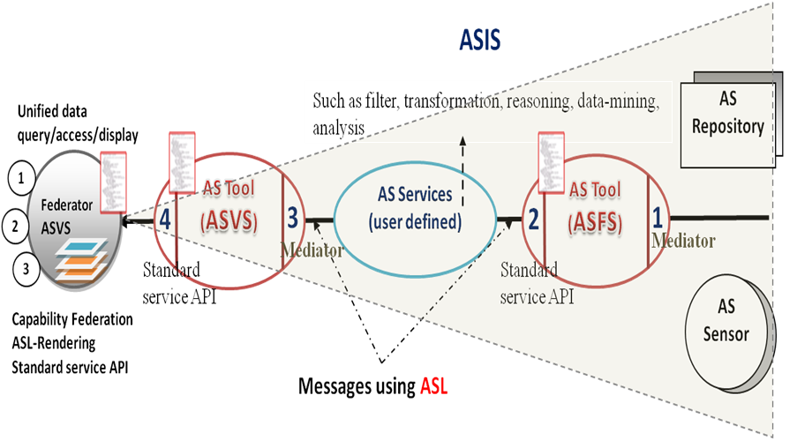
Figure 8: Application Specific Information System (ASIS)

ASIS propose a solution to heterogeneous data integration. This solution enables inter-service communication through well-defined service interfaces, message formats and capabilities metadata. Data and service integration is done through “capability” federation of these services which are implemented in Web Services. In ASIS approach, there are two general groups of services. These are Application Specific Feature Service (ASFS) and Application Specific Visualization Service (ASVS), and each service is described by corresponding generic metadata descriptions that can be queried through Web Service invocations. Going beyond the enablement of service discovery, this approach enables at least three important things. First, services of the same type that provide a subset of the request can be combined into a “super-service” that spans the query space and has the aggregate functionality of its member services. Second, the capability metadata can be used to determine how to combine services into filter chains with interconnected input-output ports. Third (and building on the previous two), capabilities of “super-services” can be broken into smaller, self-contained capabilities that can be associated with specific services. This enables performance gains through load-balancing.
ASIS consists of filter-like Web Services components (ASFS and ASVS) having common interfaces and communicating with each-other through capability exchange interface. Being a Web Service enables filter services to publish their interfaces, locate each other and chain together easily. Filters have inter-service capabilities and are chainable. If the filter is capable of communicating and obtaining data from other filters, and updates (or aggregates) its capability metadata with these data (after capability files exchange), then it can claim that it serves those data. Filter Services are information/data services that enable distributed data /information access, querying and transformation through their predictable input/output interfaces defined by capability document. Filter located in the same community network can update their capability metadata dynamically through “getCapabilities” service interface of the filters. Dynamically updating capabilities of filters enable removal of obsolete data or down filters.

Abstract Components and matching to sample science domains
- Chemistry and Astronomy

In ASIS, there are two groups of filter services ASVS and ASFS which are correspondence of WFS and WMS respectively (see Table 2). Since they have different service API and data provided, they have different schema of capabilities. In capability metadata they define service and data attributes their constraints and limitations to enable clients to make valid queries and get expected results. Capabilities metadata and Application Specific Language (ASL) are closely related to each other. One defines the domain-specific data and other defines the query and response constraints over the service and data provided.

Table 2: From GIS to ASIS components’ mapping

GIS Component |  | ASIS Component |  | Descriptions
GML | → | ASL |  | Common Data Model
WFS | → | ASFS |  | Feature data mediation
WMS | → | ASVS |  | Display data mediation
Capability.xml | → | Metadata |  | For ASFS and ASVS

ASVS both visualizes information and provides a way of navigating ASFS and their underlying database. ASVS provide human readable information such as text, graphs (scalable vector graphic (SVG) or portable network graphic (PNG)) images. An ASFS is an annotation service providing heterogeneous data in common data model with attribute-based query capability. ASFS basically serves data in ASL (domain specific XML-encoded common data model) containing content and representation tags. Heterogeneity in queries and data formats is handled through resource-specific mediators.
User defined services in ASIS (Figure 8) provide application specific data and services. These can include transformations, reasoning, event-detection, and data-mining tools for extraction knowledge from the feature data provided by ASFS in ASL format. For example, we can give Pattern Informatics Geo-physics application (Tiampo, Rundle, Mcginnis, & Klein, 2002) as an example. In Pattern Informatics, ASIS needs to overlay multi-layered map images with earthquake forecast values (Rundle, Turcotte, Shcherbakov, Klein, & Sammis, 2003) as hot-spot plots in colored boxes showing magnitudes of expected earthquake seismicity.

.

Table 3: Components and common data model matching for generalization of GIS to ASIS. Two selected domains are Astronomy and Chemistry. (2007)
……………ASIS  Science  Domains | Common data Model ASL | Components  ASFS ASVS |  | Metadata
GIS | GML | WFS | WMS | capability.xml schema
Astronomy | VOTable, FITS | SkyNode | VOPlot  TopCat | VOResource
Chemistry | CML | None | NO standard  JChemPaint | None

Inter-service communications
- Standard Service Interfaces and Mediators
Inter-service communication is achieved through common service interfaces and capability metadata exchange. The standard service interfaces can be grouped into three types: a) capability metadata exchange: inter-service communication (set-up stage); b) interactive data display: selecting layer composition and bounding box regions; and c) querying of data itself over the display: getting further information about the data content and attributes.
As mentioned before, capability helps client make valid requests for its successive queries. Capability basically provides information about the data sets and operations available on them with communication protocols, return types, attribute based constraints etc. Each domain has different set of attributes for the data and it is defined in ASL common data model. For example in GIS domain sample attributes might be bounding box values (defining a range query for data sets falling in a rectangular region) and coordinate reference system.
Standard requests/query instances for the standard service interfaces are created according to the standard agreed-on request schemas. These are defined by open standard bodies in corresponding domain. The request instances contain format and attribute constraints related to the ASL common data model. For example in GIS domain, getMap request defines a map images’ return format (JPEG, PNG, SVG etc.), height, width, bounding box values etc. Format, height and width are related to display, but bounding box values are related to the attributes of the data defined in its ASL representation provided by ASFS. In that specific example of getMap request, ASVF both visualize information through getMap service interface and provide a way of navigating ASFS and their underlying database. ASVS make successive queries to the related ASVSs to get the ASL data and render it to create final display for its clients.
In ASIS, the task of mediators is to translate requests to the standard service interfaces to those of the information/data sources’, and transform the results provided by the information source back to the ASIS’s standard formats. In ASFS case it is ASL and in ASVS case it is any kind of display format such as images.
Acting as a proxy of information source, the mediators communicate with an information source in its native language and API and communicate with the ASIS in a commonly agreed language (ASL) and Web Service API (such as getCapabilities, GetFeature and DescribeFeatureType in GIS). In this way, wrapping each information/data source into the translation software makes the particular sources manageable.
The mediators-wrappers enable data sources integrated to the system conform to the global data model (AS), but enable the data sources to maintain their internal structure and, at the end, this whole mediator system provides a large degree of autonomy. Instead of actual physical data federation, system makes distributed querying and response composition on the fly.

Conclusions and Future Trends
We proposed a service-oriented architecture for understanding and managing the production of knowledge from the distributed observation, simulation and analysis through integrated data-views in the form of multi-layered map images. Infrastructure is based on common data model, standard GIS Web-Service components and a federator. Federator federates GIS data Grid components and enables unified data access/query over integrated data-views through event-based interactive display tools. Integrated data-views are defined in the federator’s capability metadata as composition of layers provided by standard GIS Web-Services.
The framework applies just-in-time (late-binding) federation in which the data is kept in its originating sources all the time. This enables autonomy and easy data maintenance.
Creating a GIS in accordance with Open standards and Web Services, and the compatibility nature of open standard GIS services and their capability definitions, inspired us developing an information system enabling unified data access/query and display from a single access point. Open standards and Web Service technologies also enabled integrating the third party geospatial functionality and data into the custom applications easily.
We developed a framework for federated service-oriented Geographic Information Systems, and addressed interoperability issues by integrating Web Services with Open Geographic Standards for supporting interoperability at both data, service and application levels. We also enhanced the standard GIS Web Service components with the streaming data-transfer capability by using publish/subscribe based messaging middleware architecture.
We have also investigated performance efficient designs regarding federator, data transfer and rendering to support responsiveness in GIS requiring quick response times.
Open Standard’s GIS services are inherently stateless and based on on-demand processing. They don’t maintain state information between message calls, and that causes poor performance results in response times because of redoing the time and resource consuming repeated jobs. The federator enabled state-full access to stateless GIS data services from a single access point through the novel client-based caching technique.
Federator inherently makes workload sharing by fetching the different data layers from separate resources to create multi-layered map image. This is a natural load balancing and parallel processing result from the architectural features.
In addition to layer-based natural load-balancing, a layer (in the multi-layered map image) itself can be split into smaller bounding box tiles and each tile can be farmed out to a slave WFSs/WMSs. Layer-based partitioning is based on attribute-based query decomposition.
Although the framework is fine-grained for GIS, we have also defined the principles for generalizing federated service-oriented GIS to the general science domains.

[Future trends and research opportunities]

REFERENCES

* Corresponding author.

