

Indiana University
Pervasive Technology Labs
Community Grids Lab

Collaborative Audio/Video Conferencing Solution Using
Access Grid

Mustafa Varank
Computer Science, Indiana University
mvarank@cs.indiana.edu

1. Introduction 3
1.1 Video System 4
1.2 Audio System 5
1.3 Display System 6
1.4 Network 7
2. Hardware Specifications 7
2.1 Computers 7
a. Display Computer: 7
b. Video Capture Computer: 8
c. Audio Capture Computer: 9
d. Control Computer: 10
2.2 Video Equipment 10
a. Cameras: 10
b. Projectors: 11
2.3 Audio Equipment 12
a. Echo Cancellation: 12
b. Audio Balancing: 13
c. Microphones: 13
d. Speakers: 14
2.4 Network Equipment 14
a. Network Switch: 14
b. KVM Switch: 14
3. Using Access Grid System 15
3.1 Using Control Computer 15
3.2 Using Video Capture Computer 17
3.3 Using Audio Capture Computer 18
3.4 Using Display Computer 19

Abstract
Currently different standards are used for audio/video communication solutions over the internet. Most of those solutions are either in the form of low quality service or limited with their capabilities like allowing single audio/video streams and only peer-to-peer connections. To support group-to-group communications for collaborative meetings among multiple locations a better videoconferencing system is needed. Access Grid system is a research project to create such highly capable environments for especially scientific communities. The Access Grid system moves the understanding of videoconferencing to the next level where groups can have seamless collaborative meetings without having to deal with complex conferencing procedures by the help of dedicated system engineers that run and maintain the system. This paper details the understanding, requirements and usage of an Access Grid system. We tried to summarize our experience while creating a new Access Grid system by researching the best solutions possible.

1. Introduction
Extending the computational grid requires finding good solutions for group-to-group interactions. Large scale scientific and technical collaborations require more specific and complex interaction methods among different research groups. The concept of Access Grid, designed in Argonne National Laboratories, is aiming to support those more complex requirements. Access Grid project allows different groups at geographically different locations to be able see and hear simultaneously each other and encourages sharing resources among them over the internet. Access Grid nodes help creating research environments by the help of distributed data and visualization corridors in distributed collaborative work environments.
Access Grid involves more than 150 nodes all around the world and each node should be accommodating 3 to 20 people. The Access Grid nodes are designed based on “electronic environment spaces” which includes multiple video and audio streams among groups, large scale multimedia displays, presentation and interaction software environments, interfaces to gird middleware, and interfaces to remote visualization environments. All those resources are used and designed in a way that the participants of Access Grid will feel the sense of presence of remote participants in many different collaborative sessions that are supported by Access Grid like:
- Remote participation in panel discussions
- Collaborative work sessions
- Virtual site visit meetings
- Distributed seminars, lectures, tutorials and training
- Complex distributed grid based demonstrations
As we mentioned creating electronic spaces which will accommodate group interactions requires more sophisticated technologies, equipments, efforts and methods than classical desktop technologies. Access Grid is composed of four main components; we can summarize those components as follows: Video system, audio system, display system and network.

Typical Access Grid room settings.

1.1 Video System
In Access Grid system each node sends four video streams to other participating nodes. For video streams high quality PTZ cameras with tilting capabilities are used which are very powerful for feeding high frame videos and they help covering required space with tilting. Two of those video feeds are used to capture the audience, one of them is used for capturing the speaker, and the last one is used to capture the display screen to let the other nodes be aware of what is actually displayed on your site.
To be able to send video feeds on the network a video capture computer is used. Video streams are captured and converted to digital streams by the help of four video capture cards on the video capture computer, and then they are sent to other nodes over the internet by the help of video tools.
Access Grid video capture computer uses Video Conferencing Tool, VIC, to send the digitally captured streams to other nodes by encoding them with suitable protocols. VIC is a real-time multimedia application tool developed by Lawrence Berkley National Laboratory. The core of the VIC tool is the Real-time Transport Protocol (RTP), it supports many different encoding and decoding protocols including nv, nvdct, jpeg, h263+, h263, h261, cellb, pvh. Access Grid uses h261 protocol as a default for encoding and decoding the video streams, this protocol is also used by H.323 systems. VIC was designed with a flexible and extensible architecture to support heterogeneous environments and configurations.
Although VIC can be run point-to-point using standard unicast IP addresses, as in the case of Access Grid it supports multiparty conferencing by the use of IP multicast. VIC also has several dithering algorithms for representing continuous-tone color video streams on color-mapped displays. The user can trade of run-time complexity with quality. An error-diffusion dither gives the highest quality but at the greatest CPU cost, while a direct color quantization results in the lowest CPU load but yields relatively low quality. An ordered dither (derived from nv) gives moderate quality with low complexity.

1.2 Audio System
Access Grid audio system is composed of high quality table top, hands-free and wireless microphones, echo cancellation device, speaker systems, and audio capture computer. The main idea in the audio system of Access Grid is accommodating really user friendly sound environment for the Access Grid participants that they will not feel the difference between an Access Grid session and a meeting with a group that are physically in the same room.
High quality microphones will be used to capture the audio from Access Grid node and send them to echo cancellation device. The sound streams from other sites will also come to this device and send to speaker systems in the room. The echo cancellation device really stays in the heart of the system. With the help of sound processors in the echo cancellation device the echo problem, which is one of the biggest problem for quality audio conferencing, is solved. Because all incoming and outgoing audio streams are processed in this device first it is easy to manipulate the basic sound parameters and create problem-free audio environments.
For transmission of audio streams between different nodes, audio capture computer is used. With the help of audio balancing device all audio signals are converted into suitable format that can be handled by the computer sound card, then those signals are transmitted over the network by the help of Robust Audio Tool.
Robust Audio Tool (RAT) is open source software which is used for audio conferences over the Internet. RAT supports both point-to-point connections and as in our case multicast based group connections. RAT features a range of different rate and quality codec, receiver based loss concealment to mask packet losses, and sender based channel coding in the form of redundant audio transmission. It offers better sound quality relative to the network conditions than most audio tools available. Some of the popular codec that are supported by RAT can be listed as follows: G.711 (64kb/s), Wide Band ADPCM (64kb/s), DVI ADPCM (32kb/s), Variety Rate DVI ADPCM (32kb/s), G.726 ADPCM (16-40kb/s), Full Rate GSM (13kb/s), and LPC (5.6kb/s).

1.3 Display System
To be able to get high quality - close to real- video images from other Access Grid nodes, big screen displays are required. Three high ansi lumen projectors are mounted together to create huge display walls, two of those projectors are used to project the video streams and the other one is used to display other collaborative tools to participants.
A display computer is used with Access Grid Virtual Venue software to project all those video streams and collaborative tools through the display wall. The key point of this display computer is that it is equipped with high quality multi-headed display cards. As we mentioned before, some meetings requires getting more than 20 streams which is very hard to handle with regular display cards. With the help of multi-display cards it is possible to divide the streams among different displays without much performance degradation.
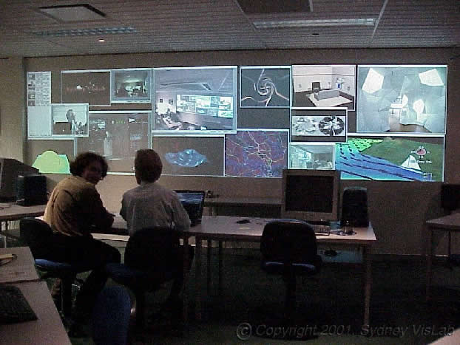
Big display wall in a typical Access Grid node setting

1.4 Network
IP multicast is a bandwidth conserving technology that can reduce traffic by transporting single streams of information across the network backbone to regional and local distribution points where the data is replicated for simultaneous delivery to multiple users. Because of its high bandwidth requirements Access Grid uses IP multicast to carry video and audio streams over the internet. As bandwidth inadequacies result in undesirable audio and video, this is a practical solution for Access Grid setup. With the help of multicast without consuming too much bandwidth it is possible to send large amount of data among different Access Grid nodes.
To be able to run Access Grid nodes correctly, the network for the Access Grid should be multicast enabled not only for local area but also for wide are backbone connection. Without proper multicast solution, Access Grid tools do not function properly.

2. Hardware Specifications
In this section we will try to list and evaluate hardware specifications of Access Grid. Creating room-based fully functional Access Grid node requires many different types of hardware and tools and it also requires sophisticated building process. We can evaluate those hardware requirements in different categories.

2.1 Computers
Regular commodity PC computers can be used for creating required computing environment for the Access Grid. Although they run in parallel, each computer is used to control specific component of the AG. Video capture and display computers requires using specific video cards for capturing the video streams and projecting them on display wall.

a. Display Computer:
QTY | Description
1 | Supermicro SUPER X5DAE Dual Xeon ATX Mainboard
2 | Dual 2x Intel Xeon 2.4GHz 512K Cache 533MHz FSB CPU Hyper Threading
1 | Micron 1024MB 1Gig PC2100 DDR SDRAM
1 | 120Gig ATA133 IDE 7,200RPM Hard Drive
1 | (1) 8x/4x AGP Pro
1 | (1) 64-bit 133MHz PCI-X, (2) 64-bit 100MHz PCI-X, (2) 32-bit 33MHz PCI
1 | PCI-128 Soundblaster Audio Card
1 | 10/1000 Onboard Gigabit LAN
1 | Matrox Millennium G450 PCI Video Card
1 | SONY 52X IDE CDROM
2 | Cooler Master 2U P4 Cooling Fans w/Heat Sink
1 | 4U Rackmount 400W 1x 51/4” 1x 31/2” Bays (External) 3x 31/2” HD Bays
1 | Windows XP Professional
1 | Microsoft Office
Multi-display Graphic Card: Matrox Parhelia 256 MB
Display computer requires using multi-display video cards. Matrox Parhelia 256MB provides the ultimate productivity and image quality for this purpose. In addition to offering award winning image quality, no compromise reliability and cutting-edge workstation features, Matrox Parhelia 256MB enables sustained productivity by providing ample local memory for the most demanding design environments including hardware accelerated 3D on triple-displays and complex rendering with abundant high-resolution texture usage.
- 512-bit GPU
- 256MB DDR memory
- High performance 2D, 3D & video
- Triple-RGB, Dual-DVI, TV output
- DualHead-HF and TripleHead Desktop
- 16x Fragment Antialiasing
- UltraSharp Display Output technology
- Realtime Display Color Adjustment
- PureVideo Preview
- AGP 4X

b. Video Capture Computer:
QTY | Description
1 | Supermicro SUPER X5DAE Dual Xeon ATX Mainboard
2 | Dual 2x Intel Xeon 2.4GHz 512K Cache 533MHz FSB CPU Hyper Threading
1 | Micron 1024MB 1Gig PC2100 DDR SDRAM
1 | 120Gig ATA133 IDE 7,200RPM Hard Drive
1 | (1) 8x/4x AGP Pro
1 | (1) 64-bit 133MHz PCI-X, (2) 64-bit 100MHz PCI-X, (2) 32-bit 33MHz PCI
1 | 10/1000 Onboard Gigabit LAN
1 | 32 MB Geforce 2 Video Card
1 | SONY 52X IDE CDROM
2 | Cooler Master 2U P4 Cooling Fans w/Heat Sink
1 | 4U Rackmount 400W 1x 51/4” 1x 31/2” Bays (External) 3x 31/2” HD Bays
4 | WinTv Model 401 Video Capture Cards
1 | RedHat Linux
Video Capture Card: WinTv Model 401
Video capture computer requires using S-video capable video capture cards. Those cards will capture 4 video streams from the cameras and digitize them to send over the network. WinTv Model 401 capture card is the really cost effective solution for this purpose. WinTv 401 digitizes the live video from the external video-input source using high quality 4:2:2 video sampling. The digitized video is sent over the PCI bus into the memory of a VGA display adapter.

c. Audio Capture Computer:
QTY | Description
1 | Supermicro SUPER X5DAE Dual Xeon ATX Mainboard
2 | Dual 2x Intel Xeon 2.4GHz 512K Cache 533MHz FSB CPU Hyper Threading
1 | Micron 1024MB 1Gig PC2100 DDR SDRAM
1 | 120Gig ATA133 IDE 7,200RPM Hard Drive
1 | (1) 8x/4x AGP Pro
1 | (1) 64-bit 133MHz PCI-X, (2) 64-bit 100MHz PCI-X, (2) 32-bit 33MHz PCI
1 | 10/1000 Onboard Gigabit LAN
1 | 32 MB Geforce 2 Video Card
1 | SONY 52X IDE CDROM
2 | Cooler Master 2U P4 Cooling Fans w/Heat Sink
1 | 4U Rackmount 400W 1x 51/4” 1x 31/2” Bays (External) 3x 31/2” HD Bays
3 | PCI-128 Soundblaster Audio Card
1 | RedHat Linux
Audio capture computer does not include any specific hardware. There are some equipment which should be used for balancing audio and echo cancellation but they are not part of the audio capture computer and they will be mentioned later.

d. Control Computer:
QTY | Description
1 | Supermicro SUPER X5DAE Dual Xeon ATX Mainboard
2 | Dual 2x Intel Xeon 2.4GHz 512K Cache 533MHz FSB CPU Hyper Threading
1 | Micron 1024MB 1Gig PC2100 DDR SDRAM
1 | 120Gig ATA133 IDE 7,200RPM Hard Drive
1 | (1) 8x/4x AGP Pro
1 | (1) 64-bit 133MHz PCI-X, (2) 64-bit 100MHz PCI-X, (2) 32-bit 33MHz PCI
1 | PCI-128 Soundblaster Audio Card
1 | 10/1000 Onboard Gigabit LAN
1 | 32 MB Geforce 2 Video Card
1 | SONY 52X IDE CDROM
2 | Cooler Master 2U P4 Cooling Fans w/Heat Sink
1 | 4U Rackmount 400W 1x 51/4” 1x 31/2” Bays (External) 3x 31/2” HD Bays (Internal)
1 | Windows XP Professional
Control computer is only used to load the echo cancellation software and to control the Gentner XAP 800 echo cancellation device.

2.2 Video Equipment

a. Cameras:
Canon VB-C10 Pan/Tilt/Zoom Camera
The Canon VB-C10 combines the benefits of an advanced Pan Tilt Zoom Camera and a Network Server in one compact unit. It offers exceptional picture quality, outstanding color reproduction, and the ability to pan, tilt and zoom to multiple positions.
- 200º Pan (VB-C10R 340º Pan)
- 120º Tilt (VB-C10R 100º Tilt)
- 16x Optical Zoom
- Horizontal view 47.5º - 3º
- 410K pixel CCD image sensor
- Capture smooth full motion video
- 30 frames per second capture rate, at 320 x 240 pixels
- Video capture sizes 160 x 120, 320 x 240, and 640 x 480
- Integrated server and compact pan/tilt/zoom base means the VB-C10 is never intrusive and easy to install.
- Center mounted head delivers precision, high speed movement
- Focal Length 4-64mm
- Optional wide angle adapter to expand the view to 65º
- Compatible with different protocols to integrate easily into any network
- Manual and automatic focus and exposure controls
- Automatic White-Balance

b. Projectors:
Sanyo PLC-XT11 Multimedia Projector
To be able to create most effective display wall requires choosing the right digital projectors. As it is for group-to-group collaboration you should keep the participants comfortable enough in terms of ligtining while having a best picture of remote connections. Sanyo PLC-XT11 is ideal for that job.
- Polysilicon LCD
- 2650 ANSI Lumens (Typical)
- True XGA (1024 x 768) Resolution Compressed SXGA Resolution
- 700:1 Contrast Ratio
- New Progressive IC for 2-3 Pulldown and 1080i to Progressive Conversion
- Digital Visual Interface (DVI-I)
- ECO Mode
- HDTV Compatible
- X-Y Digital Keystone Correction
- Whisper Quiet Fan (31 dBA in Eco Mode)
- Power Lens Shift (Up/Down)
- Power Zoom/Power Focus
- Network Connectivity (with Optional PJ-NET Organizer)
- One-Touch Lens Mount System
- A Variety of Optional Lenses Available

2.3 Audio Equipment

a. Echo Cancellation:
ClearOne XAP 800 Audio Conferencing System
The XAP 800 features proprietary Distributed Echo Cancellation and noise cancellation technology for dramatically reduced echo and noise; a proven software architecture for easy, reliable configuration; a 32x32 matrix with level control (in .5dB steps) at each cross point to simplify complex mixing operations; and 20 Hz – 20 kHz bandwidth for full-range audio response.
The XAP 800’s Distributed Echo Cancellation features 130ms of tail time, which provides highly effective echo cancellation while keeping reaction time short and additional noise from being created. A tail time of 130ms optimizes echo cancellation in the majority of room scenarios.
- Noise cancellation on each microphone/line input provides 15dB of noise attenuation
- Distributed Echo Cancellation places an echo canceller on every microphone.
- Four virtual EC references are provided which can use multiple signals as the echo cancellation reference point without sacrificing an analog output
- Enhanced expansion bus, featuring 12 bi-directional audio buses
- Eight units can be linked for a total of 64 microphones and to the XAP TH2 for teleconferencing capability
- Four input filters on each of eight microphone inputs. Programmable as parametric EQ, notch, all pass, low pass, and high pass
- Eight independent processing blocks, each with 15 filters; delay; and compressors to provide pinpoint audio configuration
- Four internal and four global microphone mixers, each with parameter adjustments
- 32 presets that can be executed on-the-fly without disturbing other ongoing preset operations
- Macro Pro scripting language simplifies macro creation with point-and-click convenience
- RAMP serial command for greater control over gain adjustments
- Adjustable minimum and maximum gain levels for each input, output, and processor to control the range of gain

b. Audio Balancing:
ATI Match Maker MM100
Consumer equipment can offer unique features, performance or pricing making it very desirable for professional use. Unfortunately, RF pick up, crosstalk, high frequency roll off, hum loops and distortion often result from direct connection of low level IHF outputs into 6001/2 systems in studio or broadcast environments.
The Match Maker matches semi-pro, industrial and consumer audio equipment into professional balanced 6001/2 systems. The Match Maker is a bidirectional interface to bridge a stereo pair of 6001/2 balanced +4 dBm lines and convert those signals to a nominal .25V (-10dB Ohm) level to those signals to feed, for example, the record inputs of a cassette or reel-to-reel tape recorder. Simultaneously the Match Maker also converts the unbalanced stereo, .25 Volt deck playback outputs to a transformer balanced, floating +4 dBm, 6001/2 professional line level.

c. Microphones:
Crown PCC-160 Supercarioid Microphone
The Crown PCC-160 is a surface-mounted, supercarioid microphone intended for professional applications on stage floors, lecterns, podiums and conference tables, wherever improved gain-before-feedback and articulation are important. Excellent gain before feedback reduces unwanted room noise and rejects sounds from the rear. A "Bass tilt" switch allows the user to tailor the low-end response for particular applications. Low profile and black finish make it almost invisible. Phantom Powered which can be used with any standard mixer with phantom power.
- Phase Coherent Cardioid uses a subminiature supercardioid microphone capsule.
- Its directional polar pattern improves gain-before-feedback, reduces unwanted room noise and rejects sounds from the rear.
- Enhanced Clarity and reach
- Side-mounted connector allows the unit to be placed effectively at the stage edge, at the top of a lectern or in other tight spots.

d. Speakers:
Genelec 1029A Bi-Amplified Monitoring System
The extremely compact 1029A is a powerful bi-amplified near field monitor system ideal for surround sound monitoring. Vented speaker enclosure contains an amplification unit, including an active electronic crossover, overload protection circuitry and two power amplifiers; one for each driver. Genelec 1029A is used to provide excellent stereo imaging and frequency balance, even in difficult acoustic environments. Versatile room response controls allow matching of the system to its surroundings. The only connections required are the mains supply and the line level input. The input is made via balanced XLR female or 1/4" jack socket connector which can also be used in parallel.

2.4 Network Equipment

a. Network Switch:
HP ProCurve 2512 Managed Switch
The HP ProCurve 2512 features 12 managed 10/100M bit/sec ports, and come with two gigabit transceiver slots for stacking or connecting to a backbone switch or server. It is ideal for network segmentation and subnetting, it also supports virtual LANs.
- Low-cost, stackable, managed 24- and 12-port switches with 10/100 auto sensing per port and 2 open transceiver slots for Gigabit or 100Base-FX
- Offers hp Auto-MDIX on all 10/100 and 100/1000 ports and high availability features
- 9.6 Gbps switch fabric integrated on-chip; high performance switch design with a non-blocking architecture

b. KVM Switch:
Belkin Omniview PRO
The OmniView PRO allows you to manage four PS/2 servers with one keyboard, mouse, and monitor at the push of a button. This 4-port KVM switch features an on-screen display for naming and selecting up to 64 servers when used in a daisy-chain configuration. It uses standard connectors and it supports all major operating systems.

3. Using Access Grid System

3.1 Using Control Computer
Control Computer is used for controlling the audio environment. Everything related with audio system should be handled through this computer and the software for Genter Echo Cancellation device, Gentner AP-Ware.
- Run the Gentner AP-Ware Main Program from Program Files.
- When Program starts running click on the File tab and choose Open Site
- Choose one of the default configurations.
- Click on the Connect tab and choose the device
Once you connected the device you can set Matrix configuration which controls the actual wiring of audio devices, you can set in-line or out-line parameters, and you can control input settings. Below you can see the basic configuration parameter windows:
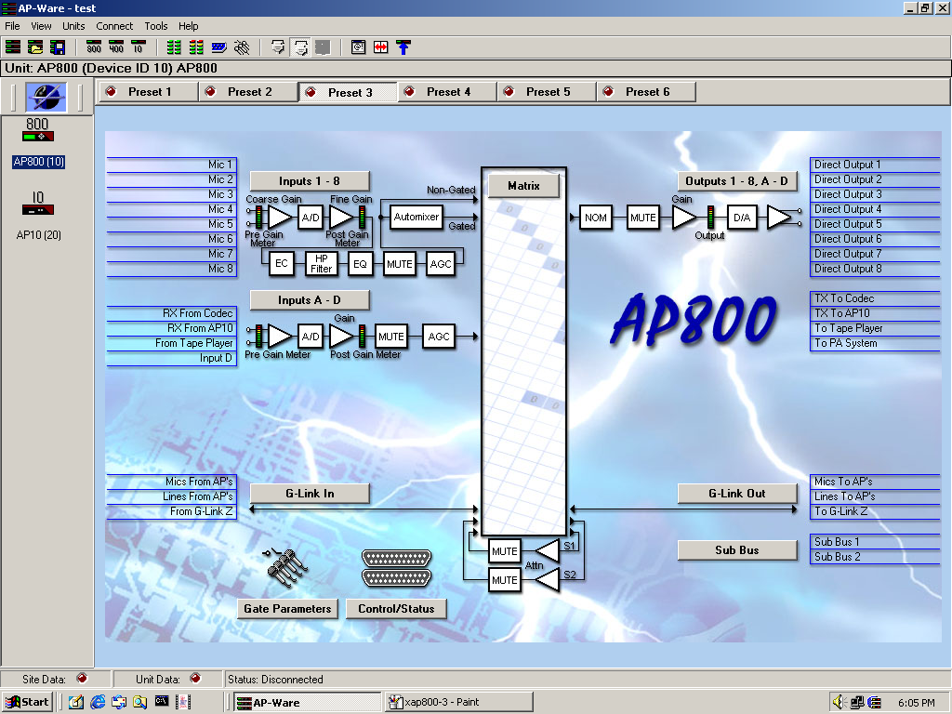
The first picture is the main configuration screen for XAP 800. You can preset 6 different configurations so you can easily switch to required audio environment when it is needed.
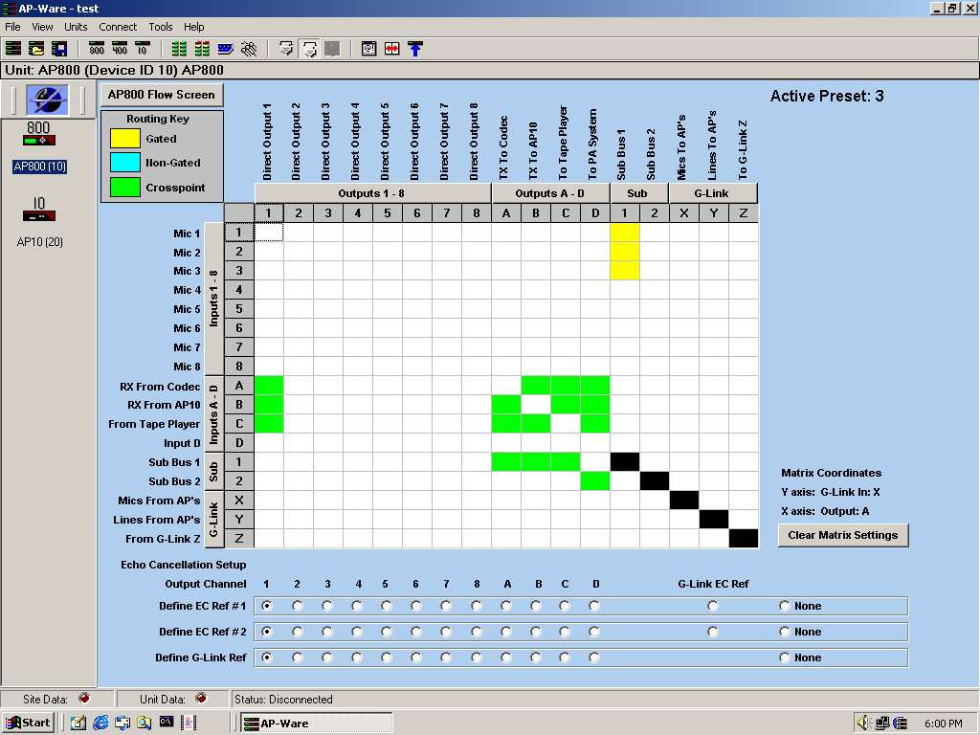
The picture above is the Matrix settings of XAP 800. All the arrangements of different streams, deciding which sources and destinations should be connected and echo cancellation arrangements are done by configuring these Matrix settings.
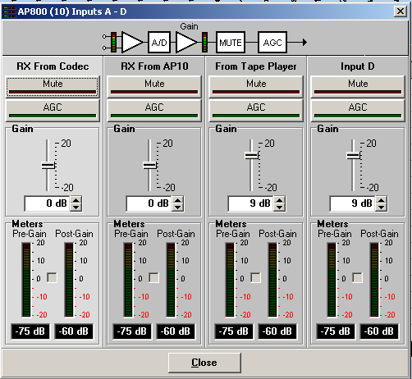
Different room settings require different gain configuration, silence suppression, and attenuation settings for input/output devices. This is done through auxiliary input configuration window (above) and microphones configuration window (below).
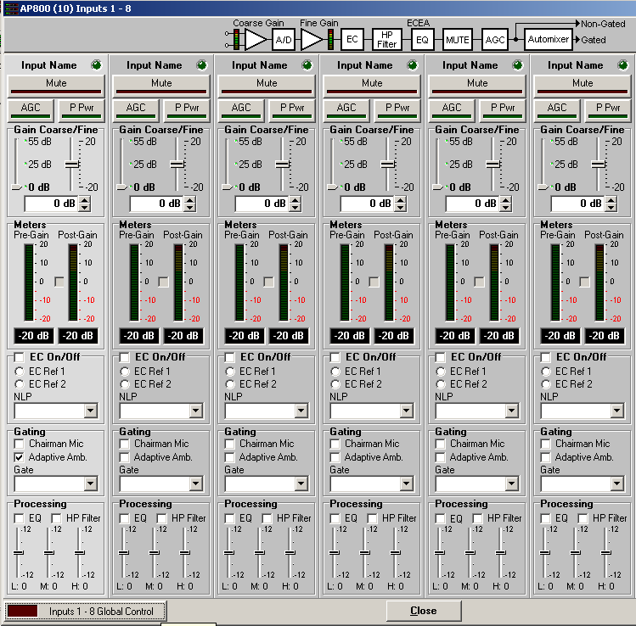

3.2 Using Video Capture Computer
Video capture computer is used to send camera images to other Access Grid nodes through the virtual venues. Here is the procedure for running video capture computer:
- Login to video capture computer
- Open a new terminal window
- Run the “vrm-eventlistener” under /usr/local/ag/bin
- Once you run the script, it will lunch the Video Resource Manager application
- The Heartbeat should be blinking if everything is working fine.
- Video Resource Manager starts sending videos once the user connected to any Virtual Venue through display computer.
In the first picture below, you can see Video Resource manager is running and waiting to send the video streams. It is what you have to see when you first the video resource manager event listener.
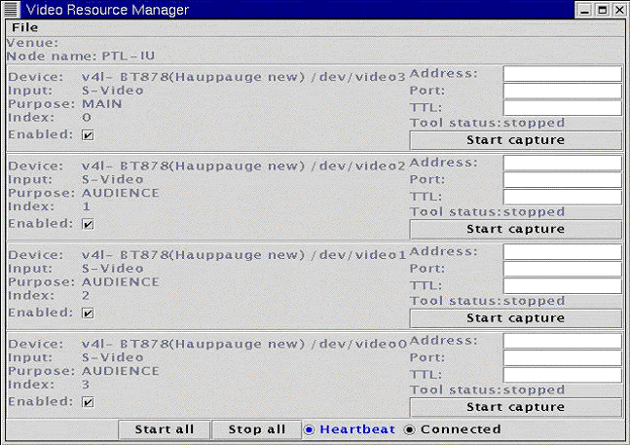
In the second picture below, you can see how video resource manager runs. Once Display Computer connected to Access Grid Lobby venue room, the video computer starts sending the videos automatically.
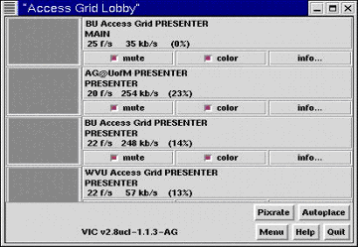

3.3 Using Audio Capture Computer
Audio capture computer is only used to send audio to other access grid nodes and get the streams that were sent by them, it uses rat as base software and directly connected to Echo Cancellation device through the Match Maker balancer.
To be able to run the audio capture computer those steps should be followed:
- Login to audio capture computer
- Open a new terminal window
- Run the “arm-eventlistener” under /usr/local/ag/bin
- Once you run the script, it will lunch the Audio Resource Manager application
- The Heartbeat should be blinking if everything is working fine.
- Audio Resource Manager starts running RAT and sending audio once the user connected to any Virtual Venue through display computer.
- When RAT program connects to a room as a default sound is disabled. To be able to start talking with other nodes, node operator should click on talk box on the RAT main window. (See second picture)
In the first picture below, you can see Audio Resource Manager is running and waiting to run RAT and send the audio. In the second picture, you can see once Display Computer connected to Access Grid Lobby venue room, the audio computer starts running RAT automatically and connects to the room, when you connected you can see other nodes that are connected to same room through RAT.
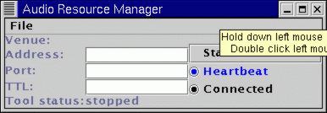
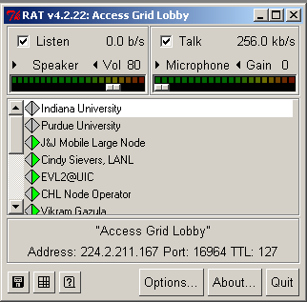

3.4 Using Display Computer
Display computer is used to project the video streams from participating Access Grid nodes and other collaborative tools. It also controls video and audio capture computers to direct their outputs to related rooms. Once display computer connects a venue room on Access Grid venue server, audio and video capture computers automatically sends their outputs to that room. To be able to run the display computer those steps should be followed:
- Login to Display Computer
- From Start menu go to Program Files, chose Access Grid Toolkit, then Venue, and then run the Event Server.
- If there is no multicast problem in your network you should see the Ready message on your Event Server Monitor tool.
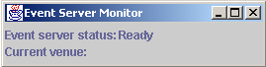
- When Event Server shows its status as Ready, this time you should run Display Manager from Program Files > Access Grid Toolkit > Venue.
- Display Manager will lunch the Display Resource Manager application and wait for you to connect a venue room
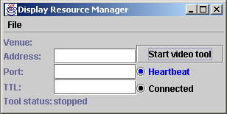

- When Event Server and Display Resource Manager is up and running. You should go to Access Grid Virtual Venues Server web site from Internet Explorer to login venue rooms. The address for the web site is http://venues.accessgird.org.
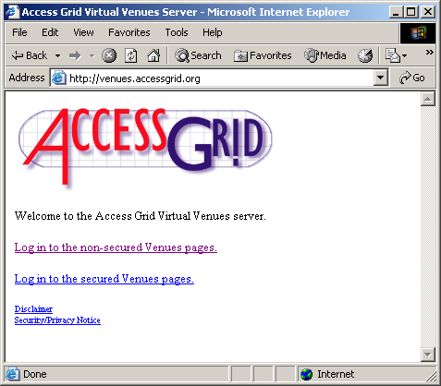
- On the login page you should click on the link where it says Login to the non-secured Venues pages. It will ask you a username and password.
- When you enter your username and password you will enter the Virtual Venue Lobby page which is the entrance to go all venue rooms for Access Grid, those rooms are the actual meeting places and they can be reserved from Access Grid web site (http://www.accessgrid.org)
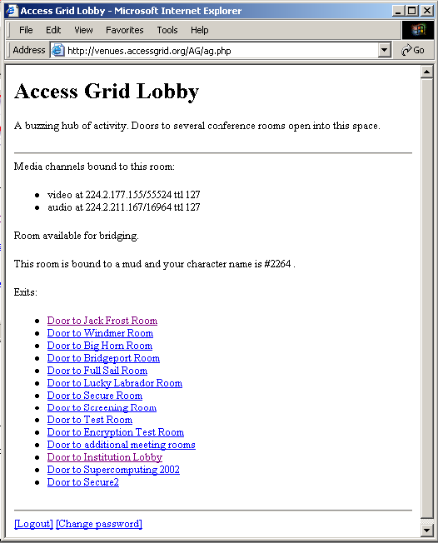
- Once the node enters any of those venue rooms, two programs lunch automatically. First a chat program, tkMOO-light, which is used between Access Grid operators to communicate without affecting the actual meeting.
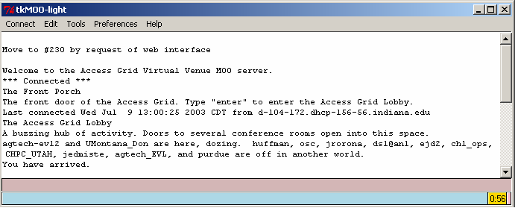
- Secondly, Virtual Room window is opened to show the nodes that are connected to the same room. Clicking on any video will pop up a separate window to show the video streams in different sizes. With the help of multi-display video card those windows can be easily arranged on the display wall by simply dragging them around.
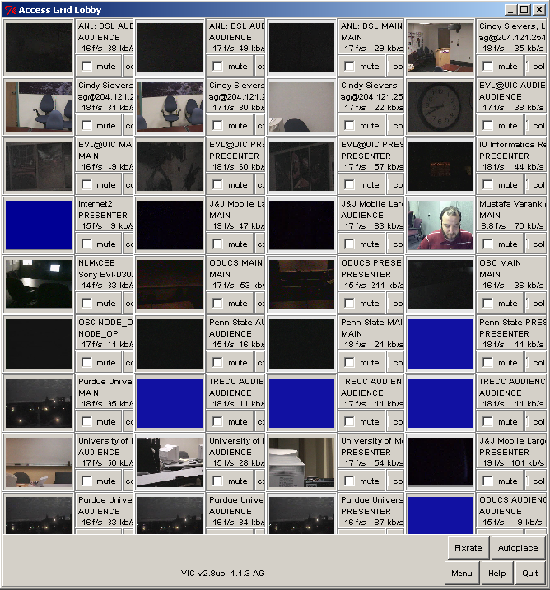

4. Conclusion
The Access Grid provides a new way of video conferencing on a large scale by the
use of purpose built rooms and operators dedicated to handle the technical side of
the conferencing. Though designed for use on the Information Grid, it has currently
been implemented successfully on the internet through the use of multicast bridging
software between international locations. The Access Grid is currently providing high
quality audio/visual videoconferencing between many distant locations, currently
having on average of almost 10 events a week according to AGSchedule. Current
events range from university tests to global group meetings, the usage can only
increase as the technology gets more cheaper, more practical to install, and thereby
more widely adopted.
Also the advent of the personal interface to the Access Grid has provided a solution
that may be more convenient to users who do not wish to travel to/build node rooms
and have sufficient access elsewhere. Recording Grid events can be useful for
historical value, and also for the distribution of recordings soon after an event rather
than requiring a non-participating audience to be watching at the time of the event.
With all this the Access Grid gives a new high standard of audio/visual conferencing
to offer a high quality experience allowing group collaboration over the internet with
ease.

Access Grid Pages, http://www.accessgrid.org
Echo Cancellation, http://www.gentner.com/product_service/audio/index.php
Multi-Display Video Cards, http://www.matrox.com/mga/home.htm
Multicast Pages, http://dast.nlanr.net/Projects/Beacon/
Robust Audio Tool, http://www-mice.cs.ucl.ac.uk/multimedia/
Video Conferencing tool, http://www-nrg.ee.lbl.gov/

